**PROCEDURE MANUAL**

**PENFAX 5**



Table of Contents

PENFAX Navigation 7

Signing In and Out 7

Viewing the Dashboard 8

PENFAX Notes 8

Searching in PENFAX 11

Person Profile Overview 16

Navigation Menu 17

Viewing and Updating Verification Icons 19

Attaching Documents in PENFAX 21

Case Management Overview 22

Suspending a Case 32

Member Data Changes 34

Address, Phone or Email 34

Social Insurance Number 39

Member’s Name 42

Marital Status 46

Adding a Beneficiary 54

Spouse as Beneficiary 56

Contingent Beneficiary 61

Editing a Beneficiary Record 63

Estate as Beneficiary 65

Deleting a Beneficiary 66

Person Status – Spousal Waiver & Consent Form 67

Work Absence 69

Scope Code, Department Code and Employment Status Change 72

Add or Change to a Department Code 72

Add, Change or Delete a Scope Code 74

Employment Status Change 76

Legal Orders 77

Procedures to Obtain Missing Information 82

Certified Documents 82

Acceptable Documentation 83

Notary Public, Commissioner of Oaths, Justice of the Peace 83

When is Identification Required from a Member? 84

Enrolment 84

New PEPP Member Enrolment 84

Creating and Maintaining Organizations 84

Searching for Organization Records 85

Organization Screens and Regions 86

Organization Profile Menu 86

Employer Profile Menu 98

Adding a New Employer or Organization 105

Investment Management 110

Account Balances 110

Deposit Allocation Change 113

Inter-Fund Transfer or Asset Rebalance 117

Payroll Contribution Processing 124

Voluntary External Transfer In Deposit 124

External Transfer In With Service 130

Leave of Absence Repayment by RRSP 130

Viewing Unit Values in PENFAX 130

Termination of Employment 132

Retirement Estimate 132

Annuity Estimate 133

VPB Illustration 136

Retirement Estimate Letter Procedures 141

Weekly Annuity Rate 142

Payment Processing 144

Small Pension Payment 145

Voluntary Contribution Payment 160

Partial Payment 173

Excess Contribution Refund (Overpayment) 184

Contributions Received in Error 184

External Transfer Out 198

2nd Payments 212

Transfer to SPAF or Outside Annuity 224

Non-Resident Payment 242

Maintenance Order Payment 255

CRA Requirement to Pay 275

Splitting a Payment 285

Terminal Illness Payment 294

Clear Residual Amount Payment 306

Transfers to another Registered Pension Plan (RPP) with Service 310

Portability Transfer Out Payments 310

Reciprocal Transfer Out Payments 311

Spousal Relationship Breakdown (SRB) 324

Spousal Relationship Breakdown (SRB) Estimate – PEPP & VPB 324

Spousal Relationship Breakdown (SRB) Payment - PEPP & VPB 338

Creating a PENFAX Account for an Ex-Spouse 359

Creating a PEPP Account for an Ex-Spouse 363

Age 71 Letters 365

Death of a Member 367

Death Option Letter 367

Death Payment Requirements 381

Death Payment Option – Leave Funds in Account 381

Death Payment – Cash Option 385

Death Payment to Spouse – Transfer to Qualified Financial Institution 402

Death Payment to a Spouse’s PEPP or VPB Account 419

Variable Pension Benefit 439

Variable Pension Benefit Enrolment PEPP Member 440

Variable Pension Benefit Setup of a Former PEPP Member 463

VPB Lump Sum Payment 480

VPB Full Payout - Transfer to a Registered Plan or Cash Payout 489

VPB Maintenance Enforcement Payment 507

Scenario: VPB Lump Sum Payment Request form received 516

Scenario: Member Receiving or Starting Scheduled Payments 531

Updating and Deleting Garnishments 536

VPB CRA Requirement to Pay 537

Splitting a Payment 546

VPB Changes to Schedule Withdrawals, Payment Instructions or Tax Instructions 555

Changes to Scheduled Withdrawals for an Income Benefit Amount 555

Changing Payment Instructions and Adding Alternate Instructions 557

Suspending Payment Instructions 562

Change Age for ITA Minimum 563

Deleting Payment Instructions 565

Changing Tax Instructions for Income Amounts 567

Deleting Tax Instructions 569

Reversals and Corrections 570

Deleting an Enrolment 571

Reverse an Employment Termination 573

Reverse a Payment from DC Benefit Selections 576

Cancel a Pending Inter-Fund Transfer, Asset Rebalance, Processing Fee or Adjustment 580

Reverse a Deposit Post-Valuation 581

Reverse an Inter-fund Transfer Post Valuation 587

Cancel a Payment Post-Valuation 592

Adjustment of Units 596

Merge Duplicate Stakeholder Records 601

Reissue a Cheque 602

Manual Cheque Request 603

Returned Cheques/EFTs for VPB 603

Voiding a Remittance 604

Tax Slips 606

Print a Duplicate Tax Slip 606

Cancel a Tax Slip 610

Tax Slip Adjustment 610

Tax Slip for a Single Member 614

# PENFAX Navigation

## Signing In and Out

#### Signing In

The PENFAX 5 system is a web based application that is accessed by logging in through the PEBA Web Applications menu. New users will be assigned a User Name and a temporary Password. User access to menu items, screens and regions within the PENFAX 5 system is controlled by the security outlined within a specific role.

1. Enter your assigned **User Name** and **Password.** If you are a first time user, enter your **Temporary Password** and change your password to a new one when you are prompted to do so.
2. Click **Sign In**.

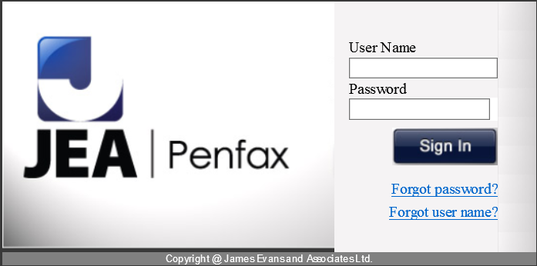

#### Signing Out

The **Sign Out** button is located in the top right corner of your screen on all PENFAX screens. Clicking the **Sign Out** button will end your PENFAX session. After 45 minutes of inactivity, the session will end automatically, with a 2 minute warning prior to expiry.



## Viewing the Dashboard

When you first sign in to PENFAX, the **Dashboard** is immediately visible. The **Dashboard** is the launch pad for all PENFAX functionality. From the **Dashboard**, you can search for a member, access Case Management assignments and perform any administrative functions assigned to your role.

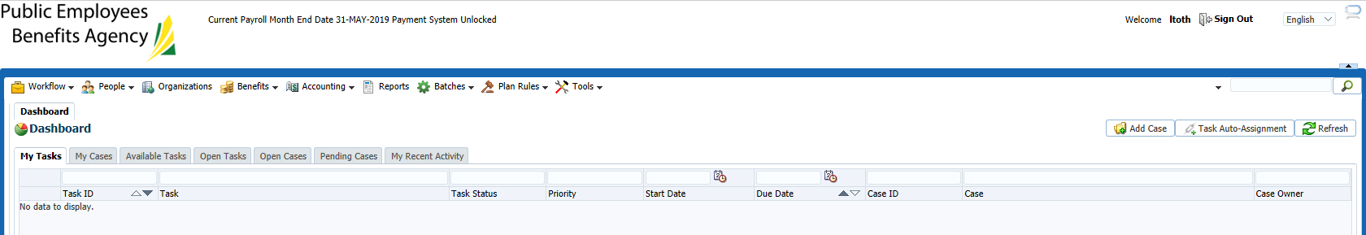

## PENFAX Notes

**Notes** can be added to most screens and during many processes such as benefit calculations. When viewing **Notes** you will only see the **Notes** added from that screen (i.e. the **Notes** region on the **Beneficiary** screen only displays the notes attached while adding or editing a beneficiary), with the exception of the **Person** **Profile** screen. The **Notes** region on the **Person Profile** displays all **Notes** added for a person from all screens.

#### Viewing Notes

1. Expand the **Notes** region at the bottom of the **Person Profile** screen.

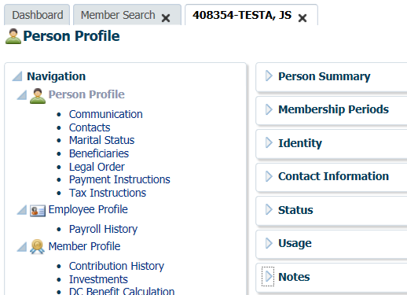

1. Highlight the desired row in the **Search Results** region to view a note previously added.

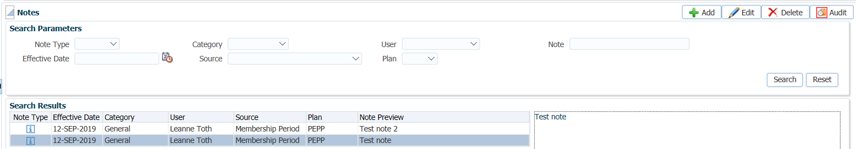

1. The context of the note will be visible in the region to the right of the **Search Results**.

#### Adding and Editing Notes

To add or edit an existing note, clicking the **Add** or **Edit** button will open the **Note** pop-up window.

1. In the **Notes** region, click **Add.**

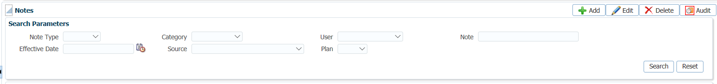

1. Enter the details of the note, click **Save.**

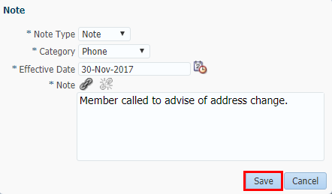

* **NOTE:** Details of the recently added note will appear in the **Search Results** region.

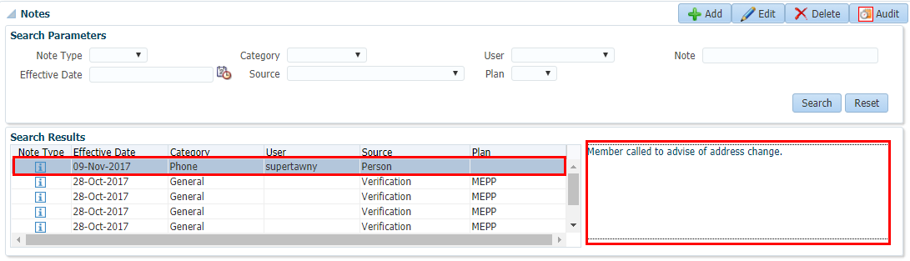

#### Searching Notes

A search feature is also available to enter various search parameters to search for a specific note on the person's record.

1. Enter your search criteria in the **Search Parameters** region.
2. Click **Search.**

s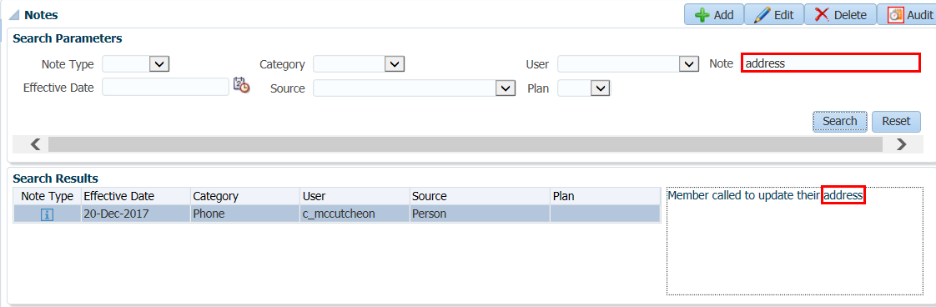

* **NOTE:** Entering search criteria in the **Note** field will search for any incidence of that word within the body of the **Note**. The search is not case sensitive.

## Searching in PENFAX

Searching for an existing Member, Stakeholder or Organization in PENFAX is done from the **Main Menu People** icon, the **Organization** icon or by using the **Quick Search** option.

When determining if a person exists in PENFAX use the **Person Search** option. When searching for an existing member of PEPP or VPB use the **Member Search** option.

If a VPB member was never a PEPP member, in the case of a non-employee enrolment, use the **Person Search.**

#### How to Search for a Person, Member, Benefit Recipient or an Organization

1. Click on the **People** icon or **Organizations** icon located at the top of the **Main Menu.**



1. If searching under **People** select the type of search (Person, Member or Benefit Recipient).

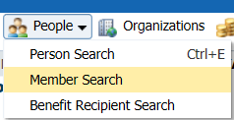

* **NOTE:** Benefit recipientwould be used to find a member receiving a benefit, such as MEPP, SPAF, PSSP, etc. and is best to use if a caller does not know what plan they are in.

1. In the **Search Parameters** region enter in the search criteria, click **Search**.

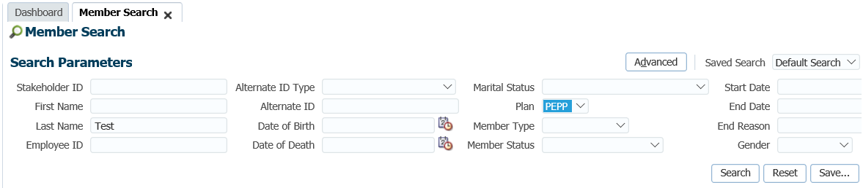

1. The results will be displayed in the **Search Results** region. All records that meet the entered criteria will be displayed.

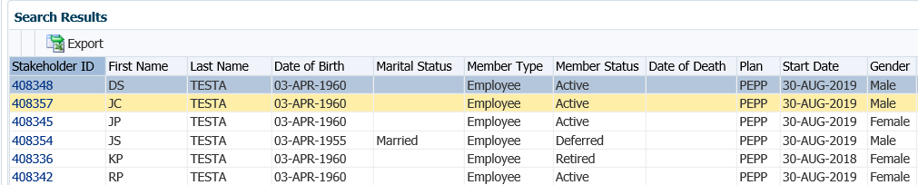

1. To retrieve a Stakeholder, click on the **Stakeholder ID** **hyperlink.** A new tab will open in the **Person Profile** screen for the Stakeholder.

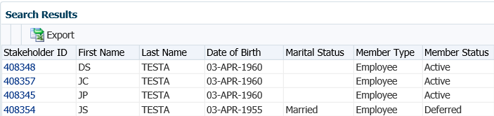

* **NOTE:** Searching for an **Organization** is done the same way as searching for a person or member.

#### Quick Search

**Quick Search** allows you to search for **People** or **Organization** records in PENFAX without the need to first access the **Search** screen.

You can quickly access a member’s or organization’s record through the **Quick Search** from any screen you are currently working on.

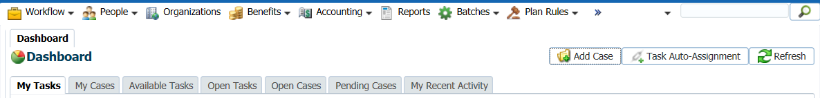

#### How to Use Quick Search

A **Quick Search** can be performed by entering complete or partial details for the following identifiers:

* **Stakeholder ID** – the PENFAX ID number for the person or organization
* **Person Name** – the last name of a person in PENFAX
* **Organization Name** – the name of an organization in PENFAX

In addition:

* **Default** – Searches for all three of the identifiers noted above.

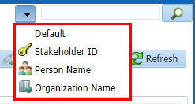

1. Select a **Quick Search** option.
2. Enter your search criteria in the text field.
3. Click the **Search** icon.



The results of a **Quick Search** will be presented to you according to the number of search results.

* **NOTE:** Clicking the **Stakeholder ID** from the **Search Results** region will open the **Person Profile** screen for that person in a new tab.

#### Advanced Search

The **Advanced** search option is available to specify for each field, specific logic or parameters to perform a search with.

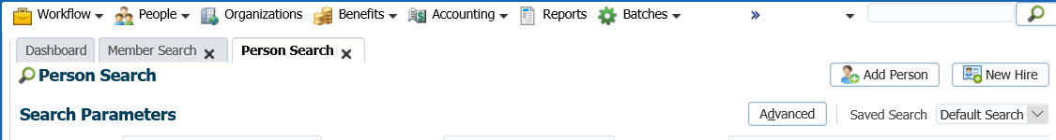

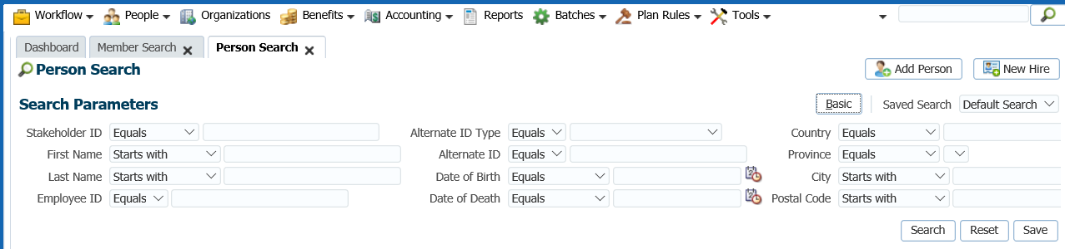

#### Saved Search

If a group of search criteria is commonly used, the user can click the **Save** button to save this group for future use. The **Saved Search** field is convenient for the user to access a list of all previously saved searches that are available for selection.

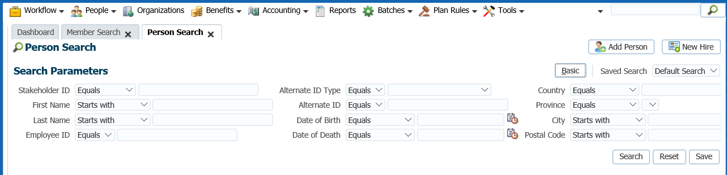

#### Reset Search Option

Clicking the **Reset** button will clear all of the search variables to allow the user to enter new search criteria. Clicking the **Basic** button will return you to the **Basic Search Parameters** screen.

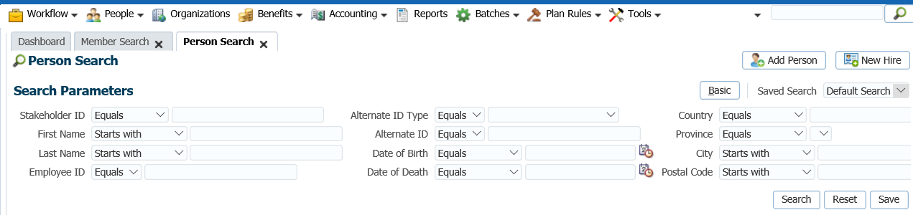

#### Personalized Saved Searches

Selecting the **Personalize** option will allow you to personalize your **Save Searches** previously created and set them as your default search option. Click **Apply** to set your search option.

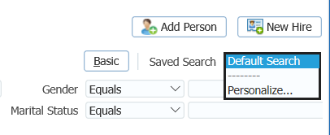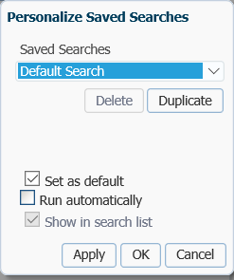

## Person Profile Overview

The **Person Profile** screen summarizes information about a person and displays current and historical demographic details, such as all current and previous contact information.

This screen is used to view or edit existing data or to add new data to a person record. Audittrails allow you to view all of the changes or updates that have been made to the person information.

The **Person Profile** screen also has a searchable **Notes** region, where you can view all the notes related to that person.

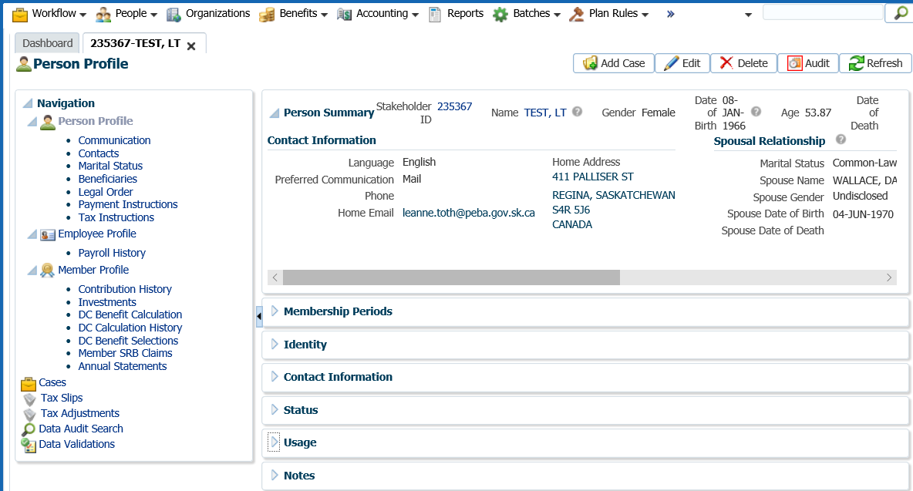

#### Viewing the Person Summary Region

The **Person Summary** regiondisplays current personal data including the ability to add/edit/delete and full audit history.

The **Person Summary** region appears throughout PENFAX at the top of all related person screens.



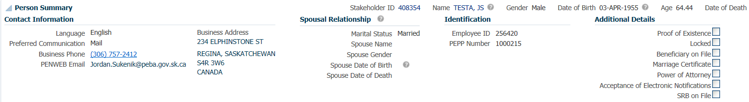

## Navigation Menu

The **Navigation** menu appears on the left side of a screen when viewing a person in PENFAX. The information related to a person within PENFAX is grouped into various screens to allow for the organization of related data. For example, a person’s marital status and spouse information are grouped together on the **Marital Status** screen. In addition, all calculations and benefit management are done through the **Navigation** menu.

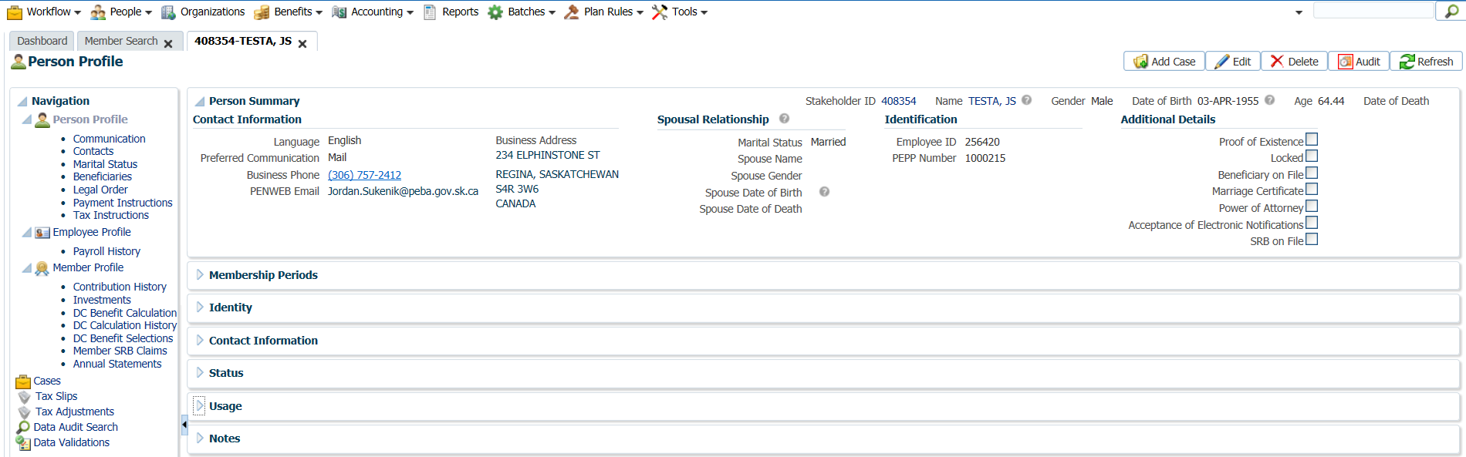

The **Person Navigation** allows the user to quickly view related information about the Person or be able to perform calculations for the person. The Cases, Data Audit Search and Data Validations allow the user to use these features in the context of this single person being viewed.

The items listed in the **Navigation** menu are dynamically displayed based on the role of the person being viewed and what role they have in PENFAX. For example, if the person is an employee, the **Employee Profile** screen will be listed, with its sub-menu of **Payroll History**. If this employee is also a member of the pension plan, then the screens that display the **Member Profile** information and perform calculations on the membership are displayed. If a person has received benefits from the Plan, the **Benefit Recipient** screen and its sub-menu items are listed.

Once navigation items are available, based on the role of the person being viewed, the system will then enable or disable the various items based on the security role of the user. If a user does not have the security role to be able to view a menu item it will appear in the Person Navigation region however it will be disabled; appear ‘greyed out’ and the user cannot click on it to open the screen.

#### Navigation of Person Profile

Menus items include:

* *Communication* – letters, statements will be saved here for inbound and outbound documents
* *Contacts* – maintains information about the relationship between a person or organization and another person or organization that is a contact for the first person or organization
* *Marital Status* – marital status, spousal relationship details if applicable and spouse details
* *Beneficiaries –* primary and/or contingent beneficiaries and their details
* *Legal Order –*  legal orders on file and anyone authorized for release of information
* *Payment Instructions* – instructions on to whom, how and where to pay a benefit entitlement (person or organization)
* *Tax Instructions* – instructions to determine the type of income tax deducted from payments

#### Navigation of Employee Profile

Menu items include:

* *Payroll History* – displays payroll data summarized by year

#### Navigation of Member Profile

Menu items include:

* *Contribution History* – displays all contributions to the plan
* *Investments* – member’s account balance and investment funds
* *DC Benefit Calculation* – estimates and options for termination, retirement and death
* *DC Benefit Selections* – payment calculations
* *DC Member SRB Claims* – spousal relationship breakdown claims and history of existing claims
* *Annual Statements* – list of issued PEPP statements for a member

#### Navigation of Benefit Recipient:

Menu items include:

* *Recipient Death* – estimates, death calculations and history
* *DC Recipient SRB Claims* – view details of a specific Recipient DC SRB claim

#### Other Navigation Items

* *Cases* – history of all Cases created for a member, able to add new Cases here
* *Tax Slips* – history of tax slips issued to a member
* *Tax Adjustments* – any adjustments done to an issued tax slip
* *Data Audit Search* – ability to search for all activity processed for a member
* *Data Validations* – ability to search for all audited information for a member

## Viewing and Updating Verification Icons

As part of pension plan administration there is often need to track the validity of certain person data that has been verified by official documentation. For example a person’s Date of Birth may require “proof of birth” documentation, such as a copy of a birth certificate or passport, to be received.

**Verification** icons are displayed in the relevant fields to indicate that the information or status **has been verified** ( ), or that it has **not yet been verified** ( ).

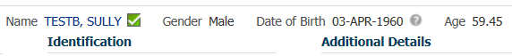

#### Adding a Verification

1. Click the **Not Verified** icon ( ) to open the **Verification** pop-up window.
2. In the **Add Verification** window, add a **Note.**
3. Click **Save**.

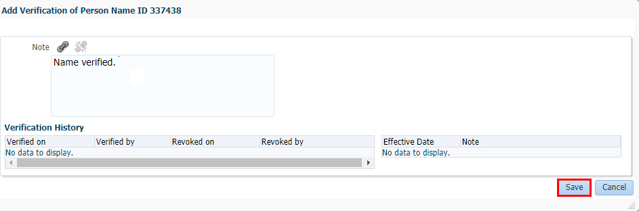

1. Once the verification is saved the icon next to **field** will display the **Verified** icon ( ).

#### Revoking a Verification

If a Verification needs to be changed or revoked, this can be done through the same **Verification** window. For example, if data was verified based on the receipt of one document, however, the member subsequently submitted a conflicting document, the verification can be revoked until a final confirmation is obtained and the data is corrected.

1. Click the **Verified** icon next to the field ( ).
2. Click **Revoke**.

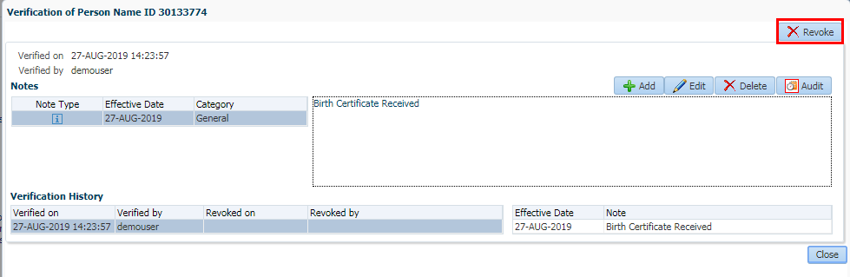

1. Add a **Note** if required.
2. Click **Save.**

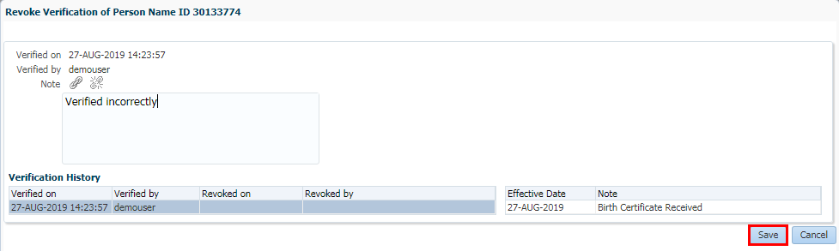

1. Once revoked, the icon will appear as the original **Not Verified** icon ( ).

## Attaching Documents in PENFAX

Organization documents, both inbound and outbound, can be viewed on the Communication screen. Interactions such as telephone calls can also be documented under this screen.

The **Outbound Documents** region lists all the outgoing correspondence that was sent to the stakeholder. The **Filename** is a **hyperlink** and when selected, the document will be viewable in a new browser window.

The **Inbound Documents** region lists all the imaged incoming correspondence that was received from the stakeholder.

1. From the Navigation menu, select the **Communication** screen**.**

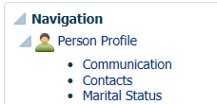

1. Expand the **Inbound Documents** region, click **Add** to add a new document or **Delete** to delete document if they have been added in error.

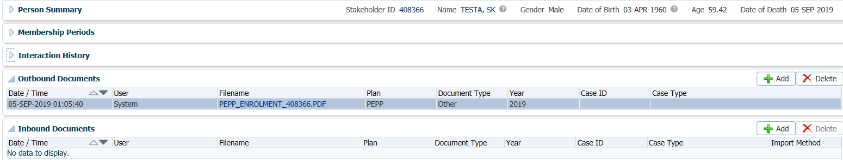

1. In the **Document** window, input the information for each field and under **File** browse to select and locate the document you wish to import, click **Save.**

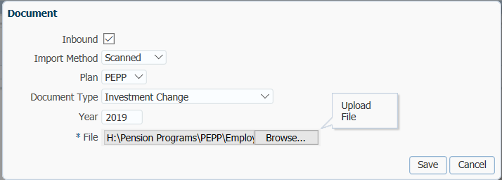

## Case Management Overview

In PENFAX, **Case Management** is used to organize and distribute tasks associated with pension plan administration.

In order to help you through common administration processes, workflows are expressed as **Cases** with specific individual steps known as **Tasks** that are performed as part of the case. Each task within a case may have several possible outcomes or a single outcome. Depending on the outcome of a single task, the process may require the user to perform alternate tasks.

#### Navigating the Case Management Region

On the **Dashboard**, the **Case Management** region contains a group of tabs used to organize and manage the cases and individual tasks within the cases. Based on the tab selected, various buttons are enabled to allow you to assign the task or case to yourself, a specific user, or a group.

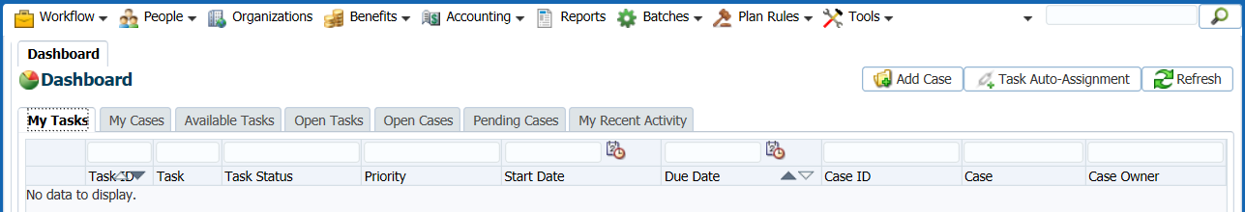

#### Case Management Buttons

At the top of the **Case Management** region are three buttons that perform case management functions.



* **Add Case** button - opens the **Add Case** screen to manually create a new case.
* **Task Auto-Assignment** button - opens the **Task Auto-Assignment** pop-up to allow you to control the re-assignment of your tasks when you are temporarily unavailable (e.g. on vacation).
* The **Refresh** button - refreshes the **Case Management** region to reflect the current status of all visible cases and tasks.

#### Case Management Tabs

**Cases** and **tasks** are grouped and filtered into different tabs to display what work is currently assigned to you, what work is available for you to work on and workload management views of current open, or on hold, cases and tasks regardless of who they may be assigned to. An additional tab provides a list of recent activities you have performed in PENFAX, regardless of whether they are part of a workflow.

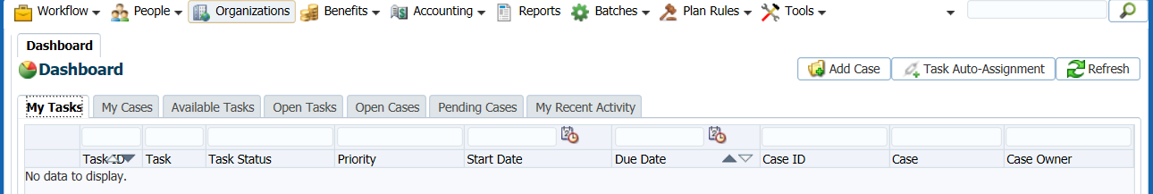

Within each tab, there are **hyperlinks** to launch the applicable PENFAX screen and perform the task or view the case or task details.

#### My Tasks Tab

The **My Tasks** tab lists the tasks currently assigned to you. These tasks are single steps of a larger case.

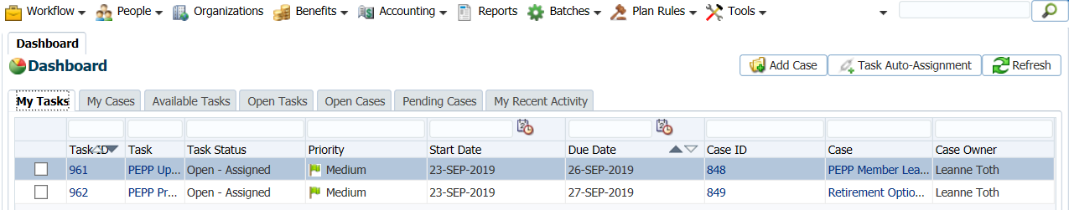

By default, the tasks are sorted by priority with those with the highest urgency first. This ensures that the most urgent tasks are at the top of the list. Tasks that have reached or exceeded the maximum days allowed to be open are moved to the top of the queue in the **My Tasks** tab to indicate the highest priority.

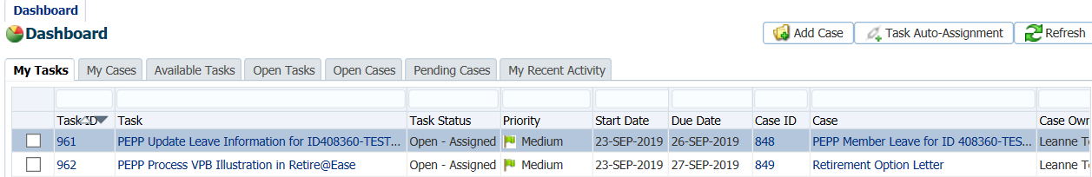

1. The first column is used to select tasks to manually assign to another user. Click to checkmark a task.
2. Click **Assign To**.

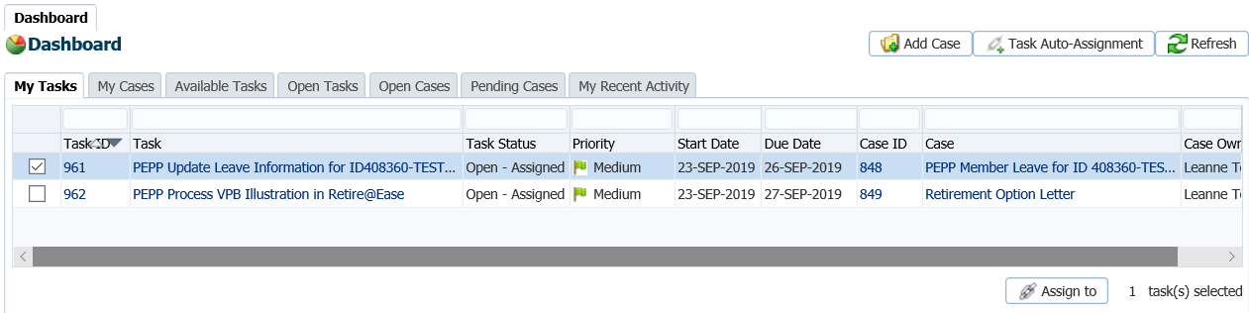

This will open the **Assign Task(s)** pop-up to re-assign the selected task.

1. From the **Assign to User** or the **Assign to Group** drop-down menu, select a name or group.
2. Click **Save**.

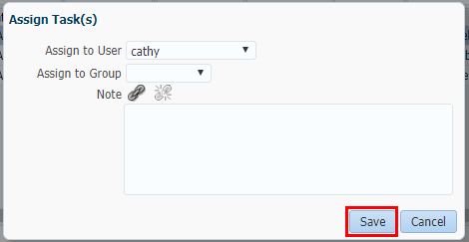

The tasks and cases listed on all the tabs are displayed as quick links to launch a workflow process or view further detailed information. The **Task ID**, **Task**, **Case ID** and **Case** values are all **hyperlinks**.

1. Click a **Task ID** **hyperlink**.

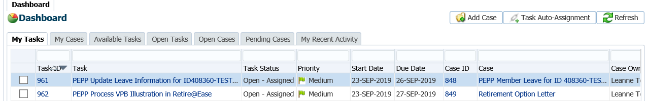

When the **Task ID** **hyperlink** is clicked, the **Task** screen will open for the task selected and allow you to view the details of the task selected.

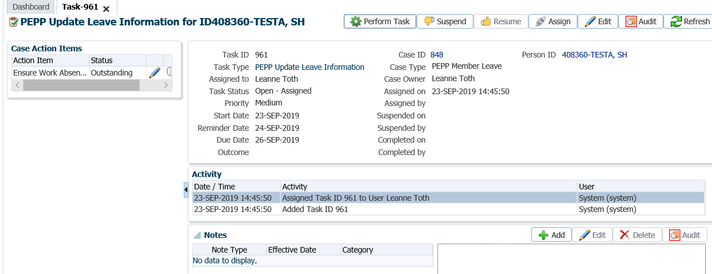

1. Click the **Perform Task** button to start the task or click the **X** on the tab to close the tab and return to the dashboard.
2. Clicking the **Task** **hyperlink** will take you to the appropriate PENFAX screen to complete the business process for this task.

|  |
| --- |
| **NOTE**  Tasks that do not require a PENFAX screen to perform the task, such as a step which requires the user to confirm they have completed something outside of the system, will take the user to the **Task** screen. |

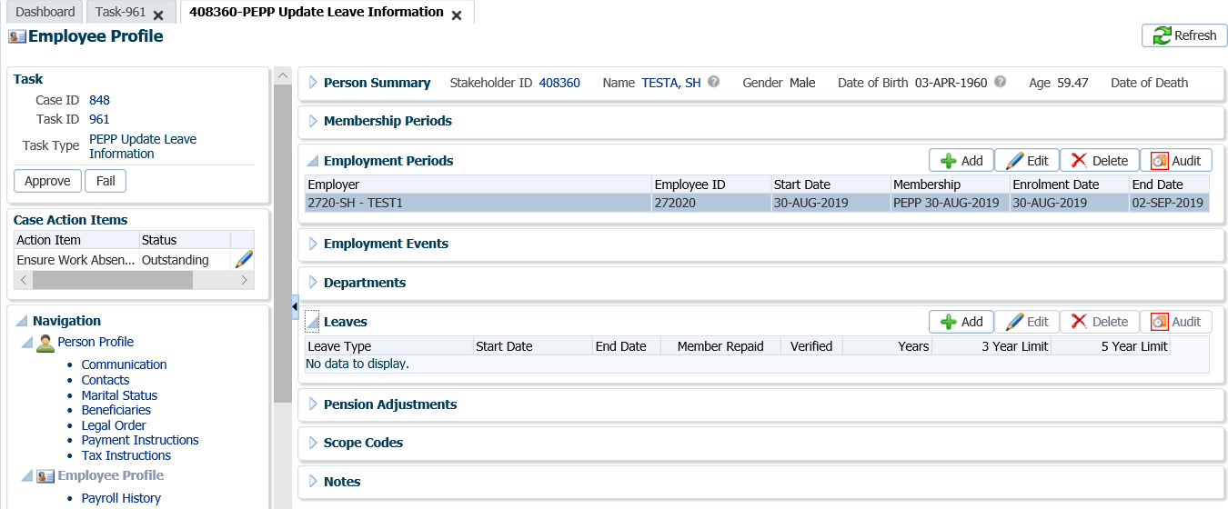

1. Click the **Case ID** **hyperlink** or the **Case** **hyperlink** to open the **Case** screen for the case selected and allow you to view the details for the case.

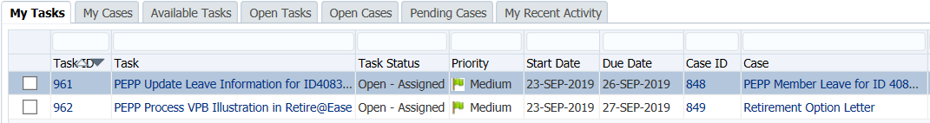

*Case Details*

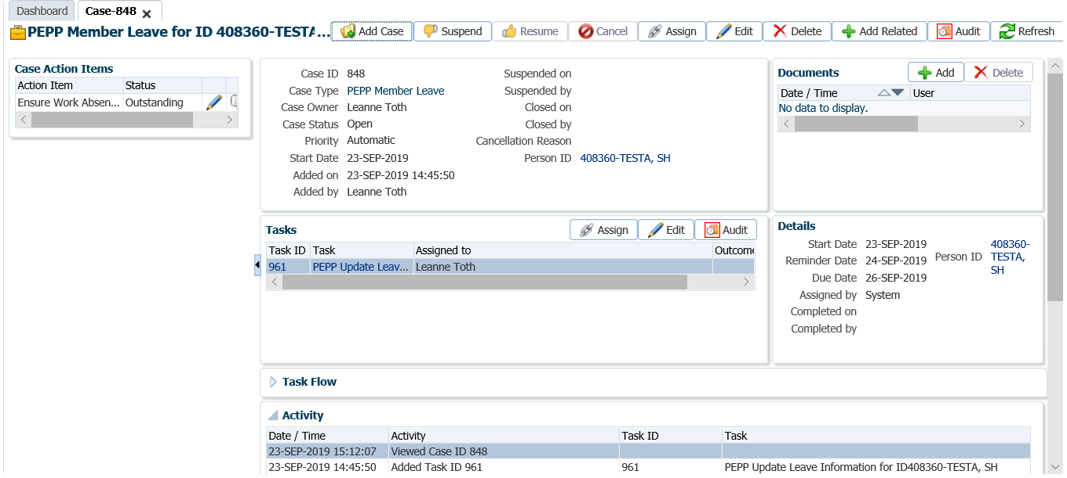

#### My Cases Tab

The **My Cases** tab lists the cases currently owned by you.

1. Click the **My Cases** tab.

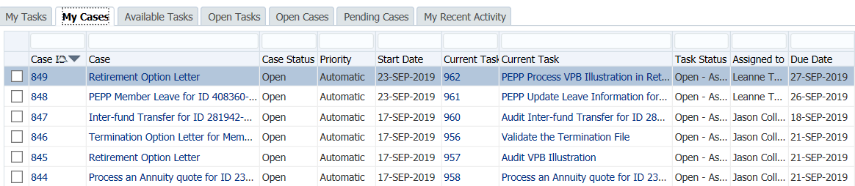

These cases owned by you are made up of tasks or single steps which may or may not be currently assigned to you (for example, you may own a case where a task has been routed to a *Supervisor* for approval).

The tasks in this list will appear in **Case ID** descending order and not based on urgency or due date as these are not active tasks assigned to you.

Viewing and manipulating information on this tab is similar to what we learned in the **My Tasks Tab** section. Similar functionality includes:

* The first column is used to select cases to manually assign to another user using the **Assign To** button.
* The **Case ID, Case, Current Task ID** and **Current Task** values are all **hyperlinks** that when clicked will present screens for you to view further detailed information.

#### Available Tasks Tab

The **Available Tasks** tab lists the currently un-assigned tasks.

1. Click the **Available Tasks** tab.



The **Available Tasks** are single steps of a larger case. This tab provides you with a snap shot of the work outstanding and ready to be assigned.

The tasks are sorted by priority with those with the highest urgency first. This ensures that the most urgent tasks are at the top of the list. Tasks that have reached or exceeded the maximum days allowed to be open are moved to the top of the queue in the **Available Tasks** tab to indicate the highest priority.

The first column is used to select one or more tasks to assign. The user can select one or multiple tasks and click the:

* **Assign to me** button - to automatically assign the select task(s) to you.

* **Assign to** button - to open the **Assign Task**(s) screen to assign the task(s) to a selected user.



The **Case ID, Case, Current Task ID** and **Current Task** values are all **hyperlinks** that navigate directly to the appropriate screen. If you click the **Task** **hyperlink** you will be taken to the appropriate PENFAX screen to complete the business process, and PENFAX will **automatically assign** this task to you.

#### Open Tasks Tab

The **Open Tasks** tab lists all open tasks for all users regardless of whether they are assigned or on hold.

1. Click the **Open Tasks** tab.

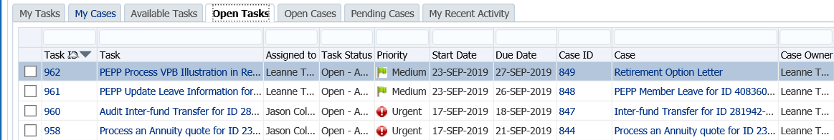

This tab provides a visual of all the current outstanding task work. This view of all tasks can assist the *Supervisor* or *Pension Specialist* in managing workloads to see the balance of assignments and where backlogs of tasks put on hold may be building.

The tasks are sorted by priority with those with the highest urgency first. Tasks in the **Open Tasks** tab that have reached or exceeded the maximum days allowed to be open are moved to the top of the queue to indicate the highest priority.

Viewing and manipulating information on this tab is similar to what we learned in the **My Tasks Tab** section. Similar functionality includes:

* The first column is used to select cases to manually assign to another user using the **Assign To** button.
* The **Case ID, Case, Current Task ID** and **Current Task** values are all **hyperlinks** that navigate directly to the appropriate screen.

#### Open Cases Tab

The **Open Cases** tab lists the cases that that are currently open.

1. Click the **Open Tasks** tab.

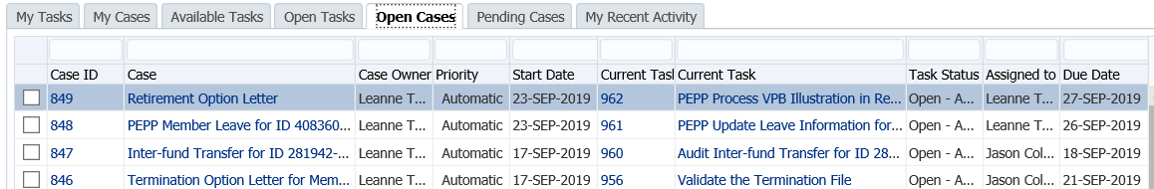

The cases in this list will appear based on the **Case ID** in descending order. This view provides the user with a snap shot of all the current outstanding Case work.

The first column is used to select one or more cases to assign. The user can select one or multiple tasks and click the:

* **Assign to me** button to automatically assign the select case(s) to you.
* **Assign to** button to open the **Assign Case**(s) screen to assign the case(s) to a selected user.



The **Case ID, Case, Current Task ID** and **Current Task** values are all **hyperlinks** that navigate directly to the appropriate screens.

#### Pending Cases Tab

The **Pending Cases** tab lists the cases that are currently on hold.

1. Click the **Pending Cases** tab.



The cases in this list will appear based on the **Case ID** in descending order.

The first column is used to select one or more cases to assign. The user can select one or multiple cases and either self-assign by clicking the **Assign to me** button or assign to another user with the **Assign to** button which will open the **Assign Case**(s) screen.

The first column is used to select one or more tasks to assign. The user can select one or multiple tasks and click the:

* **Assign to me** button - assign the select task(s) to you.
* **Assign to** button - open the **Assign Task**(s) screen to assign the task(s) to a selected user.



The **Case ID, Case, Current Task ID** and **Current Task** values are all **hyperlinks** that navigate directly to the appropriate screens.

#### My Recent Activity Tab

The **My Recent Activity** tab displays a list of the recent activities performed by you in the last 24 hours.

1. Click the **My Recent Activity** tab.

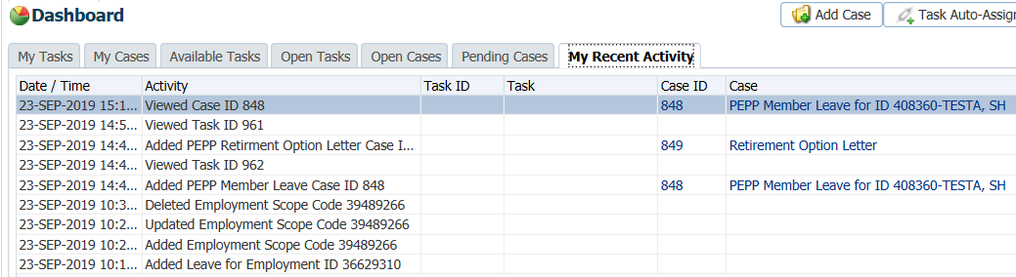

The activities in this list appear based on **Date** in descending order only (there are no other sort options). This tab provides you with a snapshot of all of your tracked actions in PENFAX including both transactions (adding or deleting records) as well as viewing records.

PENFAX audits specific actions that you perform. This includes both changes to data as well as actions such as viewing data. For example, PENFAX audits when you view a task on the **Task** screen.

### Suspending a Case

If you need to suspend a Case to wait for some additional information, final contribution, etc, change the future due date on the assigned Case to a date equal to approximately the date you expect to receive the information or a date to do a follow up if the information has not been received.

1. Click on the **Case ID** of the first **Task** to take you to the **Case.**

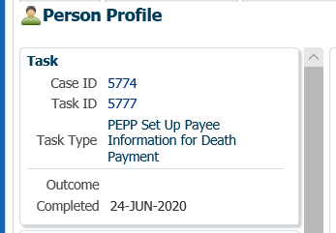

1. Select the **Suspend** option to change the **Case Status** to **On Hold**.

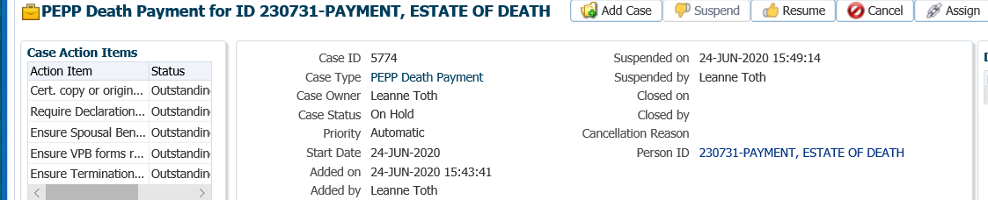

1. In the **Task** region click the **Edit** button.

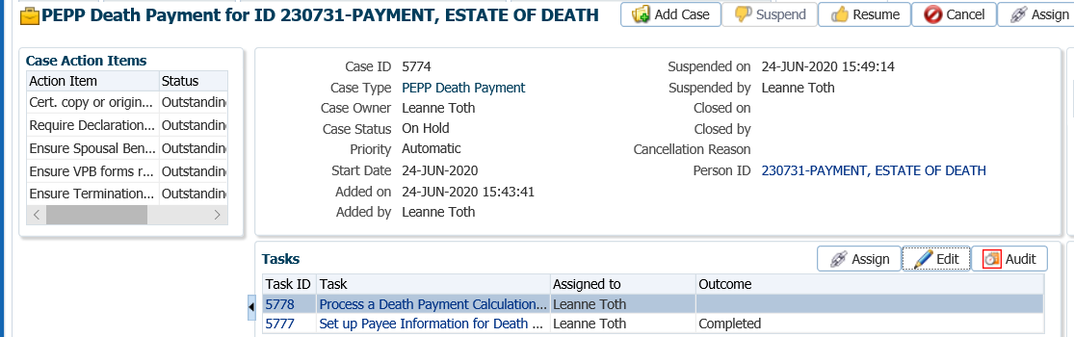

1. In the **Task** pop-up window, change the **Reminder Date** to a date in the future to approximately when the information, final contribution, etc. should be received. Change the **Due Date** to a date in which the service standard for the **Case** type would be due for completion on after the reminder date. Click **Save**.

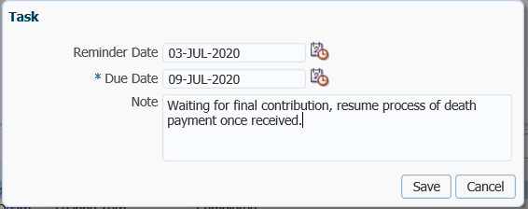

1. When the final contribution, missing information, etc. has been received and processing of the Case can continue, click the **Resume** button at the **Case** level. The **Case Status** will now be displayed as **Open**.

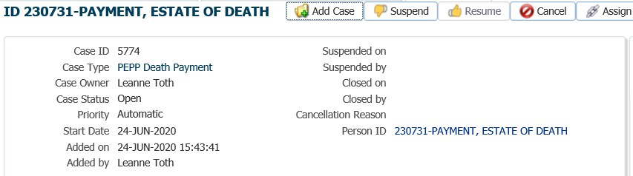

# Member Data Changes

## Address, Phone or Email

To update and maintain member’s non-financial information in the administration system as requested by the member or employer.

**Business Process Requirements - Change in Address, Phone or Email**

* PEPP will accept a request for a change of address, phone number or email from the member or the employer.
* Scanned, photocopies or fax copies are acceptable.
* Electronic signatures are not accepted.
* If information is missing or unclear on the request, follow up with the member or employer. ***Refer to Procedures to Obtain Missing Information***.

*From Member:*

* If the member is requesting a change to their address, phone or email, PEPP requires the change to be noted on the *Change in Personal Data* form. A paper request is acceptable if signed, dated and the Member Number or EEID number are provided.
* A signature is not require if the request was sent by email from the member and the email address is confirmed to be the member’s on PENFAX. The member number must be provided in the email.
* Phone requests require verification of 3 of the following: member’s name, Member Number/EEID Number, previous address, beneficiary or employer.

*From the Employer:*

* Employer must provide member’s name, EEID/SIN and date of birth.
* A signature from an authorized employer representative is not required if the request was sent by email from an authorized employer representative and the employer name can be clearly identified by the email or signature line.

#### How to Change an Address, Email or Phone Number

1. From the **Main Menu**, click the **People** icon and select **Person Search** from the drop-down menu.

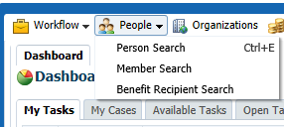

1. Enter the member’s name or identifying details (Stakeholder or Employee ID), click the **Search** button to retrieve the information or just hit enter on the keyboard.

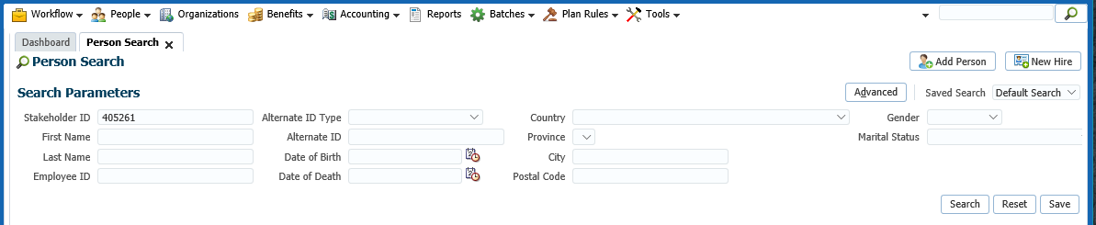

1. From the **Search Results** list, click the member’s **Stakeholder ID** **hyperlink** to navigate to the member’s **Member Profile.**

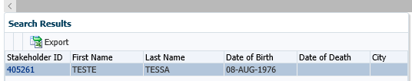

1. From the **Navigation** pane, click **Person Profile**.

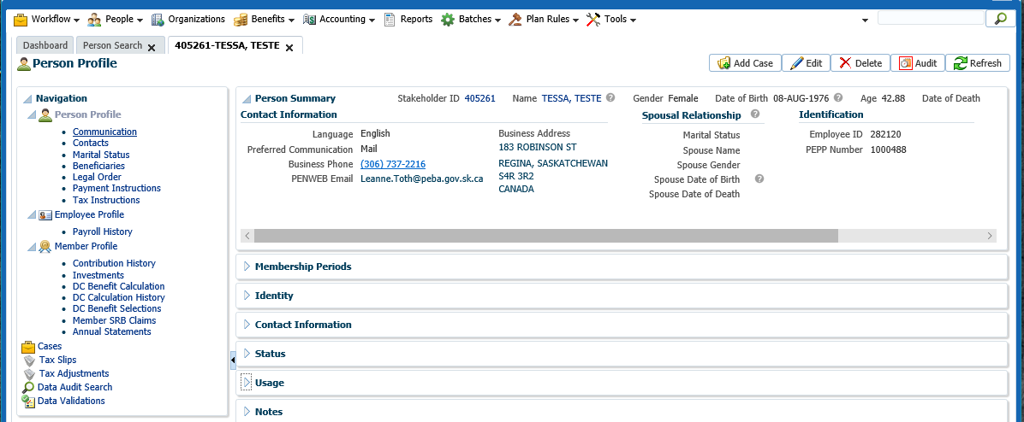

1. Click on the arrow beside **Contact Information** to expand the **Contact Information** region.

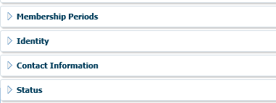

1. In the **Contact Information** region select **Edit** on the old record for the applicable section(s) (Address, Phone, Email, Correspondence Preference). Enter an **End Date** and change the **Status** to **Invalid**.

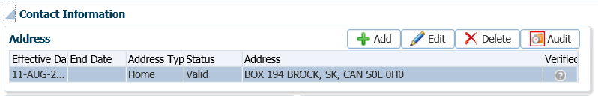

1. In the pop-up window, enter an **End Date** and change the **Status** to **Invalid**. Click **Save**.

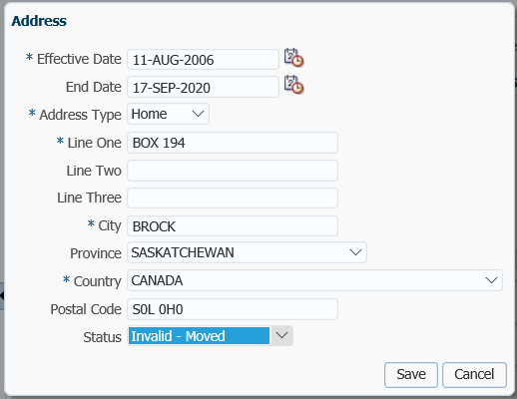

1. In the **Contact Information** region select **Add** in the applicable sections (Address, Phone, Email, Correspondence Preference) to add the new information.

* **NOTE:** DO not **EDIT** old information unless it was to correct a typo.

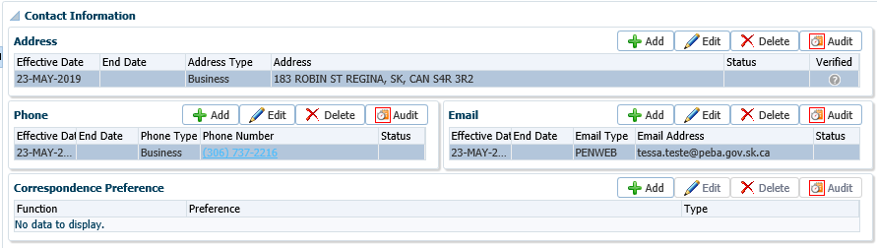

1. Enter the new information into the appropriate fields for the requested type of change (address, phone number or email address). Ensure the correct **Type** (Home, Mailing, Business, etc.) is selected and the **Status** is **Valid**. **Home** should always be used unless the member specifies to have an address as a mailing address, which happens with member’s who leave the country for the winter months. Click **Save.**

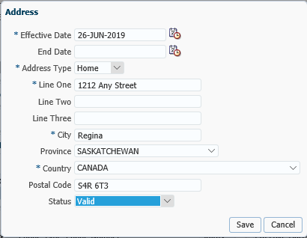

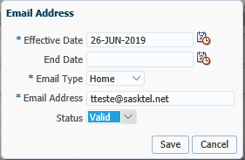

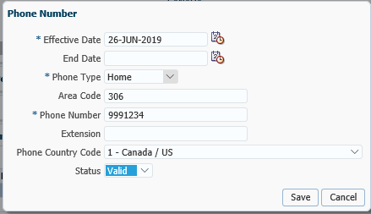

## Social Insurance Number

To update a member’s social insurance number on their PEPP account as requested by the member’s employer or the member, for one of the following reasons:

* a temporary SIN was issued and member has received a permanent SIN
* a member’s identification was lost or stolen and a new SIN issued or,
* if the incorrect SIN was provided to PEPP by the member or the employer

**Business Process Requirements - Change in Social Insurance Number**

* If the member is requesting a change to their SIN, PEPP requires the change to be noted on the *Change in Personal Data* formand supporting documentation (SIN card or Service Canada Confirmation) is required.
* Supporting documents need to be certified. PEPP will accept a copy of the certified document.
* A change to a member’s SIN is acceptable if received by the employer via email, fax, paper copy or Midas Alert. Supporting documentation is not required if received from the employer.

#### How to Change a Member’s SIN

1. From the **Main Menu**, click the **People** icon and select **Person** Search from the drop-down menu.



1. Enter the member’s name or identifying details (Stakeholder or Employee ID), click **Search** to retrieve the information or just hit enter on the keyboard.



1. From the **Search Results** list, click the member’s **Stakeholder ID** to navigate to the member’s **Member Profile.**



1. From the **Navigation** pane, click **Person Profile,** select **Contact Information.**

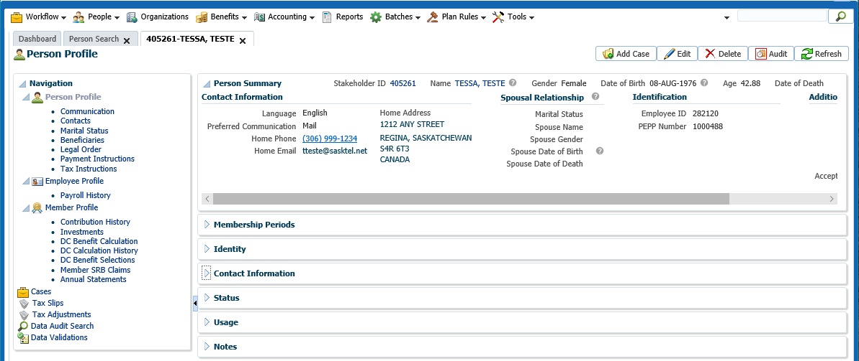

1. Click on the arrow beside **Identity** option to expand the Identity region.



1. In the **Identification** region, select **Add** to open the Identification window.

* **NOTE:** DO not **EDIT** old information unless it is to correct a typo.

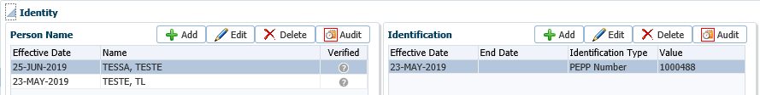

1. Enter the new identification information (SIN, PEPP Member Number) in the **Identification** fields, click **Save.**

* **NOTE:** ensure certified documents have been received for the requested change. ***Refer to the******business process requirements for a Change in SIN.***

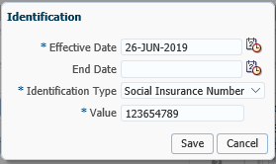

* **NOTE:** PENFAX will validate the information entered for a Social Insurance Number. If the number is invalid a warning message will be presented. DO not proceed with **“Accept and Continue”**, follow up with the member/employer is required to obtain the correct information.

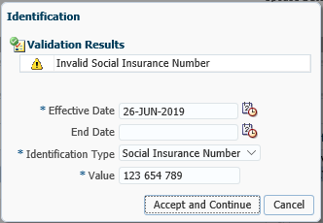

1. Expand the **Notes** region to open the notes window, select **Add** to add a note to the member’s account regarding the type of change, click **Save**.

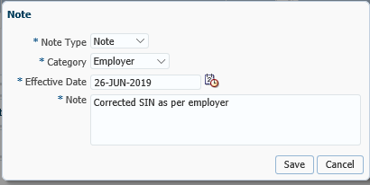

The note will appear in the **Search Results** area once saved.

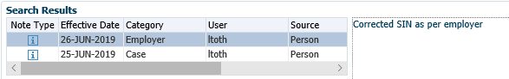

## Member’s Name

To update a member’s name due to a change in a life event such as marriage, divorce, death or a legal name change requested through Vital Statistics.

**Business Process Requirements - Change in Member’s Name**

(See scenarios outlined under Change to Marital Status for changes to member’s name)

* An original *Change in Personal Data* formalong with certified documents are required to be sent to PEPP for a change to a member’s name.
* Certified documents that are acceptable are:
  + Change of name certificate;
  + Birth certificate;
  + Divorce certificate or Decree Absolute;
  + Marriage certificate; or
  + Spouse’s death certificate*.*
* PEPP will accept a copy of the certified document.
* If a *Midas Alert* is received notifying PEPP of a change to a member’s name, PEPP **cannot** process the request from the *Midas Alert.* A *Change in Personal Data* form, letter and the Acceptable Documentation information is mailed to the member to complete and return.
* **NOTE:** if the *Decree Absolute or Divorce Certificate* has a blue **“duplicate original”** stamp on it PEPP **can** accept the document.

#### How to Change a Member’s Name

1. From the **Main Menu**, click the **People** icon and select **Person Search** from the drop-down menu.



1. Enter the member’s name or identifying details (Stakeholder or Employee ID), click **Search** to retrieve the information or just hit enter on the keyboard.

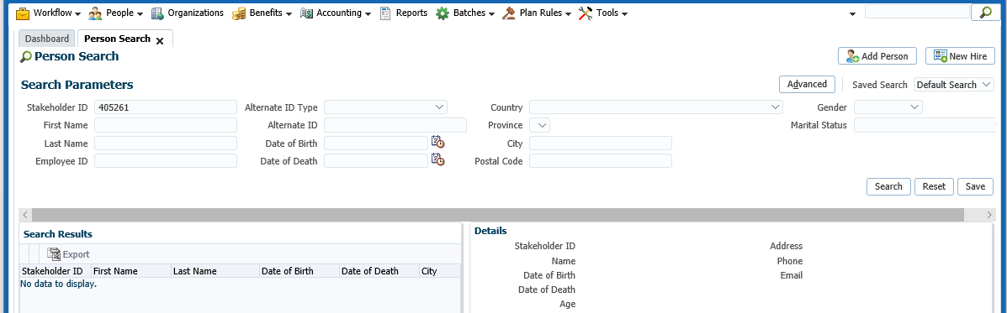

1. From the **Search Results** list, click the member’s **Stakeholder ID** to navigate to the member’s **Member Profile.**

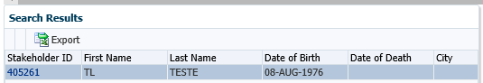

1. From the **Navigation** pane, click **Person Profile,** click on **Contact Information.**

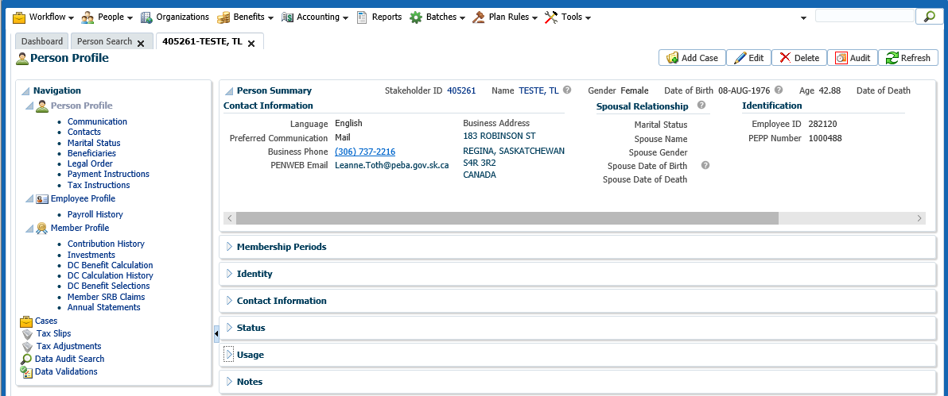

1. Click on the arrow beside **Identity** option to expand the **Identity** region.



1. In the **Identity** region, select **Add** to open the Identity window.

* **NOTE:** DO not **EDIT** old information unless it was to correct a typo.

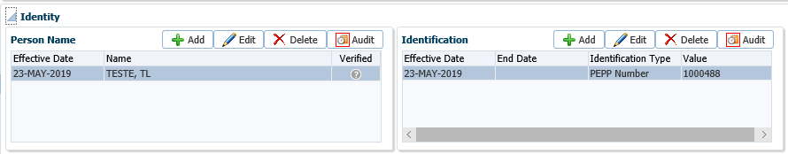

1. Enter the new name information in the **Person Name** fields, click **Save.**

* **Note:** ensure certified documents have been received for the requested change. ***Refer to the business process requirements for a Change in Name****.*

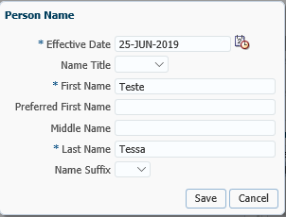

1. Expand the **Notes** region to open the notes window, select **Add** to add a note to the member’s account regarding the type of change, click **Save**. The note will appear in the Search results area once saved.

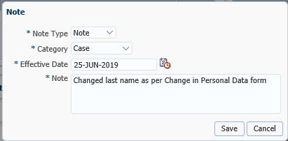

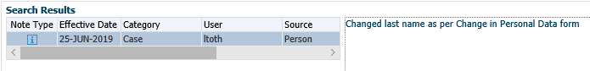

## Marital Status

To update a member’s marital status due to a change in a life event such as marriage, divorce or death of a spouse.

**Business Process Requirements - Change in Marital Status and/or Name**

* If the member is requesting a change to their marital status, PEPP requires the change to be noted on the *Change in Personal Data* formand supporting documentation provided as noted below.
* When a *Member Enrolment* form is received back from a member and the member has just been set up in PENFAX with a marital status of “Unknown” the change from “Unknown” to “Married” can be made. You DO NOT have to request a marriage certificate for this situation.
* Electronic signatures on the form are not accepted. See below regarding scanned copy, email or faxed forms.
* If information is missing or unclear on the request, follow up with the member. ***Refer to Procedures to Obtain Missing Information.***

*Scenarios:*

1. *Member wants to change from Single to Married*

* PEPP receives original *Change in Personal Data* form, with marriage certificate (not certified)
* change the marital status from single to married
* update member’s name (if requested)
* update beneficiary to spouse (if requested)
* keep a copy of the marriage certificate for the file
* **request a certified copy of the marriage certificate, noting it will be required at retirement**

1. *Member wants to change from Single to Married*

* PEPP receives scanned copy, email or fax of *Change in Personal Data* form, with marriage certificate (not certified)
* change marital status from single to married
* update member’s name (if requested)
* **do not** update beneficiary
* **request original *Change in Personal Data* form and certified copy of marriage certificate in order to update beneficiary**

1. *Member wants to change from Married to Single*

* PEPP receives original *Change in Personal Data* form, with divorce certificate (not certified)
* update member’s name (if requested)
* **do not** change marital status from married to single
* **do not** update beneficiary
* **request a certified copy of divorce certificate in order to update beneficiary and marital status**

1. *Member wants to change from Married to Single*

* PEPP receives scanned copy, email or fax of *Change in Personal Data* form, with divorce certificate (not certified)
* update name (if requested)
* **do not** change marital status from married to single
* **do not** update beneficiary
* **request original *Change in Personal Data* form and certified copy of divorce certificate in order to update beneficiary and marital status**

1. *Midas Alert received notifying PEPP of a change in member’s name*

* PEPP **cannot** update the member’s name
* send the member a letter with a *Change in Personal Data* form and the acceptable documentation information
* **NOTE:** if the *Decree Absolute or Divorce Certificate* has a blue **“duplicate original”** stamp on it PEPP can accept it.

A *Declaration of Common-Law Relationship* form is not mandatory for PEPP but it is for VPB. The form can be completed by the member and/or the common-law spouse.

#### How to Change a Member’s Marital Status

1. From the **Main Menu**, click the **People** icon and select **Person Search** from the drop-down menu.



1. Enter the member’s name or identifying details (Stakeholder or Employee ID), click **Search** to retrieve the information or just hit enter on the keyboard.

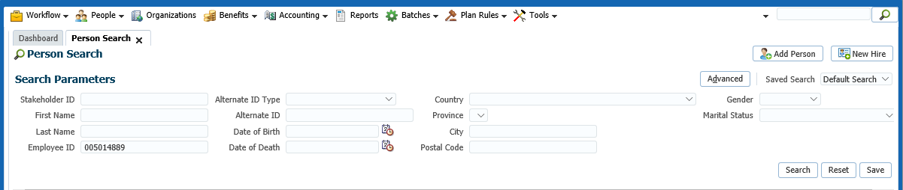

1. From the **Search Results** list, click the member’s **Stakeholder ID** to navigate to the member’s **Member Profile.**

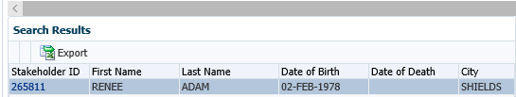

1. The **Marital Status** region displays a history of the marital status types and their effective dates. From the **Navigation** pane, clickthe **Marital Status** link.

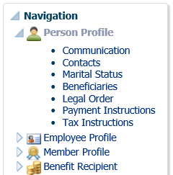

1. From the **Marital Status** region, click **Add** to open the **Marital Status** window to enter a new marital status and effective date.

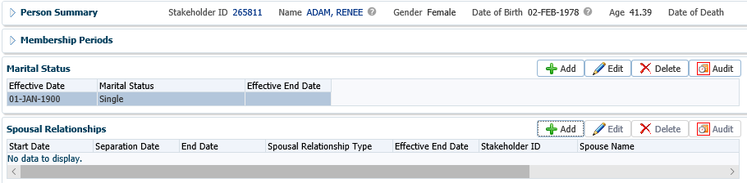

1. Select a new marital status from the drop-down list and the effective date, click **Save.**

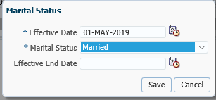

1. To modify an existing record or to add an **Effective End Date**, select **Edit**.

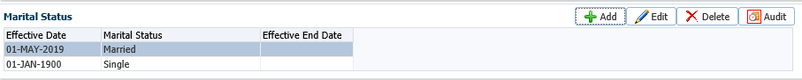

1. In the **Marital Status** pop-up window enter in the new information and click **Save**.

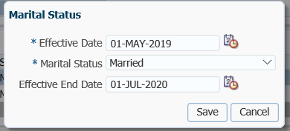

1. To remove a status, highlight the desired row in the marital status region, select the **Delete** button.



1. In the poop-up window, select **Yes** to delete the record.

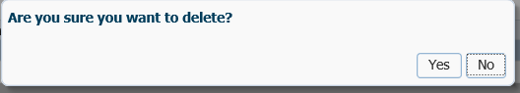

## Spousal Relationship

#### How to Change a Spousal Relationship

1. If the member’s marital status is married or common-law, you must enter the details of the spousal relationship in the **Spousal Relationship** region. This will link the spouse to the member’s account. Click the **Add** button to open the **Spousal Relationship** window and create a new record.



1. In the **Spousal Relationship** window, click on the **magnifying glass** to take you to the **Search and Select Person** screen to search for the stakeholder record.

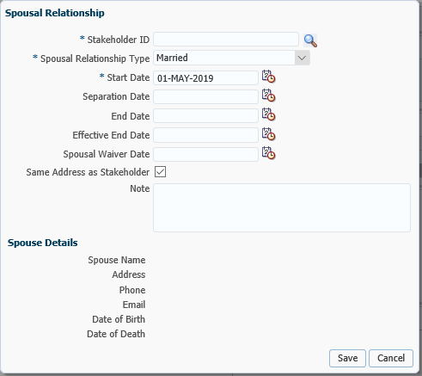

1. In the **Search and Select Person** screen enter your search criteria, click **Search**. If a record is found, highlight the row, click **Ok**. This will retrieve the stakeholder record.

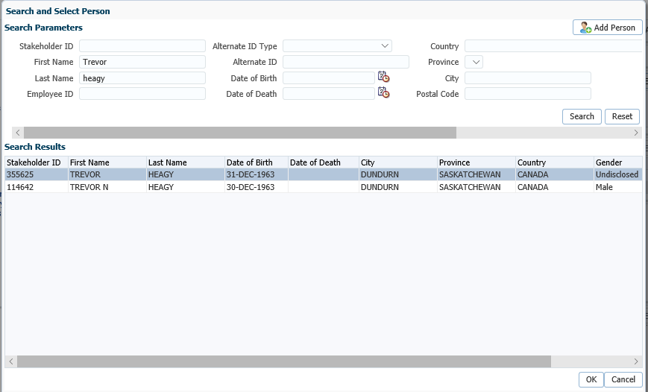

1. If the spouse is **not** found in the database after a thorough search has been performed, click the **Add Person** button. A new Stakeholder ID will be created for the spouse.

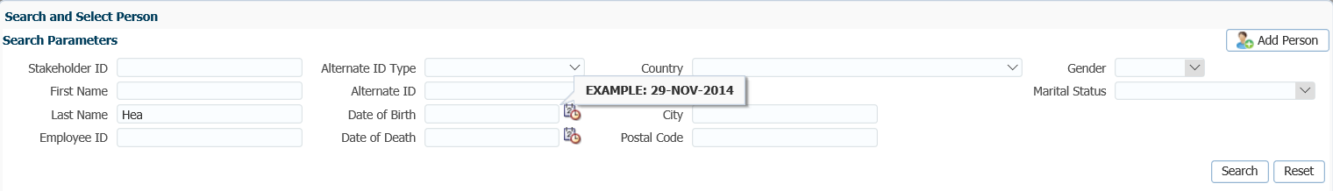

* Search Options to perform to determine if the spouse exists as a stakeholder:
* 1st three characters of the last name
* Search the last name list for the first name or initial of the first name
* date of birth
* SIN if provided

1. In the **Add Person** screen enter the spouse’s information, click **Save.**

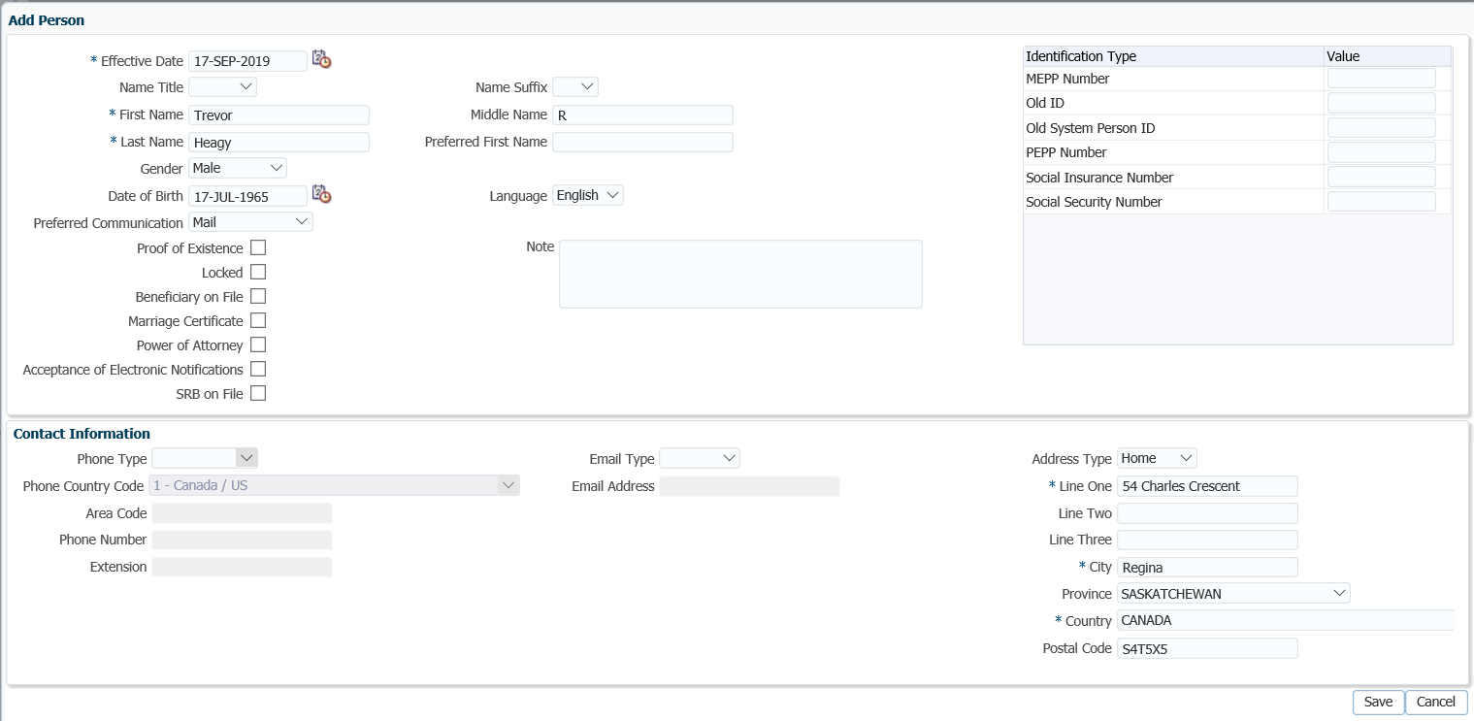

1. The spouse’s details will now be populated in the **Spousal Relationship** window. Enter the remaining information, click **Save**. You can now add the Beneficiary record.

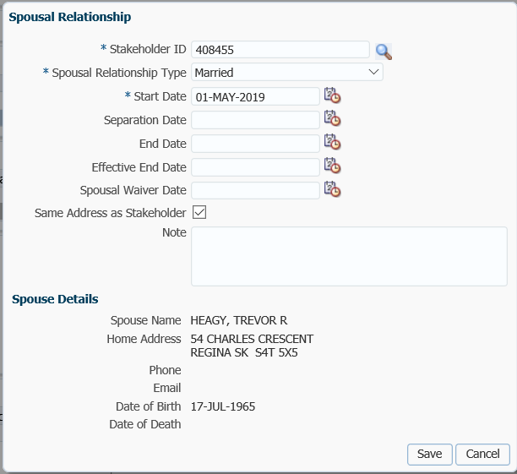

1. In the **Spousal Relationship** area, click the **Verified** icon to open the screen.

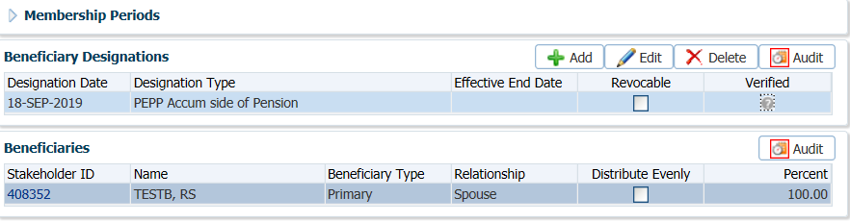

1. In the **Add** **Verification of Spousal Relationship** screen enter a note regarding the document received, click **Save.**

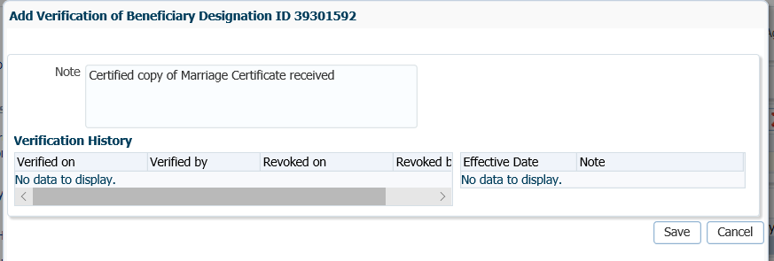

1. The **Spousal Relationships** screen will now show the **Verified** box will now be displayed as green with a check mark in it.

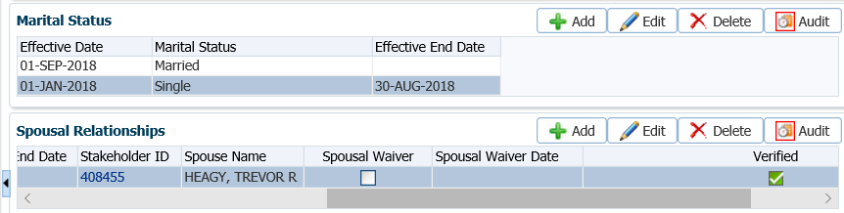

## Adding a Beneficiary

To add a beneficiary to a member’s PEPP account when a member joins the pension plan or requests to change a beneficiary due to marriage, divorce, death or a breakdown of spousal relationship.

**Business Process Requirements - Adding a Beneficiary**

* An **original** *Beneficiary* form*, Change in Personal Data* form or a *Member Enrolment* form is required for a beneficiary change.
* The *Beneficiary* form must be signed and dated by the member.
* Electronic signatures are not accepted.
* If any information is missing, unclear or the *Beneficiary* form is not signed, follow up with the member. ***Refer to******Procedures to******Obtain Missing Information***.
* If a minor child is listed inform the member a trustee must be appointed by the member for the minor child. If no trustee is appointed the member’s pension account will be paid to the Public Guardian and Trustee in trust for the minor child until the minor child turns 18 years old. Sent the member “Minor as Beneficiary Letter to Appoint a Trustee”.
* If the *Decree Absolute* or divorce certificatehas a blue **“duplicate original”** stamp on it PEPP can accept it.

***Beneficiary Scenarios:***

*Member is listed as married and electing a new spouse as beneficiary*

* PEPP receives a copy of the divorce certificate (not certified).
* Change the beneficiary to the new spouse, a divorce certificate is not required as a member cannot get remarried in Canada without being divorced.
* Request the marriage certificate but do not hold pending on your desk or in a Case.

*Member is listed as married is now electing single and a new beneficiary other than spouse*

* The ex-spouse cannot be removed without a certified divorce certificate, spousal waiver, or correct wording in the separation agreement as per the PEPP Talk on Breakdown of Spousal Relationship.
* Change the marital status to single and add a new beneficiary if one of the above documents or appropriate wording is in the separation agreement.
* If the appropriate document or wording in the separation agreement is not received, send the member a Missing Information Letter.
* If the appropriate document or separation agreement is not received in one month, send 2nd follow up.
* If the appropriate document or separation agreement is not received in two weeks do not proceed.

*Member is common-law and is now requesting a change of beneficiary to new common-law spouse*

* Make the change if the previous common-law relationship must have ceased at least 90 days from separation. This would be noted on the *PEPP Change in Personal Data* form or *Beneficiary* form.
* PEPP does not require a document as proof.
* A new *Declaration of Common-law Relationship* form.

*Member is showing as married is now requesting a change to a common-law spouse*

* You cannot make the change to the common-law spouse without a certified copy of the divorce certificate, spousal waiver form or correct wording in the separation agreement.
* Send Missing Information letter to member and add a note.
* If not received in one month, send 2nd follow up letter.
* If not received in two weeks do not proceed.

*Member is showing as married but is requesting spouse to receive less than 100% entitlement*

* You cannot make the change unless a spousal waiver is received waiving a 100% or less of entitlement.
* If no spousal waiver send the Missing Information letter to member and add a note and follow up in one month.
* If not received in one month, send 2nd follow up letter.
* If not received in two weeks do not proceed.

***Types of Beneficiary Designations:***

* If the beneficiaries are designated as **Joint**, the death benefit payable will be shared equally between the beneficiaries listed. Distribute evenly would be use when adding the beneficiary. If any of the beneficiaries designated as joint predecease the member, their portion will be distributed equally among the remaining surviving beneficiaries.
* If the beneficiaries are designated as **In common**, the member will allocate each beneficiary a share or portion out of 100% of the death benefit payable to them. If the beneficiary(s) dies before the member, that beneficiary’s portion will be paid to the deceased beneficiary’s estate.

### Spouse as Beneficiary

The steps involved to add/change a Marital Status and a Spousal Relationship should be completed prior to adding a spouse as a beneficiary. ***Refer to the procedures under Member Data Changes, How to Change a Member’s Marital Status and Spousal Relationship, How to Change a Spousal Relationship.***

#### How to Add a Spouse as a Beneficiary

1. Search for the PEPP member in PENFAX under **People**, **Member Search**.

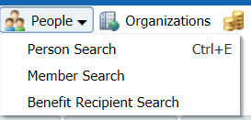

1. In the **Search Parameters** area, enter the PEPP member number, click **Search.**

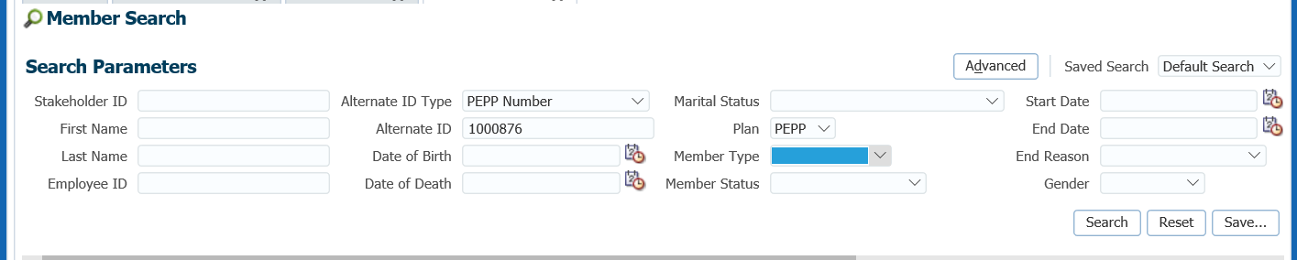

1. From the **Search Results** list, click the member’s **Stakeholder ID** to navigate to the member’s **Person Profile** menu**.**

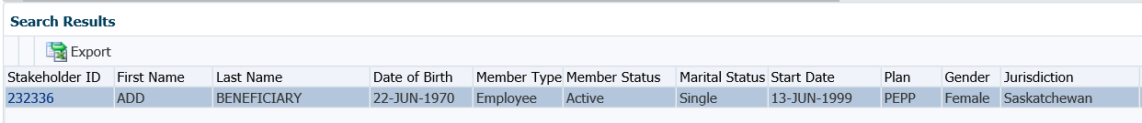

1. From the **Navigation** pane, click on the **Beneficiaries** screen.

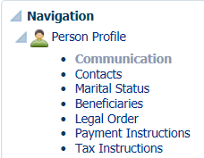

1. In the **Beneficiary Designations** region, click **Add** to add a new **Beneficiary Designation.**

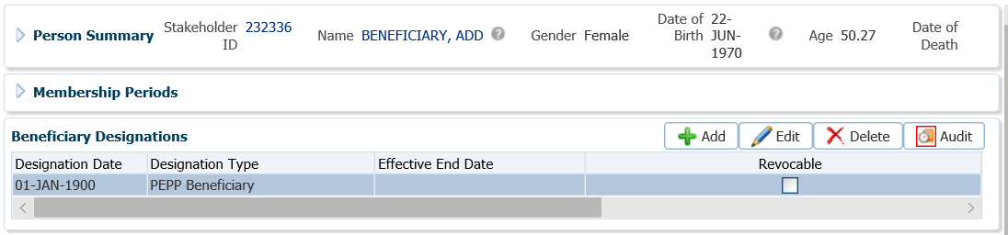

* **NOTE:** Only use **Edit** if an error was identified and you are correcting the information or when an existing record is no longer valid, an end date should be added rather than deleting the record.

1. In the **Beneficiary Designations** screen complete the following fields:

* **Designation Type –** PEPP Beneficiary or VPB Beneficiary

**In the pop-up window, select yes or no to copy the beneficiaries from a previous Designation if beneficiary records already exist.**

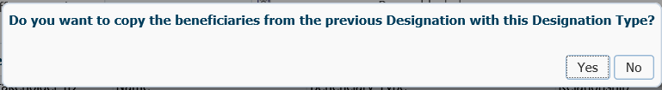

* **Designation Date –** Date the *Beneficiary* form was signed.
* **Effective Date** – enter if you are ending an existing beneficiary designation before creating a new one
* **Revocable** check the box if the designation can be revoked (see note below)
* **NOTE:** A *Spouse’s Waiver of Pre-Retirement Survivor Benefit Pursuant to Clause 33(6)(a) of the Pension Benefits Act, 1992* form must be received to allow a beneficiary other than a spouse to be named as primary beneficiary however the spouse can revoke this decision at any time.

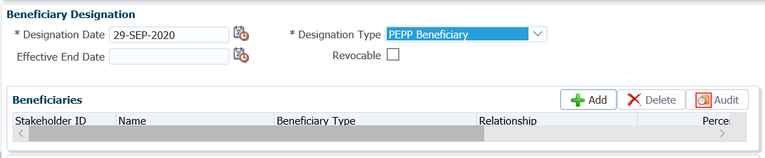

1. In the **Beneficiary** window below the **Beneficiary Designation** region, click **Add** to enter the beneficiary name and information.

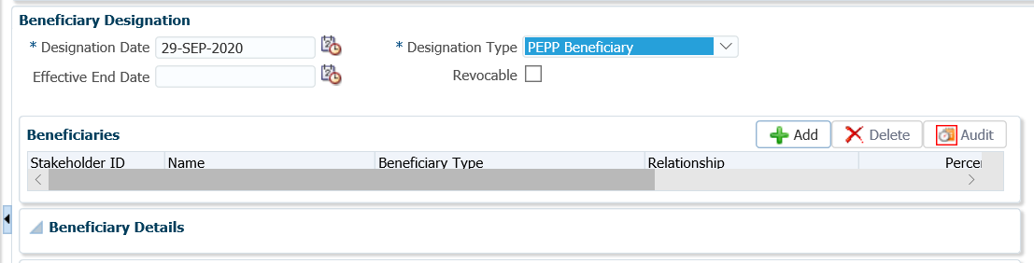

1. Enter the spouse’s Stakeholder ID if known. If the Stakeholder ID is not known click on the **magnifying glass** to search for the spouse in the **Search and Select Stakeholder** screen.

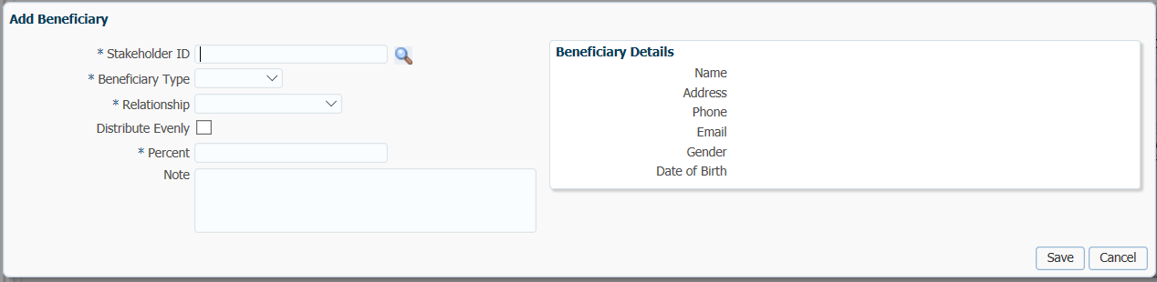

1. In the **Search and Select Stakeholder** screen, enter in the last name of the spouse and click **Search.** If the spouse is not found perform a 2nd search by d.o.b. or SIN if known. If the spouse is not found click on the **Add Person** option to create a new stakeholder account for the spouse.

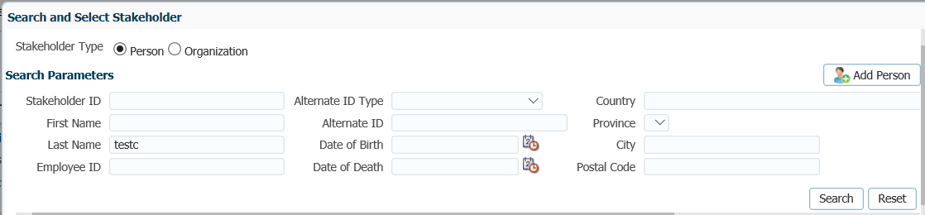

1. If the **Add Person** option was selected, complete the information in the **Add Person** pop-up window and click **Save.**

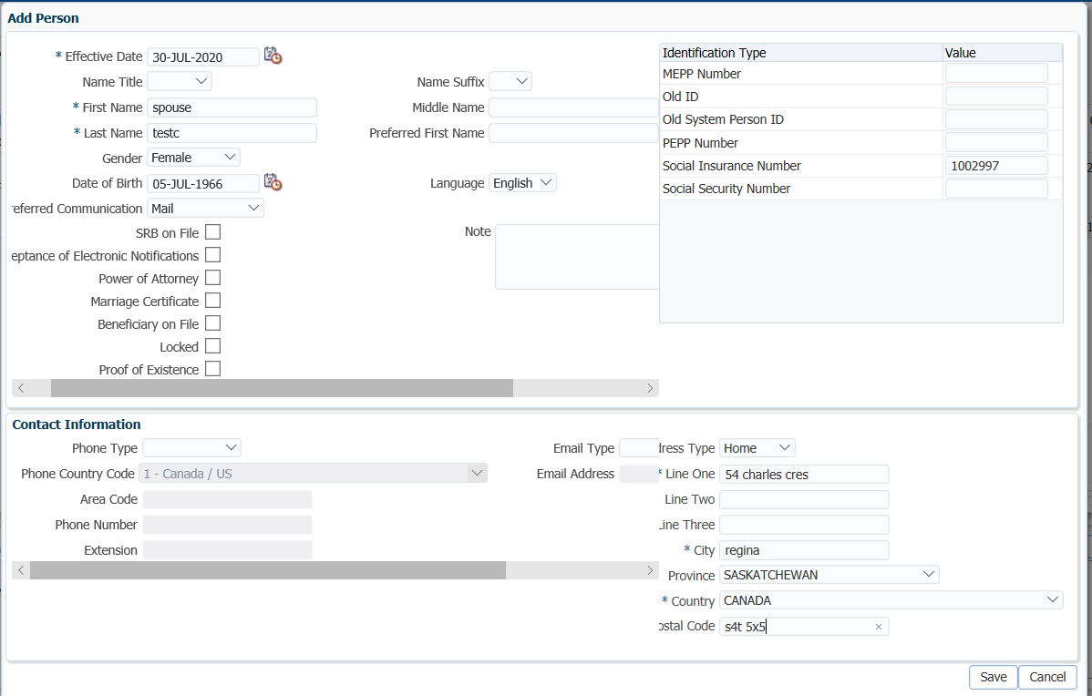

1. A new Stakeholder ID will be created for the spouse and it will populate in the **Add Beneficiary** pop-up window. Complete the remaining information and click **Save.**

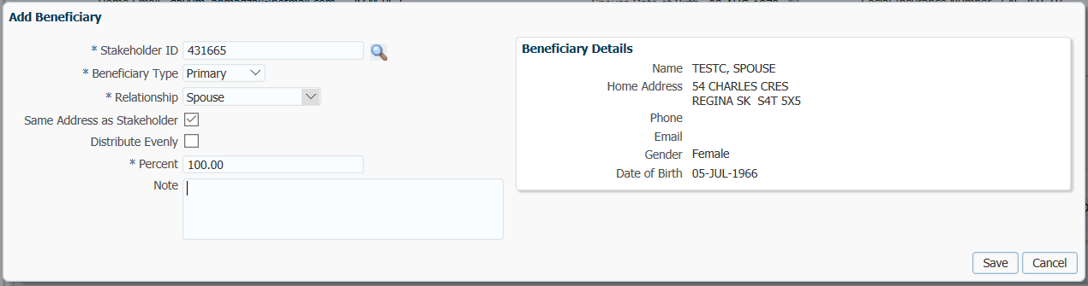

1. You will be brought back to the Beneficiary Designation window. Click **Save** at the top of the screen to complete the beneficiary setup.

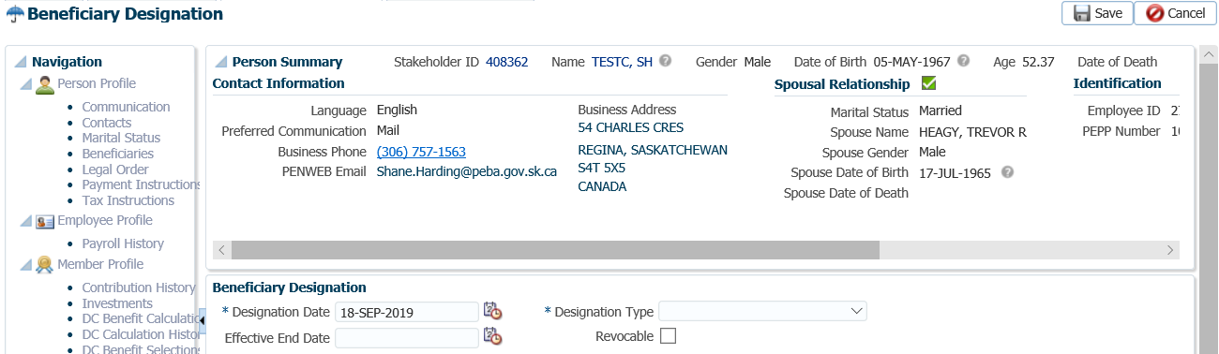

1. Click on the **Verified** icon in the **Beneficiary Designations** area to open the **Add Verification of Beneficiary Designation** screen.



1. Add a note to indicate that the Beneficiary form has been received, click **Save.**

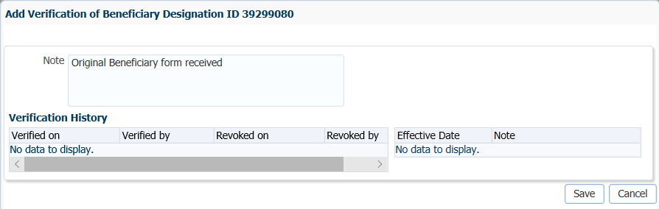

1. The **Verified** icon will now be displayed as green with a check mark in the box.

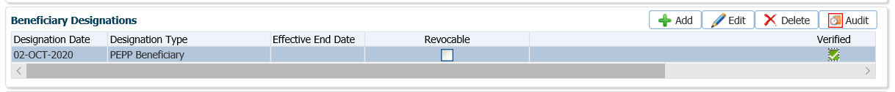

### Contingent Beneficiary

PEPP allows members to designate contingent (alternate) beneficiaries. The contingent beneficiary will take effect upon the death of a primary beneficiary. If a contingent beneficiary is not named, the death benefit will be paid to the member’s estate.

#### How to Add a Contingent Beneficiary

1. Search PENFAX to determine if the beneficiary exists as a Stakeholder, if they do not exist as a Stakeholder, **add** them as a **New Person** (follow same procedures as adding new spouse as beneficiary).
2. Once the contingent beneficiary has been found or added as a **New Person**, return to your member’s record and open the **Beneficiary** region under the **Navigation** menu, **Beneficiary Designations** area. Click **Add**.



1. In the **Beneficiary Designations** screen complete the following fields for the contingent beneficiary:

* **Designation Type –** PEPP Beneficiary or VPB Beneficiary
* **Designation Date –** Date the *Beneficiary* form was signed.
* **Effective Date** – enter if you are ending an existing beneficiary designation before creating a new one
* **Revocable** check the box if the designation can be revoked (see note below)
* **NOTE:** A *Spouse’s Waiver of Pre-Retirement Survivor Benefit Pursuant to Clause 33(6)(a) of the Pension Benefits Act, 1992* form must be received to allow a beneficiary other than a spouse to be named as primary beneficiary however the spouse can revoke this decision at any time.



1. In the pop up message ,select **Yes** to copy the beneficiary from the previous designation if it is still being kept.

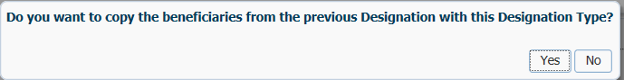

1. In the **Beneficiary** region, click **Add** to add the contingent beneficiary.

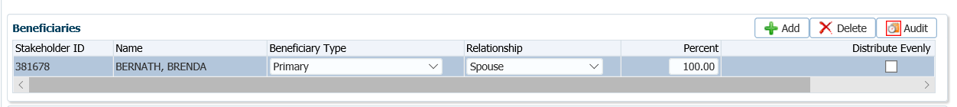

1. Enter the contingent beneficiary information in the pop-up window, click **Save.**

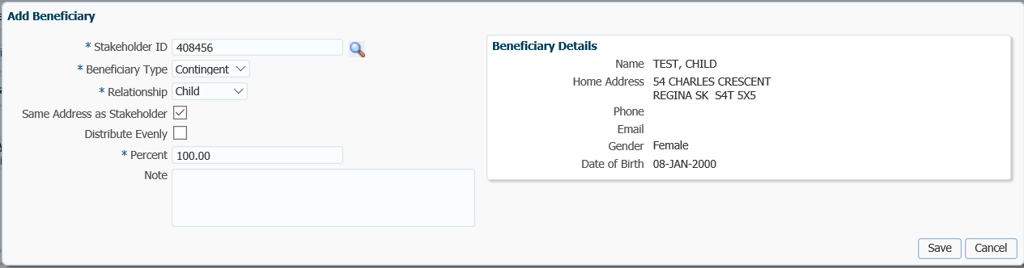

1. The contingent beneficiary will now be visible in the Beneficiary region.

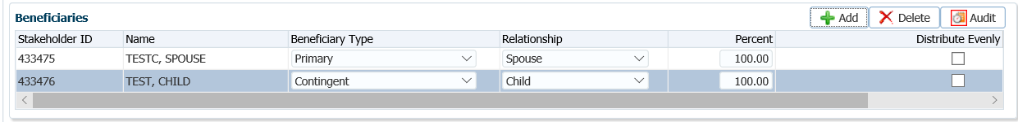

1. To complete the contingent beneficiary setup, click **Save** at the top of the screen.

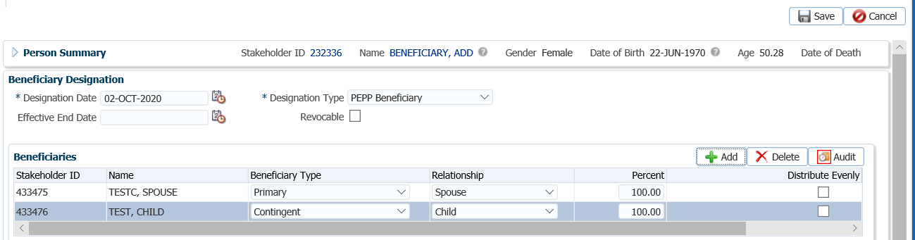

* **NOTE:** If there are more than one primary or contingent beneficiary to be added, repeat the same steps.

### Editing a Beneficiary Record

If a change is required to be made to a beneficiary record for an address, change of name, phone number, email, date of birth, etc. or if a correction needs to be made to information previously added, an edit can be done to the information. The edit is made on the beneficiary’s own stakeholder record.

1. Go to the member’s stakeholder account, then to the Beneficiary region. Highlight the beneficiary record the change pertains to and click on the **Stakeholder ID** **hyperlink**. This will take you to the beneficiary’s stakeholder account.

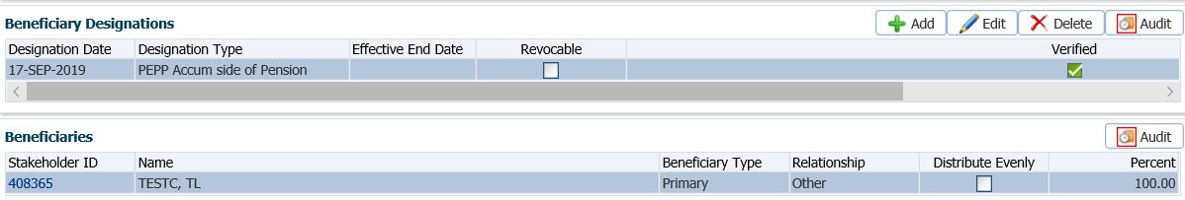

1. Once in the beneficiary’s stakeholder account go to the **Person Summary** to change the phone number, email or address information or the **Identity** region to make a change to the name. Click **Edit** to make the change.

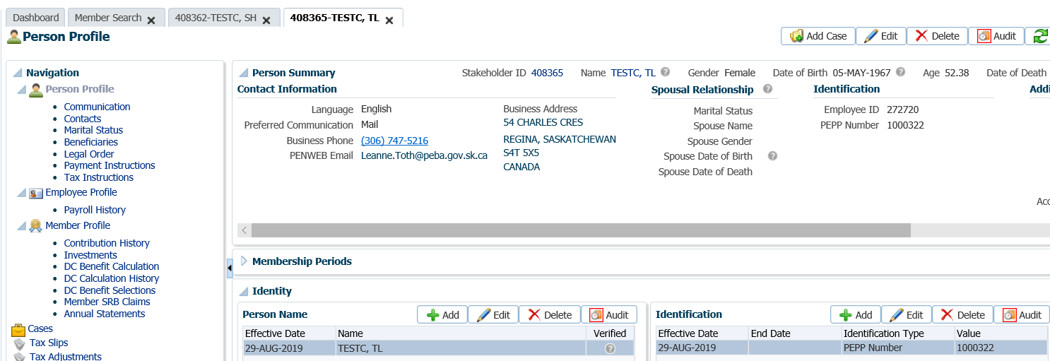

**IMPORTANT**

If the beneficiary is also a member of PEPP or another pension with PEBA, a supporting document for the change should be provided along with a *Change in Personal Data* form from the beneficiary who is also a member of a pension plan as this will update their own Stakeholder record.

**Change of last name** – marriage certificate, divorce certificate, Decree Absolute, death certificate,

change of name certificate, birth certificate.

1. A change to the beneficiary’s name is done in the **Person Name** pop up window, click **Save** once the information is entered.

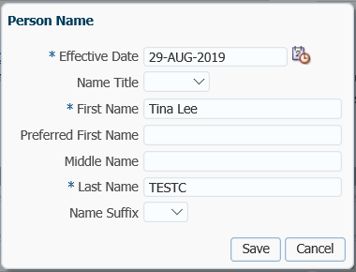

1. A change to the beneficiary’s gender or date of birth is done in the **Person** pop up window, click **Save** once the information is entered.

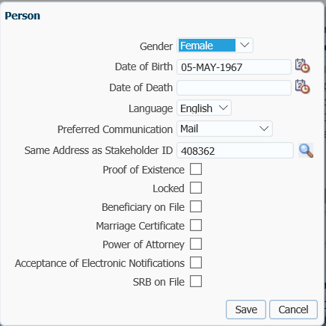

**IMPORTANT**

If the beneficiary is also a member of PEPP or another pension with PEBA, the change of address should be provided by the beneficiary/member as this will update their own Stakeholder record.

1. A change to the beneficiary’s address is done in the beneficiary’s Stakeholder record. Highlight the beneficiary from the member’s record, click on the **Stakeholder ID** **hyperlink** to take you to the beneficiary’s stakeholder record.

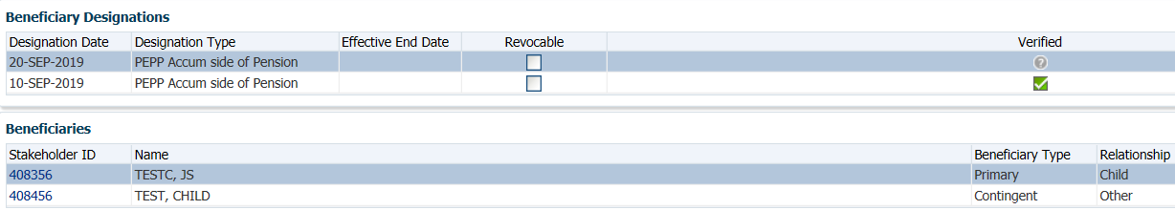

1. In the beneficiary’s stakeholder record, go to the **Contact Information** region, click **Edit.**



1. Make the required change in the **Address** pop-up window, click **Save.**

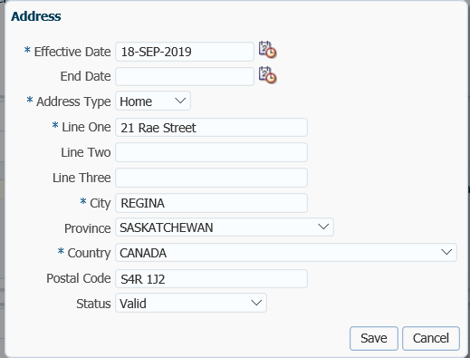

### Estate as Beneficiary

If adding a beneficiary as Estate, the Estate needs to be added as a Stakeholder. Input the first name, last name field as follows:

First Name = Estate of

Last Name = member’s full name (first and last)

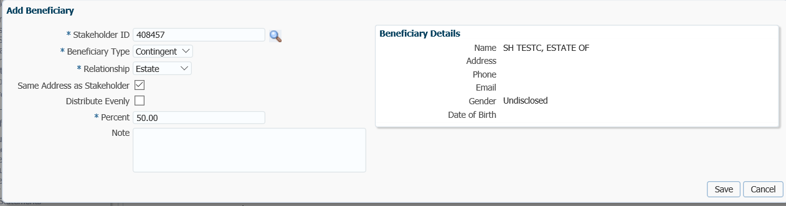

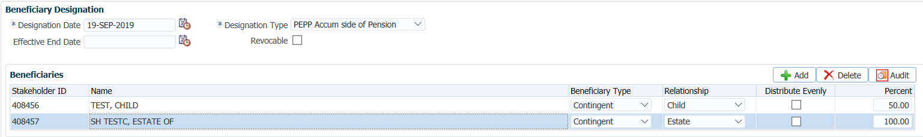

### Deleting a Beneficiary

If a beneficiary was added in error, the record can be deleted. If the beneficiary is no longer eligible (i.e. spousal relationship breakdown or the death of the beneficiary) the existing record should be end dated not deleted so that a history is kept on the member record.

1. In the **Beneficiary** region highlight the beneficiary record you want to delete or edit.

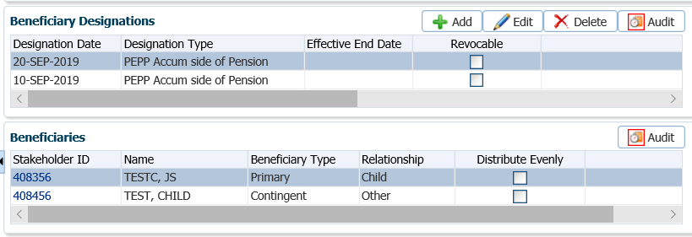

1. In the pop-up message select **Yes** to remove the record.

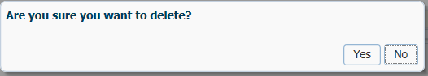

## Person Status – Spousal Waiver & Consent Form

The **Person Status** contains the details of a status type and their verification or re-certification information for a member. When waiver and consent forms have been received for a member such as PEPP Life Annuity Waiver – Spousal Consent, PEPP pRIF – Spousal Consent, PEPP VPB – Spousal Consent and Proof of Existence Pending they are added to the person’s status to indicate they are on record.

#### How to Add a Status to a Member’s Account

1. Under the **Person Profile** menu, **Person Summary** region, expand the **Status** region.

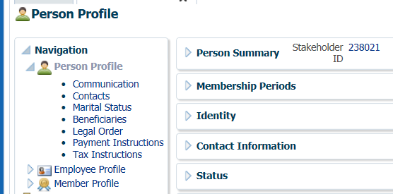

1. In the **Status** region, click **Add** or **Edit** to add a new Status or edit an existing status for the member.



1. In the **Person Status** pop-up window, select the following then click **Save**:

* **Person Status –** PEPP Life Annuity Waiver – Spousal Consent, PEPP pRIF – Spousal Consent, PEPP VPB – Spousal Consent and Proof of Existence Pending
* **Start Date –** The beginning date for which the status is considered accurate
* **End Date –** if applicable, the end date for which the status is considered accurate. The end date will automatically populate for some selections.
* **Last Verification Date –** it applicable, the last time this status was checked or certified
* **Next Verification Due Date –** if applicable, the next time a follow-up or re-certification is required for this status
* **Percentage –** percentage as noted on the document if applicable

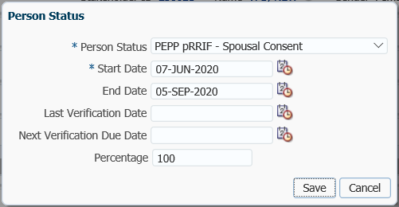

1. The **Status** region will now display the information added or changed. If a document was added in error, select the **Delete** option to delete the record.

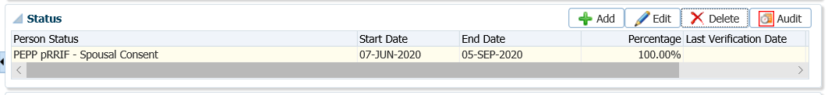

1. In the pop-up window, click **Yes**, to delete the record.

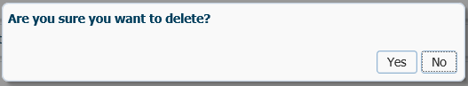

## Work Absence

To update and maintain a member’s employment status when a member begins an employer-approved leave from their position and returns from a leave of absence. The employer is to notify PEPP of the date of the start of the leave and the date of return from a leave.

Work absences start and end dates, scope code changes or status changes are to be entered in PLANet by the PEPP Employer. In the event that PEPP is required to enter a work absence, scope code change or status change, it can be processed by creating a file in PLANet**. *Refer to the procedures Manually Entering Data in PLANet in the PLANet PEPP Administrator Guide*** or ***refer to the procedures steps below on how to enter the information directly into PENFAX***.

**Business Process Requirements - Work Absence**

* PEPP will only accept a request for an employer-approved leave of absence from the employer.
* If the information is sent directly to PEPP for processing, PEPP will accept scanned, photocopies or fax copies of the *Work Absence* form.
* The *Work Absence* form must be signed by an authorized employer representative. If the signature is missing or if the form is incomplete DO NOT proceed with the requested change.
* Contact the employer representative to provide the missing information via phone, email or fax.
* If the leave start or end dates are in the future they **can** be entered into PENFAX.
* If an employee is returning from a leave of absence select the same employment status used prior to the leave of absence.
* “Leave still contributes” is used when a member is starting disability.

#### How to Enter a Work Absence Leave

The **Employee Profile** screen consists of six regions; **Membership Periods, Employment Periods, Employment Events, Departments, Leaves, Pension Adjustments**, **Scope Codes** and **Notes**.

The **Leaves** region displays details of employee leaves of absence. The information presented in the **Leaves** region relates to the current **Employment Period** selected.

1. Search for the member in PENFAX. From the **Main Menu**, click the **People** icon and select **Member Search** to locate the member.
2. Once the member record has been found, click on the member’s **Stakeholder ID** to retrieve the member’s record.
3. From the **Navigation** menu, click the **Employee Profile** menu, expand the **Employment Periods** region and highlight the **Employer** the leave pertains to if the member has more than one employer listed.

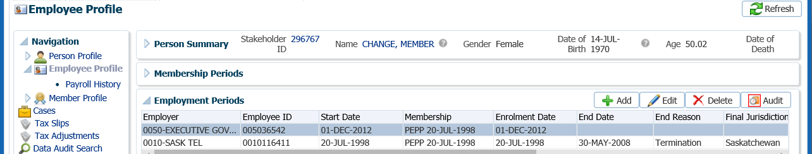

1. From the **Navigation** pane, click the **Employee Profile** and expand the **Leaves** region.

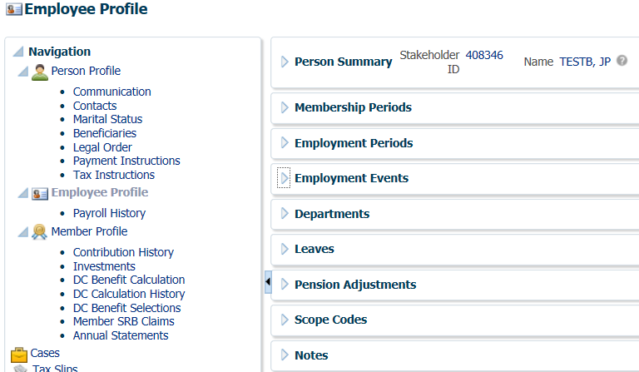

1. In the **Leaves** region, click either the **Add, Edit** or **Delete** buttons.

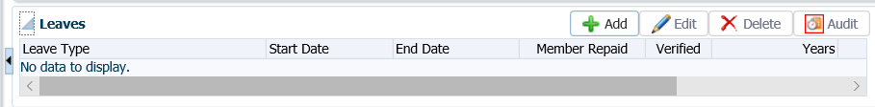

1. To add a leave for a member fill in the leave details with the date and the leave type in the **Leave** pop-up window, click **Save.**

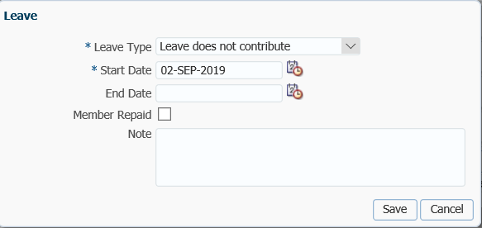

1. The **Leave** region will reflect the updated details and a full description of the changes can be viewed by clicking the **Audit** button.



1. To add an **End Date** highlight the applicable **Leave** **Type** and select **Edit**, in the **Leave** pop-up window enter the **End Date**, click **Save.**

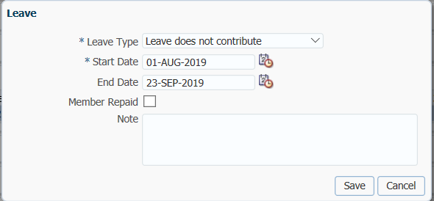

1. To delete a record if entered in error, highlight the applicable **Leave Type,** click **Delete.**

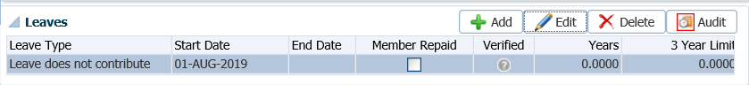

## Scope Code, Department Code and Employment Status Change

To add or update employment information for a member (scope code, department code/name, contribution rates, employee type and employment status) as provided by the employer to PEPP.

Business Process Requirements – Status Change

* PEPP will only accept a request for a change in employment status from the employer.
* If the information is sent directly to PEPP for processing, PEPP will accept scanned, photocopies or fax copies of the information.
* The request must be signed by an authorized employer representative. If the signature is missing or if the information is incomplete DO NOT proceed with the requested change, contact the employer representative to provide the missing information via phone, email or fax.
* If the dates of the change are in the future they can be entered into PENFAX.

To Do:

* Add a **Case** “*PEPP Status Change”* in PENFAX.
* Make the necessary updates to the members account.
* Add a note to the member’s account in PENFAX regarding how the request was received (paper/email/employer) and the type of change made.
* Sign and date the bottom of the form/paper request/email print out.
* Write the Member Number on the top left hand side of the form if received via paper; example 123 456.
* Complete the assigned Case in PENFAX.

### Add or Change to a Department Code

1. Search for the member in PENFAX. From the **Main Menu**, click the **People** icon and select **Member Search** to locate the member.
2. Once the member record has been found, click on the member’s **Stakeholder ID** to retrieve the member’s record.
3. From the **Navigation** menu, click the **Employee Profile** menu, expand the **Employment Periods** region and highlight the **Employer** the change pertains to if the member has more than one employer listed. Under the **Departments** region, click **Edit**.

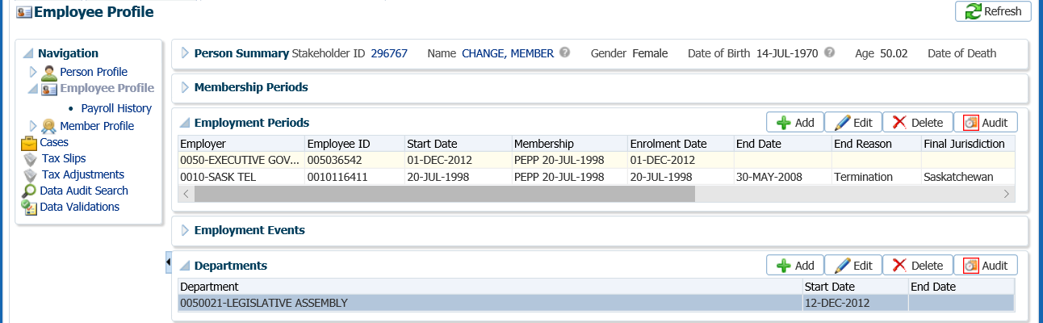

1. In the **Department** pop-up window, enter an end date for the previous department if applicable. Click **Save**.

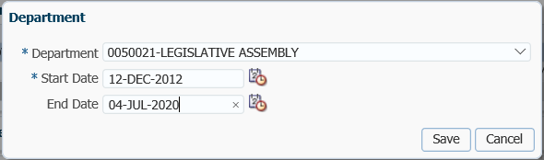

1. Under the **Departments** regions, click **Add**.

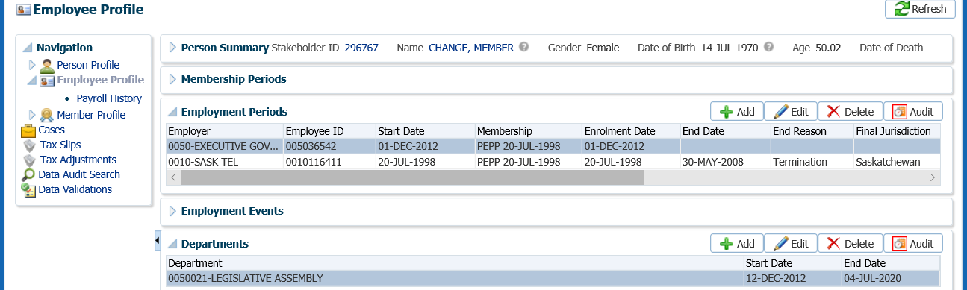

1. In the **Department** pop-up window, select a new **Department** for the member from the drop-down list, add a **Start Date**,click **Save**.

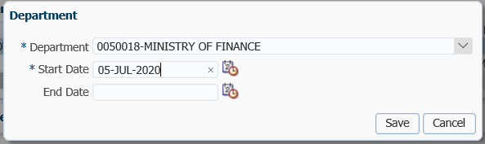

### Add, Change or Delete a Scope Code

1. Search for the member in PENFAX. From the **Main Menu**, click the **People** icon and select **Member Search** to locate the member.
2. Once the member record has been found, click on the member’s **Stakeholder ID** to retrieve the member’s record.
3. Under the **Employee Profile** menu, **Employment Periods** region, highlight the **Employer** the change pertains to. Expand the **Scope Codes** region.

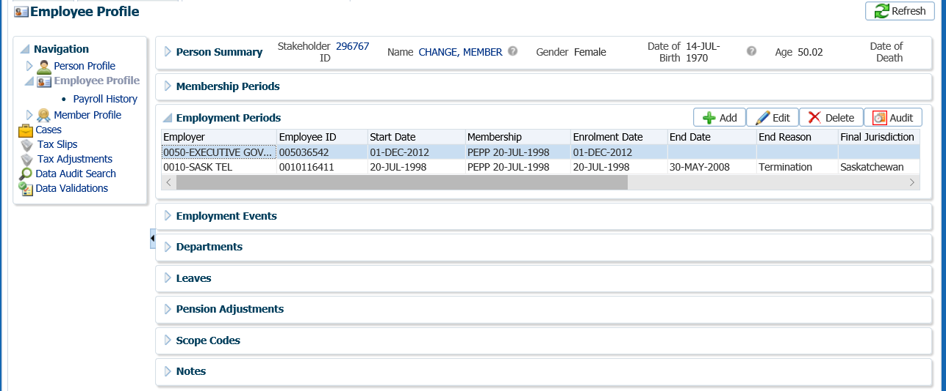

To add a new **Scope Code**, you must add an end date to the current **Scope** Code. Click **Edit**.

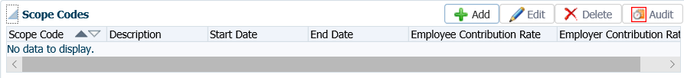

1. In the **Scope Code** pop-up window, enter the **End Date**, click **Save**.

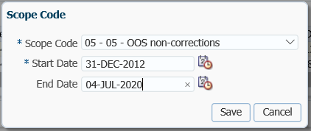

1. To add a new **Scope Code**, an end date is required to be added for an existing **Scope Code**. Click **Add**.

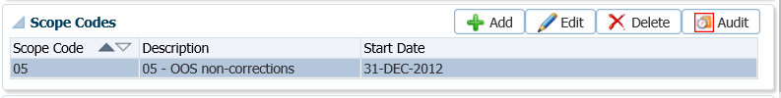

1. In the **Scope Code** pop-up window, select a new **Scope Code** from the drop-down list, add a **Start date**, click **Save**.

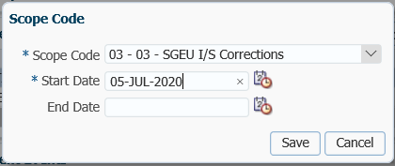

1. To delete a scope code that was entered in error, highlight the applicable **Scope Code**, click **Delete** and select **Yes** to the message “**Are you sure you want to delete?”.**

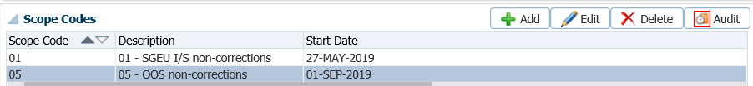

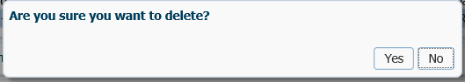

### Employment Status Change

1. Search for the member in PENFAX. From the **Main Menu**, click the **People** icon and select **Member Search** to locate the member.
2. Once the member record has been found, click on the member’s **Stakeholder ID** to retrieve the member’s record.
3. From the **Navigation** menu, click the **Employee Profile** menu and expand the **Employment Periods** region. Highlight the **Employer** the change is applicable to. Click **Edit**.



1. In the **Employment Periods** pop-up window, select the new **Employment Status** from the drop-down list, click **Save**.

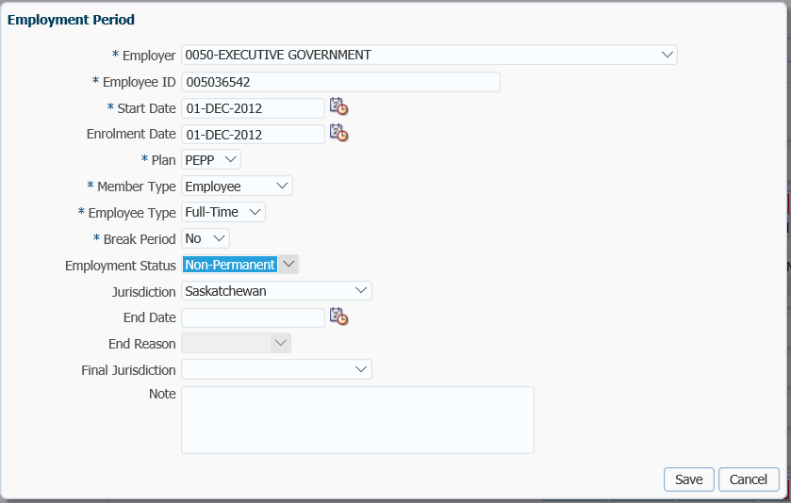

## Legal Orders

The Legal Orders screen is used to grant a specified level of authority over a member’s account to an agent. This may be related to a court order or could be used to identify other access, such as a spouse identified as an authorized contact for release of information.

Legal orders are added to PENFAX first, and then one or more agents are added to the legal order. When establishing a legal order, notes can be entered to record details for clarification.

#### How to Add a Legal Order

1. From the **Navigation**, **Person Profile** menu, click on the **Legal Orders** screen.

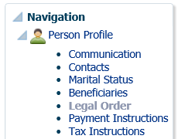

1. Ensure the correct **Membership Period** is highlighted.

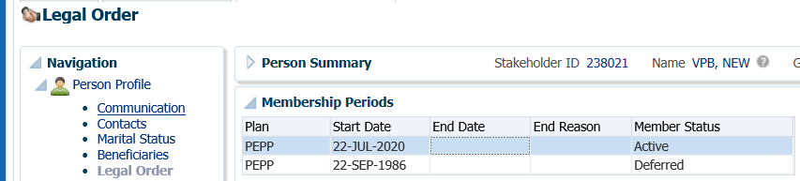

1. In the **Legal Order** region, click **Add** to add a new legal order. If changes are required to be made to an existing **Legal Order,** click **Edit** to make changes to the selections.

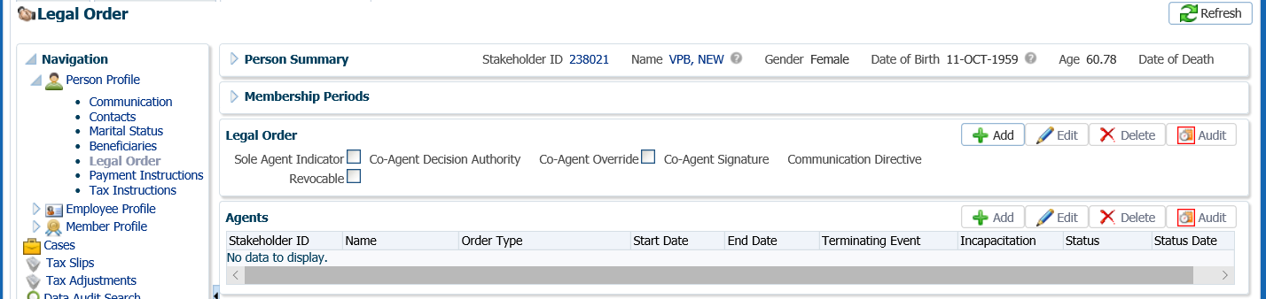

1. In the **Legal Order** pop-up window, select the appropriate information and **Save**:

* **Co-Agent Decision Authority –** Unanimously or Majority
* **Co-Agent Override –** check if applicable
* **Co Agent Signature –** All, No, One, Two, Yes
* **Communication Directive –** Agent(s) Alone, Agent(s) and Principal, Principal Alone
* **Revocable –** chick if applicable

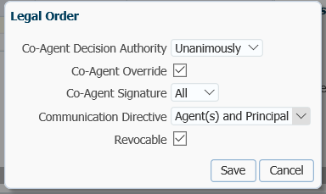

|  |  |
| --- | --- |
| **Sole Agent Indicator** | **Indicator if one agent is designated or multiple. If there is only one Approved Agent on file as of current date, this will be checked.** |
| **Co-Agent Decision Authority** | The decision making ability of co-agents |
| **Co-Agent Override** | If a co-agent is unwilling or unable (due to incapacitation or death) to make a decision the Principal allows remaining co-agents to make decisions based on decision authority level without Agent that has revoked their participation |
| **Co-Agent Signature** | If signatures are required and if so by whom |
| **Communication Directive** | Override or in addition to member's communication preferences to divert communication to one or both parties based on their contact's communication preferences and method. |
| **Revocable** | Indicator for POA if agent is revocable or not |

1. Once the Legal Order is saved, Agents can be added to the order. From the **Agents** region, click **Add**.

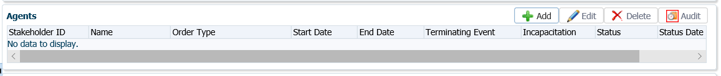

1. In the **Agent** pop-up window, enter and select the applicable information, then **Save**:

* **Stakeholder ID –** enter the Stakeholder ID for the agent or click the magnifying glass to locate in the Person Search
* **Order Type –** Conservator of Person, Executor/Executrix, Guardian, Power of Attorney or Public Trustee
* **Start Date –** date the agent started
* **End Date –** date the agent will end (entered when the agent is no longer required)
* **Terminating Event –** Agent’s Incapacitation, Court Order, Death of Agent, Dissolution of Marriage with Agent, Principal Bankruptcy, Principal Death, Resignation (entered when the agent is no longer required)
* **Incapacitation –** Durable, Enduring, Non-Durable, Non-Enduring, Springing
* **Status –** Approved, Ended, Legal Review, Pending, Rejected, Revoked, Terminated
* **Status Date –** applicable date for the Status
* **Not Authorized/Authorized –** select the activities the agent is allowed to undertake by using the arrows to move the **Authorized** column on the right (the double arrows move the entire list, the single arrows move one item at a time)

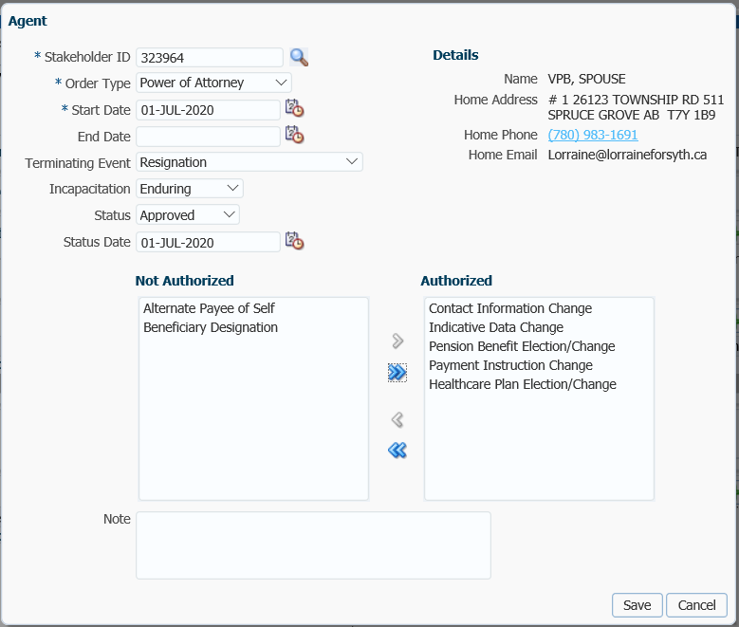

1. Once the record is saved, the **Agents** region is updated and the **Details** block below will provide information on the activities that the agent is authorized to perform. Additional agents can be added with the same, or different, authorizations.

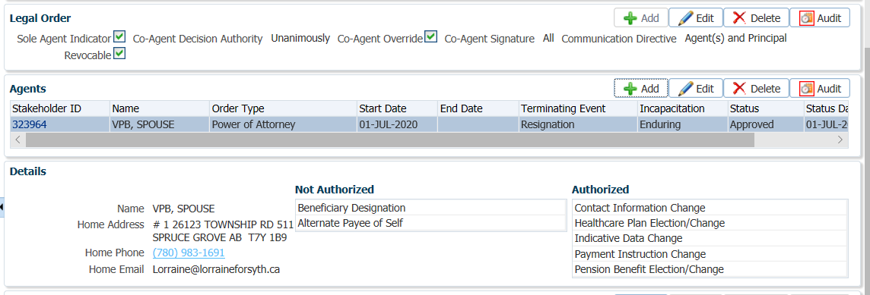

1. Any agent can be edited by clicking the **Edit** button and agents entered in error can be removed with the **Delete** button. If the agent was in effect but is no longer valid, the **Status** should be updated to **Ended** or **Terminated** with the effective date rather than deleting the record. Click **Edit** to change the **Status** of an agent.



# Procedures to Obtain Missing Information

How to proceed when information is missing, incomplete or supporting documentation is not received or acceptable.

* Contact the employer by phone or email to obtain the missing information if the form was sent to PEPP by the employer. Do not provide SIN’s over email.
* The employer can provide missing or unclear information verbally over the phone. Ensure you document the date and name of person you spoke with as well as the information provided.
* If a signature is missing on the original form(s) it must be returned to the employer or member.
* Attach a *Member Missing Information* *letter or Employer Missing Information* *letter* to the form so the member/employer is aware of why the form is being returned.
* Add a note on PENFAX as to why you cannot process the request and the person that you have contacted to obtain the missing information.
* Change the status on your Case task to a future date as a reminder to do a follow up with the employer/member if the applicable form is not received back in a timely manner.
* Keep a copy of the applicable form(s) if the original is required to be sent back and a copy of the *Member Missing Information* *letter*. The form is to be kept in a “Pending File” for follow up at a later date if not received back in a timely manner.
* On the follow up due date, check PENFAX first prior to sending out a second request to the employer or member to make sure the information/form has not already been received and processed by another P.I.O.

# Certified Documents

The certified copy must include the name of the person certifying the document, his or her official position or title, telephone number, the date they certified the document, and the following statement:

***“This photocopy is a true copy of the original document which has not been altered in any way.”***

The person certifying the documents cannot hold the same position as an individual in the same entity (i.e., a Social Worker employed by a particular branch of the government cannot certify for another Social Worker employed by the same branch).

# Acceptable Documentation

PEBA will accept electronic/scanned/fax copies of forms and documents with the following exceptions:

1. Beneficiary Designations forms, applications designating a beneficiary
2. Spousal Waivers
3. VPB Spouse’s Consent and Waiver
4. Wills
5. Powers of Attorney

# Notary Public, Commissioner of Oaths, Justice of the Peace

Some PEPP forms require the signature of a “Notary Public, Justice of the Peace or a Commissioner of Oaths”. It is important to note that:

**A Notary Public can commission documents for use in every province.  So can a lawyer, acting in the capacity of a notary.**

However, an ordinary commissioner for the province can only sign documents for the province in which they reside i.e. a Commissioner from British Columbia cannot sign PEPP’s Declaration of Common-law Relationship form for a PEPP member that now resides in BC.  They will need to find a Notary Public, Justice of the Peace or lawyer.

Ensure that the documents are reviewed for (authorized witnesses) when auditing payments especially if the member is residing outside the province.

* Member’s living in another country can get their spousal waiver form signed by a notary or go to the Canadian consulate.  A Commissioner for Oaths is not acceptable in another country.

# When is Identification Required from a Member?

* Account balance is **under $5,000**, Government issued ID is **NOT** required to confirm the member’s signature.
* Account balance is **over $5,000**, Government issued ID **IS** required to confirm the member’s signature if there is not a signature on file. The ID does not need to be certified.
  + One way to determine if there is **not** a signature on file is if there is no beneficiary listed in PENFAX or the member is still in the PEPP Steps fund by default. What about if the member added the beneficiary on PLANet?
* Account balance is **over** **the Small Pension amount ($11,740 for 2020**), Government issued ID **IS** required and it must be a certified/notarized copy.
* Member is **over age 50** and qualifies to take a Small Pension Payment, a certified copy of the birth certificate is required to confirm their age and verify their signature if no signature is on file.
* Government issued ID is acceptable via fax, email or regular mail. A copy is acceptable.
* A signature guarantee stamp on a T2151 form is not acceptable if there is not a signature on the member’s PEPP account.

# Enrolment

## New PEPP Member Enrolment

Enrolling or re-enrolling a member in PENFAX, is done by creating an enrolment file in PLANet. ***Refer to Enrolment procedure steps in the PLANet PEPP Administrator Guide.***

# Creating and Maintaining Organizations

In PENFAX, Organizations are defined as either a financial institutions or an employer. All organizations will have a unique stakeholder ID.

## Searching for Organization Records

#### How to Search for an Existing Organization

1. Search for the employer or organization to ensure it does not already exist in PENFAX. This can be done by using **Quick Search** option which allows you to search for a Stakeholder ID, Person Name or Organization or by selecting the **Organization** menu item on the top menu.

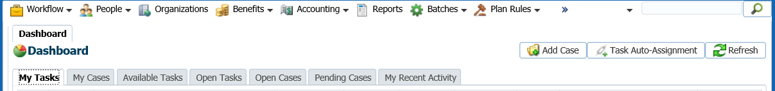

1. If using the **Quick Search** option click on the drop-down arrow to select the search option of **Organization Name** and enter the name of the organizations name, click the **magnifying glass** to execute the search.

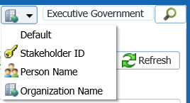

1. If using the **Organizations** menu item to search click on the menu item and a **Search Parameters** box will appear. Enter your search criteria and hit enter or click **Search**. Ensure you perform a thorough search for the name.

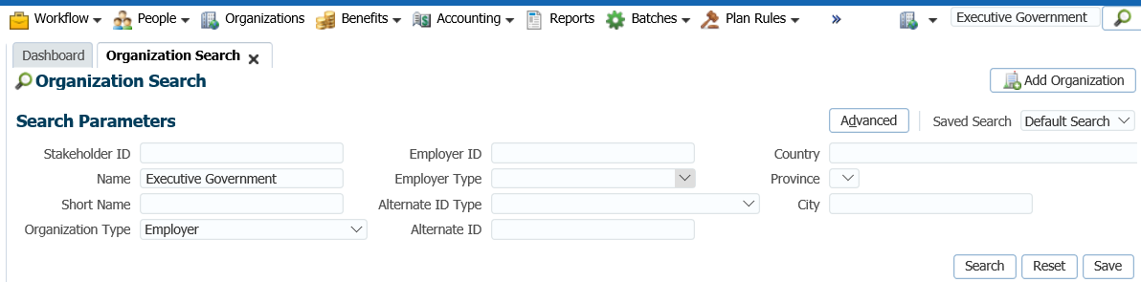

1. If the Organization is found and a change of information is required, click on the **Stakeholder ID hyperlink** or the **Name** **hyperlink** in the **Search Results** area to open the **Organization Profile** screen.

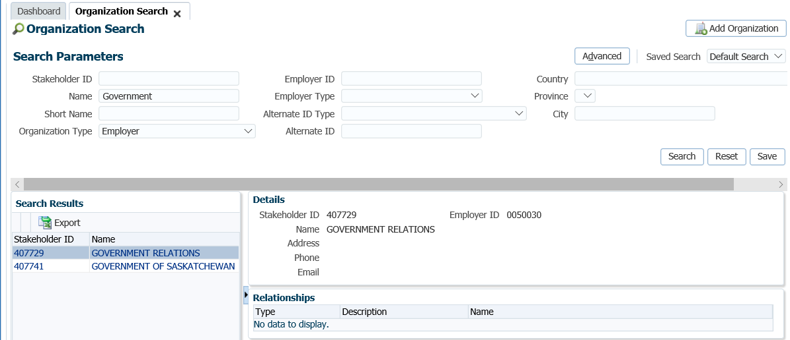

1. If the organization was not found a message will appear in the **Search Results** area stating **“no data to display”**. The organization or employer must then be set up as a new organization. See procedures for “**Adding a New Organization or Employer**”.

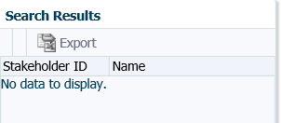

## Organization Screens and Regions

### Organization Profile Menu

The **Organization Profile** screen located under the **Navigation** menu, summarizes the information for an organization. The screen is used to view existing data, add or editexisting organization data or delete an existing organization or organization information. Cases for a specific organization can be created on this screen.

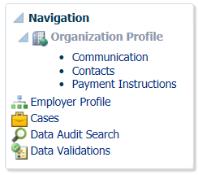

#### Organization Summary Region

The **Organization Summary** region will display a summary of the current organization information which appears on all related organization screens. The majority of the details in the **Organization Summary** can be updated in the subsequent regions as well as viewing historical data.

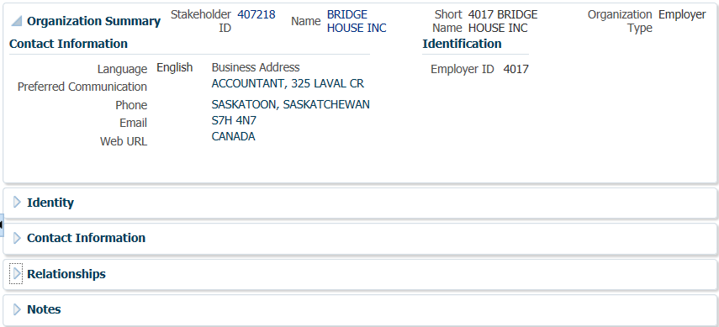

#### How to Change Preferred Communication

1. To make a change to the **Preferred Communication** for an organization, click **Edit**.

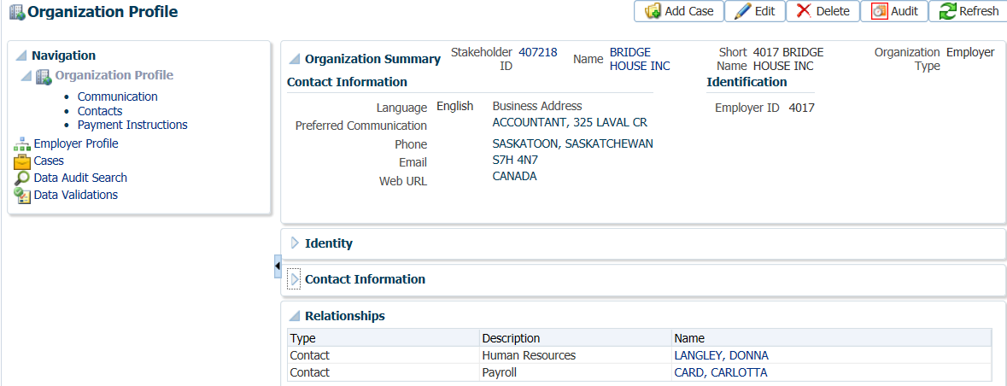

1. In the **Organization** pop-up window select the **Preferred Communication** and click **Save**.

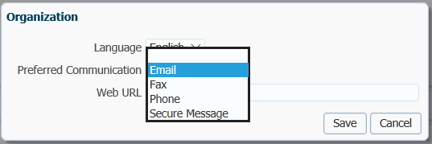

1. To add a **Case** for an Organization, click **Add Case**. Select the **Case Type**, click **Save**.

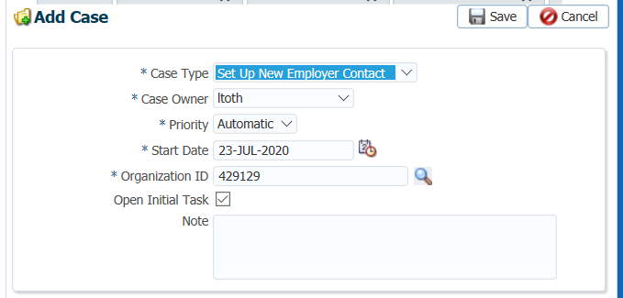

#### Identity Region

In the **Identity** region, you can view current and historical data in the **Organization Name** sub-region, and the **Identification** sub-region, which contains unique identifiers and their details.

#### How to Make Changes to the Identity Region

To make changes, add new information or delete existing information in the **Identity** region, click the **Add, Edit** or **Delete** buttons to make the required update to either the **Organization** block or the **Identification** block.

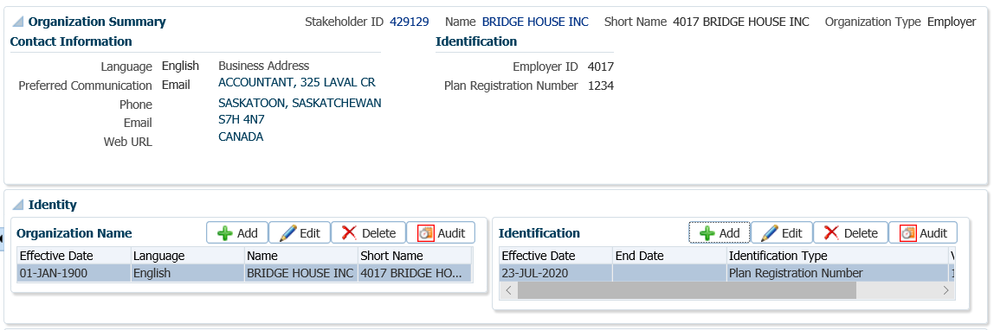

1. In the **Identity** region under **Organization Name** or **Identification** , click **Edit** to make a change then click **Save** to complete the change.

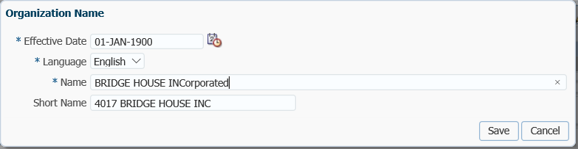

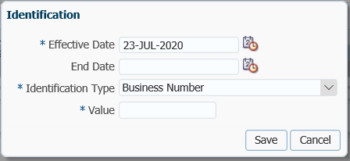

#### Contact Information Region

The **Contact Information** region contains current and historical **Address**, **Phone**, and **Email** information for the organization as well as the **Correspondence Preference**.

#### How to Make Changes to the Contact Information

To make changes to the **Contact Information** region, Address, Phone, Email or Correspondence Preference,use the **Add, Edit** or **Delete** buttons and make the required change in the applicable pop-up window.

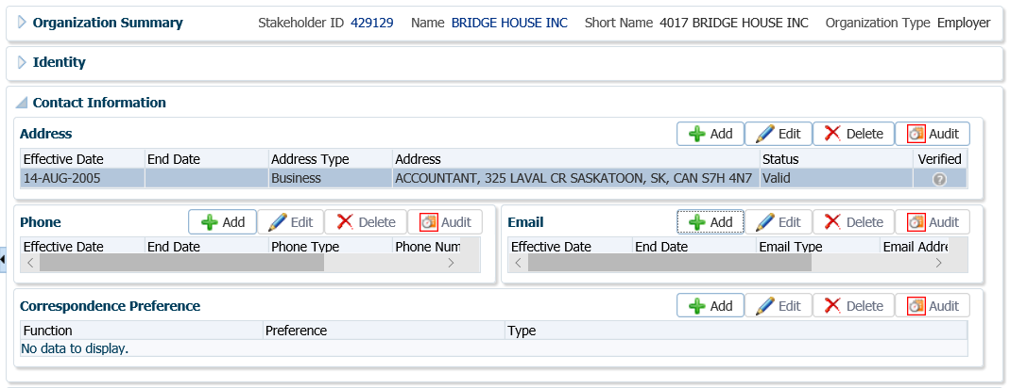

1. To add new information such as an Address, Phone, Email or Correspondence Preference, click **Add.** Enter the information in the pop-up window and click **Save**.

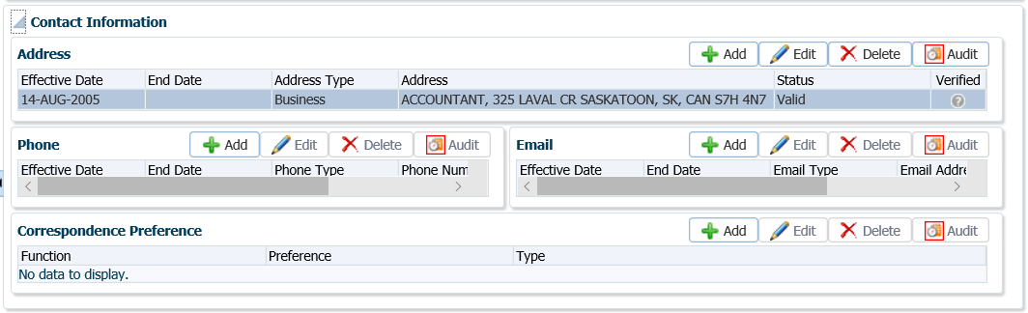

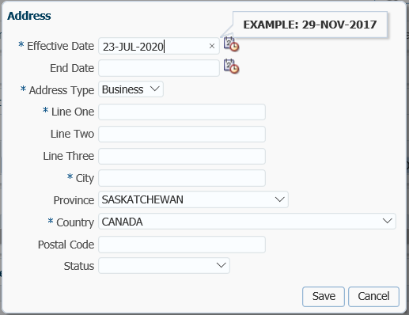

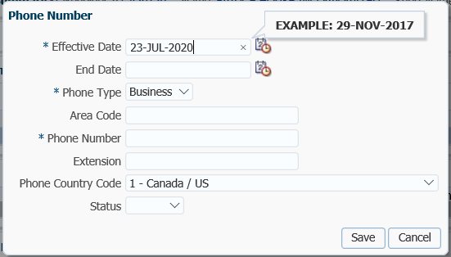

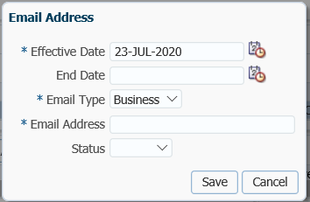

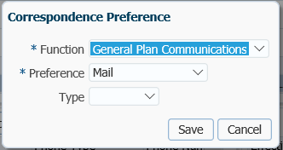

#### Relationships Region

The **Relationships** region contains the relationships that the organization has to other people or organization records in the system. This information is populated from entries on the **Contacts** screen for this organization or another organization or person in PENFAX.

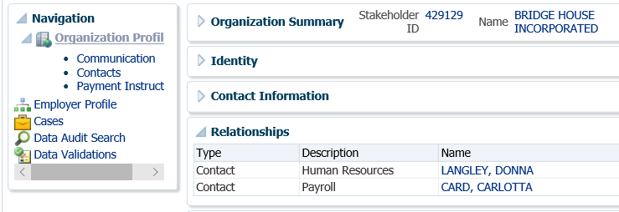

#### Notes Region

**Notes** can be added to most screens and during many processes. When viewing **Notes** you will only see the **Notes** added from that screen, with the exception of the **Organization Profile** screen. The **Notes** region here displays all **Notes** added for the organization.

#### How to Add a Note

1. Click Add, Edit or Delete in the **Notes** region to make the required update.

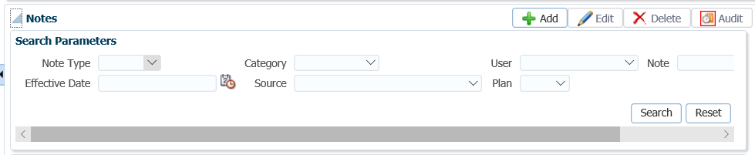

1. In the **Note** pop-up window add the Note and **Save.**

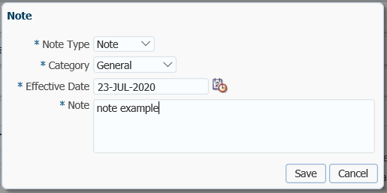

#### Communication Screen

Organization documents, both inbound and outbound, are viewable on the **Communication** screen. This area can also be used to document interactions such as telephone calls.

#### How to Make Changes to the Communication Screen

Changes can be made to the **Interaction History, Notes, Outbound Documents,** and **Inbound Documents** by clicking **Add, Edit** or **Delete.**

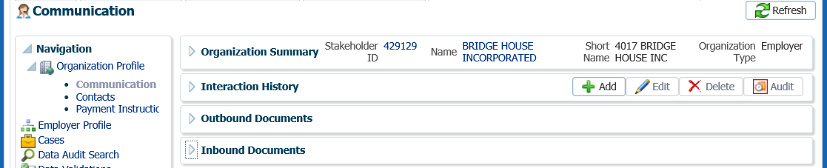

1. To addnew information click **Add** in the **Interaction History, Notes, Outbound Documents** or **Inbound Documents** regions.

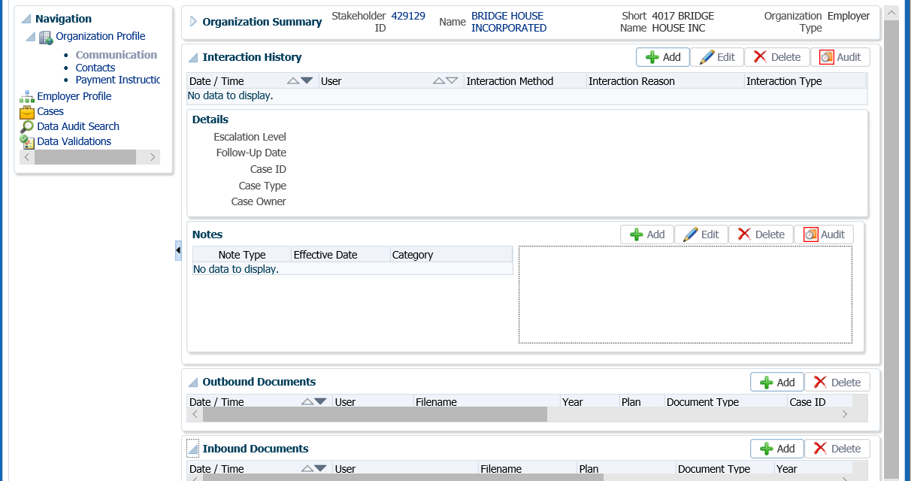

1. Enter the information and click the **Save** button.

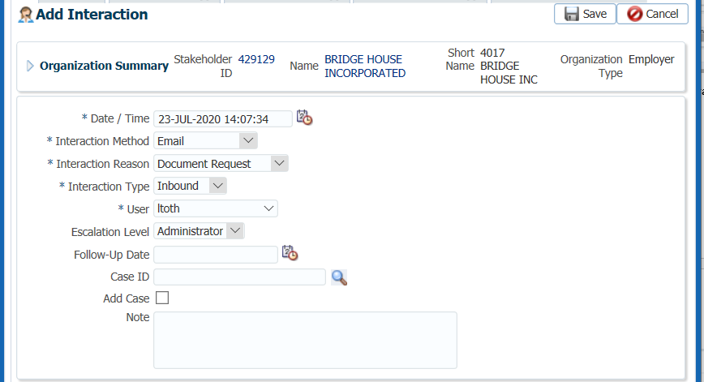

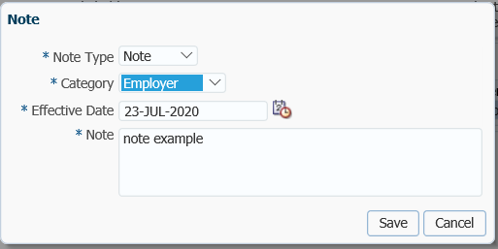

*Inbound or Outbound Document*

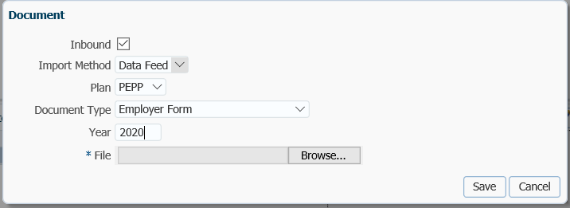

#### Contacts Screen

From the **Contacts** screen you can add a new contact for the organization or modify the details of an existing contact. The **Contacts** region lists all the stakeholders added and linked to the account by effective dates as well as the **Relationship** type of the contact, **Stakeholder ID** and their **Name**. The **Title** field will dynamically display only for a person contact and this field can be used to provide a role description for a contact of an organization. You have the ability to confirm the contact data has been **Verified** by setting the verification status.

#### How to Add a Contact

1. To add, edit or delete a **Contact** for an Organization, click **Add, Edit or Delete** then **Save**.

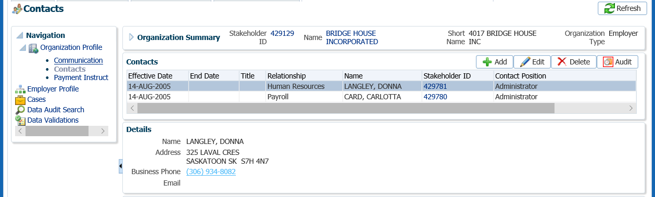

1. Enter the Contact information and click **Save.** The new information will be saved under the **Contacts** region.

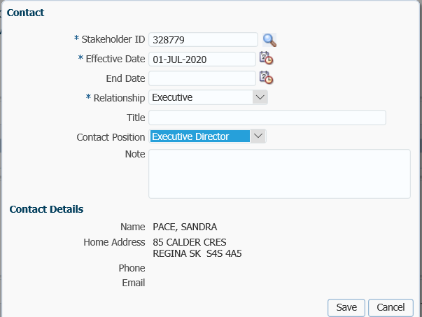

#### Payment Instructions Screen

The **Payment Instructions** screen is used to view and manage a stored set of specific instructions on to whom, how and where to pay a benefit entitlement from the Plan. These are set up for either a person or an organization to which the benefit is to be paid.

#### How to Add Payment Instructions

1. To make changes to existing **Payment Instructions** for an Organization, click **Add, Edit** or **Delete.**

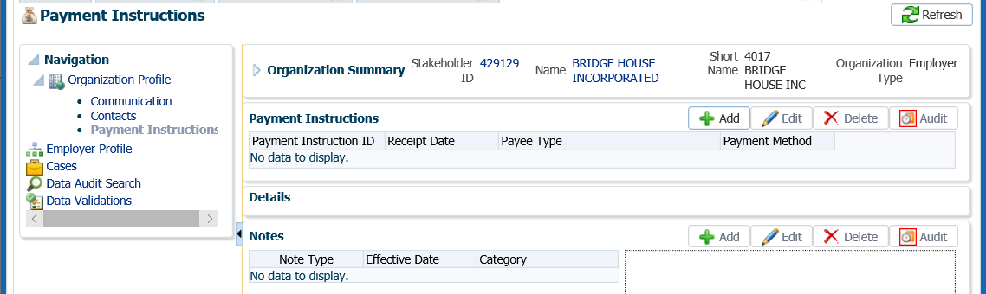

1. Select the **Payee Type, Payment Method, Receipt Date, Expiry Date** (if applicable for EFT), **Payment Note, Note, Payee Name or Override Payee Name** and **Address Type**. Click **Save**.

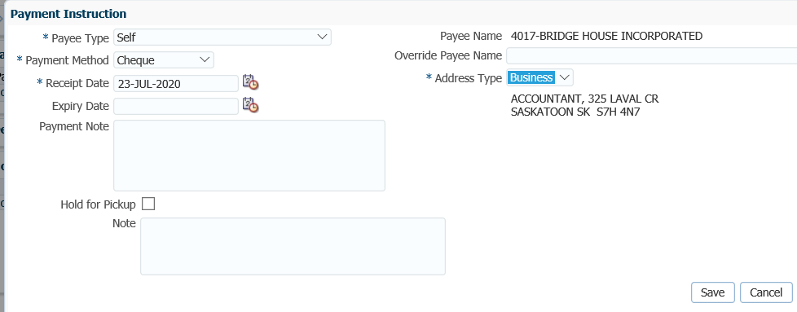

### Employer Profile Menu

The **Employer Profile** screen is used to view information about the selected employer and access related screens to add or edit information

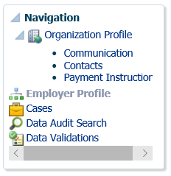

The **Employer Profile** screen displays information on the Contact Details, Employer ID, Employer Status, Plan Affiliations, Union Affiliations, Pay Cycles, Scope Codes, Departments and Amalgamations can be viewed under the Employer Profile regions.

#### Employer Region

The **Employer** region displays basic information about the employer such as the **Employer Type, Employer ID, Activation Date, Deactivation Reason** and **Status.**

#### How to Change the Employer Region

1. Clicking the **Edit** button opens the Employer window which allows you to modify all the fields in this region except for the Employer Type field, which is read-only.

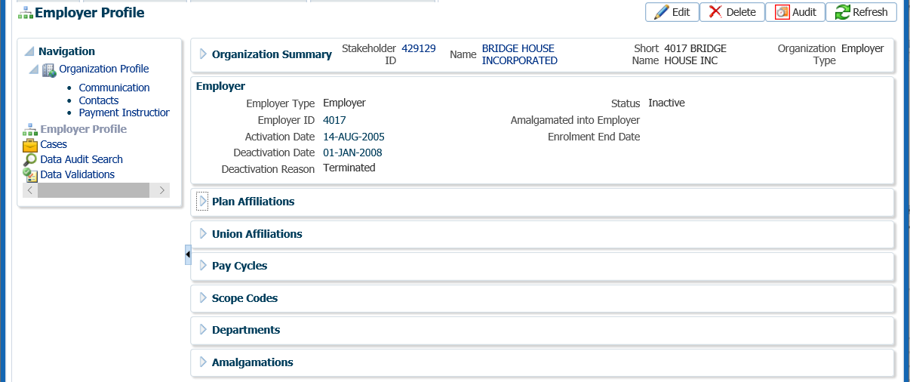

1. In the **Employer** pop-up window, update the fields as required and click **Save**. The new information will be displayed in the **Employer** region.

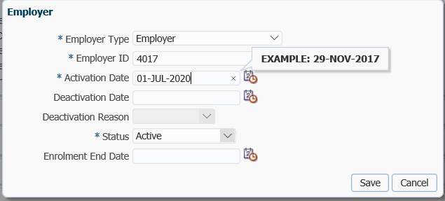

#### Plan Affiliations Region

The **Plan Affiliations** region displays a list of pension plans in which the employer participates. For each record, the **Plan** name, **Start Date**, and **End Date** are displayed.

#### How to Change the Plan Affiliations Region

1. To add or modify a record, click the **Add** or **Edit** button to open the **Plan Affiliation** window.

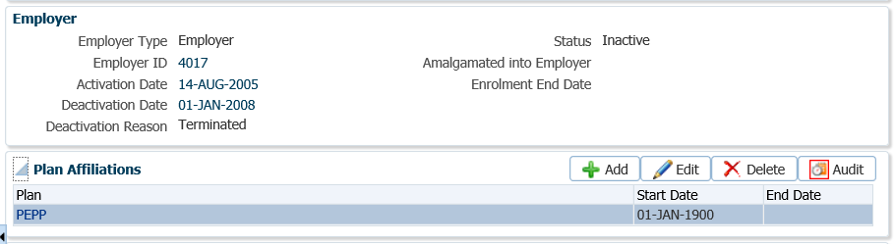

1. In the **Plan Affiliation** pop-up window, enter the information and click **Save**. Edits or additions will be displayed in the **Plan Affiliations** region.

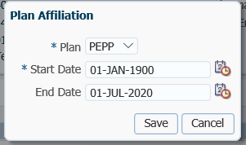

#### Union Affiliations

The **Union Affiliations** region displays a list of the employee unions affiliated with this employer. For each record, the **Employee Union** name, **Start Date,** and **End Date** are displayed.

#### How to Add or Change a Union Affiliation

1. To add or modify a union record, select the **Add** or **Edit** button to open the **Union Affiliation** pop-up window.

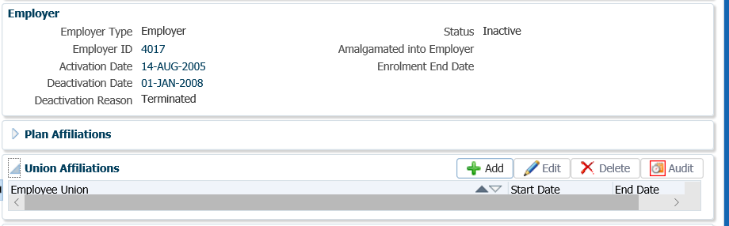

1. In the **Union Affiliation** pop-up window, select the **Employee Union** from the drop-down list, the **Start Date** if adding or **End Date** is editing. Click **Save**. The new or edited information will be displayed under the **Union Affiliations** region.

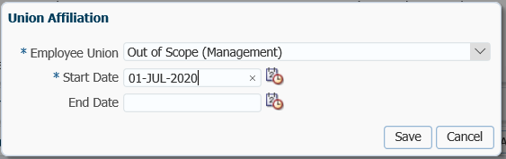

#### Pay Cycles Region

The **Pay Cycles** region displays a list of the pay cycles used by the employer. For each record, the **Pay Cycle**, **Start Date**, and **End Date** are displayed.

#### How to Add or Change Pay Cycle

1. To add or modify a record, selecting the **Add** or **Edit** button will open the **Pay Cycle** window.

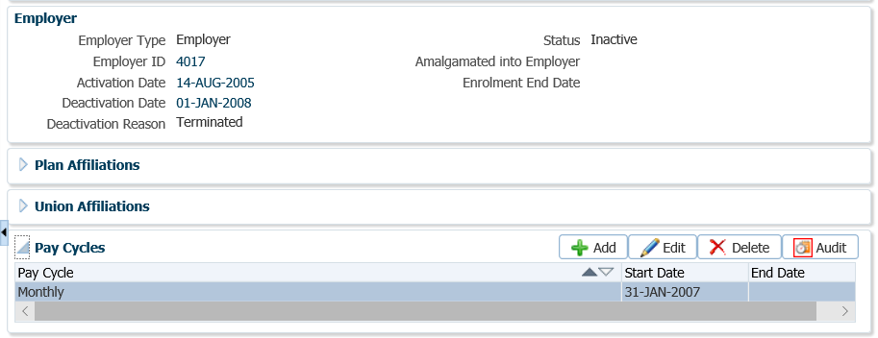

1. In the **Pay Cycle** pop-up window, select the **Pay Cycle** from the drop-down list, the **Start Date** and click **Save**. The new information will be displayed under the **Pay Cycle** region.

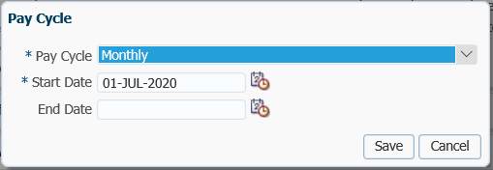

#### Scope Codes

The **Scope Codes** region displays a list of the scope codes used by the employer. For each record, the **Scope Code**, **Description**, **Start Date**, **End Date, Employee Contribution Rate** and **Employee Contribution Rate** are displayed.

#### How to Add or Change Scope Codes

1. To add or modify a record, selecting the **Add** or **Edit** button will open the **Scope Codes** window.

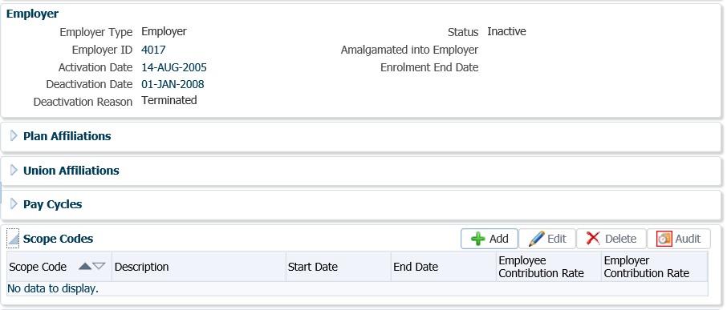

1. In the **Scope Code** pop-up window enter the information and click **Save.** The new information will be displayed on the **Scope Codes** region.

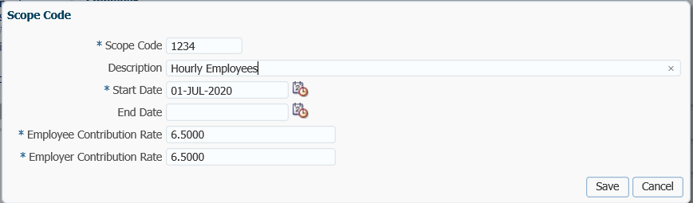

* **NOTE:** Always add a new **Scope Code** for an employer to keep a history of changes.

#### Departments

The **Departments** region will show all Departments that are sub-divisions of the employer. For each record, the **Employer** and **Employer Type** are displayed.

#### How to Add a Department

1. To add a record, select the **Add** button to open the **Subdivision** window.

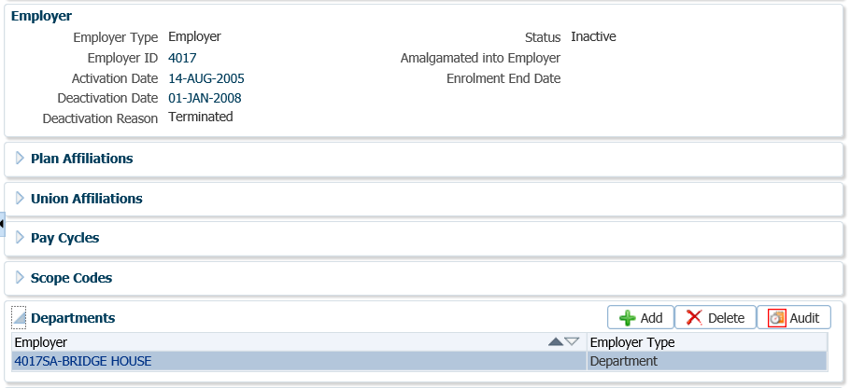

1. In the **Subdivision** pop-up window, select the **Employer** from the drop-down list. The **Employer Type** will automatically populate when the **Employer** is selected. Click **Save**. The new employer information will be displayed under the **Departments** region.

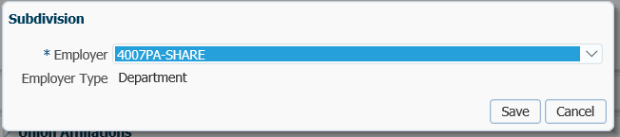

#### Amalgamations

The **Amalgamations** region displays a list of the Employers that have been amalgamated into this Employer. The **Effective Date** of when the amalgamation occurred, and the **Employer** name are displayed.

#### How to Add an Amalgamation

1. To amalgamate an Employer into the Employer account being viewed, clicking the **Add** button will open the **Amalgamation** pop-up window.

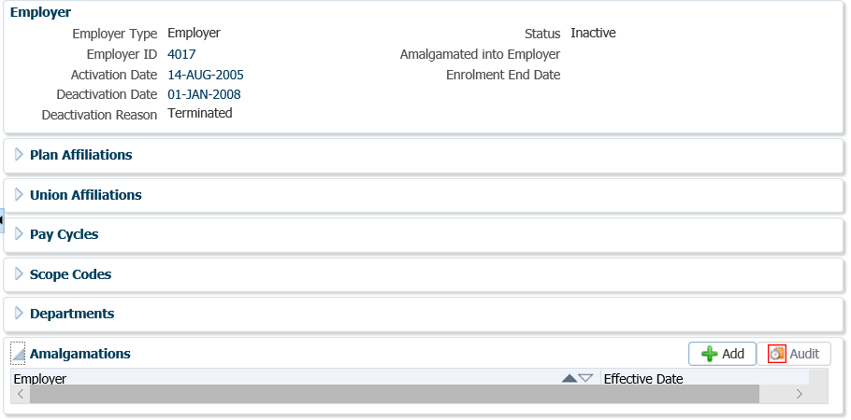

1. In the **Amalgamation** pop-up window, select the **Employer** from the drop-down list and the **Effective Date.** Click **Save**. The information will be displayed under the **Amalgamation** region

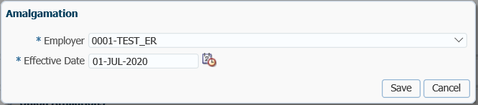

## Adding a New Employer or Organization

When an organization or employer is not found in PENFAX, it can be added to the system by using the **Add Organization** button located at the top of the **Organization Search** screen. Information entered for an Organization may differ from the information captured for an employer.

#### How to Add a New Employer

1. From the top menu select **Organizations**.
2. Navigate to the **Organization Search** screen to perform a search for the organization (see procedures **“How to Search for an Organization”**)**.**
3. If the organization was not found in PENFAX, click **Add Organization**.

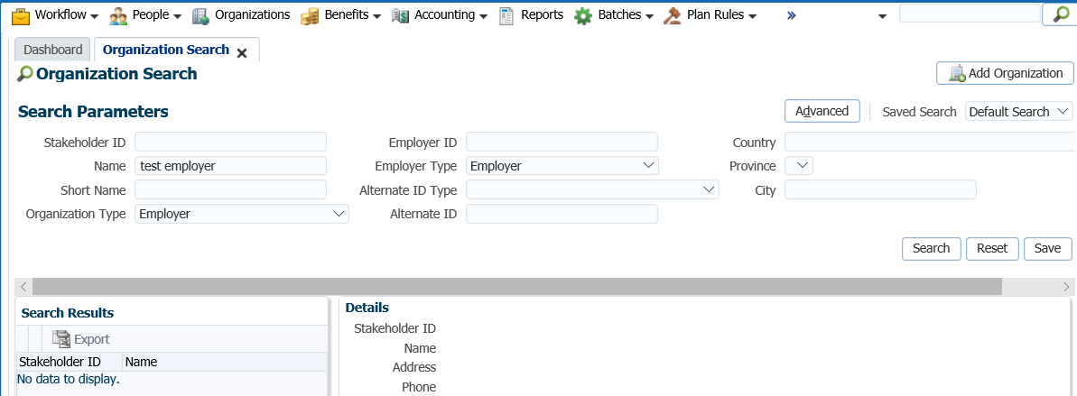

1. Complete the information pertaining to the Organization in the **Add Organization** screen, click **Save** to validate the data. The **Employer ID** is a number generated by PEPP administration.

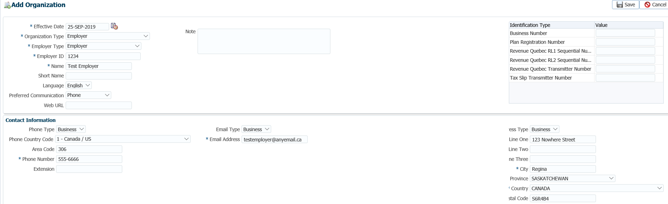

1. In **Employer Profile** screen under the Navigationmenu, select the **Employer Profile** option and expand the **Plan Affiliations** region.

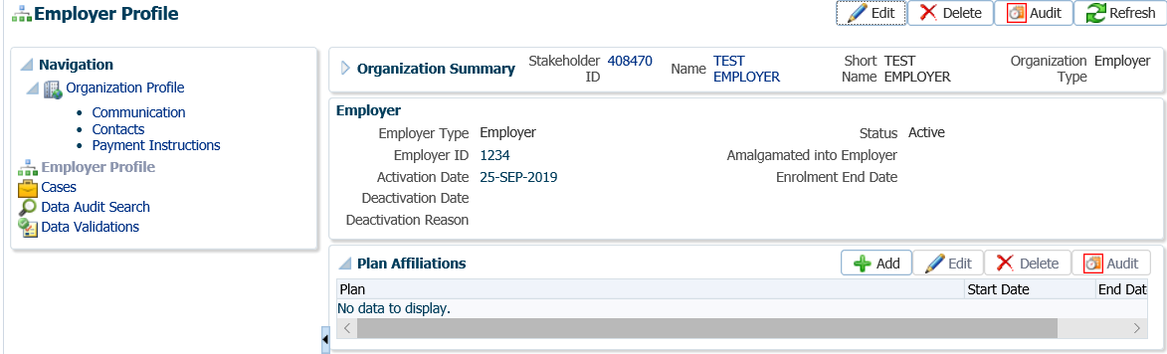

1. Click **Add** to add the employer to the PEPP, click **Save.**

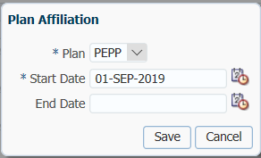

1. Expand the **Pay Cycles** region, click **Add.**

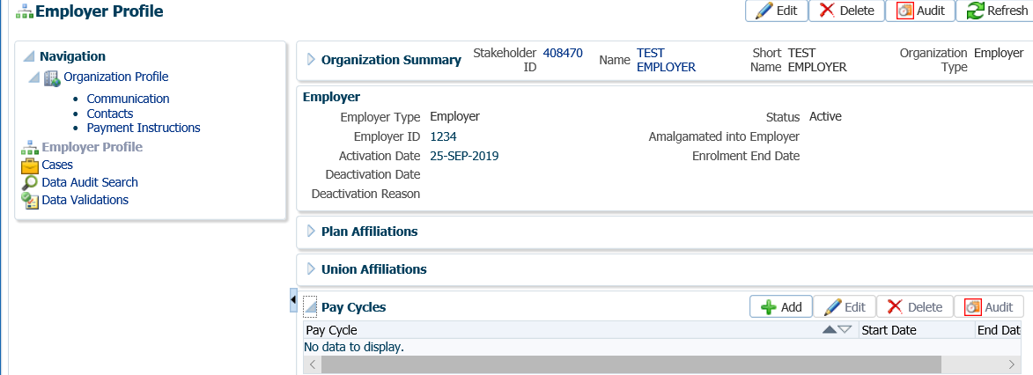

1. In the **Pay Cycle** pop-up window, select the pay cycle for the employer, click **Save.**

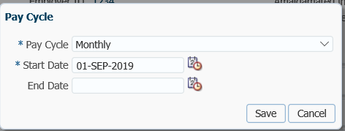

* **NOTE:** If the employer has more than one **Pay Cycle**, repeat step 8.

1. Expand the **Scope Codes** region, click **Add.**

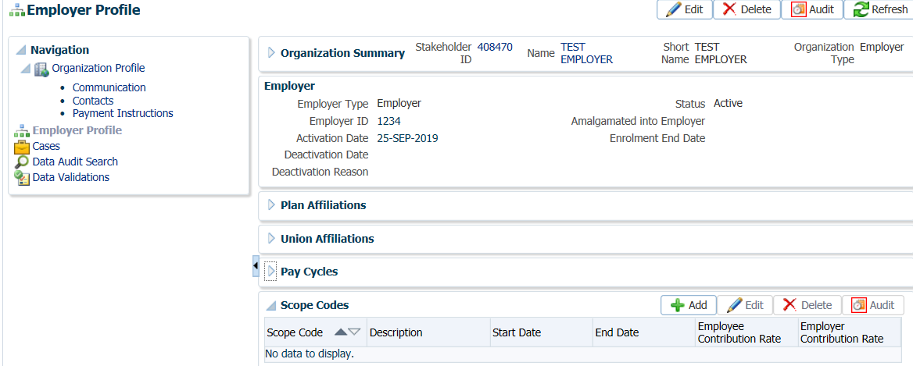

1. In the **Scope Code** pop-up window select the **Scope Code** from the drop-down menu, enter the **Description**, **Start Date**, **Employee Contribution Rate**, and **Employer Contribution Rate**, click **Save.**

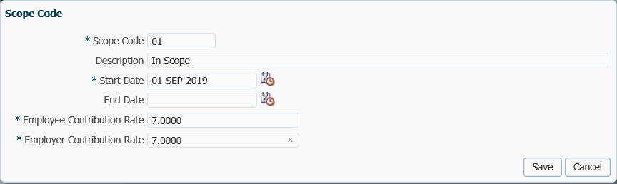

* **NOTE:** If the employer has more than one **Scope Code**, repeat step 10.

1. Departments must be added as a Stakeholder first. Refer to Steps 3- 4 to add. Once the department has been added as a stakeholder, expand the **Departments** region, click **Add** to select the department**.**

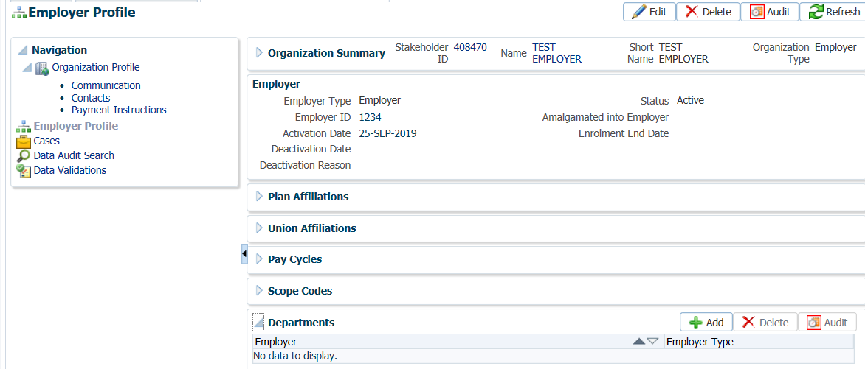

1. In the **Subdivision** pop-up window, select the **Department** from the drop-down list, click **Save.**

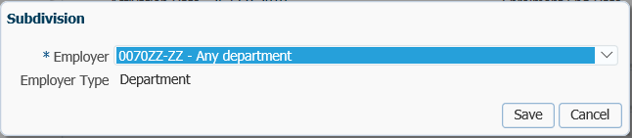

* **NOTE:** If the employer has more than one **Department**, repeat step 12.

1. From the **Navigation** menu, under **Organization Profile**, select **Contacts.**

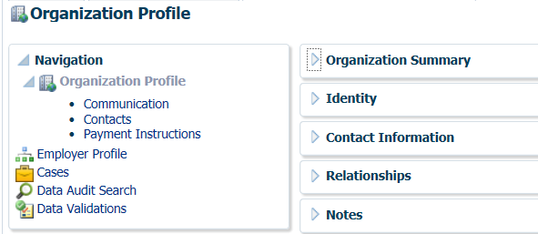

1. Expand the **Contacts** region, click **Add.**

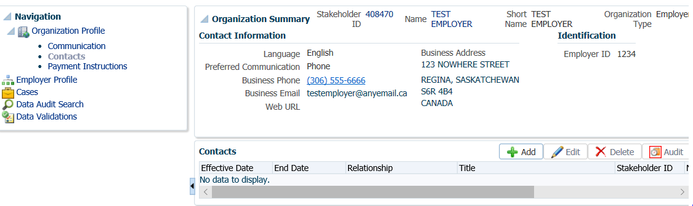

1. In the **Contacts** pop-up window, enter the contact’s stakeholder number if known or click on the **magnifying glass** to do a search for the contact name. Complete the required information for the contact, click **Save.**

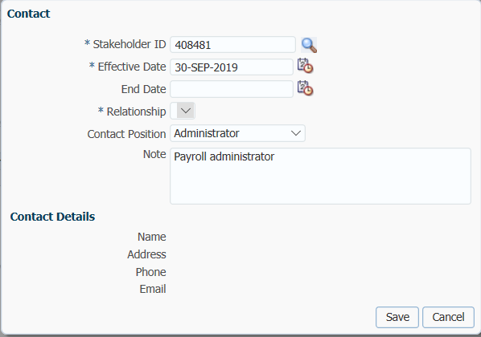

**IMPORTANT**

Contacts must first be added as a **Stakeholder** in PENFAX. Perform a search to determine if the contact exists in PENFAX, if the contact name is not found add the contact as a **New** **Stakeholder**

# Investment Management

Under the Investment Management area a user will be able to calculate an account balance, perform a change in investment fund(s) to direct future contribution, and perform an Inter-fund transfer or asset rebalance for a member.

Financial information is located under the **Navigation** menu in the **Member Profile** area under two separate screens, the **Contribution History** and the **Investments** screen.

The **Contribution History** screen displays information relating to contributions received for a member. Deposits received for an External Transfer In from another registered pension plan can be added in **Contribution History** screen for deposit directly to the member’s account.

The **Investments** screen displays a member’s current account balance, account activity, account instructions and personal account performance.

## Account Balances

Under the **Investments** screen, the **Account Summary** region provides a snap-shot of a member’s current account balance, total contributions received, total units and the current value. The information is calculated as the screen is opened and re-calculated each time a member’s account is changed in some way.

The **Account Balances** screen provides the current account balance and the option to change the valuation date to calculate a prior account balance for a member with the ability to filter by fund or contribution source.

#### How to Run an Account Balance

1. Search for the member in PENFAX.
2. Under the **Member Profile** menu, **Investments** screen, expand the **Investment Accounts** region, select the appropriate **Account Class** (PEPP or VPB if a member has both) by highlighting the row.

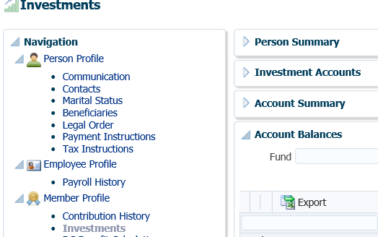

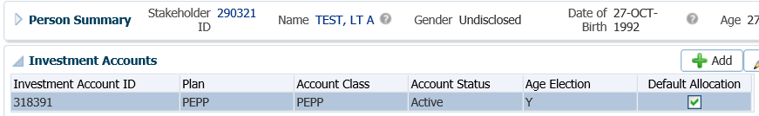

1. The **Account Summary** area, shows the current **Values** of the **Account Class** selected and includes the total of Locked-In and Vested funds.

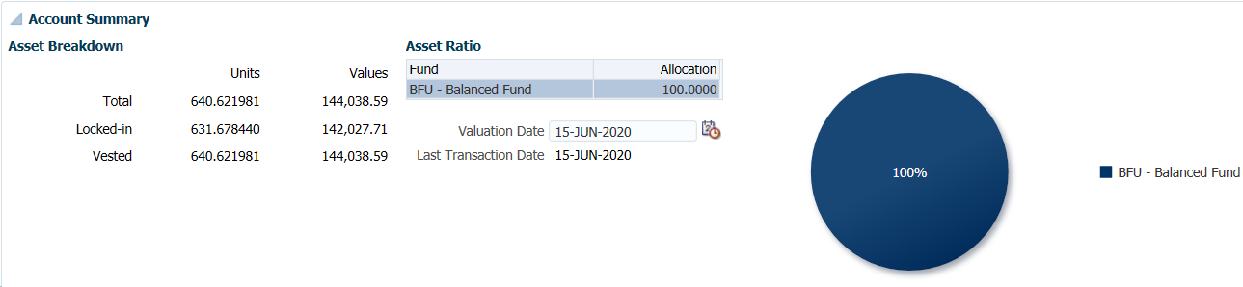

1. The **Asset Ratio** view provides the current spread of investments as a percentage of the total as of the current **Valuation Date**.



1. The **Valuation Date** can be changed to calculate a backdated account balance by changing the date in the **Valuation Date** field or clicking on the calendar icon to select the new date from the calendar display.



1. The **Account Balances** region show a breakdown of the member’s account by **Fund** and **Contribution Type.** The information can be filtered on to search for a specific **Fund** or **Contribution Type** by selecting the information from the drop-down list.

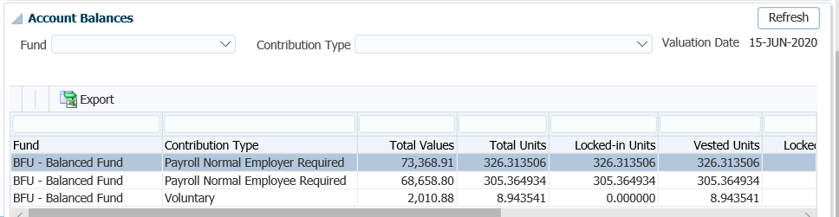

1. The information in the **Account Activity** region can be filtered by **Fund, Fund Transaction Type** or **Contribution Type**, etc. in the **Search Parameters** area. Select your search criteria from the drop-down list and click **Search.** The requested information will display in the lower region.

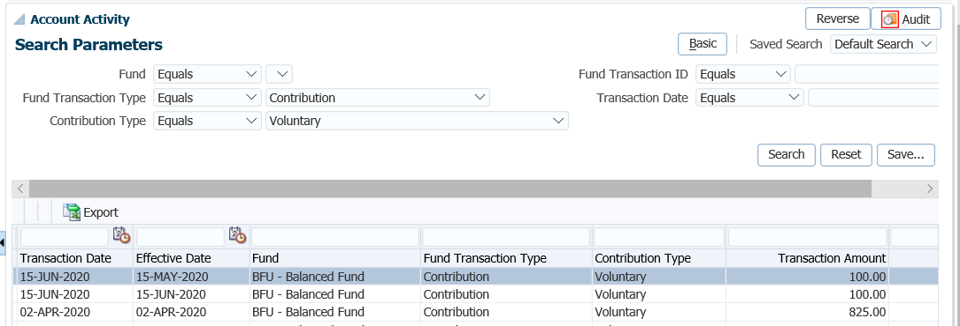

## Deposit Allocation Change

To make an investment allocation change to direct future contributions received by payroll deduction or by a voluntary transfer in of registered funds, as requested by the member.

**Business Process Requirements - Deposit Allocation Change**

* Members can invest in one or a combination of investment funds, which include only one asset allocation fund and one or both specialty funds, or invest solely in a specialty fund.
* If the PEPP account is an estate account the surviving spouse cannot control the investment fund selection and request an inter-fund transfer. If the surviving spouse wants to move the funds into a different investment fund they will have to move the account under their own name (e.g. Variable Pension Benefit).
* If a member holds an account balance in PEPP and in VPB, both accounts must hold the **same** asset allocation. The investment instruction and/or account balance can differ in percentages and amounts allocated to funds between the PEPP and VPB, as long as the member’s fund choice does not violate the “one asset allocation” fund rule.
* Review the *Investment Options* *Changes* form or *Member Enrolment* form to ensure it has been completed in full, signed and dated by the member.
* PEPP will accept a copy of the *Investment Options* *Changes* form or *Member Enrolment* form for an inter-fund transfer or deposit allocation change.
* If the member’s signature is missing or the form is incomplete or unclear, do not process the investment fund change, follow up with the member to obtain the missing information. ***Refer to******Procedures to******Obtain Missing Information***.
* If there is a change to the address, phone or email on the *Investment Options Changes* form or *Member Enrolment* formcompared to PENFAX, update PENFAX with the new information.
* Remove the **Default Flag** if a member is electing a new investment fund for the first time and was previously invested in the PEPP Steps default fund.

#### How to Change a Deposit Allocation Instruction

1. Search for the member in PENFAX.
2. Under the **Navigation**, **Member Profile** menu, select the **Investments** screen, **Investment Accounts** region.

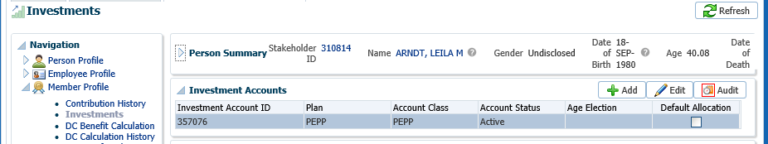

1. In the **Investment Accounts** region click **Edit** to open the **Add Investment Account** pop-up window.

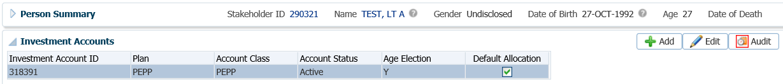

1. In the **Add Investment Account** pop-up window, leave the **Age Election** as blank, de-select the **Default Allocation** box as the member is now making an investment choice. Click **Save**.

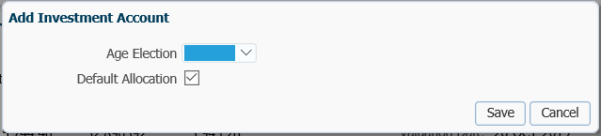

1. In the **Account Instructions** region, click **Add**.

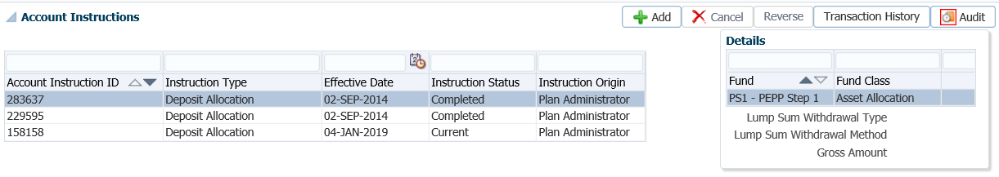

1. In the **Account Instructions** pop-up window, select **Deposit Allocation** as the **Instruction Type**. Leave the **Effective Date** as the current date. Click the **Add** button to add a new fund.

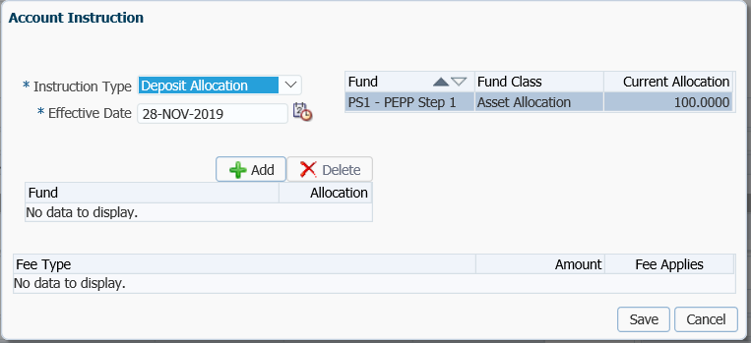

* **NOTE:** if the deposit allocation instructions need to be backdated to a different effective date for deposits to be applied to, administration breakage may result against PEPP as units in the fund will need to be purchased on previously declared unit values.

1. Select the new **Fund** from the drop-down list and add the percentagein the **Allocation** field. Click **Save.**

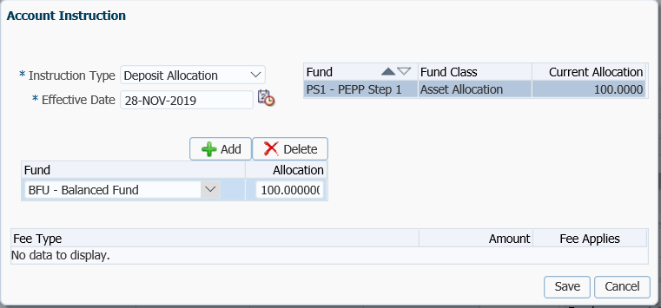

1. The new **Account Instructions** will now be displayed under the **Account Instructions** region for the member. All new contributions to the account will be deposited to the new account instructions.

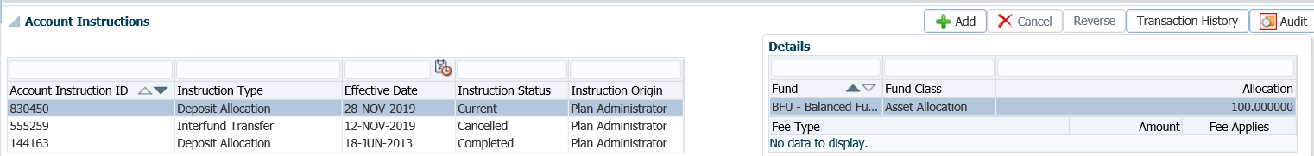

* **NOTE:**  If the Deposit Allocation Instruction was added in error or was incorrect, you cannot delete it. By adding a new Deposit Allocation Instruction it will complete the one done in error so that the new one will be the current one.

1. A Confirmation of the Investment Instruction Change will produce overnight and is to be mailed to the member. A copy of the confirmation letter will be saved to the member’s account under the **Person Profile** menu, **Communication** screen, **Outbound Documents** region. Click on the **Filename** to open the letter.

## Inter-Fund Transfer or Asset Rebalance

All PEPP members may request PEPP Administration to transfer their account balance into a different investment fund or change how their future contributions are invested at any time. If more than two are requested within a fiscal year (April 1 to March 31), a processing fee will be charged.

PLANet for members allows members to process an inter-fund transfer or deposit allocation change online when signed into PLANet. There is no charge to members for inter-funds processed on PLANet.

**Business Process Requirements for an Inter-Fund Transfer or an Asset Rebalance**

* Members can invest in one or a combination of investment funds, which include one asset allocation fund and/or both specialty funds.
* All inter-fund transfer requests must transfer a minimum of $500, or the member’s entire account balance if it is less than $500. If the transfer amount is below $500, a validation error will result and be displayed at the time of processing.
* Members are allowed up to two free inter-fund transfers per fiscal year (April 1 to March 31), if the request is processed by PEPP administrators.
* **Fee:** Inter-fund transfers exceeding 2 per fiscal year (April 1 to March 31) will be charged a $30 processing fee that will be automatically charged by the PENFAX system.
* **PLANet:** Inter-fund transfers completed by the member on PLANet are free of charge.
* If a member processes an inter-fund transfer on PLANet and changes their mind about the transfer, they are to contact PEPP and provide in writing a request by 2:00 p.m. (Saskatchewan time), to have PEPP cancel the pending inter-fund transfer.
* **Cut-off Time:** All inter-fund transfer requests must be received at PEBA by 2:00 p.m. (Saskatchewan time) on a business day in order for the change to be in effect for that same day. Any inter-fund transfer requests received at PEBA after 2:00 p.m. (Saskatchewan time) will be held for processing until the next business day.
* When meeting with a member to assist in completing the *Investment Options* form and it is prior to 2:00 p.m., indicate on the form, **signed and received December 15, 2018 at 1:59 pm** (your initials) and verbally indicate to the member “Received Prior to 2 pm – will be processed today using the market values at market close today”.
* When meeting with a member to assist in completing the *Investment Options* form and it is after 2:00 p.m., **signed and received December 15, 2018 at 2:15 pm** (your initials) and verbally indicate to the member “received after 2 pm – will be processed tomorrow using the market values at market close tomorrow”.
* Review the *Investment Options* *Changes* form or *Member Enrolment* form to ensure it has been completed in full, and signed and dated by the member.
* If the signature is missing on the *Investment Options* *Changes* form or *Member Enrolment* form is incomplete, do not process the investment fund change, follow up with the member. ***Refer to Procedures to Obtain Missing Information***.
* If there is a change to the address, phone or email on the *Investment Options Changes* form or *Member Enrolment* form, update PENFAX with the new information.
* **Estate Account:** If the PEPP account is an estate account the surviving spouse cannot control the investment fund selection and request an inter-fund transfer. If the surviving spouse wants to move the funds into a different investment fund they will have to move the account under their own name (e.g. Variable Pension Benefit).
* **One Asset Allocation Rule:** If a member holds an account balance in PEPP and in VPB, they must hold the **same** asset allocation fund in both accounts. The investment instruction and/or account balance can differ in percentages and amounts allocated to funds between the PEPP and VPB, as long as the member’s fund choice does not violate the “one asset allocation” fund rule.
* **PEPP to VPB Transfers:** Inter-fund transfers for member’s moving to VPB need to be done on the PEPP account prior to moving the member to VPB. This is to avoid being in two asset allocation funds if the final contribution hasn’t been received.
* **Audits:** All inter-fund transfers need to be audited regardless of the amount.
* Inter-fund transfers up to $50,000 *Pension Information Officer* audit only
* inter-fund transfers from $50,000 to $250,000 need to be audited by a *Pension Specialist*
* inter-fund transfers over $250,00 need to be audited by a *Supervisor*
* inter-fund transfers ***regardless*** of the amount if going to **2 or 3 funds** need to be audited by a *Supervisor*
* Inter-fund transfers need to be audited by 3:00 p.m.

#### How to Process an Inter-Fund Transfer or Asset Rebalance

1. Search for the member in PENFAX.
2. Under the **Member Profile** menu, select the **Investments** screen. Expand the **Investment Accounts** region, select the appropriate **Account Class** (PEPP or VPB if a member has both) by highlighting the row.

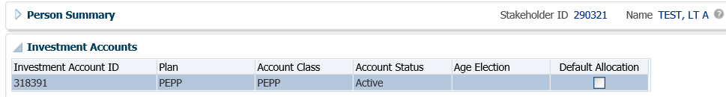

1. In the **Account Instructions** region, select **Add.**

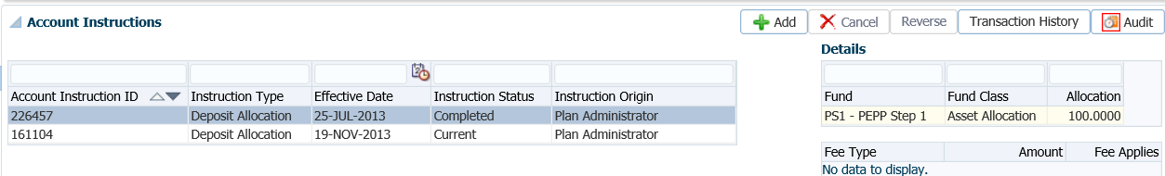

1. In the **Account Instruction** pop-up window, select from the **Instruction Type** drop-down list, **Interfund Transfer (Advanced).** Leave the date as the current date, click **Add.**

*Interfund Transfer (Advanced):*

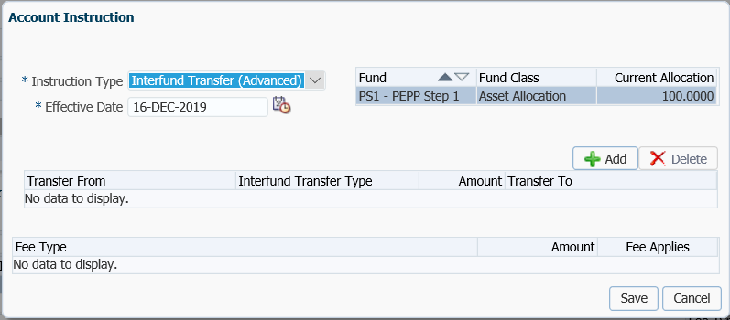

* **NOTE:** if the inter-fund transfer needs to be backdated to a different effective date, administration breakage will result against PEPP as units in the fund will need to be purchased and sold based on previously declared unit values.

1. In the bottom section of the **Account Instruction** pop-up window, fund information area, enter the following information for an **Inter-fund Transfer (Advanced)** then click **Save**:

* **Transfer From** – will default to current fund(s)
  + **Interfund Transfer Type** – select Percent
  + **Amount** - percentage to allocate to the new fund(s)
  + **Transfer To** – new fund member is transferring to
  + **Fee Applies** box - will automatically be checked if a processing fee applies to the inter-fund transfer. PENFAX tracks the number of transactions and charges a fee for the 3rd and subsequent inter-fund transfer in the fiscal year. The ability to de-select the **Fee Applies** box if a fee should not be charged for a specific reason is an option.

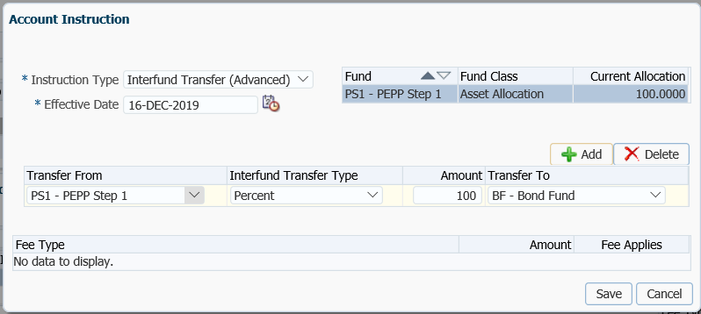

1. If doing an **Asset Rebalance**, in the **Account Instruction** pop-up window select **Asset Rebalance** in the drop-down list, leave the **Effective Date** as the current date, click **Add**.

*Asset Rebalance:*

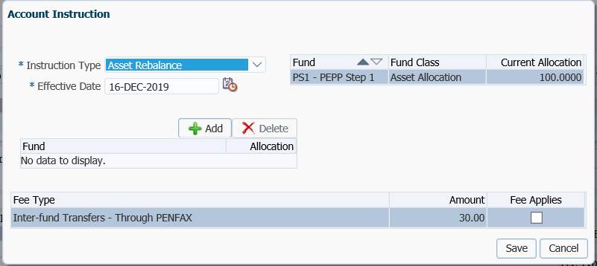

**ERROR MESSAGES:**

* All inter-fund transfer requests must transfer a minimum of $500, or the member’s entire account balance if it is less than $500. If an amount requested falls below $500 an error message “*Amount to transfer from fund name is below minimum allowed*”.
* Only one **Interfund Transfer** instruction with a **Status** of **Pending** can exist on the same day. If the administrator tries to add a new **Interfund Transfer** instruction the warning message “*Existing pending account instruction will be cancelled*” is displayed.
* If the fund allocations do not total 100%, an error message will be displayed stating “*the allocations sum must be 100%*”.

1. Select the following:

* **Instruction Type** – select  **Asset Rebalance** from the drop-down list
* **Effective Date** – leave as the current default date
* **Fund** – will default to current fund(s)
* **Fund(s)** – select the fund the transfer is going into
* **Allocation** - percentage to allocate for the fund(s)
* **Fee Applies** box - will automatically be checked if a processing fee applies to the inter-fund transfer. PENFAX tracks the number of transactions and charges a fee for the 3rd and subsequent inter-fund transfer in the fiscal year. PEPP has the ability to de-select the **Fee Applies** box if a fee should not be charged for a specific reason.

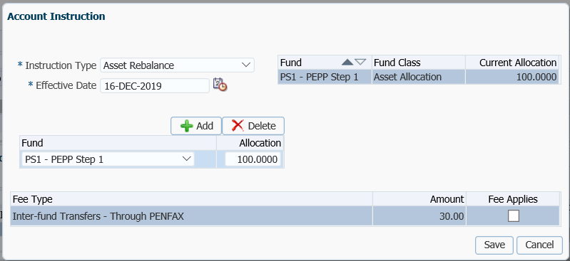

The Instruction Type of **Interfund Transfer (Basic)** is used by a member via PLANet when they are requesting an inter-fund transfer. PEPP administrators would use Interfund Transfer (advanced or asset rebalance).

*Interfund Transfer Basic:*

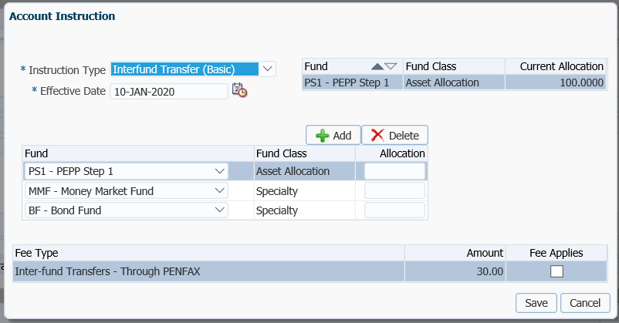

1. A Confirmation of the Investment Instruction Change will produce overnight and is to be mailed to the member. A copy of the confirmation letter will be saved to the member’s account under the **Person Profile** menu, **Communication** screen, **Outbound Documents** region. Click on the **Filename** to open the letter.

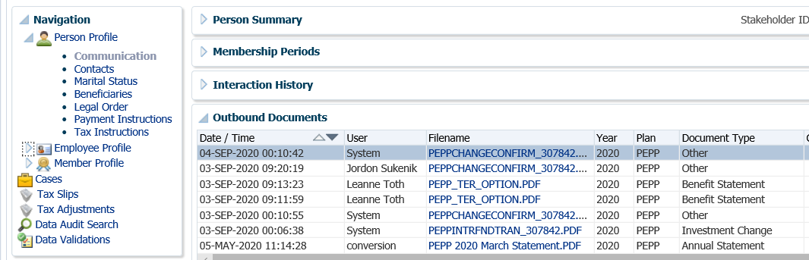

## Payroll Contribution Processing

Contribution payroll files received from the Executive Government or other one-off situations will be processed by PEPP authorized users in the PLANet application. The electronic files will continue to be sent to PEPP via email to the PEPP PDR Mailbox along with the PDF of the contribution listing. PEPP will import the file into PLANet and proceed with the steps to process once the EFT or cheque remittance amount is received and entered into PENFAX.

***Refer to the procedure steps in the PLANet Administrator Guide under Payroll Contribution Files - Overview.***

## Voluntary External Transfer In Deposit

All PEPP members (active or deferred), including Variable Pension Benefit (VPB) members can transfer registered funds from another financial institution into their PEPP account.

Transfers are allowed from RRSPs, spousal RRSPs, LIRAs, LIFs, LRIFs, RPPs and pRRIFs, or a transfer from a deceased spouse’s registered account.

Transfers received for PEPP members who are actively contributing to PEPP are inaccessible as long as the member is employed with a PEPP participating employer. VPB members will have access to their transferred in funds.

**Business Process Requirements for External Transfers In**

* Review the transfer form to ensure it has all relevant information and the form is signed and dated by the member.
* If locked-in funds are received ensure the jurisdiction is indicated on the transfer form or backup.
* If the transfer form indicates a social insurance number for the member, verify the member’s SIN on the T2151 form to the SIN on the PENFAX account to ensure it matches.
* Check PENFAX for any critical notes.
* If the member’s signature or details about the type of transfer are missing (non-locked-in, locked-in, spousal or jurisdiction) or if PEPP cannot accept the funds, do the following:
* **DO NOT** proceed with posting the funds.
* Call the applicable person (member or Financial Institution) to advise them that information is missing and PEPP cannot proceed until the information is received.
* If PEPP cannot accept the funds a manual cheque is to be requested from Financial Services. See procedures under **Manual Cheque Procedures** in the PENFAX Procedure Manual.
* Add a note to the member’s account in PENFAX stating why you cannot proceed and the action taken.
* Change your PENFAX Case to follow up at a future date if you are waiting to confirm information. The transaction will be processed effective the date the information is received back at PEPP.
* Cancel the Case if you won’t be proceeding with the request.
* If a transfer is received from a deceased PEPP member’s account for deposit to the spouse’s PEPP account, code the deposit as “Voluntary”.
* VPB married or common law members must complete the *Spouse’s Consent to Transfer Outside Registered Monies into Variable Pension Benefit (VPB)* form for any transfer in of Locked-In funds from an RPP or LIRA. It is not required if funds are non-locked-in from an RRSP, RRIF or another Variable Benefit Plan.

#### How to Add a Deposit for an External Transfer In

1. First add the Remittance in the **Accounting, Remittance Management** area. Select **Add Remittance** from the drop-down.

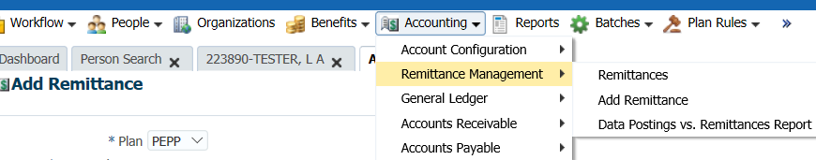

1. In the **Add Remittance** window, select the **Plan,** the **Stakeholder ID, Remittance Amount, Receipt Date, Remittance Type, Cheque Number** and add a **Note** as to where the cheque was received from and type of funds. Click **Save**.

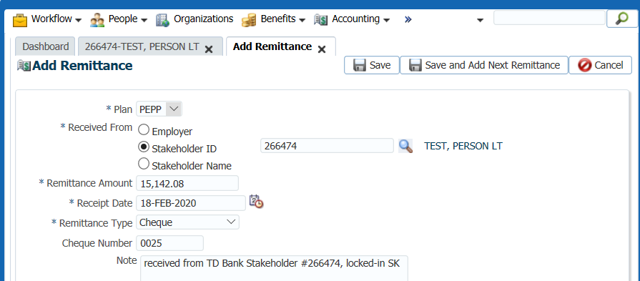

1. A **Remittance ID** number will be added in the **Remittance** screen.

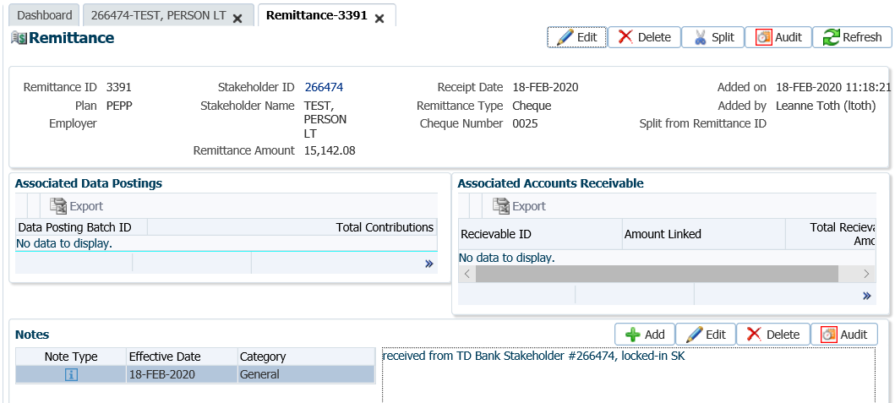

1. Search for the member in PENFAX.
2. Under the **Member Profile** menu,click on the **Contribution History** screen.

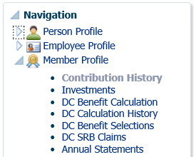

1. Under the **Contribution History** screen, expand the **Membership Periods** region, highlight the **Membership Period** the deposit is applicable for (PEPP if member is in PEPP or VPB if member is now in VPB).

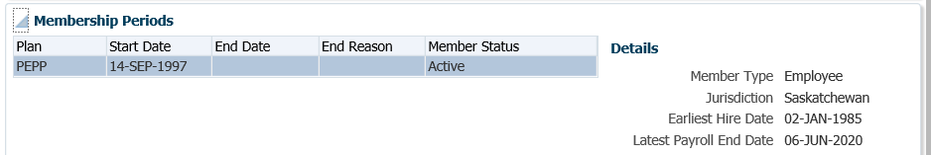

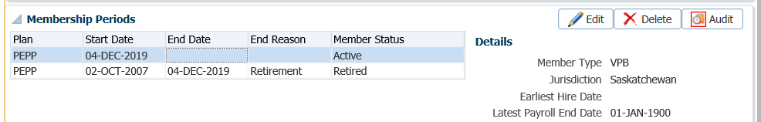

1. In the **Contribution History** screen, under the **Search Results** region, click **Add.**

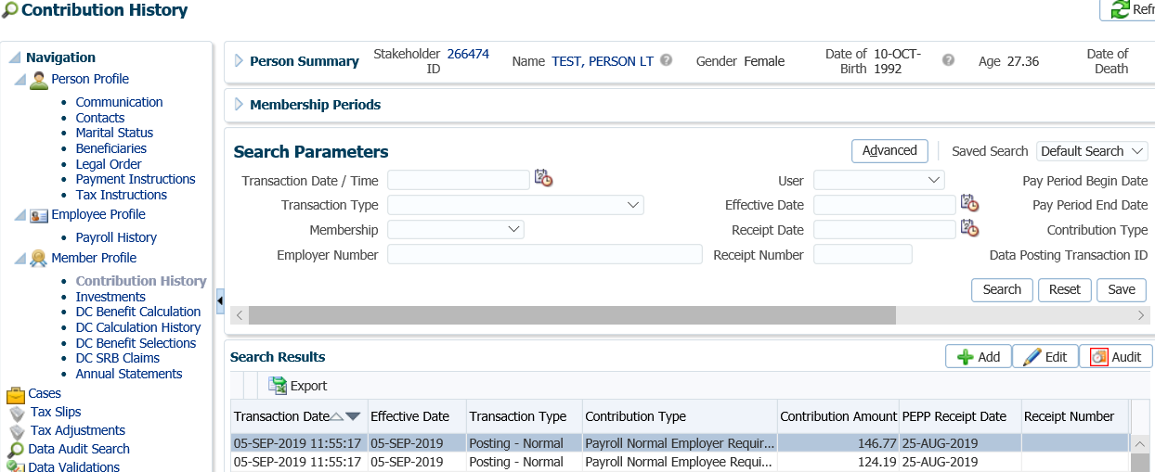

1. In the **Contribution Transaction** pop-up window, select the **Contribution Type** from the drop-down list, the **Effective date**, enter the **Amount** and add a **Note**. Click **Save**.

The correct membership period should be pre-populated in the **Membership** field.

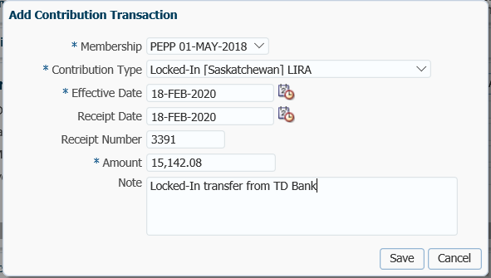

* **NOTE:** If a new investment fund was elected by the member for this deposit, ensure you add new **Deposit Allocation Instructions** prior to processing the deposit.

1. The external transfer in deposit will show under the **Contribution History** screen, **Search Results** region as **Transaction Type, Online Correction - Adjustment**. A peer audit is required to be done on the day the deposit was added.

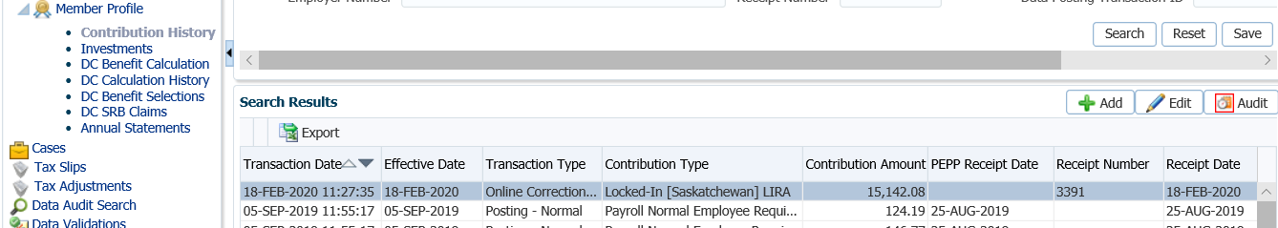

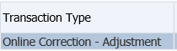

* **NOTE:** on the next valuation day the deposit will be displayed in the **Investments** area under **Account Activity**.

1. The Remittance Information will be populated once the deposit is valued.

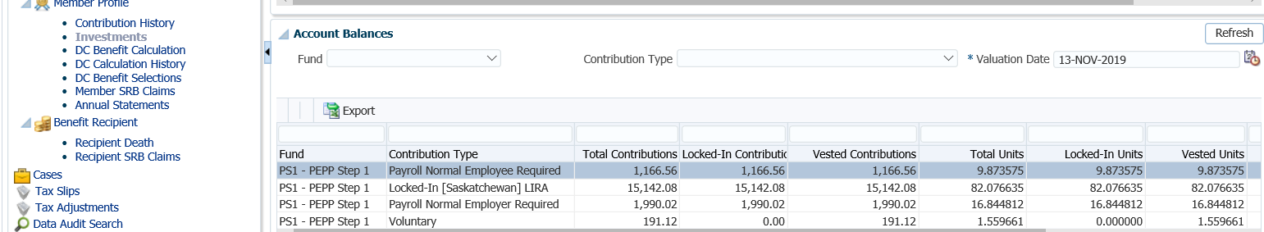

1. The Deposit Confirmation Letter will be produced in the overnight batch, a copy will be saved to the member’s account under **Communications,** **Outbound Documents**.

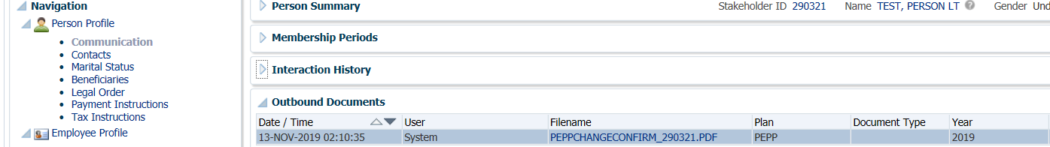

## External Transfer In With Service

External transfer in deposits for Reciprocal or Portability transfers in with service, are processed by creating an External Transfer file in PLANet. ***Refer to the External Transfer In With Service procedure steps in the PLANet PEPP Administrator Guide*.**

## Leave of Absence

A leave of absence (LOA) is employer approved time away from an employee’s position for reasons such as, maternity leave, sick leave, education leave, etc. It is the employee’s option to make up the contribution amounts representing the period of leave within 90 days from when they return to work. If the employee elects to remit the contribution amounts for the period the employer must also make up the employer portion of the contributions in the same manner that the employee chose.

A member may choose to repay for their employer approved leave of absence by payroll deduction, personal cheque, RRSP transfer or a combination of these options.

The Income Tax Act (Canada) limits the total amount of leave for which a member may make contributions. Members may contribute for a maximum of five years of accumulated leaves of absence. In the case of maternity or paternity leaves, the maximum is increased by an additional three years (eight years in total).

## Leave of Absence Repayment by RRSP

A leave of absence repayment by RRSP is processed in PLANet by creating a Leave of Absence Repayment Through RRSP file which is then submitted to PENFAX.

***Refer to the Leave of Absence Repayment Through RRSP business procedure and processing steps in the PLANet PEPP Administrator Guide*.**

## Leave of Absence by Payroll Deduction or Cheque

A member may choose to repay for their employer approved leave of absence by payroll deduction or by personal cheque sent to their employer. Contributions by payroll deduction are deducted from the employee’s payroll and sent to PEPP in the payroll contribution file along with the regular required contributions.

PEPP will receive a copy of the *Leave of Absence (LOA) – Contribution Options* form and will credit the member with applicable pensionable service in PENFAX for the approved time.

* **NOTE:** this process is for all PEPP employers except Executive Government. PEPP will continue to process LOA by cheque for Executive Government.

Business Process Requirements – Leave of Absence by Payroll Deduction or Cheque

* A member may choose to pay the full amount back or a portion of their pension contributions by payroll deduction or personal cheque.
* If a member is paying back a reduced amount the member must sign a *Reduced Amount to Pay Back Letter* in which the letter states they cannot revoke their decision at a later date.
* If the employee elects to remit the contribution amounts for the period of leave, the employer is required to contribute to the Plan using the same option as the employee elected.
* Contributions by payroll deduction can be made in one lump sum, or spread over several consecutive pay periods up to a maximum repayment period (see below).
* If the member elects to contribute by personal cheque, the payment must be made in one lump sum and the cheque sent directly to the employer. See exception below for Executive Government.
* Contributions are in addition to the regular current contributions that are deducted each pay period.
* Members have the length of their leave or until December 31 the year after the leave ends – whichever is shorter – to repay the contributions for the period of leave. PEPP begins measuring the contribution period from the date the first contribution for the leave is made.

#### Executive Government – LOA by Personal Cheque:

* If the member elects to contribute by personal cheque, the payment must be made in one lump sum.
* Any funds in excess of the amount required received by cheque will be returned to the member.
* PEPP will issue a receipt to the member to be used when filing their tax return.
* PEPP will send a memo to the employer to advise the employer that PEPP has received the employee share by personal cheque and the employer portion of the contributions can be forwarded to PEPP.

***Business Process:***

1. Review the *Leave of Absence (LOA) – Contribution Options* form to ensure it has been signed and dated by the member and the employer. If the signature(s) are missing, do the following:

* **DO NOT** process the request.
* Contact the employer by phone to advise a signed request is required and PEPP cannot proceed until received.
* Add a note under the member’s account on PENFAX stating why you cannot proceed and the action taken.
* Change the due date on your **Case** task to a future date as a reminder to follow up with the employer if the *Leave of Absence (LOA) – Contribution Options* form is not received back in a timely manner.

1. Determine if the 90-calendar day time frame allowed to remit contributions has lapsed. If the date is past the 90-calendar days allowed for repayment, DO NOT process the request, do the following:

* Contact the employer by phone to determine why the repayment is late.
* If PEPP Management does not approve the repayment, do the following:
  + - Add a note under the member’s account on PENFAX stating why you cannot proceed.
    - Request a manual cheque and return the money to the member. ***Refer to the PENFAX procedures for Manual Cheque Request.***
    - Close your **Case** task.

1. Check the address on PENFAX to the address on the *Leave of Absence (LOA) – Contribution Options* form*.* Update the address if it is different. ***Refer to the PENFAX procedures on Member Data Changes****.*
2. Confirm if contributions were received for the period of leave and if so, contact the employer.

* If deposits were received and the member is not entitled to repay for the period of leave, return the money back to the member. Request a manual cheque payable to the member. ***Refer to the PENFAX procedures for Manual Cheque Request.***
* If contributions were received for a maternity top-up or retro pay from a contract increase, document the call, who you spoke to and what the contributions were for. If clarification is received by email place a copy on the member’s file. If deposits were received for these reasons it is ok to proceed.

1. Post the funds to the member’s account. ***Refer to Step 1 – Adding the Remittance ID in PENFAX for LOA Repayment by Cheque.***
2. Follow the Leave of Absence Checklist for the remaining manual process steps for Executive Government only:

* LOA letter and *Confirmation of Deposit* *Letter* to member.
* Bill the employer for the employer match.
* Add a reminder to follow up for the employer matching contribution.

1. Close your PEPP Leave of Absence **Case** task.

**Step 1 – Adding the Remittance ID in PENFAX for LOA Repayment by Cheque**

Once the cheque is received from the financial institution, the remittance amount must be entered into PENFAX so that the remittance information can be linked to the Data Posting Batch and accounting entries generated in PENFAX.

1. From the **Accounting menu** select**:**

* **Remittance Management**
* **Add Remittance**

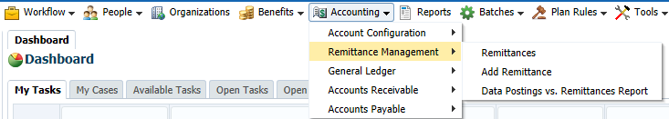

1. In the **Add Remittance** section enter the following then click **Save**:

* **Plan -** PEPP
* **Received From -** StakeholderID or Stakeholder Name the cheque is for
* **Remittance Amount –** amount received
* **Receipt Date –** date the cheque was received at PEBA and deposited in the bank
* **Remittance Type -** cheque
* **Cheque Number –** number on the cheque
* **Note –** any note that might be required

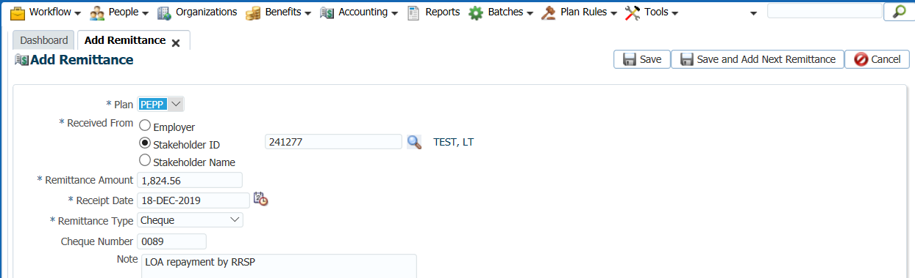

1. A new **Remittance** is created and a **Remittance ID** number generated. The **Remittance ID** number will be entered in the Data Posting Batches, Leave of Absence Repayment Through RRSP File that is created by the PLANet file submission.

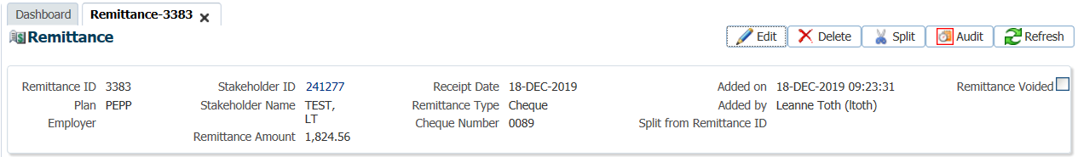

1. Record the **Remittance ID Number** on the *Member Contribution Batch Card.* Assign a Case for processing of the contribution to the member.
   * **Note:** Once a remittance record is created it cannot be deleted. The user is restricted from editing **Remittance ID**, **Receipt Date** and **Remittance Amount** due to accounting implications in the General Ledger. If the remittance was added in error but not linked to a deposit it can be **Voided**. ***Refer to procedures under Contribution Payroll Processing for Voiding a Remittance ID.***

Proceed to the PLANet application to import and validate the electronic file. See steps below.

## Leave of Absence Does Not Contribute

## Viewing Unit Values in PENFAX

Unit values will fluctuate with the investment markets, based on the market value of the investments within each fund. Each fund is valued individually. An increase or decrease in the unit value will not cause a change in the number of units in a member’s account.

Every business day, a unit value will be updated in PENFAX for every active PEPP fund. The value of each PEPP fund is determined after the close of financial markets each day. Unit values are determined and declared by PEBA’s Investment Services team following the close of business each day, normally between 5 pm and 8 pm Saskatchewan time. PEBA’s Investment Services team provides a file named **frate.dat** from their investment system with unit values for each PEPP fund with the current effective date. The file is then loaded into the PENFAX system using the Declaration of Unit Values batch process.

All unit values are recorded to six decimal places throughout the system. The unit values in PENFAX are consistent with the unit values published on the public website, on member statements, and member web applications. Once the unit values are declared and updated on the system, all pending transactions for that date will be processed and completed based on the unit value for that date.

#### How to View the Unit Values in PENFAX

The current unit values and the historical unit values for all PEPP funds are viewed on the **DC Fund Management** screen.

1. From the **Main Menu**, click **Plan Rules**, then **DC Fund Management.**

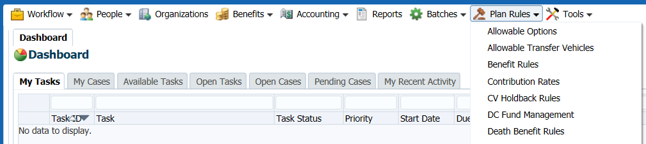

1. In the **DC Fund Management** screen, the top section under **Funds** shows a list of all PEPP funds that are open or closed and the current unit value by fund. You can search from the **Fund** drop-down list to locate a specific fund or status. Data from this region can also be export to Excel using the **Export** option.

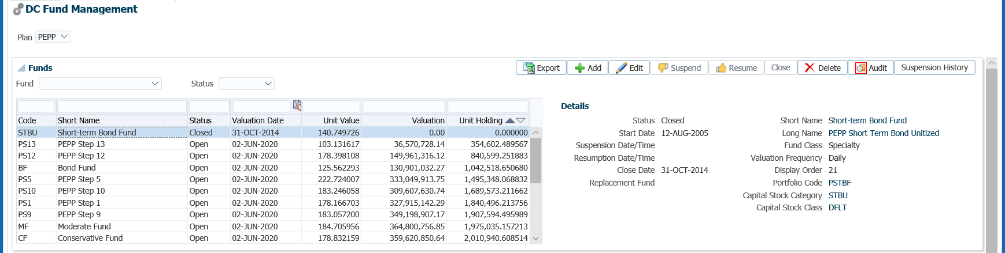

1. In the **Fund Transaction History** region you can search for historical unit values and fund transaction history by **Fund, Fund Transaction Type, Transaction Date, Fund Transaction ID** or by **Stakeholder**. Enter in the search criteria and click **Search.**

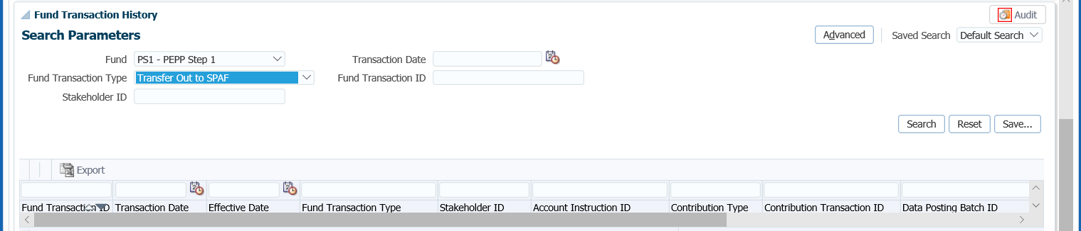

1. In the **Fund Unit Values** region will display the current unit value for each PEPP Fund as well allows you to search by **Fund** to see historical unit values for the fund. The **Export** option allows you to export the data to Excel.

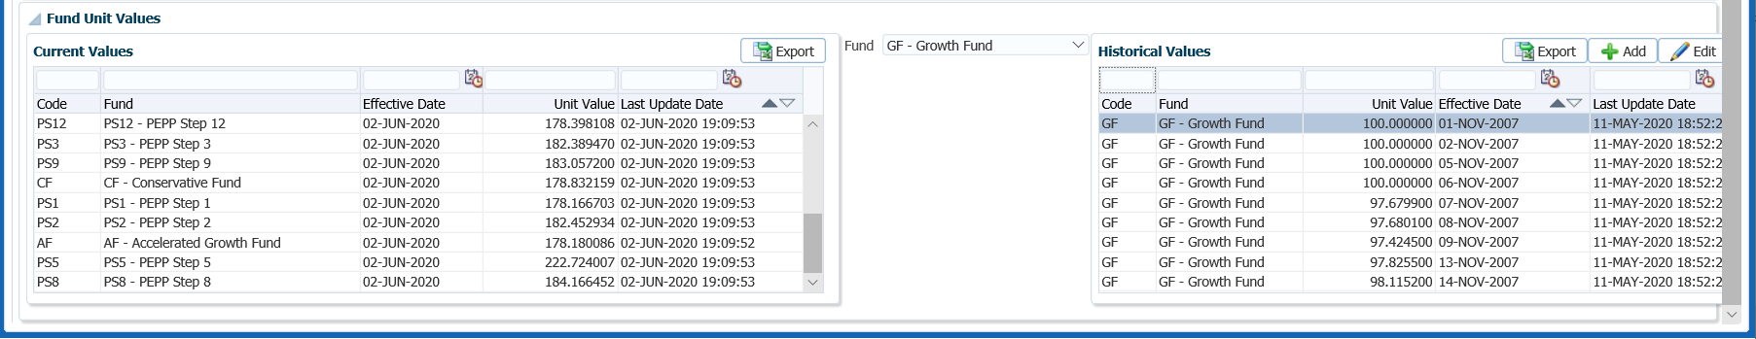

# Termination of Employment

A notice of termination is to be submitted by the PEPP employer through the Employer PLANet. In the event that PEPP is required to enter a *Notice of Termination* form, a Termination file is to be created in PLANet. ***Refer to the Termination procedure steps in the PLANet PEPP Administrator Guide.***

# Retirement Estimate

PEPP or Variable Pension Benefit members may request an estimate of their pension to assist them with determining the appropriate retirement option for them. PEPP offers the Variable Pension Benefit (VPB) or the Saskatchewan Pension Annuity Fund (SPAF), a life annuity. Members may elect one of these retirement income options or a combination of the two. Members may also transfer to an outside life annuity or a prescribed Registered Retirement Fund (pRRIF) with an outside financial institution.

An equity projection is used to project a member’s future contributions (employer required, employee required, voluntary contributions and lump sum transfers in) to determine the approximate value of their pension at a retirement date using a projected rate of return.

PEPP will provide members with a SPAF Annuity estimate and a VPB Illustration upon request.

**Business Process & Requirements for a Retirement Estimate**

* Members considering retirement should contact PEPP at least one year to 6 months prior to retirement to request a retirement estimate.
* Members nearing their retirement date within 1 to 3 months should contact PEPP again to request another retirement estimate or inquire as to what forms are necessary for the retirement option they have chosen.
* When a member calls PEPP for a retirement estimate, complete the Annuity Estimate calc. sheet in full. Obtain the following information to process the retirement estimate:
  + - * Member number
      * Member’s date of birth
      * Address
      * Phone number
      * Spouse’s name
      * Spouse’s date of birth
      * Termination date
      * Retirement date
      * Any additional amounts transferring in

## Annuity Estimate

Annuity estimates are calculated using the current weekly annuity rates and the most recent fund rates of return. PENFAX allows for these rates to be overridden by a user if different values are requested to be used. Annuity estimates use unisex mortality tables.

PENFAX automatically pulls in the current account balance for a member but allows for the account balance to be overridden to a new value if a member is wanting to transferring additional monies prior to the retirement date.

The annuity estimate will provide both single and joint (if member’s marital status is married or common-law) life annuity options, along with all guarantee periods (life only, 5 year, 10 year, and 15 year) and survivor options (60%, 66.6%, 75% and 100%). The annuity estimate will show the monthly pension payable for the member’s lifetime, and the monthly survivor benefit payable, following the expiry of any guarantee period.

#### How to Process an Annuity Estimate

1. Search for the member in PENFAX.
2. Under the **Navigation** menu, **Member Profile** area, select **DC Benefit Calculation**.

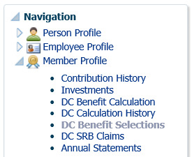

1. In **the DC Benefit Calculation: Input Data Train**, enter in the following information and click **Calculate** after the information has been entered:

* **Termination Date**
* **Retirement Date**
* **Spouse’s Date of Birth** (if not captured on PENFAX)
* **Marital Status** (if not captured on PENFAX)
* **Override Account Balance** (if member is transferring in funds or if still actively contributing)
* **Assumed Rate of Return** (if member a different value)
* **Interest Rate Type – Override Value** (if member wants different rates used)

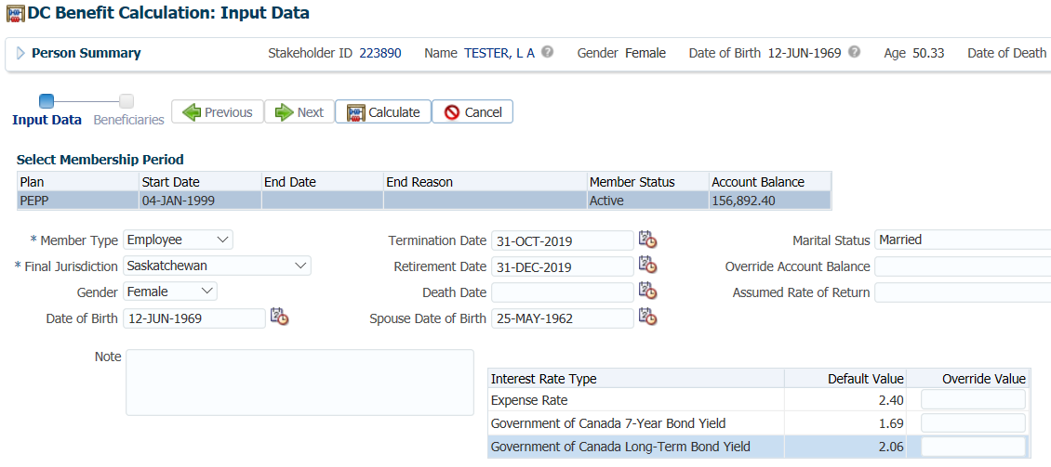

1. If the member is still actively contribution to PEPP, the calculation to determine the account balance to use needs to be first performed on Retire@ease. The amount calculated is then input in the **DC Benefit Calculation** screen and entered in the **Override Account Balance** field. ***Refer to the procedures for VPB Illustration***.
2. The Annuity Options will be calculated and display in the **DC Benefit Options** region under the **Account Balances** tab.

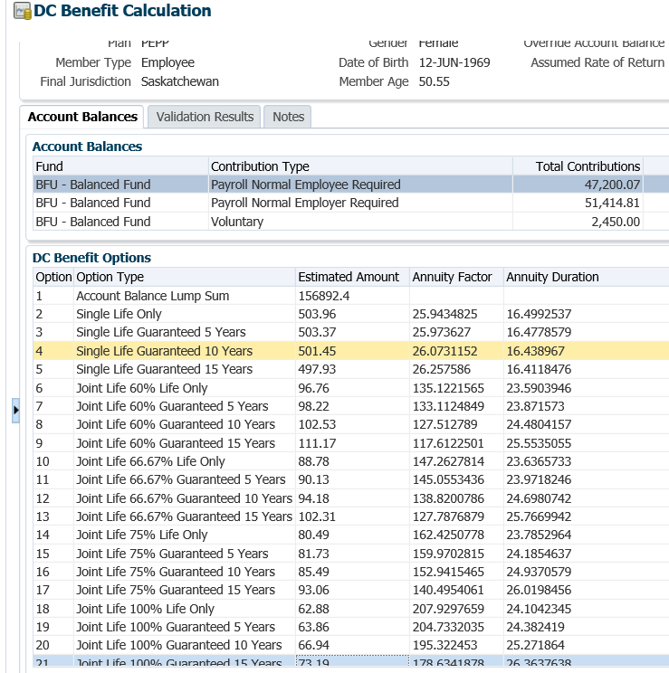

1. The PEPP Retirement Option Letter is available for viewing by clicking on the **hyperlink** under **Reporting**. The letter will print in the overnight batch.

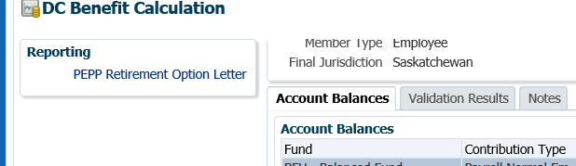

* **NOTE:** The PEPP Retirement Option Letter will be saved to the member’s account and can be found under the **Navigation** menus, **Communication** section under **Outbound Documents**. Click on the **Filename** **hyperlink** to open the document.

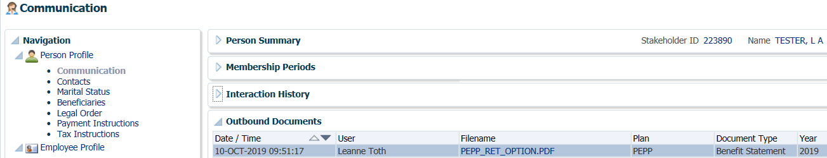

## VPB Illustration

Along with the Annuity estimate, members will receive a Retire@Ease Illustration that will show the estimated age the money will last the member to if the Variable Pension Benefit (VPB) retirement option is chosen using the PEPP Guidance Option.

#### How to Produce a VPB Illustration in Retire@Ease

1. Log-in to Retire@Ease from the link found underPEBAnet under PEPP Links.

<https://www.retireatease.ca/peba/LoginAdmin.aspx>

Administrator ID: HELPDESK

Password: 68193573902

1. Click “**Impersonate User**”.

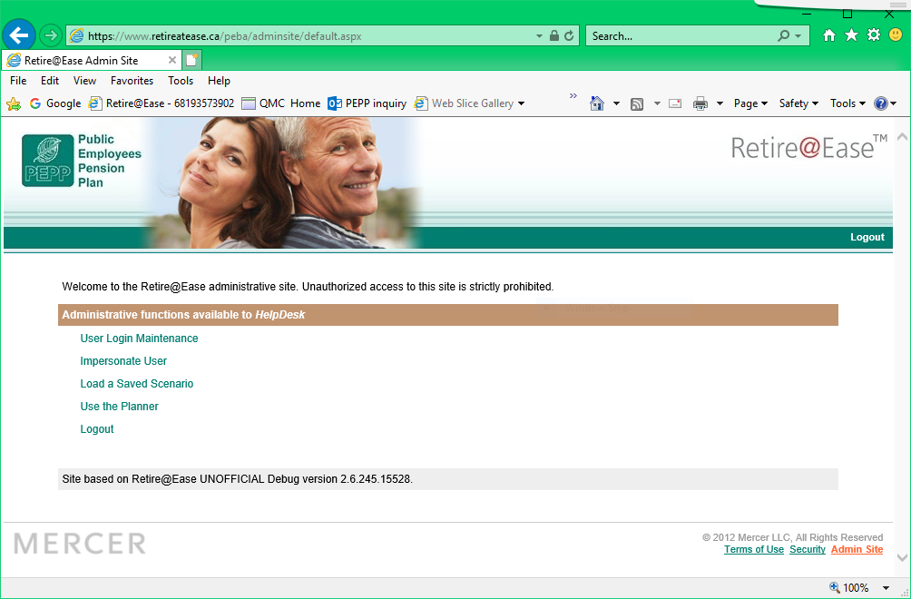

1. Enter the member number, click “**Get User Info**”, click “**Impersonate User**”.

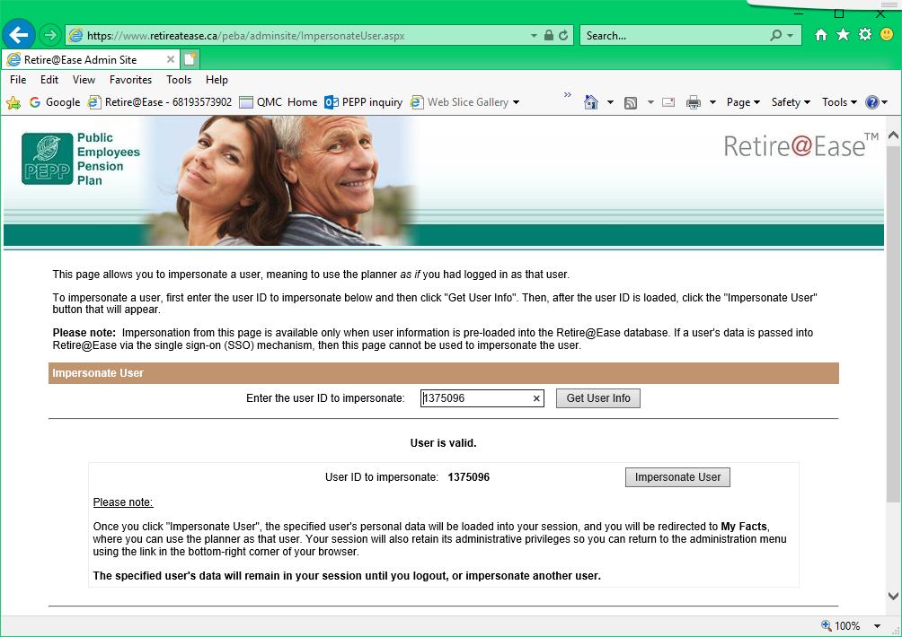

1. Click “**Let’s Get Started**”.

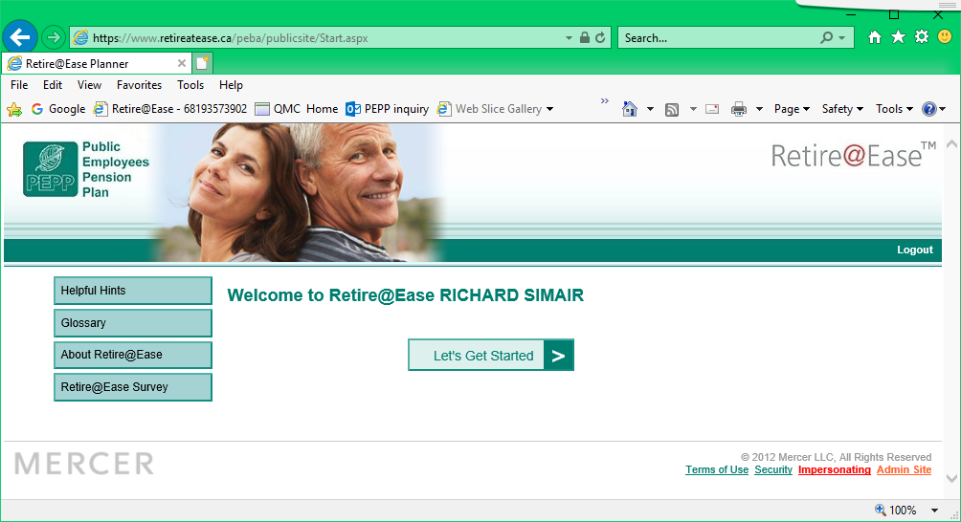

1. On the **Personal Data** page, change “**Current Retirement Status**” to “**Retired**”.

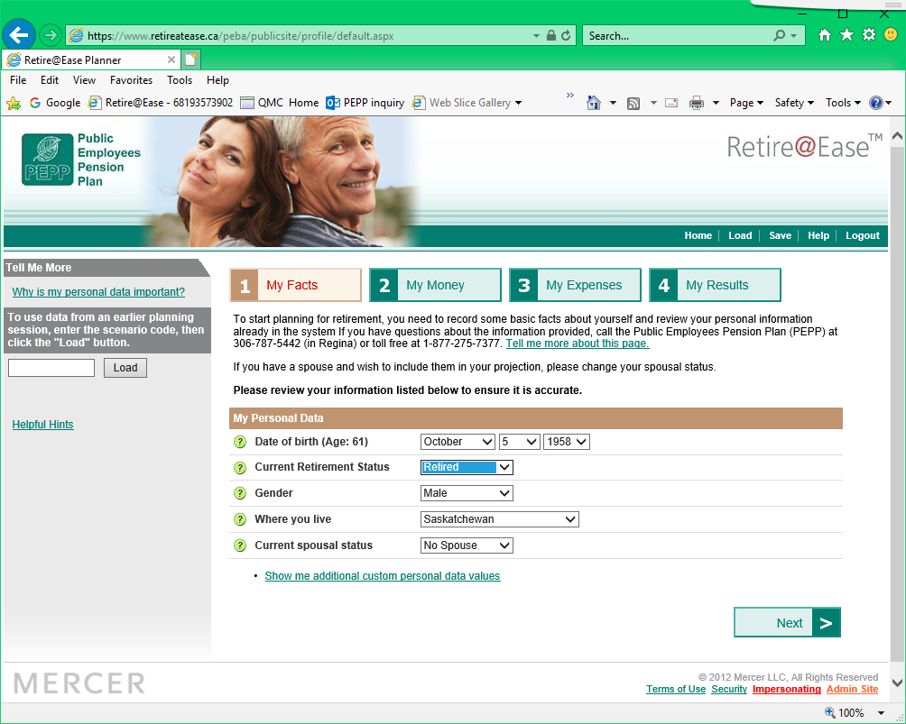

1. Click the “**My Money**” tab, then “**Revise**” for PEPP Account.

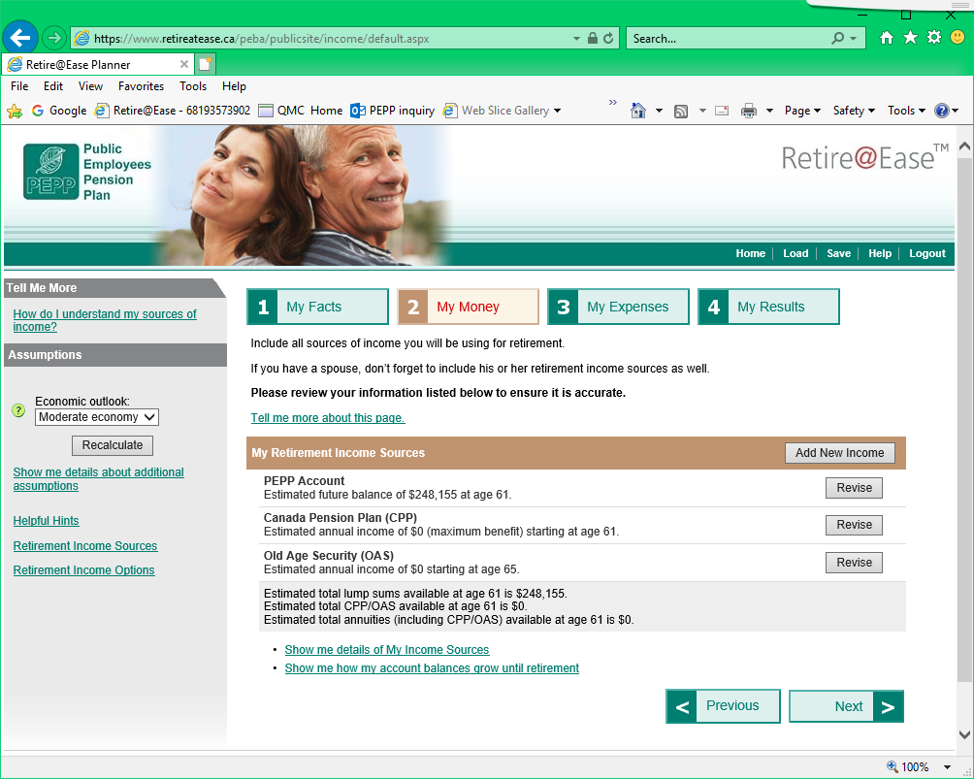

1. Select “**PEPP Guidance**”, click “**Save**”.

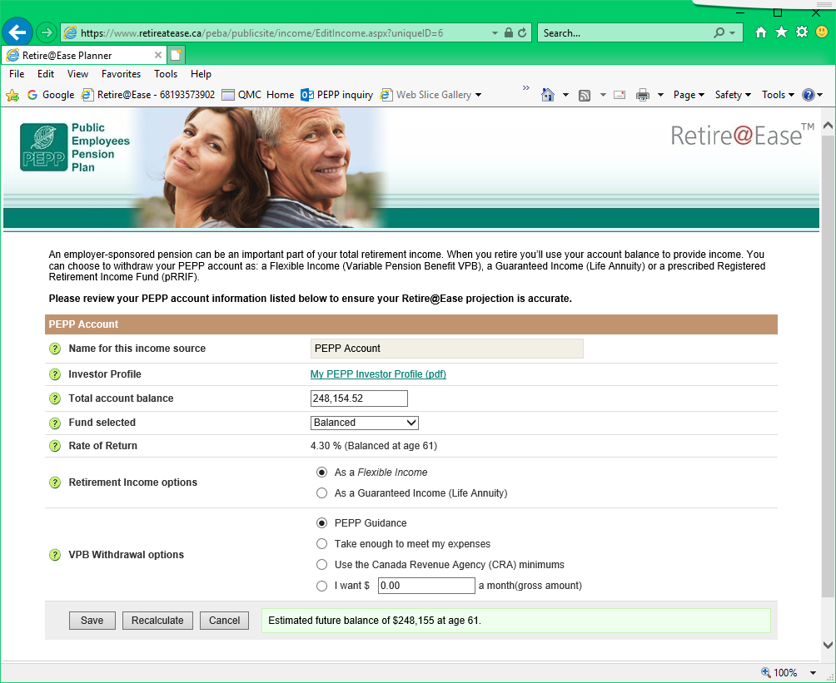

1. Click the “**My Results**” tab, click “**print a comprehensive report**”.

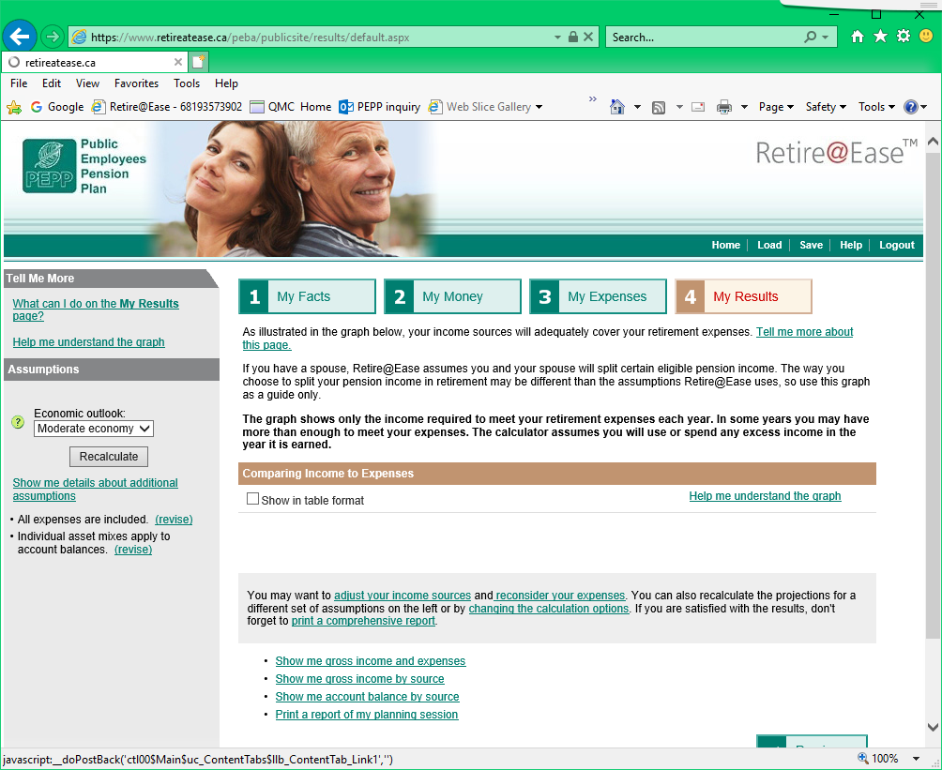

1. Under “**My Results**”, click the last 3 boxes, click “**Create My Report**”**.**

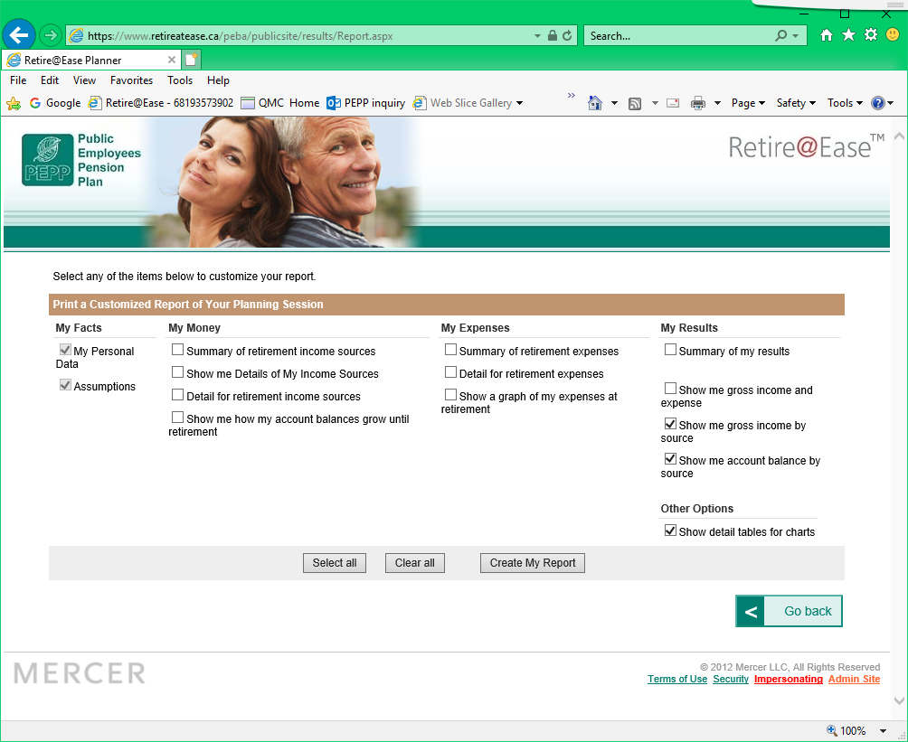

1. Click “**Print this report”**.

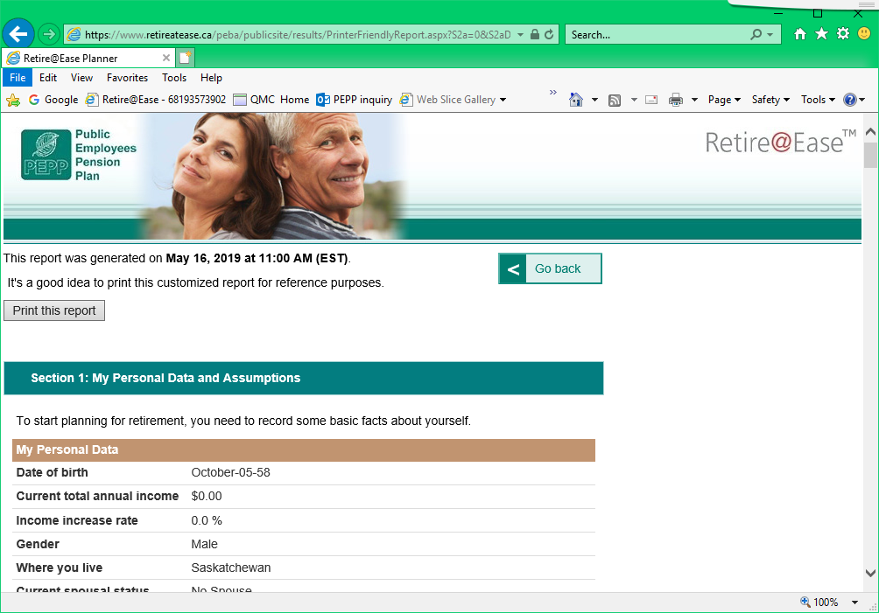

1. Click **Preferences**.

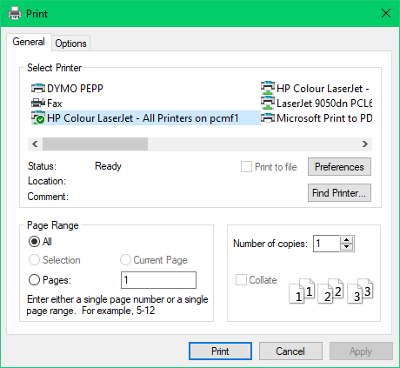

1. Select the “**Finishing**” tab, select “**Print on both sides**”. Click “**Ok**”.

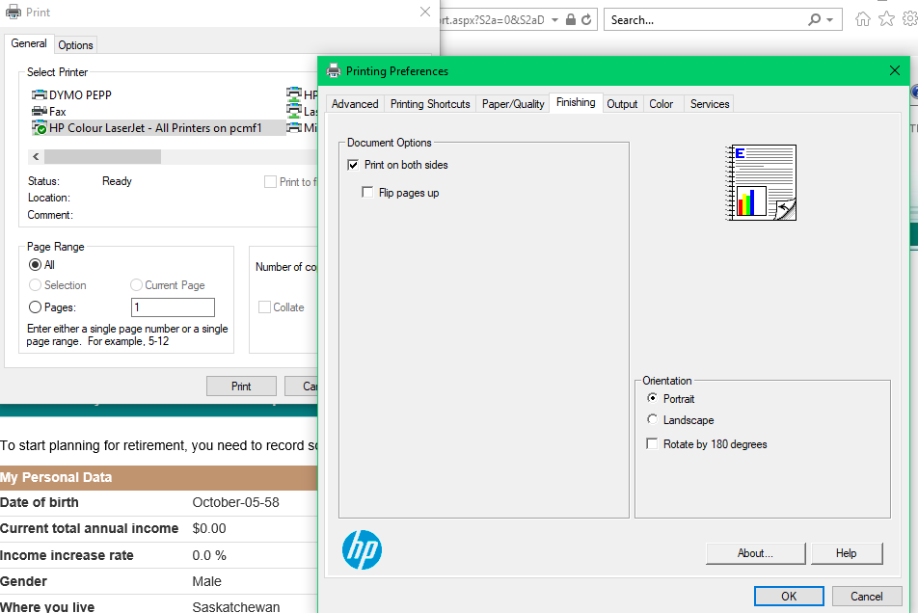

1. Click “**Print**”.

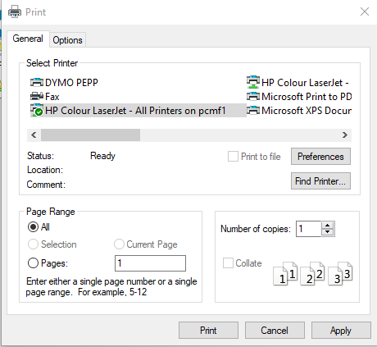

## Retirement Estimate Letter Procedures

1. Collect the Annuity Estimate letter that will print in the overnight batch.
2. Create and print the “Your VPB Estimate” in Retire@Ease (see **Procedures for How to Produce a VPB Illustration in Retire@Ease**). Ensure the print output takes up the whole page and is easy to read, not small and only about 1/3 of the page.
3. Highlight the member’s name on page 1 of the VPB Illustration.
4. Create a label with the member’s name and address if necessary.
5. Have the Annuity estimate and VPB Illustration from Retire@Ease audited.
6. Once the audit has been done, place the Annuity Estimate and VPB illustration on the right side of a Retiring with PEPP folder.
7. Give the Retiring with PEPP folder to the Operations Support Coordinator unit to review and mail.

## Weekly Annuity Rate

The weekly annuity rate is determined each Monday from the published Interest rates on the Bank of Canada website. The interest rate information is provided to the PEBA Quality Assurance area who will then update the PENFAX system with the current rates used in determining Annuity Quotes for retirement projections.

#### Weekly Annuity Rate Procedures

1. First find rates. To do so, go to: <https://www.bankofcanada.ca/rates/interest-rates/lookup-bond-yields/?page_moved=1>

* From there, select “Quick Date”.
* Scroll down and check “Daily 7 Year (V39054)” and “Daily Long-term (V39056)”.
* Click Submit and PRINT the page.

1. Open the H Drive go to:

* Pension Programs/PEPP/Templates and Forms/Retirement

1. In the Retirement folder, find “Annuity Rate Change”.

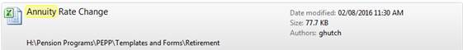

* + Enter the date and rates for the V39054 and V39056. The rest will calculate on their own.
  + Print the selection for the page, then save the document.

1. In the Retirement folder, find “Annuity Rate PENFAX Table Update Form”.

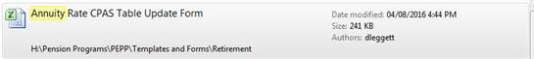

* + Enter the date and rates again in the yellow highlighted boxes. The other pages should update automatically.
  + Print, and save.
  + Sign + date on page 3 of this document.

1. Arrange the order of the printed pages as follows and paper clip them together:
   * Annuity Rate PENFAX Table Update Form (TOP.)
   * Rate Page from the Internet.
   * Annuity Rate Change Table (BOTTOM).
2. Once QA has entered the interest rates in PENFAX, a copy will be provided to the PEPP *Supervisor* to audit on PENFAX and sign off on “Annuity Rate PENFAX Table Update Form”.
3. The annuity rates in PENFAX are found under, **Plan Rules**, **Interest Rates**.

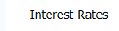

1. In the **Interest Rates** screen select the **Plan** as **PEPP** and the **Interest Rate Type** of **Government of Canada 7-Year Bond Yield** and then **Government of Canada Long-Term Bond Yield**. Verify the information is correct for each type in the **Interest Rates** region.

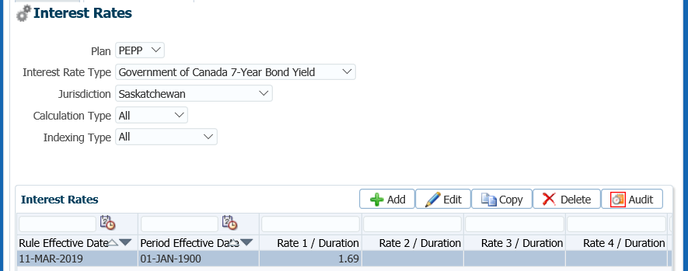

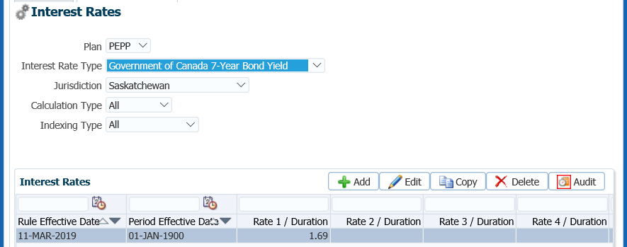

# Payment Processing

All payment processing for inactive PEPP members are process through the PENFAX **DC Benefit Selections** screen. The **DC Benefit Selections** follows the same process for all types of payments, such as Termination, Retirement, Death and any other deferred payment options.

The payment process navigates you through a series of screens in the **DC Benefit Selection** train in which the allocation instructions, payment instructions and applicable income tax instructions are selected for the type of payment.

Follow each step in the **DC Benefit Selection** train by entering the required information and click the **Next** button to advance to the next step in the process. If there was an error or a step was missed, click the **Previous** button to go back to the prior step. If you do not want to proceed with the process, select the **Cancel** button which closes the tab and nothing will be saved.

The **DC Benefit Selection** **Train** will guide the user through the various steps of withdrawing funds, including:

* *Select Investment Account:* A list of investment accounts (PEPP or VPB) for the member will be displayed. The user will select the investment account for which funds are to be distributed. Clicking the Add button will launch the train and the first step will be to review the input data.
* *Input Data:* Review of key data required for determining a member's eligibility for benefits from an accumulation account. The next step will be to review the account balance and then to initiate the fund allocations.
* *Allocations*: A summary of the account balance as of the valuation date is provided. The region below allows the user to add new account instruction allocations for the transfer of funds from the member’s account.
* *Confirm Distributions*: A summary of account distributions is provided on the final train. The user will view and confirm the details of the allocations.

 • *Update of payment instructions*: A summary of existing payment instructions will be included. The user selects from existing payment instructions or will enter new instructions for payments to the member, an alternate party or a financial institution at the time of processing the payment.

• *Update of tax instructions*: As part of the process of setting up the receipt of payments, the member may have specific instructions on the amount of income tax to be deducted from their payment. The user will be able to add these instructions to the system prior to processing the payment or at the time of processing a specific payment type.

• *Approve DC benefit selections*: Once the details of the DC benefit selection are confirmed, the final step in the process is for the user to approve the DC benefit selection using the **Approve** button. A  **Reject** button is also available to allow the user to reject the benefit selection if any errors are found with the selections or the payment was processed in error.

* + The **Reject** button is only enabled if the status of the payment is **Pending Approval** or **Approved**, which will update the status to **Rejected** when clicked and prevent the benefit selection from being processed by the investment batch.
  + If the payment is **Rejected** the payment steps are required to be entered again. There is no option of editing existing information.
  + The **Undo** button is enabled if the status of the payment is **Processed**. The status of the payment will update to **Pending Undo**, and will then update to **Undone** as a result of processing the reversal in the investment batch.
  + A history of Transactions, User and Event is shown under the **Audit** button.



## Small Pension Payment

A Small Pension Payment is allowed to be taken when a member’s account balance as of the date of payment is below a dollar minimum (20% of the Yearly Maximum Pensionable Earnings or YMPE, as determined by the Canada Pension Plan) or if the member is age 50 or over and the annual pension is less than 4% of the YMPE.

Small Pension Payment options available to the member will depend on the following:

* The vesting status of the member’s PEPP funds,
* The member’s age, and the jurisdiction of the locked-in money within the member’s PEPP account.

If the member qualifies for a Small Pension Payment, they can choose from one of the two options:

* Transfer the pension to an RRSP as unlocked, or
* Receive a lump sum cash refund (less withholding tax), a T4A slip is issued.

**Business Process Requirements - Small Pension Payment**

* A member must be terminated from all PEPP participating employers (all employment records show terminated or retired status).
* The member’s Plan status must be Deferred.
* Ensure the final contribution has been received. If the final contribution has not been received, contact the member to find out if they want to proceed without it or wait to have the transfer processed after it has been is received.
* Members must provide a signed *Application for Small Pension Payment* form if requesting a cash payment. A copy is acceptable.
* Members must provide a signed Canada Revenue Agency T2151 form indicating the receiving institutions name and plan type if transferring to an RRSP. A copy is acceptable.
* Verify the member’s SIN on the *Application for Small Pension Payment* form or T2151 form to the SIN on the PENFAX account to ensure it matches.
* Determine if identification from the member is required**. *Refer to the procedures,******When is Identification required from a Member****.*
* Small pension payments transferred to an RRSP, must be 100% of the account balance.
* A partial payment for a member who is over age 50 must go to a LIRA, it cannot go to an RRSP as a partial amount.
* If a member holds a PEPP and a VPB account, both account balances are combined when determining if a member qualifies for a Small Pension Payment.
* If any information is missing on the form follow up with the member. ***Refer to******Procedures to Obtain Missing Information****.*

#### How to Process a Small Pension Payment

1. Search for the member in PENFAX.
2. Verify that all required documents and forms have been received, signed and certified if required and that the option chosen by the member is allowed as per the business process requirements for a small pension payment.
3. Check the **Employee Profile** menu to ensure the termination information has been received and entered into PENFAX. Under the **Membership Periods** region ensure the **Member Status** is showing as **Deferred**.

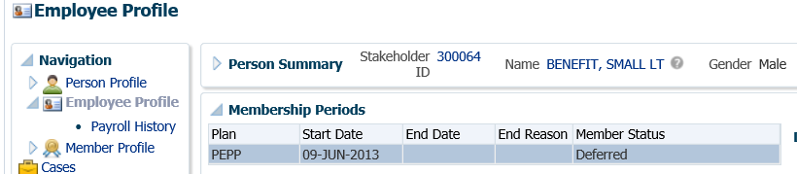

1. Under the **Employee Profile** menu, **Employment Periods** region confirm the following information has been entered:

* **End Date**
* **End Reason** is Terminated or Retired
* **Final Jurisdiction**

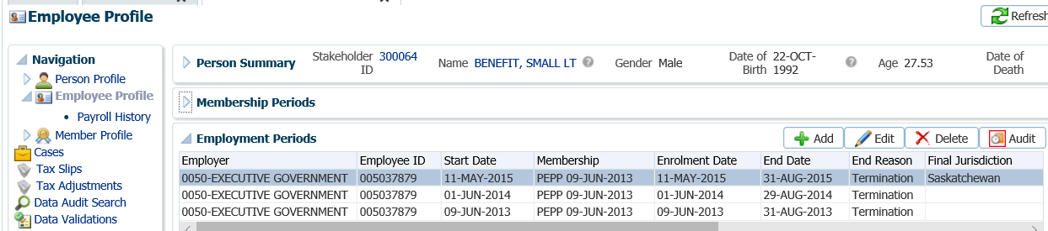

1. Under the **Employee Profile** menu, **Payroll History** region, determine if the final contribution has been received. Expand the **Payroll History** region to see the list of payroll contributions.

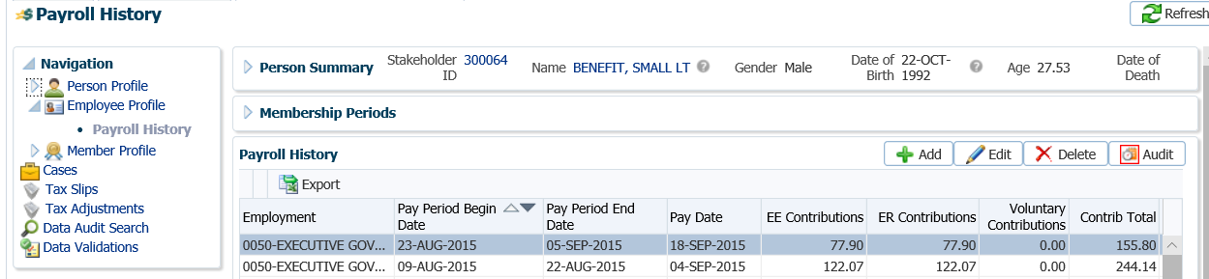

* **NOTE:** If the final contribution has not been received, contact the member to find out if they want to proceed without it or wait to have the transfer processed after it has been received. If the member wants to wait, suspend your assigned Case.

1. Under the **Member Profile** menu, click on the **DC Benefit Selections** screen. Click **Add** to add a new payment.

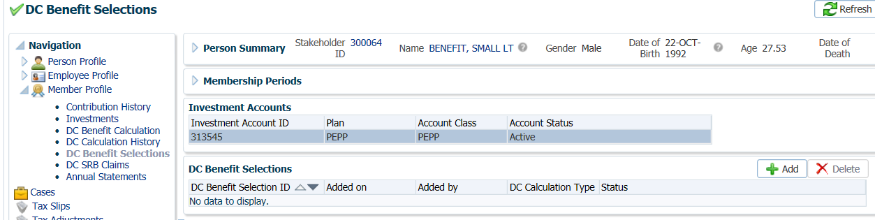

1. In the **Input Data** train, click **Next** to start the **Input Data** process.

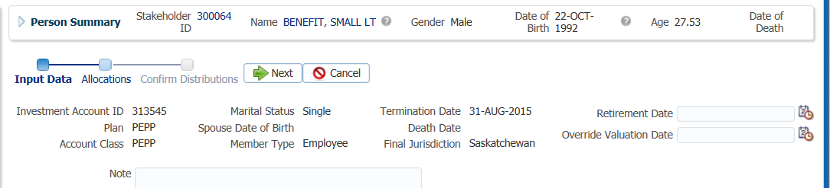

1. In the **Input Data** train under the **Allocations** region click **Add**.

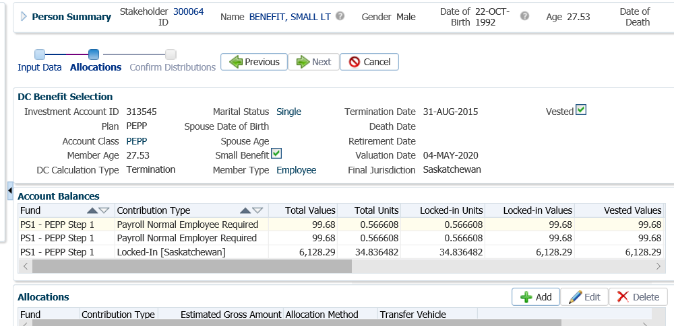

1. In the **Allocation** pop-up window, enter the following information, then click **Save:**

* **Fund** – leave blank if the entire account balance is to be transferred
* **Contribution Type** – leave blank so that all funds and all sources will be transferred
* **Allocation Method** – Percent if taking 100% out, or Gross Amount if only transferring a partial amount
* **Percent/Gross Amount** – 100% or a specific gross amount
* **Transfer Vehicle** – Cash
* **Estimated Gross Amount –** the amount will automatically populate based on the percent/gross amount, fund(s) and contribution source(s) selected

***Cash Example:*** *(for RRSP example, see Step 14)*

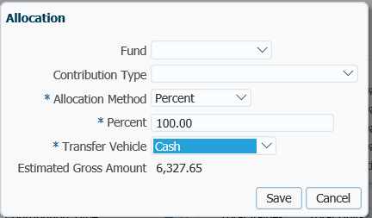

1. In the **Input Data** **train** click **Next** to Confirm the Distributions of the payment.

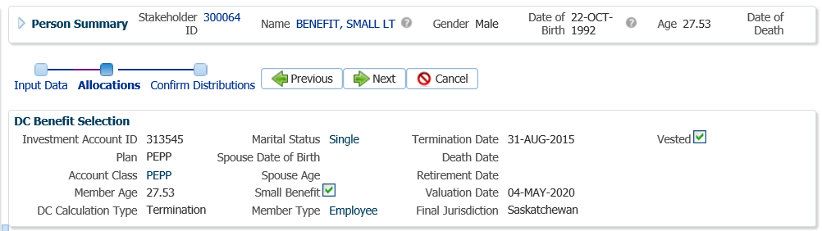

1. In the **Onetime Amounts** region under the **Payment Instruction** column, click on the drop-down list. If no information is displayed click on the **Add New** option to add the payee.

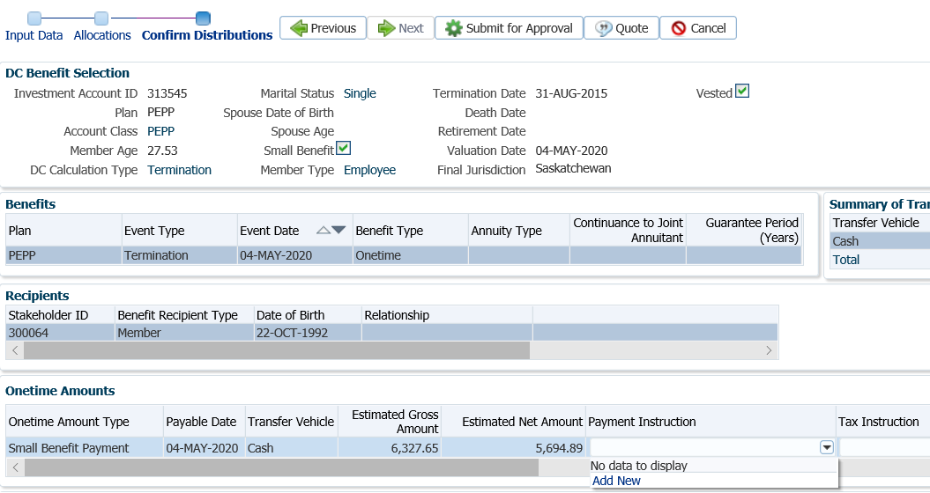

* **NOTE:** if the same payee type was previously added in the **Payment Instructions** screen under the **Person Profile**, the information will be displayed in the drop-down list under **Payment Instructions** and can be selected for the payment.

1. In the **Payment Instruction** pop-up window, select the following and click **Save**:
   * **Payee Type** – Self (for Cash payments)
   * **Payment Method** – Cheque
   * **Receipt Date** – leave as current date
   * **Expiry Date** – date that the banking instructions are valid for EFTs
   * **Payment Note** ­– used to add a note to the payment documentation (cheque or EFT receipt)
   * **Hold for Pickup ­**– checked if the member would like to pickup the cheque (will be displayed under the member’s Payment Instructionsscreen)
   * **Note** – additional notes pertaining to the payment, will appear under Person Profile Notes.
   * **Payee Name** – will default to member’s name, can be overridden in Override Payee Name field.
   * **Override Payee Name** - used to set up a payment to an alternate payee name such as a guardian or trustee, “In trust for” or “Estate of”.
   * **Address Type** – defaults to the member’s primary address on record, if another address exists on file it can be selected from the drop-down list.

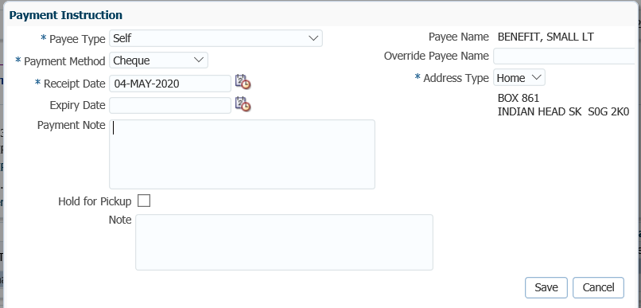

* **NOTE:** In order to determine if an alternate **payee name** has been entered, the auditor of the payment has to click on the **Payment Instructions** tab to determine if there is a different payee name listed. If an Account ID is not provided on the T2151 form, enter the member’s SIN.

1. **Tax Instructions** are not required to be added for cash payments. PENFAX will determine if tax is required to be deducted by the Transfer Vehicle chosen in the Allocation step and apply the appropriate tax rate of 10%, 20% or 30%.

***RRSP Example:***

1. In the **Allocation** pop-up window, enter the following information, then click **Save:**

* **Fund** – leave blank if the entire account balance is to be transferred
* **Contribution Type** – leave blank so that all funds and all sources will be transferred
* **Allocation Method** – Percent if taking 100% out, or Gross Amount if only transferring a partial amount
* **Percent/Gross Amount** – 100% or a specific gross amount
* **Transfer Vehicle** – RRSP
* **Estimated Gross Amount –** will populate with the gross amount by fund and contribution source

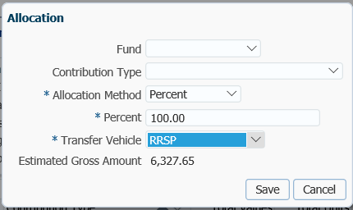

1. In the **Input Data Train** click **Next** to Confirm the Distributions of the payment.

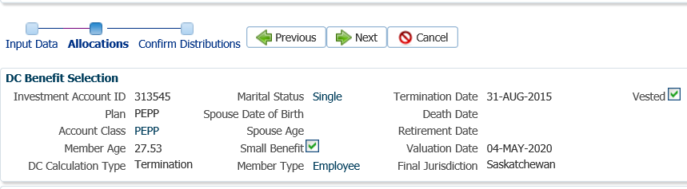

1. In the **Onetime Amounts** region under the **Payment Instruction** column, click on the drop-down list. If no information is displayed click on the **Add New** option to add the payee.

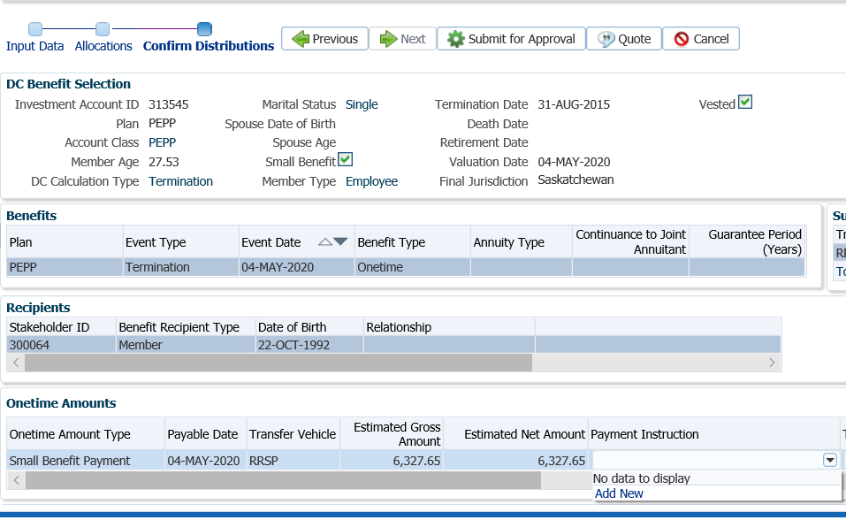

* **NOTE:** if the same payee type was previously added in the **Payment Instructions** screen under the **Person Profile**, the information will be displayed in the drop-down list under **Payment Instructions** and can be selected for the payment.

1. In the **Payment Instruction** pop-up window, select the following and click **Save**:

* **Payee Type** – Qualified Financial Institution (for registered transfer payments)
* **Payment Method** – Cheque
* **Receipt Date** – leave as current date
* **Expiry Date** – date that the banking instructions are valid for
* **Payment Note** ­– used to add a note to the payment documentation (cheque or EFT receipt)
* **Hold for Pickup ­**– checked if the member would like to pickup the cheque (will display under the member’s Payment Instructions screen)
* **Note** – additional notes pertaining to the payment, will appear under Person Profile Notes.
* **Payee Stakeholder ID** – if known enter the ID number, if unknown click on the **magnifying glass** to search for the financial institution under the Organizations menu.
* **Payee Name** – the Stakeholder name will populate when the Stakeholder ID is added
* **Overide Payee Name** – used when an alternate payee name such as “In Trust” or “Estate of” is required
* **Address Type** – defaults to the business address on record for the Qualified Financial Institution, if another address exists on file it can be selected from the drop-down list.

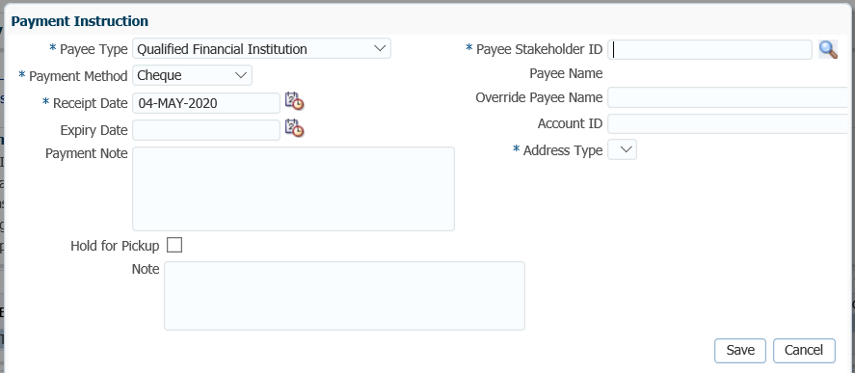

1. If the **Payee Stakeholder ID** was not known, locate the ID in the **Search and Select Organization** region, **Search Parameters** area. Click on the drop-down arrow beside **Organization Type,** select **Financial Institution.** Click **Search**.

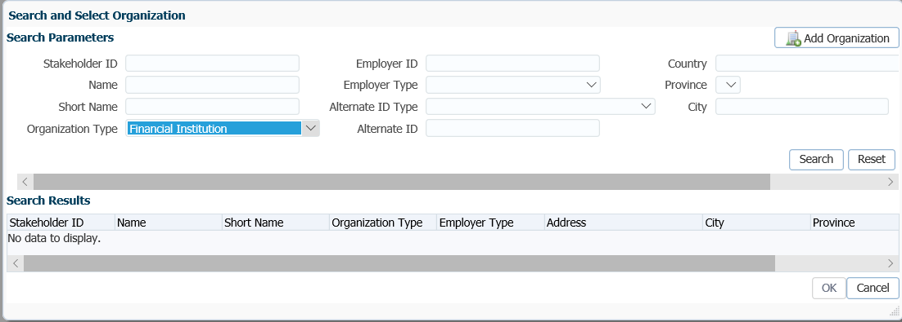

1. In the **Search Results** region, locate the correct financial institution, highlight the name and click **Ok**.

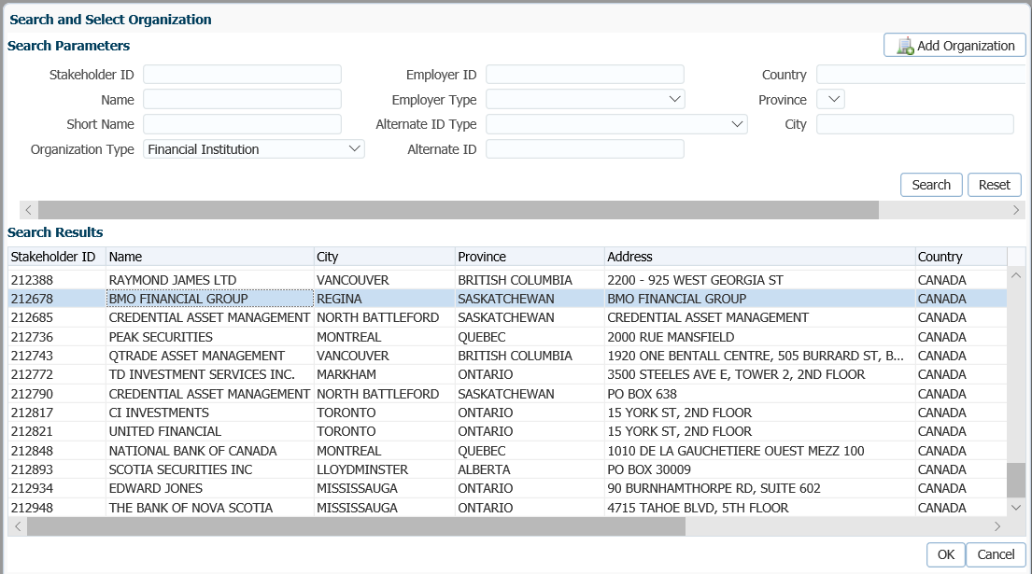

1. The **Payee Stakeholder ID**, the **Payee Name** and **Address** will now be populated in the **Payment Instructions** window. Add the **Account ID**. Click **Save.**

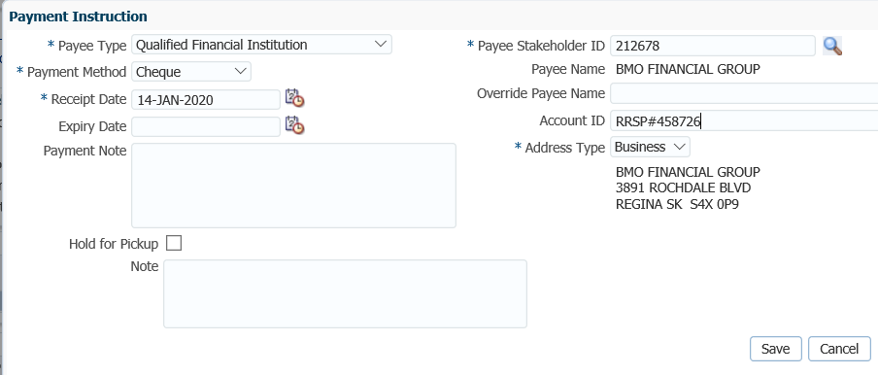

1. In the **Input Data** T**rain**, click **Submit for Approval**.

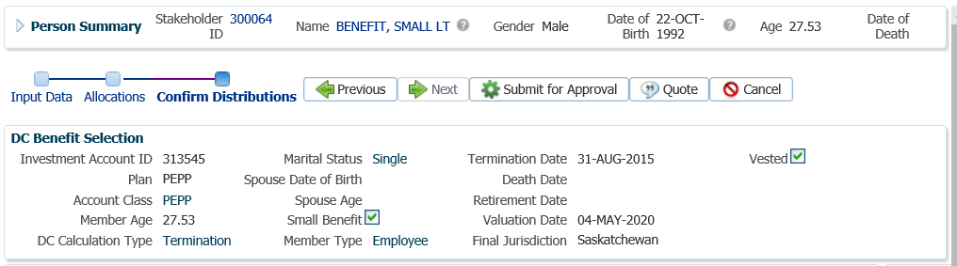

1. The *Pension Specialist* or *Supervisor* will audit and approve the payment in the **DC Benefit Selection** region by clicking **Approve**,or **Reject** if there were errors or the payment was done in error**.**

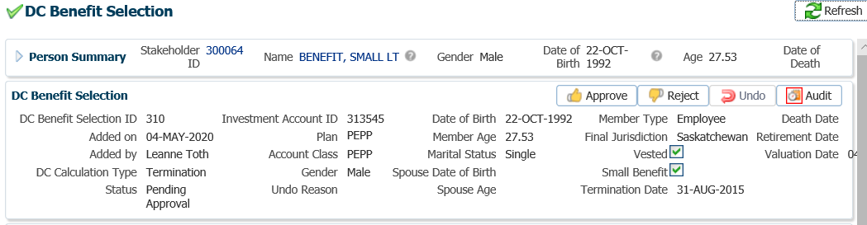

* **NOTE:** If the payment is **Rejected,** the payment steps will need to be entered again by the *Pension Information Officer*. There is no option to edit the existing information.

The **Reject** button is enabled if the status is **Pending Approval** or **Approved**. If the payment is rejected the status will update to **Rejected** when clicked and prevent the benefit selection from being processed by the investment batch.

The **Undo** button is enabled only if the status is **Processed** and will the reverse the payment in the investment batch.

1. In the **Approve DC Benefit Selection** window, add a **Note** and click **Save**. The **Status** will now show as Approved. Return the payment request to the *Pension Information Officer*.

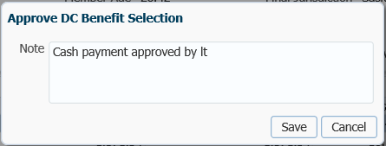

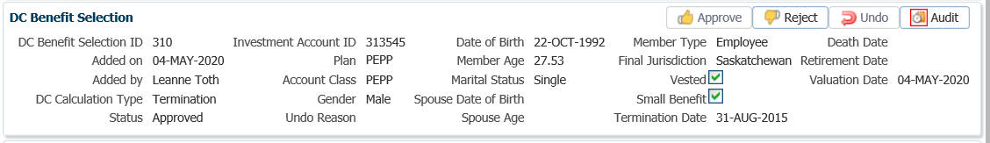

1. A history of Transactions, User and Event is shown under the **Audit** button.

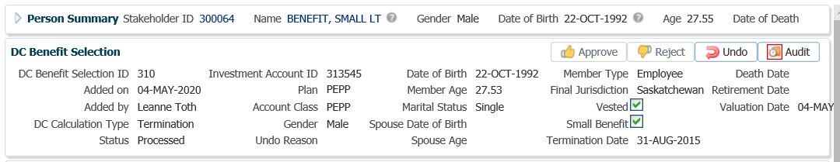

1. The payment will process in the overnight batch process and a cheque will be produced. The payment can be viewed under the **Benefit Recipient** Menu. Click on the **Onetime Amounts** tab, then **Paid by Payment Id** to see the details.

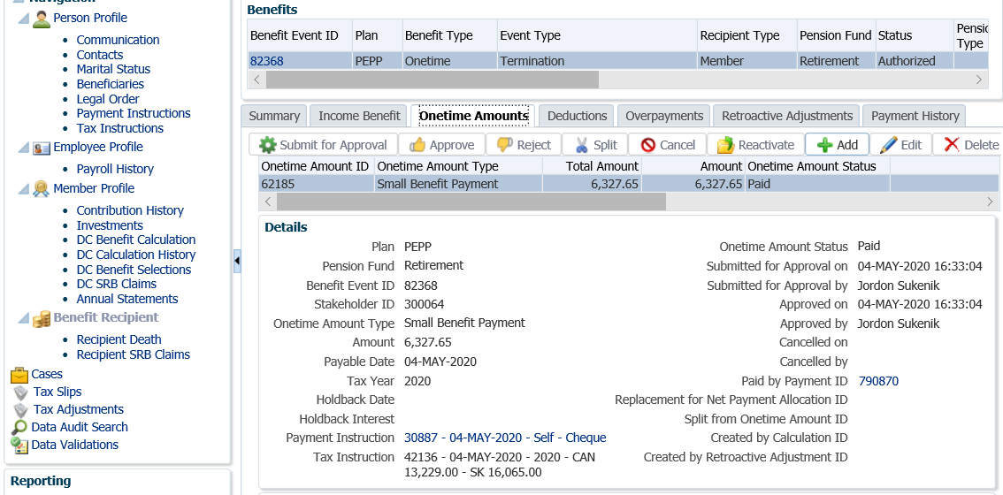

1. Click on the tabs to the right of the screen (**Line Items, Tax, Net Pay Allocation** and **Notes**) to see further details related to the payment.

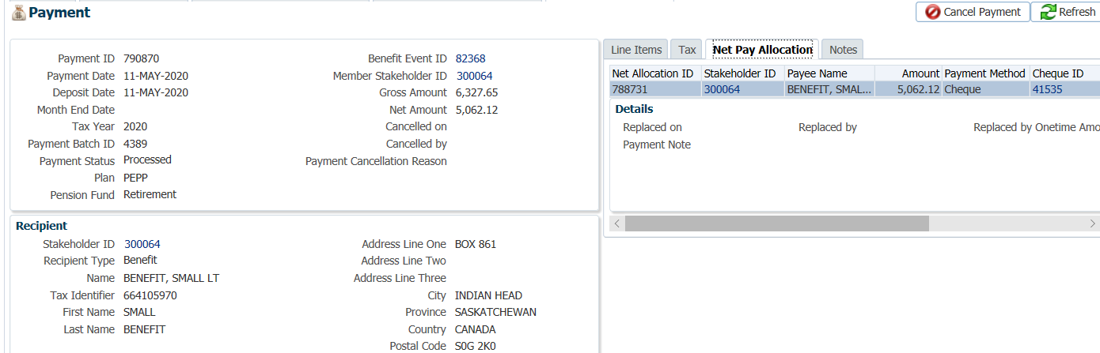

* **NOTE:** Click on the **X** in the **Payment ID Tab** to close the window.



1. A *Withdrawal Confirmation Letter* will produce overnight. The letter will be saved under the **Person Profile**, **Communications** screen underthe **Outbound Documents** region. Click on the **Filename hyperlink** to open the document.

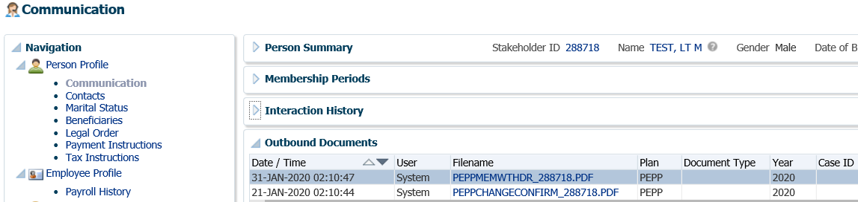

1. If the Small Pension Payment was taken in cash, a T4A **Tax Slip** will be issued at the end of the year and saved under the **Navigation** menu, **Tax Slips** screen.

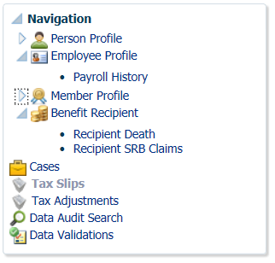

1. Under the **Member Profile** menu, the **Membership Periods** region will nowshow the **Member Status** as Terminated or Retired, depending on the age of the member, once the payment is processed overnight.

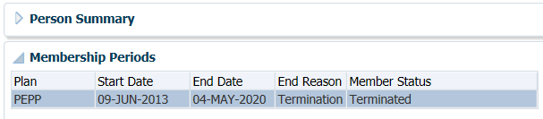

1. Under the **Member Profile** menu, **Investments** screen, the **Investment Accounts** region will now show the **Account Status** as Inactive and the balance under the **Account Summary** region will show $0.00 if all the money was requested to be paid out.

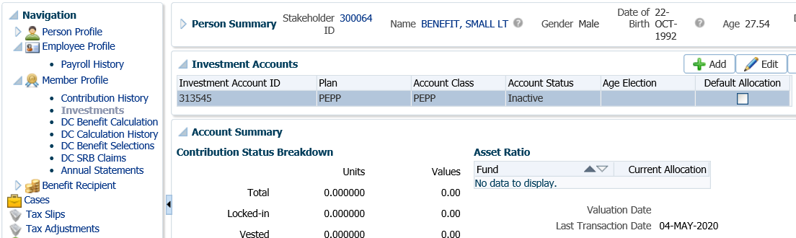

## Voluntary Contribution Payment

Members may request to withdraw their non-locked-in voluntary contributions/transfers upon termination of employment with all PEPP participating employers. Voluntary contributions can either be paid in cash (less withholding tax), or transferred to a RRSP. The remaining account balance, their locked-in portion can remain with PEPP.

**Business Process Requirements – Payment for Voluntary Funds**

* Member must be terminated from all PEPP participating employers (all employment records show terminated or retired status).
* The member’s Plan status must be Deferred.
* Ensure the final contribution has been received. If the final contribution has not been received, contact the member to find out if they want to proceed without it or wait to have the transfer processed after it has been is received.
* Members must provide the signed *Termination Option* form or the *Retirement Option* form or a written request to withdraw voluntary contributions in cash. A copy is acceptable.
* A signed Canada Revenue Agency T2151 form is required to transfer voluntary contributions to a RRSP as a tax-free rollover. A copy is acceptable. Ensure the receiving institutions name and plan type are on the form. Indicate on the form that $0.00 is locked-in.
* Verify the member’s SIN on the *Termination Option* form or the T2151 form to the SIN on the PENFAX account to ensure it matches.
* Determine if Identification is required from the member. ***Refer to the procedures, When is Identification Required from a Member.***
* If any information is missing on the form follow up with the member. ***Refer to******Procedures to Obtain Missing Information***.

#### How to Process a Voluntary Contribution Payment

#### Scenario: Cash Payment

1. Search for the member in PENFAX.
2. Verify that all required documents and forms have been received, signed and certified if required and that the option chosen by the member is allowed as per the business process requirements for a voluntary contribution payment.
3. Check the **Employee Profile** menu to ensure the termination information has been received and entered into PENFAX.

Under the **Membership Periods** region ensure the **Member Status** is showing as Deferred.

Under the **Employment Periods** region confirm the following information has been entered:

* **End Date**
* **End Reason** is Terminated or Retired
* **Final Jurisdiction**

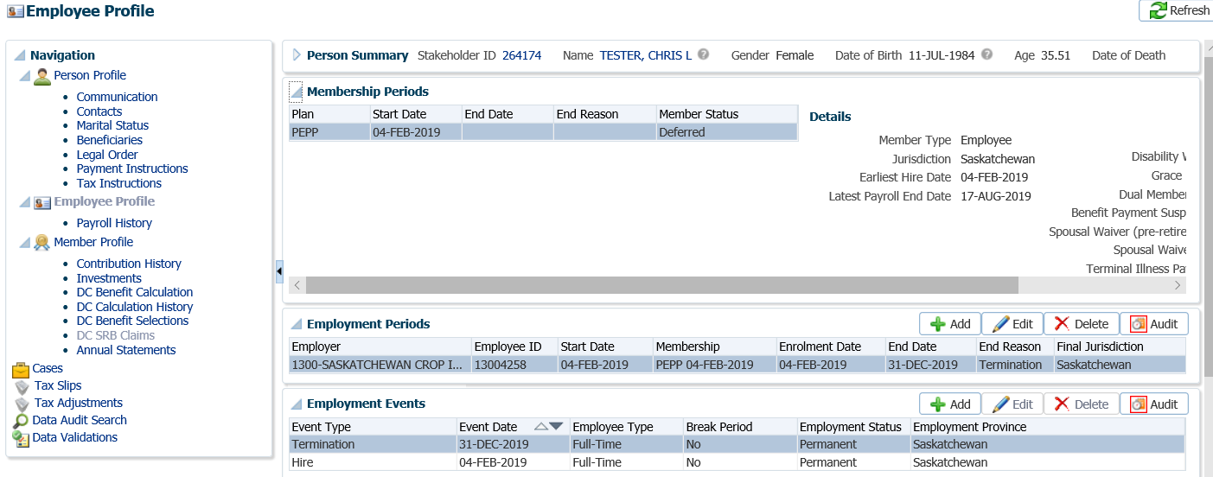

1. Under the **Employee Profile** menu, **Payroll History** screen, determine if the final contribution has been received. Expand the **Payroll History** region to see the payroll contributions.

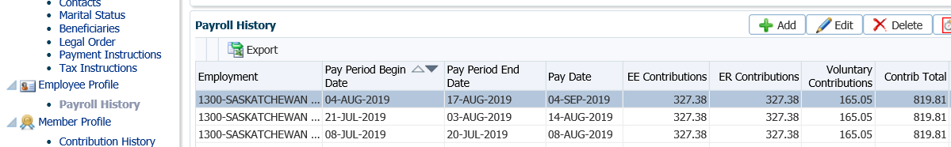

* **NOTE:** If the final contribution has not been received, contact the member to find out if they want to proceed without it or wait to have the transfer processed after it has been received. If the member wants to wait, suspend your assigned Case.

1. Under the **Navigation** menu, click on the **DC Benefit Selections** screen. Click **Add** to add a new payment.

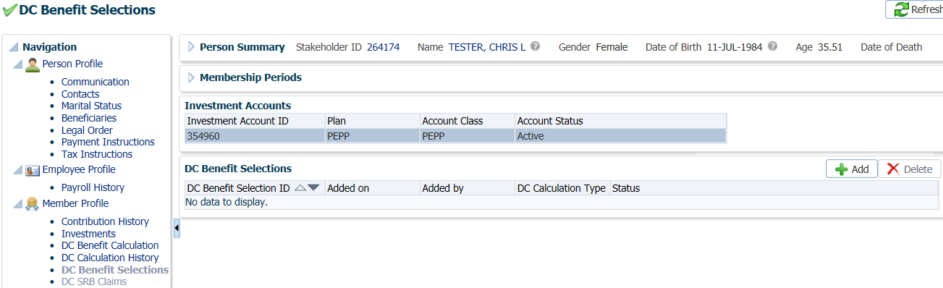

1. In the **Input Data** train, click **Next** to start the **Input Data** process.

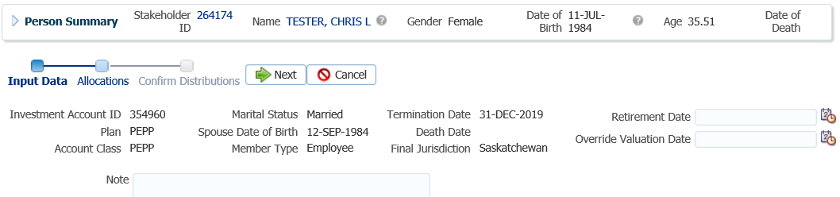

1. In the **Input Data** train under the **Allocations** region click **Add**.

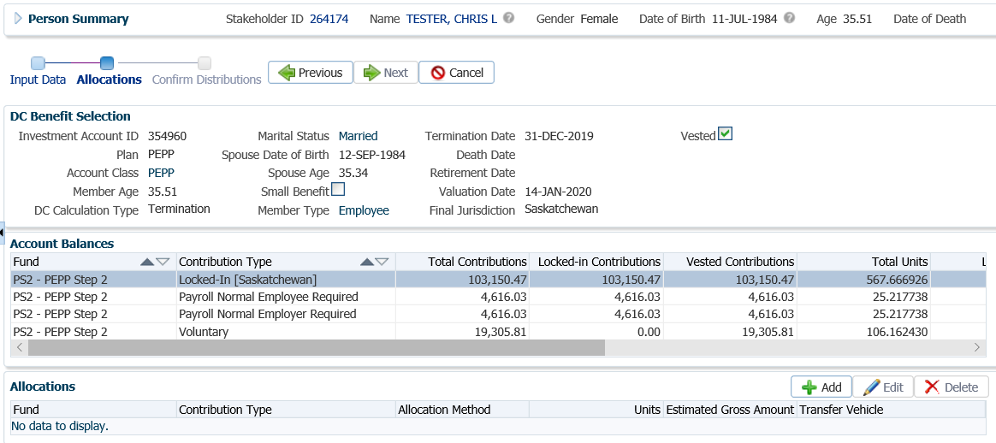

1. In the **Allocation** pop-up window, select the following information and click **Save**:

* **Fund** – leave blank to include all funds
* **Contribution Type** – Voluntary
* **Allocation Method** – Percent if taking 100% out, or Gross Amount if only transferring a partial amount
* **Percent/Gross Amount** – 100% or a specific gross amount
* **Transfer Vehicle** – Cash or RRSP

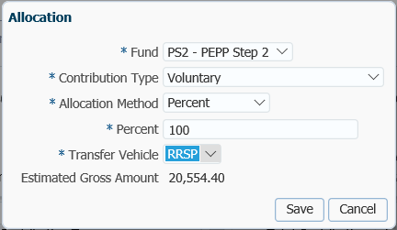

1. In the **Input Data** **Train** click **Next** to Confirm the Distributions of the payment.

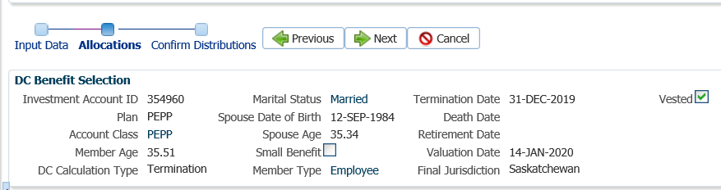

1. In the **Onetime Amounts** region under the **Payment Instruction column**, click on thedrop-down list. If no information is displayed click on **Add New** option.

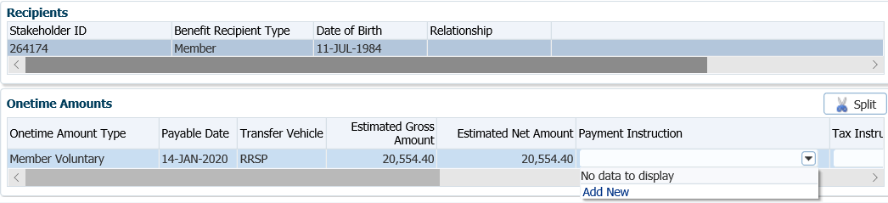

* **NOTE:** if the payee was previously added in the **Payment Instructions** screen under the **Person Profile**, then the information will be displayed in the drop-down list under **Payment Instructions** and can be selected.

1. *Cash Payment* - In the **Payment Instruction** pop-up window, leave **Payee Type** as **Self**, leave **Payment Method** as Cheque, and **Receipt Date** as the current date. Click **Save.**

If the request is to transfer to a Qualified Financial Institution see Step 11.

* **NOTE:** The **Address Type** can be changed to an alternate address if the member wants the cheque to go to a mailing address or business address.

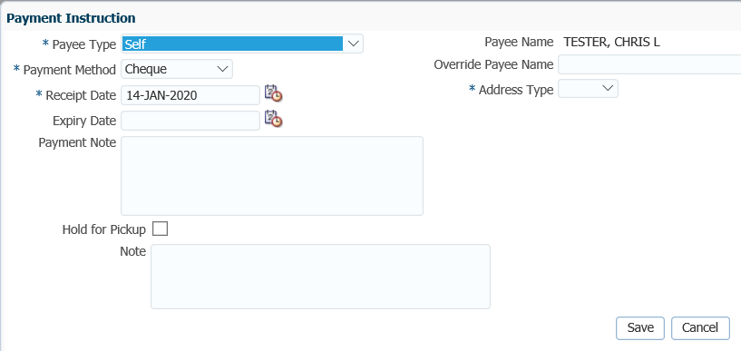

1. *Transfer to a Qualified Financial Institution* - Select **Qualified Financial Institution, LIRA** or **LRIF** as the **Payee**, leave **Payment Method** as Cheque, and **Receipt Date** as the current date. Enter the **Payee Stakeholder ID** number for the financial institution if it is known.

* **NOTE:** If the **Stakeholder ID** for the financial institution is not known, click on the **magnifying glass** to perform a search for the financial institution under the Organizations menu.

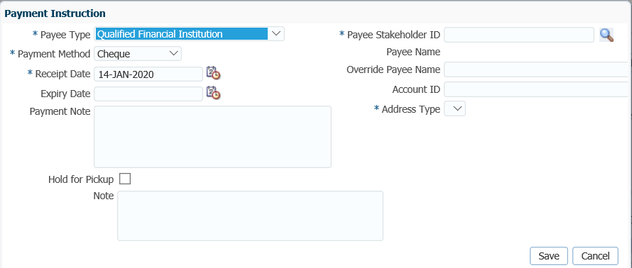

1. In the **Search and Select Organization** region, **Search Parameters** area, click on the drop-down arrow beside **Organization Type,** select **Financial Institution.** Click **Search**.



1. In the **Search Results** region, locate the correct financial institution, highlight the name and click **Ok.**



1. The **Payee Stakeholder ID**, the **Payee Name** and **Address** will now be populated in the **Payment Instructions** window. Add the **Account ID** and a **Note** if applicable. Click **Save**.



**Override Payee Name** would be used to set up a payment to an alternate payee name such as a guardian or trustee, “In trust for” or “Estate of”. Choose **Payee Type** of “Self” and enter the alternate payee name in the **Override Payee Name** field.

* In order to determine if an alternate **payee name** has been entered, the auditor of the payment has to click on the **Payment Instructions** tab to determine if there is a different payee name listed. If an Account ID is not provided on the T2151 form, enter the member’s SIN.

The **Account ID** is to be used when the payee type is set to Qualified Financial Institution E.g. used to enter RRSP/LIRA account number.

The **Notes** region will display any notes that were added during the calculation as well as allow the user to add more notes that pertain to the selected DC Benefit Selection.

1. **Tax Instructions** are not required to be added for cash payments. PENFAX will determine if tax is required to be deducted by the Transfer Vehicle chosen in the Allocation step and apply the appropriate tax rate of 10%, 20% or 30%.

* **NOTE:**  **Tax Instructions** are not required for transfers to a *Qualified Financial Institution*.

1. In the **Input Data** **train**, click **Submit for Approval**.

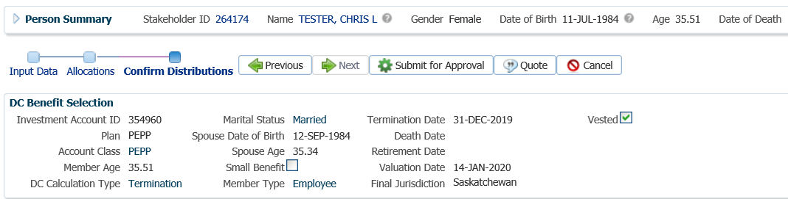

1. The *Pension Specialist* or *Supervisor* will audit and approve the payment in the **DC Benefit Selection** region by clicking **Approve,** or **Reject** if there were errors or the payment was done in error**.**

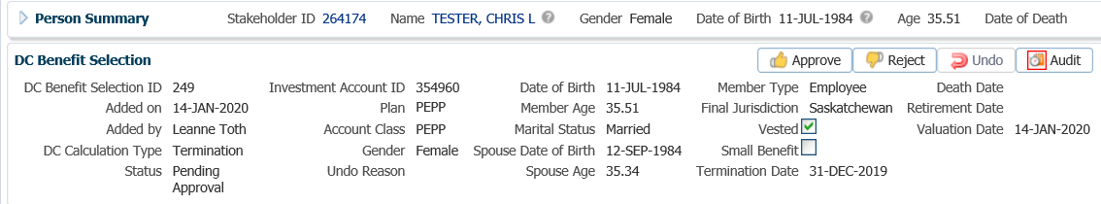

* **NOTE:** If the payment is **Rejected,** the payment steps will need to be entered again by the *Pension Information Officer*. There is no option to edit the existing information.

The **Reject** button is enabled if the status is **Pending Approval** or **Approved**. If the payment is rejected the status will update to **Rejected** when clicked and prevent the benefit selection from being processed by the investment batch.

The **Undo** button is enabled only if the status is **Processed** and will reverse the payment in the investment batch.

1. In the **Approve DC Benefit Selection** window, add a **Note** and click **Save**. Return to payment request to the *Pension Information Officer*.

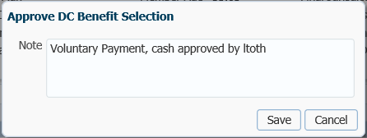

1. A history of Transactions, User and Event is shown under the **Audit** button.



1. Close the **DC Benefit Selection** tab by clicking on the **X** in the tab.



1. The payment will process in the overnight batch process and a cheque will be produced. The payment can be viewed under the **Benefit Recipient** Menu. In the **Onetime Amounts** tab, the Payment details, Recipient (Payee) details, tax deducted and cheque ID number can be viewed by, clicking on the **Paid by Payment ID** number **hyperlink**.

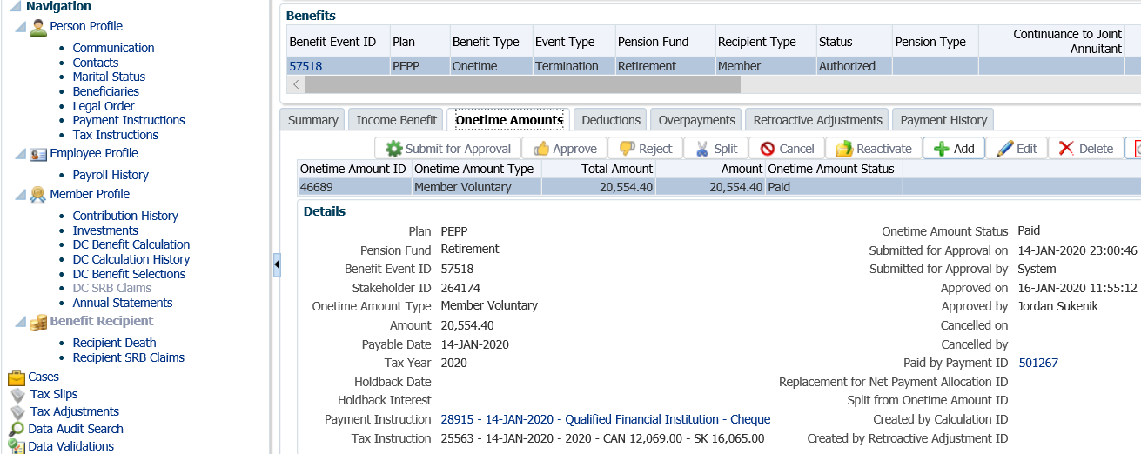

1. Click on the tabs to the right of the screen (**Line Items, Tax, Net Pay Allocation** and **Notes**) to see further details related to the payment.

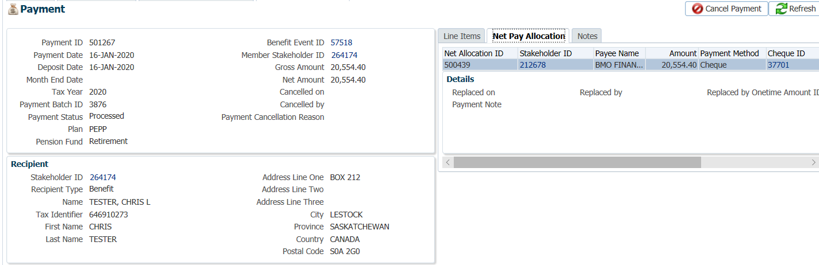

* **NOTE:** Click on the **X** in the **Payment ID Tab** to close the window.



1. A *Withdrawal Confirmation Letter* will be produced overnight. The letter will be saved under the **Person Profile**, **Communications** screen underthe **Outbound Documents** region. Click on the **Filename** link to open the document.

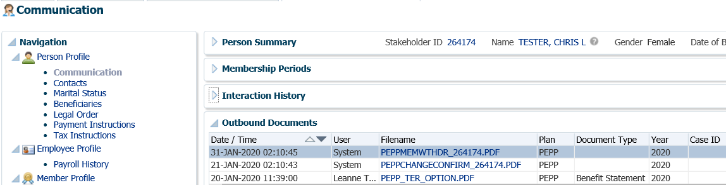

1. If the voluntary money was taken as a cash payment, a **Tax Slip** will be issued at the end of the year and saved under the **Navigation** menu, **Tax Slips** screen.

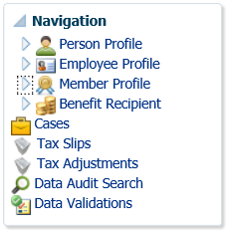

1. The balance under the **Investments** screen, **Account Summary** region will show $0.00 for the voluntary funds if all the voluntary contributions were requested to be paid out.

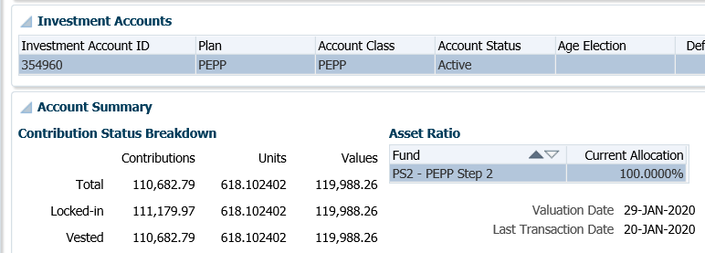

## Partial Payment

When a member terminates employment with all PEPP participating employers, they may request to transfer out a portion of their pension to another registered retirement product and leave a portion in PEPP.

**Business Process Requirements - Partial Payment**

* Member must be terminated or retired from their employment with all participating PEPP employers
* The member’s Plan status must be Deferred.
* Members can return the signed *Termination Option* form or the *Retirement Option* form. The form is not required to process the payment.
* Ensure the final contribution has been received. If the final contribution has not been received, contact the member to find out if they want to proceed without it or wait to have the transfer processed after it has been is received.
* A signed Canada Revenue Agency T2151 form is required by PEPP to transfer registered monies to another registered product as a tax-free rollover. Ensure the receiving institutions name and plan type are on the form. A copy is acceptable.
* Verify the member’s SIN on the *Termination Option* form or the T2151 form to the SIN on the PENFAX account to ensure it matches.
* Determine if Identification is required from the member. ***Refer to the procedures,******When is Identification Required from a Member***.
* If any information is missing on the form follow up with the member. ***Refer to Procedures to Obtain Missing Information***.
* Members are allowed to transfer out a partial amount once per fiscal year (April 1 to March 31) free of charge. Second and subsequent partial transfers taken in a fiscal year will be charged a fee of $60.00 to be added to the gross amount requested.

#### How to Process a Partial Withdrawal

1. Search for the member in PENFAX.
2. Verify that all required documents and forms have been received, signed and certified if required and that the option chosen by the member is allowed as per the business process requirements for a partial withdrawal payment.
3. Check the **Employee Profile** menu to ensure the termination information has been received and entered into PENFAX.

Under the **Membership Periods** region ensure the **Member Status** is showing as Deferred.

Under the **Employment Periods** region confirm the following information has been entered:

* **End Date**
* **End Reason** is Terminated or Retired
* **Final Jurisdiction**

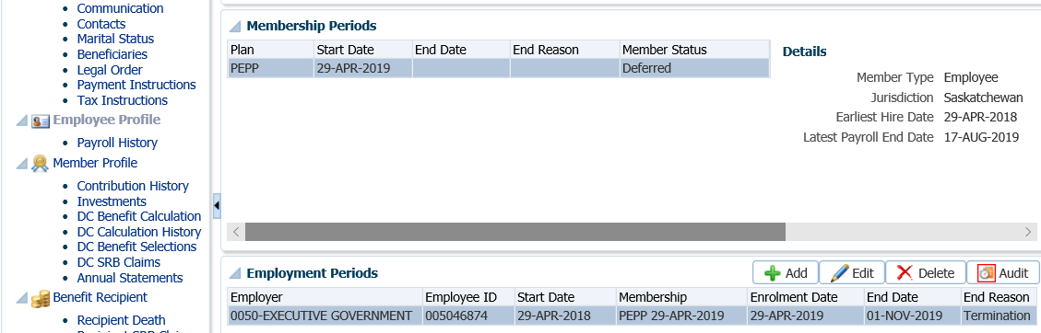

1. Under the **Employee Profile** menu, **Payroll History** screen, determine if the final contribution has been received. Expand the **Payroll History** region to see the payroll contributions.

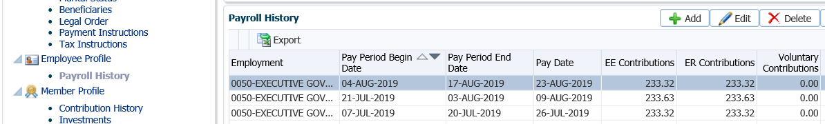

* **NOTE:** If the final contribution has not been received, contact the member to find out if they want to proceed without it or wait to have the transfer processed after it has been received. If the member wants to wait, suspend your assigned Case.

1. Under the **Navigation** menu, click on the **DC Benefit Selections** screen. Click **Add** to add a new payment in the **DC Benefits Selection** region.

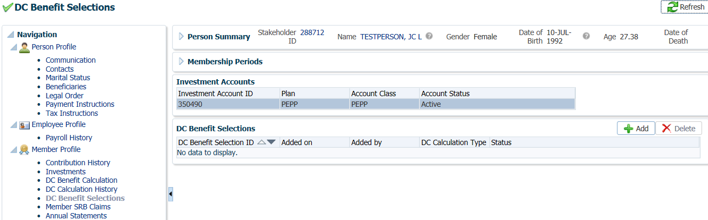

1. In the **Input Data** train, click **Next** to start the **Input Data** process.

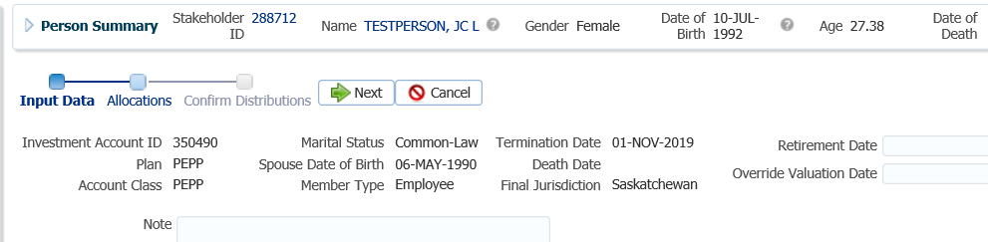

1. In the **Input Data train** under the **Allocations** regionclick **Add**.

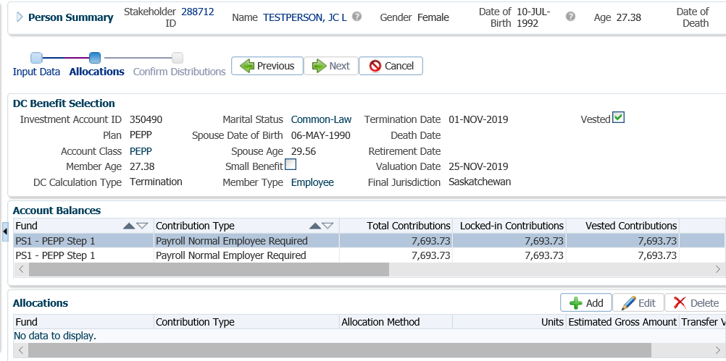

1. In the **Allocation** pop-up window, select the following and click Save:

* **Fund** – select a fund or leave blank to include all funds
* **Contribution Type** – select a contribution type or leave blank to include all Contribution Types
* **Allocation Method** - percent, dollar amount, or units (for partial amount)
* **Transfer Vehicle** – as per member’s T2151 form

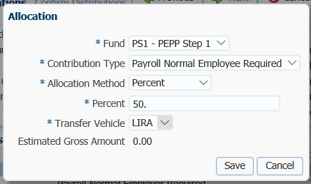

1. In the **Input Data Train** click **Next** to Confirm the Distributions of the payment.

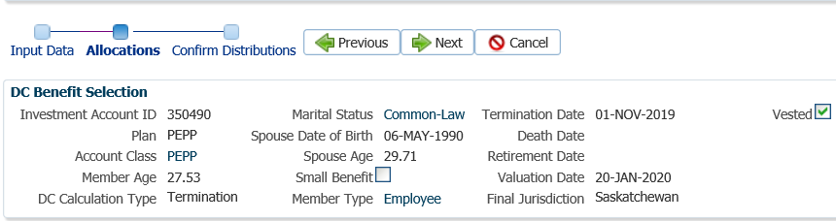

1. In the **Onetime Amounts** region under the **Payment Instruction** column, click onthe drop-down list. If no information is displayed click on **Add New** option.

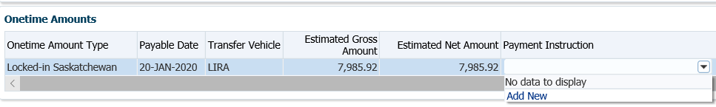

* **NOTE:** if the payee was added in the **Payment Instructions** screen previously, then the information will be displayed in the drop-down list under **Payment Instructions** and can be selected.

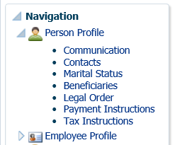

1. In the **Payment Instruction** pop-up window, select the **Payee Type** as **LIRA**, then enter the **Payee Stakeholder ID** number for the financial institution.

* **NOTE:** If the **Stakeholder ID** for the financial institution is not known, click on the **magnifying glass** to perform a search for the financial institution under the **Organizations** menu.

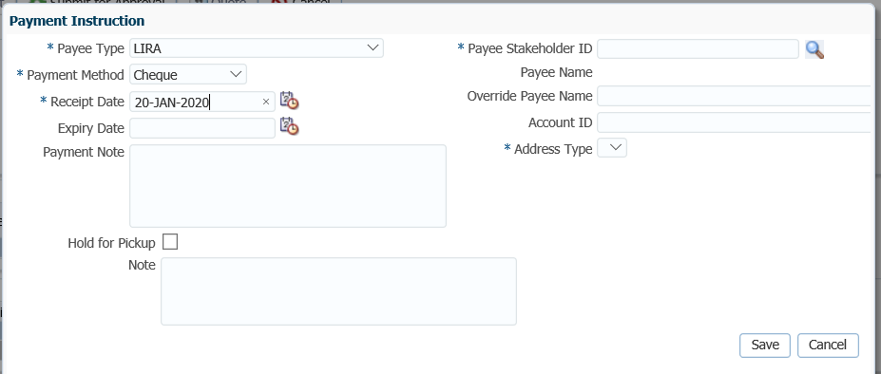

1. In the **Search and Select Organization** screen, **Search Parameters** area, click on the drop-down arrow beside **Organization Type,** select **Financial Institution**, click **Search**.



1. In the **Search** Results area, locate the correct financial institution, highlight the name and click **Ok**.



1. The **Payee Stakeholder ID**, the **Payee Name** and **Address** will now be populated in the **Payment Instructions** window. Add the **Account ID** and a **Note** if applicable. Click **Save**.

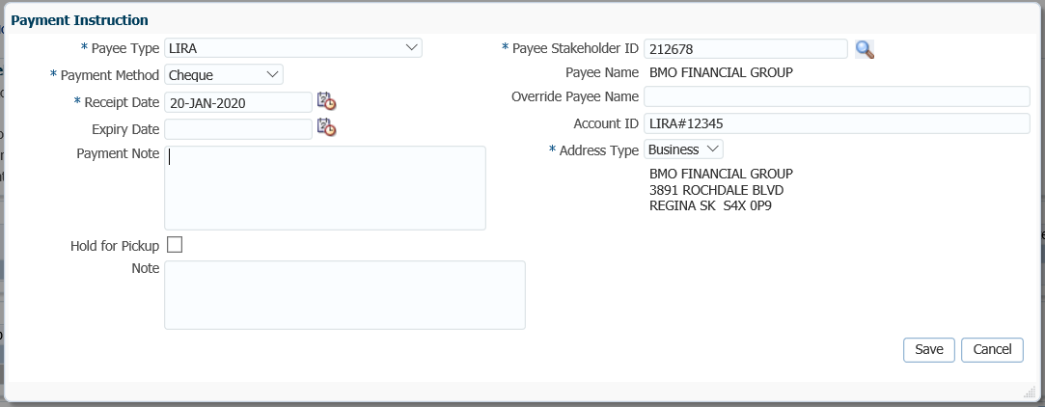

**Override Payee Name** would be used to set up a payment to an alternate payee name such as a guardian or trustee, “In trust for” or “Estate of”. Choose **Payee Type** of “Self” and enter the alternate payee name in the **Override Payee Name** field.

* In order to determine if an alternate **payee name** has been entered, the auditor of the payment has to click on the **Payment Instructions** tab to determine if there is a different payee name listed. If an Account ID is not provided on the T2151 form, enter the member’s SIN.

The **Account ID** is to be used when the payee type is set to Qualified Financial Institution E.g. used to enter RRSP/LIRA account number.

The **Notes** region will display any notes that were added during the calculation as well as allow the user to add more notes that pertain to the selected DC Benefit Selection.

1. **Tax Instructions** are not required to be added for cash payments. PENFAX will determine if tax is required to be deducted by the Transfer Vehicle chosen in the Allocation step and apply the appropriate tax rate of 10%, 20% or 30%.

1. In the **Input Data** **train**, click **Submit for Approval**.

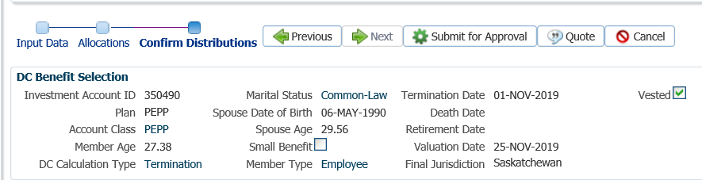

1. The *Pension Specialist* or *Supervisor* will audit and approve the payment in the **DC Benefit Selection** region by clicking **Approve**,or **Reject** if there were errors or the payment was done in error**.**

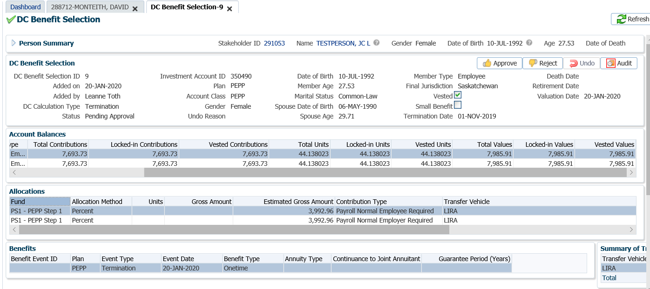

* **NOTE:** If the payment was processed incorrectly or done in error, the *Pension Specialist* or *Supervisor* will select **Reject** and all of the payment steps will need to be redone by the *Pension Information Officer*.

The **Reject** button is enabled if the status is **Pending Approval** or **Approved**, which will update the status to **Rejected** when clicked and prevent the benefit selection from being processed by the investment batch.

The **Undo** button is enabled only if the status is **Processed** and will reverse the payment in the investment batch.

1. In the **Approve DC Benefit Selection** pop-up window, add a **Note** and click **Save**.

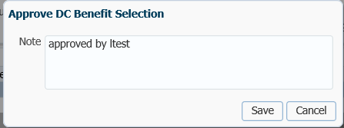

1. A history of Transactions, User and Event is shown under the **Audit** button.

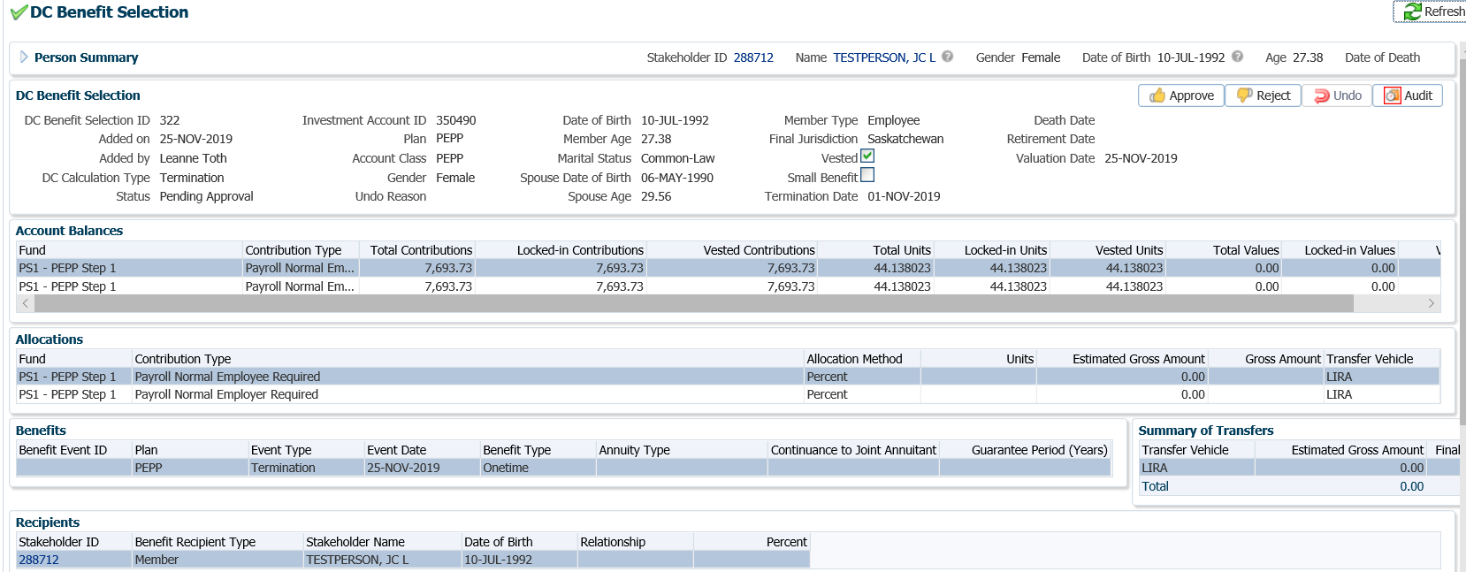

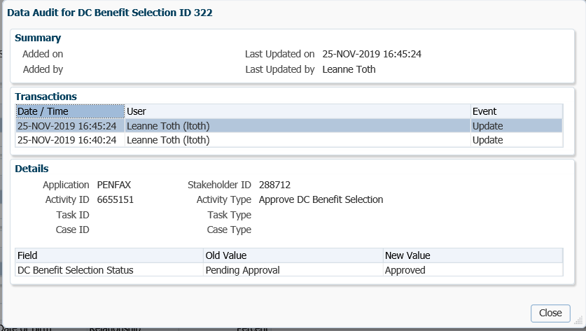

1. The payment will process in the overnight batch process and a cheque will be produced. The payment can be viewed under the **Benefit Recipient** Menu. Click on the **Onetime Amounts** tab to see the details.

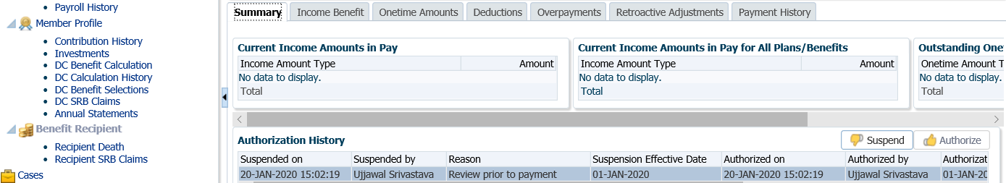

1. To see the Payment details, Recipient (Payee) details, tax deducted and cheque ID number, click on the **ID number** beside the **Paid by Payment ID.**

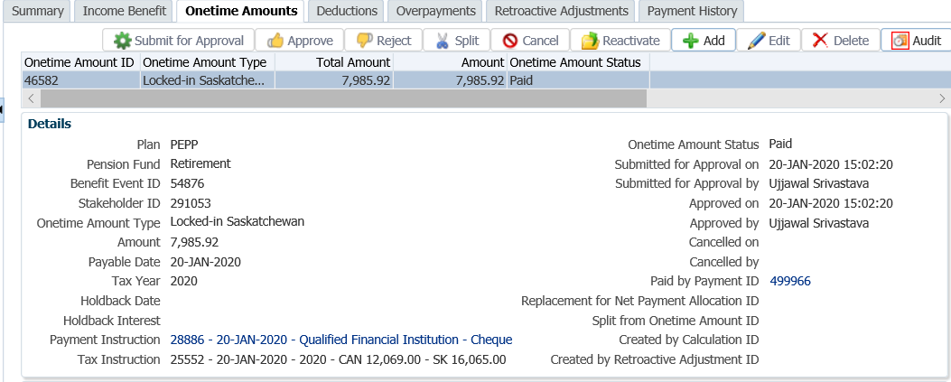

1. Click on the tabs to the right of the screen (**Line Items, Tax, Net Pay Allocation** and **Notes**) to see further details related to the payment.

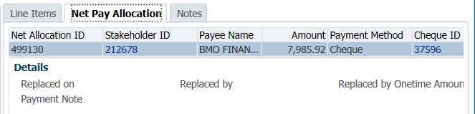

* **NOTE:** Click on the **X** in the **Payment ID Tab** to close the window.

1. A *Withdrawal Confirmation Letter*. The letter will be saved under the **Person Profile**, **Communications** screen underthe **Outbound Documents** region. Click on the **Filename** link to open the document.

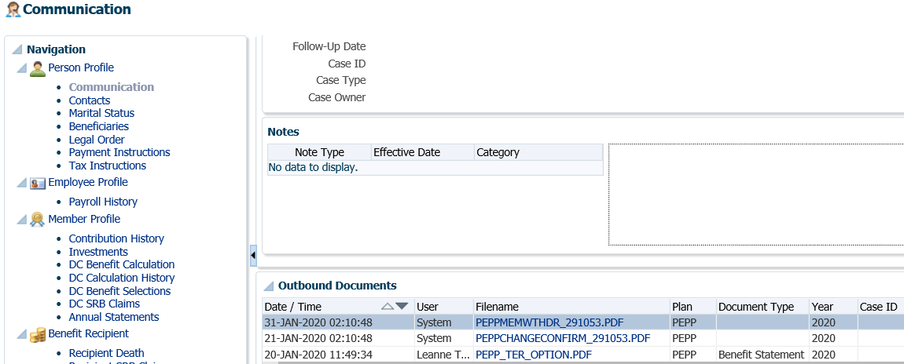

## Excess Contribution Refund (Overpayment)

The employer is responsible for ensuring all required and voluntary contributions remitted to PEPP are within the CRA guidelines and do not exceeded the Canada Revenue Agency yearly maximum contribution limit.

If the employer discovers after the contributions have been allocated to PEPP that an amount was remitted in error on behalf of an employee, the employer may request a return of excess contributions from the PEPP member’s account for all or a portion of the amount exceeding the yearly maximum.

The employer is responsible for any corrections to the tax reporting (i.e., if refund results in an amended T4 with a revised Pension Adjustment or PA), and the employer will then refund any amounts to their employee(s) where appropriate.

## Contributions Received in Error

A PEPP participating employer may request a return of contributions from an active PEPP member, should the employer discover that after the contributions have been allocated, an amount was remitted in error on behalf of an employee. The employer may request all or a portion of the amount remitted in error.

The employer is responsible for any corrections to the tax reporting (i.e., if refund results in an amended T4 with a revised Pension Adjustment or PA), and the employer will then refund any amounts to their employee(s) where appropriate.

Business Process Requirements - Excess Contribution Refund & Contributions Received in Error

* The employer will provide PEPP with a signed *Member Account Adjustment Request* form which is to include the following:
  + pay date of the remittance that contained the overpayments,
  + member(s) by last name, SIN/EEID number, department code and reason,
  + dollar amount of the employee contribution, employer contribution, and/or voluntary contribution to return to the employer.
* Ensure the member has enough funds in the contribution source the refund is being requested from. If there is not enough funds in the source being requested, pay out the amount that is available from the requested source and advise the employer.
* The cheque is to be made payable to the employer to refund to the employee if applicable.
* **Note:**  PENFAX has the ability to combine multiple excess contribution withdrawal requests processed on the same day, for the same employer into one cheque. One cheque would be produced but single Withdrawal letters would print.
* Check PENFAX for any critical notes.
* **Excess Contribution Refunds** are permitted when a member is in a terminated employment status if they have exceeded the CRA yearly maximum amount. As per CRA rules a member is only allowed to contribute 18% of their current year’s earnings to a defined contribution pension plan in a year.
* **Contributions Received in Error** are only permittedif a member is an actively contributing to PEPP with a PEPP participating employer.
* **Executive Government** has been granted an exception to allow for contributions received in error to be requested back if the member is terminated from employment and the Member Account Adjustment Request is received in the next pay period,
* **Contributions Received in Error** are permitted for a member who is terminated employment if the employer obtains written permission from the member. PEPP requires a copy of the letter of permission in order to make the refund.
* If any information is missing or unclear, follow up with the employer. ***Refer to Procedures to Obtain Missing Information.***
* Tax is not withheld on a payment for an excess contribution or a contribution received in error.
* If PEPP Is unable to process the refund as the member is in terminated status and not over the CRA yearly maximum amount, indicate in the letter to the employer the following:
  + Member currently has money in PEPP, “**terminated on (date), currently a member**”.
  + Member no longer has money in PEPP, “**terminated on (date), not a member”**.
  + This will assist the employer to know when to ask for permission from the employee to allow for the refund from their pension. PEPP requires a copy of the member letter.
* **Excess Contribution Refunds** received from an employer in excess of the 18%:
  + For audit purposes, make a copy your spreadsheet and highlight the individual to be audited.
  + Send for Audit.
  + The next day, after cheques have been verified, return the cheques to the *Supervisor*. The cheques will be sent to the Ministry of Finance and mailed out to the member’s by the Ministry of Finance with a letter of explanation.
  + Send paperwork for filing (check list / cheque stub / listing).
  + For VPB members if the request is for voluntary contributions, process the payment as cheque, payable to the member.

#### How to Process a Payment for an Excess Contribution or a Contribution Received in Error

1. Search for the member in PENFAX.
2. Verify that all required form have been received and signed and that the payment is allowed as per the business process requirements for an excess contribution payment or a contribution received in error payment.
3. Check the **Employee Profile** menu, under **Employment Periods, End Date** to determine if the member is terminated from employment or still active.

**Contributions Received in Error** – member must be an actively contributing member, with the exception of monthly paid members. If the member is terminated the employer must obtain written permission from the member to request a refund from PEPP.

**Excess Contribution Refund –** member can be an actively contributing member or a terminated member.

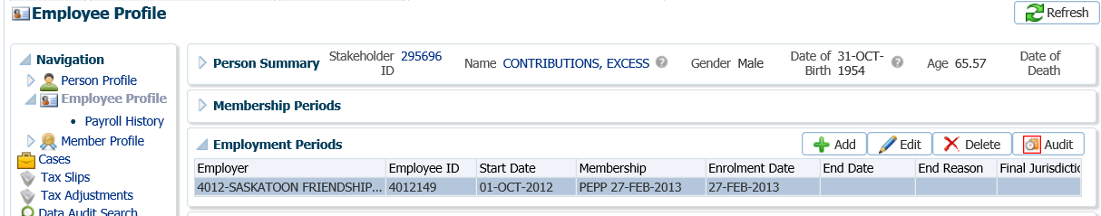

1. Under the **Navigation** menu, click on the **Investments** screen. In the **Account Balances** region confirm that there is enough money in the source requested by the employer on the *Member Account Adjustment Request* form.

* **NOTE:** if the member does not have enough money in the contribution type(s) requested pay out what is available.

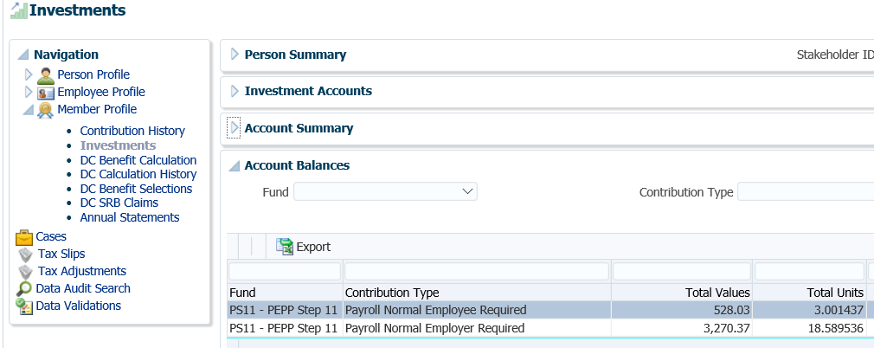

1. Under the **Investments** screen, **Account Instructions** region, click **Add** to add a new instruction for the lump sum withdrawal.

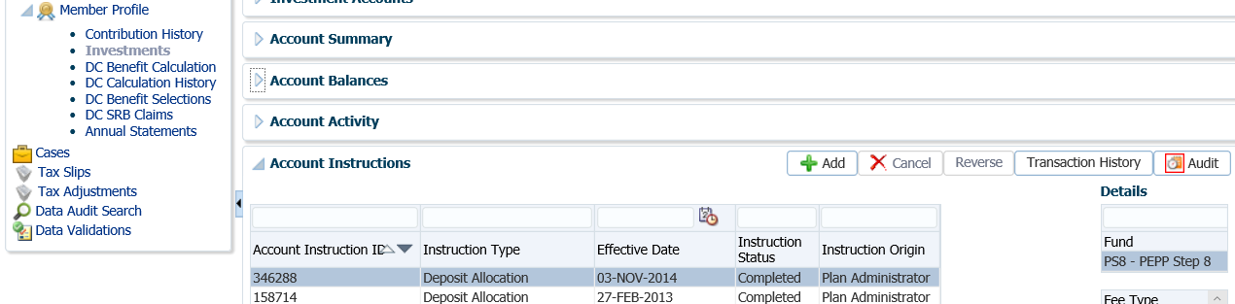

1. In the top section of the **Account Instructions** pop-up window, select the following:

* **Instruction Type** - Lump Sum Withdrawal
* **Effective Date -** Current date
* **Lump Sum Withdrawal Type -** Employer Excess Contribution Refund
* **Lump Sum Withdrawal Method -** Gross Amount
* **Gross Amount -** Amount as per the *Member Account Adjustment Request* form

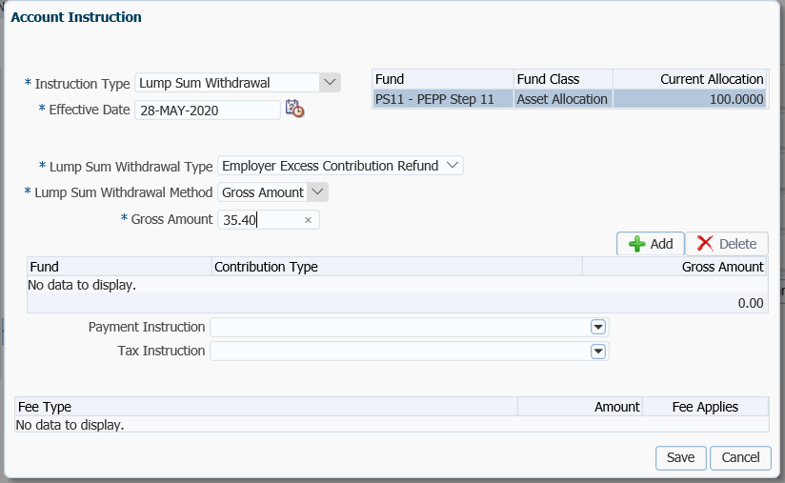

1. In the bottom section of the **Account Instruction** pop-up window under the **Fund** information box, click **Add**. Select the following information:
   * **Fund** – will pre-populate with the fund(s) the member holds and pro-rate across funds
   * **Contribution Type** – a full list of contribution types held in the displayed fund is shown in the drop-down list, select each individually. You must click **Add** each time to pick a new type.
   * **Gross Amount** – input the amount for each contribution type
   * **Fee** – leave blank, there is no fee charged

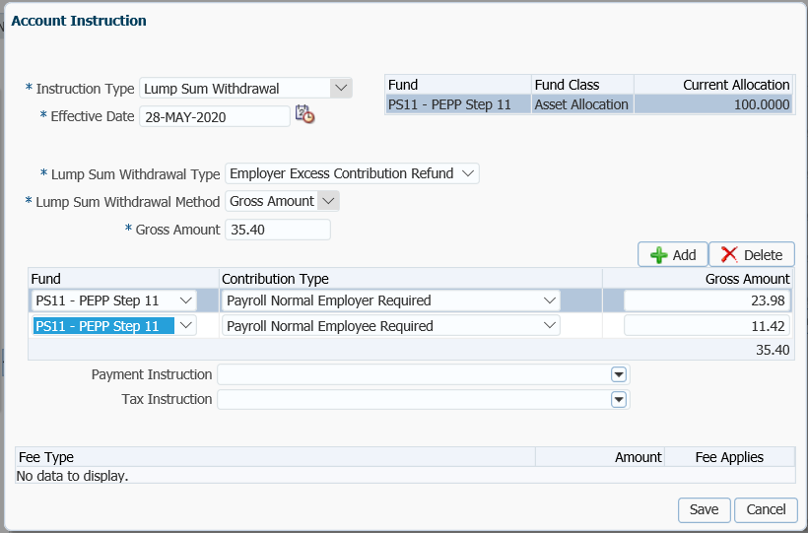

1. In the **Payment Instructions** drop-down, click **Add New**.

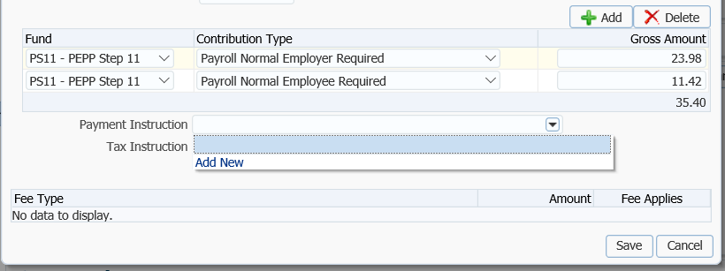

1. In the **Payment Instruction** pop-up window, select the following:
   * **Payee Type** – Alternate or Self (if *Member Account Adjustment Request* form states Voluntary Contribution Type only, make the cheque payable to the member)
   * **Payment Method** – Cheque
   * **Receipt Date** – Current Date
   * **Expiry Date** – date that the banking instructions are valid for if using EFT
   * **Payment Note** ­– used to add a note to the payment documentation (cheque or EFT receipt)
   * **Hold for Pickup ­**– checked if the member would like to pickup the cheque (this will be displayed under the member’s **Payment Instructions** screen)
   * **Note** – additional notes pertaining to the payment, will appear under Person Profile Notes
   * **Payee Stakeholder ID** – if the stakeholder ID for the Maintenance Enforcement Office is known you can enter it. If it is not known, click on the **magnifying glass** to search for the stakeholder number. See Steps #9 - 11 for searching and selecting an Organization.
   * **Payee Name –** will automatically populate when the Stakeholder ID is entered
   * **Override Payee Name** – Override Payee Nameis used to set up a payment to an alternate payee name such as a guardian or trustee, “In trust for” or “Estate of” or a “spouse” for a Maintenance Enforcement payment.
   * **Address Type** – defaults to the stakeholder’s primary address on record, if another address exists on file it can be selected from the drop-down list

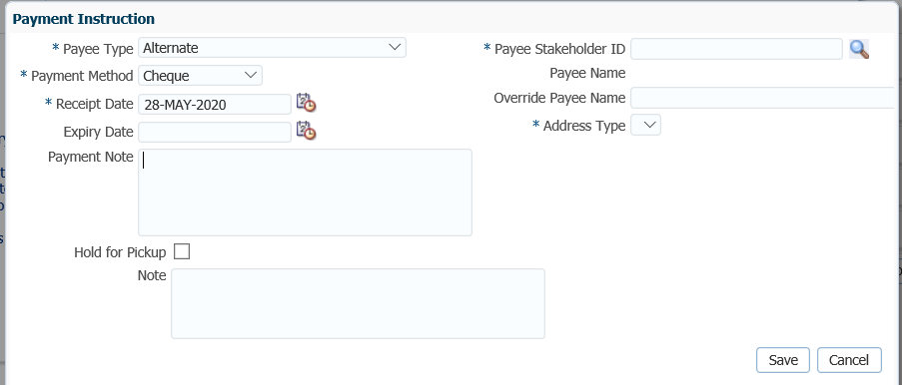

1. In the **Search and Select Organization** screen, **Search Parameters** area, click the **Organization** radio button number, in the drop-down arrow beside **Organization Type,** select **Employer**. Enter in your search information such as Employer name or Employer ID, click **Search**.

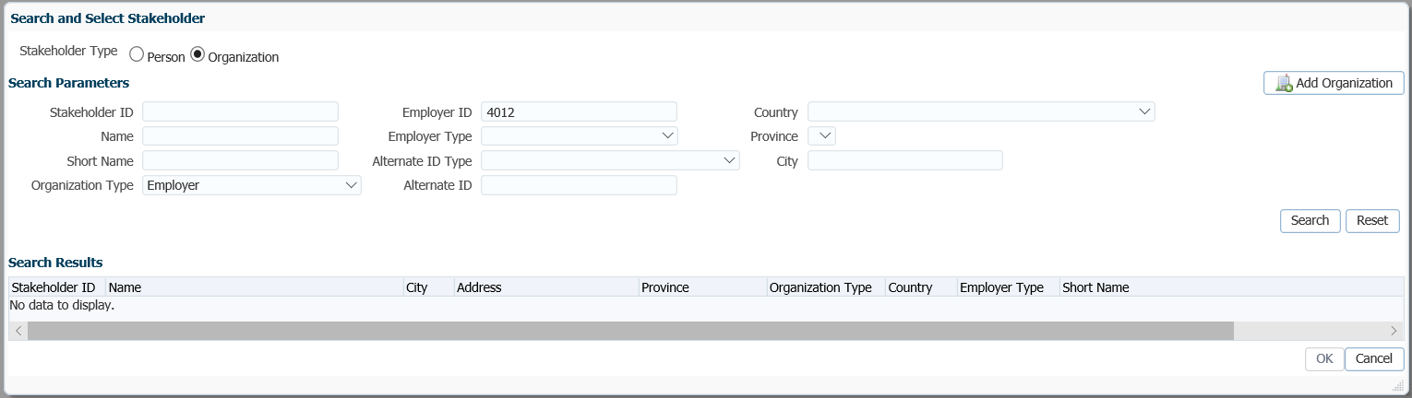

1. In the **Search Results** area, highlight the name of the employer in the **Search Results** region and click **Ok**.

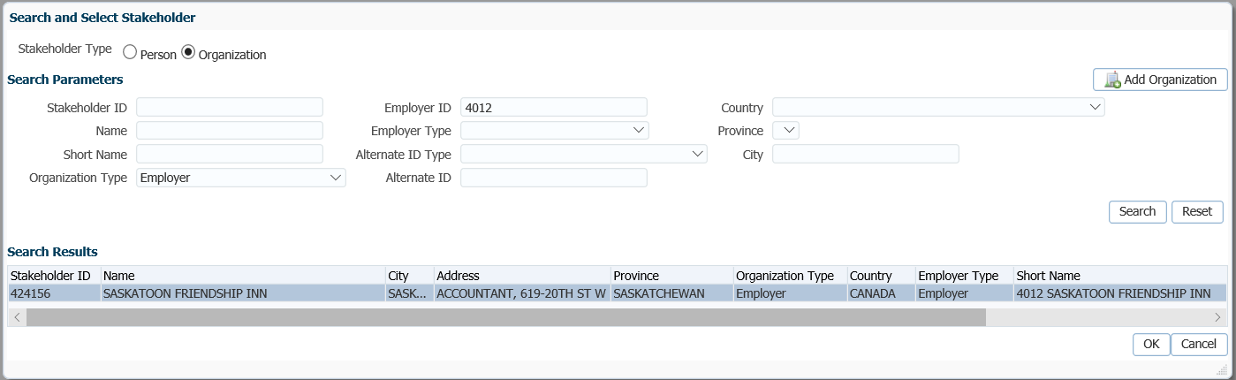

1. The **Payee Stakeholder ID**, the **Payee Name** and **Address** will now be populated in the **Payment Instructions** window. Click **Save**.

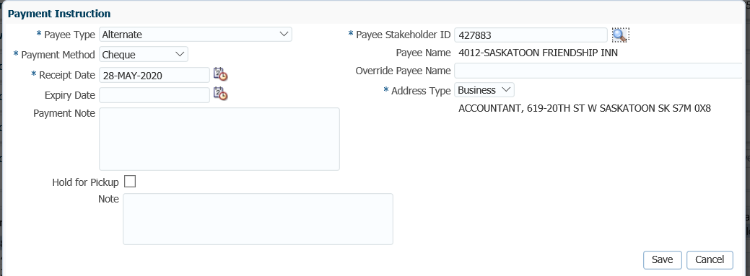

1. In the **Account Instruction** pop-up window, click **Save**.

* **NOTE:** There is no tax withheld on the payment or fee deducted.

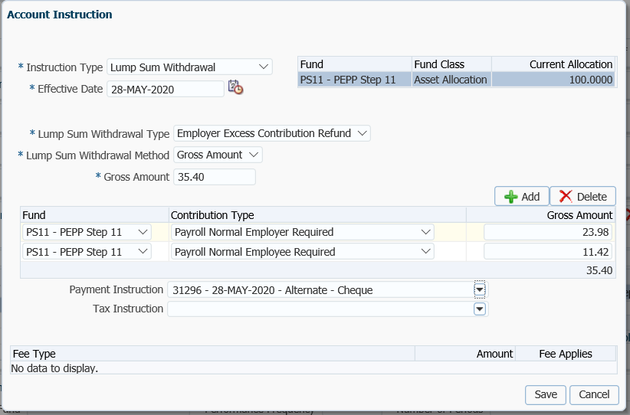

1. The payment will show as **Pending** under the **Account Instructions** region. The details of the payment will show under the **Details** area.

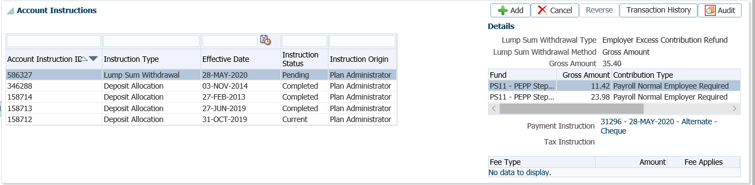

1. The *Pension Specialist* or *Supervisor* will audit the payment in the **Investments menu**, **Account Instructions, Details** region. If errors were found or the payment was done in error, the payment must be cancelled using the **Cancel** option if the status shows as **Pending**

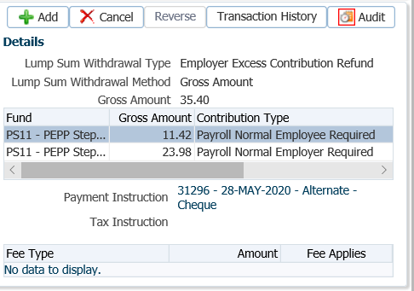

1. A history of Transactions and Details is shown under the **Audit** button. Click **Close** to close the audit window.

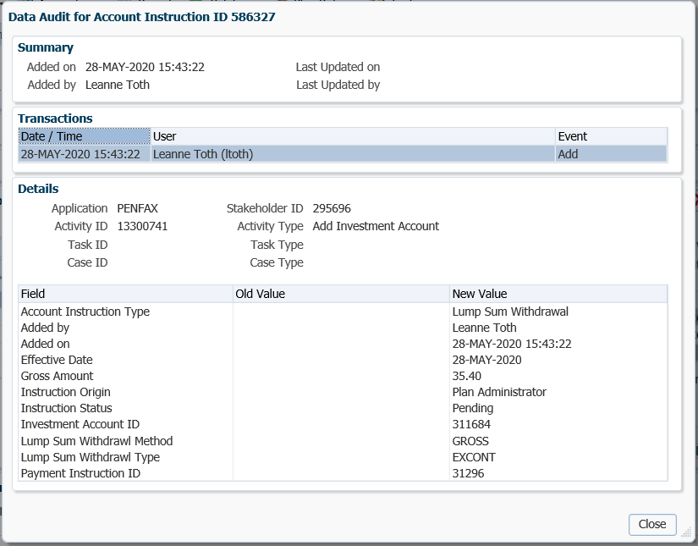

1. The payment will process in the overnight investment batch and a cheque will be produced. The payment transaction details can be viewed under the **Investments** menu, **Account Activity** region. Enter in the **Search Parameters** region under **Fund Transaction Type, Withdrawal – Lump Sum**, click **Search**. The transaction details will be displayed in the lower region.

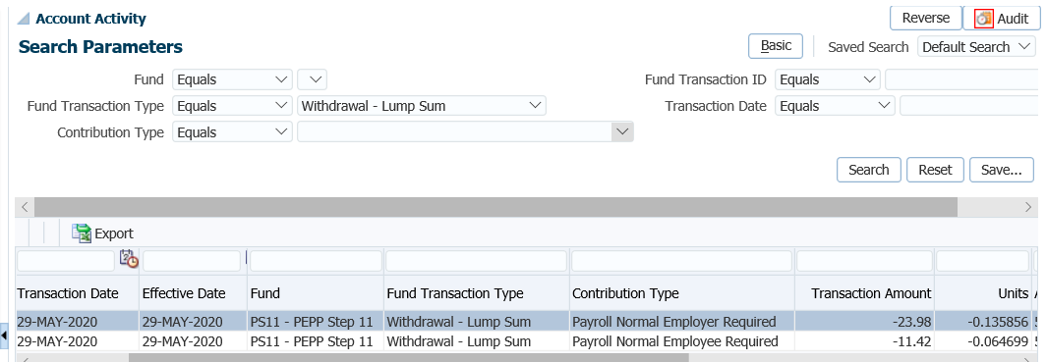

1. The total values reflected under the **Account Summary** region and the **Account Balances** region will be the difference of the payment transaction that was valued overnight.

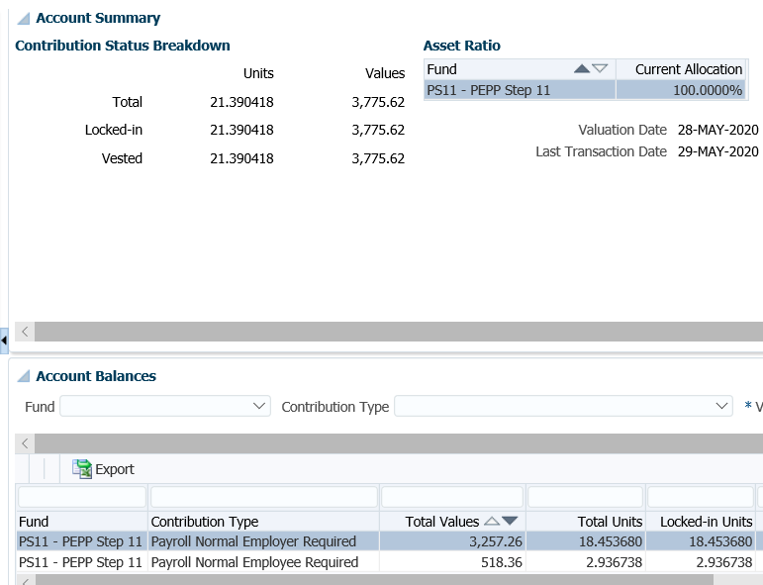

1. A **Benefit Recipient** folder is created after the payment has been processed overnight. To view the details of the payment, recipient (payee), tax deducted and cheque ID number, click on the **Benefit Recipient** menu, highlight the **Benefit Event ID** created for the payment. Click on the **Onetime Amounts** tab.

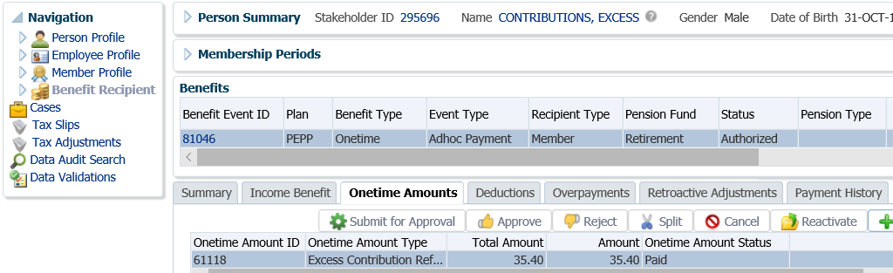

1. Under the **Onetime Amounts** tab, click on the **Paid by Payment ID** number **hyperlink** to see the payment details.

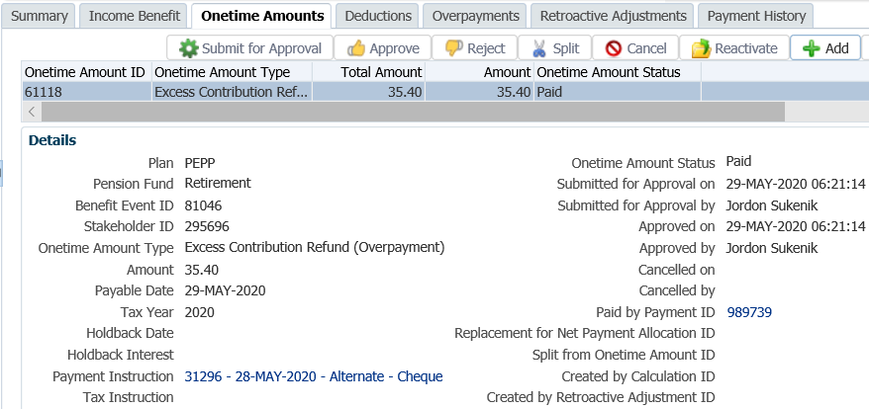

1. The tabs to the right of the screen (**Line Items, Tax, Net Pay Allocation** and **Notes**) will show further details related to the payment.

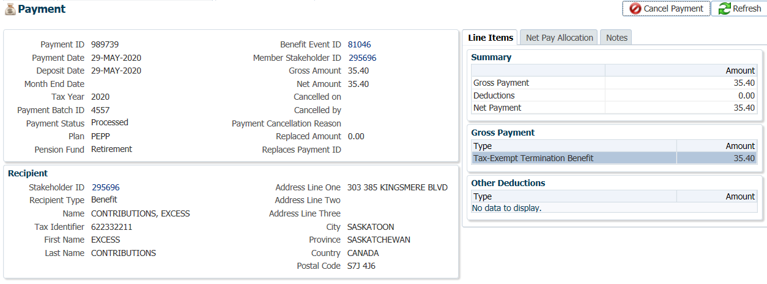

1. To see the details of the cheque, click on the **Cheque ID** number under the **Net Pay Allocation** tab.

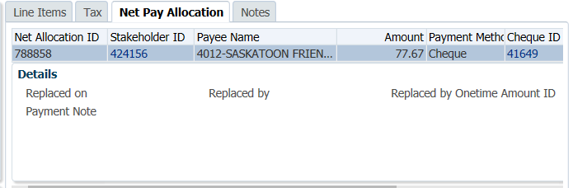

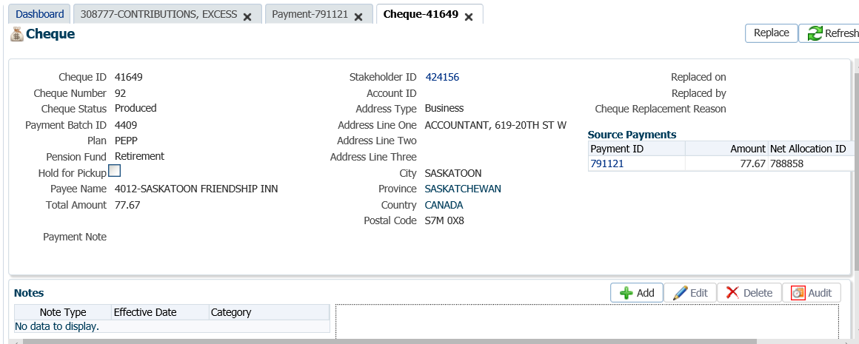

* **NOTE:** Click on the **X** in the Tab to close the window when done viewing.

1. The Pension Information Office will prepare a manual letter to the employer to be sent with the cheque. A copy is to be kept for the employer’s file.

In the letter advise the employer of the request details:

* + cheque # and amount of cheque,
  + name of member(s) request was for,
  + pay date and pay period the refund was for,
  + Names of any members on the *Member Account Adjustment Request* form that the refund could not be processed for. Include the reason why a refund could not be processed and the member status (see below).

If PEPP Is unable to process the refund as the member is in terminated status and not over the CRA yearly maximum amount, indicate in the letter to the employer the following:

* + Member currently has money in PEPP, “terminated on (date), currently a member”.
  + Member no longer has money in PEPP, “terminated on (date), not a member”.

This will assist the employer to know when to ask for permission from the employee to allow for the refund from their pension.

* **NOTE:** There is no system generated confirmation letter produced for this type of payment

## External Transfer Out

Upon termination of employment with all PEPP participating employers, members will receive a Letter outlining the options available for their pension. A member may choose one or a combination of options with their PEPP account, or defer their decision to a later date.

The options available to the member depend on their age, their vesting status and the final jurisdiction of the locked-in money within the member’s PEPP account.

If a member chooses to transfer their pension funds to an external financial institution, they may transfer their full account balance or a portion to the following options:

* a Locked-In Retirement Account (LIRA),
* a Locked-In Fund (LIF),
* a Registered Pension Plan (RPP),
* a Registered Retirement Savings Plan (RRSP) if funds are unlocked,
* a Prescribed Registered Retirement Income Fund (pRRIF),
* Locked-In Retirement Income Fund (LRIF),
* Restricted Life Income Fund (RLIF).

**Business Process Requirements - External Transfer Out Payment**

* A member must be terminated from all PEPP participating employers (all employment records show terminated or retired status).
* The member’s Plan status must be Deferred.
* Ensure the final contribution has been received. If the final contribution has not been received, contact the member to find out if they want to proceed without it or wait to have the transfer processed after it has been is received.
* A signed Canada Revenue Agency T2151 form is required indicating the receiving institutions name and plan type. A copy is acceptable.
* Verify the member’s SIN on the T2151 form to the SIN on the PENFAX account to ensure it matches.
* Determine if Identification is required from the member. **Refer to the procedures,** **When is Identification Required from a Member**.
* Transfers going to a pRRIF, require a *Spouse’s Waiver of Death Benefits Prior to Retirement* form for married or common-law members. If the member is no longer married, a certified copy of the Decree Absolute or divorce certificate is required before the payment can be processed.
* If any information is missing on the form follow up with the member. ***Refer to Procedures to Obtain Missing Information***.

#### How to Process an External Transfer Out Payment

**The following payment processing steps #1, 2 and #6 to 27 are the same for all payments going to a registered product when a member is in deferred status and transferring their full account balance to another financial institution.**

#### Scenario: pRRIF Transfer Out

1. Search for your member in PENFAX.
2. Verify that all required documents and forms have been received, signed and certified if required and that the option chosen by the member is allowed as per the business process requirements for an external transfer out payment.
3. If the member is transferring to a pRRIF, confirm the marital status of the member under the **Person Profile** menu, **Person Summary** region.

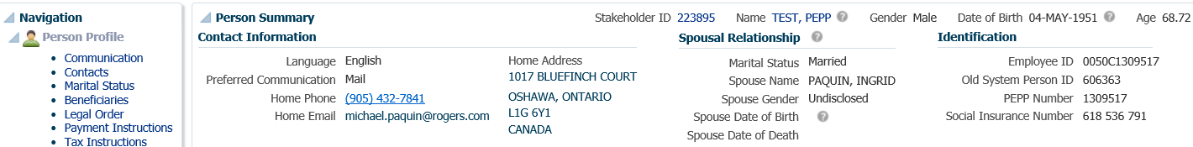

1. If the member is married or common-law and transferring to a pRRIF, confirm that a *Spouse’s Waiver of Death Benefits Prior to Retirement* form has been received and has been entered in PENFAX.

Under the **Person Profile** menu, expand the **Status** region. If the information has not been previously entered, click **Add** to enter.

* **NOTE:** If the member is no longer married, a certified copy of the Decree Absolute or divorce certificate is required before the payment can be processed

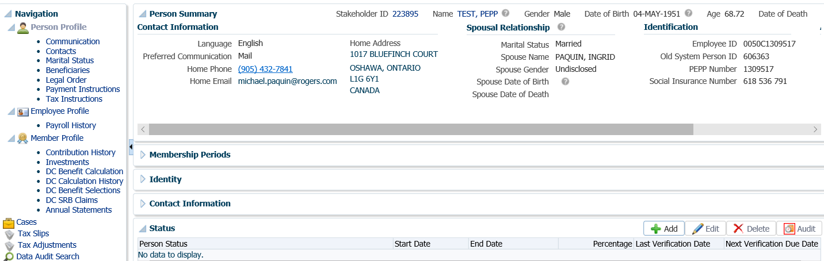

1. In the **Person Status** pop-up window, enter the information. Under the **Person Status** drop-down list select **PEPP pRRIF – Spousal Consent**, enter the **Start Date** as the date the form was signed. PENFAX will automatically calculate the 90 days and enter the date. Enter the **Percentage** from the form. Click **Save**.

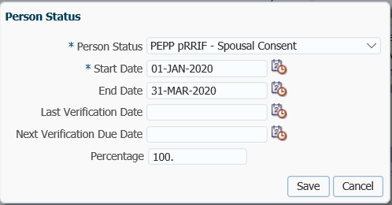

1. Check the **Employee Profile** menu to ensure the termination information has been received and entered into PENFAX.

Under the **Membership Periods** region ensure the **Member Status** is showing as Deferred.

Under the **Employment Periods** region confirm the following information has been entered:

* **End Date**
* **End Reason** is Terminated or Retired
* **Final Jurisdiction**

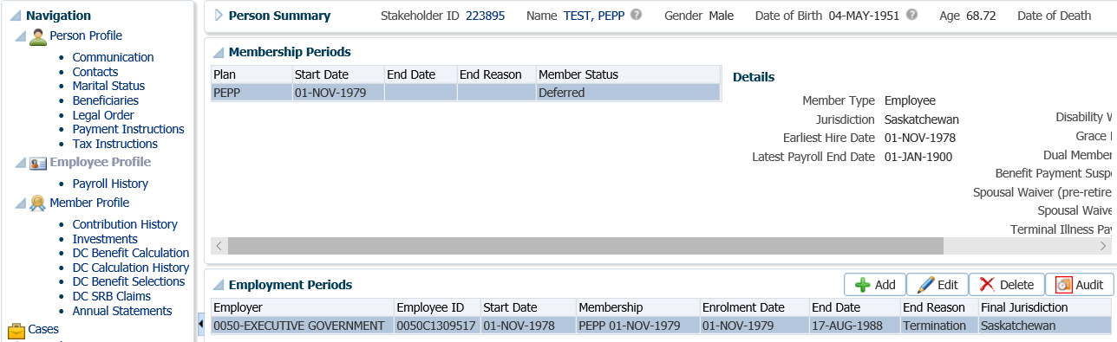

1. Under the **Employee Profile** menu, **Payroll History** screen, determine if the final contribution has been received. Expand the **Payroll History** region to see the payroll contributions.

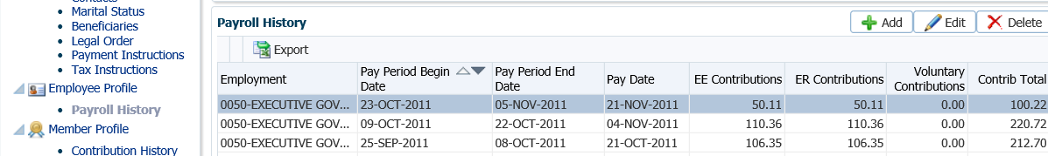

* **NOTE:** If the final contribution has not been received, contact the member to find out if they want to proceed without it or wait to have the transfer processed after it has been received. If the member wants to wait, suspend your assigned Case.

1. Under the **Navigation** menu, click on the **DC Benefit Selections** screen. Click **Add** to add a new payment.

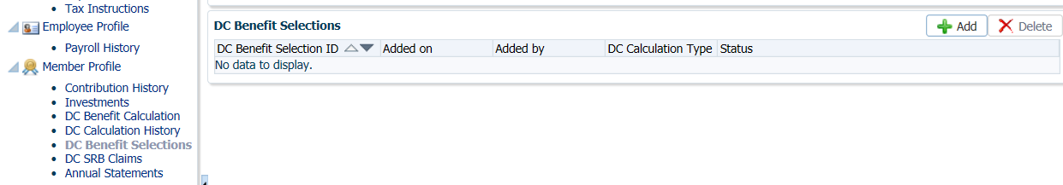

1. In the **Input Data** train, enter the **Retirement Date** if the member is over age 50. Click **Next** to start the **Input Data** process.

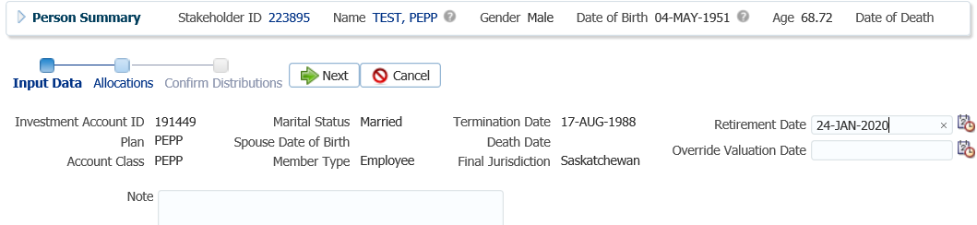

* **NOTE:** a **Retirement Date** is required when a member is over age 50 so that all retirement options will be made available. The current date can be used as the **Retirement Date**.

1. In the **Input Data train** under the **Allocations** regionclick **Add**.

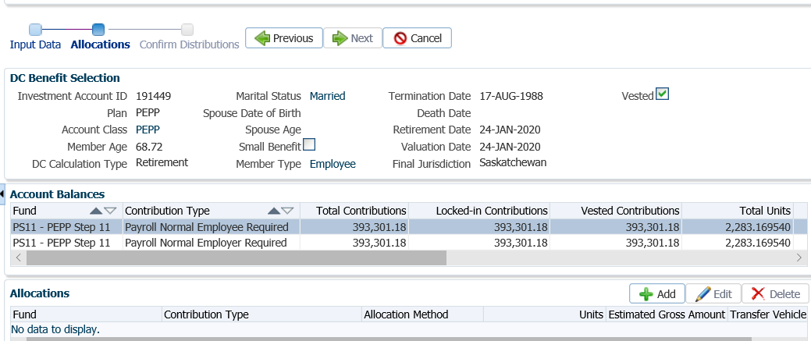

1. In the **Allocation** pop-up window, select the following information from the drop-down list and click **Save**:

* **Fund** – leave blank to include all funds
* **Contribution Type –** leave blank to include all contribution types (voluntary contributions can be included, indicate on the T2151 the unlocked amount)
* **Allocation Method** - percent, dollar amount, or units
* **Transfer Vehicle** – as per the T2151
* **Estimated Gross Amount**- will automatically populate

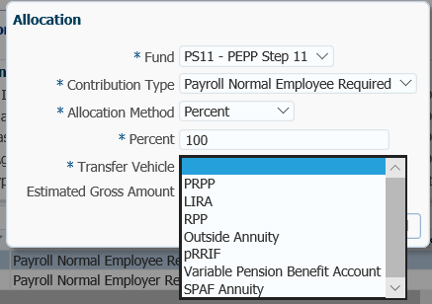

1. In the **Input Data Train** click **Next** to Confirm the Distributions of the payment.

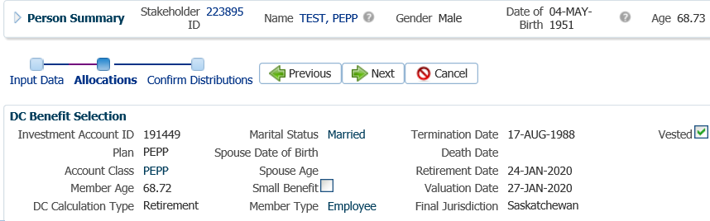

1. In the **Onetime Amounts** region under the **Payment Instruction** column, click onthe drop-down list. If no information is displayed click on **Add New** option.

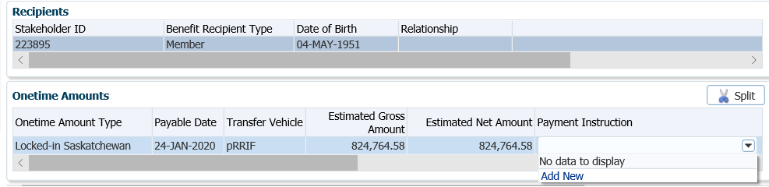

* **NOTE:** if the payee was previously added in the **Payment Instructions** screen under the **Person Profile**, then the information will be displayed in the drop-down list under **Payment Instructions** and can be selected.

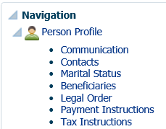

1. In the **Payment Instruction** pop-up window, select the following:

* **Payee Type** - Qualified Financial Institution or if the transfer is to a **LIRA or LRIF**, ensure this is selected as the Payee Type
* **Payment Method** – cheque
* **Receipt Date** – leave as current date
* **Expiry Date** – used for an expiry date of an EFT instructions
* **Payment Note** – add if applicable, the note will appear on the Person Profile menu, Notes screen.
* **Hold for Pickup** – select if a member would like to pick up the cheque
* **Note** - optional
* **Payee Stakeholder ID** – Stakeholder number for the financial institution, if not known click on the **magnifying glass** to perform a search for the financial institution under the **Organizations** menu, see next processing step for procedures
* **Account ID** - number for the transferring institution as noted on the T2151 form
* **Address Type** – will default to primary address for Payee

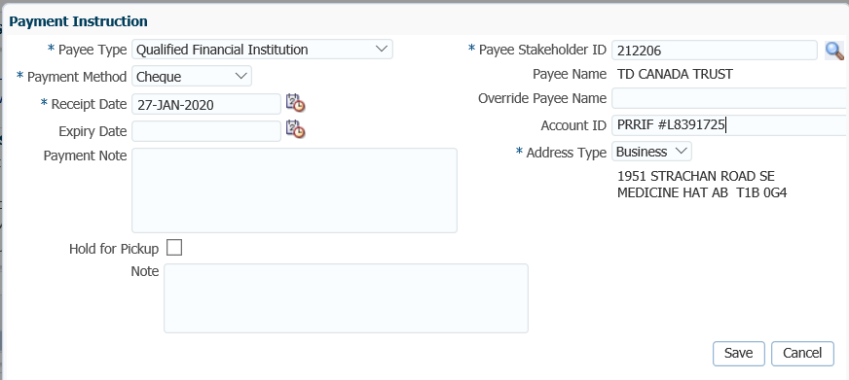

1. If the Payee Stakeholder ID is not known, click on the **magnifying glass**. In the **Search and Select Organization** screen, **Search Parameters** area, click on the drop-down arrow beside **Organization Type,** select **Financial Institution**, click **Search**.



1. In the **Search Results** area, locate the correct financial institution, highlight the name and click **Ok**.

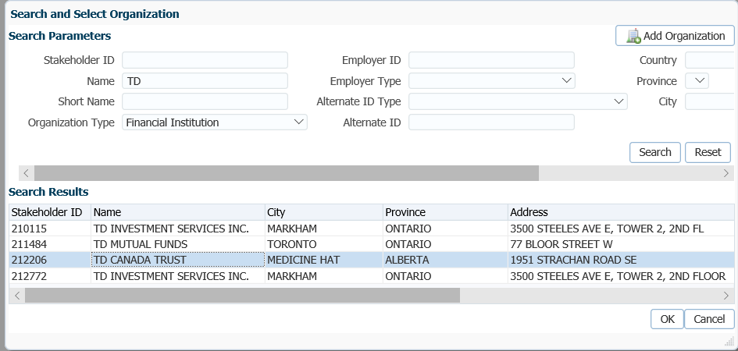

1. The **Payee Stakeholder ID**, the **Payee Name** and **Address** will now be populated in the **Payment Instructions** window. Add the **Account ID** and a **Note** if applicable. Click **Save**.



**Override Payee Name** would be used to set up a payment to an alternate payee name such as a guardian or trustee, “In trust for” or “Estate of”. Choose **Payee Type** of “Self” and enter the alternate payee name in the **Override Payee Name** field.

In order to determine if an alternate **payee name** has been entered, the auditor of the payment has to click on the **Payment Instructions** tab to determine if there is a different payee name listed. If an Account ID is not provided on the T2151 form, enter the member’s SIN.

The **Account ID** is to be used when the payee type is set to Qualified Financial Institution E.g. used to enter RRSP/LIRA account number.

The **Notes** region will display any notes that were added during the calculation as well as allow the user to add more notes that pertain to the selected DC Benefit Selection.

1. In the **Input Data** **train**, click **Submit for Approval**.

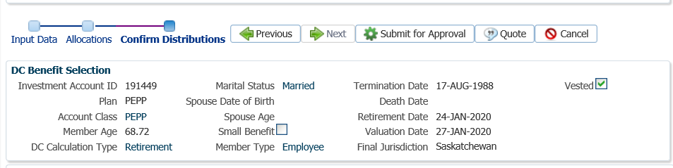

1. The *Pension Specialist* or *Supervisor* will audit and approve the payment in the **DC Benefit Selection** region by clicking **Approve**,or **Reject** if there were errors or the payment was done in error**.**

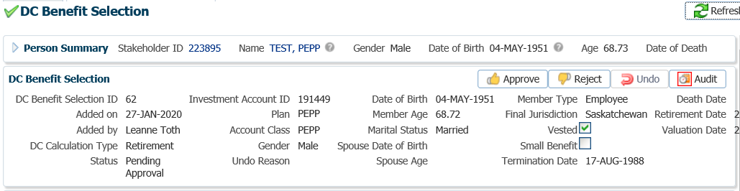

* **NOTE:** If the payment is **Rejected,** the payment steps will need to be entered again by the *Pension Information Officer*. There is no option to edit the existing information.

The **Reject** button is enabled if the status is **Pending Approval** or **Approved**. If the payment is rejected the status will update to **Rejected** when clicked and prevent the benefit selection from being processed by the investment batch.

The **Undo** button is enabled only if the status is **Processed** and will update the status to **Pending Undo** after selecting **Save.** Select an **Undo Reason**. After the investment batch runs, the status will be updated to **Undone** as a result of processing the reversal in the investment batch.

1. In the **Approve DC Benefit Selection** pop-up window, add a **Note** and click **Save**.

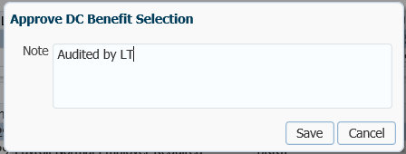

1. A history of Transactions, User and Event is shown under the **Audit** button.

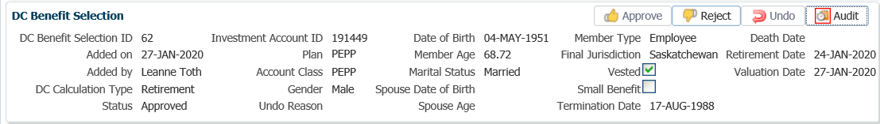

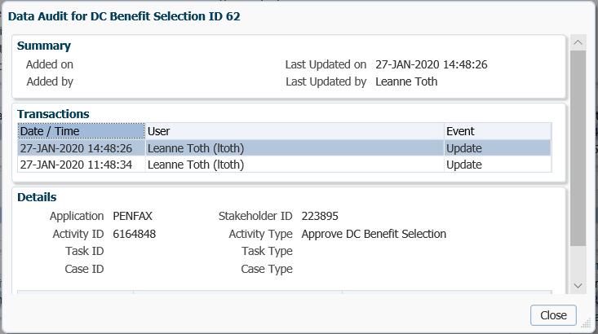

* **NOTE:** Click on the **X** in the **Payment ID Tab** to close the window.

1. The payment will process in the overnight batch process and a cheque will be produced. The payment can be viewed under the **Benefit Recipient** Menu, **Benefits** region. Click on the **Onetime Amounts** tab to see the details.

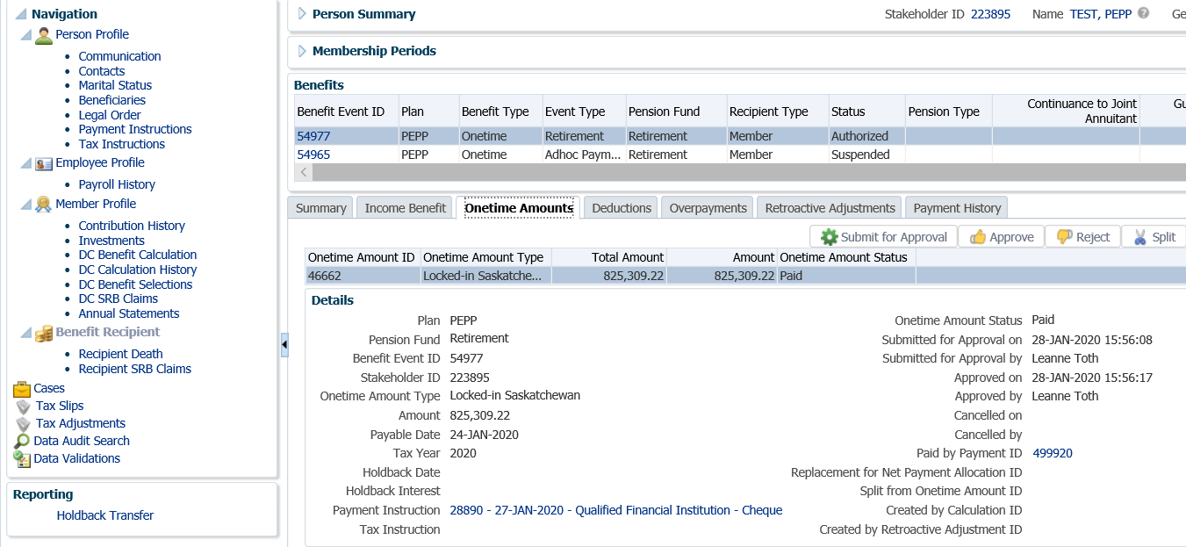

1. To see the Payment details, Recipient (Payee) details, tax deducted and cheque ID number, click on the **ID number** beside the **Paid by Payment ID.**

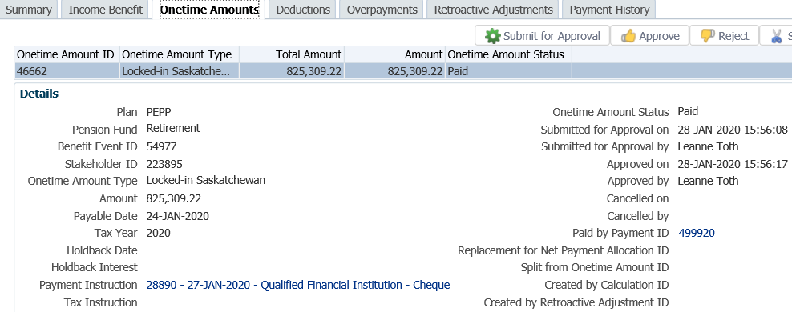

1. Click on the tabs to the right of the screen (**Line Items, Tax, Net Pay Allocation** and **Notes**) to see further details related to the payment.

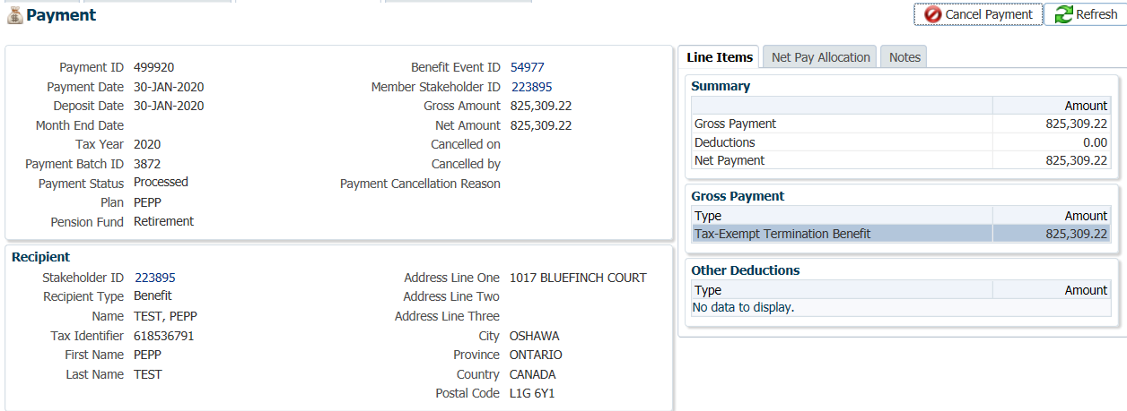

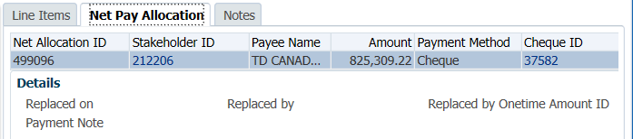

* **NOTE:** Click on the Payment tab **X** to close the window when done viewing.

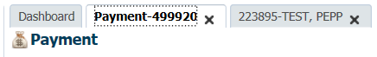

1. A *Withdrawal Confirmation Letter* will be saved under the **Person Profile**, **Communications** screen underthe **Outbound Documents** region. Click on the **Filename** link to open the document.

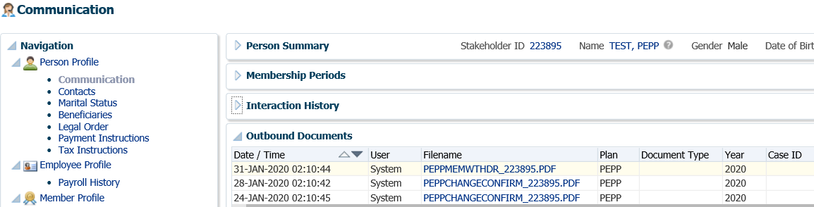

1. Under the **Member Profile** menu, the **Membership Periods** region will nowshow the **Member Status** as Terminated or Retired, depending on the age of the member once the payment is processed overnight.

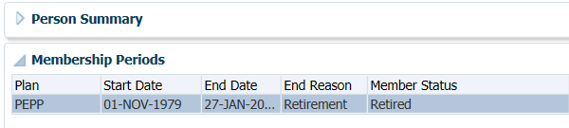

1. Under the **Investments** screen the **Investment Accounts** region will now show the **Account Status** as **Inactive** and the balance under the **Account Summary** region will show $0.00 if all the money was requested to be paid out.

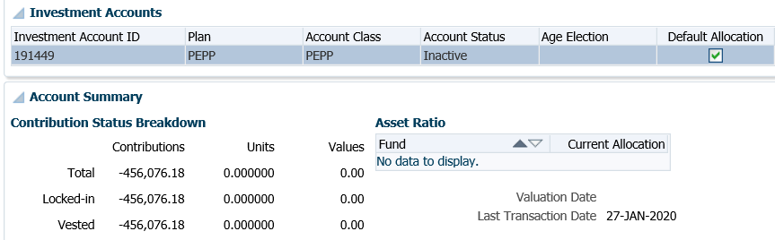

## 2nd Payments

There will be situations when a final payroll contribution is received after the payout of the pension funds at termination or retirement resulting in a second payment to be made to the member or financial institution.

The member has the option to proceed with a payment at termination or retirement prior to PEPP receiving the final payroll contribution. The second payment representing the final payroll contribution can either be made directly to the member in cash, or transferred to the financial institution if the financial institution agrees to accept it.

**Business Process Requirements - 2nd Payment**

* A member must be terminated from all PEPP participating employers (all employment records show terminated or retired status).
* The member’s Plan status must be Terminated or Retired.
* Ensure the final contribution has been received.
* If the final contribution is less than $10.00, a cheque will NOT be issued for this amount unless the member requests one. A Clear Residual Account Balance payment will be processed to remove the money from the member’s account. ***Refer to the Clear Residual Balance procedures***.
* Check PENFAX for any critical notes.
* Determine who the final contribution is to be made payable to; the member or the financial institution. The member is responsible for advising PEPP of this information at the time the initial payment request was received.
* The financial institution must agree to accept the final contribution. If they do not agree, a cash payment to the member must be made.
* 100% of the account balance must either be paid in cash or transferred to the registered product the first payment was made to.
* If the final contribution is to be transferred to a financial institution, make a copy of the initial T2151 form to send along with the 2nd payment cheque.
* If the initial account balance was transferred to a financial institution as locked-in, the final contribution will be transferred as locked-in.
* If the member chose the Small Pension Payment option to be taken in cash, the final contribution will be made payable to the member.
* If the member has transferred the account balance to the Variable Pension Benefit (VPB), the funds can be transferred to VPB.

#### How to Process a 2nd Payment

1. Search for the member in PENFAX.
2. Verify that the required forms and documents have been received, signed and certified if required and that the option chosen by the member is allowed as per the business process requirements for a 2nd payment.
3. Check the **Employee Profile** menu under the **Membership Periods** to ensure the **Member Status** is showing as **Terminated** or **Retired**.

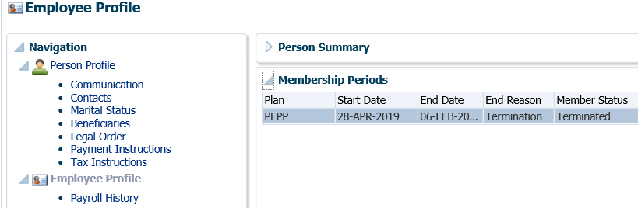

1. Under the **Employee Profile** menu, **Payroll History** screen, determine if the final contribution has been received under the **Payroll History** region.

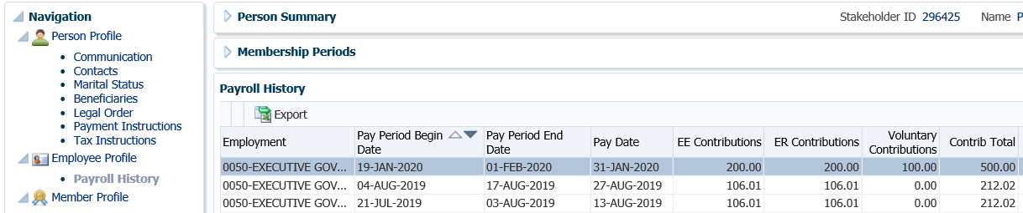

1. Determine the amount, if under $10.00 ***refer to the Clear Residual Balance Procedures***.
2. Check the member **Notes** to determine how the member would like the final contribution to be paid, in cash or transferred to a financial institution if the initial payment was transferred out.

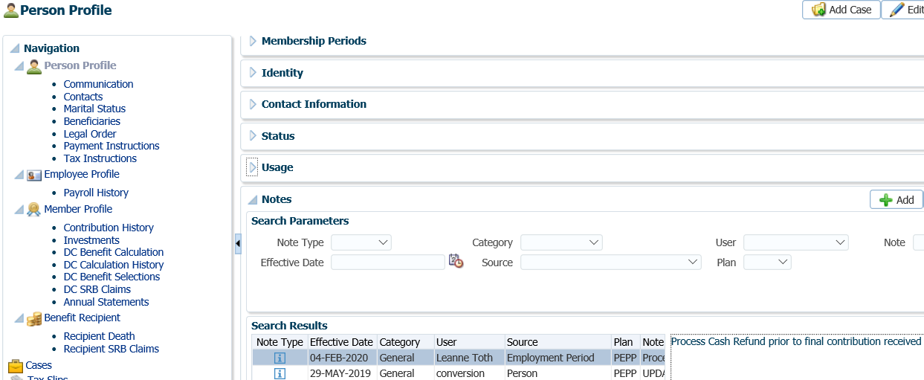

1. Under the **Navigation** menu, click on the **DC Benefit Selections** screen. Click **Add** to add a new payment in the **DC Benefit Selections** region.

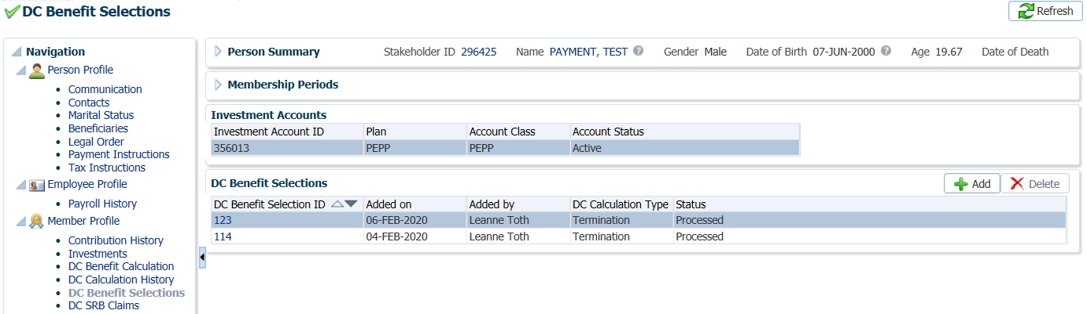

1. In the **Input Data** train, enter the **Retirement Date** if the member is over age 50. Click **Next** to start the **Input Data** process.

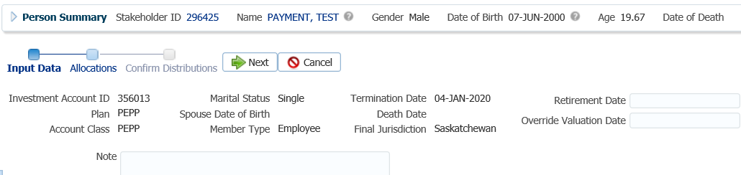

* **NOTE:** a **Retirement Date** is required when a member is over age 50 so that all retirement options will be made available. The current date can be used as the **Retirement Date**.

1. In the **Input Data train** under the **Allocations** regionclick **Add**.

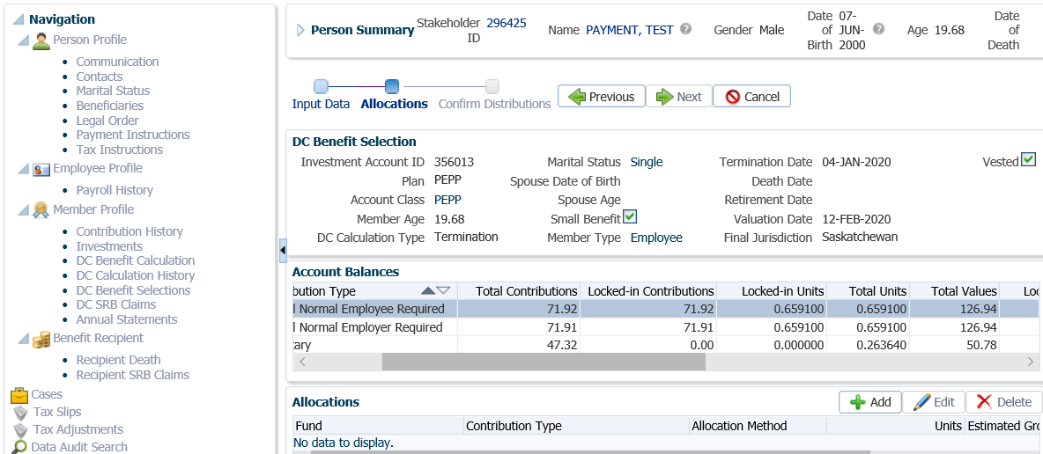

1. In the **Allocation** pop-up window, select a fund from the drop-down list. A second window will open.

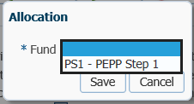

1. In the second **Allocation** pop-up window, select the **Contribution Type** from the drop-down list, the **Allocation Method** (percent, dollar amount, or units) and the **Transfer Vehicle** from the drop-down list. Click **Save**.

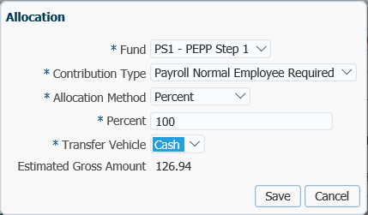

1. Run the **Allocation** step for each **Contribution Type** the member holds. Follow the same process as in Steps 9, 10 and 11.

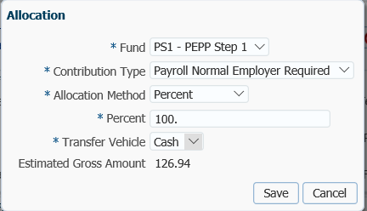

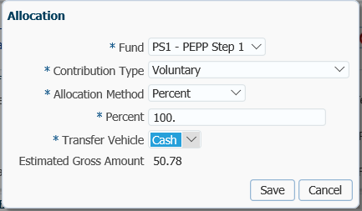

* **NOTE:** the **Contribution Type** and **Allocation Method** and **Transfer Vehicle** will vary depending on the member’s request and the contribution types each member holds.

1. In the **Input Data Train** click **Next** to Confirm the Distributions of the payment.

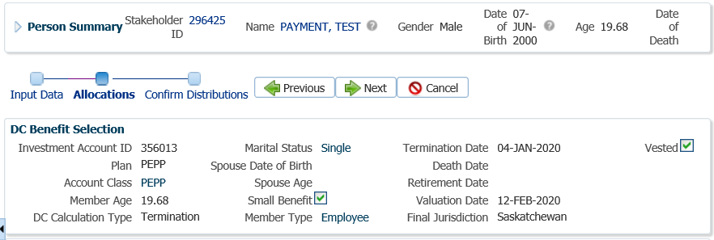

* **NOTE:** if the payee was added in the **Payment Instructions** screen previously then the information will be displayed in the drop-down list under **Payment Instructions** and can be selected.



1. Under the **Onetime Amounts** region, **Payment Instruction** field, click on the drop-down arrow to select a **Payment Instruction**, select **Add New** to select a different payee in the **Payment Instruction** pop-up window.

* **NOTE:** In this example payee type of **“Self”** was used to pay the 2nd payment to the member in cash. If the initial payment was transferred to a Qualified Financial Institution it will be listed in the drop-down list under **Payment Instruction** and can be selected.

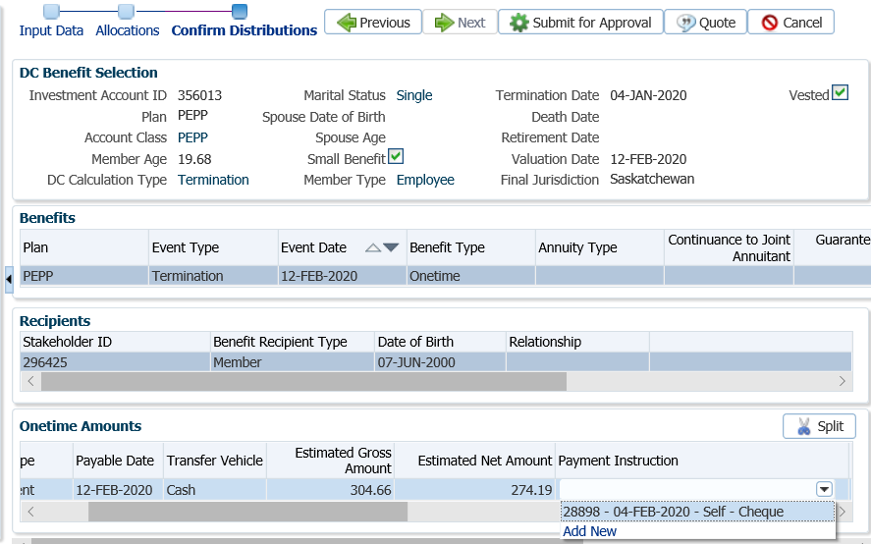

1. The **Payee Stakeholder ID**, the **Payee Name** and **Address** will now be populated in the **Payment Instructions** window. Add the **Account ID** and a **Note** if applicable. Click **Save**.

**Override Payee Name** would be used to set up a payment to an alternate payee name such as a guardian or trustee, “In trust for” or “Estate of”. Choose **Payee Type** of “Self” and enter the alternate payee name in the **Override Payee Name** field.

* In order to determine if an alternate **payee name** has been entered, the auditor of the payment has to click on the **Payment Instructions** tab to determine if there is a different payee name listed. If an Account ID is not provided on the T2151 form, enter the member’s SIN.

The **Account ID** is to be used when the payee type is set to Qualified Financial Institution E.g. used to enter RRSP/LIRA account number.

The **Notes** region will display any notes that were added during the calculation as well as allow the user to add more notes that pertain to the selected DC Benefit Selection.

1. **Tax Instructions** are not required to be added for cash payments. PENFAX will determine if tax is required to be deducted by the Transfer Vehicle chosen in the Allocation step and apply the appropriate tax rate of 10%, 20% or 30%.
2. In the **Input Data** **train**, click **Submit for Approval**.

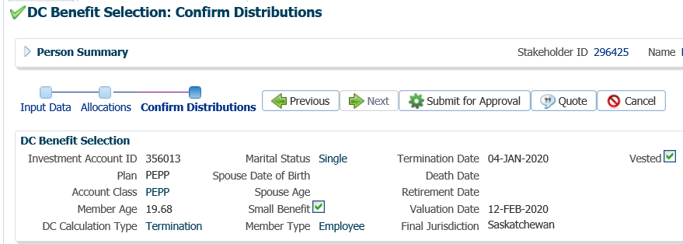

1. The *Pension Specialist* or *Supervisor* will audit and approve the payment in the **DC Benefit Selection** region by clicking **Approve**,or **Reject** if there were errors or the payment was done in error**.**

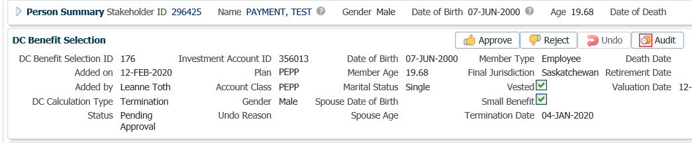

* **NOTE:** If the payment is **Rejected,** the payment steps will need to be entered again by the *Pension Information Officer*. There is no option to edit the existing information.

The **Reject** button is enabled if the status is **Pending Approval** or **Approved**. If the payment is rejected the status will update to **Rejected** when clicked and prevent the benefit selection from being processed by the investment batch.

The **Undo** button is enabled only if the status is **Processed** and will update the status to **Pending Undo** after selecting **Save.** Select an **Undo Reason**. After the investment batch runs, the status will be updated to **Undone** as a result of processing the reversal in the investment batch.

1. In the **Approve DC Benefit Selection** pop-up window, add a **Note** and click **Save**.

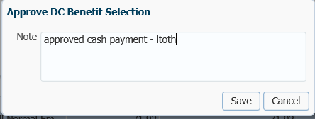

1. A history of Transactions, User and Event is shown under the **Audit** button.

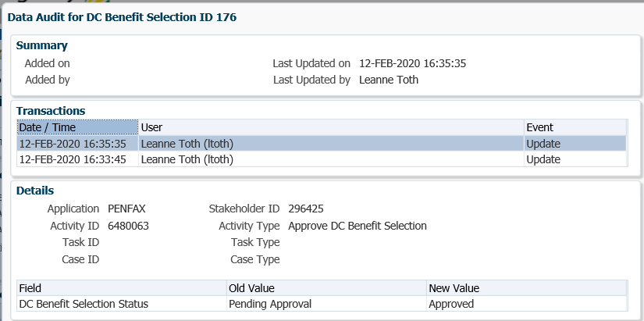

* **NOTE:** Click on the **X** in the **Payment ID Tab** to close the window.

1. The payment will process in the overnight batch process and a cheque will be produced. The payment can be viewed under the **Benefit Recipient** Menu, **Benefits** region. Click on the **Onetime Amounts** tab to see the details.

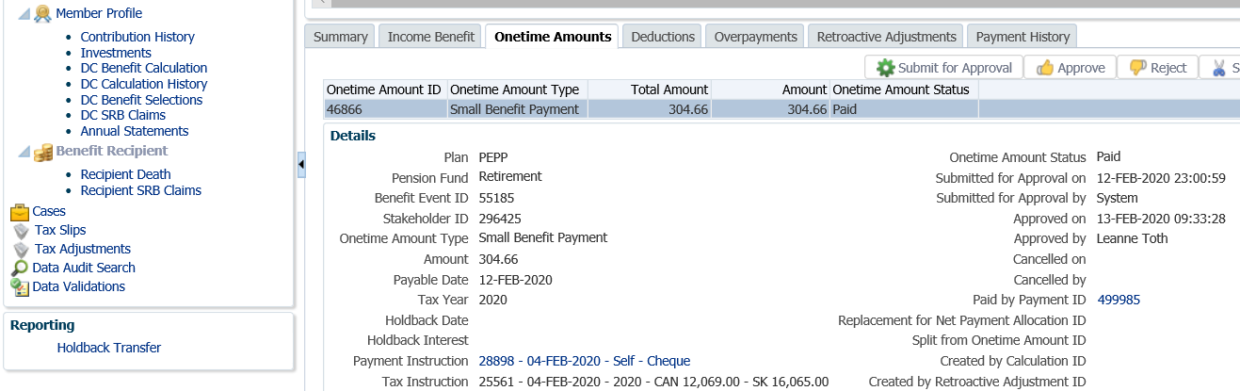

1. To see the Payment details, Recipient (Payee) details, tax deducted and cheque ID number, click on the **ID number** beside the **Paid by Payment ID.**

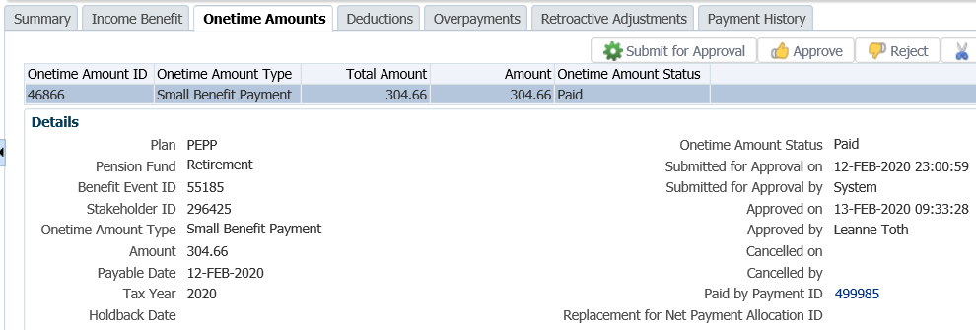

1. In the **Payment** screen, click on the tabs to the right of the screen (**Line Items, Tax, Net Pay Allocation** and **Notes**) to see further details related to the payment.

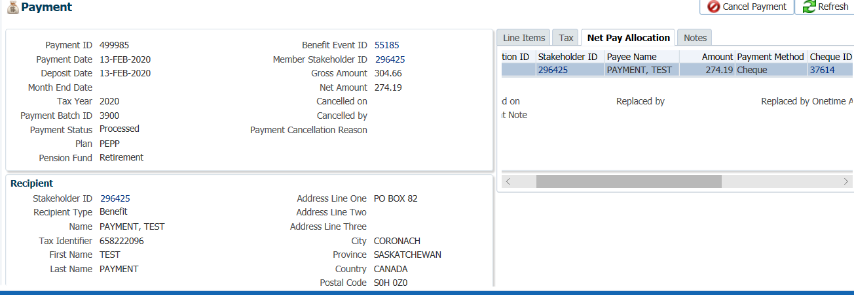

* **NOTE:** Click on the Payment tab **X** to close the window when done viewing.



1. A *Withdrawal Confirmation Letter* will be saved under the **Person Profile**, **Communications** screen underthe **Outbound Documents** region.

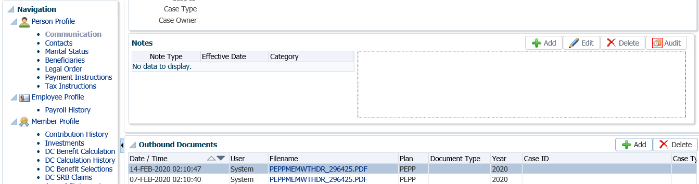

1. If the 2nd Payment was paid to the member in cash, a **Tax Slip** will be issued at the end of the year and saved under the **Navigation** menu, **Tax Slips** screen.



1. Under the **Member Profile** menu, the **Membership Periods** region will still show the **Member Status** as Terminated or Retired (depending on the age of the member) from the initial payout, once the payment is processed overnight.

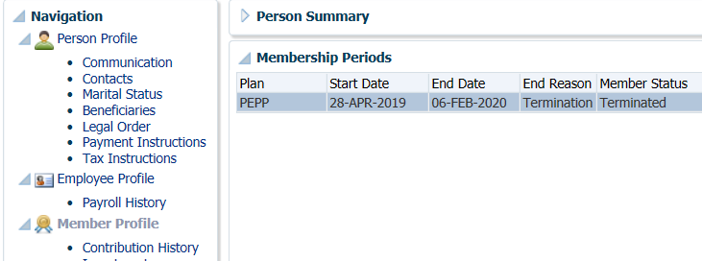

1. Under the **Investments** screen the **Investment Accounts** region will now show the **Account Status** as **Inactive** and the balance under the **Account Summary** region will show $0.00 if all the money was requested to be paid out.

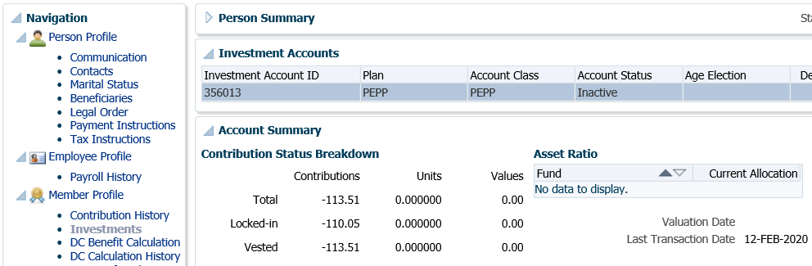

## Transfer to SPAF or Outside Annuity

Upon retirement, members can choose to all or a portion of their PEPP account to the Saskatchewan Pension Annuity Fund (SPAF), or purchase an outside life annuity administered by an insurance company.

A life annuity provides a fixed monthly retirement income guaranteed for the lifetime of a member. Monthly payments are based on the type of annuity and options selected.

SPAF offers two types of annuities, single life annuity and joint life annuity. The single life annuity provides guaranteed fixed monthly income for the member’s lifetime. The joint life annuity provides at a minimum guaranteed fixed monthly payments for the members lifetime, and upon death of the member, payments will continue in whole or as a percentage to the spouse for their lifetime (as per the elected contract). A married member may elect a single life annuity if the spouse waives the right to the lifetime survivor benefit.

Once the SPAF contract has been signed and the annuity issued the member cannot change their decision, alter the terms of the contract or transfer it out. Payments from SPAF are fixed and do not increase with inflation (non-indexed).

Business Process Requirements - Transfer to SPAF or Outside Annuity

* Members must be age 50 or older.
* Member must be terminated from all PEPP participating employers (all employment records show terminated or retired status).
* The Plan status must be Deferred.
* Ensure the final contribution has been received. If the final contribution has not been received, contact the member to find out if they want to proceed without it or wait to have the transfer processed after it has been is received.
* Members may transfer a portion of their pension to an annuity or the full account balance.
* Members must complete the *Retirement Option* form or the *Death Option* form.
* Members will receive an annuity estimate for SPAF if choosing to stay with PEBA.
* Members must complete and provide the following:
  + *Application for Saskatchewan Pension Annuity Fund*
  + *Spouse’s Consent and Waiver of Post-Retirement Survivor Benefits* form
  + Members in a common-law relationship must complete a *Declaration of Common-Law Relationship* form
  + Proof of Death if their spouse is deceased or the Decree Absolute or Certificate of Divorce if the member is divorced
  + *Canada Revenue Agency form TD1 Personal Tax Credits Return (*federal and provincial forms)
  + Proof of age, a certified copy of their birth certificate, passport or driver’s license
  + Married members must submit a certified copy of their marriage certificate and a certified copy of their spouse’s birth certificate
  + Void personal cheque
* Verify the member’s SIN on the *Application for Saskatchewan Pension Annuity Fund* to the SIN on the PENFAX account to ensure it matches
* If members are transferring to an outside annuity with an insurance company a T2151 form and the *Spouse’s Consent and Waiver of Post-Retirement Survivor Benefits* formare required.
* If any information is missing on the form follow up with the member. ***Refer to Procedures to Obtain Missing Information***.

#### How to Process a Transfer to SPAF or an Outside Annuity

1. Search for the member in PENFAX.
2. Verify that all required documents and forms have been received, signed and certified if required and that the option chosen by the member is allowed as per the business process requirements for a transfer to SPAF or outside annuity payment.
3. Under the **Person Profile** menu, **Status** region, click **Add** to add the *Spouse’s Consent and Waiver of Post-Retirement Survivor Benefits* form information. This will indicate the percentage the member’s spouse has indicated on the form.

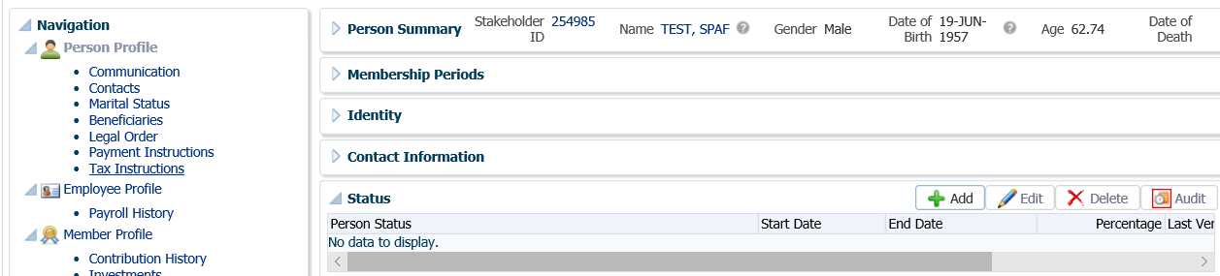

1. In the **Person Status** pop-up window under **Person Status** select **PEPP Life Annuity Waiver – Spousal Consent**, **Start Date** is the date the consent form was sign. PENFAX will automatically populate the **End Date** to be 90 days from the start date. Under **Percentage** indicate the percentage from the consent form. Click **Save**.

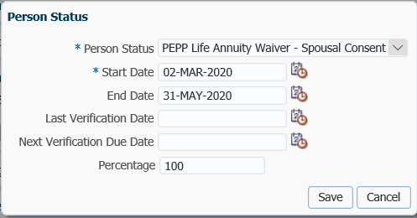

1. Check the **Employee Profile** menu to ensure the termination information has been received and entered into PENFAX.

Under the **Membership Periods** region ensure the **Member Status** is showing as Deferred.

Under the **Employment Periods** region confirm the following information has been entered:

* **End Date**
* **End Reason** is Terminated or Retired
  + **Final Jurisdiction**

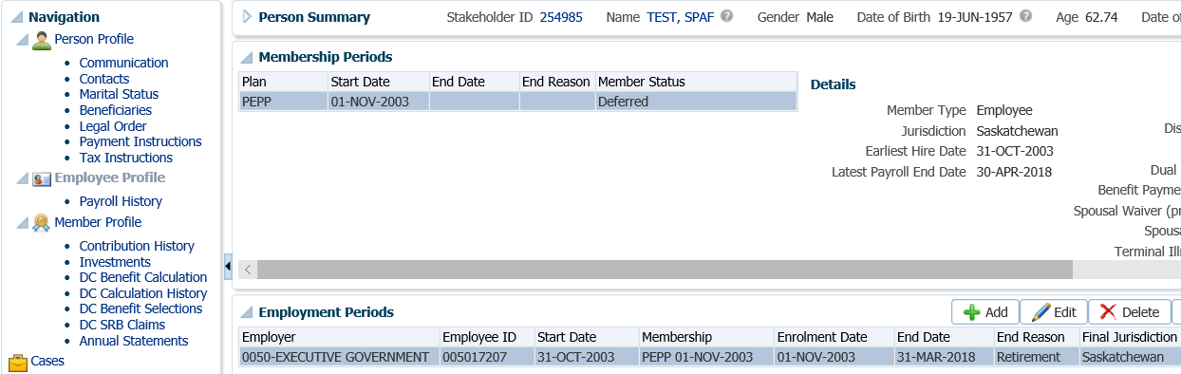

1. Under the **Employee Profile** menu, **Payroll History** screen, determine if the final contribution has been received, if the employment termination date has been recent. Expand the **Payroll History** region to see the payroll contributions.

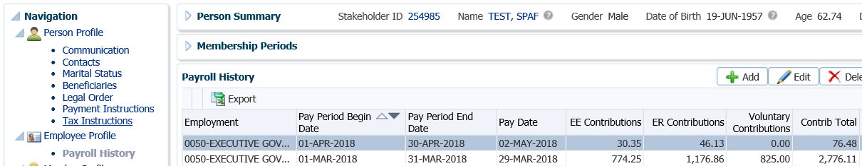

* **NOTE:** If the final contribution has not been received, contact the member to find out if they want to proceed without it or wait to have the transfer processed after it has been received. If the member wants to wait, suspend your assigned Case.

1. Under the **Navigation** menu click on the **DC Benefit Selections** screen. Highlight the **Investment Account** the payment pertains to, PEPP or VPB.

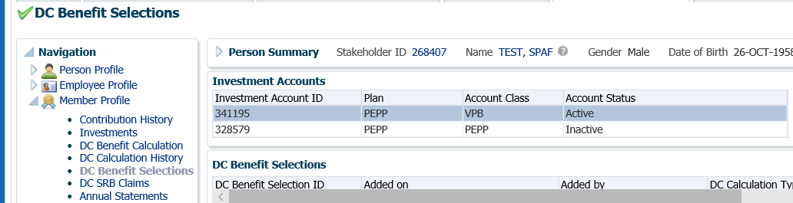

1. If the member is in VPB and receiving scheduled payments, the payment schedule needs to be suspended. Click on the **Benefit Recipient** menu. Under the **Authorization History** region, click **Suspend**.

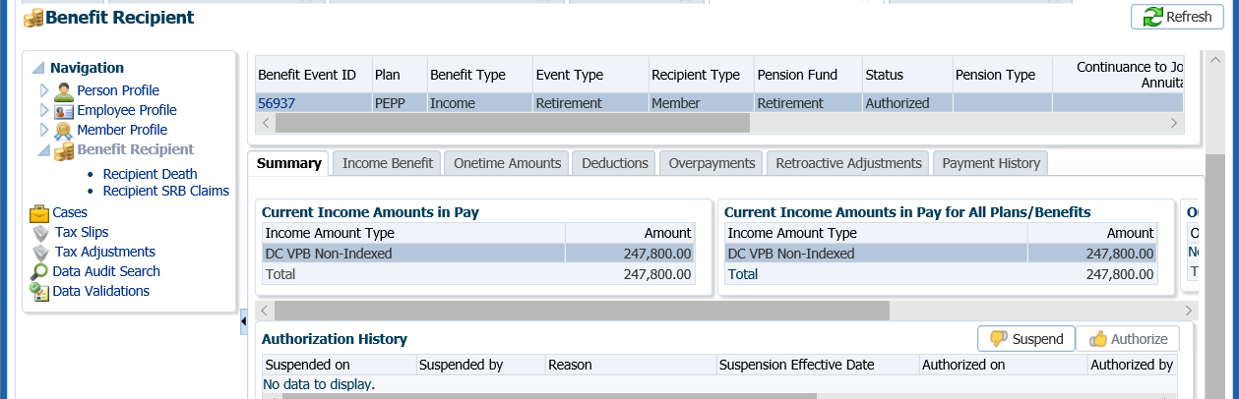

1. In the **Suspend Benefit Recipient** pop-up window, select a **Reason** and add a **Note**. Click **Save.**

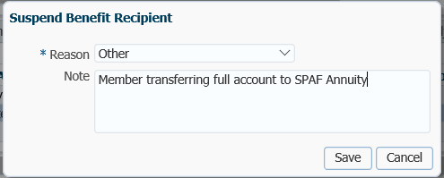

1. Highlight the correct **Investment Account** and click **Add** to add a new payment in the **DC Benefit Selections** region.

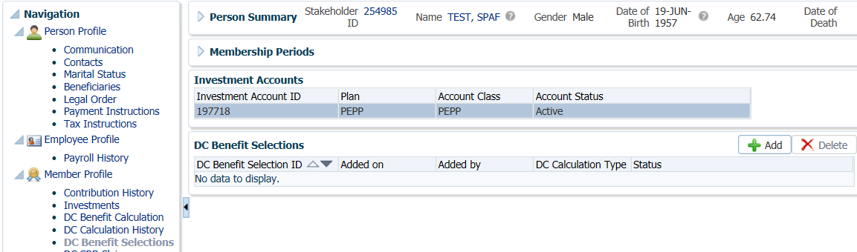

1. In the **Input Data** train, enter the **Retirement Date** (current date can be used), click **Next** to start the **Input Data** process.

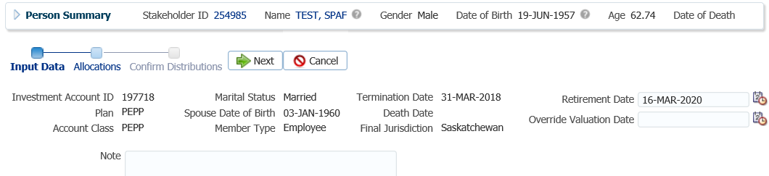

1. In the **Input Data** train under the **Allocations** region click **Add**.

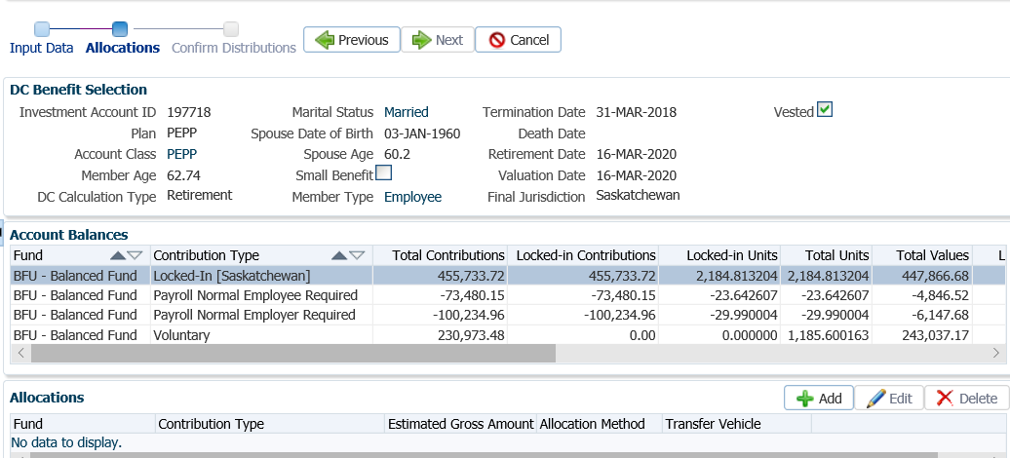

1. In the **Allocation** pop-up window, select the information applicable to the SPAF transfer and click **Save** once completed.
   * **Fund –** BFU Balanced Fund
   * **Contribution Type -**  Locked-In (Saskatchewan) perform Steps 6 & 7 to Add all contribution types to include in the payment to SPAF
   * **Allocation Method –** Percent
   * **Percent –** 100
   * **Transfer Vehicle –** SPFA Annuity (an Annuity Option chart will appear) highlight the Annuity Option chosen by the member on the *SPAF Application* form
   * **Estimated Gross Amount –** PENFAX will auto populate based on the percentage chosen

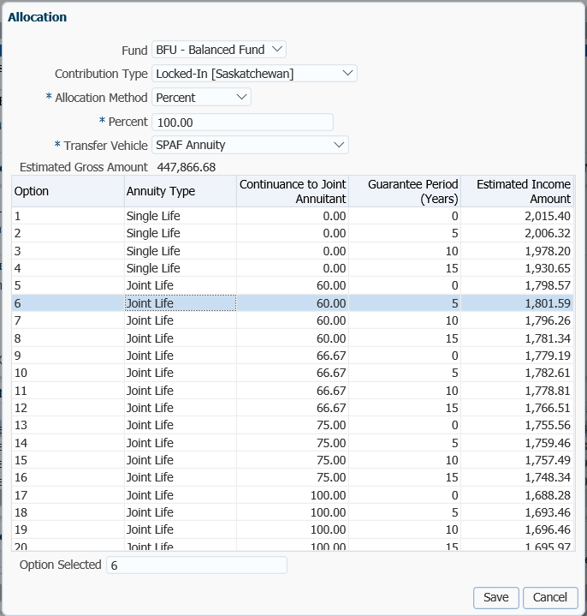

* **NOTE:** The **Allocation** region will show you the **Contribution Type(s)** that have been included in the payment.



1. In the **Input Data** **Train** click **Next** to Confirm the Distributions of the payment.

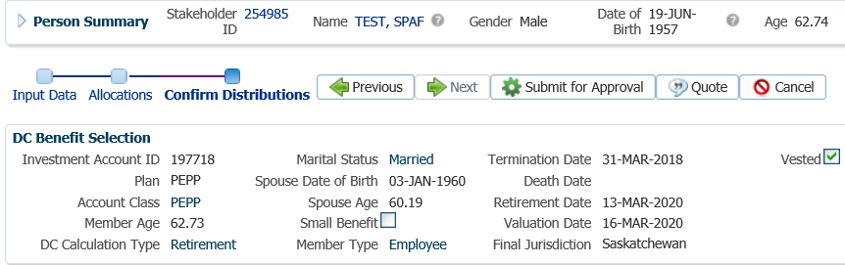

1. Highlight the **Benefits** region, **Plan** type of **PEPP**. In the **Onetime Amounts** region under the **Payment Instruction column**, click on thedrop-down list. Click on the **Add New** option.

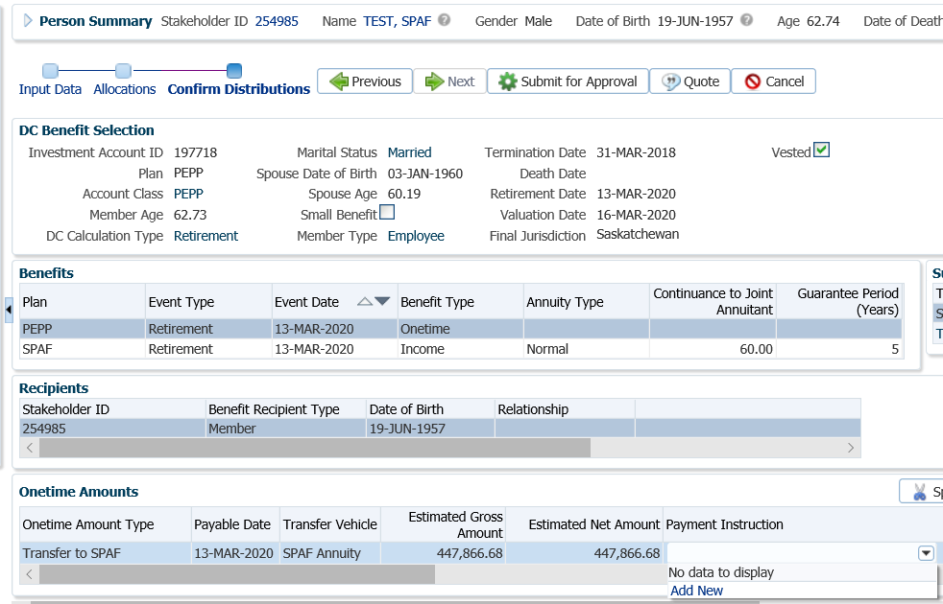

* **NOTE:** if the tax instructions were previously added in the **Tax Instructions** screen under the **Person Profile**, then the information will be displayed in the drop-down list under **Tax Instructions** and can be selected.

1. In the **Payment Instruction** pop-up window, under **Payee Type** select **Qualified Financial Institution,** under **Payment Method** select **Cheque**, leave the **Receipt Date** as the **current date**. Select the **Payee Stakeholder ID** for SPAF. Click on the magnifying class to search for the Stakeholder ID if it is not known, ***refer to PENFAX procedures, Searching for Organization Records***.

Click **Save** once completed.

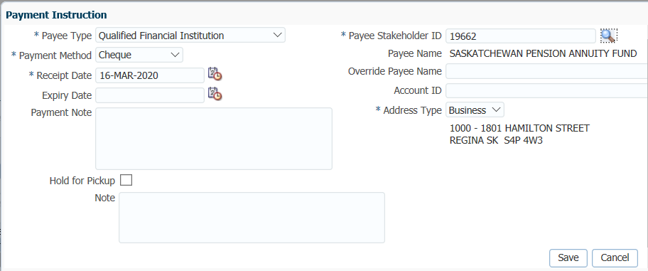

1. Under the **DC Benefit Selections** menu, **Benefits** region, highlight the **Plan** type of **SPAF**. Under the **Onetime Amounts** region, **Payment Instructions** column, click on the drop-down arrow and select **Add New.**

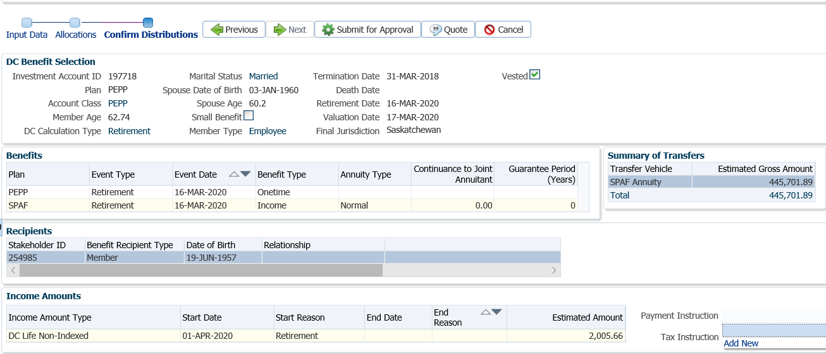

1. In the **Payment Instruction** pop-up window, under **Payee Type** select **Self,** under **Payment Method** select **EFT – Canadian**, leave **Receipt Date** as the current date and enter the **Bank Number, Transit Number** and **Account Number** as per the void cheque provided by the member with the *SPAF Application form*.

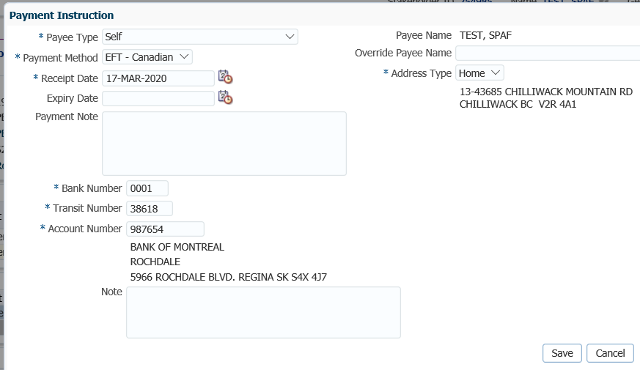

1. In the **Onetime Amounts** region under **Tax Instructions**, click on thedrop-down list. Click on the **Add New** option.

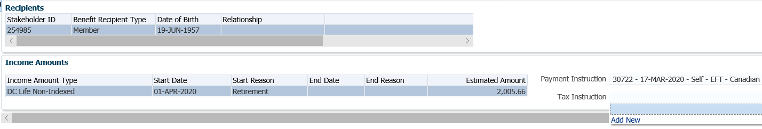

1. In the **Tax Instruction** pop-up window leave the **TDI Type** as **Advanced**. Enter in the information provided by the member on the Federal and Provincial TD1 forms. Click **Save** once completed.

**ADVANCED TD1 Type**

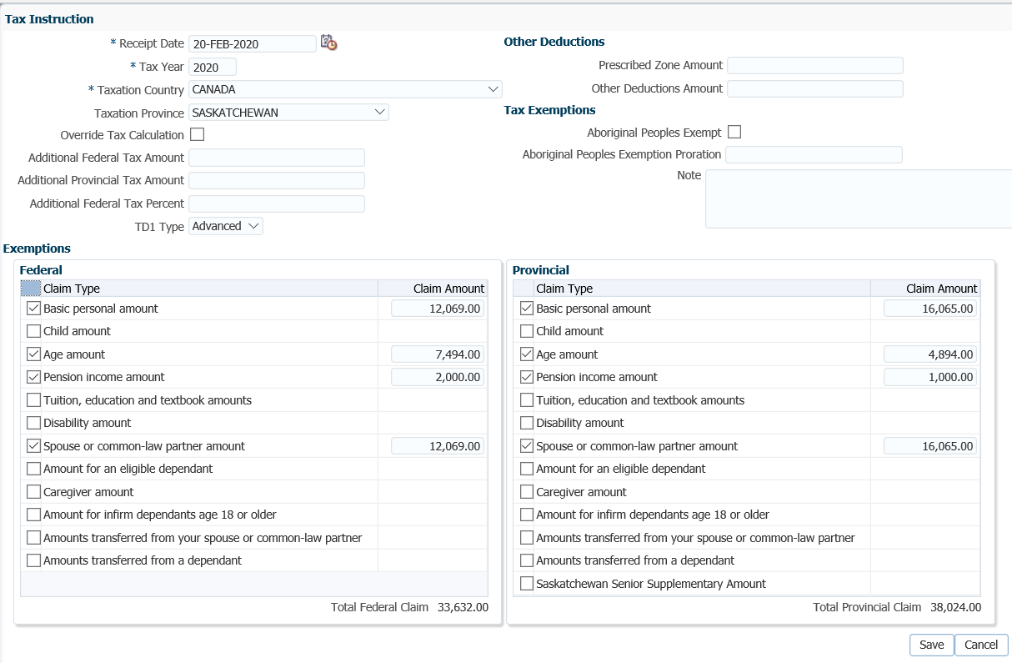

1. In the **Input Data** **train**, click **Submit for Approval** once all the details are update.

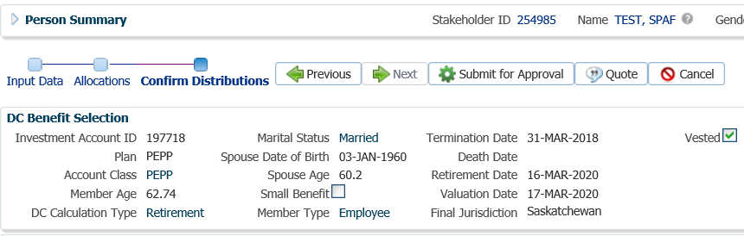

1. The *Pension Specialist* or *Supervisor* will audit and approve the payment in the **DC Benefit Selection** region by clicking **Approve,** or **Reject** if there were errors or the payment was done in error**.**

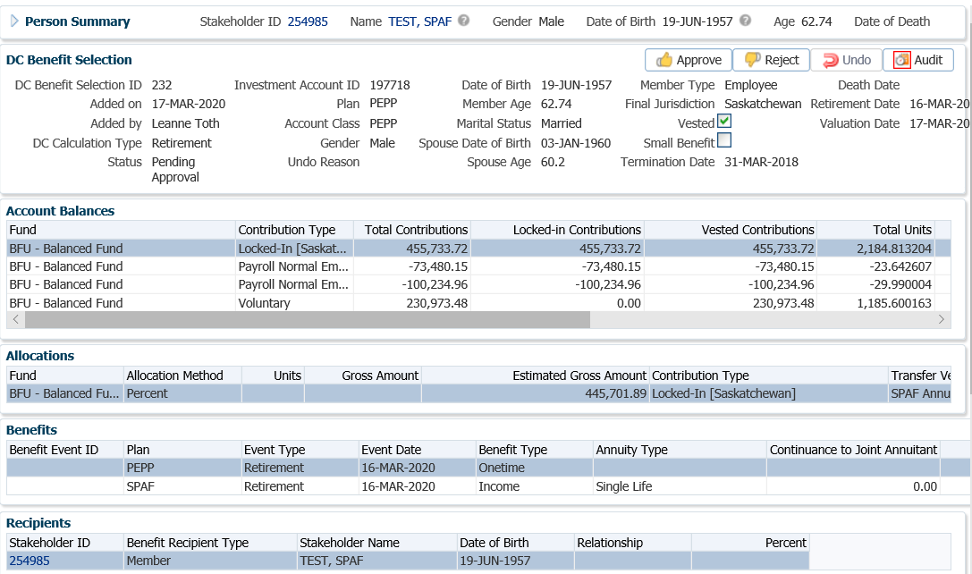

* **NOTE:** If the payment is **Rejected,** enter in a reason for the rejection. The payment steps are required to be entered again by the *Pension Information Officer*. There is no option to edit the existing information.

The **Reject** button is enabled if the status is **Pending Approval** or **Approved**. If the payment is rejected the status will update to **Rejected** when clicked and prevent the benefit selection from being processed by the investment batch.

The **Undo** button is enabled only if the status is **Processed** and will reverse the payment in the investment batch.

1. In the **Approve DC Benefit Selection** window, add a **Note** and click **Save**. Return to payment request to the *Pension Information Officer*.

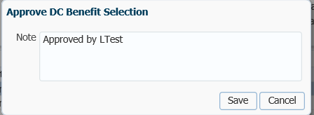

1. A history of Transactions, User and Event is shown under the **Audit** button. Click **Close** to close the Data Audit window.

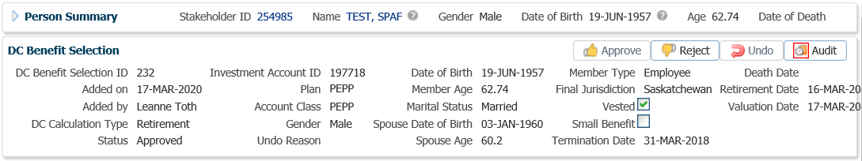

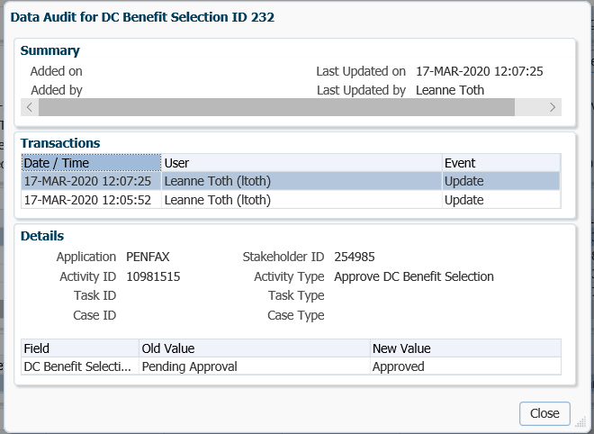

1. To close the **DC Benefit Selection** tab, click on the **X** in the tab.



1. The payment will process in the overnight batch process and a cheque will be produced for deposit to the SPAF account. The payment can be viewed under the **Benefit Recipient** Menu. Highlight the **PEPP** Plan under the **Benefits** region. Click on the **Onetime Amounts** tab to see the details of the transfer to SPAF. The **Onetime Amount Status** will now show as **Paid.**

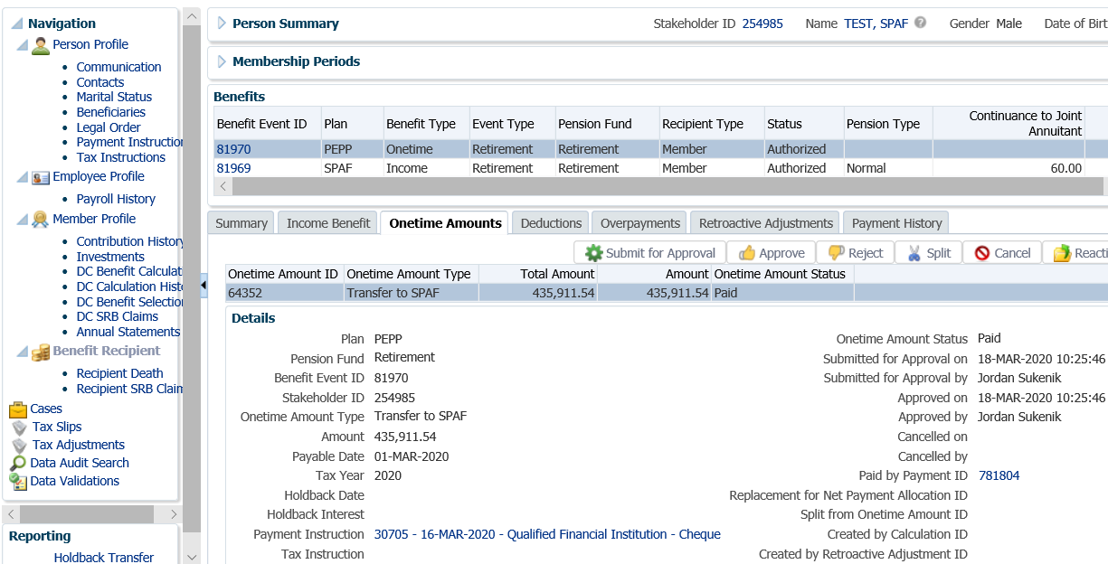

1. In the **Onetime Amounts** tab, click on the **ID number** beside the **Paid by Payment ID** to see the Payment details, Recipient (Payee) details, tax deducted and cheque ID number**.**

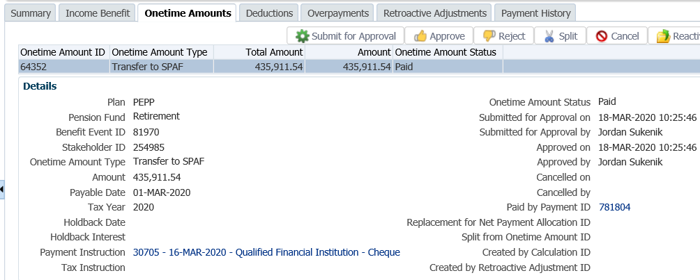

1. When in the **Paid by Payment ID** details, click on the tabs to the right of the screen (**Line Items, Tax, Net Pay Allocation** and **Notes**) to see further details related to the payment.

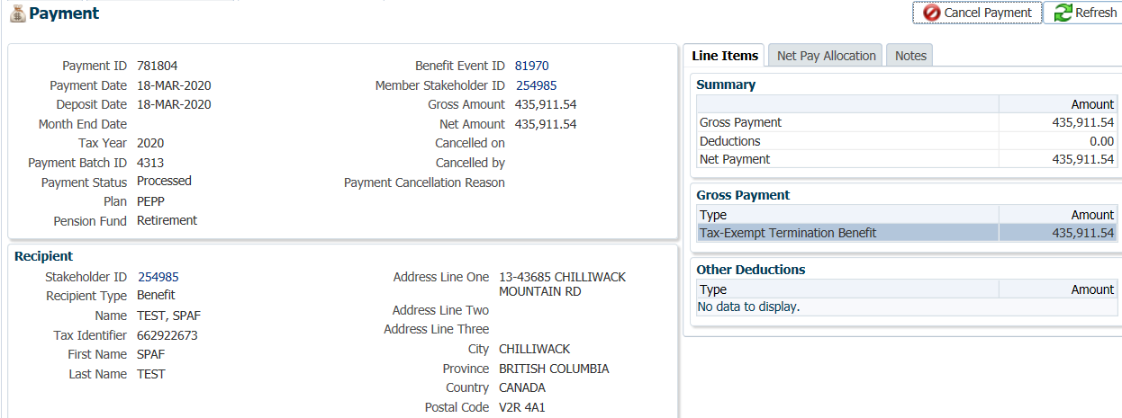

* **NOTE:** Click on the **X** in the **Payment ID Tab** to close the window.



1. To see the selected SPAF Annuity option and details, highlight the **SPAF** Plan under the **Benefits** region. The **Payment Information** and **Tax Instructions** will appear in the lower region under the **Income Benefit** tab.

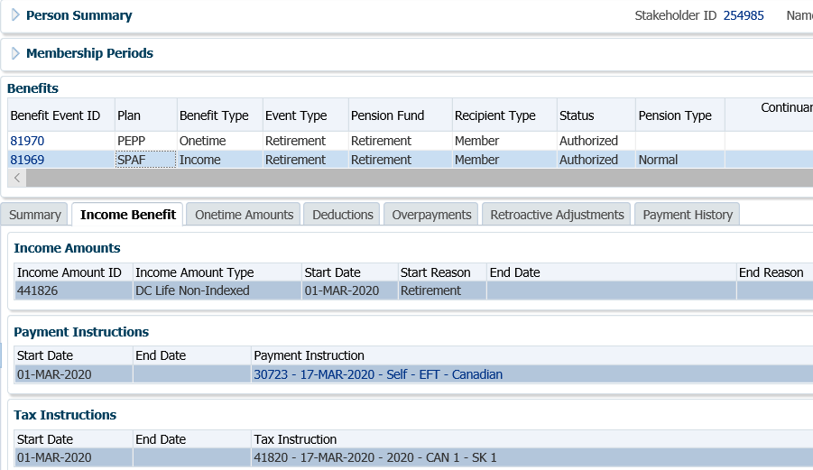

1. A *Withdrawal Confirmation Letter* will be produced overnight. The letter will be saved under the **Person Profile**, **Communications** screen underthe **Outbound Documents** region. Click on the **Filename** link to open the document.

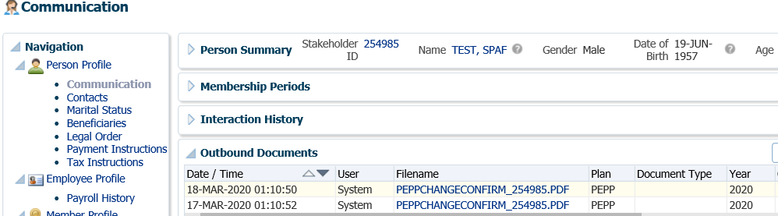

1. The balance under the **Investments** screen, **Account Summary** region will reflect a balance of $0.00 if all the funds were used to purchase a SPAF Annuity, or the difference of the amount requested to purchase the annuity. *In this scenario the member only used a portion of the pension to purchase an annuity so there are still funds remaining.*

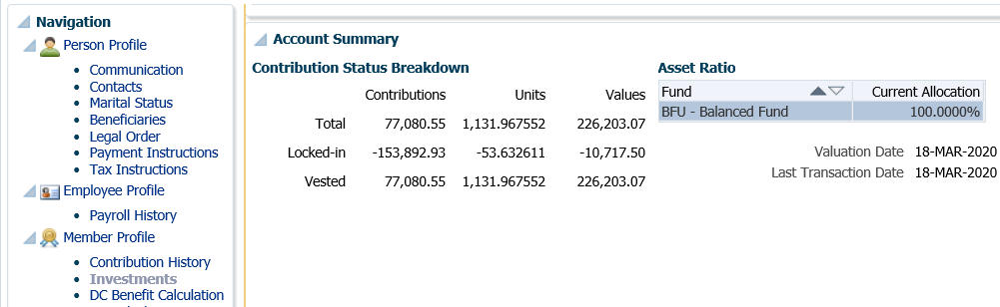

1. If the entire PEPP account balance was transferred to SPAF then the **Membership Periods** under the **Person Profile** would be reflected as **Member Status,** Retired. *In this scenario the member only used a portion of the pension to purchase an annuity so the* ***Member Status*** *is still showing as Deferred.*

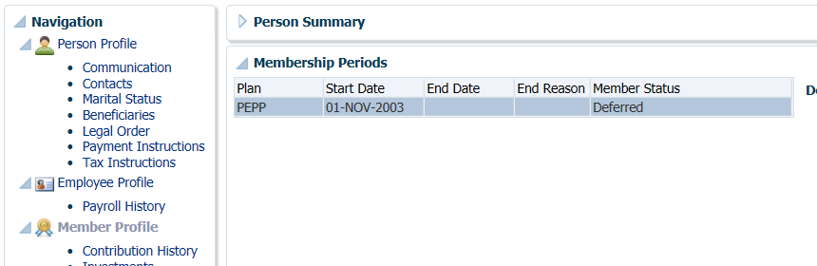

1. Create a manual SPAF Welcome Letter to inform the annuitant of the option chosen and the monthly amount. **QUESTION**: what if a 1 time catch up payment/retro payment is required? Who calcs? Who enters?

## Non-Resident Payment

A member that has been living outside of Canada for a minimum of 2 years can request to have their PEPP account balance paid out to them as a lump sum cash refund if they qualify, under the *Income Tax Act* non-residency requirements.

If a member qualifies, they must withdraw their entire account balance as a single lump sum cash payment. All lump sum payments are taxable based on the non-resident tax rate of 25% and paid in Canadian currency. This rate may be lower if Canada has a tax treaty with the non-resident’s country. A Canada Revenue Agency NR4 *Statement of Amounts Paid or Credited to Non-Residents of Canada* form will be issued for the payment amount.

Business Process Requirements - Non-Resident Payment

* Determine if the member is eligible for the payment. Members must meet the following qualifications:
* Must be terminated with all PEPP participating employers;
* The member’s Plan status must be Deferred;
* Must be a non-resident of Canada;
* Has not resided in Canada for at least two consecutive years;
* Has not started receiving a pension benefit;
* Is not eligible for a Small Pension Payment;
* Must withdraw the entire account balance.
* Provide the Determination of Residency Status Form to Canada Revenue Agency (CRA) to initiate the process.
* CRA will send a letter to the member to forward to PEPP confirming the member is a non-resident*.*
* Members must complete and submit the *Pension Benefits 1993 Form 4: Certificate of Non-Residency* and send it to PEPP with the letter from CRA*.*
* If the member is married, the spouse must complete a *Pension Benefits 1993 Form 5: Spouse’s Consent to the Withdrawal and Waiver of Entitlements under a Pension Plan or a LIRA Contract for Non-Residency Status.* PEPP must receive this form along with the letter and Form 4.
* Verify the member’s SIN on the T2151 form to the SIN on the PENFAX account to ensure it matches.
* Determine if Identification is required from the member. ***Refer to the procedures,******When is Identification Required from a Member***.
* If any information is missing on the form follow up with the member. ***Refer to the******Procedures to Obtain Missing Information.***

#### How to Process a Non-Resident Payment

1. Search for the member in PENFAX.
2. Confirm that the member meets the qualifications for a non-resident payment as outlined in the business process requirements. If so you can then proceed with processing the payment to the member for a lump sum cash payment.

* **NOTE:**  check the marital status, if listed as married ensure the *Pension Benefits 1993 Form 5: Spouse’s Consent to the Withdrawal and Waiver of Entitlements under a Pension Plan or a LIRA Contract for Non-Residency Status.* PEPP must receive this form along with the letter and Form 4.

1. Under the **Navigation, Person Profile** menu, **Membership Periods** region ensure the **Member Status** is showing as **Deferred** and that the member is not in the Variable Pension Benefit receiving payments.

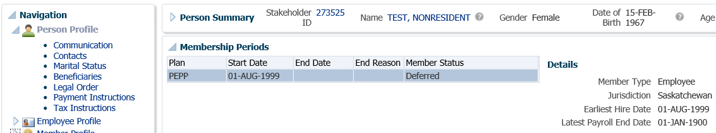

1. Check the **Navigation, Employee Profile** menu to ensure the termination information has been received and entered into PENFAX.

Under the **Employment Periods** region confirm the following information has been entered:

* **End Date**
* **End Reason** is Terminated or Retired
* **Final Jurisdiction**

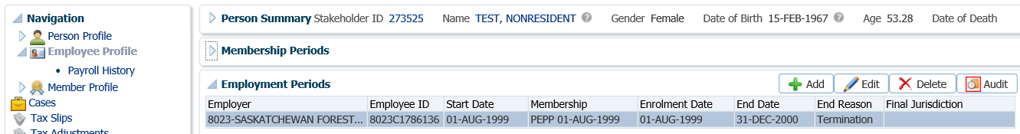

1. Under the **Navigation**, **Member Profile** menu click on the **DC Benefit Selections** screen. Click **Add** to add a new payment under the **DC Benefit Selections** region.

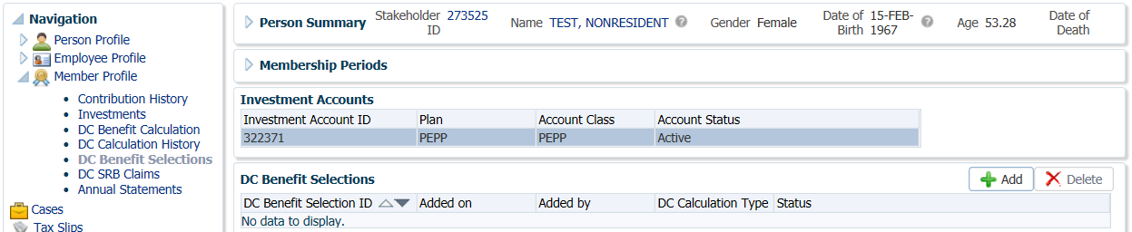

1. In the **DC Benefit Selection, Input Data** train, click **Next** to start the **Input Data** process.

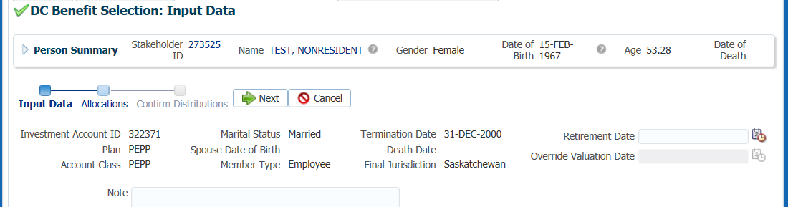

1. In the **DC Benefit Selection, Iput Data** train under the **Allocations** region click **Add**.

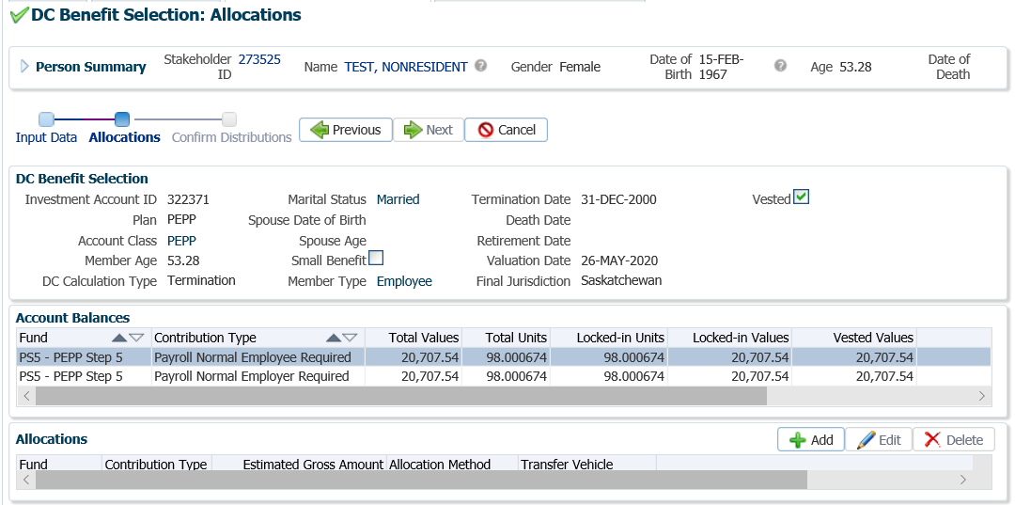

1. In the **Allocation** pop-up window, select the following information and click **Save** once completed:

* **Fund** - leave blank to include all funds
* **Contribution Type –** leave blank to include all contribution types
* **Allocation Method –** Percent
* **Percent -** 100%
* **Transfer Vehicle -** Non-Resident Cash

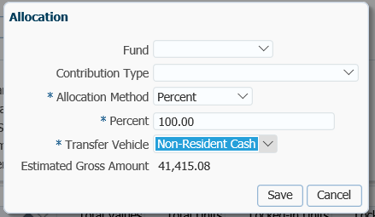

* **NOTE:** the information will be displayed in the **Allocations** Region.



1. In the **DC Benefit Selection, Input Data** **Train** click **Next** to Confirm the Distributions of the payment.

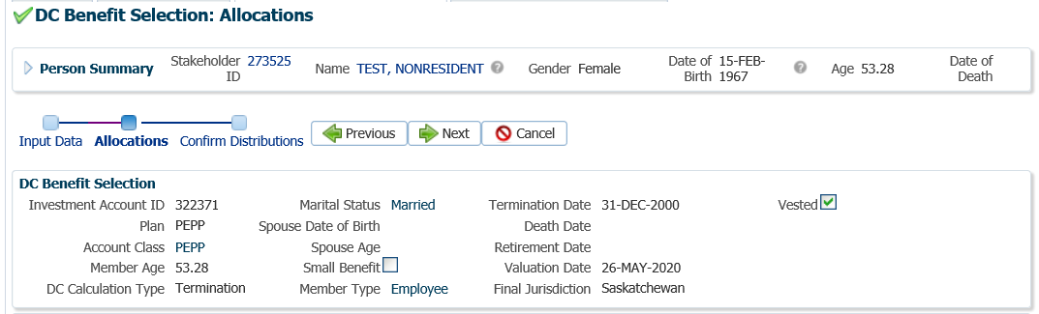

1. In the **Onetime Amounts** region, highlight the **Onetime Amount Type** of **Locked-in Saskatchewan**. Under the **Payment Instruction** column, click on thedrop-down list. If no information is displayed select the **Add New** option.

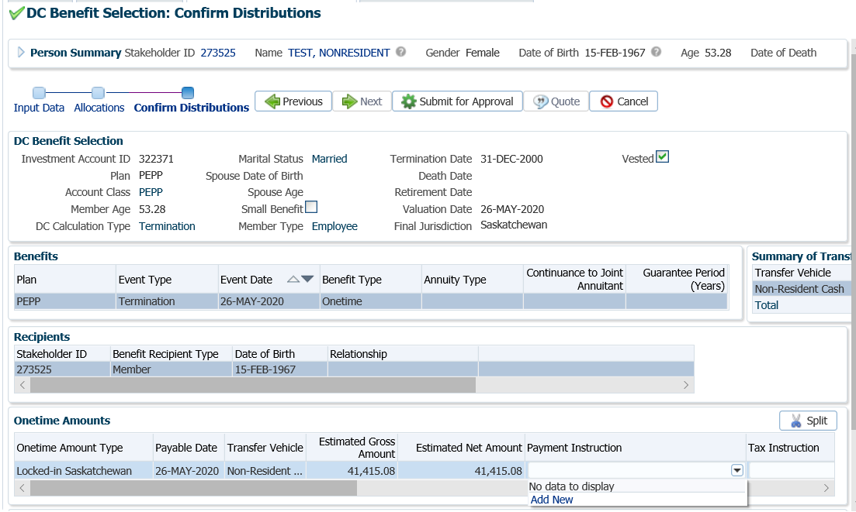

* **NOTE:** if the payee was previously added in the **Payment Instructions** screen under the **Person Profile**, then the information will be displayed in the drop-down list under **Payment Instructions** and can be selected.

1. In the **Payment Instruction** pop-up window, leave **Payee Type** as **Self, l**eave **Payment Method** as **Cheque**, and the **Receipt Date** as the **Current Date**. Click **Save.**

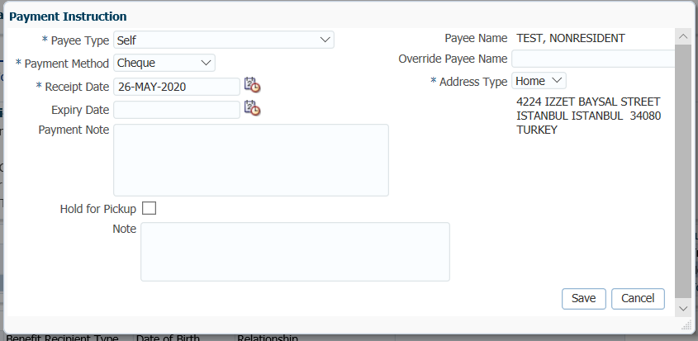

The **Address Type** can be changed to an alternate address if the member wants the cheque to go to a mailing address or business address.

The **Notes** region will display any notes that were added during the calculation as well as allow the user to add more notes that pertain to the selected DC Benefit Selection.

1. **Tax Instructions** are not required to be added for cash payments. PENFAX will determine if tax is required to be deducted by the Transfer Vehicle chosen in the Allocation step and apply the appropriate tax rate of 10%, 20% or 30%.
2. The **Tax Instructions** pop-up window will appear and default to the **Canada TD1 Type Advanced** instruction. Under the **Taxation Country** select the country the member lives in from the drop-down list.

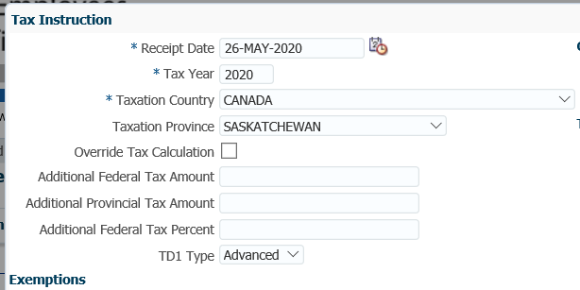

1. A new **Tax Instruction** window will appear showing the **Non-Resident Tax Rate** for that country. The options to **Override Tax Calculation** or request **Additional Federal Tax Percent** is available if the member requested it. Click **Save** once the information has been entered**.**

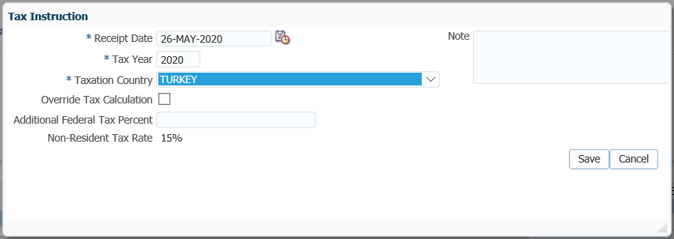

1. If the member holds **Member Voluntary** contributions, you must select this contribution type separately under the **Onetime Amounts** region. Then choose the **Payment Instruction** for it. Click on thedrop-down list and select the **Self - Cheque** option that already exists. The payment instruction information will populate in the **Payment Instruction** column.

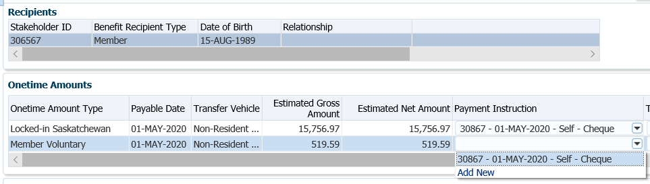

1. In the **Onetime Amounts** region, highlight the **Onetime Amount Type** of **Member Voluntary**. Under the **Tax Instruction** column, click on thedrop-down list and select the existing tax instruction. The tax instruction information will populate in the **Tax Instruction** column for the **Member Voluntary Onetime Amount Type**.

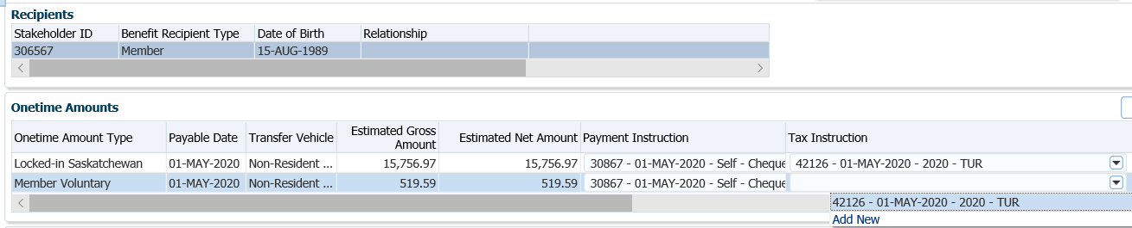

1. In the **Input Data** **train**, click **Submit for Approval** to approve the onetime amounts.

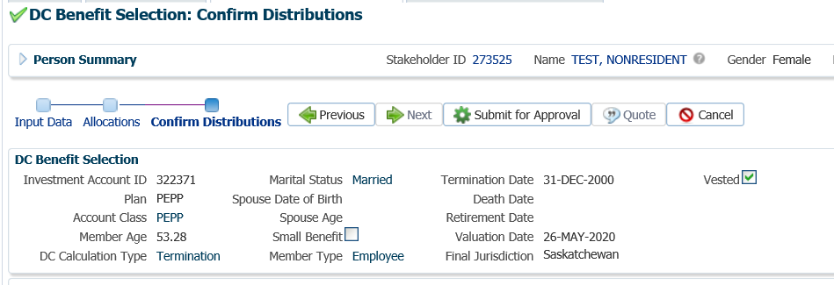

1. The *Pension Specialist* or *Supervisor* will audit and approve the payment in the **DC Benefit Selection** region by clicking **Approve**,or **Reject** if there were errors or the payment was done in error**.** Once approvedthe status will change to **Approved**.

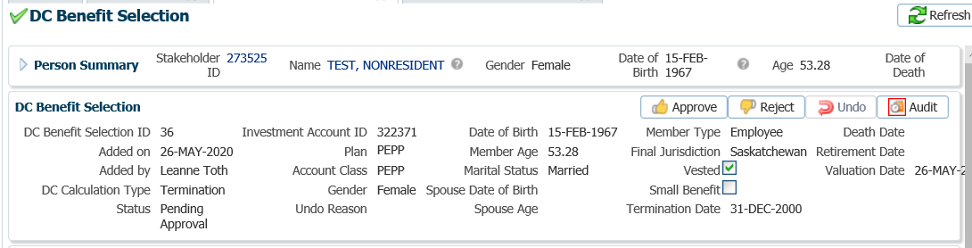

* **NOTE:** If the payment is **Rejected,** the payment steps will need to be entered again by the *Pension Information Officer*. There is no option to edit the existing information.

The **Reject** button is enabled if the status is **Pending Approval** or **Approved**. If the payment is rejected the status will update to **Rejected** when clicked and prevent the benefit selection from being processed by the investment batch.

The **Undo** button is enabled only if the status is **Processed** and will reverse the payment in the investment batch.

1. In the **Approve DC Benefit Selection** window, add a **Note** and click **Save**. Return to payment request to the *Pension Information Officer*.

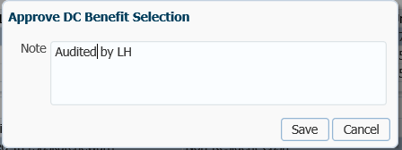

* **NOTE:** Close the **DC Benefit Selection** tab by clicking on the **X.**



1. The **Status** will now be updated to Approved. To see a history of Transactions, User and Event is shown under the **Audit** button.

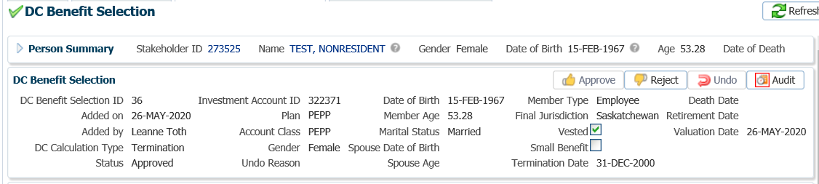

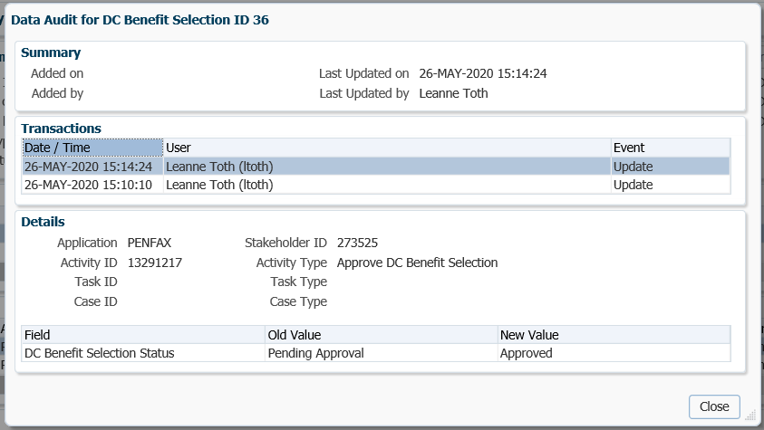

1. The payment will process in the overnight batch process and a cheque will be produced. The payment can be viewed under the **Benefit Recipient** Menu. Click on the **Onetime Amounts** tab to see the details.

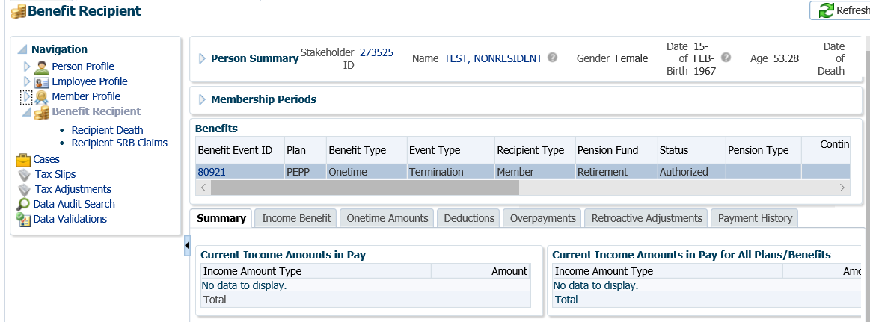

1. In the **Onetime Amounts** tab, the Payment details, Recipient (Payee) details, tax deducted and cheque ID number can be viewed by clicking on the **ID number** beside the **Paid by Payment ID.**

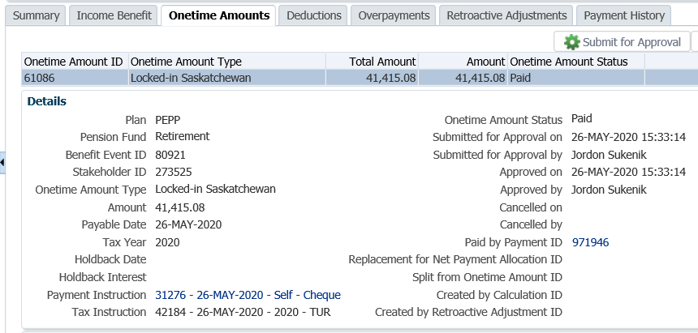

1. Click on the tabs to the right of the screen (**Line Items, Tax, Net Pay Allocation** and **Notes**) to see further details related to the payment. Clicking on the **Cheque ID** number will display further details of the cheque.

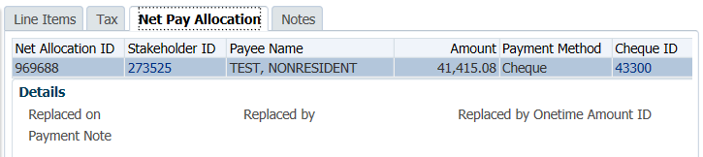

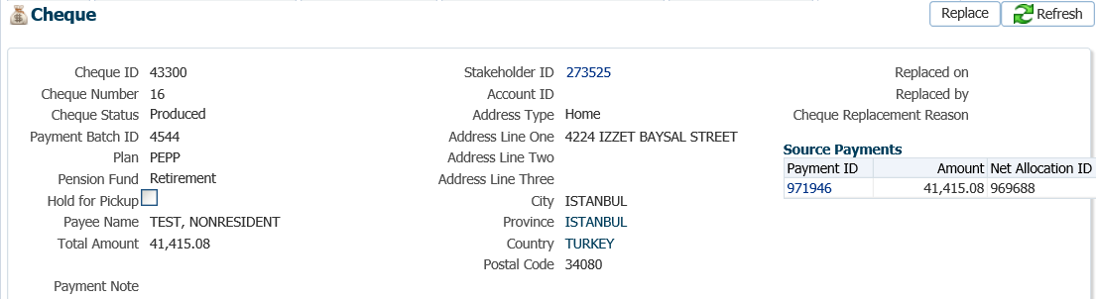

* **NOTE:** Clicking on the **X** in the **Cheque Tab** and **Payment ID Tab** will close the windows.



1. A *Withdrawal Confirmation Letter* will be produced overnight. The letter will be saved under the **Person Profile**, **Communications** screen underthe **Outbound Documents** region. Click on the **Filename** link to open the document.

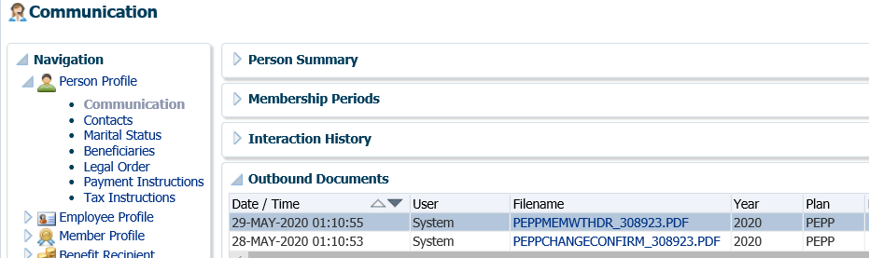

1. A **Tax Slip** for a cash payment will be issued at year end and saved under the **Navigation** menu, **Tax Slips** screen.



1. Under the **Member Profile** menu, the **Membership Periods** region will nowshow the **Member Status** as Terminated or Retired, depending on the age of the member once the payment is processed overnight.

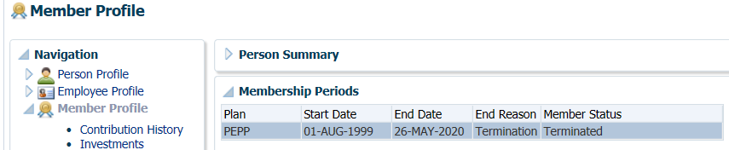

1. Under the **Investments** screen the **Investment Accounts** region will now show the **Account Status** as Inactive and the balance under the **Account Summary** region will show $0.00 if all the money was requested to be paid out.

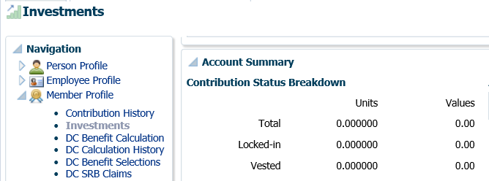

## Maintenance Order Payment

If a member is in arrears of maintenance payments for at least three months, the Director of the Maintenance Enforcement Office (MEO) may file a “*Notice to Administrator of Intention to Attach Pension Entitlement”* with PEPP.

If a notice is filed, an indicator flag or critical note  is added to PENFAX to notify administrators of the receipt of a request for a maintenance order payment from the members account. The indicator flag or critical note  is to advise the pension administrators that **no** further payments can be paid within 60 days unless notified earlier by the MEO.

If the MEO proceeds with the payment from the member’s account, a *Notice of Attachment of Pension Entitlement* will be sent to PEPP. PEPP is obligated to make the payment from the members pension account to enforce the maintenance order.

Business Process Requirements - Maintenance Order Payment

* Maintenance Enforcement Office (MEO), sends in 2 copies of the *Notice of Intention.*
* Confirm that the member is eligible. The member **cannot** be actively contributing and must be terminated from all PEPP participating employers. A member’s Plan status must be *Deferred*.
* Place a 60 day freeze on the member’s account on PENFAX stating “NO WITHDRAWALS permitted until after “date the 60 days are over”.
* Provide the Information letter to the Maintenance Enforcement Office (MEO) with the requested information within 30 days of receiving the *Notice of Intention*.
* Mail the *Notice of Intention* letter to the MEO and send a copy of the letter and a copy of the *Letter of Intention* by registered mail to the member. Keep a copy for the member’s file.
* If the Maintenance Enforcement Office (MEO) is proceeding they will send in 2 copies of the *Notice of Attachment of Pension Entitlement.*
* Remove the 60 day freeze.
* The payment must be for a net amount as specified in the *Notice of Attachment of Pension Entitlement*. The gross amount withdrawn must be for the net amount plus the fee, plus the appropriate withholding tax. This amount will be submitted to the Canada Revenue Agency.
* The payee on the cheque is the name of the person receiving the money, as noted on the *Notice of Attachment of Pension Entitlement*, c/o the Maintenance Enforcement Office, Room 100-3085 Albert Street, Regina SK S4S 0B1.
* A $45 administration fee is charge and deducted from the members account and must be included in the T4A slip.
* Payments are subject to lump sum withholding tax and a T4A slip is issued.
* The member is required to declare the attachment amount as income in the year the payment was issued as per the T4A slip.
* Prepare the Maintenance Payment letter to send with the cheque. Include a copy of the *Notice of Attachment of Pension Entitlement* with the cheque and the payment letter. A copy is to be sent to the member and a copy kept for the member’s file.
* If the MEO advises they are not proceeding prior to the 60-day date, unfreeze the account and add a new note stating the MEO is not proceeding with the request.
* If nothing is received back and the 60-days has lapsed, follow up with the MEO.
* Verify the member’s SIN on the T2151 form to the SIN on the PENFAX account to ensure it matches.
* Determine if Identification is required from the member. ***Refer to the procedures,******When is Identification Required from a Member***.
* If any information is missing on the form follow up with the member. ***Refer to the Procedures to Obtain Missing Information*.**

#### How to Process a Maintenance Enforcement Payment

1. Search for the member in PENFAX.
2. Once the *Notice of Intention* from the Maintenance Enforcement Office is received, determine if the member is eligible. To be eligible, the member **cannot** be actively contributing in PEPP. Ensure the appropriate forms and documents have been received, signed and certified if required as per the business process requirements for a maintenance enforcement payment.
3. Under the **Employee Profile** menu, **Membership Periods** region check the **Member Status** to ensure is shows as *Deferred* for PEPP members.

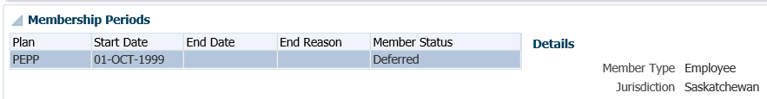

1. If the member is eligible and not actively contributing, place a 60 day freeze on the member’s account. Under the **Person Profile** menu, **Person Summary** region, click **Edit**.

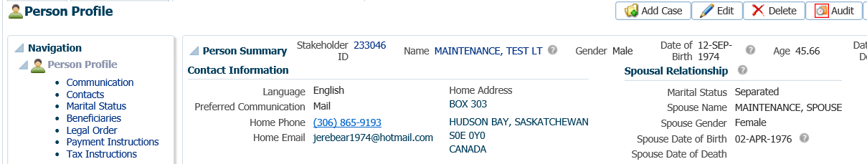

1. In the **Person** pop-up window, check the **Locked** option and click **Save**. This will lock the member’s account so that no further payments will be allowed to be processed.

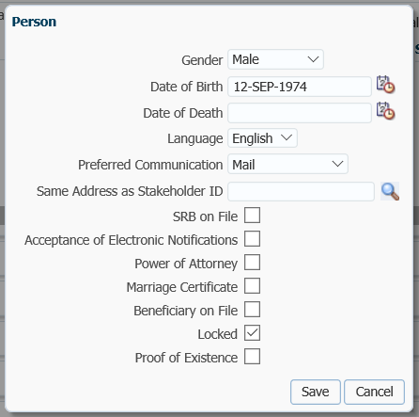

* **NOTE:** the account is to be locked for 60 days.

1. Provide the *Information* letter to the Maintenance Enforcement Office (MEO) with the requested information within 30 days of receiving the *Notice of Intention*. Send a copy of the *Letter of Intention* to the member by registered mail. Keep a copy for the member’s file.
2. Change your **Case Task** to a 60 day follow up date by **Suspending** the **Task**. Locate your **Case**, click on the **Case ID** number, Under Your **Case Task** click the **Suspend** option.

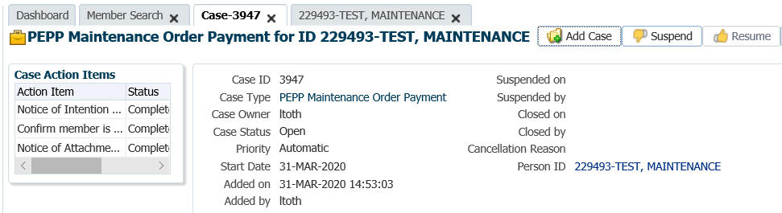

1. Under the **Task** region click on the **Edit** option to add a **Due Date** reminder.

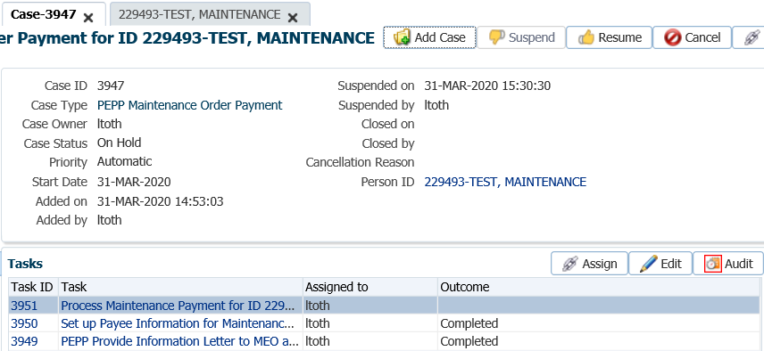

1. In the **Task** pop-up window, change the **Reminder Date** to a date 60 days in the future. Change the **Due Date** to a date in which the service standard for the **Case** type would be due for completion on after the reminder date. Click **Save**.

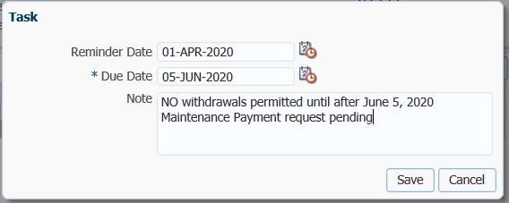

1. If the Maintenance Enforcement Office (MEO) is proceeding they will send in 2 copies of the *Notice of Attachment of Pension Entitlement.* Remove the 60 day freeze from the member’s account in PENFAX. Under the **Person Profile** menu, **Person Summary** region, click **Edit**.



1. In the **Person** pop-up window un-check the **Locked** box and click **Save**.

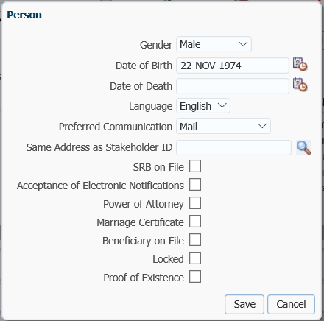

1. Determine if the person noted in the *Notice of Attachment of Pension Entitlement* to receive the payment is a stakeholder on PENFAX. Under the **People Search** option, select the **Person Search.**

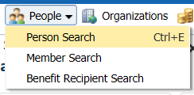

1. In the **Search Parameters** region enter in your search criteria such as the last name of the person and click **Search**.

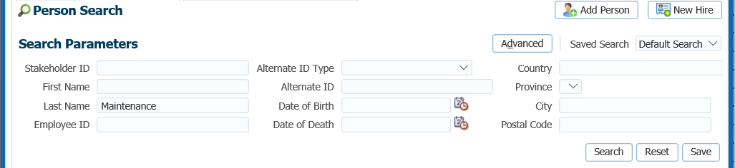

1. If the correct person has been located, click on the **Stakeholder ID** number to open the record.

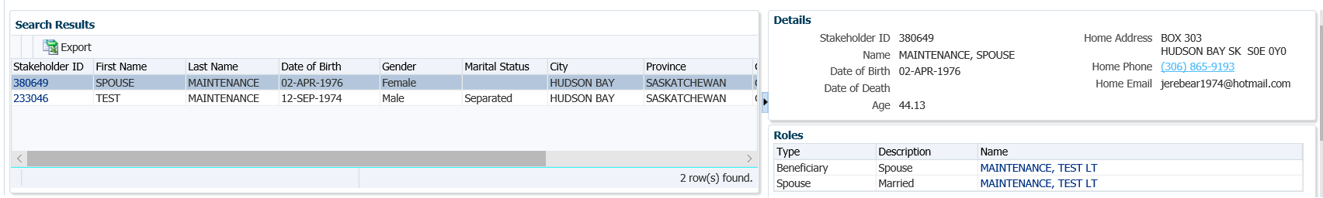

1. Under the **Person Profile** menu, expand the **Contact Information** region. Click **Add** to add a new address type.

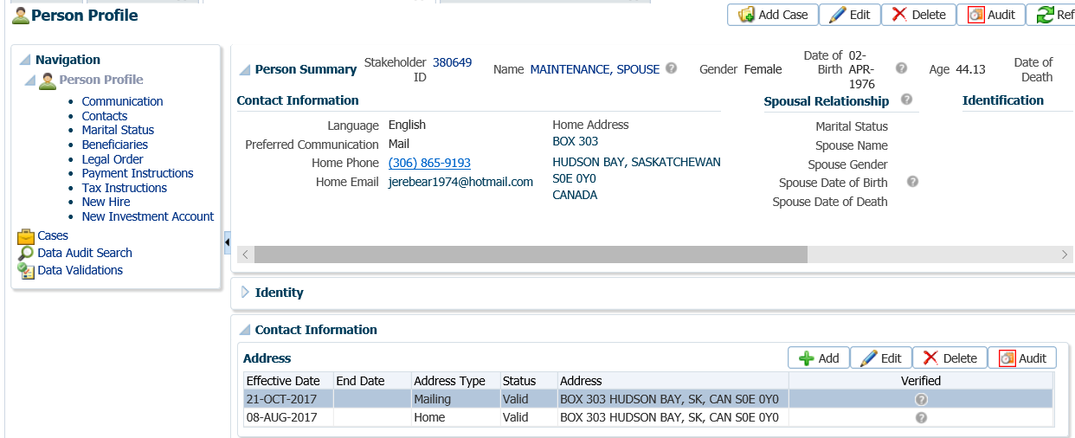

1. In the **Address** pop-up window, add the mailing address of the Maintenance Enforcement Office as noted on the request. Enter the following and click **Save**:
   * **Effective Date** – leave as current
   * **End Date** – choose a date a couple of days after
   * **Address Type** – Business (if there is not already a business address)
   * **Line One** – c/o Maintenance Enforcement Office
   * **Line Two** – street address
   * **Line Three –** leave blank
   * **City –** city of Maintenance Enforcement Office
   * **Province** – province of Maintenance Enforcement Office
   * **Country** – country of Maintenance Enforcement Office
   * **Postal Code** – postal code for Maintenance Enforcement Office
   * **Address Type** - select Valid

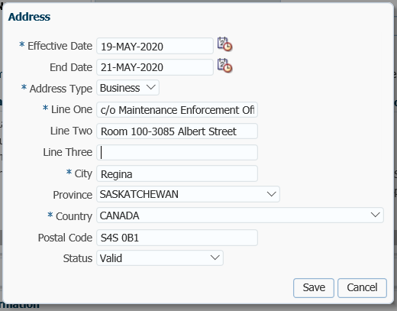

* **NOTE:** The payment has to be payable to the person listed on the *Notice of Attachment of Pension Entitlement* but has to be sent to the Maintenance Enforcement Office.

1. Under the **Member Profile** menu, **Investments** screen, highlight the applicable **Investment Account,** PEPP. Under the **Account Balances** region, check the account balance and the amount the member holds in each contribution type to ensure there is enough money in each contribution type to cover the amount of the payment as you will have to pro-rate the payment across all funds and contribution types if the member holds sufficient funds.

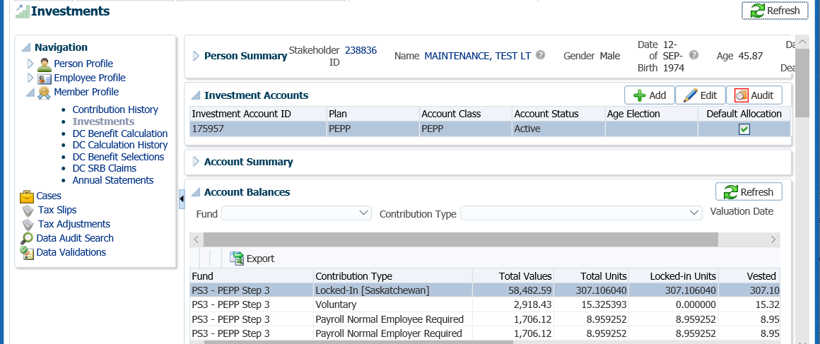

1. Under the **Member Profile** menu, **Investments** screen, highlight the correct **Investment Account**, if the member is also in VPB. Go to the **Account Instructions** region, click **Add** to start the payment process.

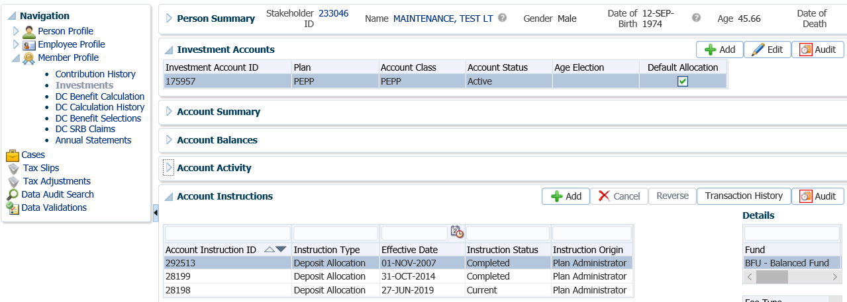

1. In the top section of the **Account Instruction** pop-up window, select the following:
   * **Instruction Type** - Lump Sum Withdrawal
   * **Effective Date -** current date
   * **Lump Sum Withdrawal Type** - Maintenance Order
   * **Lump Sum Withdrawal Method** – Net Amount After Fees
   * **Net Amount After Fees** – the amount specified in the *Notice of Attachment of Pension Entitlement*
   * **Gross Amount**  - this will populate once the net amount is entered

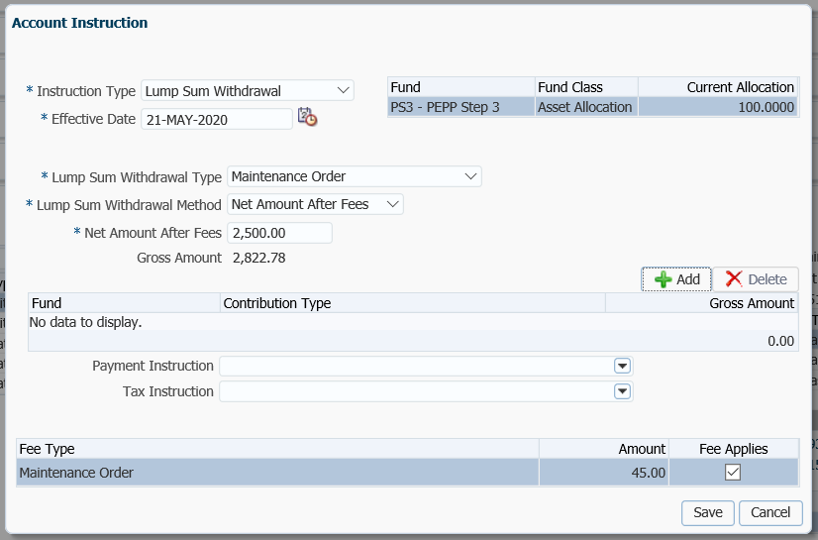

1. In the bottom section of the **Account Instruction** pop-up window under the **Fund** information box, click **Add**. Select the following information:
   * **Fund** – will pre-populate with the fund(s) the member holds and pro-rate across funds
   * **Contribution Type** – a full list of contribution types held in the displayed fund is shown in the drop-down list, select each individually. You must click **Add** each time to pick a new type.
   * **Gross Amount** – input the pro-rated calculated amount for each contribution type. All contribution types amounts selected must equal the gross payment amount.
   * **Fee** – a $45 fee will be charged automatically and the **Fee Applies** box is checked

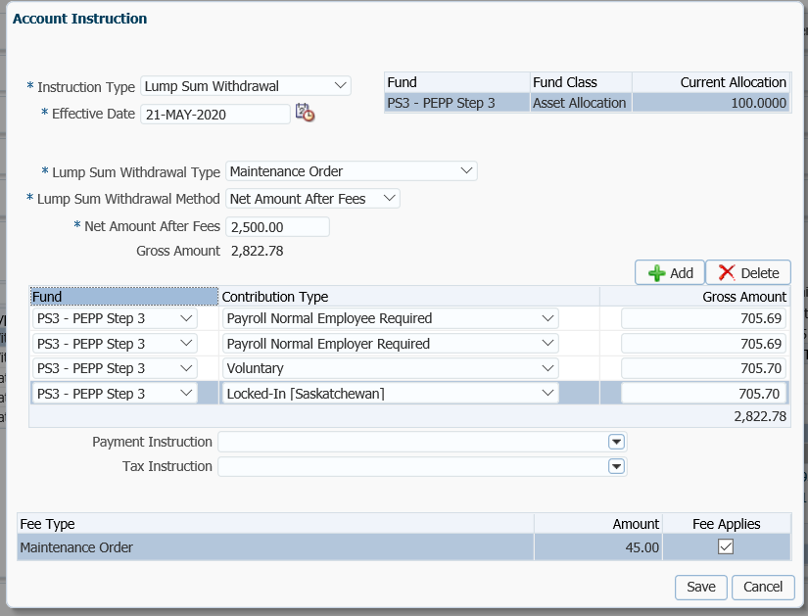

1. In the **Payment Instruction** drop-down, click **Add New**.

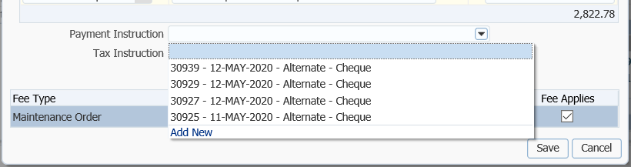

* **NOTE:** if the payee was added in the **Payment Instructions** screen previously, then the information will be displayed in the drop-down list under **Payment Instructions** and can be selected to use for the payment. To view the details of a previous payment instruction go to the **Payment Instruction** screen under the **Person Profile.**

1. In the **Payment Instruction** pop-up window select the following:
   * **Payee Type** - Alternate
   * **Payment Method** – Cheque
   * **Receipt Date** – Current Date
   * **Expiry Date** – date that the banking instructions are valid for
   * **Payment Note** ­– used to add a note to the payment documentation (cheque or EFT receipt)
   * **Hold for Pickup ­**– checked if the member would like to pickup the cheque (this will be displayed under the member’s **Payment Instructions** screen)
   * **Note** – additional notes pertaining to the payment, will appear under Person Profile Notes
   * **Payee Stakeholder ID** – if the stakeholder ID for the person named on the *Notice of Attachment of Pension Entitlement* is known you can enter it. If it is not known, click on the **magnifying glass** to search for the stakeholder number.
   * **Payee Name –** will automatically populate when the Stakeholder ID is entered
   * **Override Payee Name** – n/a
   * **Address Type** – defaults to the stakeholder’s primary address on record, if another address exists on file it can be selected from the drop-down list

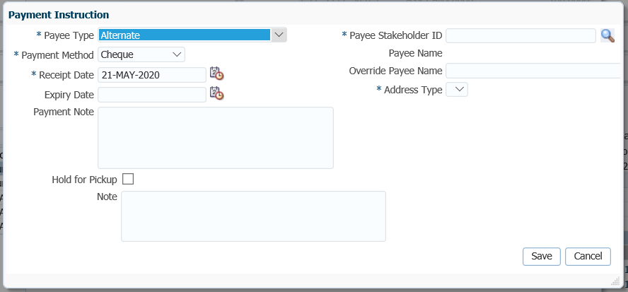

1. In the **Search and Select Stakeholder** screen, **Search Parameters** area, enter in the search criteria for the person such as last name, click **Search**.

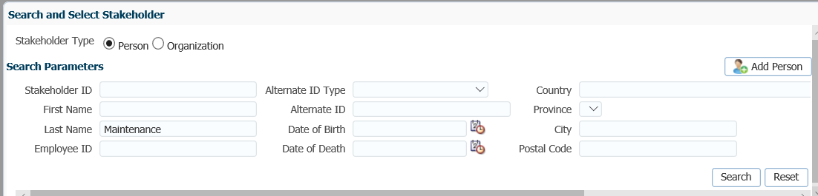

* **NOTE:** If the person does not exist as a stakeholder in PENFAX, use the **Add Person** option to add them as a new stakeholder. ***Refer to the PENFAX procedures, Creating a PENFAX Account for a Spouse***.

1. In the **Search Results** area, highlight the name in the **Search Results** region of the person and click **Ok**.

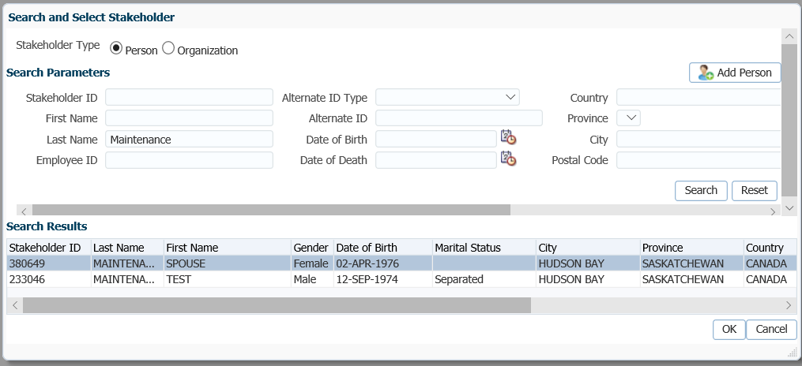

1. The **Payee Stakeholder ID** and the **Payee Name** will automatically populate in the **Payment Instructions** window. In the **Address Type** field select the **Business** address from the drop-down list. This will be the address of the Maintenance Enforcement Office that the cheque is to be sent to. Click **Save**.

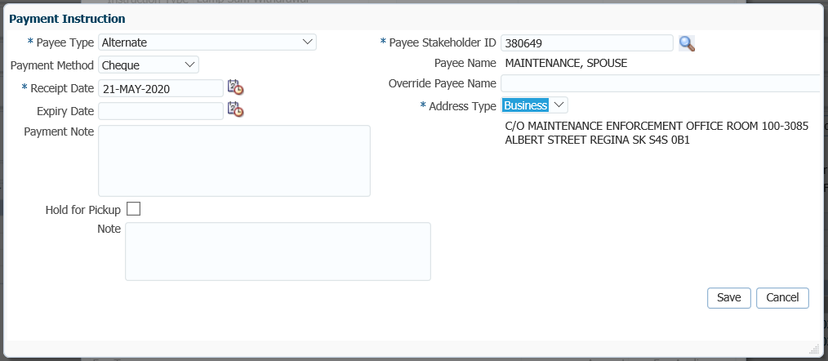

1. In the **Account Instruction** pop-up window, under the **Tax Instructions** field, click on the drop-down list. If no information is displayed, click on the **Add New** option.

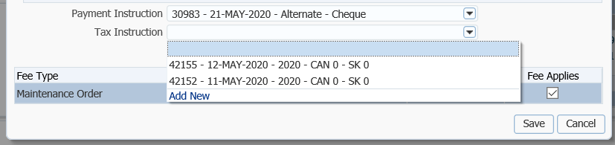

* **NOTE:** if the same tax instruction were previously added in the **Tax Instruction** screen, then the information will be displayed in the drop-down list under **Tax Instruction** and can be selected to use for the payment. To view the details of a previous tax instruction go to the **Tax Instruction** screen under the **Person Profile.**

1. The **Tax Instruction** pop-up window will default to the **Advanced** option. If the payment request doesn’t require any additional exemptions, the **TDI Type** can be changed to **Basic.**  This will remove the **Federal** and **Provincial Exemption** checklists but does require that you populate both the **Federal Claim Code** and **Provincial Claim Code**. If required, an **Additional Federal Tax Amount** or **Percentage** or an **Additional Provincial** **Tax Amount** can be entered. Click **Save**.

*Advanced TDI Option:*

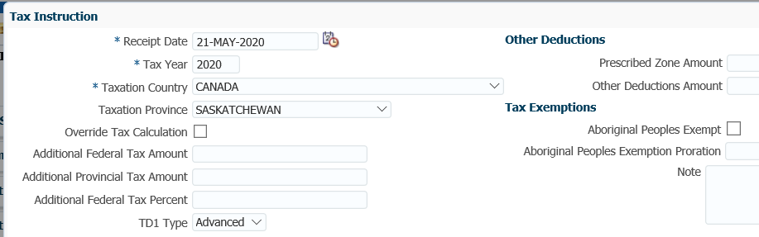

1. In the **Account Instruction** pop-up window, click **Save**.

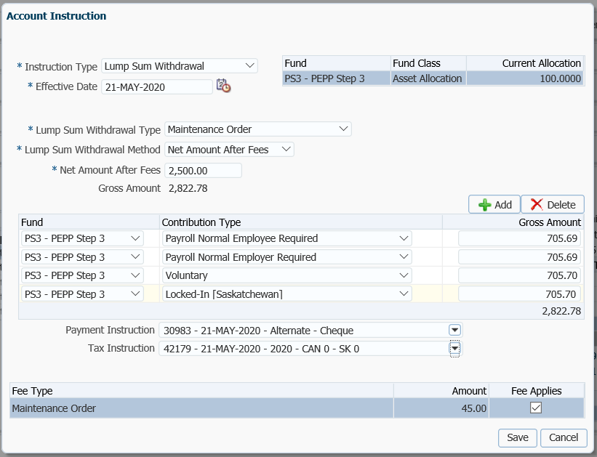

1. The payment will show as **Pending** under the **Account Instructions** region.

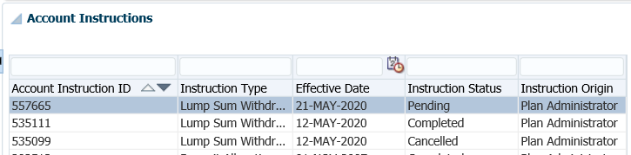

1. The *Pension Specialist* or *Supervisor* will audit the payment in the **Account Instructions** region, **Details** area. If errors are found or the payment was done in error, the payment will be cancelled using the **Cancel** option if the status shows as **Pending**. The payment will need to be reprocessed again as an edit option is not available

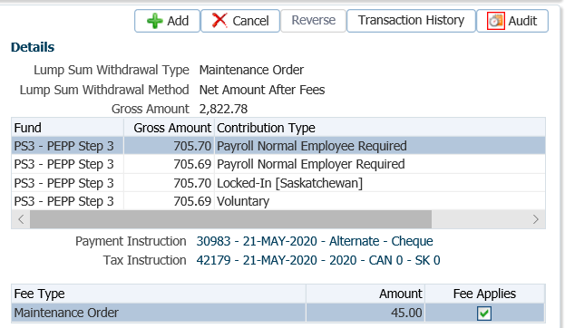

1. Prepare the *Maintenance Payment* letter to be sent with the cheque to the Maintenance Enforcement Office. A copy is to be sent to the member, and a copy kept for the member file.
2. A history of Transactions and Details is shown under the **Audit** button. Click **Close** to close the window.

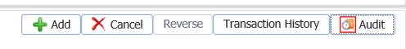

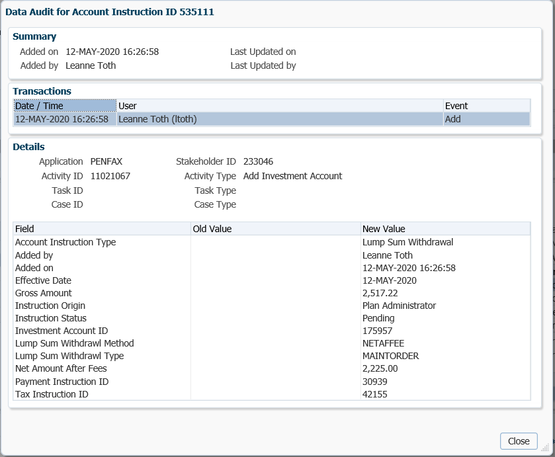

1. The payment will process in the overnight batch process and a cheque will be produced. The payment transaction details can be viewed under the **Investments** menu, **Account Activity** region.

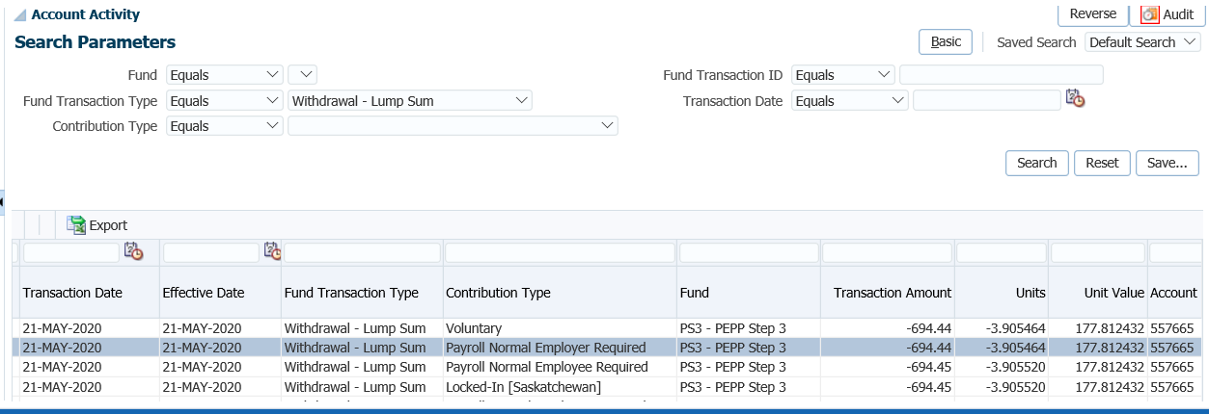

1. The Payment details, Recipient (Payee) details, tax deducted and cheque ID number can be seen under the **Benefit Recipient** menu under the **Benefits** region. Click on the **Onetime Amounts** tab.

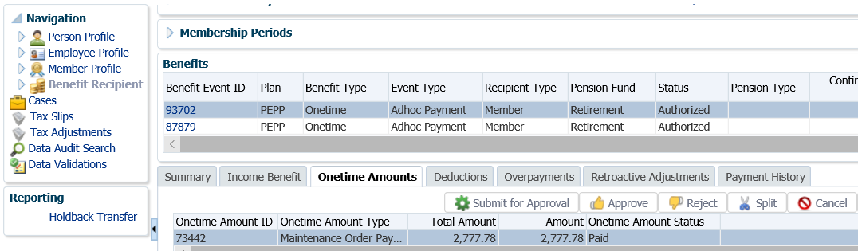

1. Under the **Onetime Amounts** tab, click on the **Paid by Payment ID** number to see further details of the cheque details.

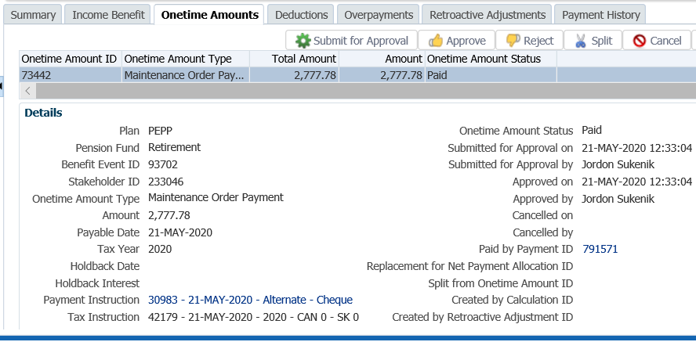

1. The tabs to the right of the screen (**Line Items, Tax, Net Pay Allocation** and **Notes**) will show further details related to the payment.

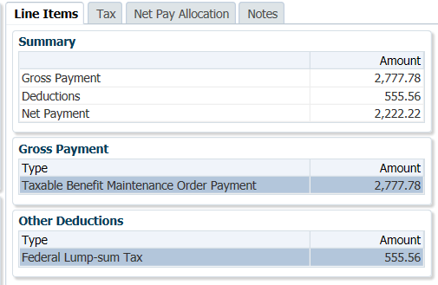

1. To see the details of the cheque, click on the **Cheque ID** numberunder the **Net Pay Allocation** tab.

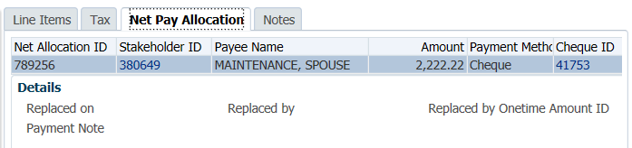

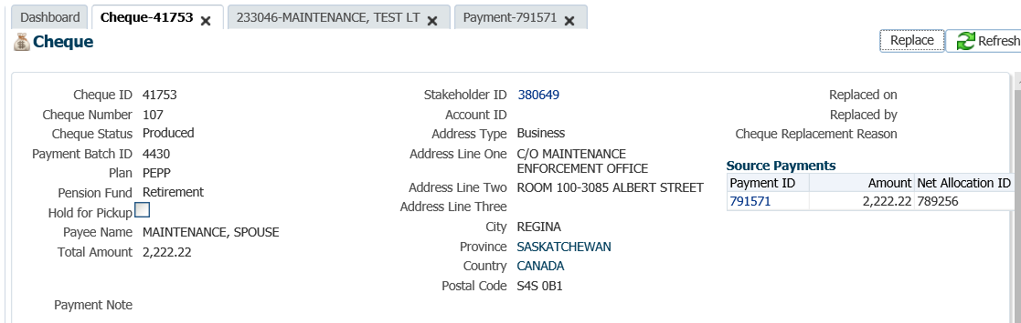

* **NOTE:** Click on the **X** in the Tab to close the window when done viewing.



1. A *Withdrawal Confirmation Letter* will produced overnight and saved under the **Person Profile** menu, **Communications** screen, **Outbound Documents** region. Click on the **Filename** link to open the document.

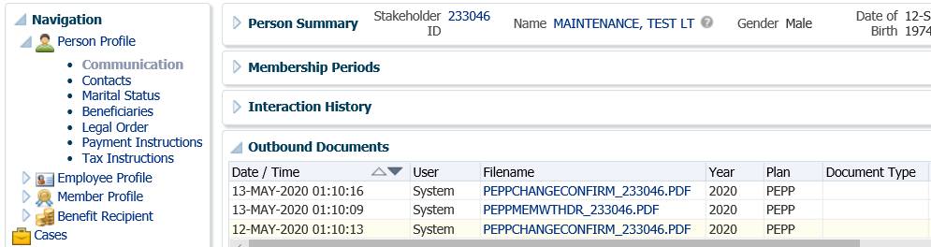

1. The **Investments** screen, **Investment Accounts** region will now show the current balance under the **Account Summary** region and the **Account Balances** region. The total values will reflect the difference of the payment transaction that was valued overnight.

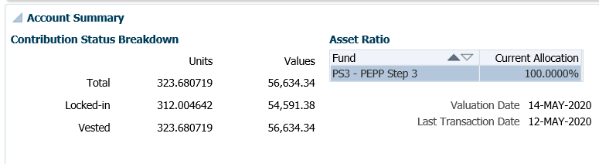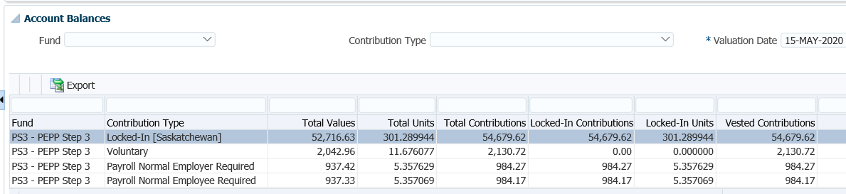

1. The member will be issue a T4A slip for the gross payment amount at the end of the year. The member is required to declare the attachment amount as income in the year of the payment as per the T4A. The T4A slip details and a PDF copy of the T4A slip will be saved to the member’s account on PENFAX. A PDF of the T4A slip can be viewed under the **Navigation** menu, **Communications** screen. The tax slip details can be viewed under the **Tax Slips** screen.



## CRA Requirement to Pay

If a member owes tax but refuses to pay, the CRA can issue a type of garnishment known as a *Requirement to Pay*. The *Requirement to Pay* will advise PEBA to redirect all or a portion of any payment(s) due to the member to the CRA instead (i.e., the member is receiving Variable Pension Benefits). The CRA will then use these funds to reduce or pay off the member’s tax debt.

The *Requirement to Pay* will indicate the maximum amount to withhold from any payment due to the member. PEBA will forward this amount to the CRA for every payment that is made to the member unless the *Requirement to Pay* instructs PEBA to withhold:

* a fixed amount from each payment;
* a fixed amount from all amounts paid in a set time period (for example, one month); or
* a percentage from each payment.

Business Process Requirements - CRA Requirement to Pay

* PEPP must receive a *Requirement to Pay* request from CRA.
* The *Requirement to Pay* will instruct PEPP of the net amount to forward to the CRA after any applicable fees and the appropriate federal and provincial taxes are withheld from each payment.
* No fees are charged for this type of payment.
* A CRA *Requirement to Pay* is **not** allowed to be processed for members who are **actively** contributing to PEPP. PEPP member’s must be in a deferred plan status and request a cash refund to be eligible. The CRA requirement to pay amount would be deducted from the cash refund amount.
* If the member requested a registered transfer to another financial institution we would not deduct the CRA requirement to pay amount.
* If the member is in receipt of scheduled payments from the Variable Pension Benefit, PEPP will withhold the requested amount of each scheduled payment and send the amount to the CRA during the requirement period, or until the total sent equals the maximum amount on the *Requirement to Pay*.
* PEPP will only submit the percentage of partial payments.
* If a member is doing a full withdrawal, PEPP will pay the CRA the total outstanding debt first.
* PEPP will add a critical note  on PENFAX to advise PEPP administrators not to make any payments to the member that do not comply with the CRA’s directions.
* Once the payments to CRA have been activated, there is no longer an expiry date of one year. PEPP is required to continue to pay the debt until it is paid or until the member depletes their account, whichever comes first.
* Once the requirement to pay has been met, the critical note  is to be removed from PENFAX.
* If the member is not receiving payments, a critical note is added on PENFAX for one year, and then the order will expire. If the member starts scheduled payments or requests a lump sum payment, the CRA requirement to pay request can be honored if within the 1 year.
* Verify the member’s SIN on the Requirement to Pay request to the SIN on the PENFAX account to ensure it matches.
* If any information is missing on the form follow up with the member. ***Refer to the Procedures to Obtain Missing Information.***

#### How to Process a CRA Requirement to Pay

1. Search for the member in PENFAX.
2. Verify that the required forms have been received and signed and that the member meets the qualifications for a payment as outlined in the business process requirements for a CRA requirement to pay. If the member is in PEPP, they must be a deferred member and qualify for a cash refund. If a cash refund is requested the CRA required amount is taken from the payment.
3. If the member meets the qualifications, add a critical note  on PENFAX to advise PEPP administrators **not** to make any payments to the member that do not comply with the CRA’s directions. Under the **Person Profile** menu, **Notes** region, click **add**.

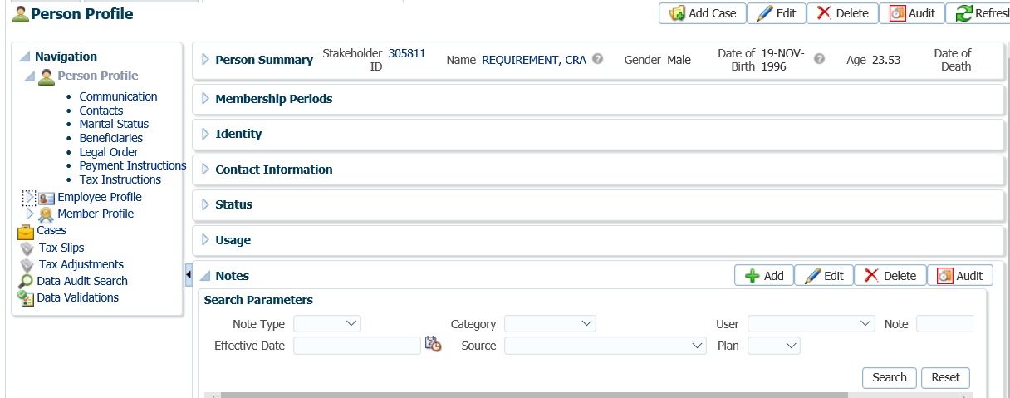

1. In the **Note** pop-up window, choose **Alert** as the **Note Type**, leave the **Category** as **General**. At message in the **Note** area and click **Save.**

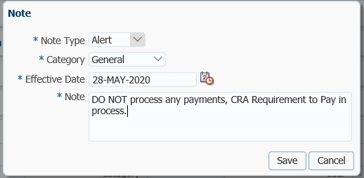

1. If the PEPP or VPB member does **not** meet the qualifications, add a critical note  to their account for one year. The CRA requirement to pay order will expire after one year. If a VPB member starts scheduled payments or requests a lump sum payment within the one year, the request can be honored. If a PEPP member requests a cash refund, the request can be honored if within the one year time frame.

1. Suspend the assigned **Case** for a future date of one year. Create the **Case**, then go to **Open Tasks** on your Dashboard, select the first **Task** and click **Suspend.**

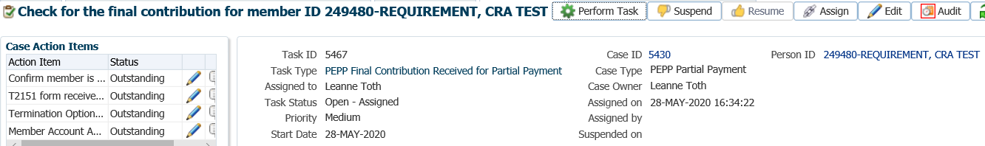

1. In the same Task, click **Edit**.

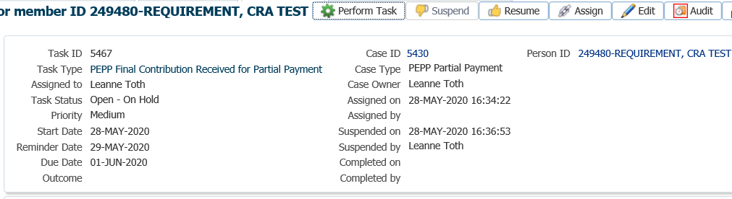

1. In the **Task** pop-up window change the **Reminder Date** to a year in advance and the **Due Date** to 3 days after, add a message in the **Note** field. Click **Save.**

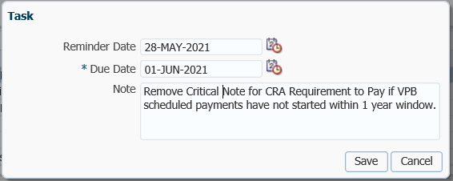

1. Under the **Navigation** menu, **Employee Profile** menu, **Membership Periods** region ensure the **Member Status** is showing as **Deferred** for a PEPP member or **Active** for a VPB member.

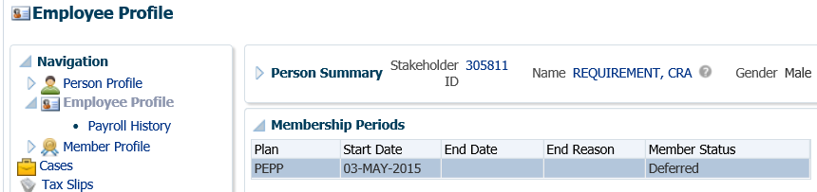

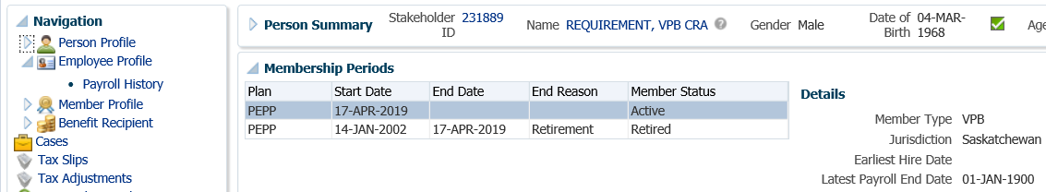

1. Check the **Navigation** menu, **Employee Profile** menu to ensure the termination information has been received and entered into PENFAX for a PEPP member.

Under the **Employment Periods** region confirm the following information has been entered:

* **End Date**
* **End Reason** is Terminated or Retired
* **Final Jurisdiction**

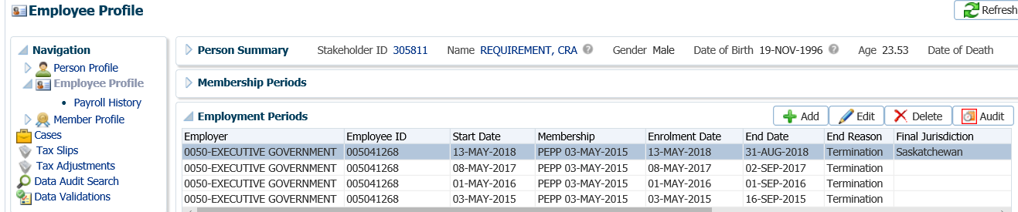

1. *PEPP member requesting a cash refund*. Under the **Navigation** menu, click on the **DC Benefit Selections** screen. Click **Add** to add a new payment in the **DC Benefits Selection** region.

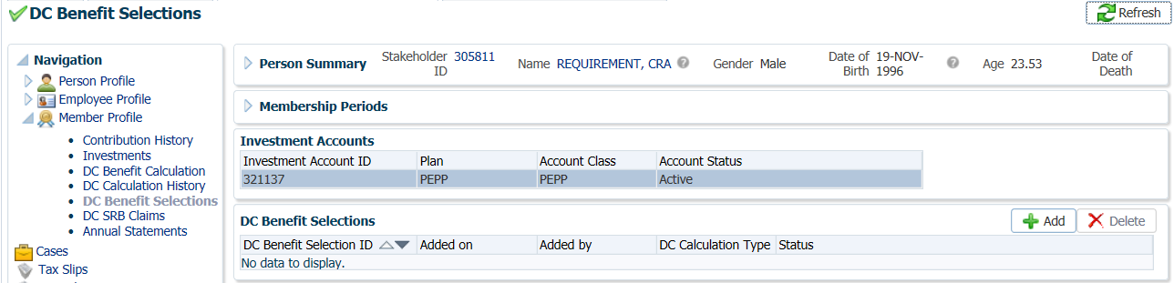

1. In the **Input Data** train, click **Next** to start the **Input Data** process.

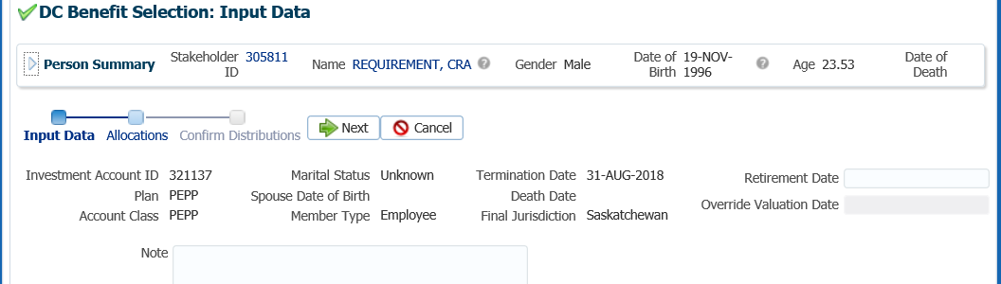

1. In the **Input Data** train under the **Allocations** region click **Add**.

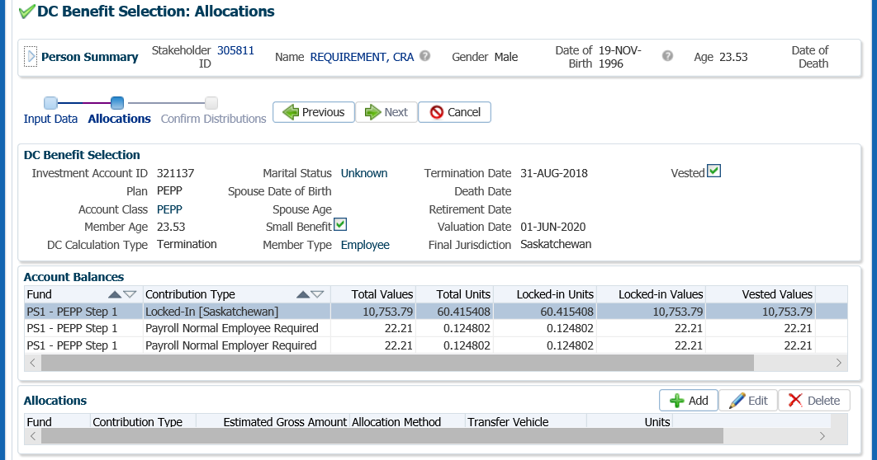

1. In the **Allocation** pop-up window, select the following information and click **Save** once completed:

* **Fund** - leave blank to pro-rate across include all funds
* **Contribution Type –** leave blank to include all contribution types
* **Allocation Method –** percent
* **Net Amount –** 100.00 (a split payment will be done)
* **Transfer Vehicle –** Cash
* **Estimated Gross Amount** – amount will automatically populate

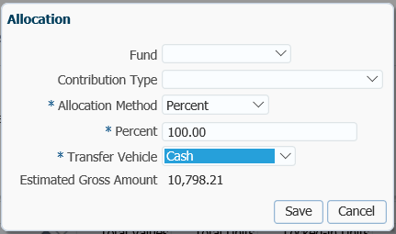

* **NOTE:** the information will be displayed in the **Allocations** Region once saved.

1. In the **Input Data** **Train** click **Next** to Confirm the Distributions of the payment.

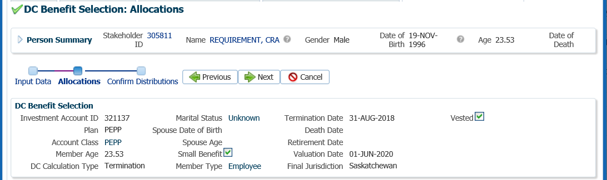

1. In the **Onetime Amounts** region under the **Payment Instruction** column, click on thedrop-down list. If no information is displayed select the **Add New** option.

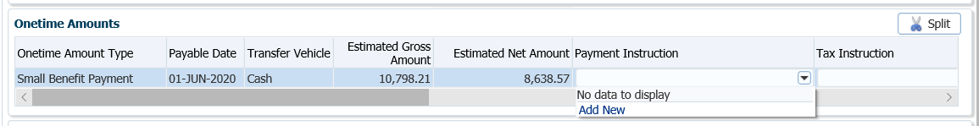

* **NOTE:** if the same payee was previously added in the **Payment Instructions** screen under the **Person Profile**, then the information will be displayed in the drop-down list under **Payment Instructions** and can be selected for the payment.

1. In the **Payment Instruction** pop-up window, change **Payee Type** to Alternate, **l**eave **Payment Method** as **Cheque**, and the **Receipt Date** as the **Current Date**. Click on the **magnifying glass** to find the stakeholder ID for CRA.

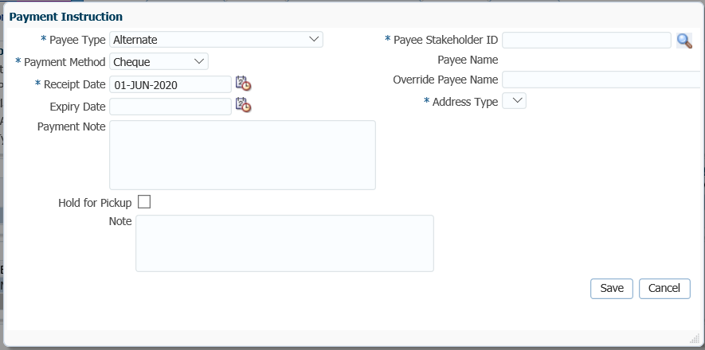

1. In the **Search and Select Stakeholder** screen, select **Organization** as the **Stakeholder Type**. Under **Organization Type,** select **Tax Authority**, click **Search**.

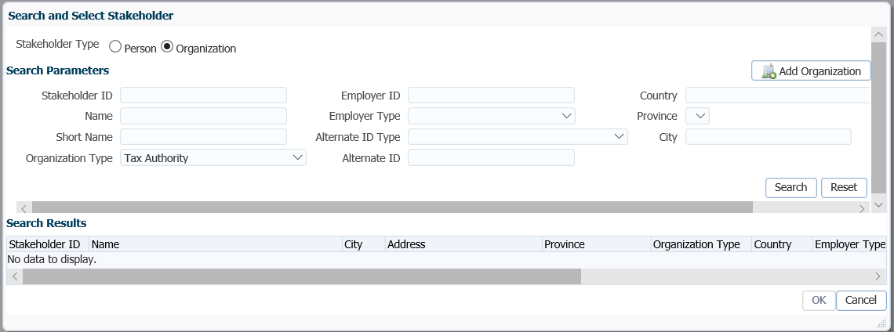

1. In the **Search** Results area, locate the correct tax authority, highlight the name and click **Ok.**

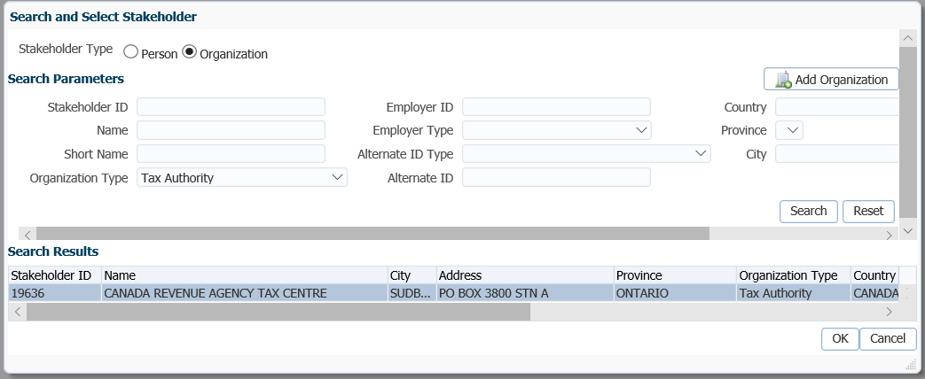

1. The **Payee Stakeholder ID**, the **Payee Name** and **Address** will now be populated in the **Payment Instructions** window. Add the **Account ID** and a **Note** if applicable. Click **Save**.

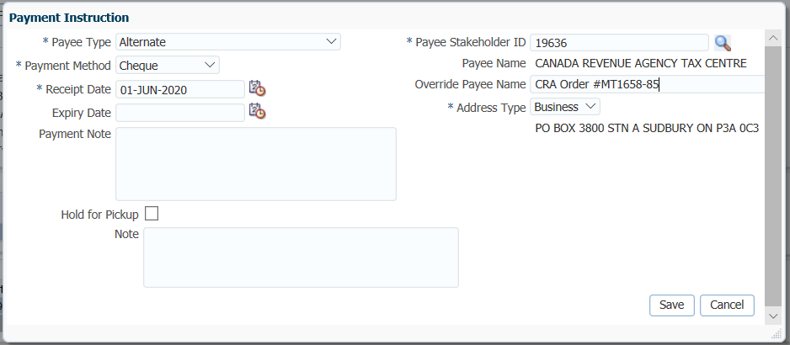

1. In the **Onetime Amounts** region under the **Payment Instruction** column, click on thedrop-down list. If no information is displayed select the **Add New** option.



1. In the **Payment Instruction** pop-up window, leave the **Payee Type** as Self, the **Payment Method** as Cheque and the **Receipt** Date as the current date. Click **Save.**

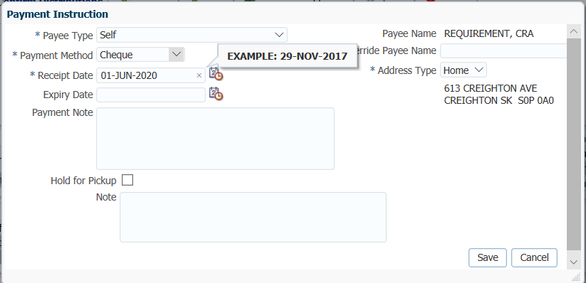

The **Address Type** can be changed to an alternate address if the member wants the cheque to go to a mailing address or business address.

The **Notes** region will display any notes that were added during the calculation as well as allow the user to add more notes that pertain to the selected DC Benefit Selection.

## Splitting a Payment

The Split Payment function allows you to split a payment to divide between different financial institutions or accounts

1. In the **Onetime Amounts** region, click to highlight the payment. Choose the **Alternate Payment Instructions.** Click the **Split** button.

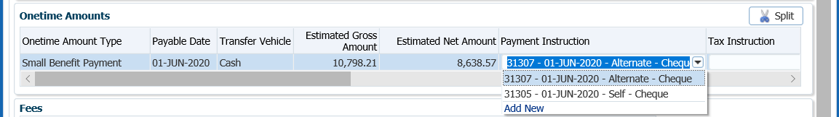

1. In the **Split Onetime Amounts** pop-up window, enter in the applicable amount type (gross amount to split, net amount to split or percent to split). For the CRA Requirement to Pay, select **Net Amount to Split** as per the CRA *Requirement to Pay* request. Click **Save**.

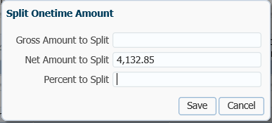

1. The **Onetime Amounts** region will now show the split of the payment and the **Estimated Gross Amounts** for each.

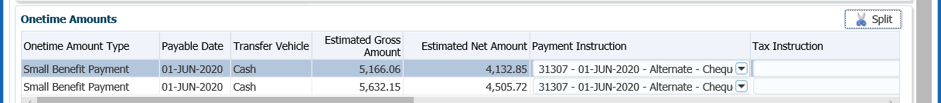

1. **Tax Instructions** are not required to be added for cash payments. PENFAX will determine if tax is required to be deducted by the Transfer Vehicle chosen in the Allocation step and apply the appropriate tax rate of 10%, 20% or 30%.
2. In the **Input Data** **train**, click **Submit for Approval.**

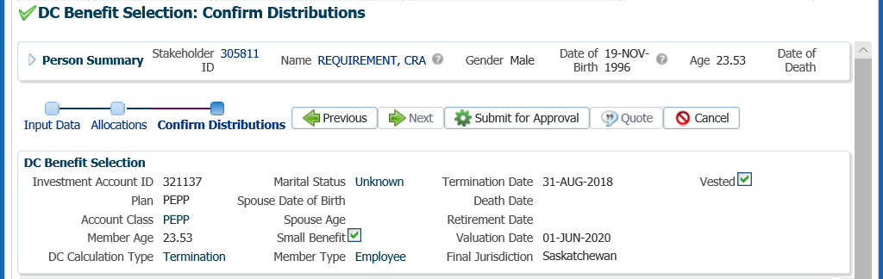

1. The *Pension Specialist* or *Supervisor* will audit and approve the payment in the **DC Benefit Selection** region by clicking **Approve,** or **Reject** if there were errors or the payment was done in error**.** Once **Approved** the status will change to **Approved**.

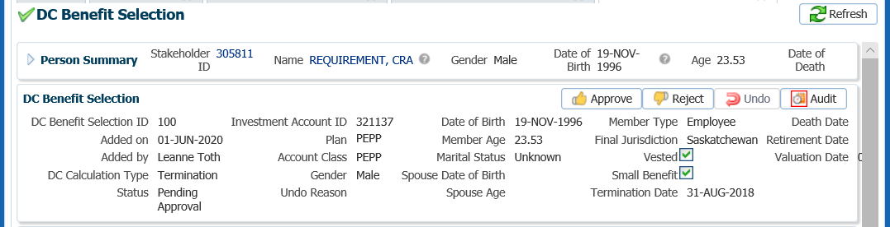

* **NOTE:** If the payment is **Rejected**, the payment steps will need to be entered again by the *Pension Information Officer*. There is no option to edit the existing information.

The **Reject** button is enabled if the status is **Pending Approval** or **Approved**. If the payment is rejected the status will update to **Rejected** when clicked and prevent the benefit selection from being processed by the investment batch.

The **Undo** button is enabled only if the status is **Processed** and will reverse the payment in the investment batch.

1. In the **Approve DC Benefit Selection** window, add a **Note** and click **Save**. The **Status** will now show as Approved. Return to payment request to the *Pension Information Officer*.

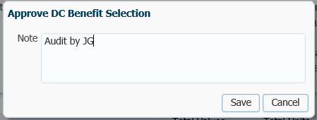

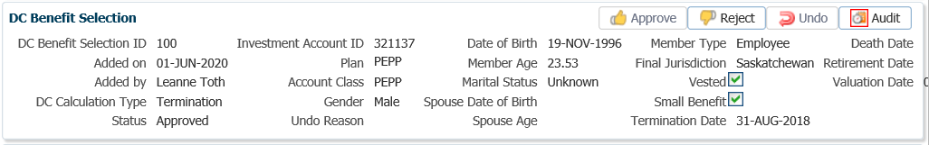

1. Close the **DC Benefit Selection** tab by clicking on the **X.**



1. A history of Transactions, User and Event is shown under the **Audit** button.

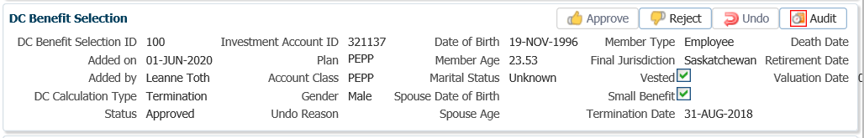

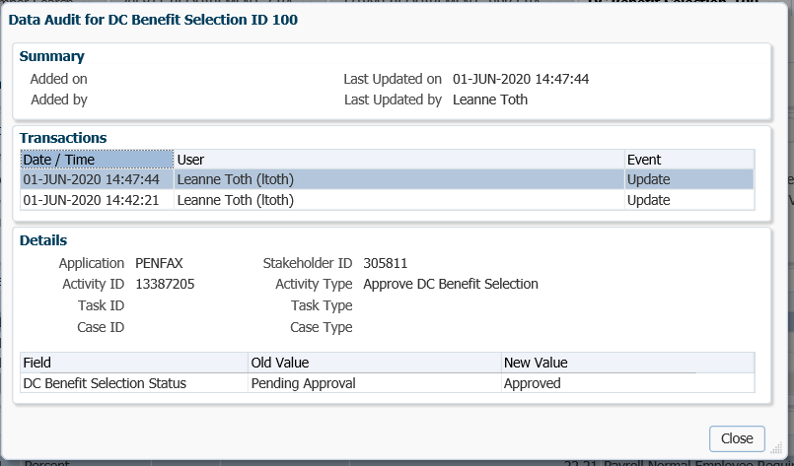

1. The payment will process in the overnight batch process and a cheque will be produced. The payment can be viewed under the **Benefit Recipient** Menu. Click on the **Onetime Amounts** tab to see the details.

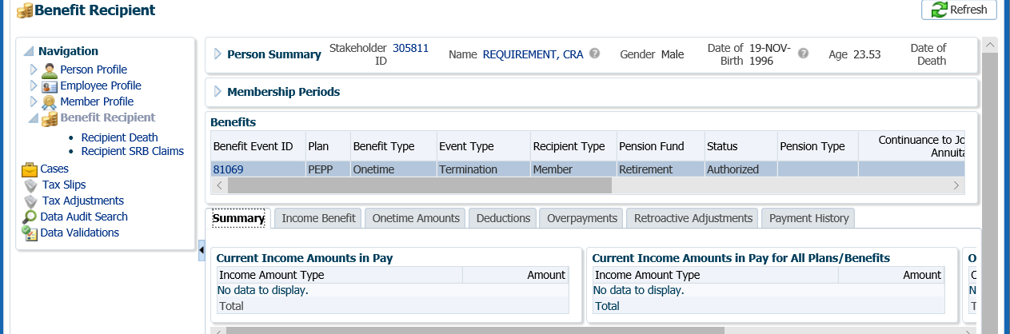

1. Highlight each **Onetime Amount ID** row to see the applicable Payment details, Recipient (Payee) details, tax deducted and cheque ID number, click on the **ID number** beside the **Paid by Payment ID.**

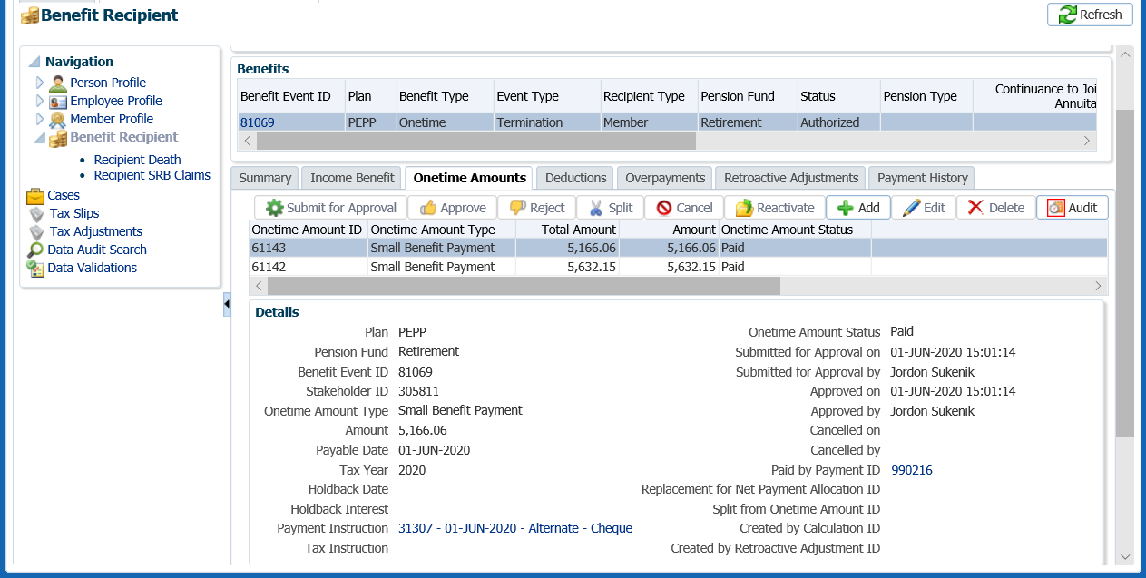

1. Click on the tabs to the right of the screen (**Line Items, Tax, Net Pay Allocation** and **Notes**) to see further details related to the payment.

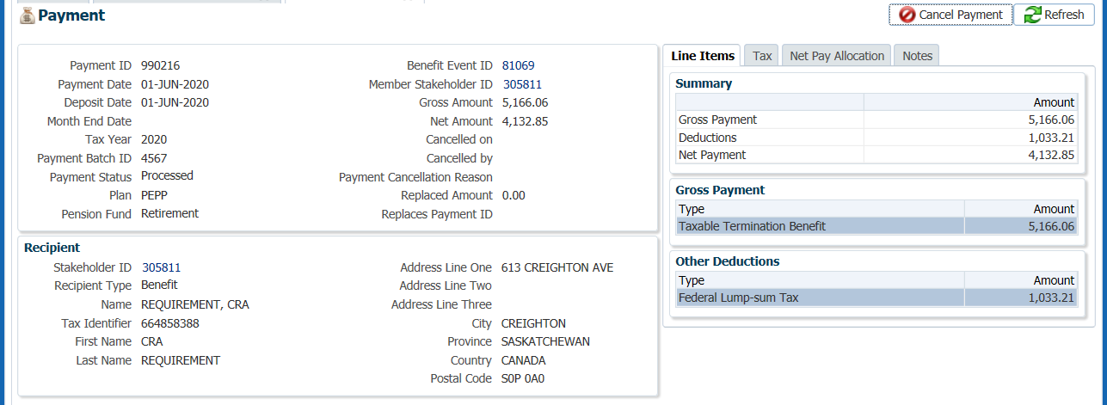

1. To see the details of the cheque, select the **Net Pay Allocation** tab. Click on the **Cheque ID** to open the **Cheque** window.

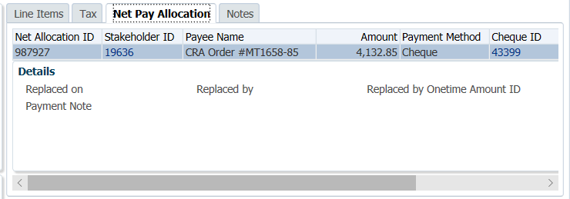

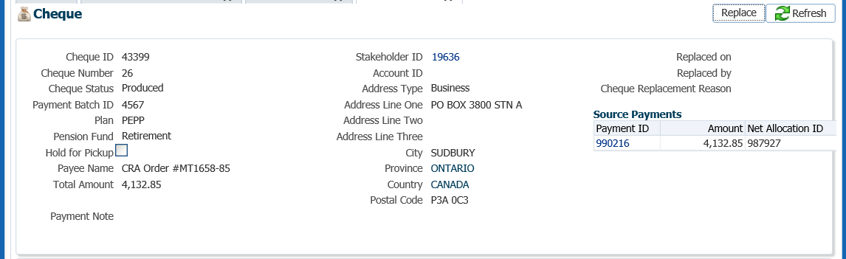

* **NOTE:** Click on the **X** in the **Payment ID Tab** to close the window.



1. A *Withdrawal Confirmation Letter* will be produced overnight. The letter will be saved under the **Person Profile**, **Communications** screen underthe **Outbound Documents** region. Click on the **Filename** link to open the document.

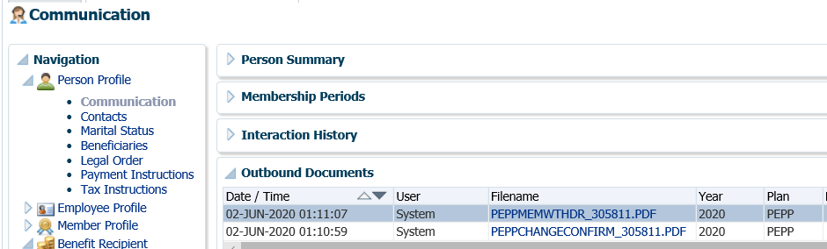

1. A **Tax Slip** for a cash payment will be issued at the end of the year and saved under the **Navigation** menu, **Tax Slips** screen.

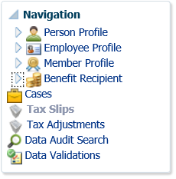

1. Under the **Member Profile** menu, the **Membership Periods** region will nowshow the **Member Status** as Terminated or Retired, depending on the age of the member once the payment is processed overnight.

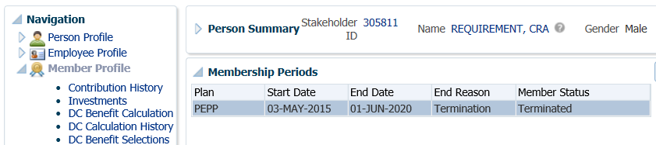

1. Under the **Investments** screen the **Investment Accounts** region will now show the **Account Status** as Inactive and the balance under the **Account Summary** region will show $0.00 if all the money was requested to be paid out.

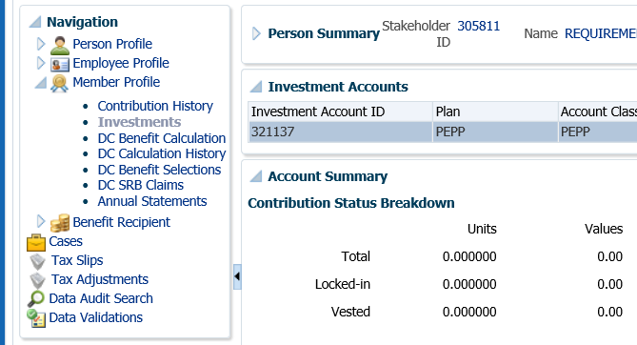

1. Once the payments to CRA have been activated, there is no longer an expiry date of one year. PEPP is required to continue to pay the debt until it is paid or until the member depletes their account, whichever comes first.
2. Remove the critical note  from PENFAX once the requirement to pay has been met, or if the one year window in which no cash refund request was made by the member. Under the **Person Profile, Notes** region. Highlight the applicable note and click **Delete**.

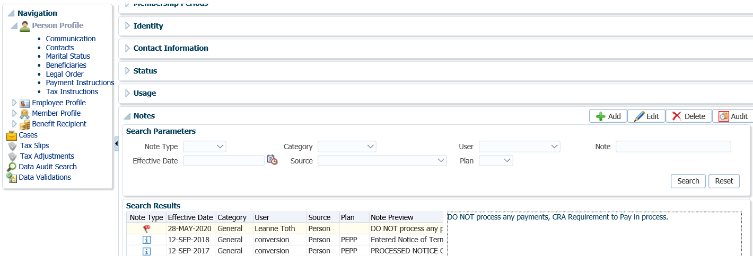

1. In the note pop-up window, click **Yes**.

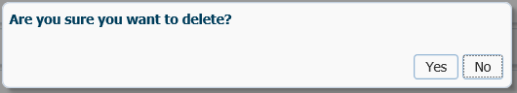

## Terminal Illness Payment

PEPP has a provision that allows members to apply for a full or partial payout of their account balance on the basis of their terminal illness. This allows the member to access additional funds at a critical time even if they have not terminated from employment.

PEPP defines terminal illness as an active, progressive disease leading to death within one year. The condition must be certified by a duly qualified medical practitioner.

PEBA’s adjudicator compiles and reviews all medical information, and provides a recommendation to PEPP as to whether the application meets PEPP’s definition of terminal illness.

PEPP does not have access to any of the medical information provided by PEBA’s adjudicator.

**Business Process Requirements - Terminal Illness Payment**

* Upon request by a member, PEBA administrators will provide the member with the following:
  + *Application for Terminal Illness Payout* form (member to complete Section A);
  + Terminal Illness Procedure letter;
  + PEPP postage paid envelope;
  + An *Authorization for Release of Information* form (to be completed by the attending physician);
  + A *Medical Status Statement* (to be completed by the attending physician);
  + An *Attending Physician’s Statement – Advanced Payment Request* form
  + Canada Life cover letter (address to Canada Life);
  + Canada Life addressed envelope (is not postage paid).
* The member returns the completed *Application for Terminal Illness Payout* form to PEPP.
* The attending physician completes the *Attending Physician Statement – Advance Payment Request* form. Either the member or the physician will forward the completed *Attending Physician Statement – Advance Payment Request* form to and Canada Life cover letter to Canada Life.
* PEBA’s adjudicator will provide their recommendation to PEBA to proceed with the payout, provided that the physician’s assessment is in accordance with the PEPP Board’s definition of terminal illness.
* If the adjudicator approves a terminal illness payout, a **critical note**  for Terminal Illness should be set to notify administrators of the receipt of a terminal illness payment request.
* If PEBA’s adjudicator approves the request, PEPP will return the *Application for Terminal Illness Payout* to the member to completed Section B of the application and provide a spousal waiver if applicable.
* If the member has a spouse, the spouse must provide a written waiver of their entitlement to a benefit, or of a portion of their entitlement to a benefit in a form acceptable to the board (i.e., the *Spouse’s Waiver of Pre-Retirement Survivor Benefit Pursuant to Clause 33(6)(a) of the Pension Benefits Act, 1992* form).
* PEPP will allow a Terminal Illness payment to be processed as either a percentage (100%) or a flat dollar amount of the account, based on the member’s request indicated on the Application for Terminal Illness Payout form.
* If the member’s marital status is married or common-law, the spouse must complete and submit a spousal waiver.
* Verify the member’s SIN on the *Application for Terminal Illness Payout* to the SIN on the PENFAX account to ensure it matches*.*
* If any information is missing on the form follow up with the member. ***Refer to the******Procedures to Obtain Missing Information***.
* The lump sum cash payment will be processed and subject to lump sum tax withholding rates. A Canada Revenue Agency T4A slip will be issued, reporting the gross amount of payment and tax withheld.
* If the terminal illness payment is denied, PEPP will notify the member by letter. If the member disagrees with the decision they may appeal to the Board.

#### How to Process a Terminal Illness Payment

When the Application for Terminal Illnessis approved by PEBA’s adjudicator you can proceed with the Terminal Illness payment process on PENFAX.

1. Search for the member in PENFAX.
2. Verify that all required documents and forms have been received, signed and certified if required and that the option chosen by the member is allowed as per the business process requirements for a terminal illness payment.
3. Under the **Navigation** menu, click on the **Investments** screen. In the **Account Summary** region confirm that the amount on the *Application for Terminal Illness Payout* form is allowed based on the account balance the member currently holds.

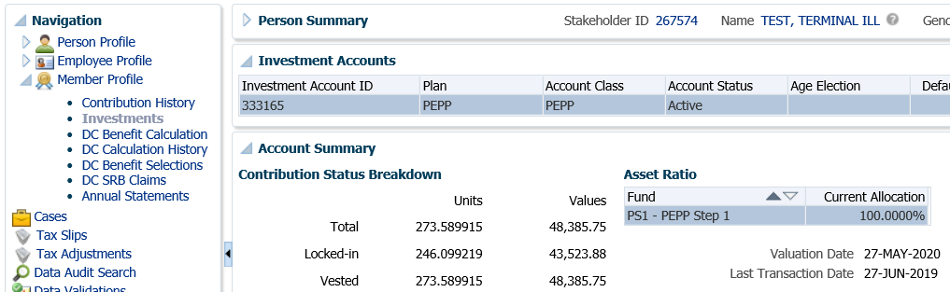

1. Under the **Investment** menu, **Account Instructions** region, click the **Add** option to add a new account instruction to process the payment.

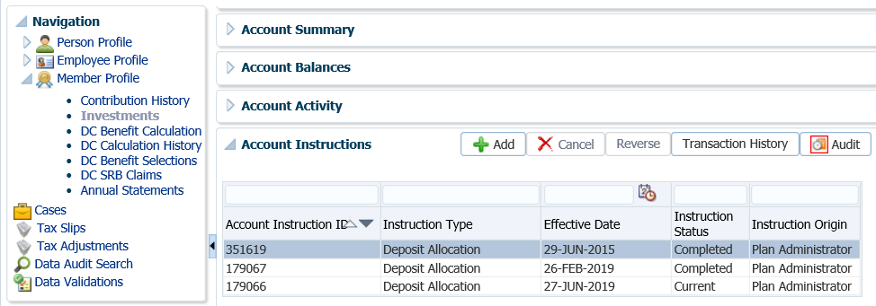

1. In the **Account Instruction** pop-up window, under **Instruction Type** select **Lump Sum Withdrawal** from the drop-down list and leave the **Effective Date** as the current date.

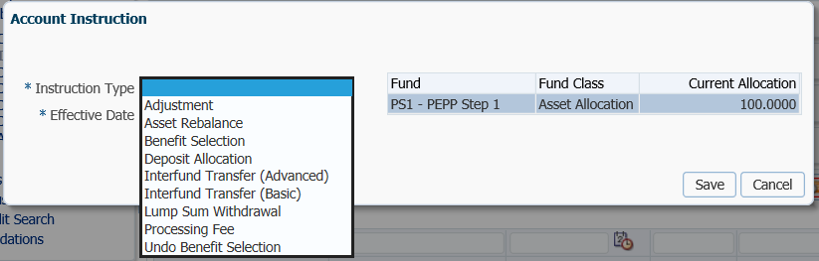

1. The **Account Instruction** window will expand. Under **Lump Sum Withdrawal Type** select **Terminal Illness**. Under **Lump Sum Withdrawal Method** select the amount as requested on the *Application for Terminal Illness Payout* form, (gross amount, net amount after fees, net amount before fees or percent).

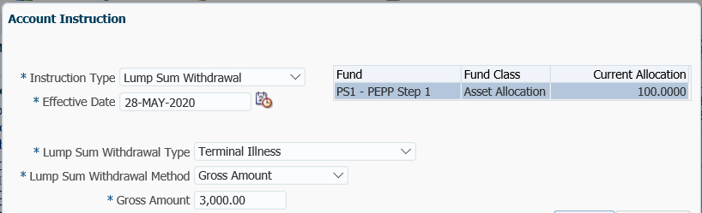

1. In the **Account Instruction** pop-up window in the bottom section click the **Add** button.

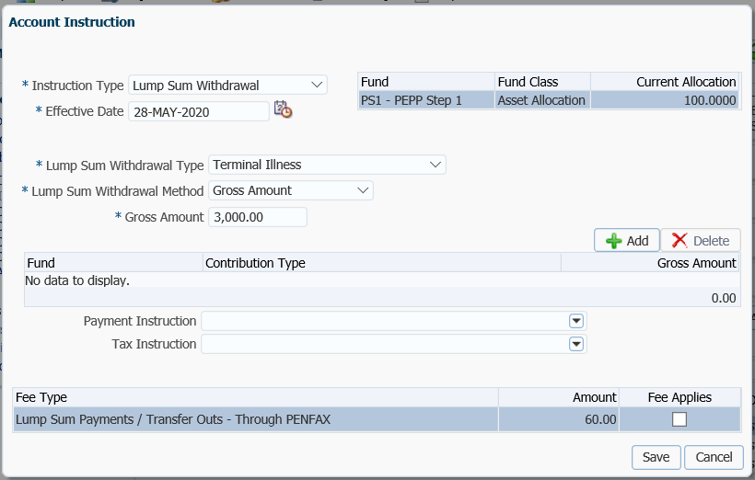

1. The investment fund the member holds an account balance in will populate in the **Fund** area. Select the **Contribution Type** from the drop-down list and enter the **Gross Amount** to be taken from that contribution type. Click **Add** again to select the additional contribution type(s) and enter the gross amount to take from each contribution type.

If there are more than one **Contribution Type**, you can just leave the field blank and it will prorate across all contribution types. Input the total gross amount in the **Gross Amount** field.

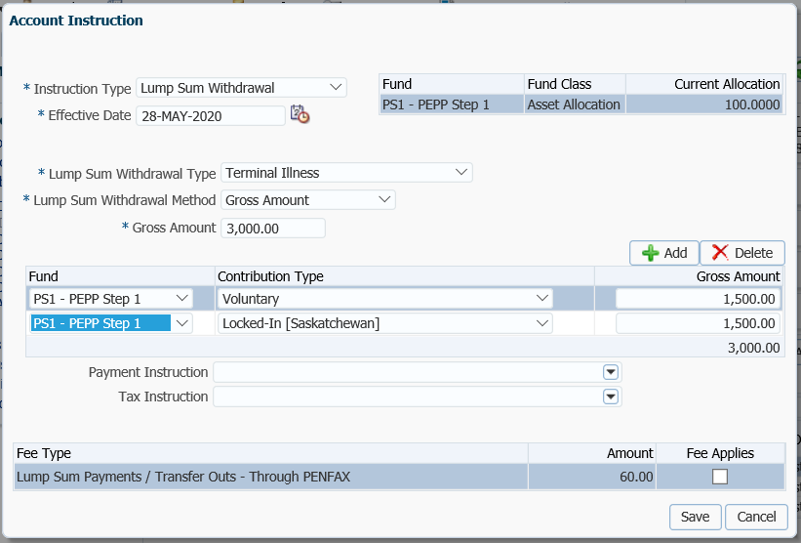

* **NOTE:** a **Fee** is never charged for a Terminal Illness payment, even if there are multiple payments taken in a year.

1. Under the **Payment Instruction** area, click **Add New** from the drop-down list.

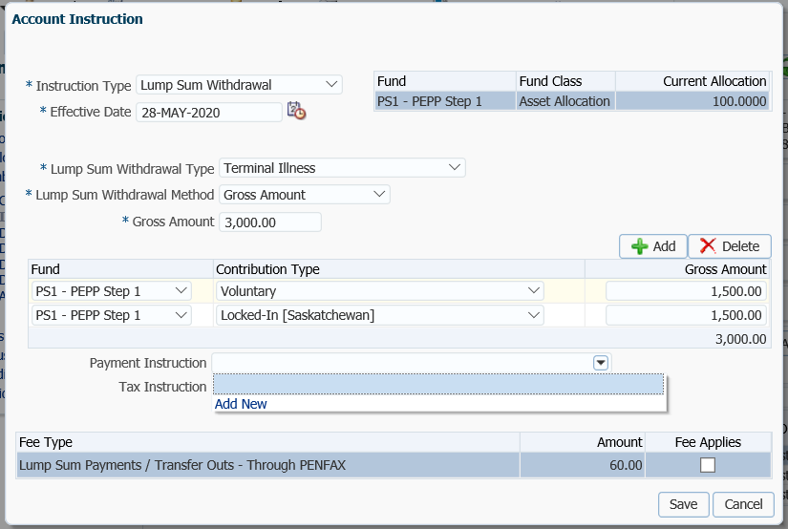

1. In the **Payment Instruction** pop-up window, leave **Payee Type** as **Self** and **Payment Method** as **cheque, Receipt Date** will be the current date. The **Payee Name** and **Address Type** will populate with the member’s name and primary address. Click **Save**.

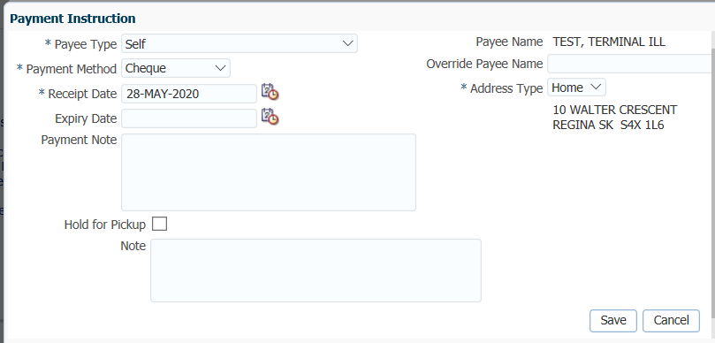

1. In the **Account Instruction** pop-up window, the **Payment Instruction** will now be populated. Click **Save**.

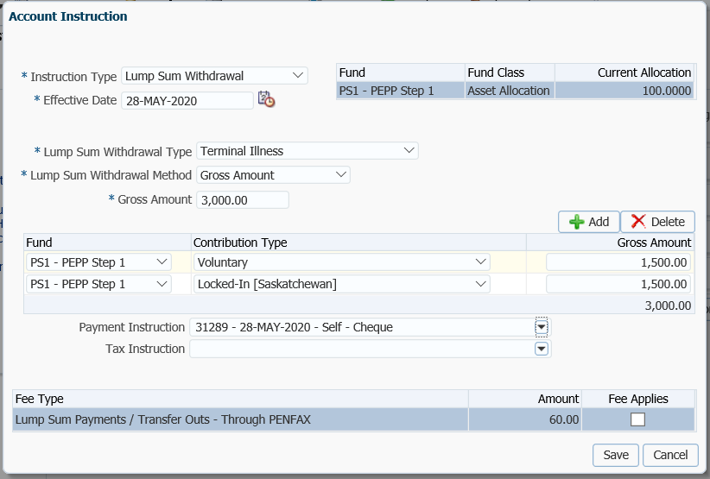

1. **Tax Instructions** are not required to be added for cash payments. PENFAX will determine if tax is required to be deducted by the Withdrawal Type selected and apply the appropriate tax rate of 10%, 20% or 30%.
2. The payment will now show as **Pending** under the **Account Instructions** region with the details of the payment under the **Details** area to the right.

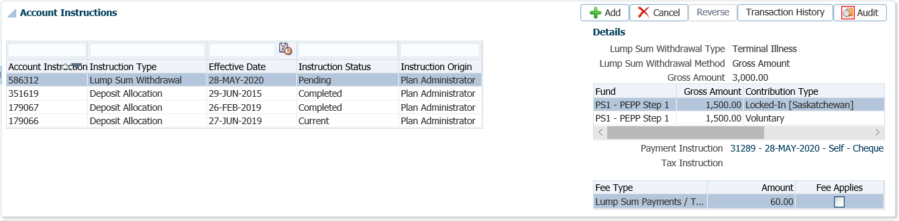

1. The *Pension Specialist* or *Supervisor* will audit the payment in the **Investments menu, Account Instructions, Details** region. If errors were found or the payment was done in error, the payment must be cancelled using the **Cancel** option if the status shows as **Pending.**

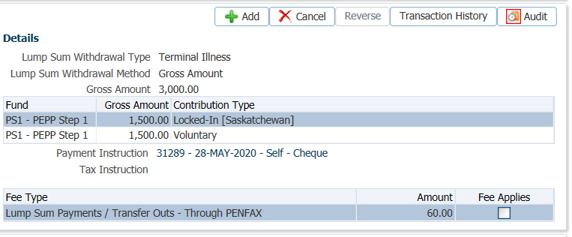

1. A history of Transactions and Details is shown under the **Audit** button. Click **Close** to close the audit window.

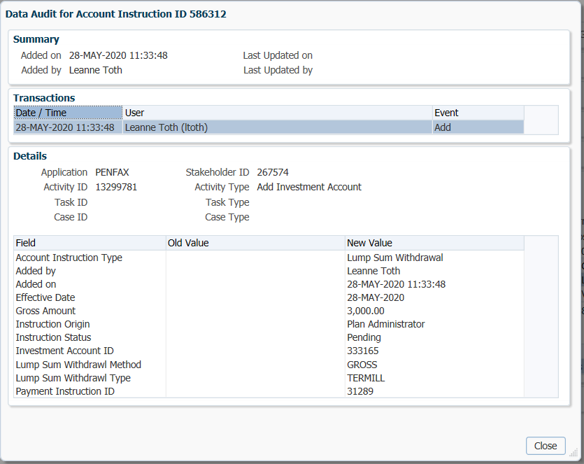

1. The payment will process in the overnight investment batch and a cheque will be produced. The payment transaction details can be viewed under the **Investments** menu, **Account Activity** region.

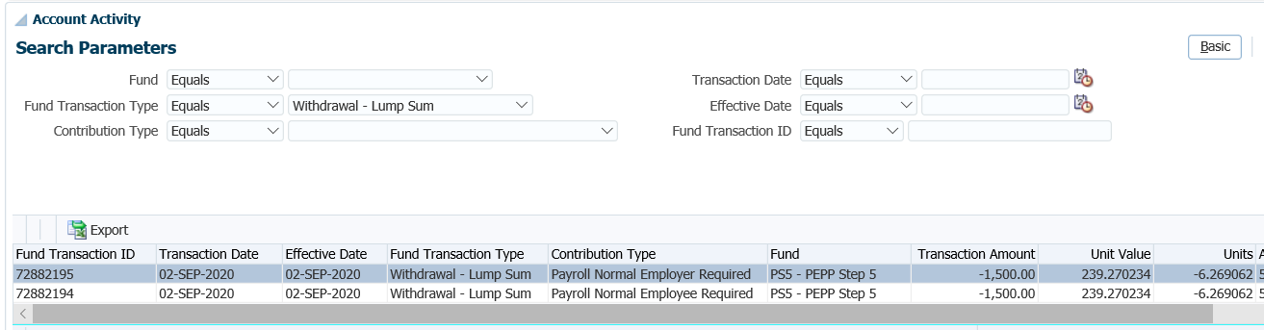

1. The total values reflected under the **Investments** screen, **Account Summary** region and the **Account Balances** region will be the difference of the payment transaction that was valued overnight.

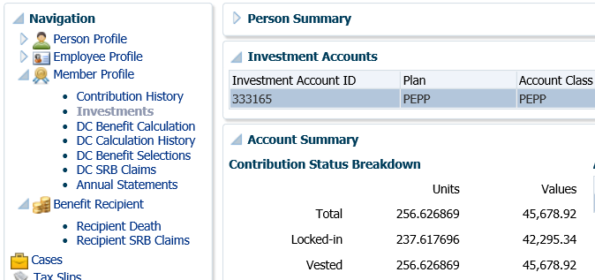

1. A **Benefit Recipient** folder is created after the payment has been processed overnight. To view the details of the payment, recipient (payee), tax deducted and cheque ID number, click on the **Benefit Recipient** menu, highlight the **Benefit Event ID** created for the payment. Click on the **Onetime Amounts** tab.

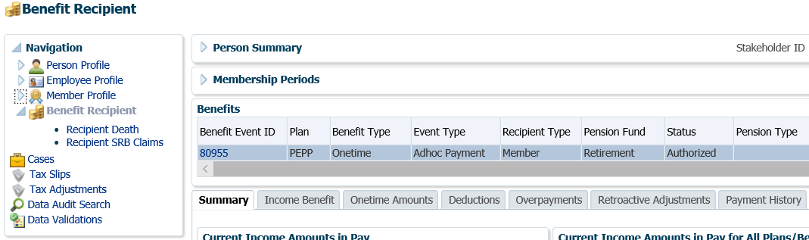

1. Under the **Onetime Amounts** tab, click on the **Paid by Payment ID** number **hyperlink** to see the payment details.

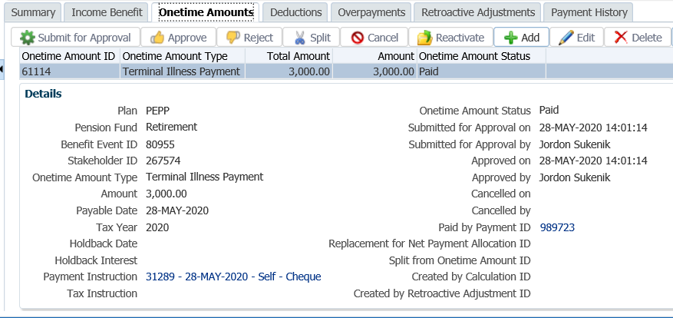

1. The tabs to the right of the screen (**Line Items, Tax, Net Pay Allocation** and **Notes**) will show further details related to the payment.

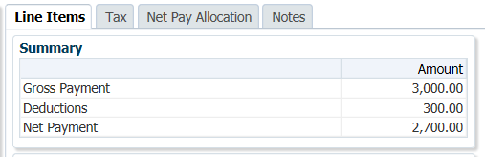

1. To see the details of the cheque, click on the **Cheque ID** number under the **Net Pay Allocation** tab.

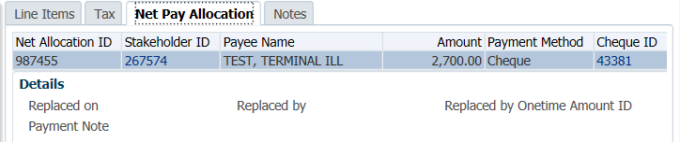



* **NOTE:** Click on the **X** in the Tab to close the window when done viewing.

1. A *Withdrawal Confirmation Letter* will be produced overnight. The letter will be saved under the **Person Profile**, **Communications** screen underthe **Outbound Documents** region. Click on the **Filename** link to open the document.

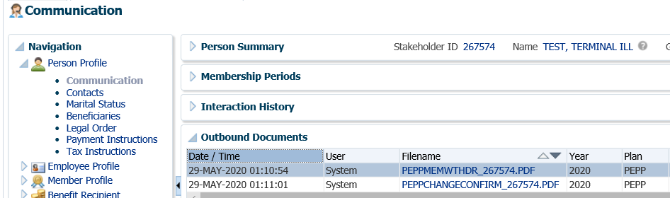

1. A **Tax Slip** for a cash payment will be issued at the end of the year and saved under the **Navigation** menu, **Tax Slips** screen.

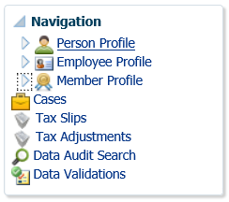

## Clear Residual Amount Payment

A clear residual payment is a result of contributions being received for a member after the member has requested a cash payout or a transfer out of all their pension funds at termination, retirement or upon death. The contributions are usually a result of the final payroll contribution being received after the final payout.

A clear residual payment has the ability to write off small amounts in a PEPP member’s account (PEPP or VPB) whose plan status is terminated, retired or deceased and the employment status is terminated, retired or deceased. The funds that are withdrawn will be reinvested in PEPP as income to the plan (similar to amounts that are forfeited by non-vested members at plan termination).

Business Process Requirements – Clear Residual Amount

* Member Plan and employment status must be terminated, retired or deceased.
* Member can be in PEPP or VPB.
* Member must have an account balance of $10 or under.
* No cheque is issued to the member.
* Residual amounts are reinvested back into PEPP As income to the plan.
* If the residual amount exceeds $10, the member must be contacted to advise PEPP on how to proceed. Options are:
  + cash lump sum payment less withholding tax to the member.
  + transfer to a financial institution if funds were originally transferred. The financial institution must agree to accept the money.

#### How to Process a Clear Residual Amount Payment

1. Search for the member in PENFAX.
2. Determine that the **Member Status** is showing as Terminated, Retired or Deceased by checking the **Navigation menu, Person Profile** menu, **Membership Periods** region.

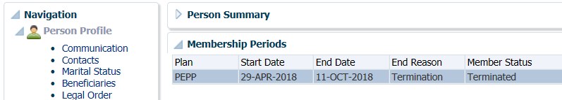

1. Under the **Navigation**, **Member Profile** menu, **Investments** screen, **Account Summary** region confirm the account value is $10.00 or less.

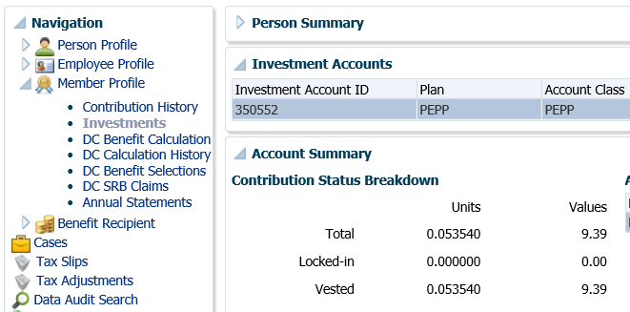

1. Under the **Investments** screen, **Account Instructions** region, ensure you have the **Investment Account** highlighted if more than one. Click **Add**.

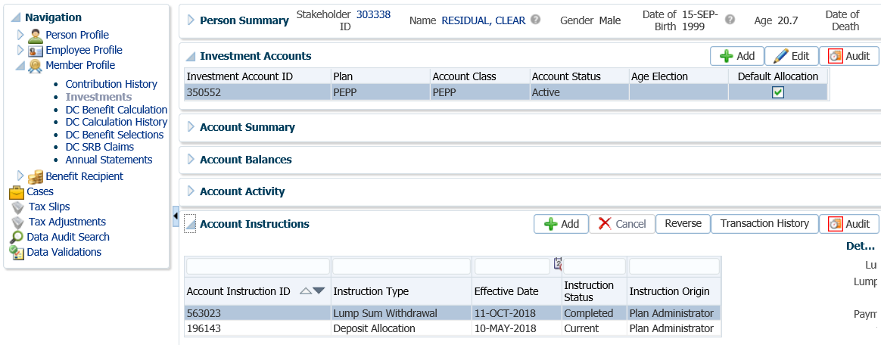

1. In the top section of the **Account Instruction** pop-up window, select the following and click **Save**:
   * **Instruction Type** - Lump Sum Withdrawal
   * **Effective Date -** current date
   * **Lump Sum Withdrawal Type** – Clear Residual
   * **Lump Sum Withdrawal Method** – Percent
   * **Percent** – 100%
   * **Payment Instructions** – leave blank (is not required as no cheque is issued)
   * **Tax Instructions** - leave blank (is not required as no tax is withheld)

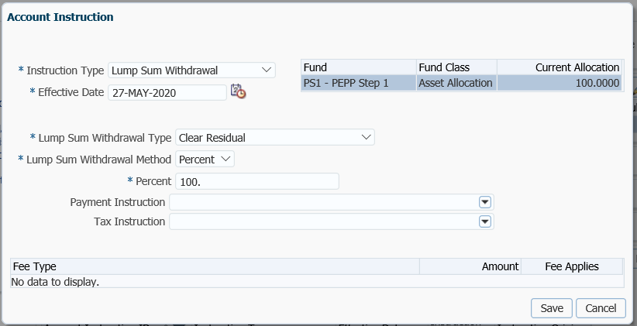

1. The *Pension Specialist* or *Supervisor* will audit the clear residual payment in the **Investments menu**, **Account Activity** region. Select **Withdrawal – Lump Sum** in the **Search Parameters** region, click **Search.**

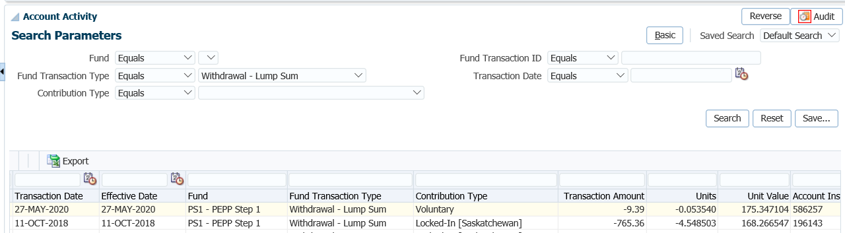

1. If errors were found or the payment was done in error, the payment will need to be cancelled in the **Account Instructions** region using the **Cancel** option if the status shows as **Pending**. The payment will need to be redone as an edit option does not exists to correct the details.

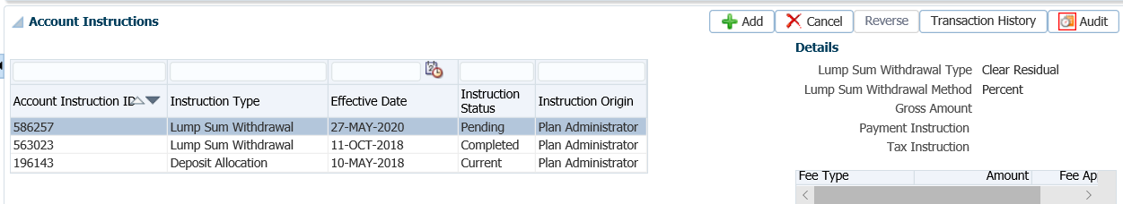

1. The payment will be auto approved and processed in the overnight investment batch. The payment transaction details can be viewed under the **Investments** menu, **Account Activity**. Select **Withdrawal – Lump Sum** in the **Search Parameters** region, click **Search.**

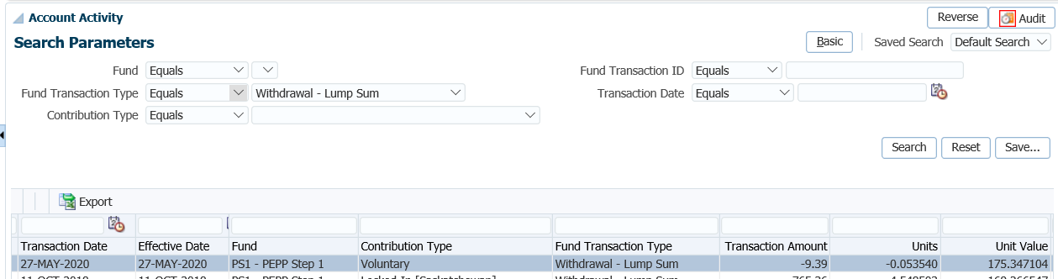

1. Details of the transaction can also be viewed in the **Benefit Recipient** folder. Highlight the correct **Benefit Event ID** in the **Benefits** region, then open the **Onetime Amounts** tab.

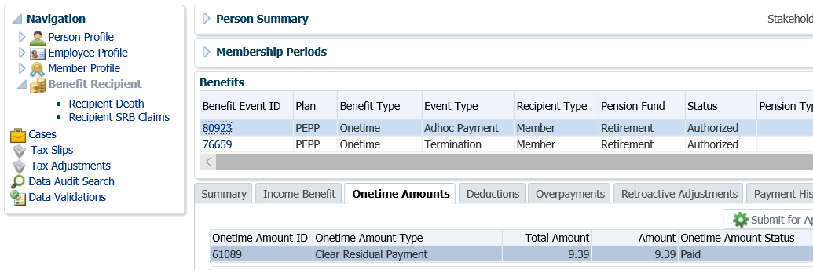

1. The remaining funds will be removed from the account. Under the **Investments** screen, **Account Summary** region, the account values will now show $0.00.

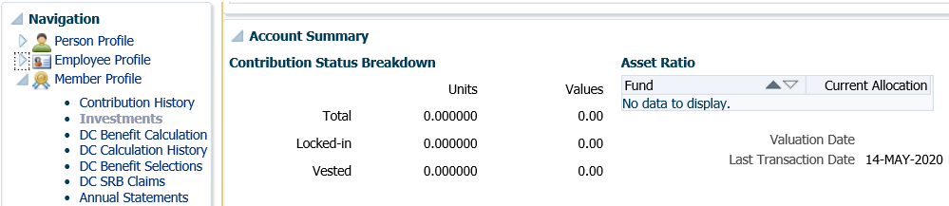

1. There is no withdrawal letter printed or cheque issued for the amount processed as a clear residual payment. The amount withdrawn will be reinvested back into PEPP as income to the Plan.

## Transfers to another Registered Pension Plan (RPP) with Service

Upon termination of employment with a PEPP Participating Employer, a member may apply to transfer their full account balance, (member and employer contributions) and pensionable service to another Registered Pension Plan (RPP), in accordance with a reciprocal or portability agreement.

The service transferred to the importing plan would be recognized as credited service, resulting in the member qualifying for retirement sooner in a defined benefit plan.

### Portability Transfer Out Payments

A portability agreement transfer is a direct transfer of pensionable service and the member’s accumulated PEPP account balance to another Registered Pension Plan (RPP).

The importing plan determines how much service can be credited to the member based upon the amount of money transferred from PEPP as a result of the portability transfer.

A legal transfer agreement such as what is required for a reciprocal transfer in not required for a portability transfer. The Importing plan must agree to accept all or a portion of the pension money and the pensionable service.

Business Process Requirements and Process Overview - Portability Transfer Out

* The member must initiate the transfer with the importing plan.
* Employer, member or the importing RPP sends in the *Portability Agreement* Form.
* Determine if all forms have been completed in full and signed. Copies are acceptable.
* Determine if the member is eligible for the portability transfer.
* Request the *salary information* from the former PEPP employer(s).
* Former Employer(s) sends the *salary information* to PEPP.
* Forward the *Portability Agreement* Form and *salary information* to the importing RPP.
* Importing RPP receives the *salary information* and sends to PEPP a *Letter of Demand* or the completed *Portability Agreement Form* indicating the amountto transfer on it.
* Review the request to determine if all information is completed and signed.
* Check the member’s plan and employment status. The member must be terminated from all PEPP Participating Employers and be in deferred plan status.
* Determine if the final contribution has been received. If the final contribution has not been received, contact the member to find out if they want to proceed without it or wait to have the transfer processed after it has been is received.
* Verify the member’s SIN on the forms to the SIN on the PENFAX account to ensure it matches.
* Proceed with the Portability transfer payment.
* If any information is missing on the form(s) follow up with the member or employer. ***Refer to the Procedures to Obtain Missing Information.***

### Reciprocal Transfer Out Payments

A reciprocal agreement is a legal agreement between two registered pension plans (RPP) established to transfer pension money and credited service between the two plans. The reciprocal transfer agreement defines the terms and conditions under which a member may transfer their pensionable service and monies. PEPP must hold an active reciprocal transfer agreement with the other pension plan. See PEPP Talk on Reciprocal Agreements.

Business Process Requirements and Process Overview - Reciprocal Transfer Out

* The member must initiate the transfer with the importing plan.
* Employer, member or importing RPP sends in the *Appendix A* *or B* *Form* (depends on the *Reciprocal Agreement* in place). Copies are acceptable.
* Review the *Appendix A* *or B Form* (depends on the *Reciprocal Agreement* in place) is signed and completed. Copies are acceptable.
* Determine if the member is eligible for the transfer.
* Send a letter to the importing RPP along with 1 copy of the *Appendix A* *or B* *Form* only if the *Appendix A or B Form* was received from the member.
* Request the *salary information* from the former PEPP employer(s) if required.
* Former PEPP employer(s) sends in the *salary information* to PEPP.
* Forward the *salary information* and *Appendix A or B Form* (depends on the *Reciprocal Agreement* in place*)* if required to the importing RPP.
* Importing RPP receives the *salary information* and sends in a *Letter of Demand* to PEPP.
* Check the member’s plan and employment status. The member must be terminated from all PEPP Participating Employers and be in Deferred Plan status.
* Determine if the final contribution has been received. If the final contribution has not been received, contact the member to find out if they want to proceed without it or wait to have the transfer processed after it has been is received.
* Verify the member’s SIN on the form to the SIN on the PENFAX account to ensure it matches.
* Proceed with the Reciprocal transfer payment.
* If any information is missing on the form(s) follow up with the member or employer. ***Refer to the Procedures to Obtain Missing Information***.

#### How to Process a Portability or Reciprocal Transfer Out Payment

1. Search for the member on PENFAX.
2. Once the *Letter of Demand* is received from the importing plan, determine if the member is eligible as per the Portability or Reciprocal Agreement. The member must be terminated with all PEPP participating employers and show a Plan status of Deferred.
3. Verify that all required documents and forms have been received, signed and certified if required and that the option chosen by the member is allowed as per the business process requirements for a portability or reciprocal transfer out payment.
4. Under the **Person Profile** menu, **Membership Periods** region ensure the **Member Status** is showing as Deferred.

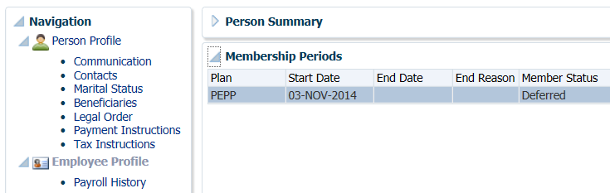

1. Under the **Employment Periods** region confirm the following information has been entered:

* **End Date**
* **End Reason** is Terminated or Retired
* **Final Jurisdiction**

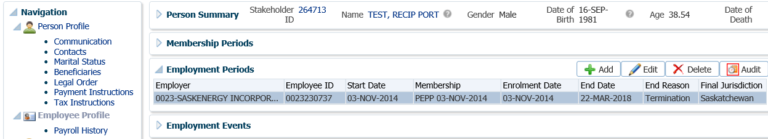

1. Under the **Employee Profile** menu, **Payroll History** screen, determine if the final contribution has been received if the termination from employment has been recent. Expand the **Payroll History** region to see the payroll contributions.

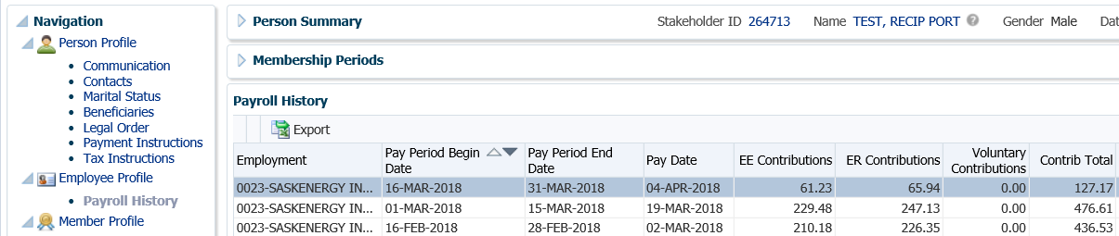

* **NOTE:** If the final contribution has not been received, contact the member to find out if they want to proceed without it or wait to have the transfer processed after it has been received. If the member wants to wait, suspend your assigned Case.

1. Under the **Navigation** menu, click on the **DC Benefit Selections** screen. Click **Add** to add a new payment.

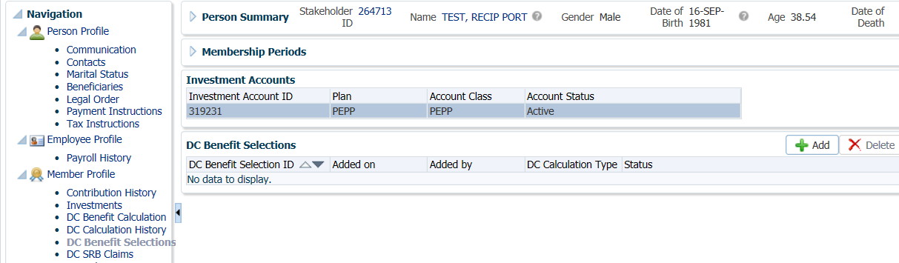

1. In the **Input Data** train, enter a **Retirement Date** if the member is over age 50. Click **Next** to start the **Input Data** process.

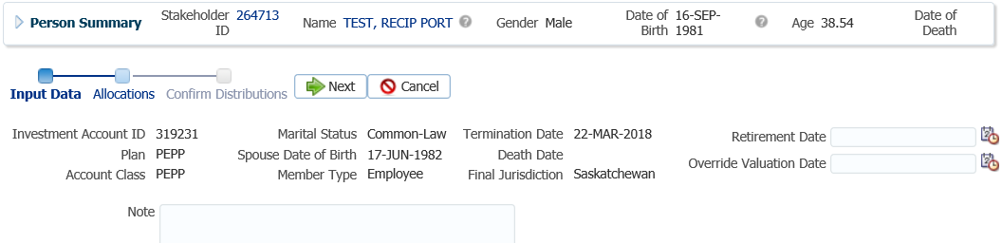

* **NOTE:** the **Retirement Date** can be the current date. It is required to generate retirement options for members over age 50.

1. In the **Input Data** train under the **Allocations** region click **Add**.

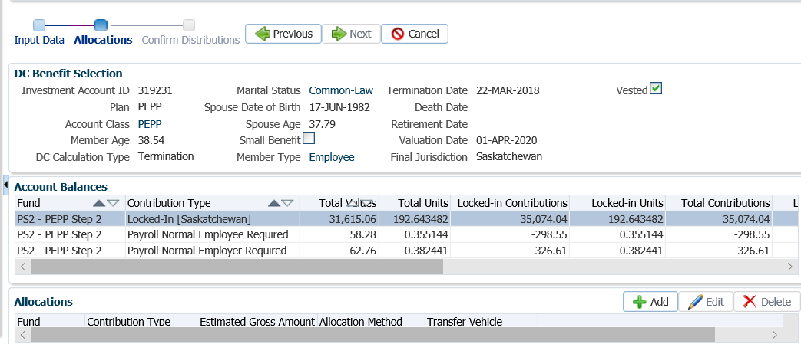

1. In the **Allocation** pop-up window enter the following information, then click **Save**:

* **Fund –** leave blank if the entire account balance is to be transferred
* **Contribution Type** – leave blank so that all funds and all sources will be transferred
* **Allocation Method** – Percent if taking 100% out, or Gross Amount if only transferring a partial amount
* **Percent/Gross Amount** – 100% or a specific gross amount
* **Transfer Vehicle** - RPP

*Full Amount:*

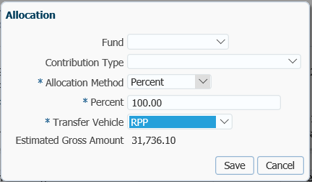

*Partial Amount:*

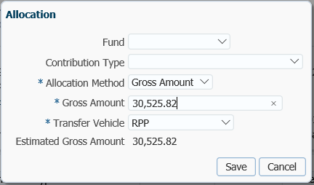

1. In the **Input Data** **train** click **Next** to Confirm the Distributions of the payment.

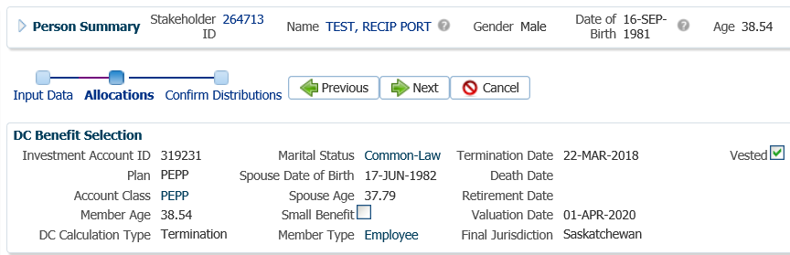

1. In the **Onetime Amounts** region under the **Payment Instruction** column, click on the drop-down list. If no information is displayed click on the **Add New** option.

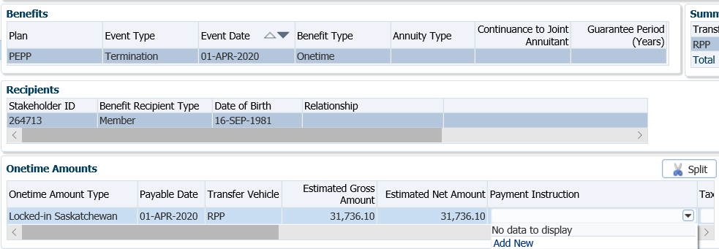

* **NOTE:** if the payee was previously added in the **Payment Instructions** screen under the **Person Profile**, then the information will be displayed in the drop-down list under **Payment Instructions** and can be selected.

1. In the **Payment Instruction** pop-up window select the following:
   * **Payee Type** - Reciprocal Plan
   * **Payment Method** – Cheque
   * **Receipt Date** – Current Date

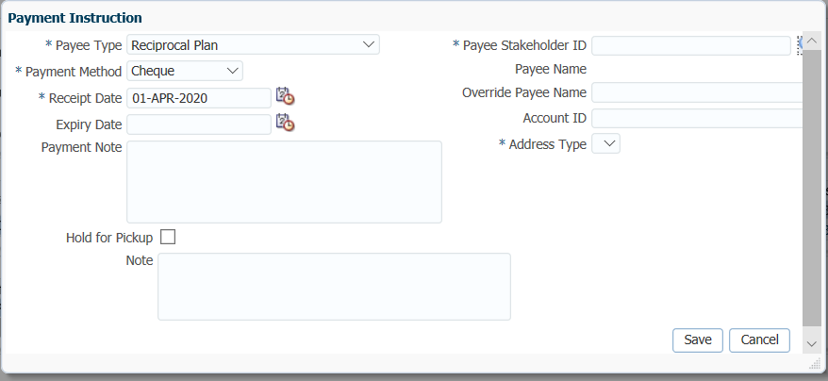

1. Locate the **Stakeholder ID** for the Importing RPP by clicking on the **magnifying glass**. This will take you to the **Search and Select Organization** screen.

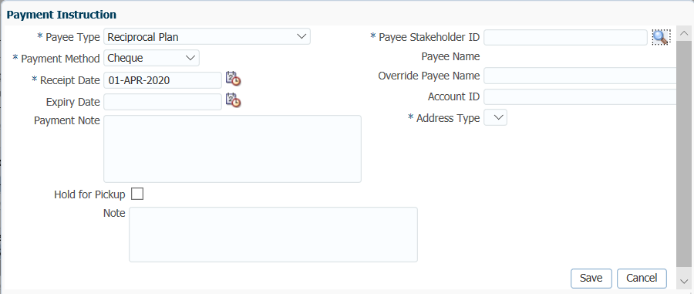

1. Under the **Search and Select Organization** screen select **Organization Type** as **Reciprocal Plan** if the transfer is under a Reciprocal Agreement or **Pension Plan** if done via a Portability Agreement. Click **Search**. Highlight the Reciprocal Plan/Pension Plan in the **Search Results** and click **OK**.

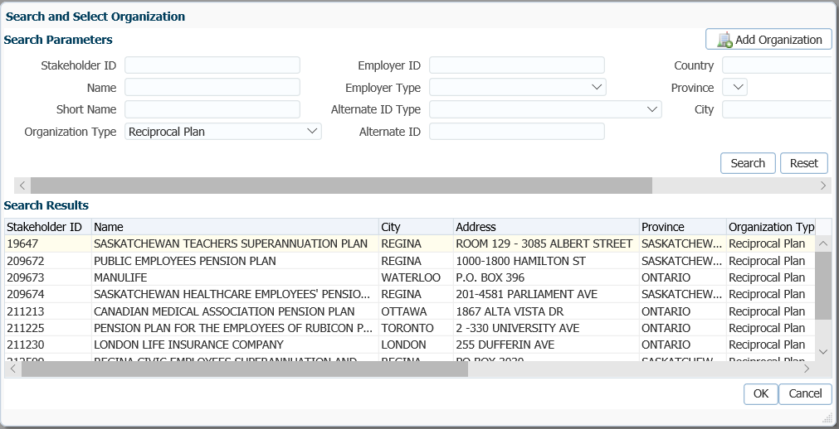

1. The **Stakeholder ID** for the Importing Plan will auto populate in the **Payment Instruction** screen. Click **Save**.

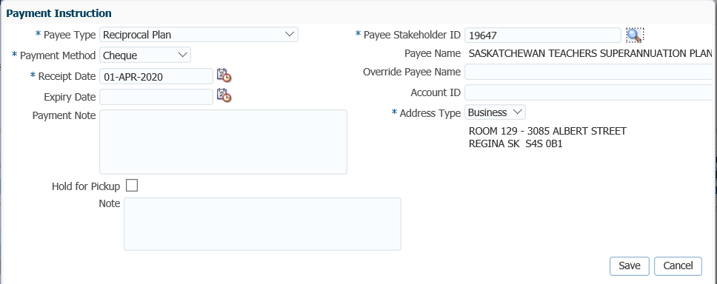

**Override Payee Name** would be used to set up a payment to an alternate payee name such as a guardian or trustee, “In trust for” or “Estate of”. Choose **Payee Type** of “Self” and enter the alternate payee name in the **Override Payee Name** field.

* In order to determine if an alternate **payee name** has been entered, the auditor of the payment has to click on the **Payment Instructions** tab to determine if there is a different payee name listed. If an Account ID is not provided on the T2151 form, enter the member’s SIN.

The **Notes** region will display any notes that were added during the calculation as well as allow the user to add more notes that pertain to the selected DC Benefit Selection.

1. In the **Input Data** T**rain**, click **Submit for Approval**.

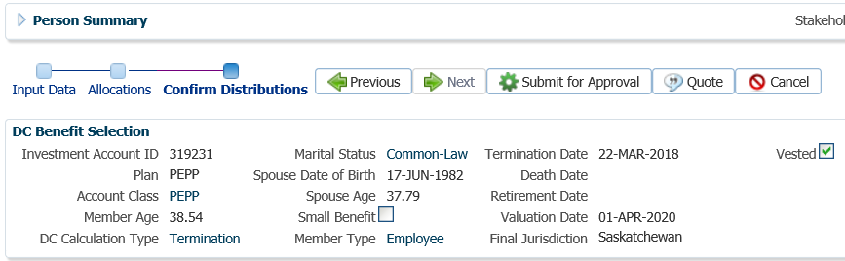

1. The *Pension Specialist* or *Supervisor* will audit and approve the payment in the **DC Benefit Selection** region by clicking **Approve**,or **Reject** if there were errors or the payment was done in error**.**

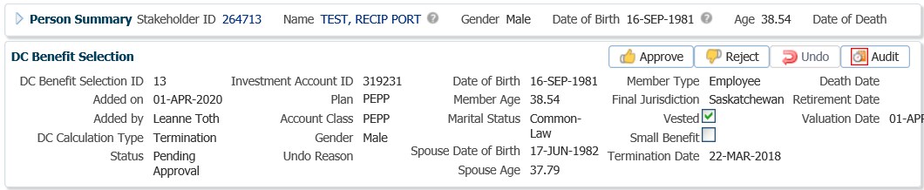

* **NOTE:** If the payment is **Rejected,** the payment steps will need to be entered again by the *Pension Information Officer*. There is no option to edit the existing information.

The **Reject** button is enabled if the status is **Pending Approval** or **Approved**. If the payment is rejected the status will update to **Rejected** when clicked and prevent the benefit selection from being processed by the investment batch.

The **Undo** button is enabled only if the status is **Processed** and will the reverse the payment in the investment batch.

1. In the **Approve DC Benefit Selection** window, add a **Note** and click **Save**.

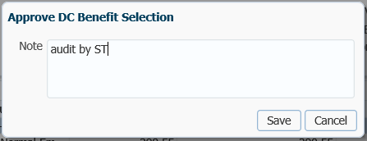

1. Close the **DC Benefit Selection** tab by clicking on the **X**. Return the payment request to the *Pension Information Officer*.



1. A history of Transactions, User and Event is shown under the **Audit** button.

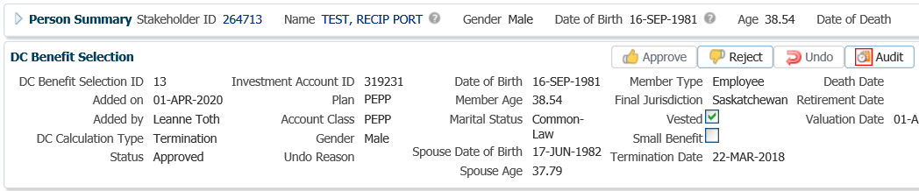

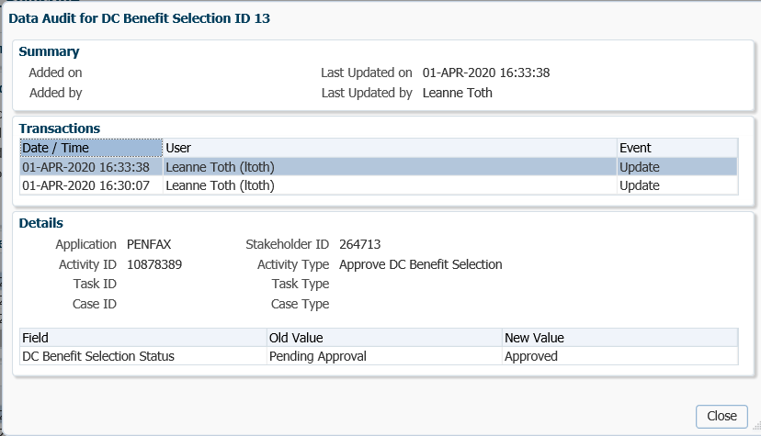

1. The payment will process in the overnight batch process and a cheque will be produced. The payment can be viewed under the **Benefit Recipient** Menu. Click on the **Onetime Amounts** tab to see the details.

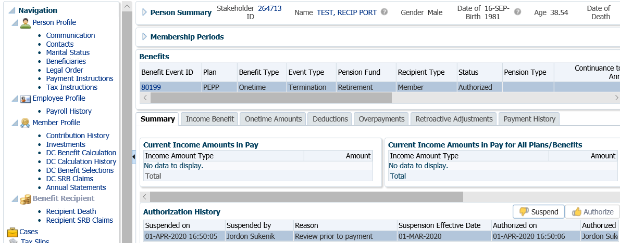

1. To see the Payment details, Recipient (Payee) details, tax deducted and cheque ID number, click on the **ID number** beside the **Paid by Payment ID** in the **Onetime Amounts tab.**

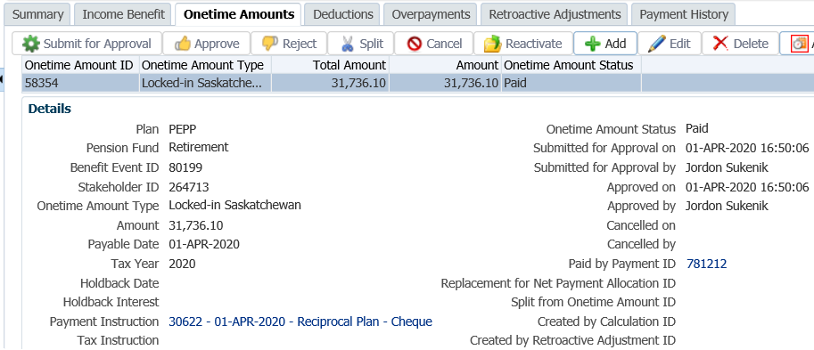

1. Click on the tabs to the right of the screen (**Line Items, Net Pay Allocation** and **Notes**) to see further details related to the payment.

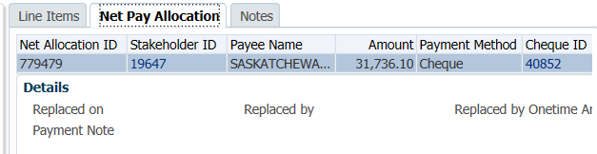

* **NOTE:** Click on the **X** in the **Payment ID Tab** to close the window.



1. A *Withdrawal Confirmation Letter* will produce overnight. The letter will be saved under the **Person Profile**, **Communications** screen underthe **Outbound Documents** region. Click on the **Filename hyperlink** to open the document.

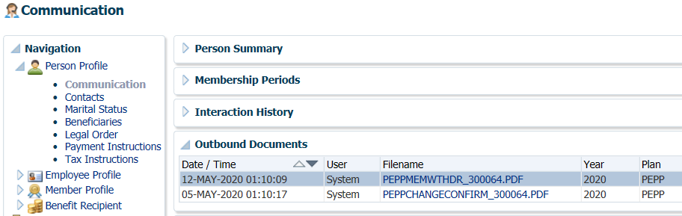

1. Under the **Member Profile** menu, the **Membership Periods** region will nowshow the **Member Status** as Terminated or Retired, depending on the age of the member once the payment is processed overnight.

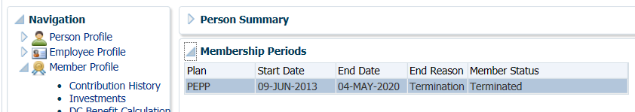

1. Under the **Investments** screen the **Investment Accounts** region will now show the **Account Status** as **Inactive** and the balance under the **Account Summary** region will show $0.00 if all the money was requested to be paid out.

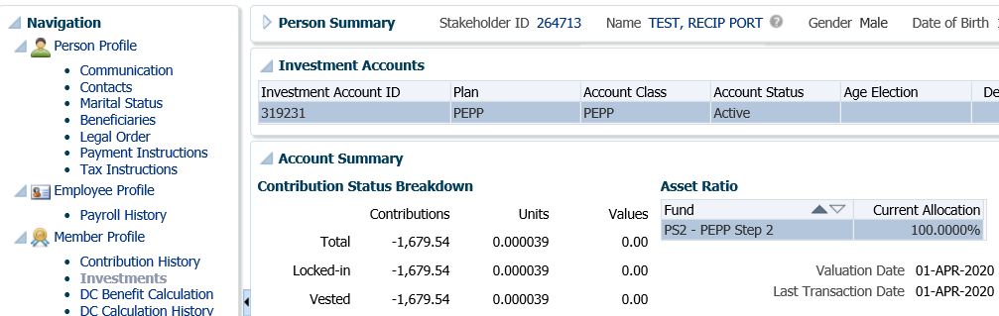

# Spousal Relationship Breakdown (SRB)

## Spousal Relationship Breakdown (SRB) Estimate – PEPP & VPB

A member’s PEPP account is considered property under the *Family Property Act* and can be divided upon a breakdown of a spousal relationship in accordance with the terms and conditions set out in a court order or an interspousal agreement.

A member, spouse of a member, common-law partner, or their authorized legal representative may request a calculation of the value of the member’s pension upon a breakdown of spousal relationship.

PEPP will calculate an amount based on the value as of the date of marriage to the date of dissolution. These dates would be provided by the member or spouse in their estimate request sent to PEPP. The request can specify a fixed dollar amount or a percentage of the pension at a fixed date provided it does not exceed 50% of the member’s current account balance. If requested, PEPP will calculate the return on investment (ROI).

Business Process Requirements – Spousal Relationship Breakdown (SRB) Estimate

* A member, spouse of a member, common-law partner, or their authorized legal representative may request a SRB calculation.
  + In the event of a breakdown of a common-law relationship the member and the spouse must have cohabited in a conjugal relationship for 24 consecutive months.
* Requests for a SRB calculation need to be in writing and signed.
* Requests can be sent to PEPP by mail, fax or emailed and scanned.
* SRB calculations can be provided for members of PEPP or VPB.

***A Calculation Request from a Member Should Include:***

* + Member’s name
  + Member Number
  + Address to send the calculations to
  + Exact dates to be used for the purpose of the calculation

***A Calculation Request from a Spouse/Common-Law Spouse Should Include:***

* + Member’s name
  + Member’s date of birth
  + Employer (if known)
  + Member’s address
  + Address to send the calculations to
  + Exact dates to be used for the purpose of the calculation
  + A common-law declaration is required to be completed and provided to PEPP by the common-law spouse if the common-law spouse is not indicated on the member’s records. No information can be released without the common-law declaration on file.
* The initial estimate is calculated free of charge. Subsequent requests for calculations are charged at a rate of $60 per hour (billed in half-hour increments, rounded to the nearest half hour). Fees are deducted directly from the member’s account. State the fee amount in the *SRB Quote letter*.
* PEPP cannot allow for more than 50% of the member’s account balance to be paid to the spouse. The 50% rule is applied on the specified date of division, and then again on the date the actual payment is processed on.
* If the start date to be used in the calculation is prior to CPAS (August 12, 2005), the data is to be obtained from the fiche or Year End CD Data on the *interest forward and/or equity calculation spreadsheet*. You must do a calculation to divide the last pay period if required. Microfiche data and Year End CD Data are from 1996 to August 12, 2005. **See example of a calculation below**.
* If the member is in VPB and the marriage start date was a date in which they were a PEPP member, a calculation is to be done in PEPP and then another in VPB. The two calculations will be added together and Specified Lump Sum used as the method.
* A *SRB Quote letter* is sent to the requestor along with a copy of PEPP *Talk* on *Breakdown of Spousal Relationships*. If the member did not initiate the request, a copy of the *SRB Quote letter* is sent to the member.
* If a request is from an ex-spouse for a SRB calculation, 2 separate letters are to be sent for privacy reasons.  One to the member, and one to the ex-spouse.  **DO** not c.c. either party.  The letter must state that both parties will be receiving the letter.
* A copy of the *SRB Quote letter* is to be kept for the member’s file.

**Example of Information for a Marital Calculation using Data Prior to PENFAX:**

* Information for June 21, 1993 will be found on the microfiche copy for before year-end 1994. This will give the year-end balance at March 31, 1993 and all contributions received from April 1, 1993 to March 31, 1994.
* If the member is a monthly employee; calculate the working days from June 1 – 21, 1993 divide by the working days in the month, times the contribution for that period.
* If the member is a bi-weekly employee and June 21, 1993 falls in the pay period of June 13 – 26, 1993; calculate the working days from June 13 – 21 divide by the working days in the pay period, times the contribution for that period.
* If the member requests a calculation from June 3, 1985 to May 1, 2000; print off the required information and do a calculation of their equity at June 2, 1985 and subtract that from the equity at May 1, 2000.
* Use PENFAX to calculate the remaining contributions. Go to the **Member Profile, Contribution History** screen under the **Search Results** region by using the **Export** option Calculate the member’s contributions up to the date of dissolution (CPAS converted and PENFAX will be display). Add the two amounts (total from manual spreadsheet and the amount determined by CPAS) together to obtain the amount at the date of division or date specified in the legal document.

#### How to Process a Spousal Relationship Breakdown Estimate

1. Once a request for a marital calculation is received, ensure all required information has been provided as outlined in the business process requirements for a SRB estimate.
2. Search for the member on PENFAX.
3. Under the **Navigation** menu, **Person Profile** menu, select the **Marital Status** screen. The **Marital Status** and **Spousal Relationships** regions might already be populated with the marriage and spouse details. If the information is missing or incorrect, it should be entered in order to calculate the SRB estimate correctly.

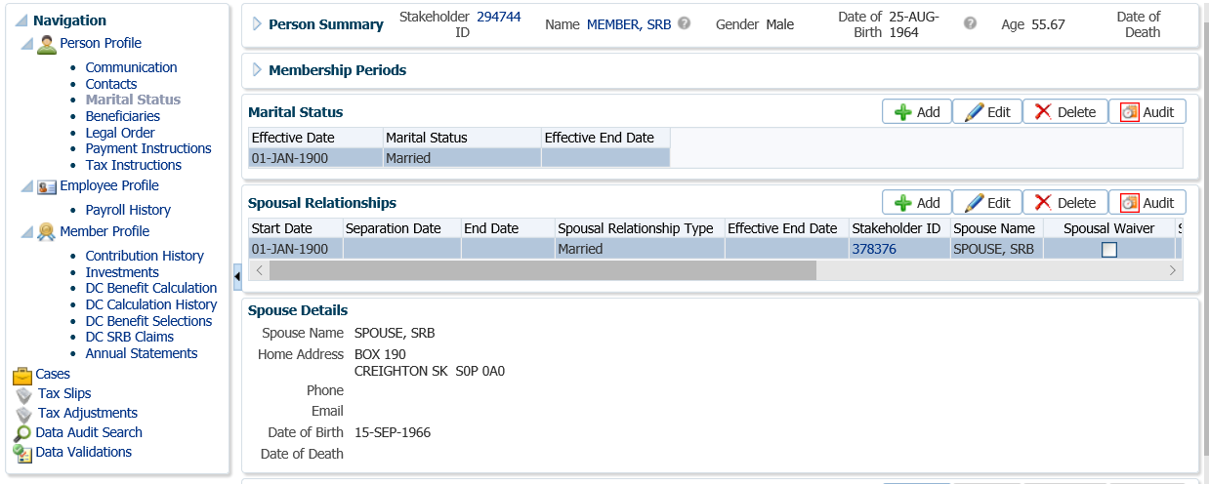

* **NOTE:** The **Effective Date** of the **Marital Status** and the **Start Date** of the **Spousal Relationships** were set to **01-Jan-1900** during the conversion. This ensures that, as a default, the entitlement period includes the member’s entire contributory period.

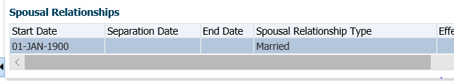

1. If the date of marriage and date of separation were not entered or are incorrect, enter them in the **Marital Status** region. Click **Edit** to make the changes.

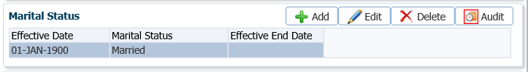

1. In the **Marital Status** pop-up window enter the marriage **Effective Date** and the separation date under the **Effective End Date**. Click **Save.**

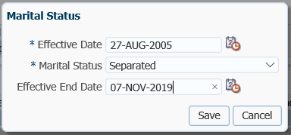

1. In the **Spousal Relationships** region click **Edit** to make the required changes to the **Separation Dates** if they were not entered or are incorrect.

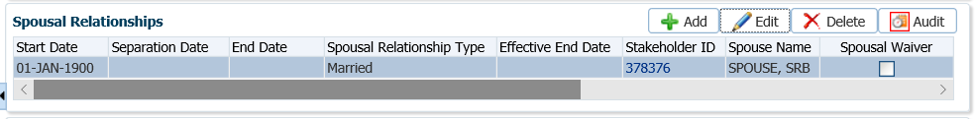

1. In the **Spousal Relationships** pop-up window, enter the **Start Date** of the marriage, the **Separation Date**, **End Date** of the spousal relationshipand the **Effective End Date** ofthe spousal relationship. Click **Save.**

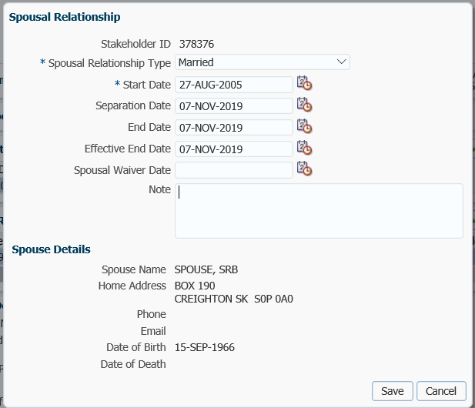

1. From the **Navigation** menu, **Member Profile** menu, select **DC SRB** Claims.

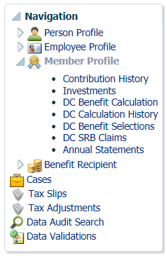

1. Under the **DC SRB Claims** screen, highlight the row of the **Investment Account** that you are processing the SRB estimate for if there are more than one displayed (a member can be in PEPP and/or VPB).

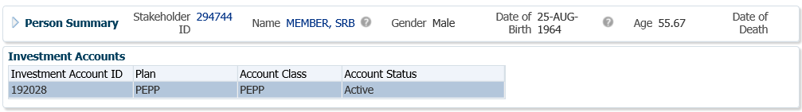

* **NOTE:** if the member is in VPB but the date of marriage was prior to VPB (while in PEPP), you will have to run a calculation for each **Investment Account**. The amounts are to be added together to achieve the final calculation.

1. From the **DC SRB Claims** region, click **Add** to add a new DC SRB claim estimate.



1. In the **Add DC SRB Claim** screen will default to selecting the current **Spousal Relationship** that pertains to the marriage and the **Claim Status** of **Estimate.** Click **Save**.

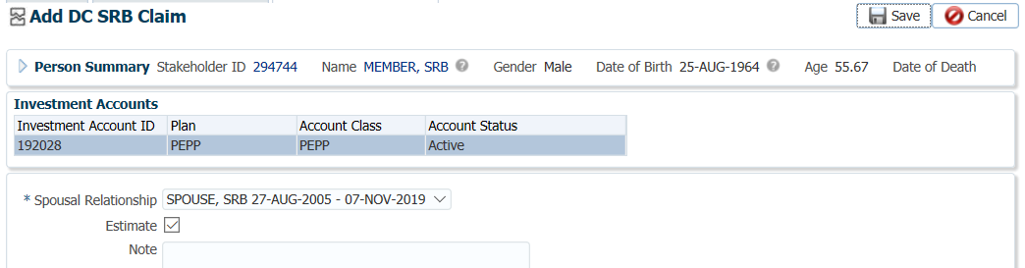

1. In the **DC SRB Calculation** pop-up window enter in the following information and click **Calculate**:

* **Method** – Share of Account No ROI as per the member’s/spouse’s request
* **Claim Percent** – percentage specified as per the member’s/spouse’s request. Will default to 50%.
* **Start Date –** start date of the marriage or claim period. It will automatically populate with either the **Date of Membership** or the **Spousal Relationship Start Date**.
* **End Date** – date of dissolution of the marriage
* **Calculation Date** – same date as the end date
* **Payment Date** – current date

*Method Example: Share of Account No ROI*

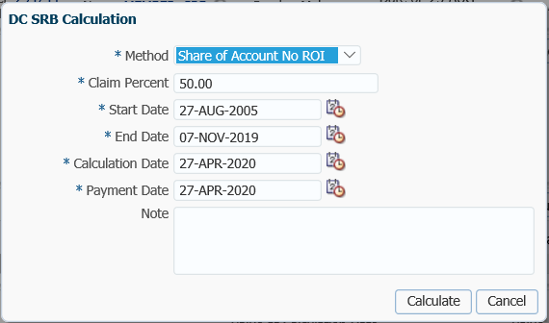

*Method Example: Share of Account With ROI*

* **Method** – Share of Account With ROI as per the member’s/spouse’s request
* **Claim Percent** – percentage specified as per the member’s/spouse’s request. Will default to 50%.
* **Start Date –** start date of the marriage or claim period. It will automatically populate with either the **Date of Membership** or the **Spousal Relationship Start Date**.
* **End Date** – date of dissolution of the marriage
* **Calculation Date** – current date (equal to **Payment Date**)
* **Payment Date** – current date

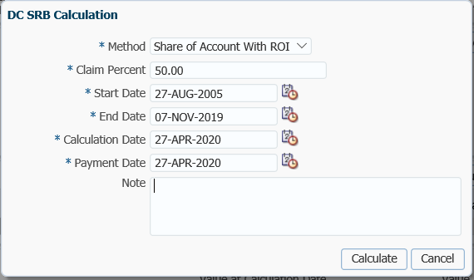

*Method Example: Specified Lump Sum*

* **Method** – Specified Lump Sum
* **Specified Amount** – amount as per the member’s/spouse’s request
* **Start Date –** start date of the marriage or claim period. It will automatically populate with either the **Date of Membership** or the **Spousal Relationship Start Date**.
* **End Date** – date of dissolution of the marriage
* **Calculation Date** – current date (equal to **Payment Date**)
* **Payment Date -** current date

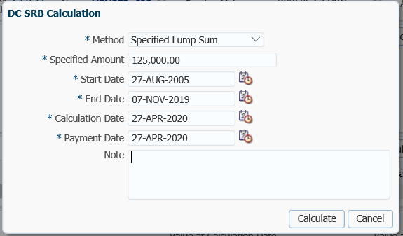

1. The **DC SRB Claim** will now be calculated and the results saved with a claim status of **Estimate**. In the **Calculations** region the **Ex-Spouse Amount** will be the amount available to the spouse based on the calculation method chosen.

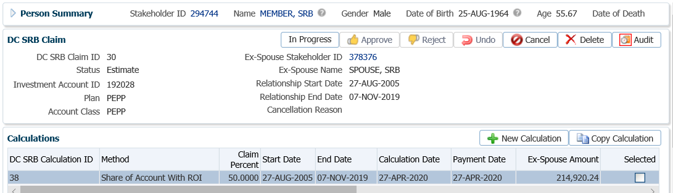

1. The **Calculation Details** region shows further details of the DC SRB Claim calculation:

* **Value at Start Date**: the value of the investment account at the start of the spousal relationship period
* **Value at End Date**: the value of the investment account and the end of the spousal relationship period
* **Change in Value**: the value at the End Date minus the value at the Start Date
* **Value at Payment Date**: the value of the investment account payable to the ex-spouse at the specified payment date
* **ROI Calculation Date to Payment Date**: the percentage of return on investment between calculation date and payment date
* **Value at Current Date**: The value of the ex-spouse’s portion of the investment account at time of performing the calculation
* **Calculated by**: The user who performed the calculation

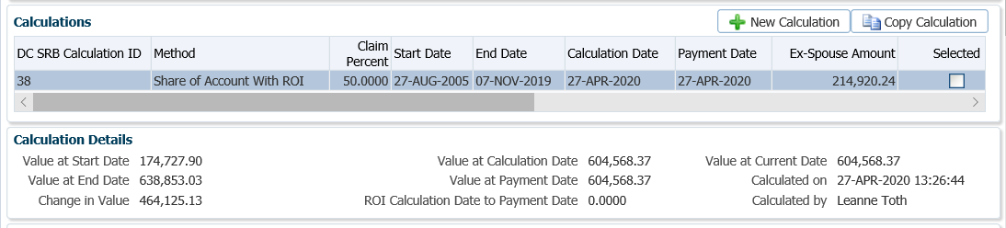

1. If the member requests multiple calculations at the same time, the **New Calculation** and **Copy Calculation** buttons allows the user to create additional calculations for comparison.

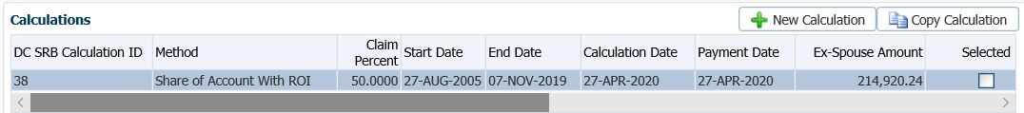

* **NOTE:** if the member requests additional calculations at a later date, these should be done as a brand new estimate, rather than adding new calculations to a previous estimate.

The **New Calculation** button opens a new **DC SRB Calculation** window and populates the **Start Date** and **End Date** with the information from the **Marital Status** screen. The **Calculation Date** and **Payment Date** default to a current date. Changes can be made to any of the fields.

*New Calculation:*

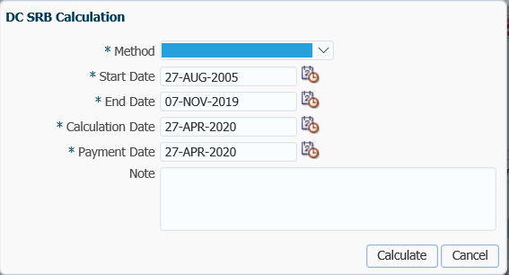

The **Copy Calculation** button opens with pre-populated information that was used in the initial estimate calculation and allows you to edit any fields as needed.

*Copy Calculation:*

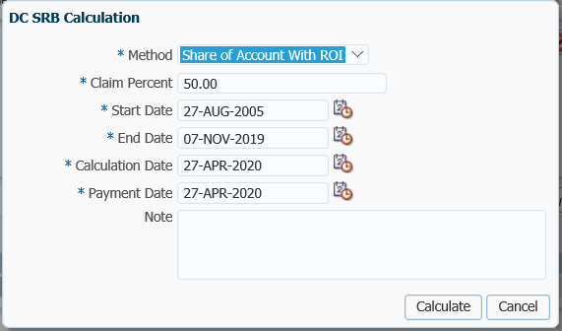

1. The information on the **DC SRB Claim** screen will be broken down into two regions, **Account Balance at Calculation Date** and **Account Balance at Current Date.**

The **Account Balance at Calculation Date** shows the estimate value as of the **Calculation Date** that was used in the chosen **Method**. Details of the SRB account balance as of the calculation date are shown for all funds and contribution types and includes a breakdown of contribution amounts and units of locked-in amounts, vested amounts and totals.

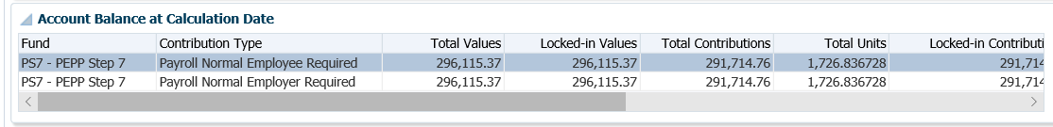

The same breakdown of amounts for funds and contributions types are provided as of the current date in the **Account Balance at Current Date** region based on the chosen **Method**.

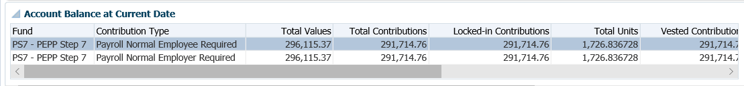

|  |  |  |
| --- | --- | --- |
| **Label\Column** | **Field Type** | **Description** |
| Fund | Text | The name of the fund |
| Contribution Type | Text | The type of the contribution |
| Total Contributions | Decimal | Total amount of the ex-spouse’s portion of contributions for the fund and contribution type as of the relevant date. |
| Locked-in Contributions | Decimal | Total amount of the ex-spouse’s portion of locked-in contributions for the fund and contribution as of the calculation date. |
| Vested Contributions | Decimal | Total amount of the ex-spouse’s portion of vested contributions for the fund and contribution type as of the relevant date. |
| Total Units | Decimal | Total number of the ex-spouse’s portion of units for the fund and contribution type as of the relevant date. |
| Locked-in Units | Decimal | Total number of the ex-spouse’s portion of locked-in units for the fund and contribution type as of the relevant date. |
| Vested Units | Decimal | Total number of the ex-spouse’s portion of vested units for the fund and contribution type as of the relevant date. |
| Total Values | Decimal | Total value of the ex-spouse’s portion of the fund and contribution type as of the relevant date. |
| Locked-in Values | Decimal | Total locked-in value of the ex-spouse’s portion of the fund and contribution type as of the relevant date. |
| Vested Values | Decimal | Total vested value of the ex-spouse’s portion of the fund and contribution type as of the relevant date. |

1. Prepare the *SRB Quote Letter* for the requester with the **Ex-Spouse Amount** or the **Amount Payable** found in the **Calculations** region.

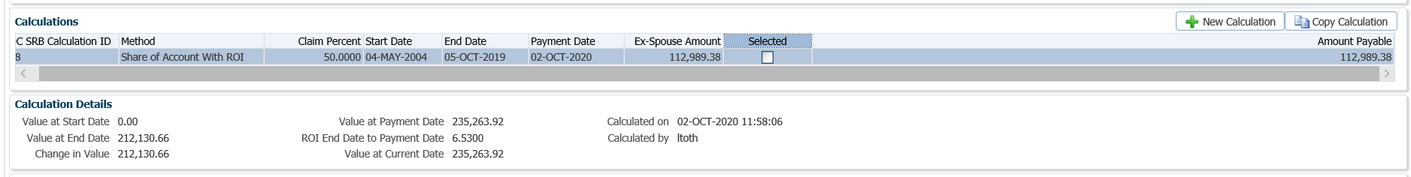

1. The *Pension Specialist* or *Supervisor* will audit any manual calculations from the *interest forward and/or equity calculation spreadsheet* if applicable, the SRB calculation in the **DC SRB Claims** screen and review the *SRB Quote Letter***.**
2. Mail the *SRB Quote Letter* and a copy of the PEPP *Talk* on Breakdown of Spousal Relationships to the requestor. If the member did not initiate the request, a copy of the *SRB Quote Letter* is required to be sent to the member as well and a copy kept for the member’s file.
3. If the SRB calculation was for a 2nd request, a fee of $60.00 per half hour increments is charged. The fee is added under the **Member Profile** menu, **Investments** screen. If the member has money in more than one fund, the system will withdraw the fee on a prorated basis on the account balance within each fund.

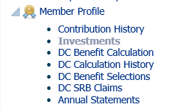

1. Under the **Investments** screen, select the **Account Instructions** region, click **Add.**

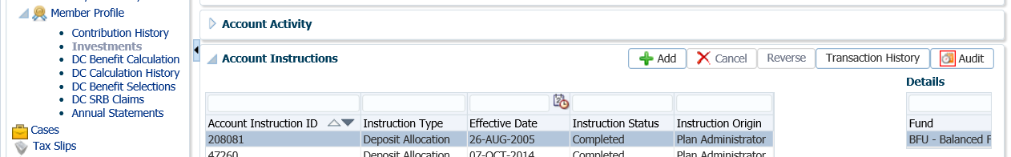

1. In the **Account Instruction** pop-up window, select **Instruction Type** of **Processing Fee**. Under **Fee Type** check the **Fee Applies** box for **Marital Breakdown Calculations (Estimates)**. Click **Save**.

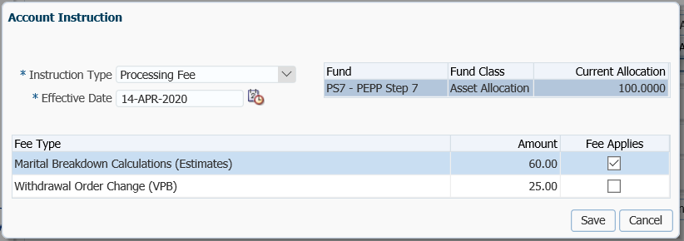

1. The **Instruction Type** of **Processing Fee** will show as a transaction under the **Account Instructions** region and will process overnight. The fee will be withdrawn from the member’s account.

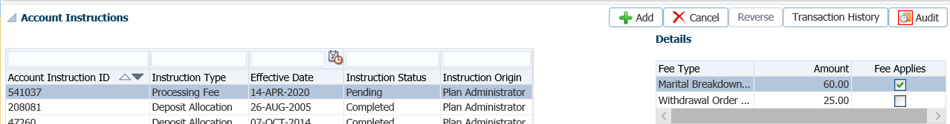

## Spousal Relationship Breakdown (SRB) Payment - PEPP & VPB

If a member and their spouse agree to proceed with the division of the pension, the pension will be divided in accordance with a court order or an inter-spousal agreement issued under *The Family Property Act*. Either the member or their spouse can provide the court order or interspousal agreement to PEPP to initiate the process.

The member’s spouse has the following options available for payment:

* Set up a new PEPP account of their own
* Transfer the spousal amount to their own account if the spouse is a PEPP member
* Transfer the spousal amount to a locked-in Retirement Account (LIRA) or a RPP
* Set up a VPB account if the spouse’s age is 50 years old or older

*The Public Employees Pension Plan Act* prohibits payment of more than 50% of the member’s account balance to be paid to the spouse. The 50% rule is applied on the specified date of division, and then again on the date the actual payment is processed on.

If the member is working for a PEPP participating employer outside of Saskatchewan, or has locked-in funds subject to legislation not under the *Public Employees Pension Plan Act*, the definition of spouse and amount available for division will be based on that jurisdiction’s legislation.

Business Process Requirements - Spousal Relationship Breakdown (SRB) Payment

*Initiating the SRB Claim:*

* If the member or spouse is proceeding, confirm that **one** of the following documents have been received:
  + *Court Order*
  + *Judgment*
  + *Separation Agreement*
  + *Interspousal Contract*
  + *Minutes of Settlement*
* The *Separation Agreement* or *Interspousal* Agreement **must** meet the following requirements:
  + State that the parties are living separate and apart.
  + Include a paragraph indicating the division and either dates to calculate or the dollar amount to be transferred and specify if return on investment (ROI) is to be paid from the date of the valuation of the pension asset to the date of the payment.
  + Both parties must have independent legal advice.
  + Signed by all concerned parties i.e., member, spouse and their lawyers.
* If a court order was issue in a province other than Saskatchewan, it must be reissued by a Saskatchewan Court pursuant to *The Family Property Act*.
* If the *Minutes of Settlement* is received advise the member’s lawyer and the spouse’s lawyer that PEPP cannot proceed without a letter stating that the *Minutes of Settlement* have been filed with the court and all court action has been finalized in accordance with the *Minutes of Settlement.*
* The documents must be originals or certified true copies of originals signed by a Commissioner of Oaths, a Notary Public or a Justice of the Peace. Refer to PEBA’s Acceptable Documentation.
* In the event of a breakdown of a common-law relationship the member and the spouse must have cohabited in a conjugal relationship for 24 consecutive months.
* For a common-law relationship, PEPP must have on file a common-law declaration from the common-law spouse. If the common-law spouse is not indicated on the member’s records no information can be released or payment processed without the common-law declaration.
* If the request was from the spouse and an estimate was never provided to the spouse or member, a *30-day Notice Letter* is to be sent to the member before proceeding. ***Refer to the 30-day Notice Letter information below.***

*30-day Notice Letter:*

* Lock the member’s account on PENFAX to prevent any payments from being processed.
* Add a note to the member’s account indicating that a “Marriage breakdown is in progress - **DO NOT** process any payments until resolved”. Include the date the legal documents were received and the type of documents.
* Send the member a *30-day Notice Letter* stating a court order or inter spousal agreement has been received at PEPP and that they have 30 days to object to the division of their pension. If they do not object a payment will be processed after the 30th day.
* The member must provide documentary evidence to substantiate their objection to the division. The member may object on the grounds that:
  + the court order or agreement has been varied or is of no force or effect;
  + the terms of the court order or agreement have been or are being satisfied by other means; or;
  + proceedings have begun to appeal, or to review the court order, or to challenge the terms of the agreement.
* The *30 day Notice Letter* must be sent by **Registered Mail** to ensure the member gets the letter.
* The member can waive the 30 days by contacting PEPP to give permission to proceed prior to the 30 days.
* Enclosed a copy of the spouse’s request.
* Keep a copy of the *30 day Notice Letter* for the member’s file.
* Add a note on the member’s account of the action taken.
* Suspend the assigned PENFAX Case and change the Due Date to a date equal to 31 days.

*Processing the Division - 31st Day:*

* If the member did not object to the division, process the payment on the 31st day in accordance with the terms and condition set out in the legal document received (court order, interspousal contract, separation agreement, judgment or minutes of settlement).
* If a different date was specified on the request, re-calculate the payment amount on the *Interest forward and/or Equity Calculation spreadsheet* and use PENFAX to determine the value of the member’s transaction details after the date of the CPAS conversion.
* The legal document cannot specify for more than 50 per cent of the member’s current account balance to be paid to the spouse. The 50% rule is applied on the specified date of division, and then again on the date the actual payment is processed on.
* For a common-law relationship, the SRB payment cannot be processed until the parties have been separated for more than 90 days.
* Unlock the member’s account in PENFAX.
* Remove the future date on your Case if you are proceeding with the payment prior to the 30 days.
* Funds can only be transferred to locked-in vehicle and must remain locked-in until the spouse reaches age 50 as per the PEPP Act and PBA.
* Tax is not withheld on this type of transfer request as it is considered a transfer from a registered plan to another registered plan.

*Options Available for the Spouse to Transfer To:*

* LIRA – *Direct Transfer of a Single Amount form*, *T2151*
* RPP - *Direct Transfer of a Single Amount form*, *T2151*
* PEPP Account in Spouse’s Name - *Direct Transfer of a Single Amount form, T2151,* *PEPP Non-Employee Application form*. The PEPP account has to be set up before the SRB claim is processed. ***Refer to the procedures on Creating a PENFAX Account for the Spouse and Creating a PEPP Account for the Spouse***.
* Outside Life Annuity – *Direct Transfer of a Single Amount form, T2151*
* Prescribed RRIF – *Direct Transfer of a Single Amount form, T2151*
* SPAF – *Direct Transfer of a Single Amount form, T2151*, *Application for Saskatchewan Pension Annuity Fund form*.
* Variable Benefit – *Direct Transfer of a Single Amount form T2151, Application for Variable Pension Benefit form*, *Banking Information form*, *TD1* Provincial and Federal forms*, Spouse’s Consent to Transfer to a Variable Benefit Account form*, *Declaration of Common-law Spouse to be Completed by Member form*. The VPB account has to be set up before the SRB claim is processed. ***Refer to the procedures******Creating a VPB Account for a Spouse***.
* **NOTE:** Funds cannot be paid directly as a lump sum cash payment to a spouse.
* **NOTE: Divided funds are prorated out of the member and employer contributions only. Voluntary contributions remain with the PEPP member.**

*Beneficiary after the Breakdown of a Spousal Relationship:*

* Send the member a *Marital Status and Beneficiary Letter.* The letter is to advise them that their marital status has been changed, if applicable and inform them who is presently listed as their beneficiary on file. If they are not divorced this letter will advise them that their spouse remains as their legal beneficiary until such time as they are divorced or the spouse waives their right to spousal beneficiary privileges of the remaining funds in the members account.
* Enclose a *Change in Personal Data Form* and a *Spouse’s Waiver of Pre-Retirement Survivor Benefit Pursuant to Clause 33(6)(a) of the Pension Benefits Act, 1992* formwith the letter*.*
* The spouse remains as the beneficiary until the spousal relationship is legally dissolved.
  + In a marriage, the spousal relationship is legally dissolved when the divorce is final. PEBA requires proof of divorce, such as a certified copy of the divorce certificate or Decree Absolute;
  + In a common-law relationship, it is legally dissolved when the member and spouse cease living together for at least 90 days (a written declaration on the period of common-law relationship will need to be provided to PEBA by the member and/or former common-law spouse).
* If a *Spouse’s Waiver of Pre-Retirement Survivor Benefit Pursuant to Clause 33(6)(a) of the Pension Benefits Act, 1992* form is received the designated beneficiary can be changed to a new beneficiary as the spouse is waiving their rights to the beneficiary benefits of the remaining equity by signing this form. However until they are legally divorced, the spouse can revoke the waiver at any time.
* An alternate to completing the *Spouse’s Waiver of Pre-Retirement Survivor Benefit Pursuant to Clause 33(6)(a) of the Pension Benefits Act, 1992* form is, ifthe interspousal agreement includes wording that states that the spouse has waived their rights to the spousal benefits (see below). The member’s spouse can be removed as the beneficiary and the marital status changed to single or separated. A *Designation of Beneficiary Form* must be received electing a new beneficiary for the PEPP account.

*Interspousal Agreement Wording:*

* In the event of the death of a member the spouse waives any and all entitlement to a benefit under the Plan;
* The waiver is given for the purposes of subsection 21(4) of *The Public Employees Pension Plan Act*; and
* The spouse understands that as a consequence of the waiver, s/he will not be the deemed beneficiary of the amount standing to the credit of the member in the Plan.

#### How to Process the SRB Payment

1. Review the request and determine if all required information and legal documents have been received in order to proceed with the division of the pension. ***Refer to the Business Process Requirements - Spousal Relationship Breakdown (SRB) Payment***.
2. Search for the member on PENFAX.
3. Prepare and send out the *30-day Notice Letter* to the member before proceeding with the payment. ***Refer to the Business Process Requirements 30-day Notice Letter***.
4. To prevent any lump sum payments from being processed within the 30-days, the member’s account on PENFAX is set to **Locked**.

Under the **Navigation** menu, **Person Profile** menu, **Person Summary** region click on the **Edit** option.

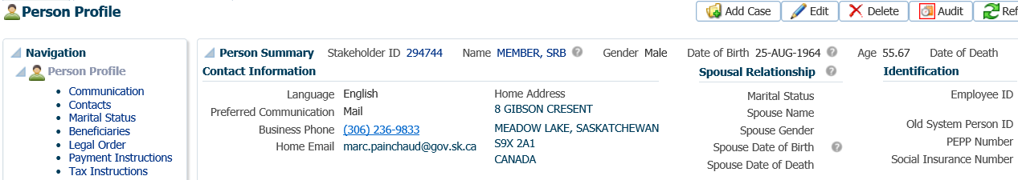

* **NOTE:**  accounts that are set to **Locked** will be prohibited from requesting a VPB lump sum withdrawal on PLANet. VPB members that have scheduled monthly/yearly withdrawals will not be affected by the **Locked** status.

1. In the **Person** pop-up window, check the **SRB on File** and **Locked** boxes and click **Save**.

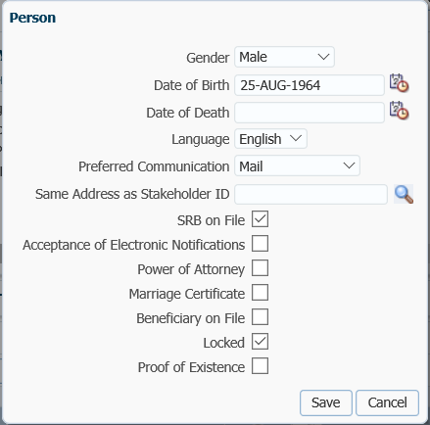

1. Add a note to the member’s account indicating that *a “Marriage breakdown is in progress - DO NOT process any payments until resolved”*. Include the date the legal documents were received and the type of documents. Under the **Person Profile, Notes** region, click **Add**. Select **Alert** as **Note Type, Category** leave as **General**, enter **Note** message and click **Save.**

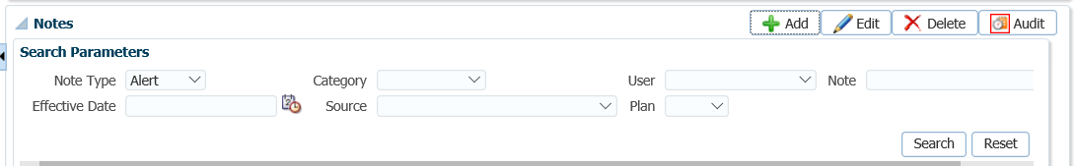

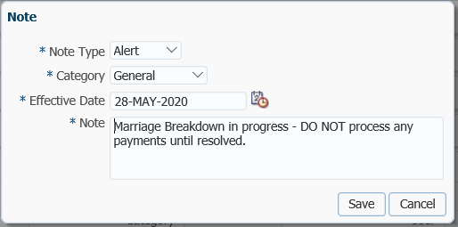

1. If the member did not object to the division of their pension, proceed with the division of the claim on the 31st day or earlier, if the member authorized PEPP to proceed prior to the 30 days.
2. Determine the option chosen by the Ex-spouse as per the T2151 form. If the ex-spouse elected to keep the portion of the SRB DC Claim with PEPP and they do not have a PENFAX account, a new account must be created in PENFAX **prior** to processing the SRB Claim. **Refer to the PENFAX procedures, Creating a PENFAX Account for a Spouse and Creating a PEPP Account for the Spouse** at the end of this section.
3. If the date of marriage and date of separation were not entered or are incorrect, enter the dates in the **Marital Status** region. Click **Edit** to make the changes.

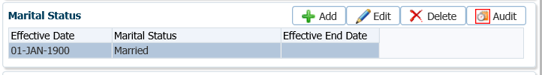

1. In the **Marital Status** pop-up window enter the marriage **Effective Date** and the separation date under the **Effective End Date**. Click **Save.**

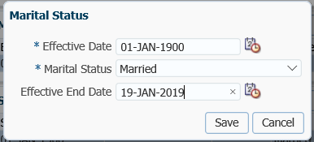

1. In the **Spousal Relationships** region click **Edit** to make the required changes to the **Separation Dates** if they were not entered or are incorrect.

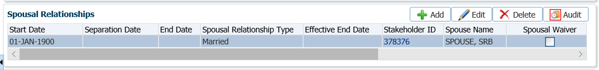

1. In the **Spousal Relationships** pop-up window, enter the **Start Date** of the marriage, the **Separation Date**, **End Date** of the spousal relationshipand the **Effective End Date** ofthe spousal relationship. Click **Save.**

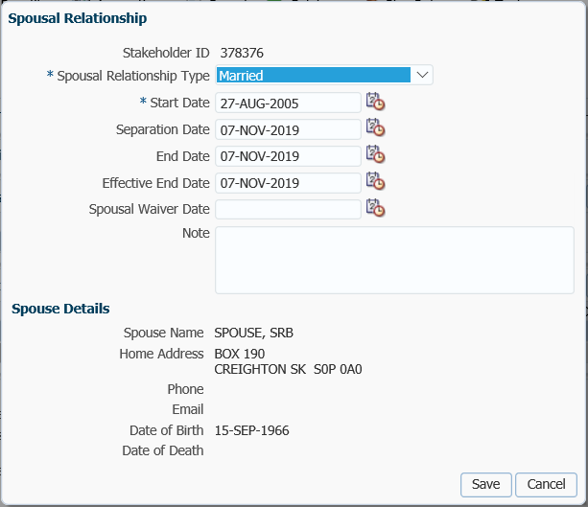

1. If the documentation has been received to confirm the effective start and end dates of the spousal relationship, the details can be verified in PENFAX.

From the **Spousal Relationship** region, click the **Verified** icon.



1. In the **Add Verification of Spousal Relationship** pop-up window, enter a note and click **Save**.

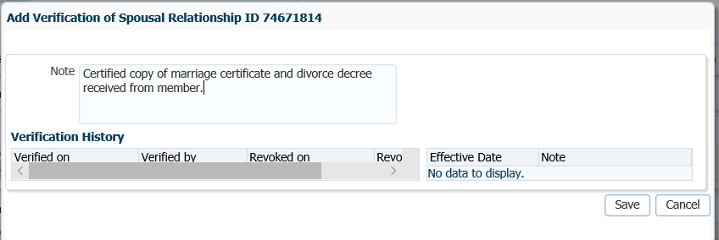

1. The **Verified** icon is updated to indicate that the documentation has been received.

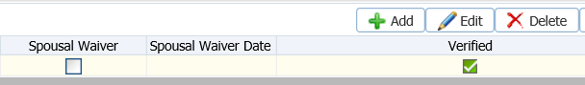

1. If the ex-spouse is not linked as a spouse on the member's account, the user should first add the information to PENFAX through the **Marital Status** functionality, ***refer to the PENFAX procedures, Member Data Changes, Marital Status, How to Change a Member’s Marital Status, steps 9 – 17.***
2. The Social Insurance Number (SIN) has to be added to the ex-spouse’s PENFAX record in order to process the DC SRB Claim. Search for the ex-spouse’s record in PENFAX.
3. On the ex-spouse’s record under the **Navigation** menu, **Person Profile** menu expand the **Identity** region. Under **Identification** click **Add**.

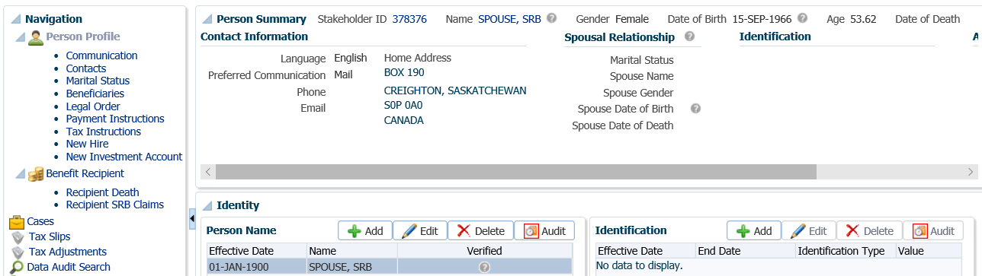

1. In the **Identification** pop-up window enter the ex-spouse’s SIN in the **Value** field, click **Save.**

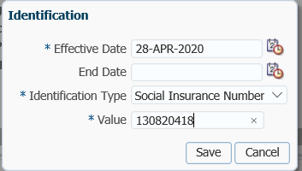

1. On the member’s account, from the **Navigation** menu, **Member Profile** menu, select **DC SRB** Claims.

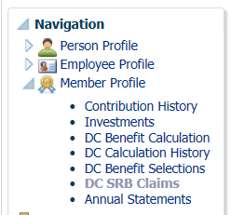

1. Under the **DC SRB Claims** screen, highlight the row of the **Investment Account** that you are processing the estimate on if there are more than one displayed (a member can be in PEPP and/or VPB).

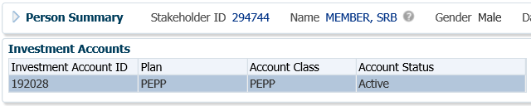

* **NOTE:** if the member is in VPB but the date of marriage was prior to VPB (while in PEPP), you will have to run a calculation for each **Investment Account**. The amounts are to be added together to achieve the final calculation.

1. In the **DC SRB Claims** region click **Add** to add a new calculation.

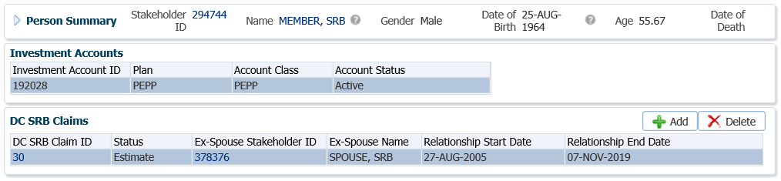

1. In the **Add DC SRB Claim** screen, deselect the **Estimate** box. Click **Save**.

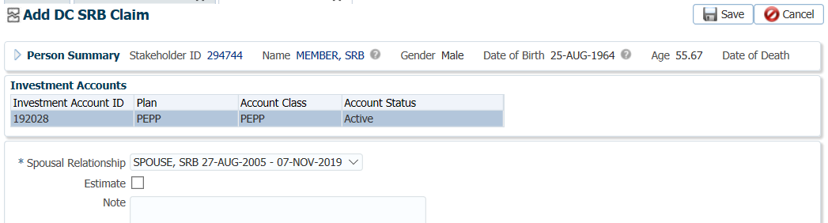

1. In the **DC SRB Calculation** pop-up widow select the **Method** of calculation. The **Start Date** and **End Date** will populate with the dates entered in the **Marital Status** and **Spousal Relationship** regions. The **Calculation Date** and **Payment Date** will default to the current date. Click **Calculate**.

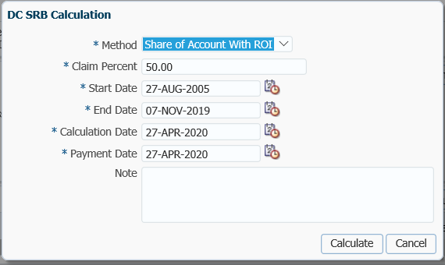

1. The results of the calculation will now be displayed under the **Calculations** region. Highlight the correct **Calculation** to be used for the claim.

* **NOTE:** if the calculation method used is **Specified Lump Sum**, PENFAX will calculate 50% of the account and if the **Specified Lump Sum** amount exceeds the 50% of the account balance, the value in the **Amount Payable** field will be paid to the ex-spouse instead.

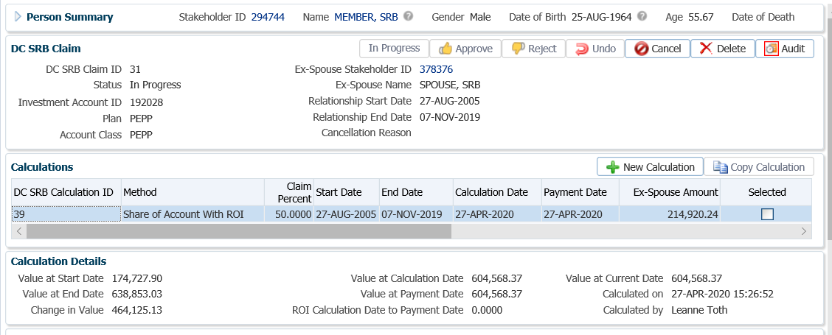

1. Under the **Allocations** region click **Add**.

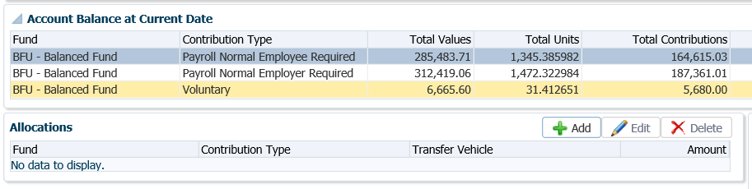

1. In the **DC SRB Allocation** pop-up window select the following and click **Save**:

* **Fund –** leave it blank so that the payment will prorate from all funds the member holds.
* **Contribution Type –** leave blank to prorate from both contribution types if the member holds **only** Employee Required and Employer Required contribution types.
  + **NOTE:** If the member holds Voluntary contributions these are **not** to be paid out for a SRB claim. The DC SRB Allocation pop-up window will have to be ran twice with each Contribution Type selected separately.
* **Transfer Vehicle –** select the transfer vehicle elected by the spouse on the T2151 form.
* **Amount –** divide the **Ex-Spouse Amount** by 2 and take half the amount from the first required source, **Payroll Normal Employee Required**.



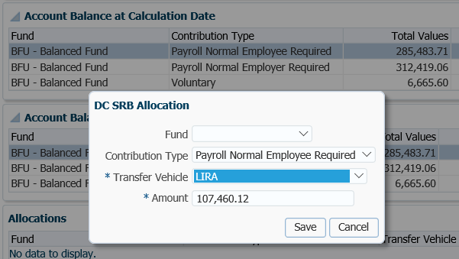

1. Select **Add** again to add another **Allocation.**

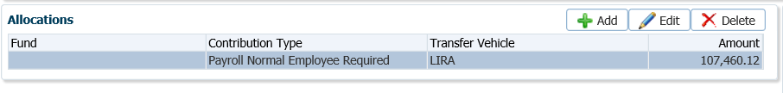

1. In the **DC SRB Allocation** pop-up window, enter the following information and click **Save**.

* **Fund –** leave it blank so that the payment will prorate from all funds the member holds.
* **Contribution Type –** leave blank to prorate from both contribution types if the member holds **only** Employee Required and Employer Required contribution types.
  + **NOTE:** If the member holds Voluntary contributions these are **not** to be paid out for a SRB claim. The DC SRB Allocation pop-up window will have to be ran twice with each Contribution Type selected separately.
* **Transfer Vehicle –** select the transfer vehicle elected by the spouse on the T2151 form.
* **Amount –** divide the **Ex-Spouse Amount** by 2 and take half the amount from the first required source, **Payroll Normal Employer Required**

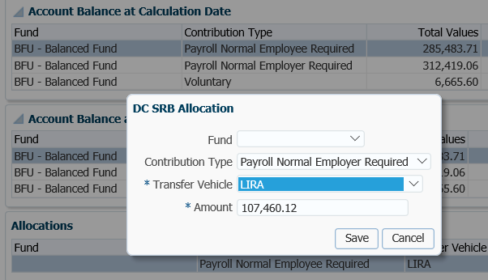

1. The **Summary of Allocations** region will show the total amount once all allocations have been added. If the amount is correct, click **Confirm**.

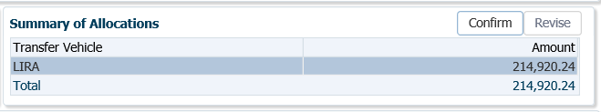

1. If the allocations **Total** does not match the full claim amount, a validation error is displayed at the top of the window. You must **Edit** the allocations until the total and claim amount are equal.

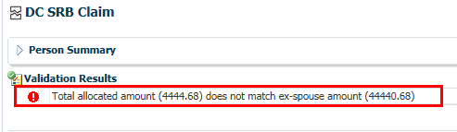

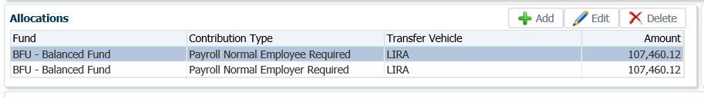

1. Once the allocations have been confirmed, the **Onetime Amounts** are created. You may have to click the **Refresh** button at the top of the screen for these regions to populate. 

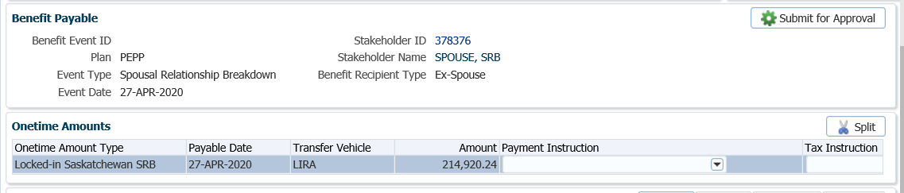

1. In the **Onetime Amounts** region under the **Payment Instruction** column, click on the drop-down list. If there is no information displayed, click on the **Add New** option.

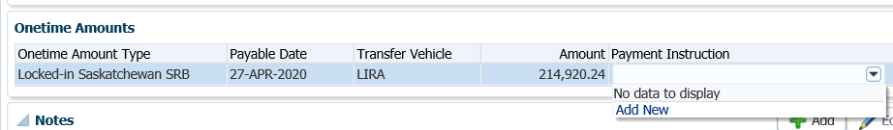

* **NOTE:** if the payee was previously added in the **Payment Instructions** screen under the **Person Profile**, then the information will be displayed in the drop-down list under **Payment Instructions** and can be selected.

1. In the **Payment Instruction** pop-up window, select the **Payee Type** as **Qualified Financial Institution**, then enter the **Payee Stakeholder ID** number for the financial institution and enter the **Account ID** number for the transferring institution as noted on the T2151 form.

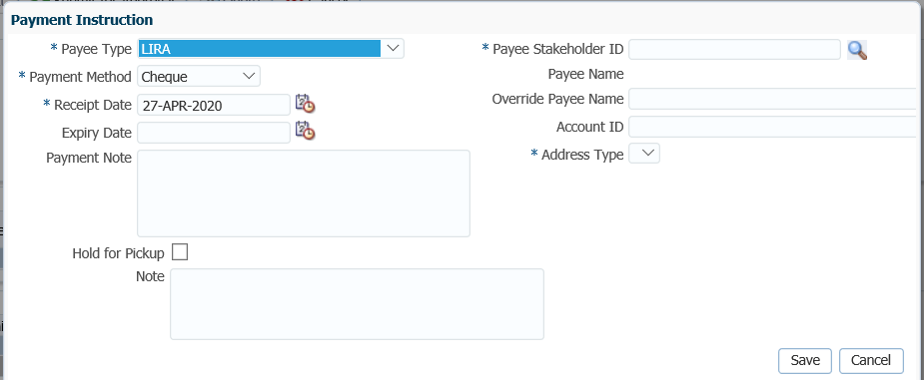

* **NOTE:** If the **Stakeholder ID** for the financial institution is not known, click on the **magnifying glass** to perform a search for the financial institution under the **Organizations** menu.

1. In the **Search and Select Organization** screen, **Search Parameters** area, click on the drop-down arrow beside **Organization Type,** select **Financial Institution**, click **Search**.

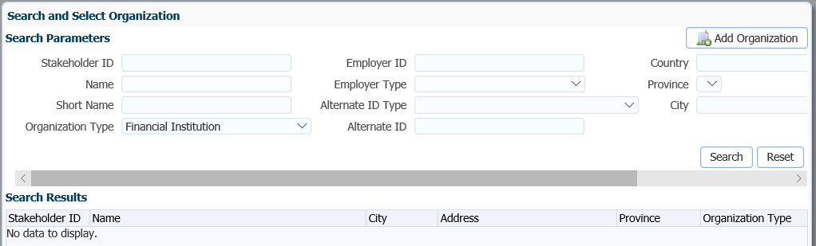

1. In the **Search Results** area, locate the correct financial institution, highlight the name and click **Ok**.

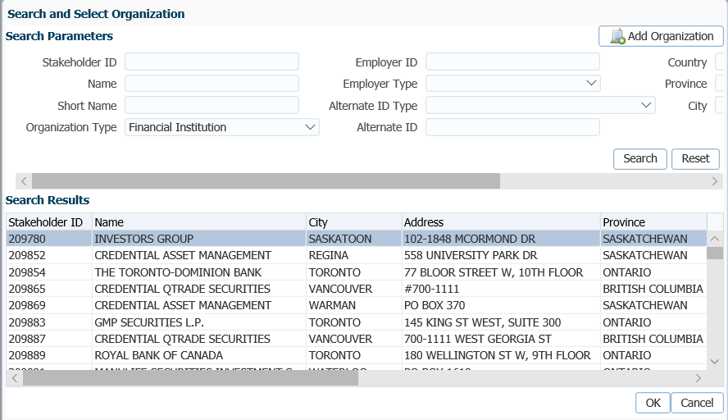

1. The **Payee Stakeholder ID**, the **Payee Name** and **Address** will now be populated in the **Payment Instructions** window. Add the **Account ID** and a **Note** if applicable. Click **Save**.

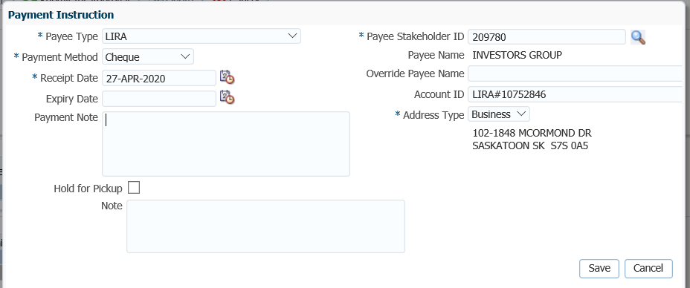

The **Account ID** is to be used when the payee type is set to Qualified Financial Institution E.g. used to enter RRSP/LIRA account number for reference.

1. Once all details are updated and confirmed as required, the **Onetime** amounts must be approved before payments are made to the ex-spouse. Click **Submit for Approval.**

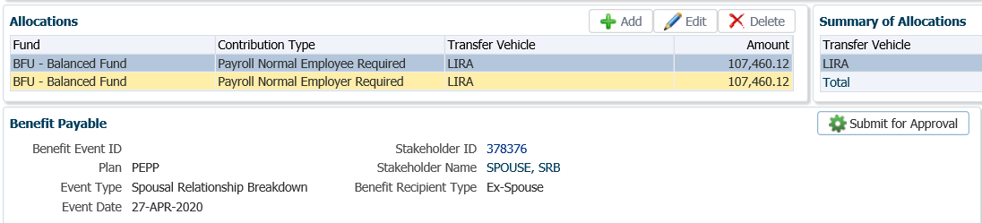

1. The *Pension Specialist or Supervisor* will audit the SRB Claim and click **Approve** if the amount and payment details are correct.

When auditing confirm that the correct documents have been received, the dates used in the calculation are correct and the final total is correct(total calculated by PENFAX plus manual calculation from the *Interest Forward and/or Equity Calculation Spreadsheet* if applicable).

1. If there is incorrect information the **Reject** button will reject the payment. Once the payment is corrected, the **Submit for Approval** button must be clicked again to reactivate the **Approve/Reject** buttons.

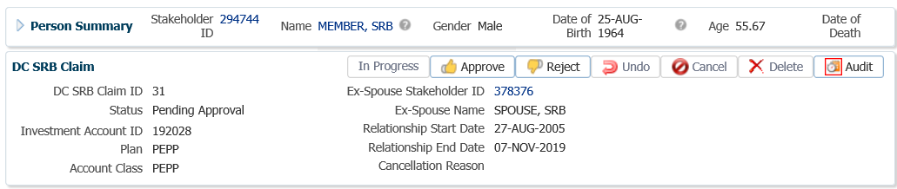

The **DC** **SRB Claim** region provides seven buttons to assist the user in navigating through the claim process:



* **In Progress**: clicking on the In Progress button updates the claim status from **Estimate** to **In Progress.**
* **Approve**: this button is enabled once the claim has been submitted for approval. This will update the status to **Approved** and and will then be updated to **Processed** as a result of processing the DC SRB claim in the investment batch.
* **Reject**: the reject button is enabled if the status is **Approved** which will update the status to **In Progress**.
* **Undo**: the **Undo** button is enabled if the status is **Processed** and will update the status to **Pending Undo.** After the investment batch runs, the status will be updated to **Undone**.
* **Cancel**: allows the user to cancel the claim without saving any changes and updates the status to **Cancelled**.
* **Delete**: allows the user to delete the claim if the status is **Estimate** or **In Progress** and it was not previously **Approved.**
* **Audit**: displays the audit record of activity on the claim.
* **Pending Approval**: once the details of the DC SRB Claim are confirmed, the user submits the claim for approval using the **Submit for Approval** button in the **Benefit Payable** region.

1. The claim will be processed for payment or reallocation to the ex-spouse in the overnight Process Investment Transactions (PIT) batch. This will create a benefit event on the ex-spouse’s PENFAX record.
2. To view the benefit created the following day, go to the **DC SRB Claim** screen, click on the **Ex-Spouse Stakeholder ID** **hyperlink** to navigate to the ex-spouse’s PENFAX record.

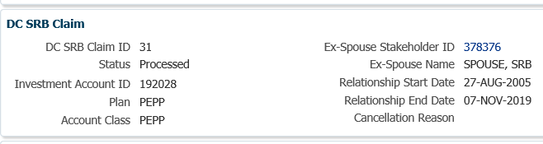

1. In the Ex-spouse’s PENFAX record, under the **Navigation** menu, click on the **Benefit** **Recipient** menu. In **Benefit Recipient** screen, click on the **Onetime Amounts** tab to open the screen.

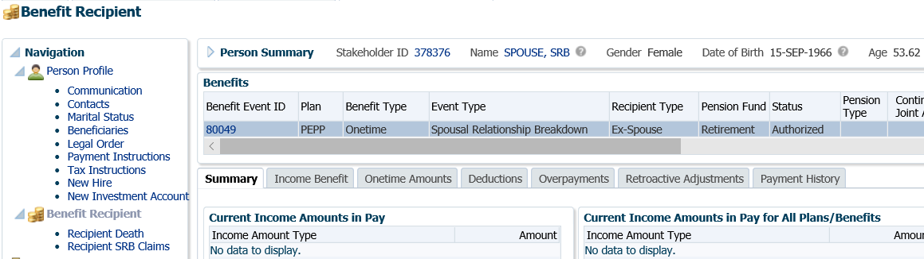

1. The details of the SRB payment will be displayed in the **Onetime Amounts** tab.

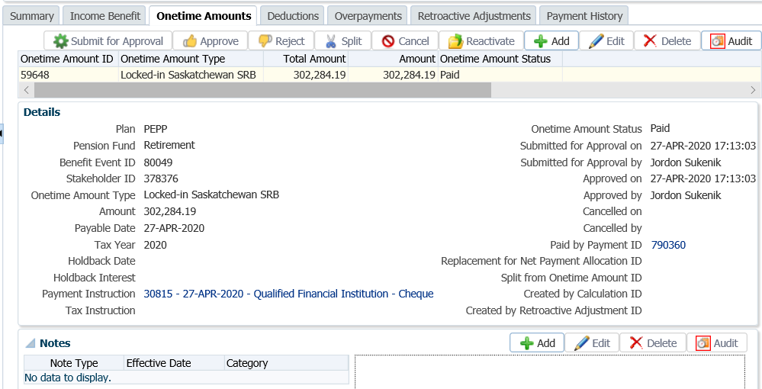

1. If the legal document states that the spouse waives their rights to beneficiary benefits of the remaining equity, change the member’s marital status to single and the member’s designated beneficiary if a *Designation of Beneficiary Form* was received***. Refer to the Member Data Change procedures***.
2. A Withdrawal Letter will produce overnight and will be saved under the members account **Communication** screen, **Outbound** Documents region. This will be sent to the member along with a copy of the *Payment Letter, Options Letter* and *Marital Status and Beneficiary Letter* (if the member did not indicate a new beneficiary). The ex-spouse will get copy of the *Payment Letter* anda *Welcome* letter if they are keeping the funds with PEPP or VPB.

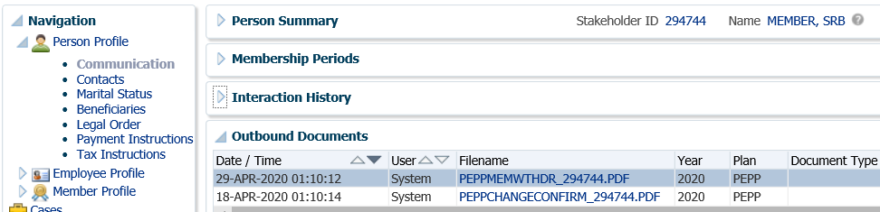

## Creating a PENFAX Account for an Ex-Spouse

The ex-spouse of a PEPP member upon a breakdown of spousal relationship, as well as the spouse of a deceased PEPP member have the option to keep their benefit entitlement with PEPP.

If it has been determined that the spouse does not hold a PEPP account of their own, a new PENFAX stakeholder account and PEPP account are required to be created **prior** to proceeding with the SRB claim payment or the payout of a death benefit.

#### How to Create a PENFAX Account for a Spouse

1. From the main menu in PENFAX, from the **People** drop-down list select the **Person Search** option.

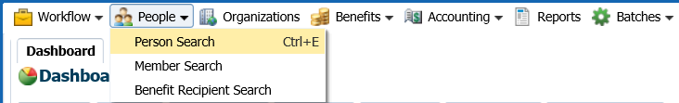

1. In the **Person Search** window, select the **Add Person** option.

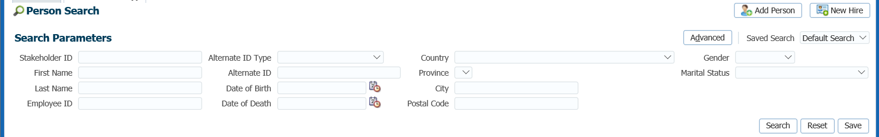

1. In the **Add Person** window, enter the spouse’s first name, last name, date of birth and the contact information. Click **Save**.

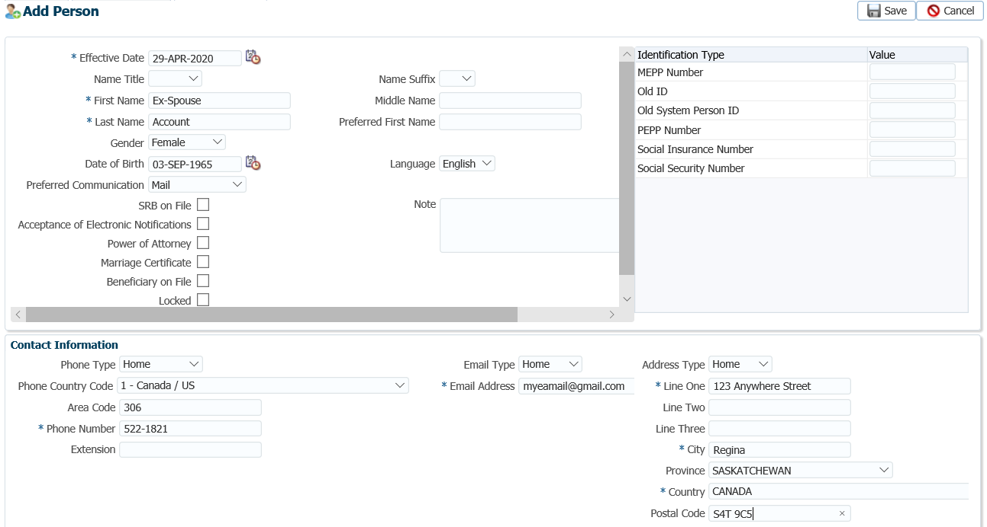

1. A new account is created for the spouse and a Stakeholder ID number assigned to the spouse’s record.

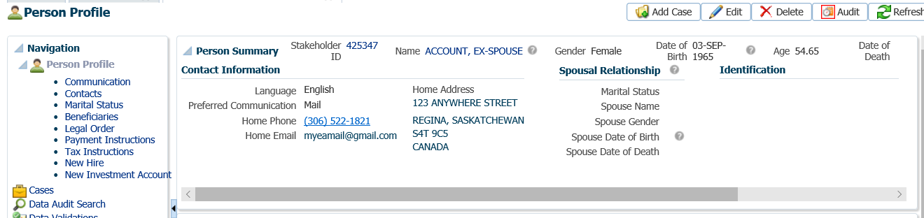

1. Enter the additional information for the spouse under the **Person Profile** screens such as **Identification (SIN)**, **Contacts, Marital Status** and **Beneficiaries**. ***Refer to the******Member Data Change Procedures*** for steps on how to add the person information.

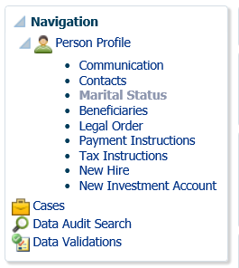

1. Once the spouse’s PENFAX account is created, add the spouse to the member’s **Marital Status** screens. Click **Edit** in the **Marital Status** region.

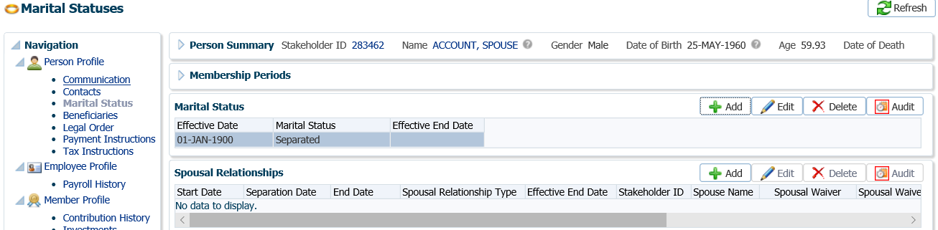

1. In the **Marital Status** window enter in the correct **Effective Date**, **Marital Status** and **Effective End Date** of the marriage. Click **Save**.

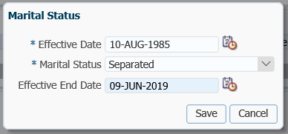

1. In the **Spousal Relationships** region, click **Add**.

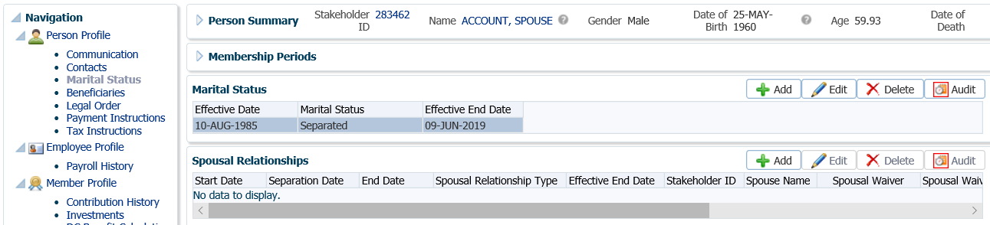

1. In the **Spousal Relationship** pop-up window enter in the spouse’s information. Entering in the **Stakeholder ID** number for the spouse will populate the **Spouse Details** automatically. Click **Save**.

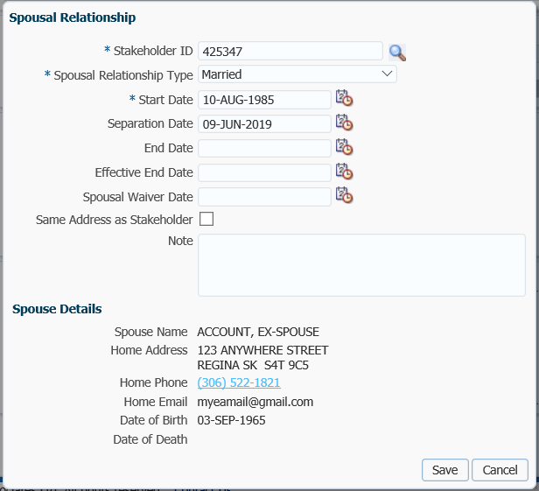

* **NOTE:** The PENFAX account for the ex-spouse can also be added directly from the Marital Status screen by clicking on the **magnifying glass.** You will be taken to the same **Person Search** screen. From that screen, click the **Add Person** button as proceed as shown above. Once you save the new Person record, you will be redirected back to the Add Spousal Relationship window.

## Creating a PEPP Account for an Ex-Spouse

An ex-spouse, upon breakdown of a spousal relationship or a spouse of a deceased member may elect to keep their share of the benefit in the PEPP plan. They must first be added to PENFAX as a Stakeholder then a new PEPP account can be created. The PEPP account is created as part of the SRB processing.

#### How to Create a PEPP Account for an Ex-Spouse

1. The **procedures under, “Spousal Relationship Breakdown (SRB) Payment (PEPP and VPB)** are to be followed. At Step 26, adding the **Allocations** the **Transfer Vehicle** to be selected is **PEPP**.

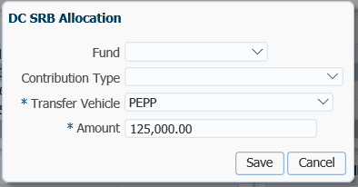

1. Once the Allocations have been confirmed and approved, the Process Investment Batch (PIT Batch) will run overnight and the ex-spouse’s account will be updated with the amount appearing under the **Investments** screen.

The **Account Summary** region shows the total value in the spouse’s account and number of units purchased are display along with the investment fund.

The **Account Balances** region displays the **Total Contributions** and **Total Units** purchased for each **Contribution Type**.

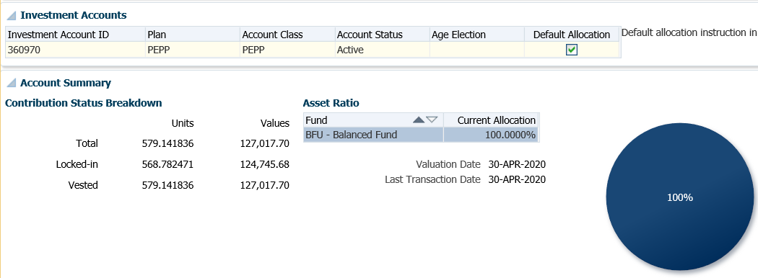

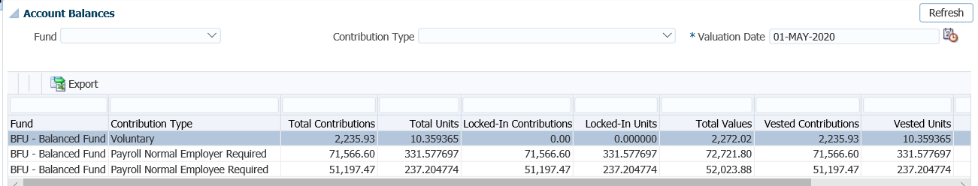

1. Under the spouse’s **Member Profile** menu, **Membership Periods** region the **Member** Status will show as active in the PEPP Plan and a **Member Type** of **Non-Employee.**

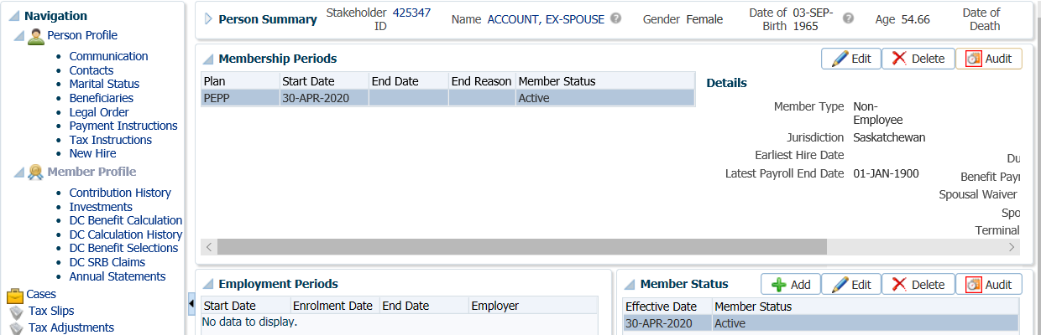

1. If the investment fund chosen by the ex-spouse on the *PEPP Non-Employee Enrolment* form differs from the fund the member was invested in, perform an inter-fund transfer to the correct fund. ***Refer to the******Inter-Fund Transfer or Asset Rebalance Procedures***.

# Age 71 Letters

When a member of PEPP turns age 71 and still holds money in a PEPP account, CRA requirements state the pension must be converted to a retirement income option by the December 31st of the year in which the member turns age 71. Pension income must commence in the year the member is age 72.

Age 71 Letters will be produced and mailed to any members who are age 71 to remind them that they must choose a retirement income option prior to December 31st of that year.

Members may continue to work for a PEPP participating employer past age 71 but contributions can no longer be contributed into the PEPP Plan.

Business Process Requirements – Age 71 Letters

* Ensure members are terminated from employment under PEPP.
* If members are still actively employed, contact the employer for a termination date and a PEPP *Notice of Termination* form.
* Keep a shared spreadsheet with the date the age 71 letter was sent and the appropriate letter that was mailed to the member
* Record the member’s decision on how they are proceeding (transfer to VBP, Purchase an Annity, issue a small pension payment, or Transfer to a Financial Institution).
* Members with a PEBA address still must comply with regulations and move their pension to a retirement option. Try locate a new address for the member. If a new address is not found PEPP will determine the retirement option based on the value in the pension account and transfer the money accordingly.
* Members in which a new address cannot be found and who qualify for a small pension payment, will have their payment processed less income tax and as a “cheque not to be issued”.  Financial Services is notified to place the money in a holding account until the member contacts PEPP.  A T4 will be issued and forwarded to CRA.
* For members who that cannot be located and have a balance greater than $55,900, a transfer to VPB is processed and the funds will remain in the VPB account until the member contacts PEPP.  The funds cannot be accessed until all applicable VPB forms are submitted or the appropriate forms for another retirement option.
* Transfers to VPB for members who could not be located, should be done approximately 2 weeks before December 31st.

#### Age 71 Process

1. The Age 71 Letters are to be generate from PENFAX at the beginning of October each year and mailed to the applicable members.
2. Try locate a new address for any member’s with a PEBA address. PEPP still must comply with moving the member to a retirement option even if an address for the member cannot be located.
3. Update the shared spreadsheet with the date the letter and the type of letter mailed to each member.
4. Update the shared spreadsheet with the member’s decision once known.
5. Determine if the member is terminated from employment with the PEPP employer. If not contact the member to have them send in a *Notice of Termination* form. PEPP requires a termination date for payment processing or transfers to VPB. If the member is continuing to work past age 71, the termination date can be any date, such as the end of a pay.
6. For members that qualify for a small pension payment and cannot be located, process the payment from PENFAX for the full amount less income tax. Do not issue a cheque. Advise Financial Services to make the necessary accounting entries to hold the money until the member contacts PEPP.  A T4 will be issued and forwarded to CRA at year end. ***Refer to the Small Pension Payment procedures***.
7. Members that cannot be located and who have an account balance greater than $55,900, process a full transfer to VPB. ***Refer to the procedures, Variable Pension Retirement Option*.**
8. Set up the member’s VPB account with the following until a VPB application form and documents are received:

* Payment schedule set to yearly for minimum payments to start December 31st of the following year when the member is age 72.
* Tax claim code set to Basic.
* Use member’s age for the Age Election for minimum payments.
* If the member has a spouse set the spouse up as the Specified Beneficiary.
* Keep the Investment fund the same as PEPP.
* ***Refer to the procedures,******Variable Pension Benefit Setup of a PEPP Member*.**

1. Add a note under the member’s account on PENFAX, “member age 71. Account transferred to VPB prior to Dec 31, yyyy in compliance with CRA regulations”.
2. Ensure an audit is performed on all payment and VPB transfers.

# Death of a Member

In the event of the death of a PEPP or VPB member, PEPP will provide the named beneficiary on the account with a statement of the account value and outline the options available for the pension proceeds in an Option Letter package.

## Death Option Letter

Upon receiving notification of the death of the member, PEPP will verify the beneficiary on record and provide the spouse or non-spouse beneficiary with an option letter package and a current statement of the account. The option letter package will include the option letter, a statement of activity of the member’s account, a *Spousal Options on Death* form and a *Declaration Upon Member’s Death* form.

Business Process Requirements – Death Option Letter

* Notification of the death of a member can be sent by mail, phone, fax, email or by the employer sending in a PEPP *Notice of Termination* form.
* If the member was still actively contributing and notification of the death was not received by the employer, contact the employer to advise them and have them provided a PEPP *Notice of Termination* form.
* An Option Letter package is mailed to the named beneficiary or executor, outlining the options for the member’s pension and the documents required for processing the payment.
* Confirm the beneficiary listed on the PENFAX system to the beneficiary listed in the member file.
* If a PEPP or VPB member has a spouse or common-law partner they are automatically the sole primary beneficiary unless they agree to waive their right. If the death benefit was waived ensure the correct forms for PEPP or VPB have been completed and are on file. ***Refer to Documents and Forms Required***.
* If a VPB member is taking scheduled payments, the payment schedule is to be suspended upon receiving notification of the member’s death.

#### Documents and Forms Required:

* Death Certificate– issued by Vital Statisticsoriginal or certified copy or,
* Funeral directors Statement of Death - original or certified copy.
* Spouse’s death certificate – issued by Vital Statisticsoriginal or certified copy (required when the spouse predeceases the member).
* *Spousal Options Upon Member’s Death* form
* *Declaration Upon Member’s Death* form– original (always required). The form must be completed and signed in the presence of a Commissioner for Oaths, Notary Public or Justice of the Peace.
* Marriage certificate *-* original orcertified copy (always required if status is married).
* *Declaration of Common-Law Relationship* form– required when the PEPP or VPB member’s status is common-law.
* *Spouse’s Waiver of Survivor Benefits Prior to Retirement* form – required for a PEPP member if the spouse/common-law partner waived their entitlement to a survivor benefit.
* *Spouse’s Waiver of Designated Beneficiary Status* form – required for a VPB member if spouse/common-law partner waived their entitlement to a survivor benefit.
* Spouse’s birth certificate *–* original orcertified copy (always required).
* Beneficiary(s) birth certificate – original or certified copy (required when a minor is listed as the beneficiary).
* *PEPP Non-Employee Enrolment* form, for PEPP account in spouse’s name.
* *VPB Application* form, *Banking* form, TD1’sfor VPB account in spouse’s name.
* **NOTE:** All the documents must be originals or certified true copies of originals by a Commissioner of Oaths, a Notary Public or a Justice of the Peace. An employee of PEBA can certify all documents except the *Declaration Upon Member’s Death* form. If originals are received make copies and send the originals back to the member by registered mail. **Refer to** **PEBA’s Acceptable Documentation**.

#### Beneficiary Options:

*Surviving Spouse of a PEPP Member:*

* Cash lump sum payment less withholding tax (*T4A* is made out to the spouse’s).
* Transfer to an RRSP, LIRA, LRIF or RPP if under age 71. If the funds are transferred to a locked-in account they will remain locked-in until the surviving spouse is age 50 as per PEPP Legislation.
* Purchase a life annuity from SPAF or an outside annuity (spouse can be under age 50).
* Transfer to a pRRIF (if eligible).
* Transfer to VPB (spouse does not have to be age 50).
* Transfer funds to their own PEPP account (if they are an active PEPP member).
* Transfer to a new Non-employee PEPP account (if under age 71).
* Transfer a portion of the deceased member’s account to one of the transfer options above and leave the remainder in the deceased member’s PEPP account. Take a portion of the deceased member’s account in cash and leave the remainder in the deceased member’s PEPP account.
* Leave funds in the deceased member’s PEPP account. Funds must be converted to a retirement income payment option before December 31st of the year the surviving spouse turns age 71.
* A combination of any of these options.

*Surviving Spouse of a VPB Member:*

* A **Specified Beneficiary** can only be the spouse or common-law partner. The may choose from the following options:
  + Continue to receive the VPB payments;
  + Transfer the account balance to another registered account; or
  + Receive a lump-sum cash payment less withholding taxes.
  + The spouse must choose an option for the death benefit and inform PEPP by the end of the year following the member’s death.
* A spouse listed as an ***Other* beneficiary** has the following options available with all or a portion of the VPB account balance:
  + Transfer to an RRSP or RPP (if spouse is under age 71);
  + Transfer to an outside pRRIF (if eligible);
  + Purchase a life annuity from SPAF or an outside annuity;
  + Receive a lump-sum cash payment, less withholding taxes.
  + Payments cease upon the death of a member
  + Can receive the VPB scheduled payments to the end of the calendar year following the year of death. At that point in time, the remaining account balance must be paid in a lump-sum less withholding tax.
* **NOTE:** if the spouse dies before the member and the beneficiary has not been updated or an alternate beneficiary named, the total benefit will be paid to the member’s estate as a lump sum, less withholding tax.

*Beneficiary Other than Spouse PEPP and VPB:*

* Receive a lump-sum cash payout less withholding taxes.
  + A T4A is required to be made out to the beneficiary,
  + If the beneficiary is the estate the T4A is to be made out to the executor.
  + If a minor child is named beneficiary the T4A is to be made out in the minor child’s name c/o the Trustee.
  + A minor child can be named beneficiary but without a trustee appointed the deceased member’s pension is paid to the Public Trustee.

*Options for funds outside of Saskatchewan differ see the chart below*

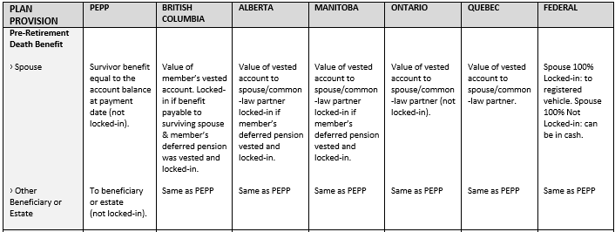

#### How to Process a Death Option Letter

1. Search for the deceased member in PENFAX.
2. Enter the member’s date of death in the **Person Profile** menu, **Person Summary** screen. Click **Edit** to add the date of death.

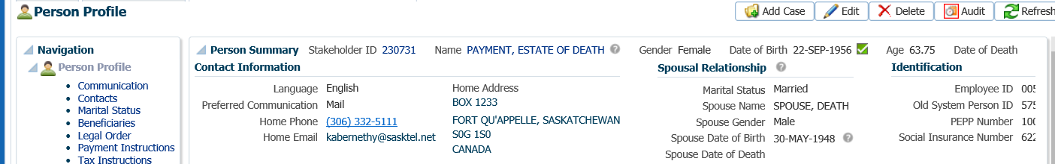

1. In the **Person** pop-up window, enter the **Date of Death**, click **Save**.

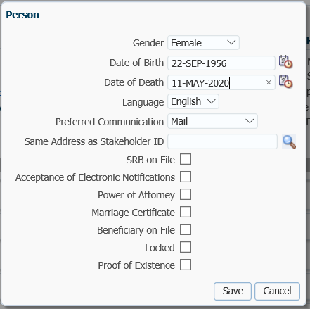

1. The **Member Status** in the **Membership Periods** region will automatically update to **Deferred Survivor.**

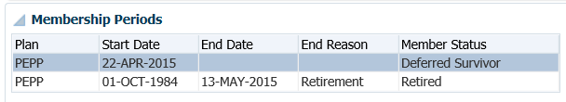

1. For *PEPP Members*, determine if the member is still contributing to the plan. Under the **Employee Profile** menu, check the **Membership Periods** and **Employment Periods**. If the member has more than one **Membership Period**, ensure the correct one is highlighted. If it is determined that the member is still contributing, click **Edit.**

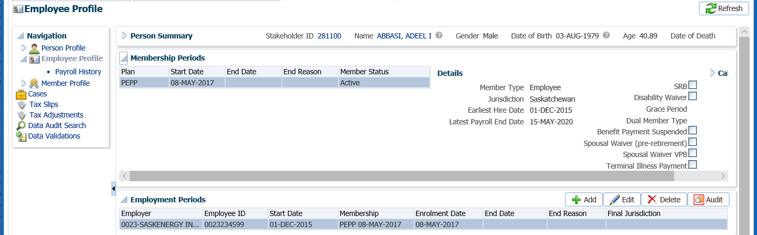

* **NOTE:** Contact the employer for the *Notice of Termination* form if it has not been received and the member is actively contributing.

1. In the **Employment Period** pop-up window, add the employment status **End Date** as the date of death, the **End Reason** as **Deceased** and the **Final Jurisdiction**. Click **Save**.

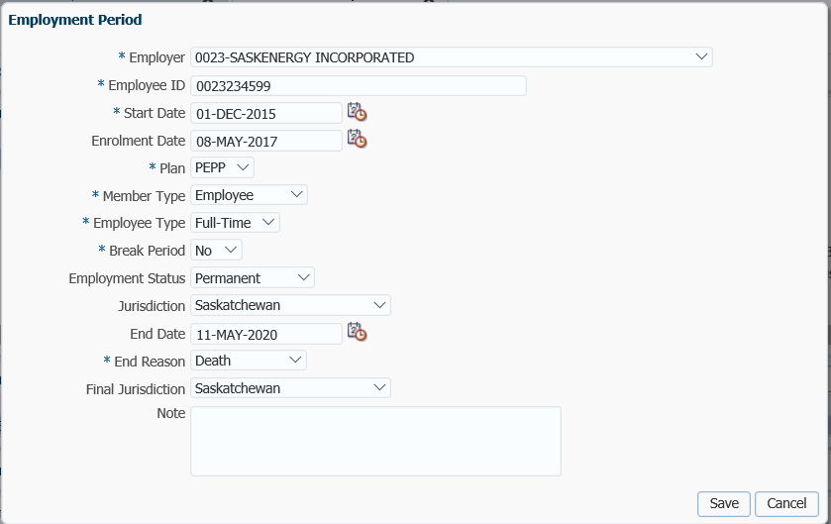

1. Check the member’s marital status under the **Person Profile** menu, **Marital Status** screen, **Spousal Relationship** region. If the marital status shows married but the beneficiary is other than the spouse, confirm that the following form(s) are on file:

PEPP Members:

* *Spouse’s Waiver of Survivor Benefits Prior to Retirement* form and/or,
* *Declaration of Common-Law Relationship by Member* form or,
* *Declaration of Common-Law Relationship by Spouse* form.

VPB Members:

* *Spouse’s Waiver of Designated Beneficiary Status* form and/or,
* *Declaration of Common-law Relationship by Member* form or’
* *Declaration of Common-Law Relationship by Spouse* form.

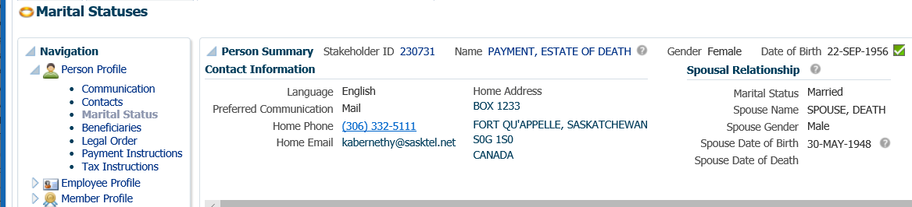

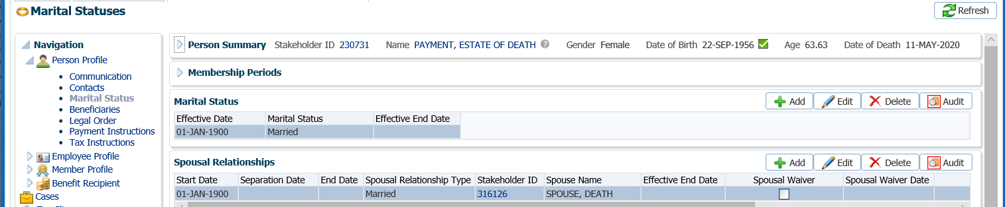

1. Confirm the beneficiary on PENFAX match the beneficiary listed in the member file to ensure PENFAX is updated with the most recent information. Under the **Person Profile** menu, click on the **Beneficiary** screen and expand the **Beneficiary** region to see the beneficiary(s) listed.

* **NOTE:** Ensure the beneficiary(s) stakeholder record has a valid address.

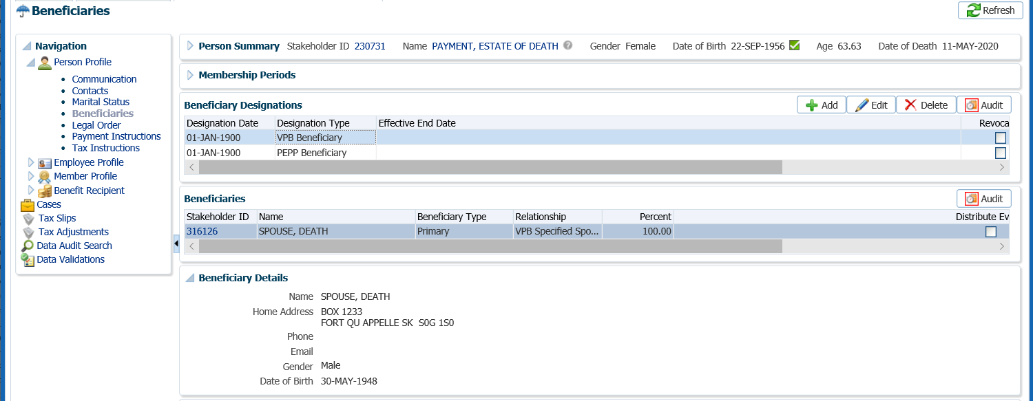

1. For *VPB Members* that are receiving scheduled payments, the payment schedule needs to be suspended. Under the **Benefit Recipient** menu, highlight the most recent **Benefit Event ID**. Under **Authorization History** click **Suspend**.

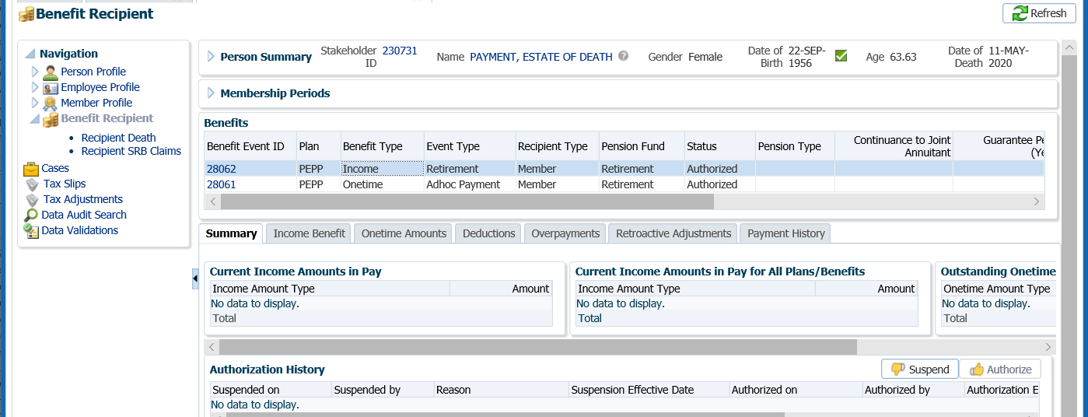

1. In the **Suspend Benefit Recipient** pop-up window, select the **Reason** of “**Date of death entered**”. Click **Save**. This will stop any future payments from being made to the deceased member.

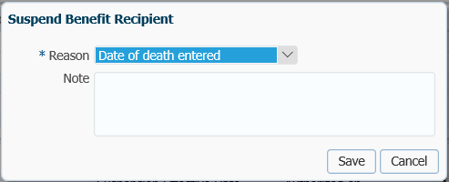

1. The **Authorization History** region will now show the information entered with a reason and an effective date.

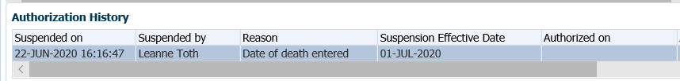

1. Click on the **DC Benefit Selections** screen to process the Death Option letter.

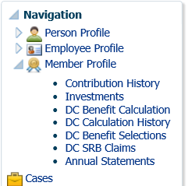

1. In the **DC Benefit Calculation: Input Data** screen ensure the **Death Date** is populated. Ensure the correct **Membership Period** is selected if the member has more than one membership period. Click **Next** on the data input train to navigate to the **Beneficiaries** step.

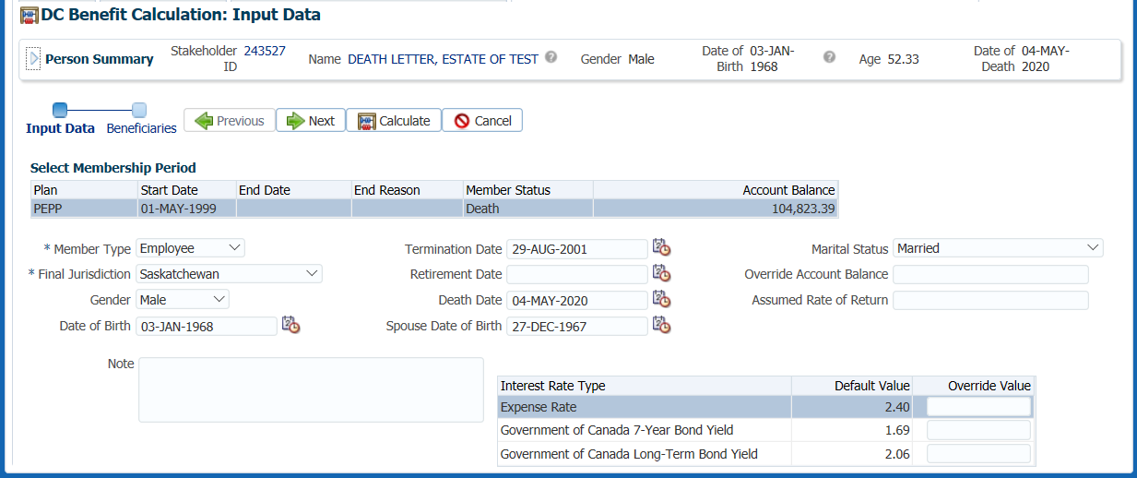

1. On the **Beneficiary confirmation** screen ensure the beneficiary(s) listed and percentage is correct. Click **Calculate**. A warning message will be displayed reminding you to verify that the beneficiary(s) listed are correct and the percentage displayed. Click **OK** to clear the message.

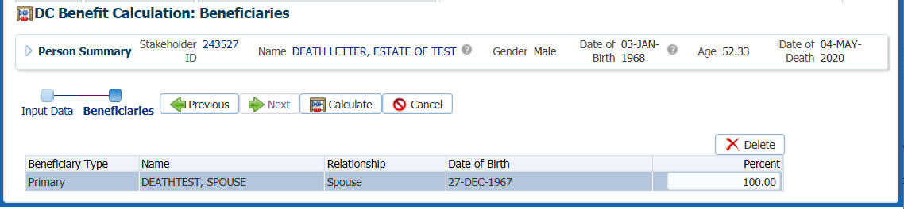

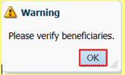

1. The status will update to **Calculated** and the details of the calculation will be displayed on the **DC Benefit Calculation** screen. Beneficiary information will be displayed under the Beneficiaries tab. The calculation can also be stored as a **Quote**, by clicking on the **Quote** button. Quotes can be viewed at any time from the **DC Calculation History** screen.

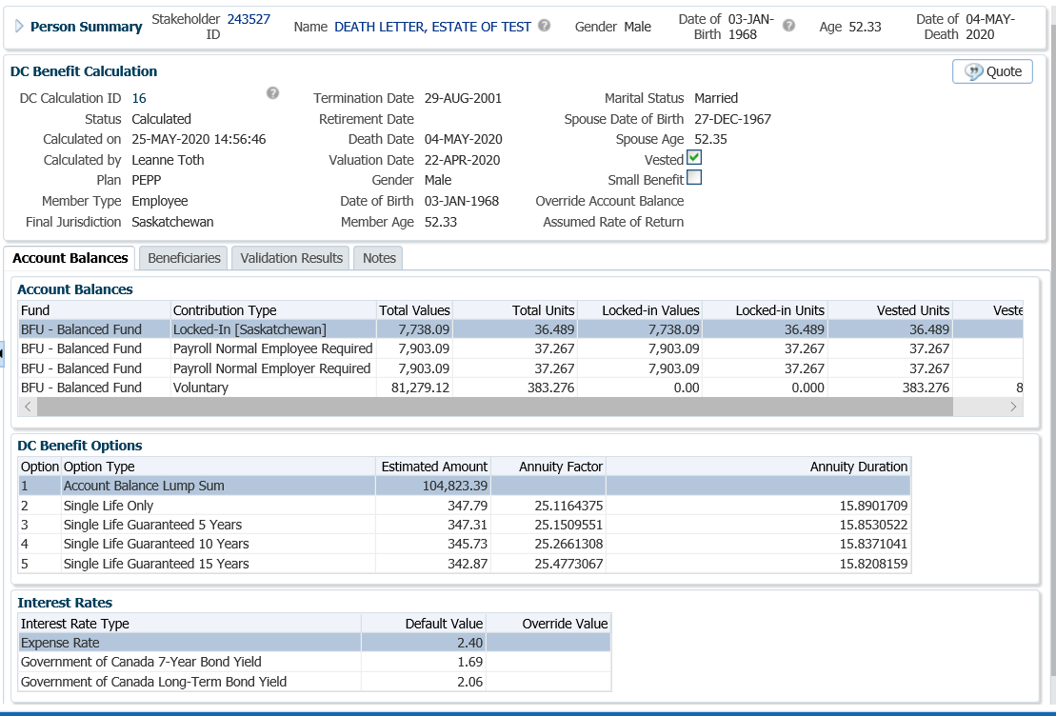

1. The Option Letter can be viewed by clicking on the link under Reporting on the **DC Benefit Calculation** screen.

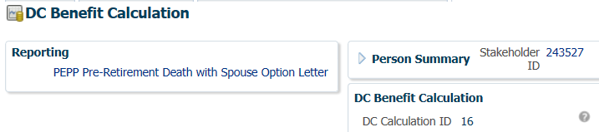

1. To close the DC Benefit Calculation window, click on the **X**.

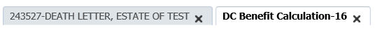

1. The *Supervisor* or *Pension Specialist* will audit the death option letter calculation in the **DC Calculation History** screen to ensure the information entered is correct before the Death Option Estimate is sent out. Click on the **DC Calculation ID** number to view the information.

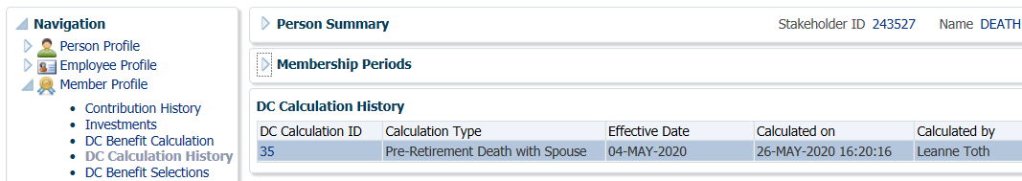

1. In the **DC Benefit Calculation** region click on the various tabs to view the information saved from the quote.

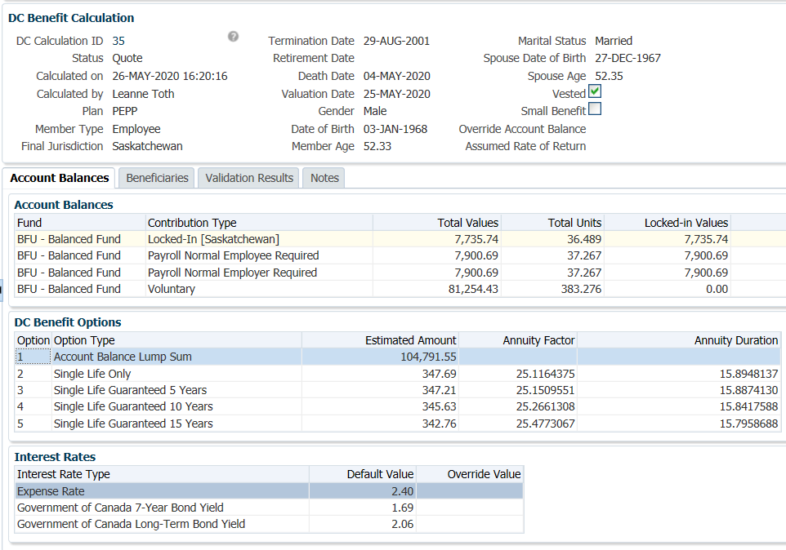

1. If an error was noted, the calculation will need to be redone. Click **Delete** on the **DC Calculation History** region to remove the incorrect calculation.

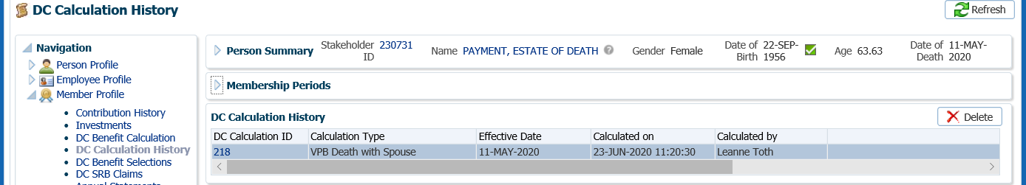

1. The *PEPP Pre-Retirement Death Option* Letter can be viewed under the **Reporting** area. Click the link to open the letter.

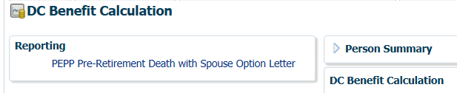

* **NOTE:** click the **X** in the DC Benefit Calculation tab to close the window.



1. The *PEPP Pre-Retirement Death Option* Letter will print overnight and a copy saved to the member’s account under the **Navigation, Person Profile** menu**, Communication** screen, **Outbound Documents** region. Mail the Death Options letter package to the spouse or beneficiary(s).

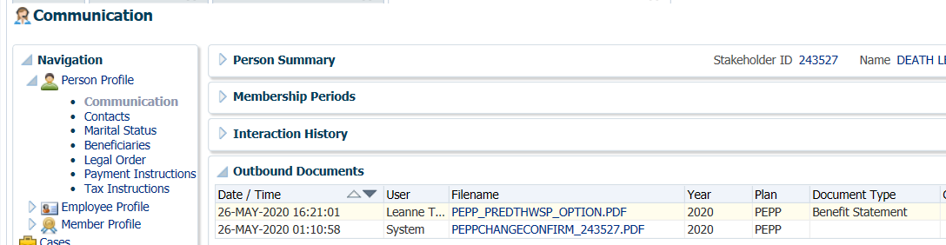

1. Under the **Person Profile** menu**, Notes** region, add a note stating who the Death Option Letter was sent to. Click **Add**, enter your note and **Save**.

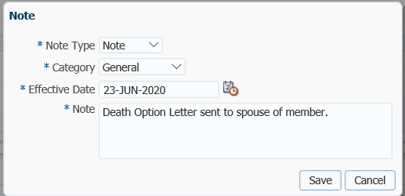

1. Keep the member file at your desk for follow up with the spouse/beneficiary if the option letter is not received back in a timely manner.

### Death Payment Requirements

When the Death Option Letter is received back, PEPP will provide a death benefit to the spouse, non-spouse beneficiary(s) or estate. The death benefit is equal to the value of the member’s account balance on the payment date and includes employee, employer and voluntary contributions and all investment earnings on those contributions up to the payment date.

Business Process Requirements – Death Payment

* Death Certificate or funeraldirectors Statement of Death – original or certified copy received to confirm the member’s date of death.
* *PEPP Declaration upon member’s death* form received.
* *Spousal Options upon member’s death* form received.
* Confirm that other required documents and forms have been received.  ***Refer to the procedures for Death Option Letter, Documents and Forms Required.***
* *Notice of Termination* form required if member was actively contributing. If the *Notice of Termination* form has still not been received, contact the employer.

## Death Payment Option – Leave Funds in Account

The spouse of the deceased PEPP member has the option to leave the funds in the deceased member’s PEPP account. The funds must be converted to a retirement income payment option before December 31st of the year the surviving spouse turns age 71.

The spouse of a deceased VPB member spouse listed as a *Specified Beneficiary* must choose an option for the death benefit and inform PEPP by the end of the year following the member’s death.

The spouse of a deceased VPB member listed as *Other Beneficiary* must take a lump-sum payment less withholding tax as soon as it is practical after the member’s death.

The non-spouse beneficiary of a PEPP or VPB member, must take a lump-sum payment less withholding tax as soon as it is practical after the member’s death.

The beneficiary may receive the *VPB* scheduled payments to the end of the calendar year following the year of death. At that point in time, the remaining account balance must be paid in a lump sum less withholding tax.

#### How to Process a Death Leave In

1. Search for the deceased member in PENFAX.
2. Verify that all required documents and forms have been received, signed and certified if required as per the business process requirements for a death leave in option.
3. Confirm that the deceased member’s date of death is correctly recorded on PENFAX under the **Person Profile** menu, **Person Summary** region as indicated on the Death Certificate or funeral directors Statement of Death.

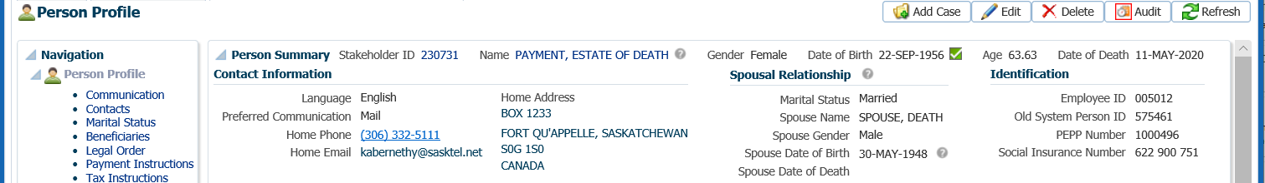

1. Under the **Person Profile** menu**, Identity** region, click **Edit**.

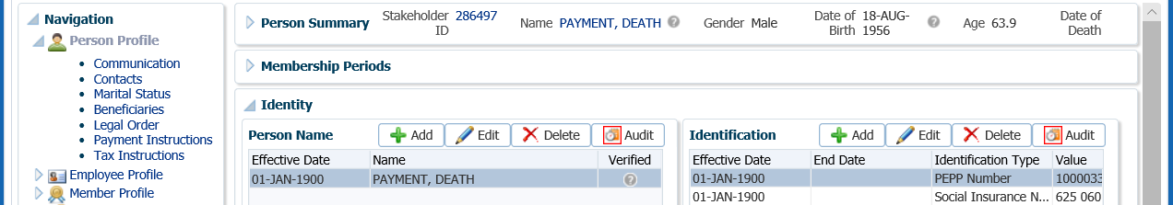

1. In the **Person Name** pop-up window, change the first name of the member to be reflected as “Estate of member’s 1st name”. Click **Save**.

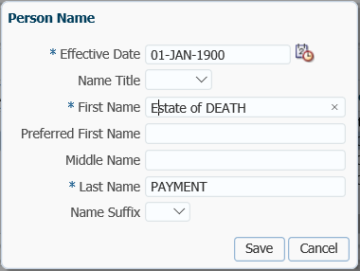

1. Ensure the beneficiary information in PENFAX is correct as per the information provided by the beneficiary on the *Declaration upon member’s death* form. If changes are required to a name, address or the SIN needs to be entered, the information must be updated on the beneficiary’s stakeholder record before the payment is started. To access the beneficiary’s stakeholder account, click on the link in the deceased member’s account.

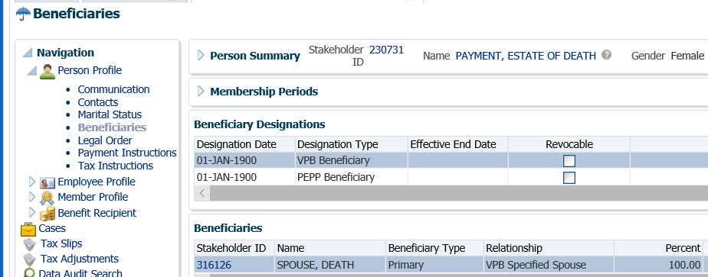

Click

1. Verify that all required documents and forms have been received, signed and certified if required.
2. If the member is in VPB and receiving scheduled payments, the payments are required to be stopped at the time of the notification of death. If they VPB scheduled payments were not stopped, go to the **Benefit Recipient** menu. Highlight the most recent **Benefit Event ID**. Under **Authorization History,** click **Suspend**.

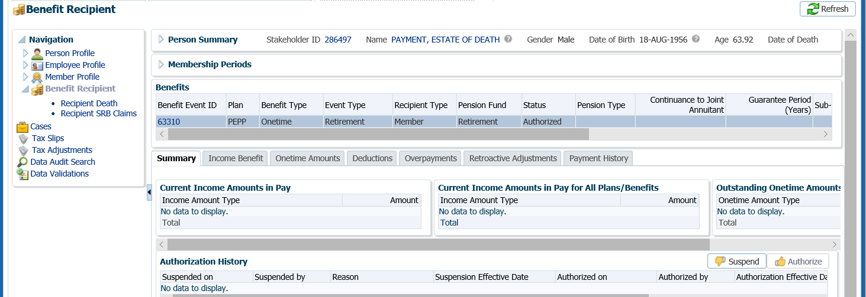

1. In the **Suspend Benefit Recipient** pop-up window, select the **Reason** of **Date of death entered**, click **Save**. This will ensure no further payments will be made to the deceased member.

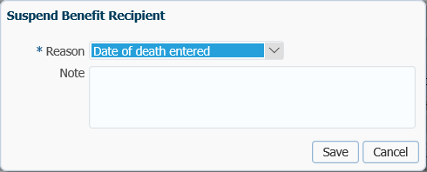

1. The **Authorization History** region will now show the information entered with a reason and an effective date.



1. If the spouse has chosen to leave the funds in the deceased member’s PEPP or VPB account, add a note on the member’s account stating the decision. Under the **Person Profile** menu, **Notes** region click **Add**, enter the note, click **Save**.

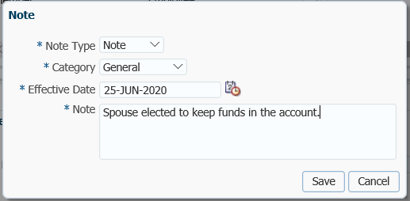

1. Keep the member file at your desk for follow up with the spouse/beneficiary if the option letter is not received back in a timely manner.

## Death Payment – Cash Option

One of the options for a *spouse* upon the death of a PEPP member is to take the death benefit as a cash lump-sum payment.

A spouse listed as *Other* beneficiaryunder a VPB account must take the death benefit as a cash lump-sum payment, there is no other option. *Specified Beneficiaries* under a VPB account have the option to take the death benefit as a cash lump-sum payment, transfer to another registered account or continue receiving VPB payments.

For all *non-spouse* beneficiaries of PEPP or VPB, the only option for the death benefit is a cash lump-sum payment.

#### How to Process a Death Payment – Cash Option

The payment processing steps are almost identical for members of PEPP or VPB. The one difference is that if a member is receiving scheduled VPB payments, the payment schedule must be stopped.

1. Search for the deceased member in PENFAX.
2. Confirm that the deceased member’s date of death is correctly recorded on PENFAX under the **Person Profile** menu, **Person Summary** region as indicated on the Death Certificate or funeral directors Statement of Death.



1. Ensure the beneficiary information in PENFAX is correct as per the information provided by the beneficiary on the *Declaration upon member’s death* form. If changes are required to a name, address or the SIN needs to be entered, the information must be updated on the beneficiary’s stakeholder record before the payment is started. To access the beneficiary’s stakeholder account, click on the link in the deceased member’s account.



Click

1. If the beneficiary is the Estate, ensure the beneficiary record displays the deceased member’s address and the SIN is populated with a valid dummy SIN (deceased member’s Member number + 18).

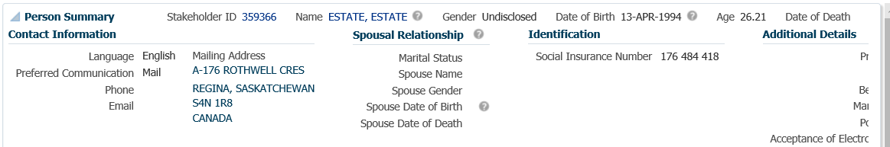

1. Verify that all required documents and forms have been received, signed and certified if required. Determine that the option chosen by the spouse/beneficiary is allowed before proceeding with the payment. ***Refer to Business Process Requirements for a cash payment under the Death Option Letter process***.
2. If the member was still contributing to PEPP at the time of death, confirm that the *Notice of Termination* form has been received by checking the **Employee Profile** menu, **Employment Periods** and the member **Notes** region.

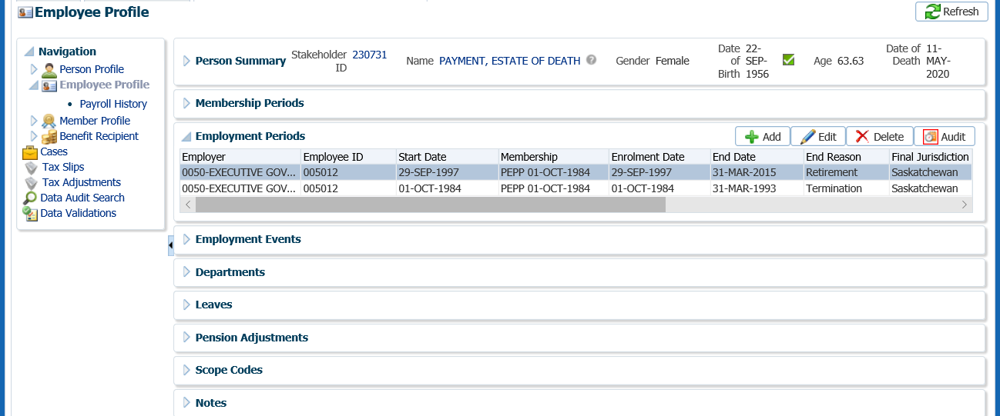

1. If the PEPP member was still contributing to PEPP at the time of death, determine if the final contribution has been received under the **Employee Profile** menu, **Payroll History** screen, **Payroll History** region. If the final contribution has not been received, contact the spouse or beneficiary(s) to find out if they would like to proceed without the final contribution or wait until it has been received.

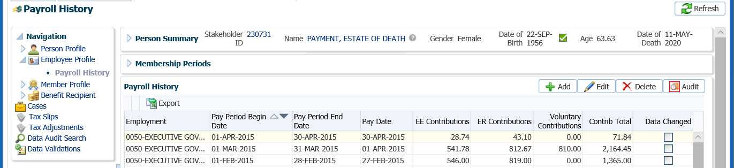

* **NOTE:** If the spouse would like to proceed without the final contribution, a 2nd payment is required to be processed when the final contribution is received. ***Refer to the 2nd Payment Procedures***.

1. If the spouse or beneficiary decides to wait until the final contribution has been received to have it included in the total payout amount, change the future due date on your Case to a date equal to approximately the date the employer remits the next contribution payroll. If the final contribution is not received with the employer’s next contribution remittance contact the employer.

Click on the **Case ID** of the first **Task** to take you to the **Case.**



1. Select the **Suspend** option to change the **Case Status** to **On Hold**.



1. In the **Task** region click the **Edit** button.



1. In the **Task** pop-up window, change the **Reminder Date** to a date in the future to approximately when the final contribution should be received. Change the **Due Date** to a date in which the service standard for the **Case** type would be due for completion on after the reminder date. Click **Save**.



1. When the final contribution has been received and processing of the death payment is to resume, click the **Resume** button at the **Case** level. The **Case Status** will now be reflected as **Open**.



1. If the member is in VPB and receiving scheduled payments, the payments are required to be stopped at the time of the notification of death. If they VPB scheduled payments were not stopped, go to the **Benefit Recipient** menu. Highlight the most recent **Benefit Event ID**. Under **Authorization History,** click **Suspend**.

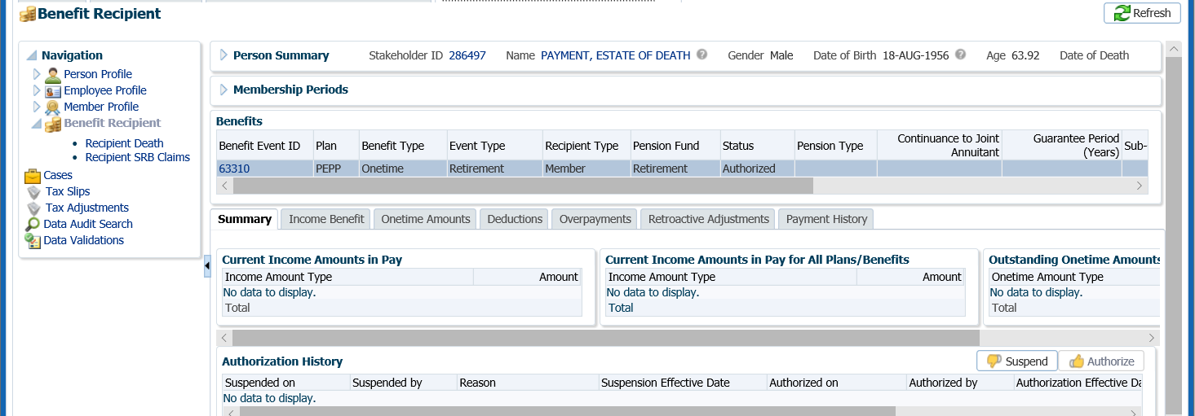

1. In the **Suspend Benefit Recipient** pop-up window, select the **Reason** of **Date of death entered**, click **Save**. This will ensure no further payments will be made to the deceased member.



1. The **Authorization History** region will now show the information entered with a reason and an effective date.



1. Process the death benefit payment to the spouse or designated beneficiary as per the option chosen. All payments regardless of the option chosen will be processed through **the DC Benefit Selections** screen. Under the **Member Profile** menu, **DC Benefit Selections** screen, **DC Benefit Selections** region, click **Add**.

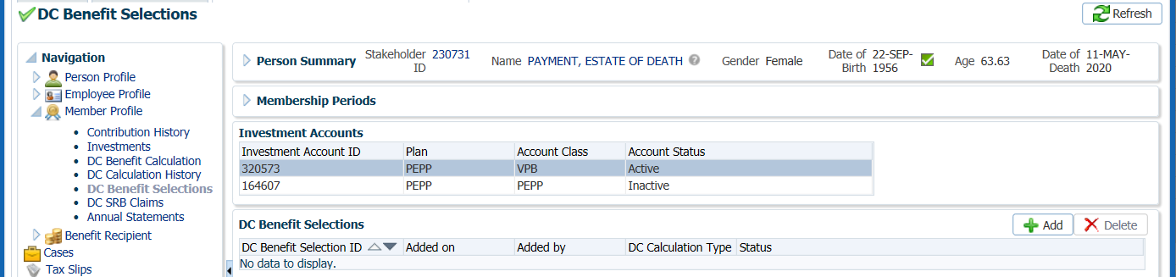

1. In the **Data Input Train** ensure the **Death Date** is populated. Click **Next**.

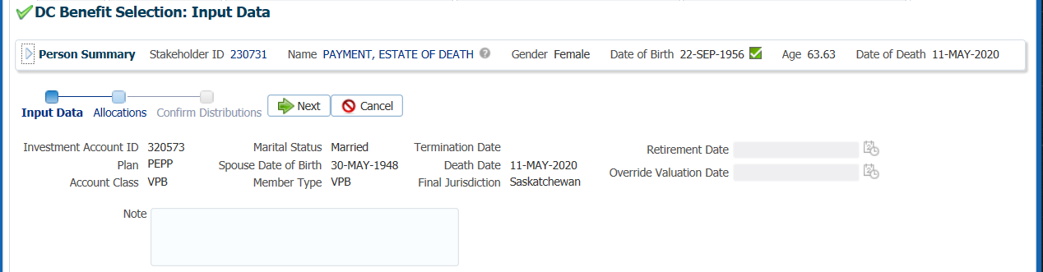

1. Under the **Allocations** region, click **Add**.

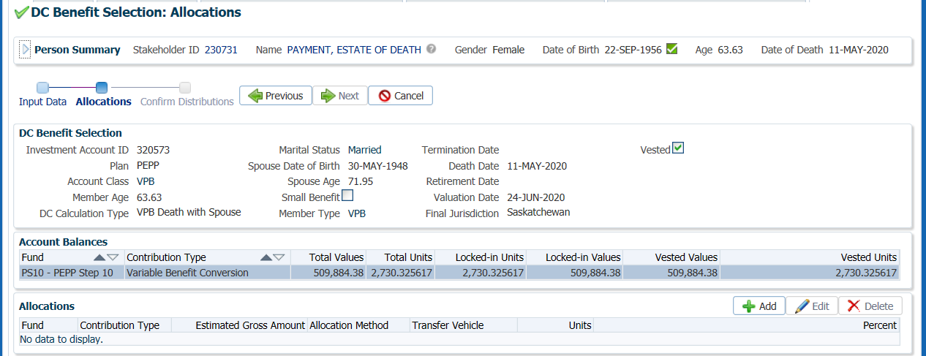

1. In the **Allocation** pop-up window, enter the following information and click **Save**:

* **Fund** – leave blank so that all funds will be included
* **Contribution Type** – leave blank so that all contribution types will be included
* **Allocation Method** – Percent if the entire account balance is being paid out, or Gross Amount if only a partial amount is being paid out
* **Percent/Gross Amount** – 100% or a specific gross amount
* **Transfer Vehicle** – Cash, (select the option chosen by the spouse, if a non-spouse option is Cash only)
* **Estimated Gross Amount –** the amount will automatically populate based on the percent/gross amount, fund(s) and contribution source(s) selected

*This example is using a Cash option to the spouse or non-spouse beneficiary:*

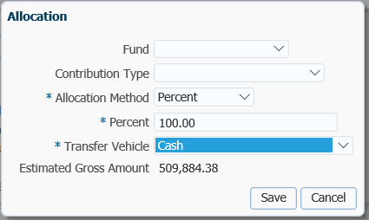

1. In the **Input Data Train**,click **Next** to Confirm the Distributionsof the payment.

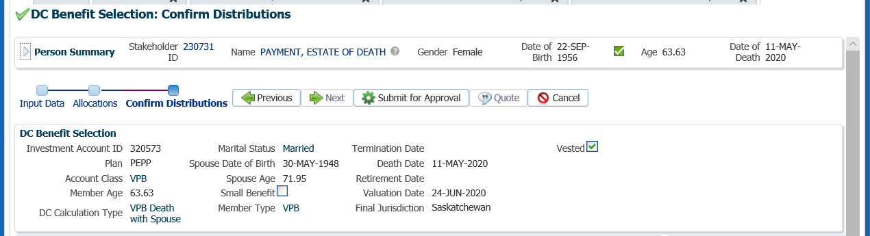

1. In the **Onetime Amounts** region under the **Payment Instruction** column, click on the drop-down list. If no information is displayed click on the **Add New** option to add the payee information.

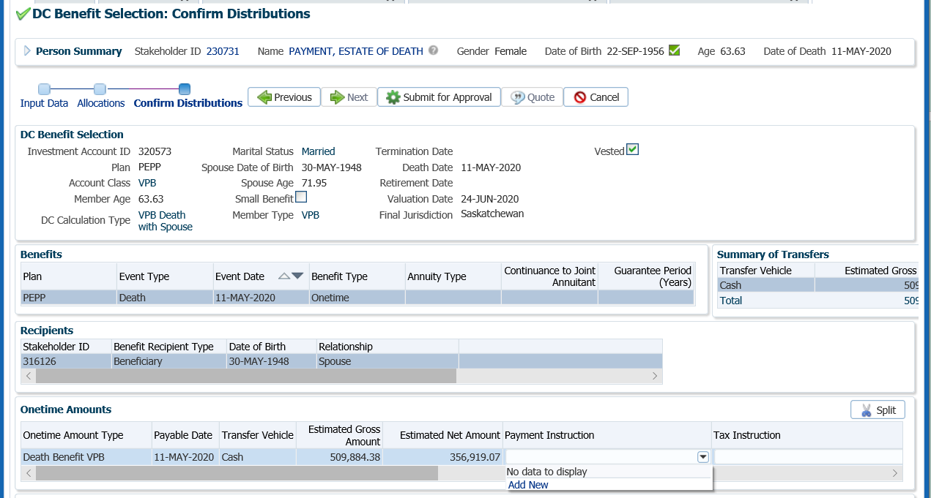

* **NOTE:** if the same payee type was previously added in the **Payment Instructions** screen under the **Person Profile**, the information will be displayed in the drop-down list under **Payment Instructions** and can be selected for the payment.

1. In the **Payment Instruction** pop-up window, select the following and click **Save**:
   * **Payee Type** – Self (for Cash payments)
   * **Payment Method** – Cheque
   * **Receipt Date** – leave as current date
   * **Expiry Date** – date that the banking instructions are valid for for EFT
   * **Payment Note** ­– used to add a note to the payment documentation (cheque or EFT receipt)
   * **Hold for Pickup ­**– checked if the member would like to pickup the cheque (will be displayed under the member’s Payment Instructionsscreen)
   * **Note** – additional notes pertaining to the payment, will appear under Person Profile Notes.
   * **Payee Name** – will default to the spouse or beneficiary’s name, can be overridden in Override Payee Name field.
   * **Override Payee Name** - Override Payee Nameis used to set up a payment to an alternate payee name such as a guardian or trustee, “In trust for” or “Estate of”.
   * **Address Type** – defaults to the spouse or beneficiary’s primary address on record, if another address exists on file it can be selected from the drop-down list.

*Payment to the Spouse*

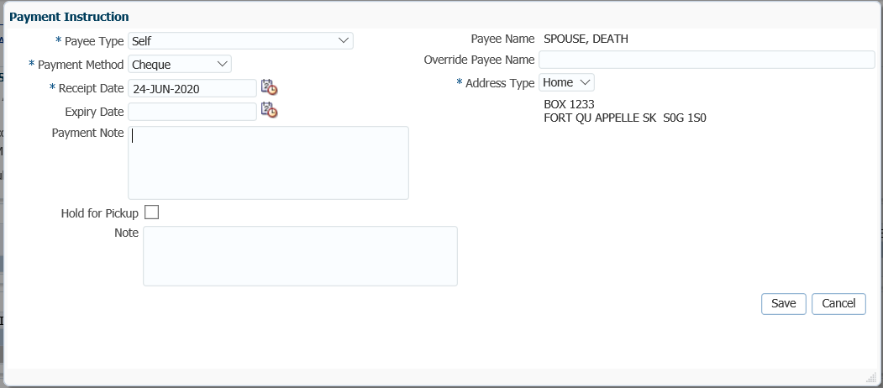

*Payment to the Estate*

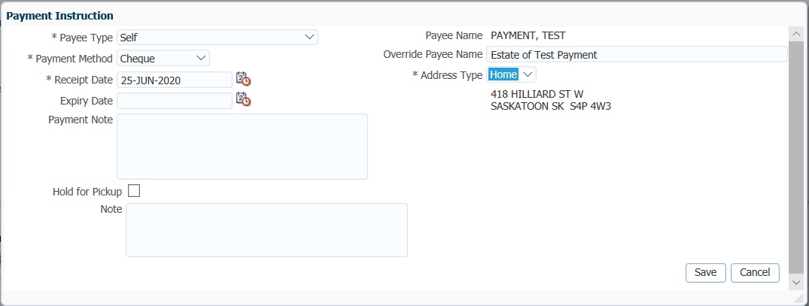

1. **Tax Instructions** are not required to be added for cash payments. PENFAX will determine if tax is required to be deducted by the Transfer Vehicle chosen in the Allocation step and apply the appropriate tax rate of 10%, 20% or 30%.
2. In the **Input Data Train**, click **Submit for Approval**.

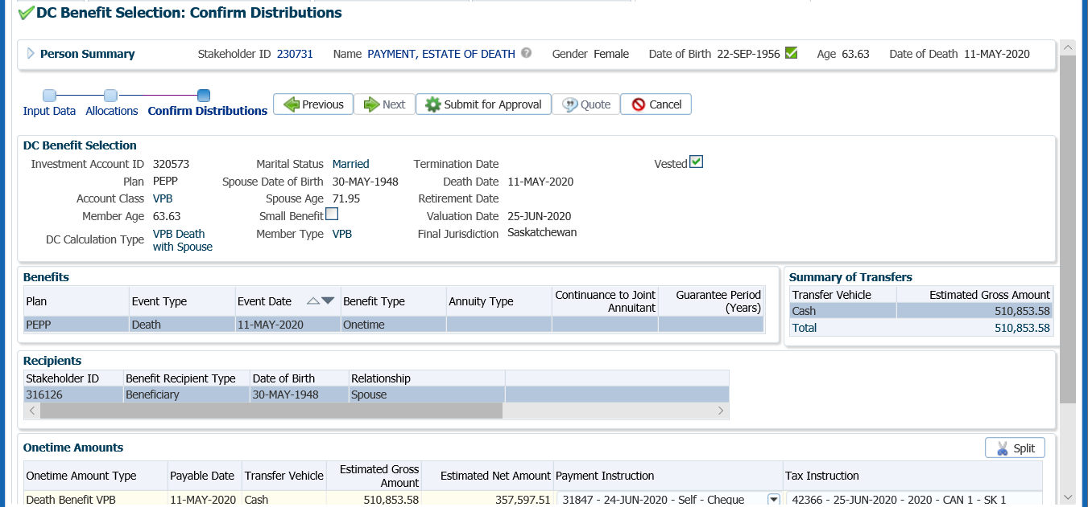

1. The Pension Specialist or Supervisor will audit and approve the payment in the DC Benefit Selection region by clicking Approve, or Reject if there were errors or the payment was done in error.

* **NOTE:** If the payment is **Rejected,** the payment steps need to be entered again by the *Pension Information Officer*. There is no option to edit the existing information.

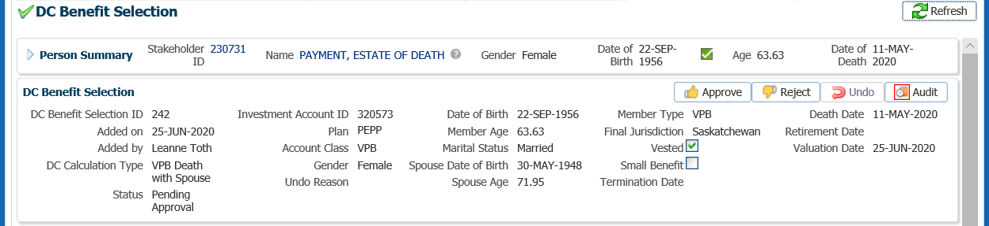

The **Reject** button is enabled if the status is **Pending Approval** or **Approved**. If the payment is rejected the status will update to **Rejected** when clicked and prevent the benefit selection from being processed by the investment batch.

The **Undo** button is enabled only if the status is **Processed** and will update the status to **Pending Undo** after selecting **Save.** Select an **Undo Reason**. After the investment batch runs, the status will be updated to **Undone** as a result of processing the reversal in the investment batch.

1. In the **Approve DC Benefit Selection** pop-up window, add a **Note** and click **Save.**

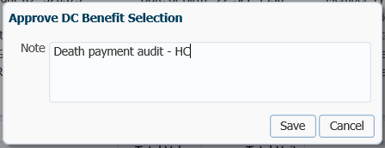

1. A history of Transactions, User and Event is shown under the **Audit** button.

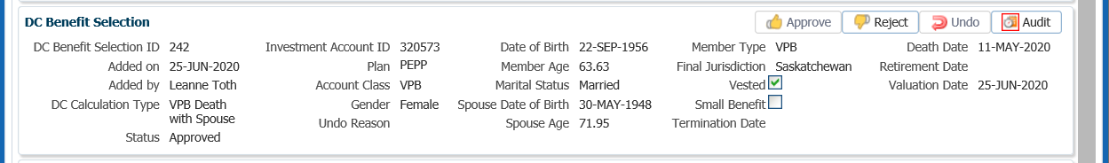

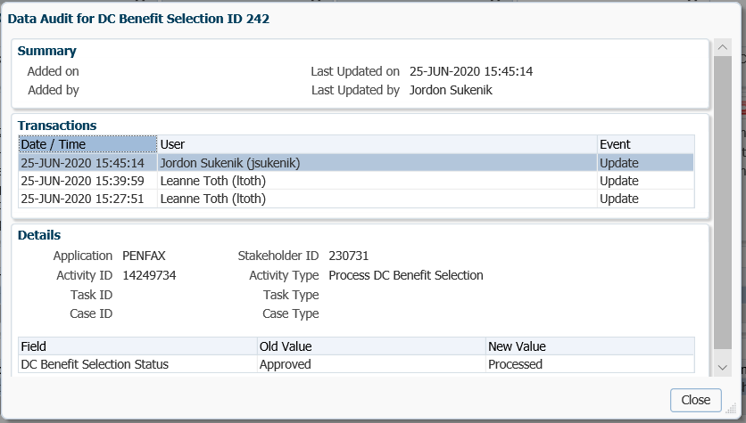

* **NOTE:** Click on the **X** in the **Payment ID Tab** to close the window.



1. The following business day confirm that the **Member Status** under the **Member Profile** menu, **Membership Periods** region shows as Death.

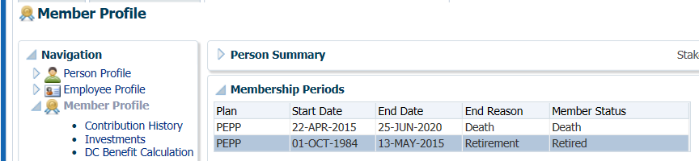

1. Under the Investments screen the Investment Accounts region will now show the Account Status as Inactive and the balance under the Account Summary region will show $0.00 if all the money was requested to be paid out.

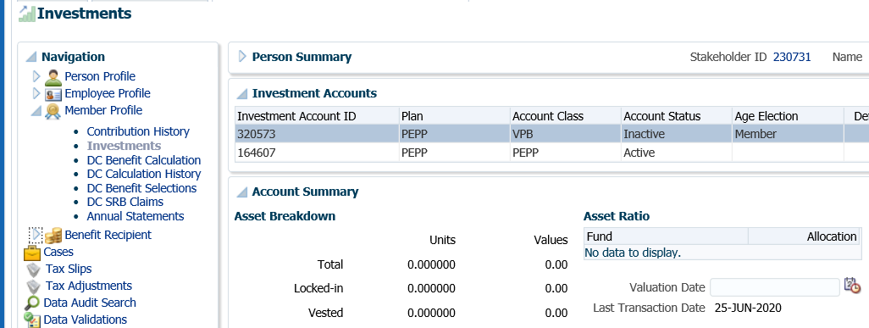

1. The payment will process in the overnight batch process and a cheque will be produced. To view the payment details, click on the **DC Benefit Selections** screen. Under the **DC Benefit Selections** region, click on the **DC Benefit Selection ID** number.

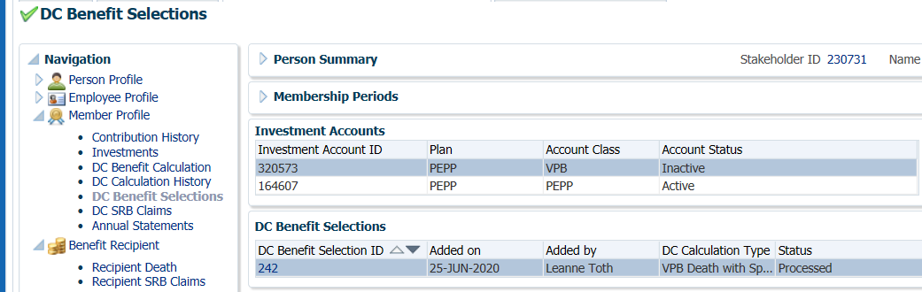

1. Under the **Recipients** region click on the **Stakeholder ID** to take you to the beneficiary’s stakeholder account.

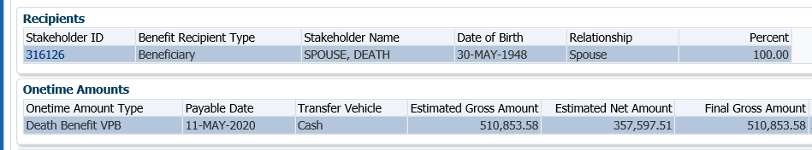

1. Under the spouse’s account (benefit recipient), a **Benefit Recipient** folder has been created. Click on the **Onetime Amounts** tab to see further details of the payment.

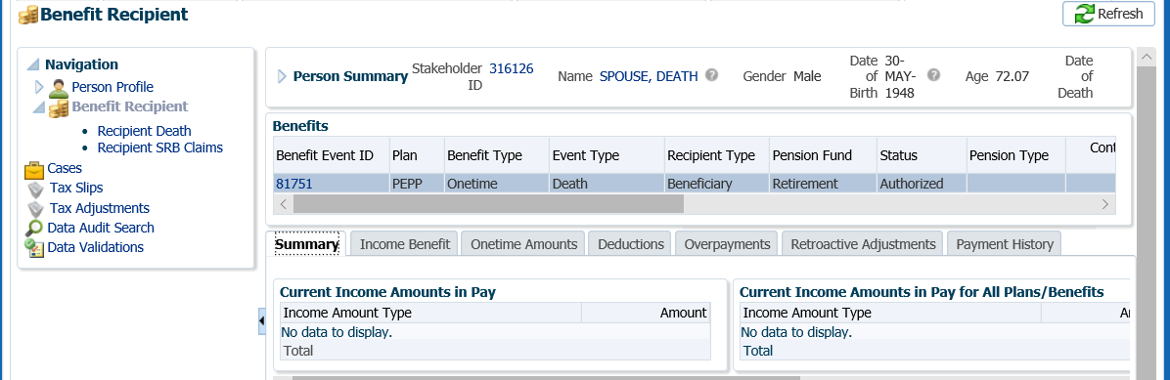

1. In the **Onetime Amounts** tab, click on the **Paid by Payment ID** number.

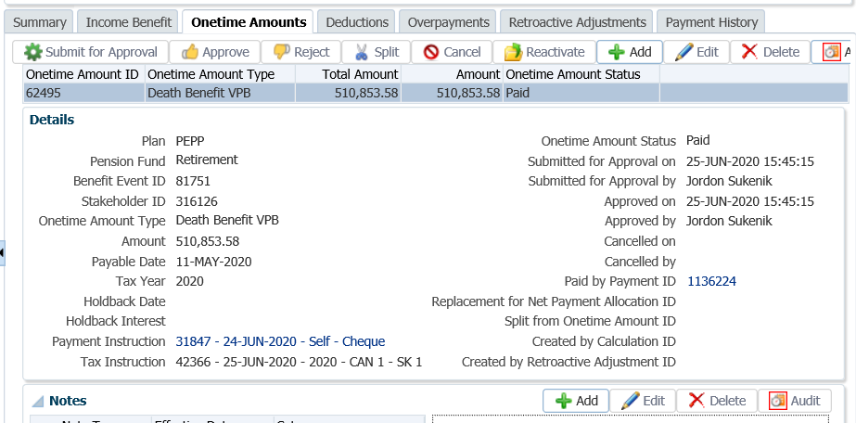

1. Click on the tabs to the right of the screen (**Line Items, Tax, Net Pay Allocation** and **Notes**) to see further details related to the payment.

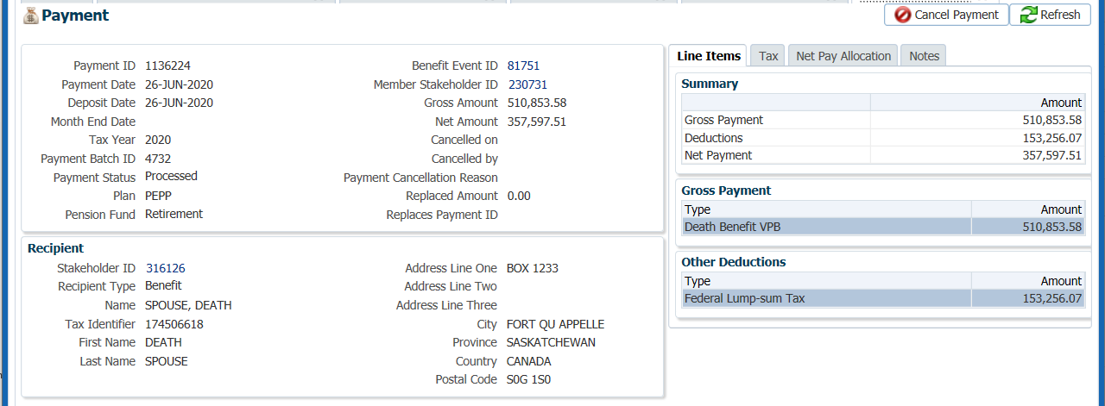

1. Under the **Net Pay Allocation** tab, further details related the cheque can be found by clicking on the **Cheque ID hyperlink**.

*Cash Payment to Spouse*

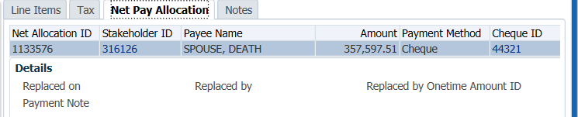

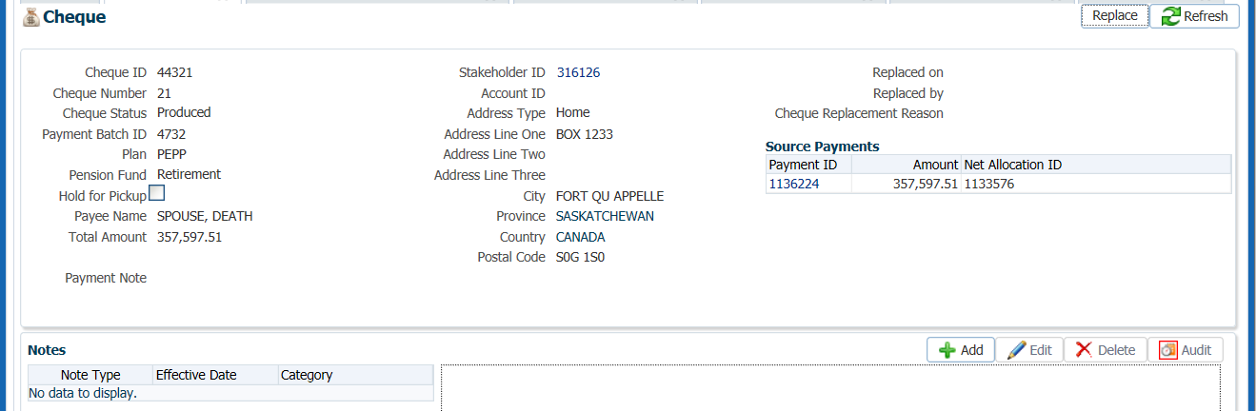

*Cash Payment to Estate*

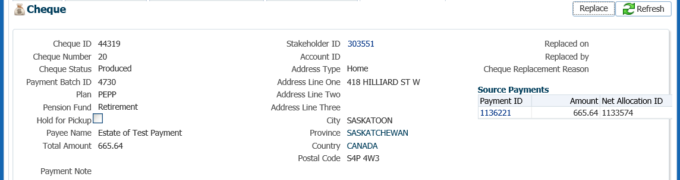

* **NOTE:** Click on the **X** in the Cheque and Payment screens to close the windows.



1. *Withdrawal Confirmation Letter* will be saved on the Spouse’s account under the **Person Profile**, **Communications** screen underthe **Outbound Documents** region. Click on the **Filename** link to open the document.

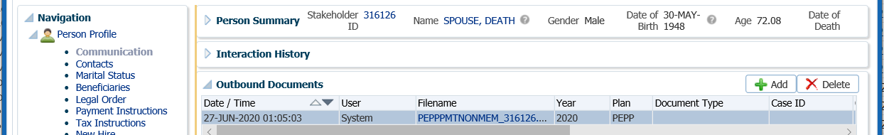

1. A tax slip is to be manually generated at the time of the death payment and a list kept to verify against at calendar year end when the tax slip batch is run. This is to ensure that a duplicate tax slip is not sent to the member. ***Refer to the Tax Slips procedures in this manual***.

#### Tax Withholding for Cash Option:

* + Spouse or common-law partner
    - estate pays taxes on final tax return
    - spouse pays no tax
    - no probate fees paid
  + Non-spouse beneficiary
    - estate pays taxes on final tax return
    - beneficiary pays no further tax
    - no probate fees paid
  + Estate
    - estate pays taxes on final tax return
    - probate fees paid
* Charity
  + Estate pays taxes on final tax return
  + Tax slip issued to Charity?

## Death Payment to Spouse – Transfer to Qualified Financial Institution

The spouse of a deceased PEPP member has the option to transfer the death benefit to a registered product with a financial institution.

The spouse of a deceased VPB member, listed as a *Specified Beneficiary* has the option to transfer the VPB account balance to a registered product with a financial institution.

Transfers are allowed to an RRSP, LIRA, LRIF or RPP if the spouse is under age 71. If the funds are transferred to a locked-in account they will remain locked-in until the surviving spouse is age 50 as per PEPP Legislation. For transfers to a pRRIF or outside annuity, the spouse must be over age 50. The appropriate transfer forms are to be completed to initiate the transfer.

If the deceased member is 72 or older and has not received the minimum amount for the year, it is not required to be paid out prior to the transfer if the spouse is transferring the death benefit to another RPP.

#### How to Process a Death Payment – Transfer to Qualified Financial Institution

The payment processing steps are almost identical for members of PEPP or VPB. The one difference is that if a member is receiving scheduled VPB payments, the payment schedule must be stopped.

1. Search for the deceased member in PENFAX.
2. Confirm that the deceased member’s date of death is correctly recorded on PENFAX under the **Person Profile** menu, **Person Summary** region as indicated on the Death Certificate or funeral directors Statement of Death.



1. Ensure the beneficiary information in PENFAX is correct as per the information provided by the spouse on the *Declaration upon member’s death* form. If changes are required to the name, address, d.o.b. or the SIN needs to be entered, the information must be updated on the beneficiary’s stakeholder record before the payment is started. To access the spouse’s stakeholder account, click on the link in the deceased member’s account.



Click

1. Verify that all required documents and forms have been received, signed and certified if required. Determine that the option chosen by the spouse is allowed before proceeding with the payment. ***Refer to Business Process Requirements under Death Option Letter***.
2. If the member was still contributing to PEPP at the time of death, confirm that the *Notice of Termination* form has been received by checking the **Employee Profile** menu, **Employment Periods** and the member **Notes** region.



1. If the PEPP member was still contributing to PEPP at the time of death, determine if the final contribution has been received under the **Employee Profile** menu, **Payroll History** screen, **Payroll History** region. Ensure the correct **Membership Periods** is highlighted if the member has more than one. If the final contribution has not been received, contact the spouse to find out if they would like to proceed without the final contribution or wait until it has been received.

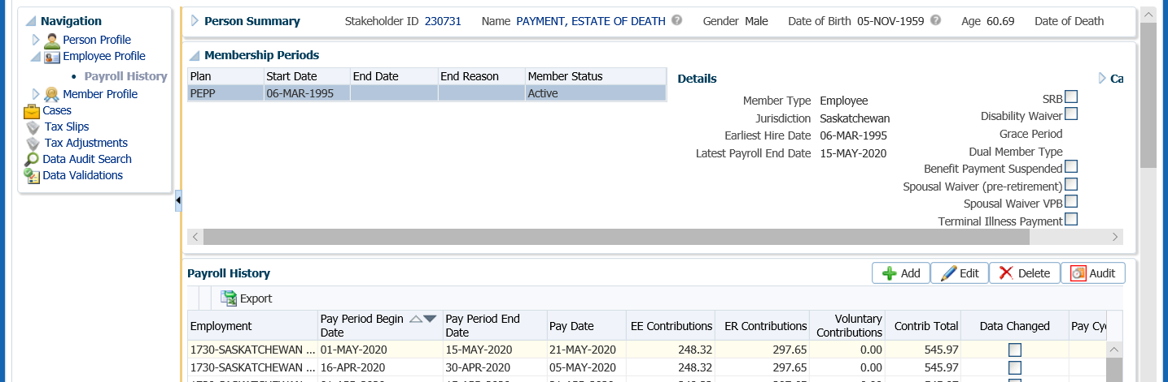

* **NOTE:** If the spouse would like to proceed without the final contribution, a 2nd payment is required to be processed when the final contribution is received. ***Refer to the 2nd Payment Procedures***.

1. If the spouse decides to wait until the final contribution has been received to have it included in the total payout amount, change the future due date on the assigned Case to a date equal to approximately the date the employer remits the next contribution payroll. If the final contribution is not received with the employer’s next contribution remittance contact the employer.

Click on the **Case ID** of the first **Task** to take you to the **Case.**



1. Select the **Suspend** option to change the **Case Status** to **On Hold**.



1. In the **Task** region click the **Edit** button.



1. In the **Task** pop-up window, change the **Reminder Date** to a date in the future to approximately when the final contribution should be received. Change the **Due Date** to a date in which the service standard for the **Case** type would be due for completion on after the reminder date. Click **Save**.



1. When the final contribution has been received and processing of the death payment is to resume, click the **Resume** button at the **Case** level. The **Case Status** will now be reflected as **Open**.



1. If the member is in VPB and receiving scheduled payments, the payments are required to be stopped at the time of the notification of death. If they VPB scheduled payments were not stopped, go to the **Benefit Recipient** menu. Highlight the most recent **Benefit Event ID**. Under **Authorization History,** click **Suspend**.

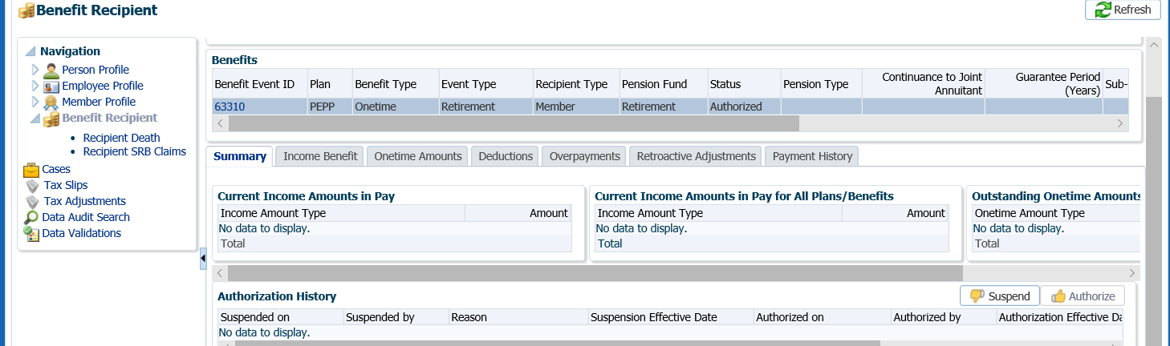

1. In the **Suspend Benefit Recipient** pop-up window, select the **Reason** of **Date of death entered**, click **Save**. This will ensure no further payments will be made to the deceased member.



1. The **Authorization History** region will now show the information entered with a reason and an effective date.



1. Process the death benefit payment to the spouse as per the option chosen. Under the **Member Profile** menu, **DC Benefit Selections** screen, **DC Benefit Selections** region, click **Add**.



1. In the **Data Input Train** ensure the **Death Date** is populated. Click **Next**.



1. Under the **Allocations** region, click **Add**.



1. In the **Allocation** pop-up window, enter the following information and click **Save**:

* **Fund** – leave blank so that all funds will be included
* **Contribution Type** – leave blank so that all contribution types will be included
* **Allocation Method** – Percent if the entire account balance is being paid out, or Gross Amount if only a partial amount is being paid out
* **Percent/Gross Amount** – 100% or a specific gross amount
* **Transfer Vehicle** – RRSP (the option chosen by the spouse)
* **Estimated Gross Amount –** the amount will automatically populate based on the percent/gross amount, fund(s) and contribution source(s) selected

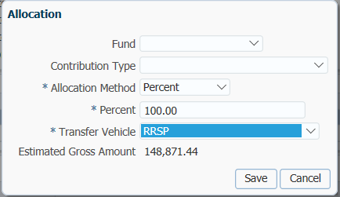

1. In the **Input Data Train**,click **Next** to Confirm the Distributionsof the payment.

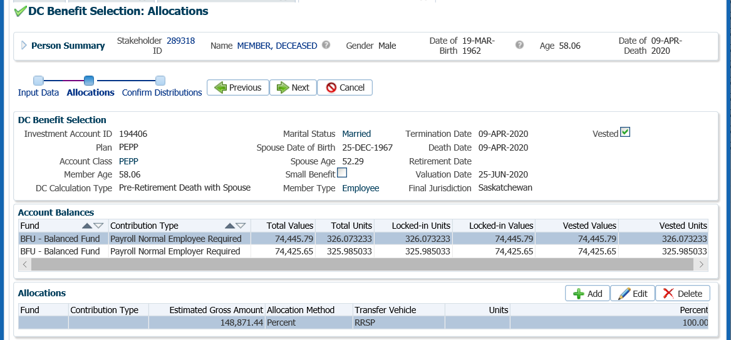

1. In the **Onetime Amounts** region under the **Payment Instruction** column, click on the drop-down list. If no information is displayed click on the **Add New** option to add the payee information.

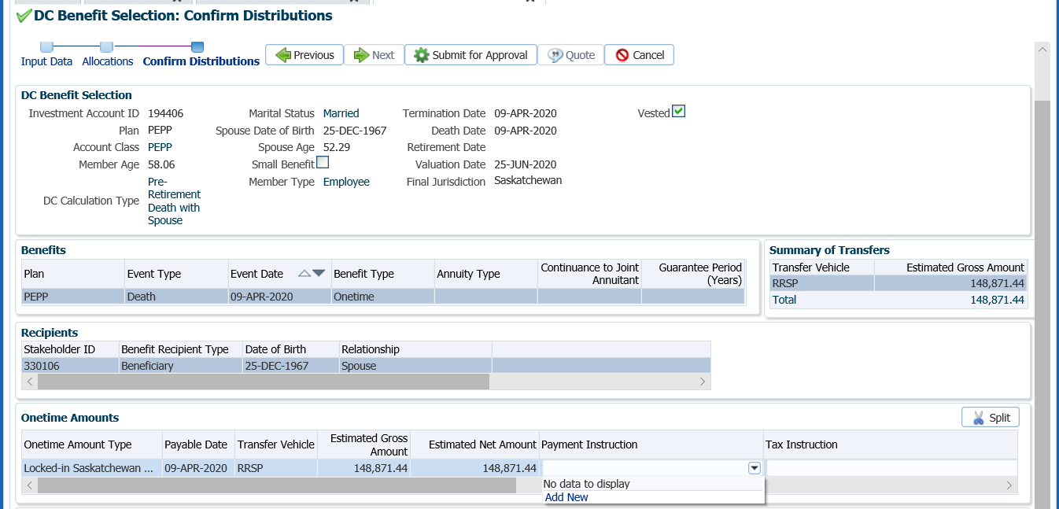

1. In the **Payment Instruction** pop-up window, select the following:
   * **Payee Type** – Qualified Financial Institution
   * **Payment Method** – Cheque
   * **Receipt Date** – leave as current date
   * **Expiry Date** – date that the banking instructions are valid for for EFT
   * **Payment Note** ­– used to add a note to the payment documentation (cheque or EFT receipt)
   * **Hold for Pickup ­**– checked if the member would like to pickup the cheque (will be displayed under the member’s Payment Instructionsscreen)
   * **Note** – additional notes pertaining to the payment, will appear under Person Profile Notes.

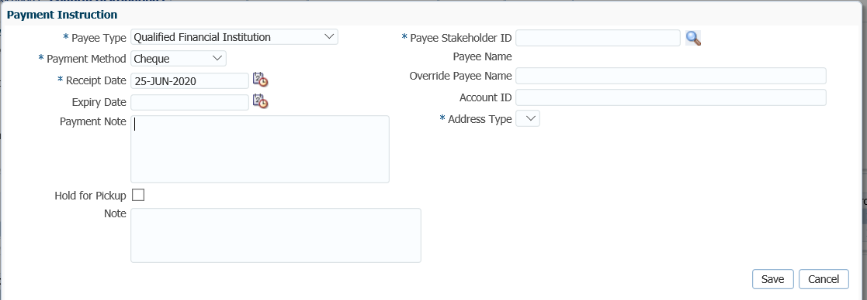

1. In the **Payee Stakeholder ID** field, click on the **magnifying glass** to find the stakeholder ID for the Qualified Financial Institution the funds are being transferred to.



1. In the **Search and Select Organization** screen, **Search Parameters**, select **Financial Institution** as the **Organization Type** from the drop-down list.Click **Search**.

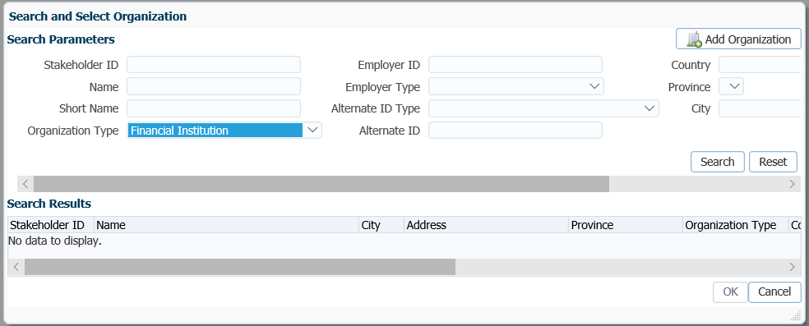

1. In the **Search Results** area, highlight the correct Financial Institution from thelist. Click **OK**.

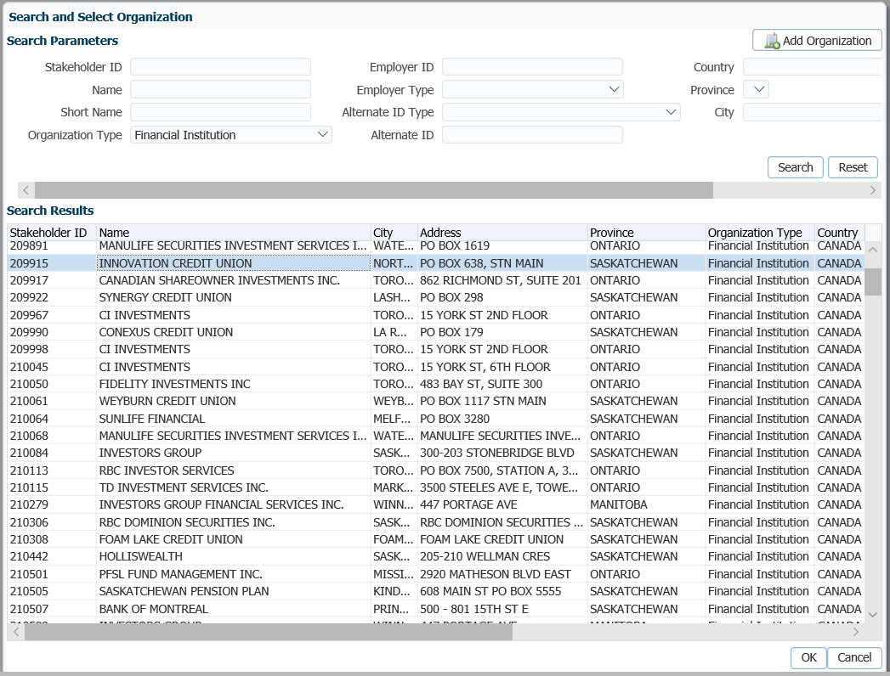

1. The **Payee Stakeholder ID**, the **Payee Name** and **Address** will now be populated in the **Payment Instructions** window. Add the **Account ID** for the financial institution the funds are being transferred to and add a **Note** if applicable. Click **Save**.

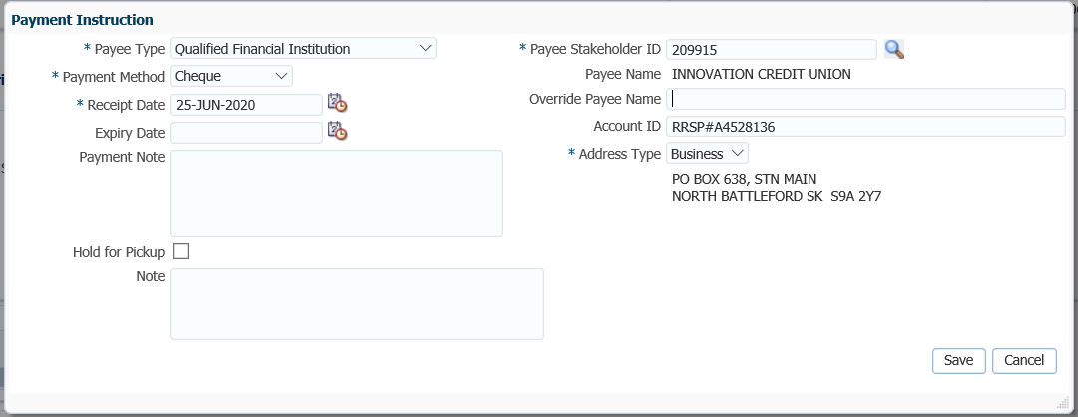

1. In the **Input Data Train**, click **Submit for Approval**.

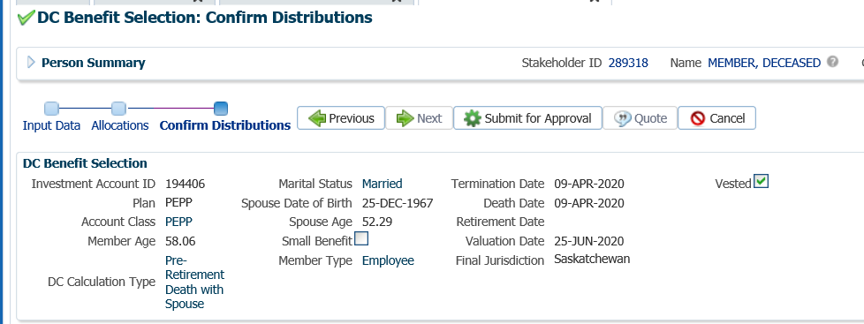

1. The Pension Specialist or Supervisor will audit and approve the payment in the DC Benefit Selection region by clicking **Approve**, or **Reject** if there were errors or the payment was done in error.

* **NOTE:** If the payment is **Rejected**, the payment steps need to be entered again by the Pension Information Officer. There is no option to edit the existing information.

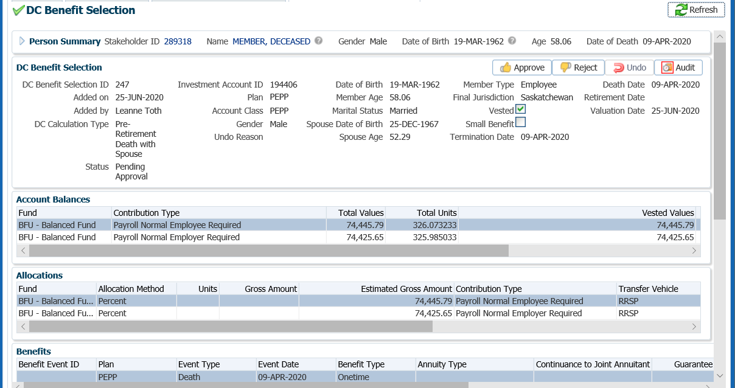

The **Reject** button is enabled if the status is **Pending Approval** or **Approved**. If the payment is rejected the status will update to **Rejected** when clicked and prevent the benefit selection from being processed by the investment batch.

The **Undo** button is enabled only if the status is **Processed** and will update the status to **Pending Undo** after selecting **Save.** Select an **Undo Reason**. After the investment batch runs, the status will be updated to **Undone** as a result of processing the reversal in the investment batch.

1. In the **Approve DC Benefit Selection** pop-up window, add a **Note** and click **Save.**

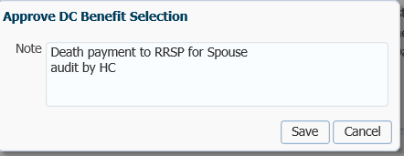

1. A history of Transactions, User and Event is shown under the **Audit** button.

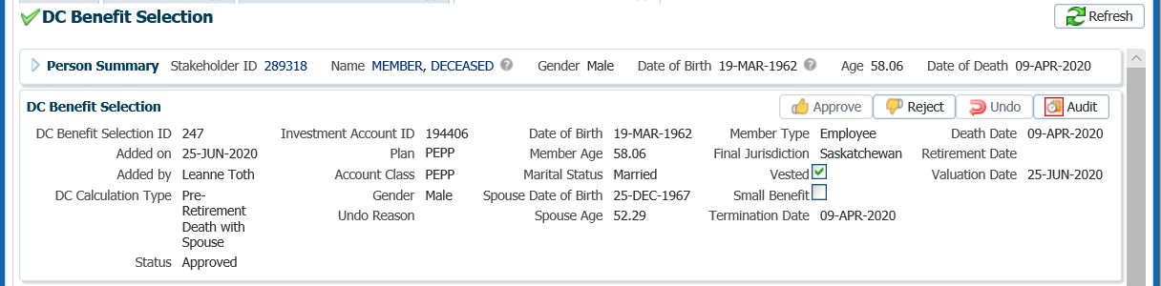

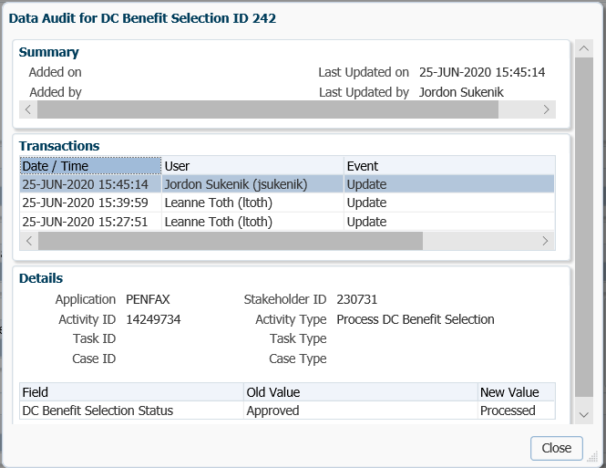

* **NOTE:** Click on the **X** in the **Payment ID Tab** to close the window.



1. The following business day confirm that the **Member Status** under the **Member Profile** menu, **Membership Periods** region shows as Death.

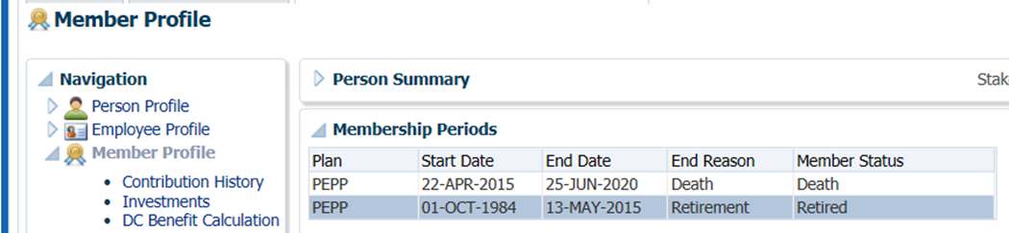

1. Under the Investments screen the Investment Accounts region will now show the Account Status as Inactive and the balance under the Account Summary region will show $0.00 if all the money was requested to be paid out.



1. The payment will process in the overnight batch process and a cheque will be produced. To view the payment details, click on the **DC Benefit Selections** menu. Under the **DC Benefit Selections** region, click on the **DC Benefit Selection ID** number.



1. Under the **Recipients** region click on the **Stakeholder ID** to take you to the Spouse’s stakeholder account.

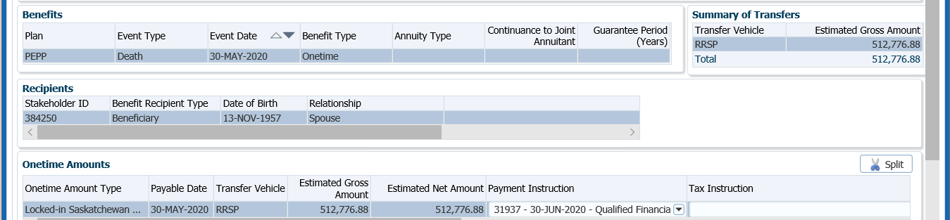

1. Under the Spouse’s account (benefit recipient), a **Benefit Recipient** folder is created. Click on the **Onetime Amounts** tab to see further details of the payment.

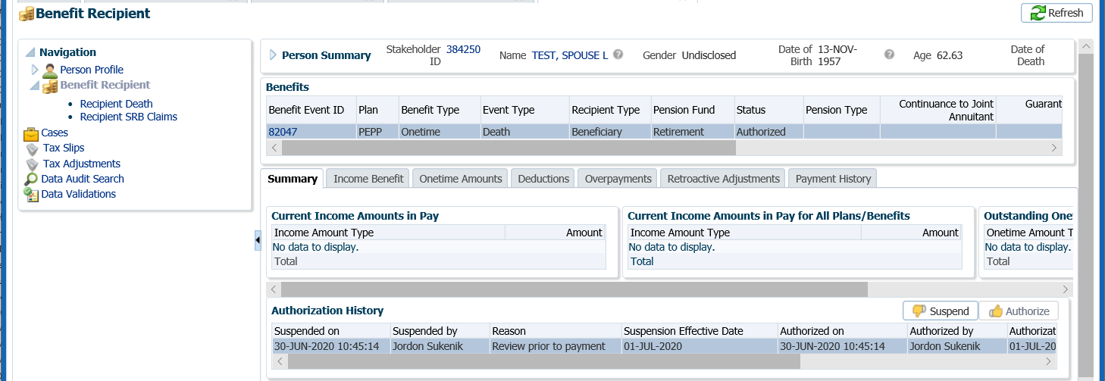

1. To see the Payment details, Recipient (Payee) details, tax deducted and cheque ID number, click on the **ID number** beside the **Paid by Payment ID.**

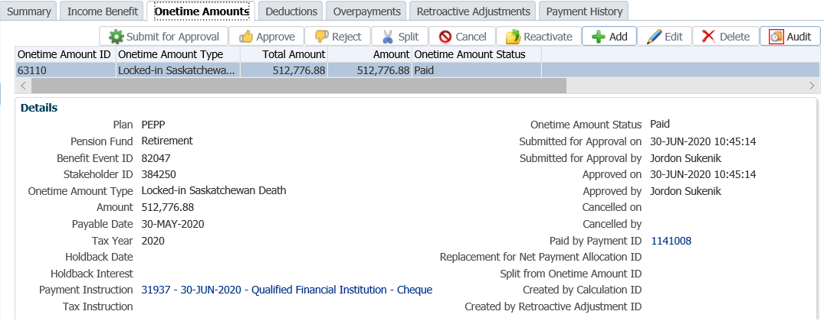

1. Click on the tabs to the right of the screen (Line Items, Tax, Net Pay Allocation and Notes) to see further details related to the payment.

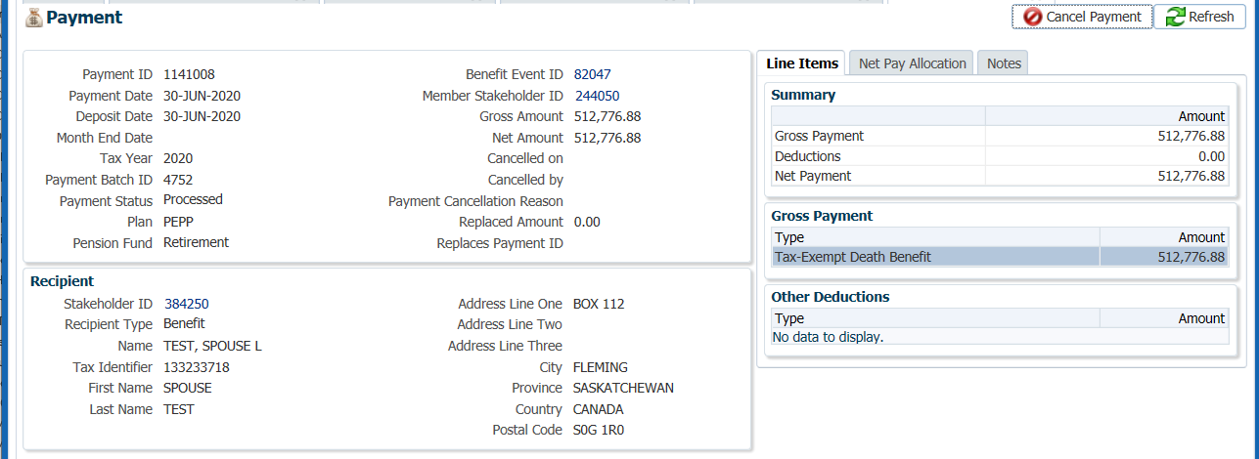

1. Under the **Net Pay Allocation** tab, further details related the cheque can be found by clicking on the **Cheque ID hyperlink**.

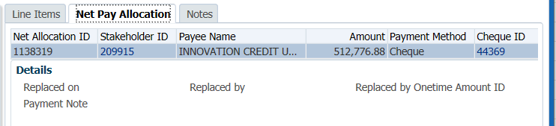

1. The **Cheque** screen will display the details of the cheque.

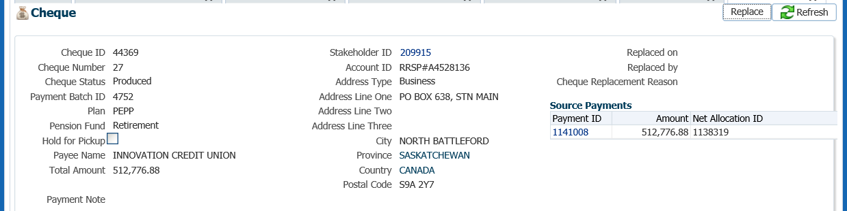

* **NOTE:** Click on the **X** in the Cheque tab and the Payment tab to close the windows.

 

1. *Withdrawal Confirmation Letter* will be saved on the Spouse’s account under the **Person Profile**, **Communications** screen underthe **Outbound Documents** region. Click on the **Filename** link to open the document.

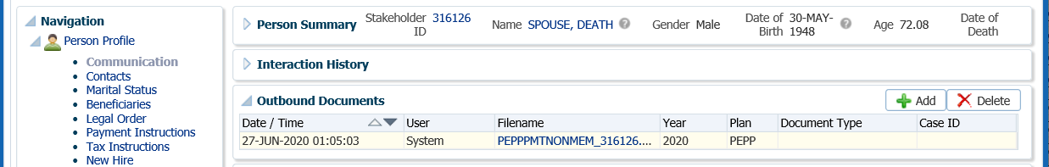

## Death Payment to a Spouse’s PEPP or VPB Account

When a member of PEPP or VPB passes away, the surviving spouse has the option to transfer the death benefit to a PEPP account in their name, or a VPB account in their name if the spouse is listed as a *Specified Beneficiary* under the VPB account.

The spouse of a deceased PEPP member can transfer the death benefit from the member’s account into a VPB account at any age or to a PEPP account in their name if they are under the age of 71.

If the spouse does not have a current PEPP or VPB account in their name, the appropriate PEPP *Non-Employee Enrolment* form or *VPB Enrolment* forms are required to be completed by the spouse.

If the deceased member is 72 or older, and has not received the minimum amount for the year, it is **not** required to be paid out prior to the transfer if the spouse is transferring the death benefit to another RPP (PEPP).

#### How to Process a Death Payment to a Spouse’s PEPP or VPB Account

The payment processing steps are almost identical for members of PEPP or VPB. The one difference is that if a member is receiving scheduled VPB payments, the payment schedule must be stopped.

#### Scenario: VPB member deceased – transfer to spouse’s new VPB account

1. Search for the deceased member in PENFAX.
2. Verify that all required documents and forms have been received, signed and certified if required. Determine that the option chosen by the spouse/beneficiary is allowed before proceeding with the payment. ***Refer to Business Process Requirements under Death Option Letter***.
3. Confirm that the deceased member’s date of death is correctly recorded on PENFAX under the **Person Profile** menu, **Person Summary** region as indicated on the Death Certificate or funeral directors Statement of Death.

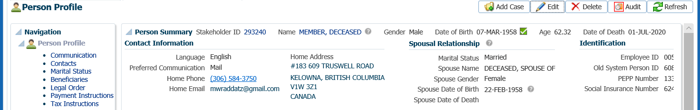

Confirm Beneficiary

1. Ensure the beneficiary information in PENFAX is correct as per the information provided by the beneficiary on the *Declaration upon member’s death* form. If changes are required to a name, address or the SIN needs to be entered, the information must be updated on the beneficiary’s stakeholder record before the payment is started. To access the beneficiary’s stakeholder account, click on the link in the deceased member’s account. ***Refer to Member Data Changes procedures*.**

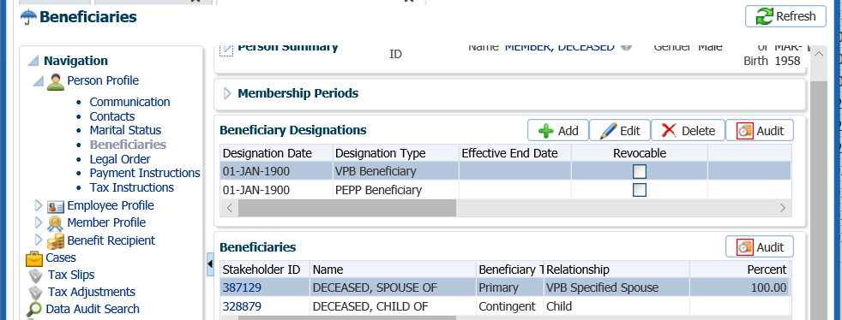

Click

Suspend Scheduled Payments

1. If the member is in VPB and receiving scheduled payments, the payments are required to be stopped at the time of the notification of death. To stop the VPB scheduled payments, go to the **Benefit Recipient** menu. Highlight the most recent **Benefit Event ID**. Under **Authorization History,** click **Suspend**.

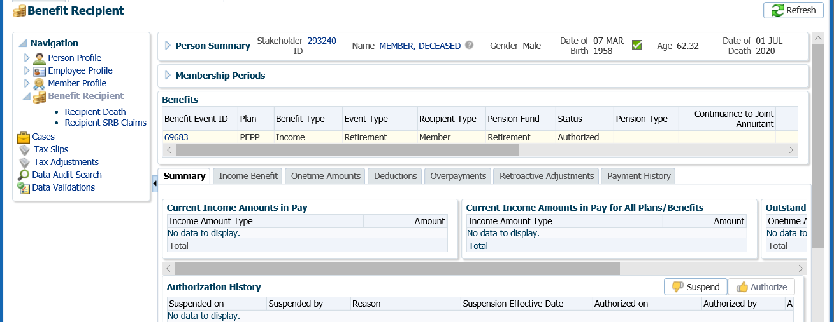

1. In the **Suspend Benefit Recipient** pop-up window, select the **Reason** of **Date of death entered**, click **Save**. This will ensure no further payments will be made to the deceased member.



1. The **Authorization History** region will now show the information entered with a reason and an effective date.



Confirm Notice of Termination Received

1. If the PEPPmember was still contributing at the time of death, confirm that the *Notice of Termination* form has been received by checking the **Employee Profile** menu, **Employment Periods** region and the member **Notes** region.

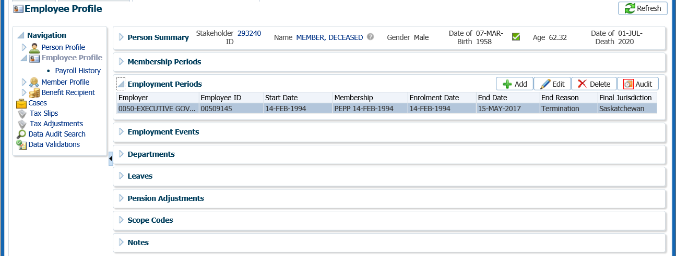

Confirm Final Contribution

1. If the PEPP member was still contributing to PEPP at the time of death, determine if the final contribution has been received under the **Employee Profile** menu, **Payroll History** screen, **Payroll History** region. If the final contribution has not been received, contact the spouse or beneficiary(s) to find out if they would like to proceed without the final contribution or wait until it has been received.

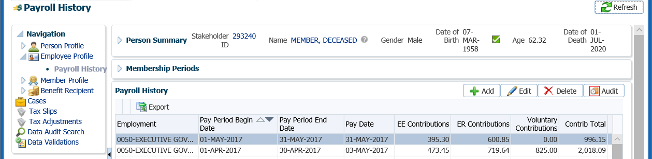

* **NOTE:** If the spouse would like to proceed without the final contribution, a 2nd payment is required to be processed when the final contribution is received. ***Refer to the 2nd Payment Procedures***.

Suspend Case

1. If the spouse or beneficiary decides to wait until the final contribution has been received to have it included in the total payout amount, change the future due date on your Case to a date equal to approximately the date the employer remits the next contribution payroll. If the final contribution is not received with the employer’s next contribution remittance contact the employer.

Click on the **Case ID** of the first **Task** to take you to the **Case.**



1. Select the **Suspend** option to change the **Case Status** to **On Hold**.

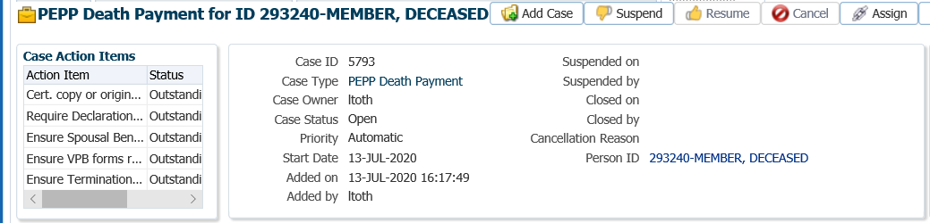

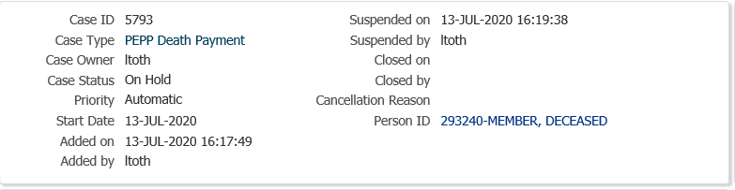

1. In the **Task** region click the **Edit** button.

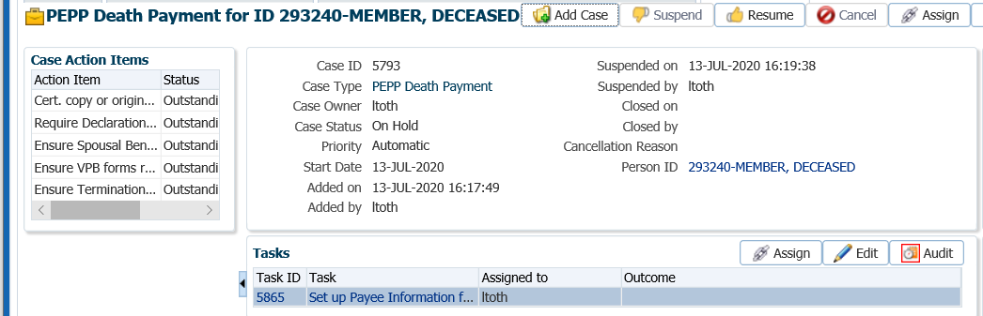

1. In the **Task** pop-up window, change the **Reminder Date** to a date in the future to approximately when the final contribution should be received. Change the **Due Date** to a date in which the service standard for the **Case** type would be due for completion on after the reminder date. Click **Save**.

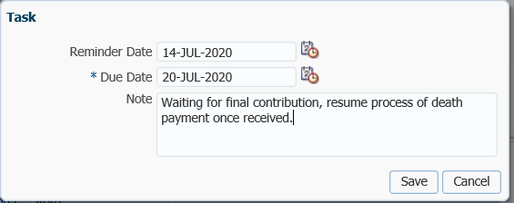

Resume Case

1. When the final contribution has been received for the PEPP member, processing of the death payment can resume, click the **Resume** button for your **Case** at the **Case** level. The **Case Status** will now be reflected as **Open**.

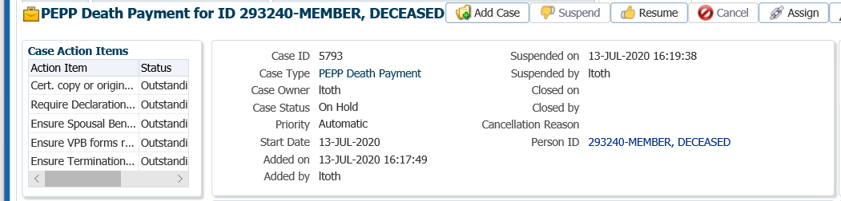

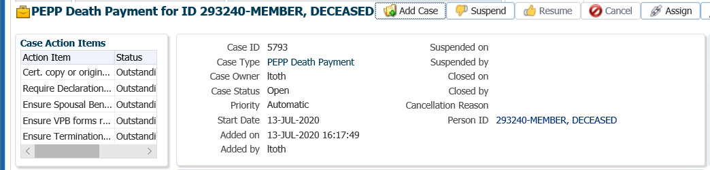

**Setup Spouse’s Account**

Add VPB Investment Account

1. In the spouse’s stakeholder account under the **Person Profile** menu, select the **New Investment Account** screen.

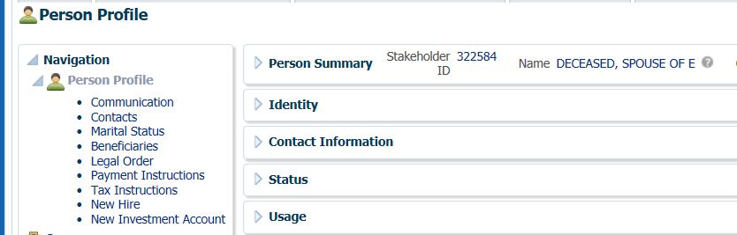

1. Under **Plan** select **PEPP**, under **Account Class** select **VPB** or **PEPP** (depending on the spouse’s option), under **Deposit Allocation** select **Default Allocation** if the spouse did not elected an investment fund on the *VPB Application for Enrolment* form, and under **Age Election** select **Member**. Click **Save**.

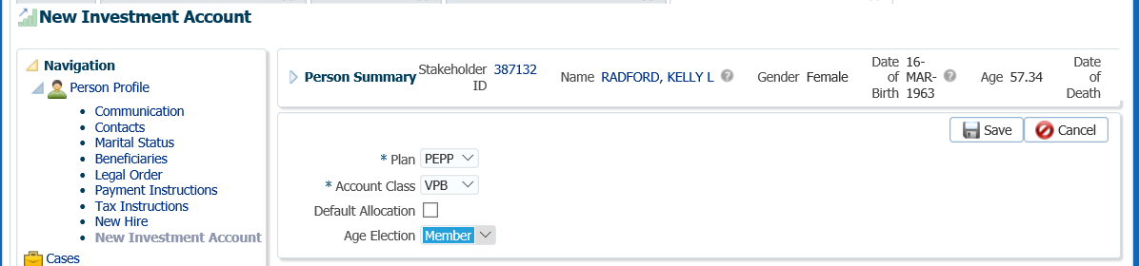

1. A **Member Profile** menu is now added under the spouse’s account with a **Member Type** of **VPB** and a **Member Status** of **Active**.

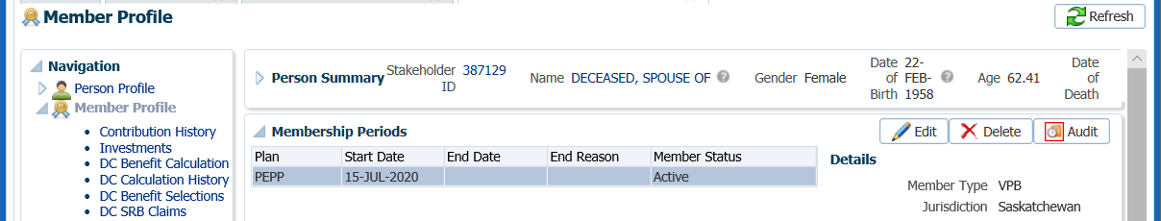

Add Deposit Allocation Instructions

1. Once the VPB account has been created under the spouse’s account, go to the **Member Profile** menu, **Investments** screen to add the deposit allocation instructions elected by the spouse on the VPB Application form.

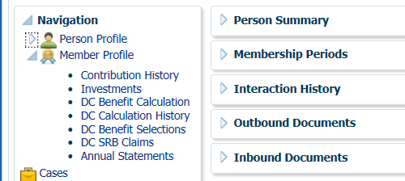

1. Under the **Investment** screen, **Investment Accounts** region, click **Edit** to uncheck the **Default Allocation** box.

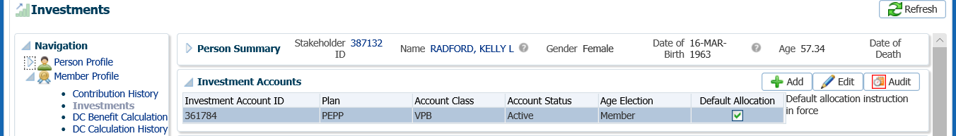

1. In the **Add Investment Account** pop-up window, de-select the **Default Allocation**, click **Save.**

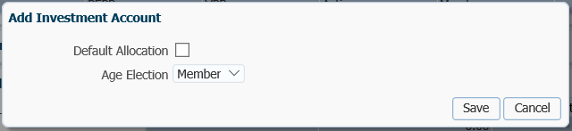

1. Under the **Investments** screen, **Account Instructions** region, click **Add** to add the deposit allocation instructions.

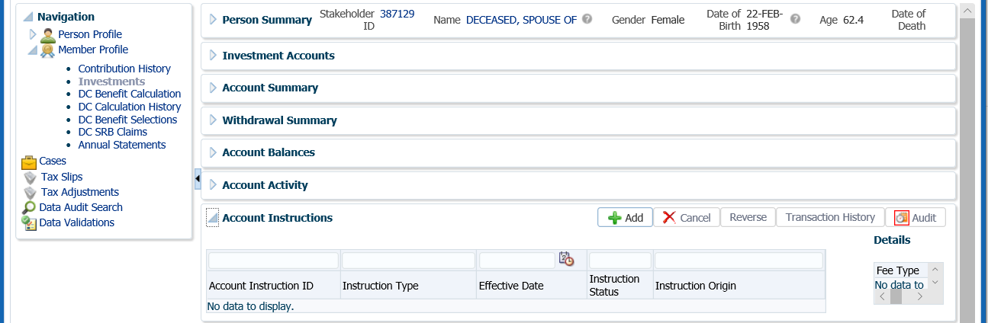

1. In the **Account Instruction** pop-up window, select from the **Instruction Type** drop-down list, **Deposit Allocation**. Under the **Fund** region click **Add**. Select the **Fund**(s) and **Allocation** percentage as per the spouse’s *VPB Application* form. Click **Save.**

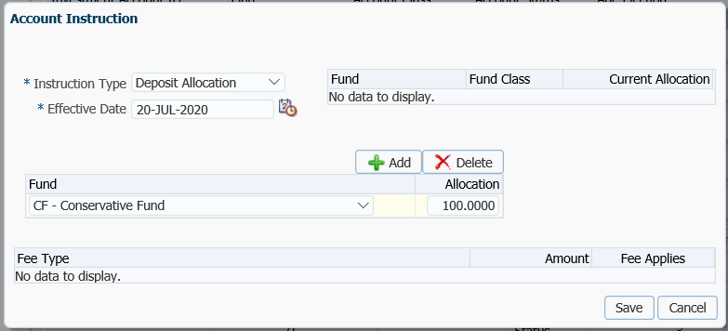

1. The **Account Instructions** will now be updated with the new **Deposit Allocation Instructions**.

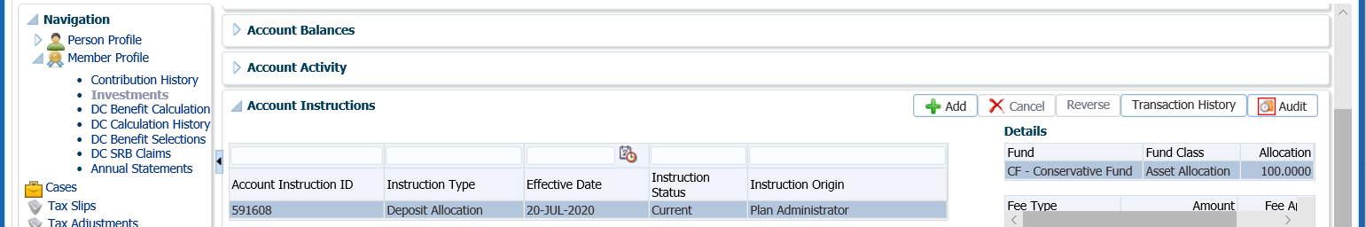

Add Scheduled Withdrawal

1. If the spouse elected to start taking scheduled withdrawals immediately the schedule needs to be set up. Under the **Investments** screen, **Account Instructions** region, click **Add**.

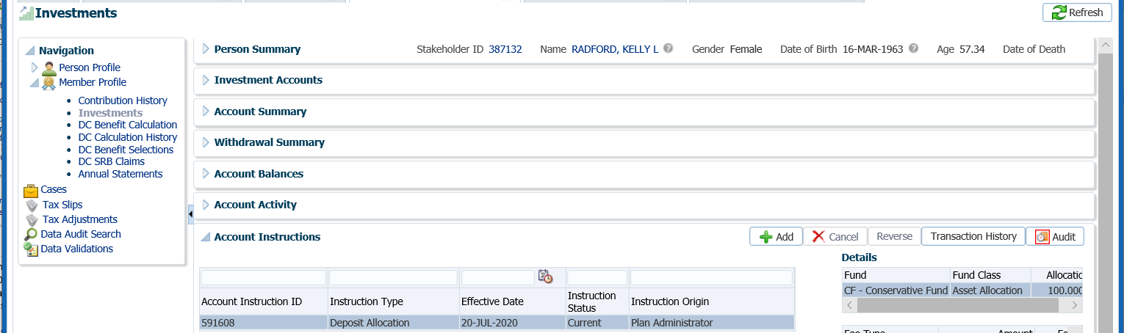

1. In the **Account Instruction** pop-up window, select the following and click **Save**:

* **Instruction Type -** Scheduled Withdrawal
* **Effective Date –** the date the spouse’s is starting VPB scheduled payments
* **Scheduled Withdrawal Type -** Fixed Amount, ITA Minimum, or Fixed Amount
* **Scheduled Withdrawal Frequency –** Annual, Monthly
* **Scheduled Withdrawal Amount –** as per the spouse’s application form
* **Fund Depletion Method –** Prorated, Specified Order, Specified Percentage
* **Fee Type –** not applicable upon setup of a new VPB

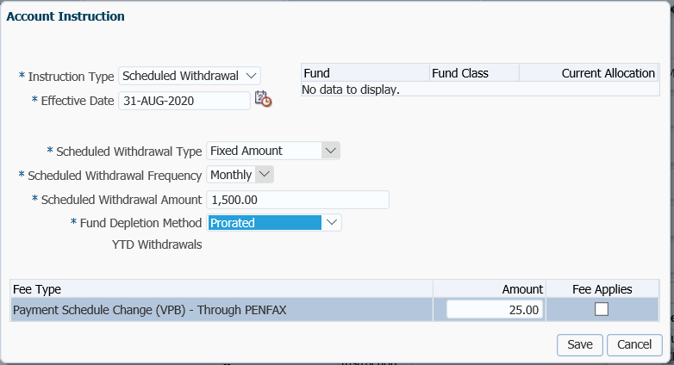

1. The **Scheduled Withdrawal** instructions will now be displayed under the spouse’s **Account Instructions** region.

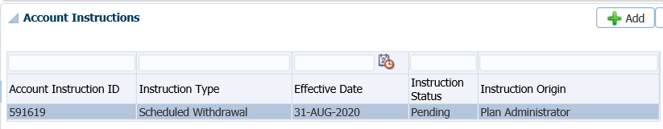

Add Payment Instructions

1. Add the payment instructions under the **Person Profile** menu, **Payment Instructions** screen. Click **Add** under the **Payment Instructions** region.

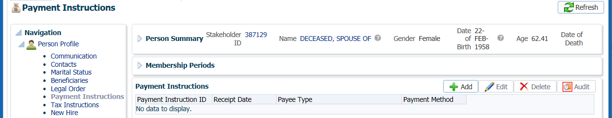

1. In the **Payment Instruction** pop-up window, select the following and click **Save**:

* **Payee Type** – Self
* **Payment Method** – EFT – Canadian, or Cheque
* **Receipt Date** – leave as current date
* **Expiry Date –** only added if there is an expiry date for the payment instructions
* **Payment Note –** a note can be added but is optional
* **Bank Number –** as per the spouse’s void cheque, for EFT
* **Transit Number –** as per the spouse’s void cheque, for EFT
* **Account Number –** as per the spouse’s void cheque, for EFT
* **Note –** optional
* **Payee Name –** will default to spouse’s name
* **Override Payee Name –** used if payment was going to an alternate payee
* **Address Type –** select the address the member elects if there are more than one, for payment by cheque

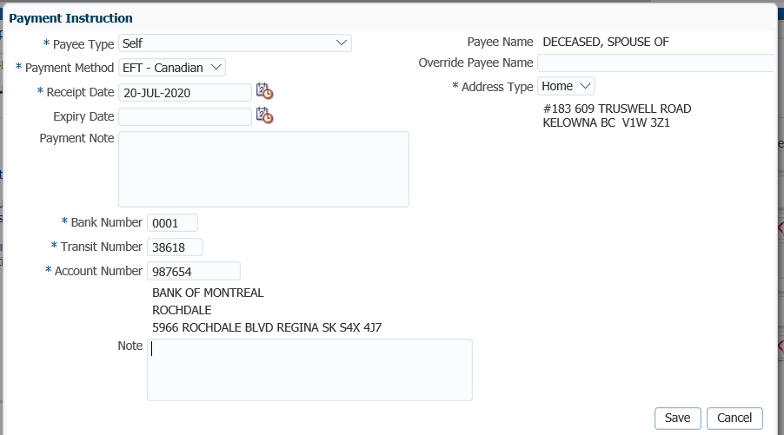

Add Tax Instructions

1. The tax instructions can now be added under the **Person Profile** menu, **Tax Instructions** screen. In the **Tax Instructions** region, click **Add**.

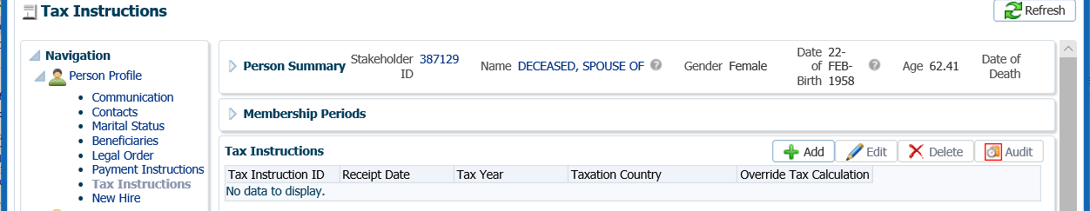

1. In the **Tax Instruction** pop-up window, select the following and click **Save**:

* **Receipt Date –** leave as current date
* **Tax Year –** leave as current year
* **Taxation Province –** select the province the spouse lives in
* **TD1 Type –** leave as Advanced
* **Exemptions –** enter any other exemptions as noted by the spouse on the federal and provincial TD1 forms

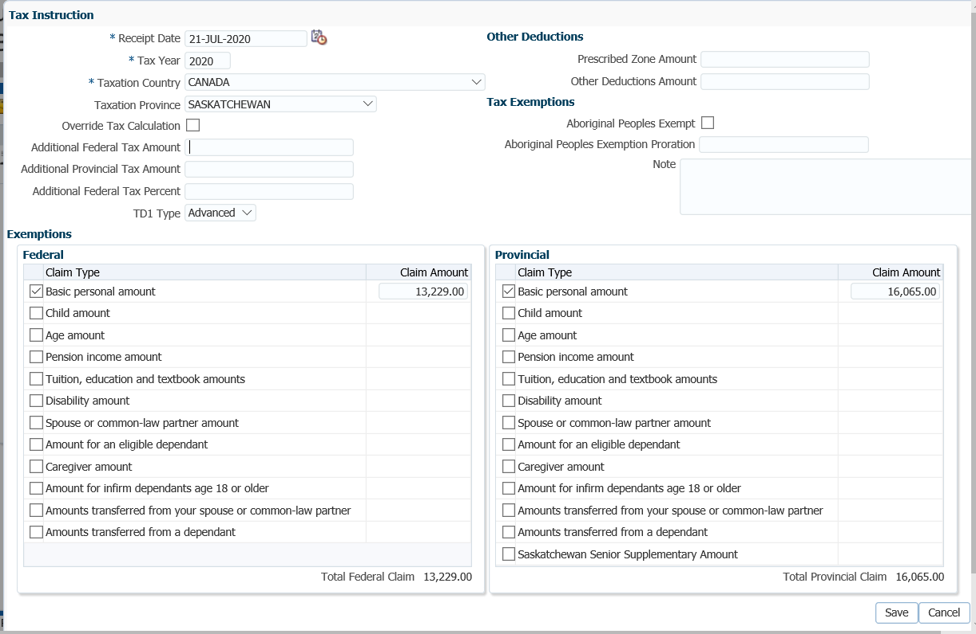

Process Death Benefit Payment

1. Go back to the deceased member’s PENFAX account to process the death benefit payment to the spouse’s PEPP or VPB account. All payments regardless of the option chosen will be processed through the **DC Benefit Selections** screen.
2. Under the **Member Profile** menu, **DC Benefit Selections** screen, **DC Benefit Selections** region, click **Add**.

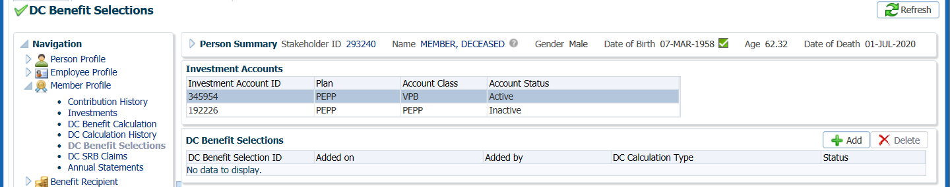

1. In the **Data Input Train** ensure the **Death Date** is populated. Click **Next**.

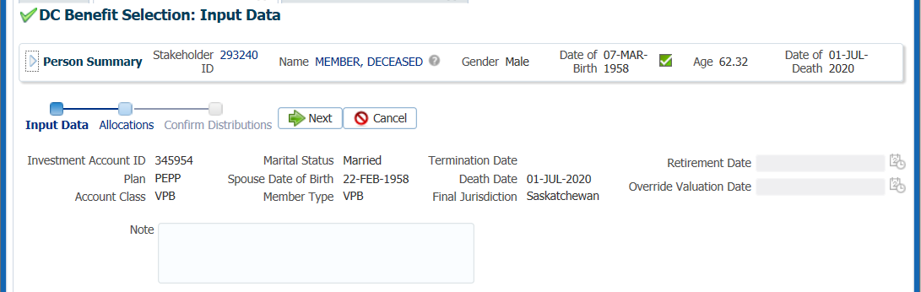

1. Under the **Allocations** region, click **Add**.

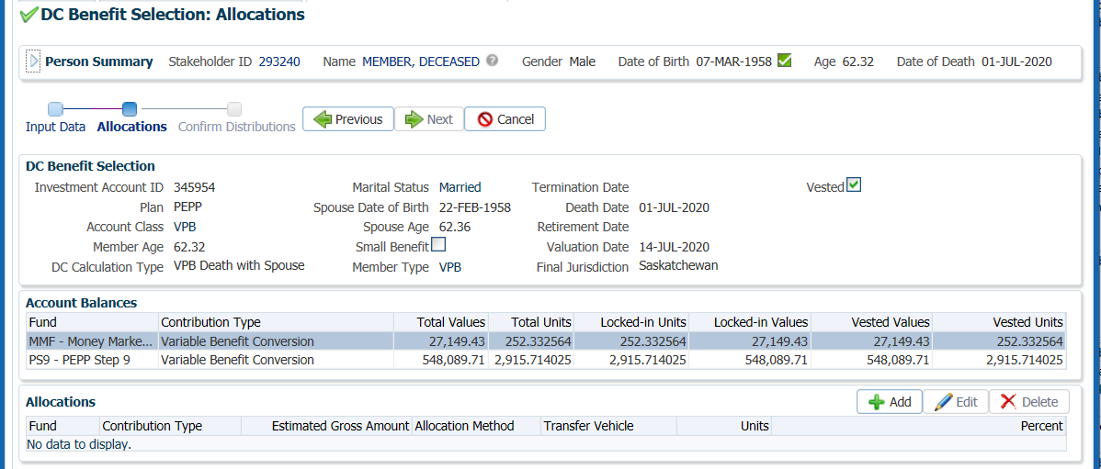

1. In the **Allocation** pop-up window, enter the following information and click **Save**:

* **Fund** – leave blank so that all funds will be included
* **Contribution Type** – leave blank so that all contribution types will be included
* **Allocation Method** – Percent if the entire account balance is being paid out, or Gross Amount if only a partial amount is being paid out
* **Percent/Gross Amount** – percentage amount or a specific gross amount
* **Transfer Vehicle** – PEPP or Variable Pension Benefit Account (select the option chosen by the spouse)
* **Estimated Gross Amount –** the amount will automatically populate based on the percent/gross amount, fund(s) and contribution source(s) selected.

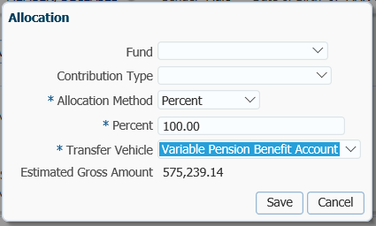

1. In the **Input Data Train**,click **Next** to Confirm the Distributionsof the payment.

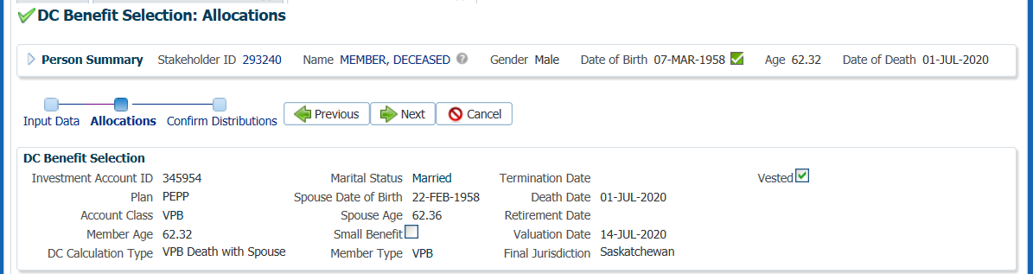

1. In the **Confirm Distributions** of the payment step, click **Submit for Approval**.

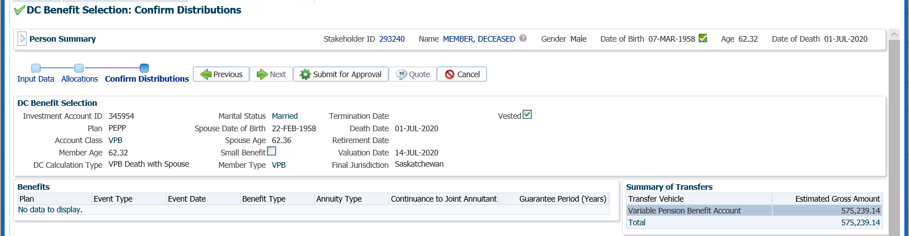

Audit Payment

1. The Pension Specialist or Supervisor will audit and approve the payment in the DC Benefit Selection region by clicking **Approve**, or **Reject** if there were errors or the payment was done in error.

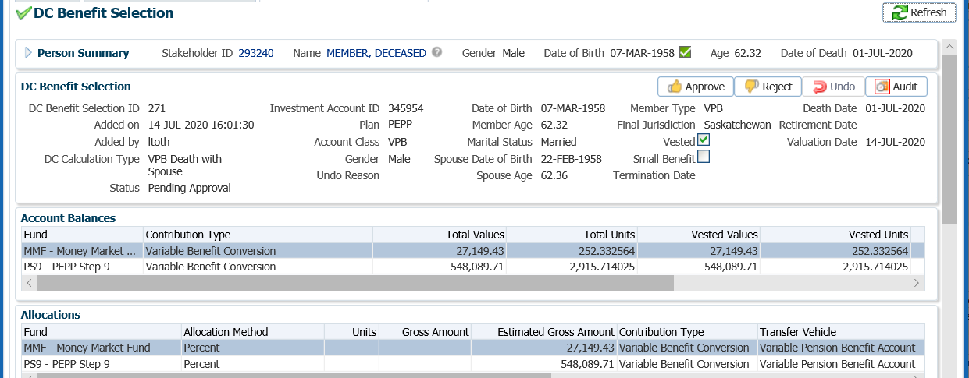

* **NOTE:** If the payment is **Rejected,** the payment steps need to be entered again by the *Pension Information Officer*. There is no option to edit the existing information.

The **Reject** button is enabled if the status is **Pending Approval** or **Approved**. If the payment is rejected the status will update to **Rejected** when clicked and prevent the benefit selection from being processed by the investment batch.

The **Undo** button is enabled only if the status is **Processed** and will update the status to **Pending Undo** after selecting **Save.** Select an **Undo Reason**. After the investment batch runs, the status will be updated to **Undone** as a result of processing the reversal in the investment batch.

1. In the **Approve DC Benefit Selection** pop-up window, add a **Note** and click **Save.**

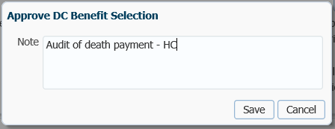

1. The **DC Benefit Selection Status** will now update to **Approved**.

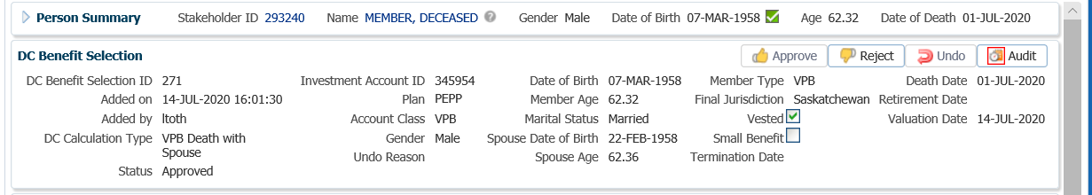

1. A history of Transactions, User and Event is shown under the **Audit** button.

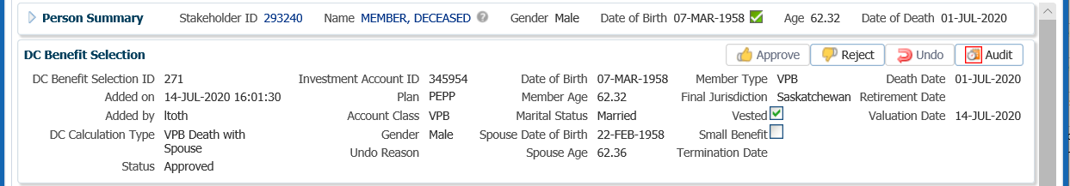

* **NOTE:** Click on the **X** in the **Payment ID Tab** to close the window.



1. The following business day confirm that the **Member Status** under the **Member Profile** menu, **Membership Periods** region shows as **Deferred Survivor**.

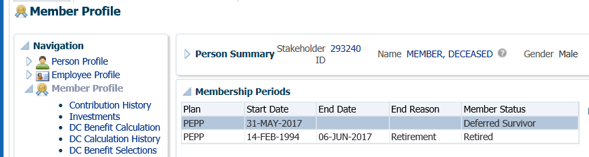

1. Under the **Investments** screen the **Investment Accounts** region will now show the **Account Status** as **Inactive** and the balance under the **Account Summary** region will show $0.00 if all the money was requested to be paid out.

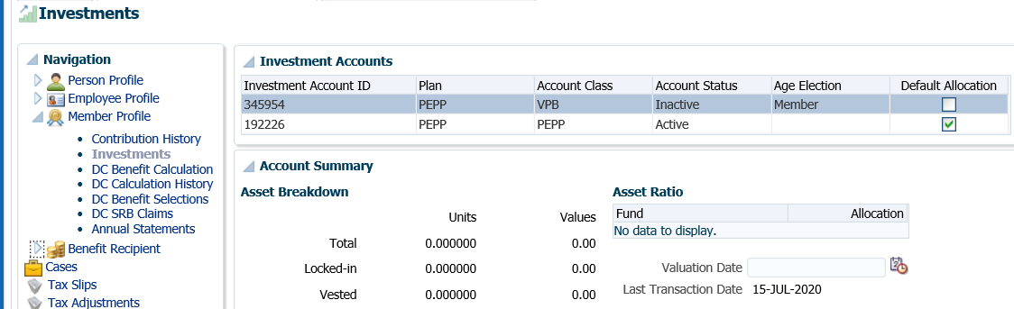

1. The payment will process overnight creating a PEPP or VPB account for the spouse. The funds will be transferred into the spouse’s account into the same investments and percentages as held under the deceased member’s account.
2. Search for the spouse’s account in PENFAX.
3. Under the **Member Profile** menu, confirm that a **Membership Period** for PEPP or VPB was created for the spouse and the **Member Status** region shows as **Active**.

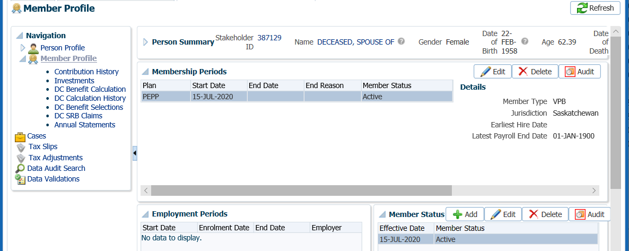

1. Confirm the funds were transferred over and appear under the **Member Profile** menu, **Investments** screen.

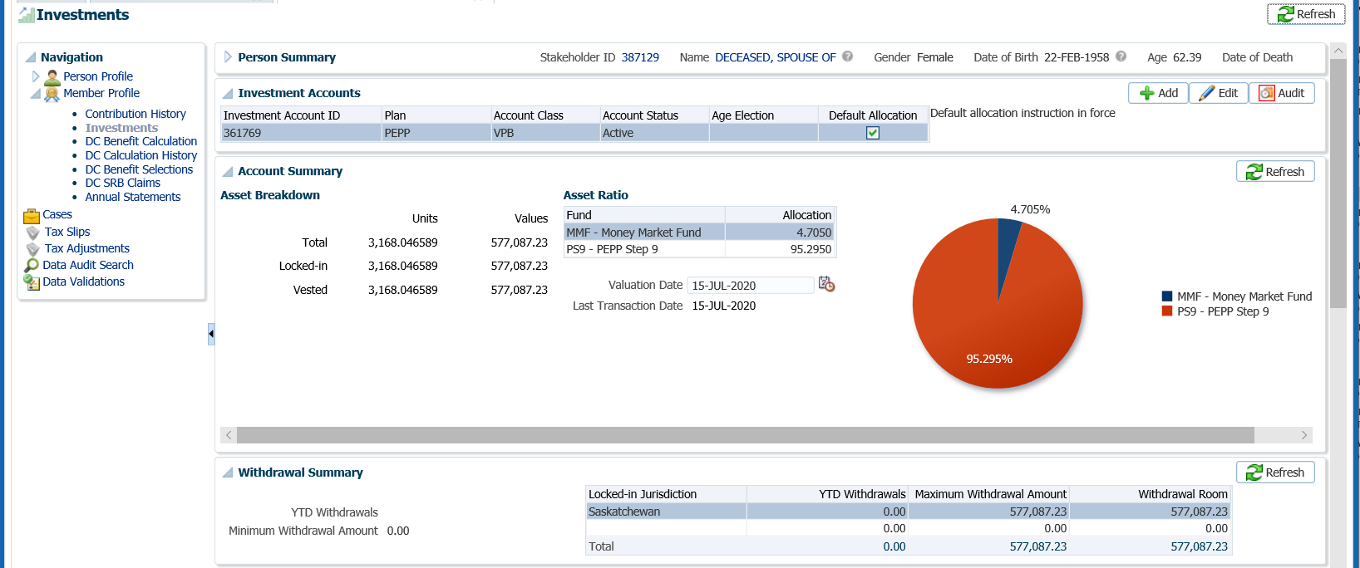

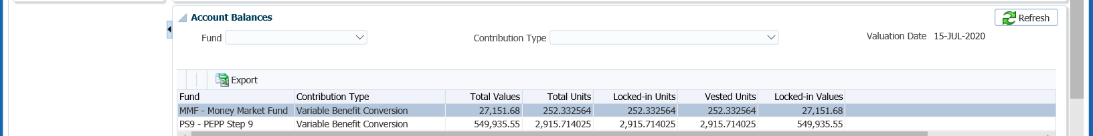

1. If the spouse elected different Deposit Allocation Investments, perform an inter-fund transfer to the elected fund(s) and percentage. ***Refer to the Inter-fund Transfer or Asset Rebalance procedures*.**
2. A *VPB Welcome Letter* will be saved to the Spouse’s account under the **Person Profile** menu, **Communications** screen, **Outbound Documents** region. Click on the **Filename** link to open the document.

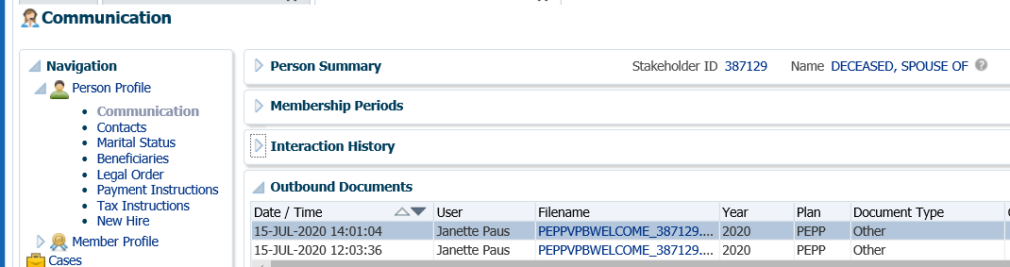

# Variable Pension Benefit

The Variable Pension Benefit (VPB) is a flexible retirement income option available for members of PEPP upon termination of employment or former members of PEPP. Members must be at least age 50 and have terminated employment with a PEPP employer or former PEPP employer. The VPB allows members to access their retirement income while still remaining invested in any of the available PEPP tax-sheltered investment funds.

Members may transfer a portion or the entire PEPP account balance into a VPB account as long as the amount transferred is at least equal to the small benefit amount for the current year.

Members determine the annual income amount to withdraw, subject to minimum withdrawal requirements set by the *Income Tax Regulations* and maximums as determined by provincial regulations. Payments from the VPB account are not mandatory until the year the member reaches age 72. Minimum withdrawals are required to be taken at age 72 based on a prescribed factor using the member or spouse’s age, multiplied by the total account balance as of January 1st each year. Any minimum amount remaining at the end of a calendar year will be automatically paid out to the member.

VPB members may transfer other eligible registered accounts into their VPB account, such as RRSPs, RRIFs, spousal RRSPs, RPPs (subject to approval), pRRIFs, LIFs and LRIFs or another approved variable benefit account. *A Spouses Consent for Member to Transfer Outside Registered Monies into the Variable Benefit* form is required to be completed and signed by the spouse.

## Variable Pension Benefit Enrolment PEPP Member

To apply for the VPB, members must complete the *Application for Variable Pension Benefit (VPB)* form and other related forms, and return the forms to PEPP along with any other certificates or required documents.

Members may transfer all or a portion of their PEPP account balance into VPB upon enrolment. Additional registered monies may be transferred in at any time after enrolment.

If a member has a spouse or common-law partner, they must be named as the primary *Specified Beneficiary*. If the spouse elects not to be named as the *Specified Beneficiary* the spouse can waive their rights to all or a portion of the survivor benefit by completing the *Spouse’s Waiver of Designated Beneficiary Status* form.

VPB members must specify an age on the application form that is to be used for calculating the ITA Minimum annual payment amount when a member reaches age 72. They can elect to use their age or their spouse’s age for the calculation.

Scheduled payments from the VPB may be set up to be paid on the last business day of the month either annually or monthly.

VPB members are required to specify on the application form the fund depletion order for their payments. They have two choices which are:

* Pro-rated: Funds will be withdrawn in the same ratio as the member’s current account balance. or
* Specified fund order: Funds will be withdrawn by depleting the funds in an order specified by the member.

Business Process Requirements - VPB Enrolment

* Members must be age 50 or older and terminated from employment with any PEPP participating employers.
* Members must have a minimum PEPP account balance of approximately $10,000.00
* Former members are allowed to transfer back into the VPB by providing proof of prior membership in PEPP, such as a previous PEPP member statement, payslip or T4).
* If the member has a spouse or common-law partner they must be listed as the *Specified Beneficiary* or complete a *Spouse’s Consent and Waiver of Post-Retirement Survivor Benefits* form.
* If a beneficiary is indicated on the *Application for Variable Pension Benefit* form, the beneficiary is to be listed as the Estate of the member. The beneficiary cannot revert back to the PEPP beneficiary unless indicated on the form by the member “same as PEPP”.
* PEPP must receive the following forms:
  + *Application for Variable Pension Benefit (VPB)* form (original)
  + *Banking Information* form (copy is acceptable)
  + *Spouse’s Consent and Waiver of Post-Retirement Survivor Benefits* form (married members only) (original)
  + *Declaration of Common-Law Relationship* form (if common-law)
  + *Spouse’s Waiver of Designated Beneficiary Status* form (require if spouse chooses to waive their right to a survivor benefit when the member dies and allow the member to name a beneficiary other than their spouse)
  + *TD1 Federal and Provincial Tax Credits Return* forms
* PEPP must receive the following documents:
  + Member’s proof of age document e.g.: certified copy of member’s birth certificate, valid Canadian passport, valid driver’s license. See PEBA Acceptable Documentation.
  + Spouse’s proof of age document e.g.: certified copy of spouse’s birth certificate, valid Canadian passport, valid driver’s license. See PEBA Acceptable Documentation.
  + Marriage certificate
  + Certificate of Divorce or decree absolute
  + Spouse’s death certificate
  + Void cheque, must be either a joint account or member’s own account.  It cannot be the spouse’s or a company’s account.

#### How to Setup a PEPP Member in VPB

#### Day 1:

1. Search for the member in PENFAX.
2. Ensure the *Application for Variable Pension Benefit (VPB)* form and other related forms and documents have been received, signed and certified if required. ***Refer to Business Process Requirements – VPB Enrolment*.**

Confirm Notice of Termination Received

1. Check the **Employee Profile** menu to ensure the termination information has been received and entered into PENFAX. If the *Notice of Termination* form has not been received, review the member’s **Notes** to see if it has been requested. If not contact the employer.

Under the **Membership Periods** region ensure the **Member Status** is showing as Deferred.

Under the **Employment Periods** region confirm the following information has been entered:

* **End Date**
* **End Reason** is Terminated or Retired
* **Final Jurisdiction**

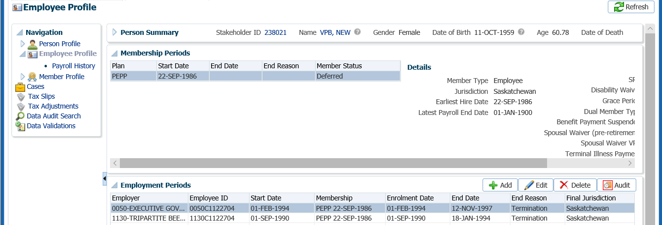

Confirm Final Contribution Received

1. Determine if the final contribution has been received under the **Employee Profile** menu, **Payroll History** screen. Expand the **Payroll History** region to see the payroll contributions.

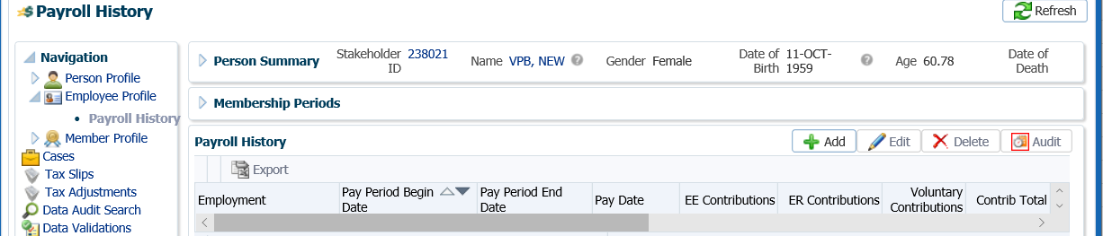

* **NOTE:** If the final contribution has not been received, contact the member to find out if they want to proceed without it or wait to have the transfer to VPB processed after the final contribution has been is received. If the member wants to wait, suspend your assigned Case.

Suspend Case for Final Contribution

1. If the member to wait until the final contribution has been received to have it included in the total transfer amount, change the future due date on your **Case** to a date equal to approximately the date the employer remits the next contribution payroll. If the final contribution is not received with the employer’s next contribution remittance contact the employer.

Click on the **Case ID** of the first **Task** to take you to the **Case.**

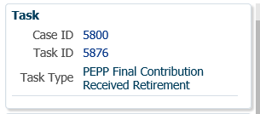

1. Select the **Suspend** option to change the **Case Status** to **On Hold**.

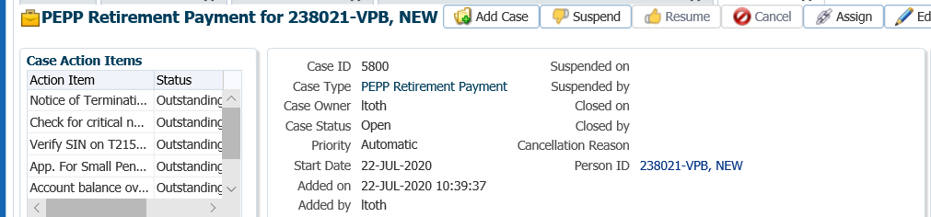

1. In the **Task** region click the **Edit** button.

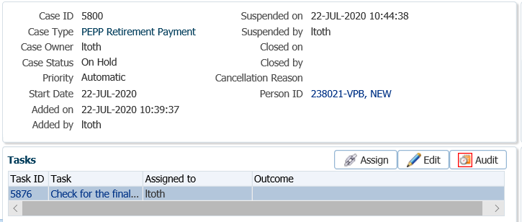

1. In the **Task** pop-up window, change the **Reminder Date** to a date in the future to approximately when the final contribution should be received. Change the **Due Date** to a date in which the service standard for the **Case** type would be due for completion on after the reminder date. Click **Save**.

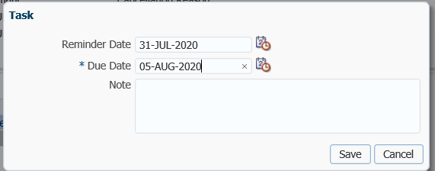

Resume Case

1. When the final contribution has been received for the PEPP member, processing of the death payment can resume, click the **Resume** button for your **Case** at the **Case** level. The **Case Status** will now be reflected as **Open**.

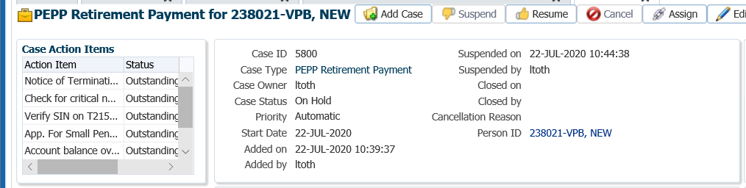

Confirm Deposit Allocation Instructions and Investment Funds on PEPP Account

If the member elected a different investment fund(s) on the *Application for Variable Pension Benefit (VPB)* form, add new Deposit Allocation Instructions and perform an interfund transfer to the new fund(s) prior to processing the PEPP To VPB internal transfer.

Add Deposit Allocation Instructions

1. In the **Investments** screen, highlight the **PEPP** **Investment Account**,expand the **Account Instructions** region to add the deposit allocation instructions elected by the member on the *Application for Variable Pension Benefit (VPB)* form. Click **Add**.

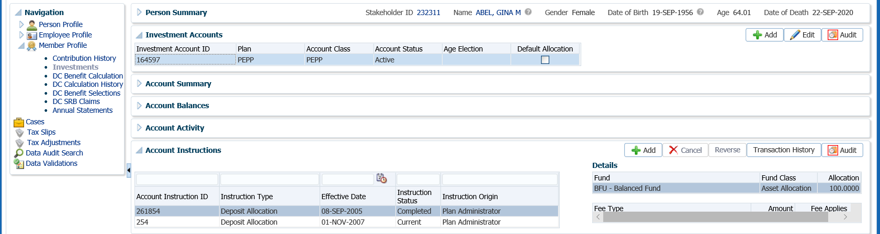

1. In the **Account Instruction** pop-up window, select from the **Instruction Type** drop-down list, **Deposit Allocation** and leave the **Effective Date** as the current date. Under the **Fund** area click **Add**. Choose the **Fund**(s) and **Allocation** percentage the member indicated on the VPB Application form. Click **Save.**

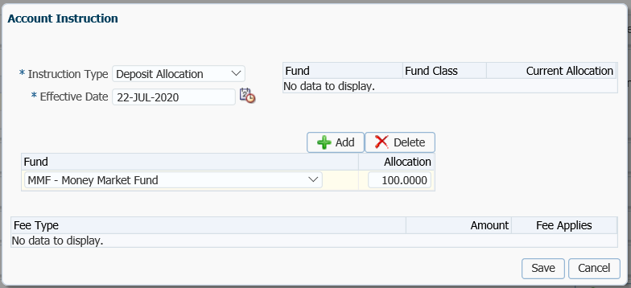

1. The **Account Instructions** will now be updated with the new **Deposit Allocation Instructions** or the member’s VPB account.

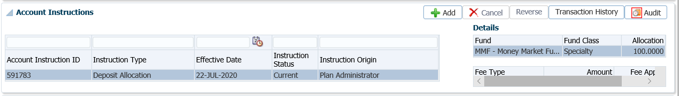

Perform Interfund Transfer (Advanced) or Asset Rebalance

1. If the member requested different investment instructions for the VPB account compared to the PEPP account, perform an inter-fund transfer on the PEPP account to the new investment fund(s) prior to doing the PEPP to VPB transfer. If the final contribution comes in after the PEPP to VPB transfer they will be deposit into the new funds.
2. In **Account Instructions** region, click **Add.**

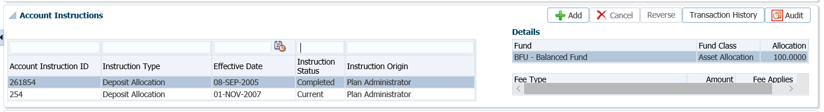

1. In the **Account Instructions** pop-up window under **Instruction Type** select **Interfund Transfer (Advanced)** or **Asset Rebalance**. Leave the **Effective Date** as the current date.

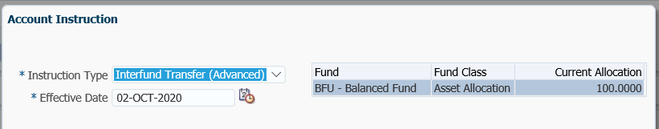

1. In the lower area of the pop-up window, click **Add** then select the **Transfer From fund** (if more than one), the **Interfund Transfer Type, Amount** and **Transfer To** fund. Click **Save.**

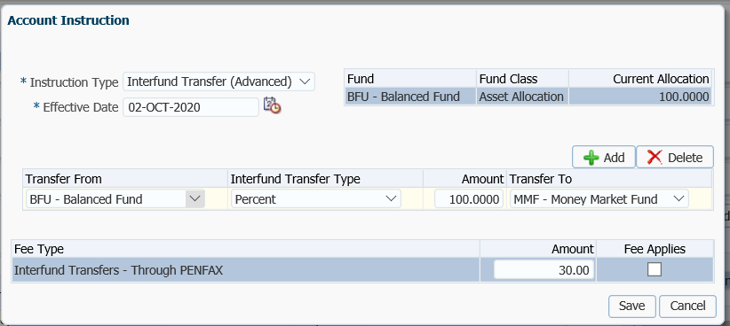

Add Spouse’s Consent and Waiver of Post-Retirement Survivor Benefits form

1. Indicate on the member’s account that the *Spouse’s Consent and Waiver of post-Retirement Survivor Benefits* form has been received. Under the **Person Profile** menu, **Status** region, click **Add**.

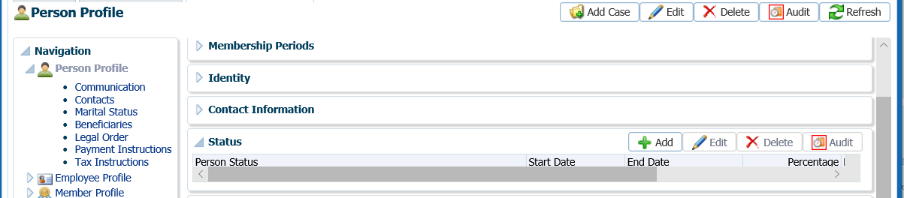

1. In the **Person Status** pop-up window select from the **Person Status**,PEPP VPB – Spousal Consent and **Start Date** (date the form was signed), **End Date** will automatically populate to 90 days from the start date. Under **Percentage** indicate the percentage the spouse indicated on the form. Click **Save** to save the details under the **Person Status** region. The form is required to be on file for the payment processing.

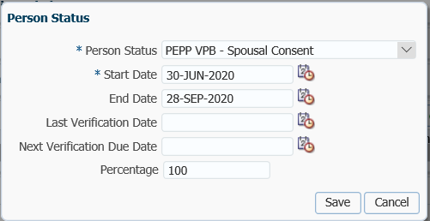

Process PEPP to VPB Transfer

1. The payment can now be processed for the member. Under the **Member Profile** menu, click on the **DC Benefit Selections** screen. Highlight the PEPP **Investment Account.** Under the **DC Benefit Selections** region, click **Add**.

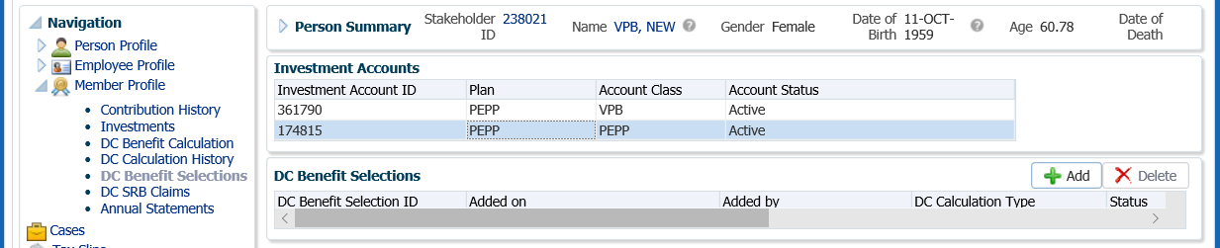

1. In the **Data Input Train** enter the **Retirement Date**. Click **Next**.

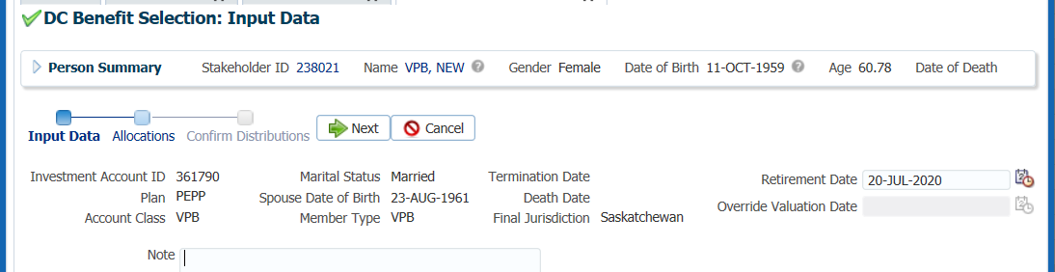

1. Under the **Allocations** region, click **Add**.

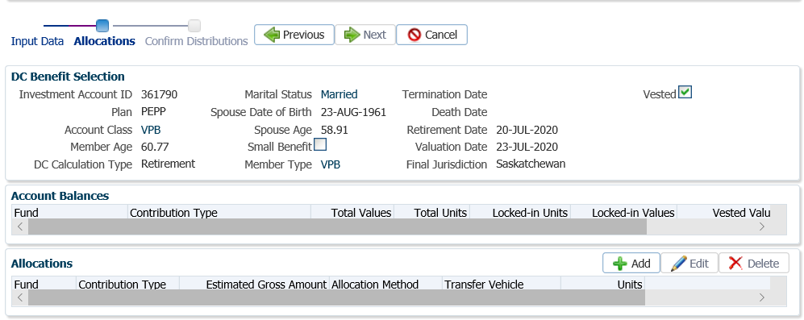

1. In the **Allocation** pop-up window, enter the following information and click **Save**:

* **Fund** – leave blank so that all funds will be included
* **Contribution Type** – leave blank so that all contribution types will be included
* **Allocation Method** – 100% Percent if the entire account balance is being paid out, or Gross Amount or a partial percentage if only a partial amount is being paid out
* **Percent/Gross Amount** – percentage amount or a specific gross amount
* **Transfer Vehicle** – PEPP or Variable Pension Benefit Account (select the option chosen by the spouse)
* **Estimated Gross Amount –** the amount will automatically populate based on the percent/gross amount, fund(s) and contribution source(s) selected.

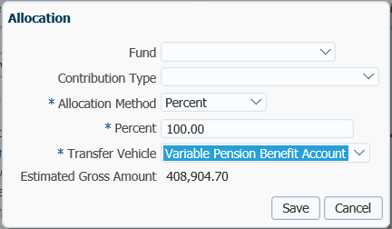

1. In the **Input Data Train**,click **Next** to Confirm the Distributionsof the payment.

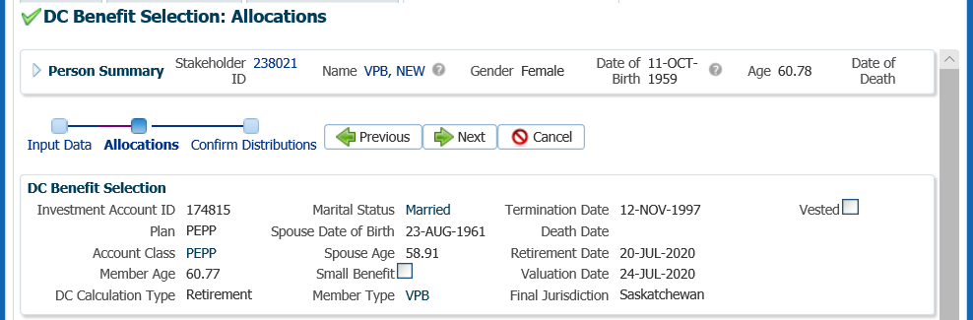

1. In the **Confirm Distributions** of the payment step, click **Submit for Approval**.

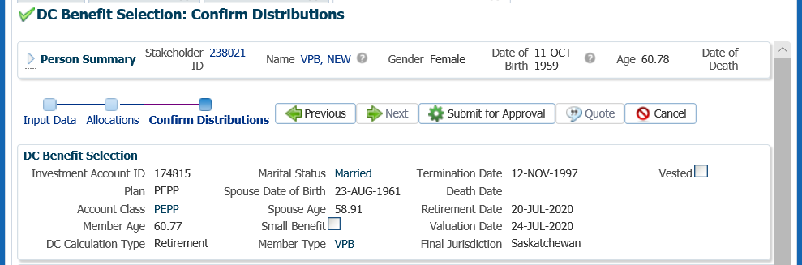

Audit Payment

1. The Pension Specialist or Supervisor will audit and approve the payment in the DC Benefit Selection region by clicking **Approve**, or **Reject** if there were errors or the payment was done in error.

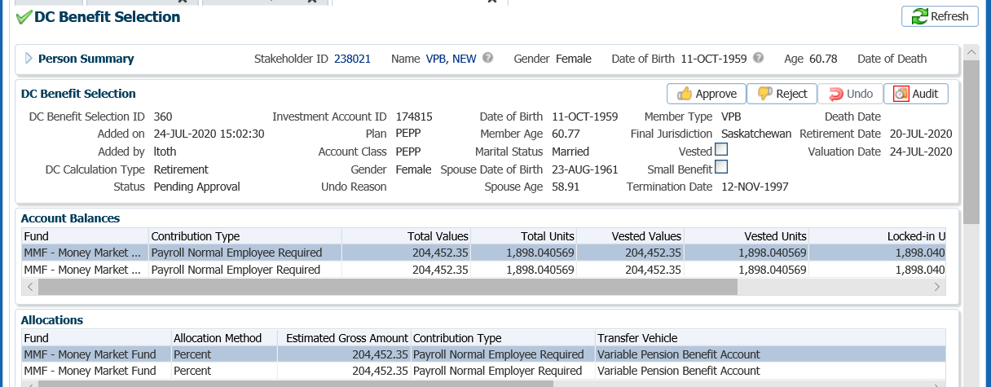

* **NOTE:** If the payment is **Rejected,** the payment steps need to be entered again by the *Pension Information Officer*. There is no option to edit the existing information.

The **Reject** button is enabled if the status is **Pending Approval** or **Approved**. If the payment is rejected the status will update to **Rejected** when clicked and prevent the benefit selection from being processed by the investment batch.

The **Undo** button is enabled only if the status is **Processed** and will update the status to **Pending Undo** after selecting **Save.** Select an **Undo Reason**. After the investment batch runs, the status will be updated to **Undone** as a result of processing the reversal in the investment batch.

1. In the **Approve DC Benefit Selection** pop-up window, add a **Note** and click **Save.**

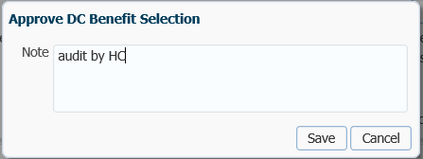

1. The **DC Benefit Selection Status** will now update to **Approved**.

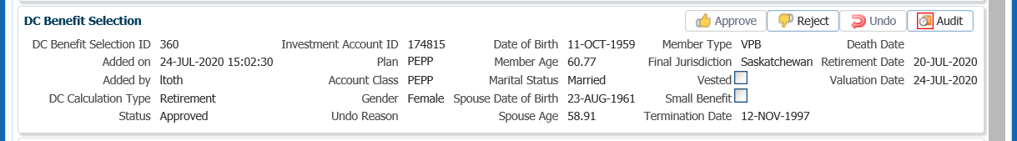

1. A history of Transactions, User and Event is shown under the **Audit** button.

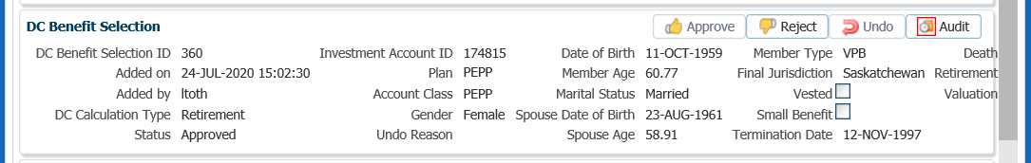

* **NOTE:** Click on the **X** in the **Payment ID Tab** to close the window.



#### Day 2:

1. The following business day confirm that the **Member Status** under the **Member Profile** menu, **Membership Periods** region shows as **Retired**.

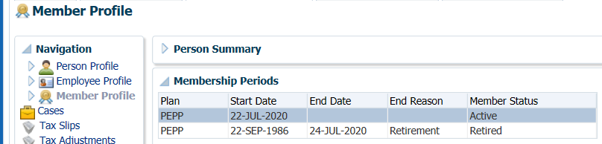

1. Under the **Investments** screen the **Investment Accounts** region will now show the **Account Status** as **Inactive** and the balance under the **Account Summary** region will show $0.00 if all the money was requested to be paid out.

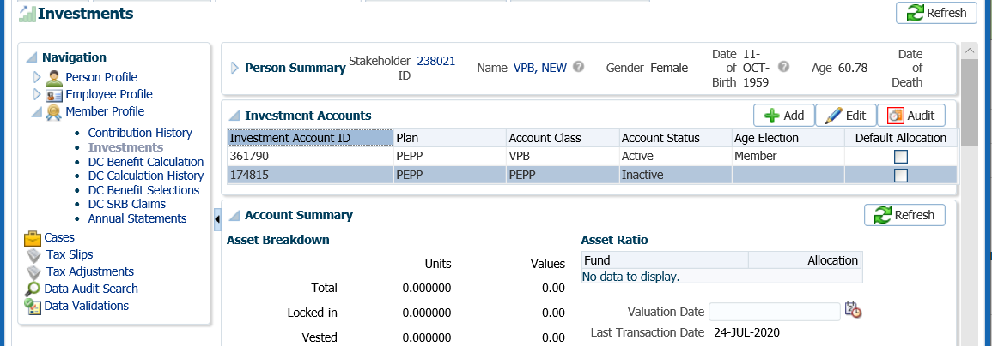

1. The payment to transfer the funds from the PEPP Investment Account to the new VPB Investment Account will process overnight and the funds will be transferred into the member’s account into the same investments and percentages as held under the member’s PEPP account.

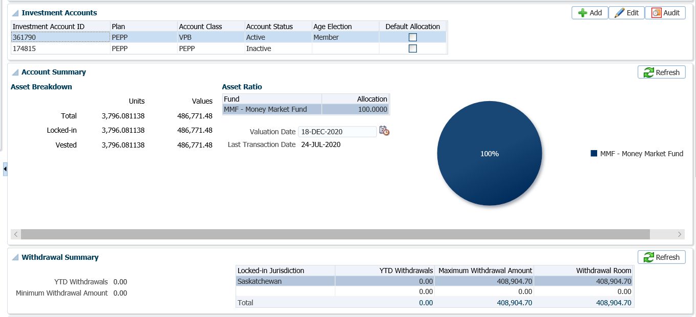

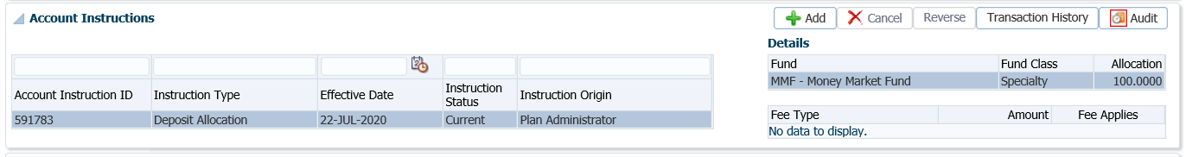

Add Scheduled Withdrawal

1. If the member elected to start taking scheduled withdrawals immediately the schedule needs to be set up. Under the **Investments** screen, **Account Instructions** region, click **Add**.

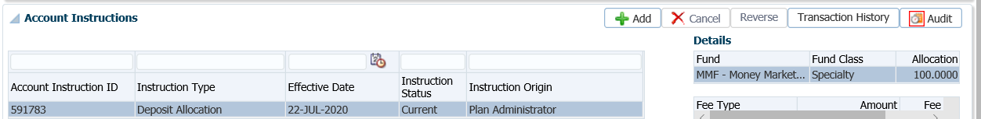

1. In the **Account Instruction** pop-up window, select the following and click **Save**:

* **Instruction Type -** Scheduled Withdrawal
* **Effective Date –** the date the member is starting VPB scheduled payments (1st day of the month)
* **Scheduled Withdrawal Type -** Fixed Amount, ITA Minimum, or Fixed Amount

**Scheduled Withdrawal Frequency –** Annual, Monthly

* **Scheduled Withdrawal Amount –** as per the member’s application form
  + **Fund Depletion Method –** Prorated, Specified Order, Specified Percentage
  + **Fee Type –** not applicable upon setup of a new VPB

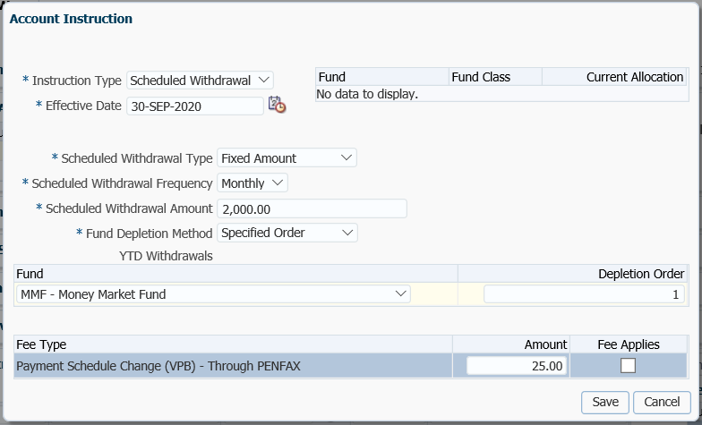

1. The **Scheduled Withdrawal** instructions will now be displayed under the member’s **Account Instructions**.

Add Payment Instructions

1. Add payment instructions under the **Person Profile** menu, **Payment Instructions** screen. Click **Add** under the **Payment Instructions** region.

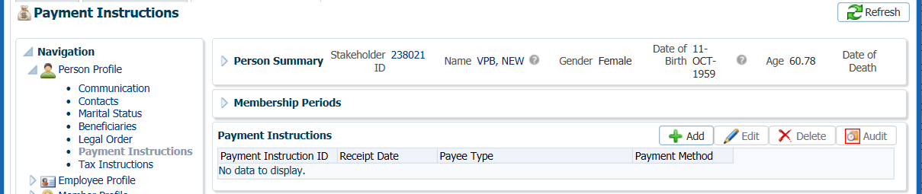

* **NOTE:** If the member elects not to take a payment and does not provide banking details, set up payment instructions by cheque. This is in case a member decides to request a lump sum payment via Member PLANet. The payment would process by cheque but would fail if there were no payment instructions entered in PENFAX.

1. In the **Payment Instruction** pop-up window, select the following and click **Save**:

* **Payee Type** – Self
* **Payment Method** – EFT – Canadian, or Cheque
* **Receipt Date** – leave as current date
* **Expiry Date –** only added if there is an expiry date for the payment instructions
* **Payment Note –** a note can be added but is optional
* **Bank Number –** as per the spouse’s void cheque, for EFT
* **Transit Number –** as per the spouse’s void cheque, for EFT
* **Account Number –** as per the spouse’s void cheque, for EFT
* **Note –** optional
* **Payee Name –** will default to spouse’s name
* **Override Payee Name –** used if payment was going to an alternate payee
* **Address Type –** select the address the member elects if there are more than one, for payment by cheque

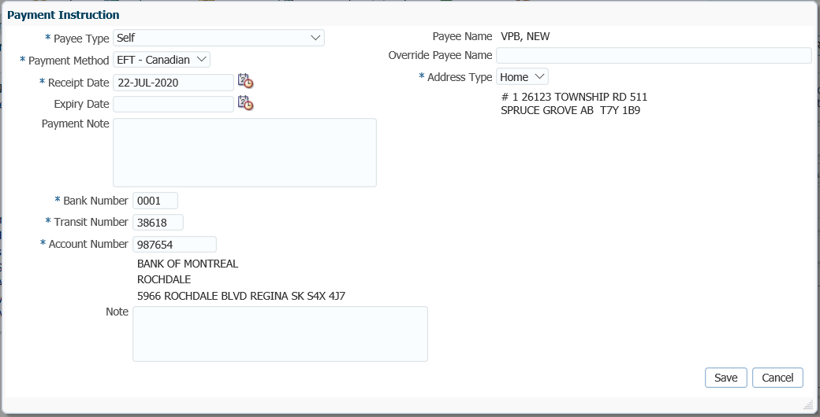

Add Tax Instructions

1. Add the tax instructions under the **Person Profile** menu, **Tax Instructions** screen. In the **Tax Instructions** region, click **Add**.

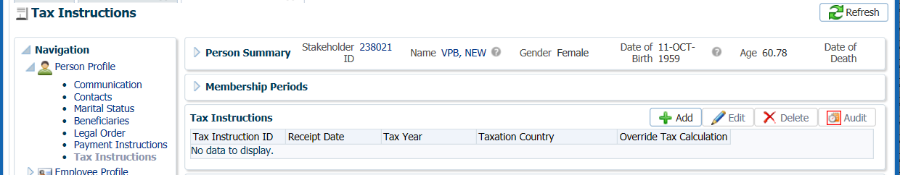

1. In the **Tax Instruction** pop-up window, select the following and click **Save**:

* **Receipt Date –** leave as current date
* **Tax Year –** change to the year the payments are to start
* **Taxation Province –** select the province the member lives in
* **Override Tax Calculation –** if selected will populate Override Federal and Provincial Tax Amount boxes
* **Additional Federal Tax Amount –** enter an amount if requested on TD1 forms
* **Additional Provincial Tax Amount –** enter an amount if requested on TD1 forms
* **Additional Federal Tax Percent –** enter amount if requested on TD1 forms
* **TD1 Type –** select Advanced or Basic
* **Exemptions –** enter any exemptions as per the member’s TD1 forms
* **Other Deductions –** enter if applicable to the member
* **Tax Exemptions –** enter if applicable to the member

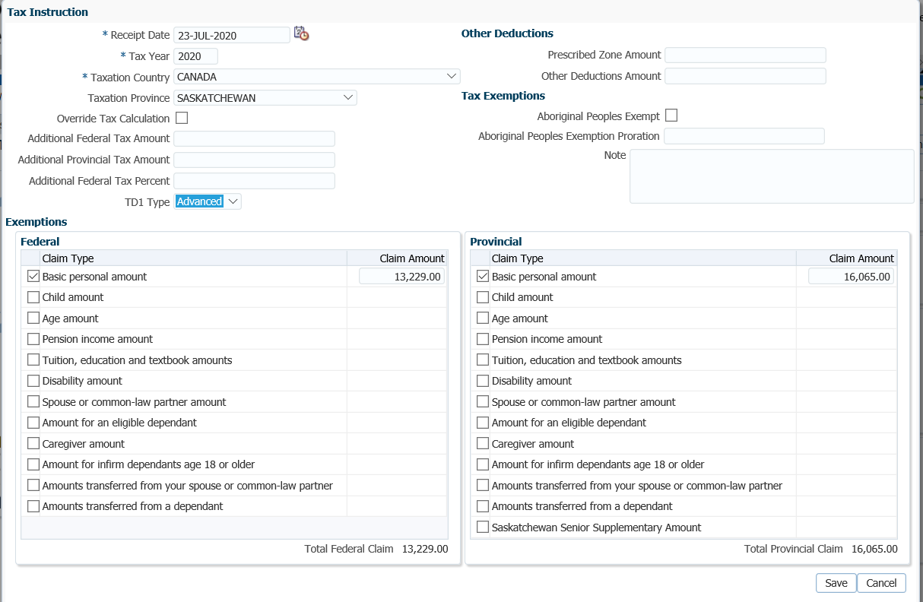

Confirm Beneficiary

1. Ensure the beneficiary information on the member’s PEPP account is correct as per the *VPB Application for Enrolment* form.

To access the beneficiary’s stakeholder account, click on the link in the member’s PEPP account under the **Person Profile** menu, **Beneficiary** screen, **Beneficiaries** region.

If the member has no spouse or the spouse waives all or a portion of the survivor death benefit, the *Spouse’s Waiver of Designated Beneficiary Status* form is required to allow the member to name a beneficiary other than their spouse or their spouse as a non-spouse beneficiary.

***Refer to the Member Data Changes procedures to make any updates to name, address, SIN or date of birth.***

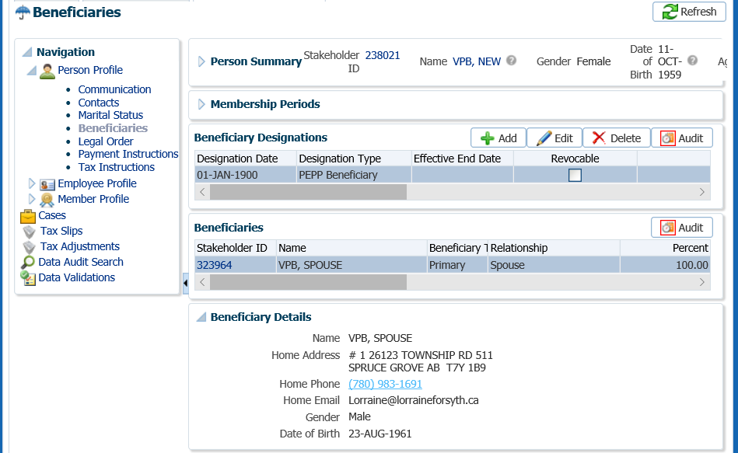

Click

* **NOTE:** It’s important to ensure the date of birth is correct for the spouse if the member is using the spouse date of birth to calculate the minimum payment at age 72.

Spouse as Specified Beneficiary

1. If the spouse is listed as the ***Specified Beneficiary*** on the *VPB Application for Enrolment* form this needs to be added to the beneficiary record in the **Beneficiary Designations** region. Click **Add**.

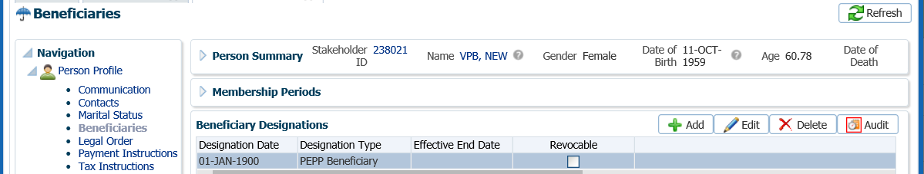

1. In the **Beneficiary Designation** region leave the **Designation Date** as the current date, leave the **Effective End Date** blank and select **Designation Type** of **VPB Beneficiary**. Under the **Beneficiary** region click **Add**.

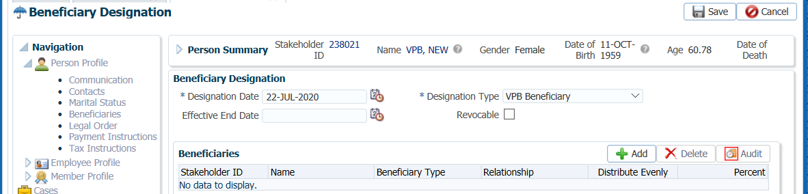

1. In the **Add Beneficiary** pop-up window, enter the following information then click **Save**:
   * **Stakeholder ID** - Spouse’s or non-spouse beneficiary’s Stakeholder ID if known or click the **magnifying glass** to search in the **Person Search**.
   * **Beneficiary Type** – Primary, Contingent or Trustee **Relationship** – as noted on the *VPB Application for Enrolment* form.
   * **Same Address as Stakeholder** – check the box if beneficiary listed as the same address as the member
   * **Distribute Evenly** – if there are more than one beneficiary and percentages allotted are to be equal. If box is selected the **Percent** option disappears.
   * **Percent** – 100% or other as noted on the *VPB Application for Enrolment* form
   * **Note** – optional

* **NOTE: *Refer to the procedures on how to add a Beneficiary*** if adding a contingent or trustee as a beneficiary.

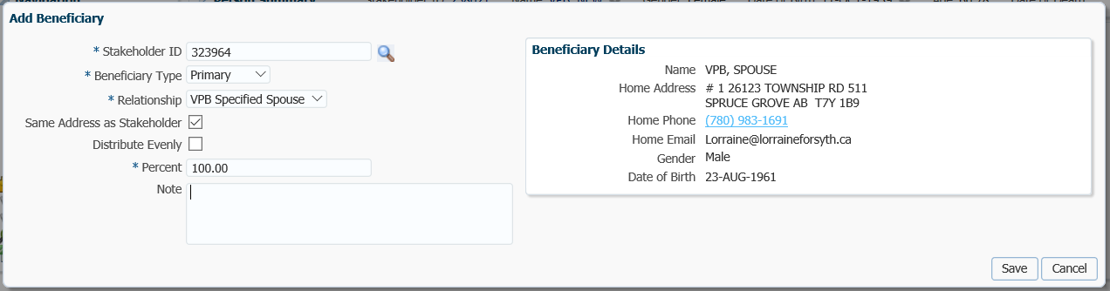

1. On the top of the **Beneficiary Designation** screen click **Save** to save the new information entered for the beneficiary.

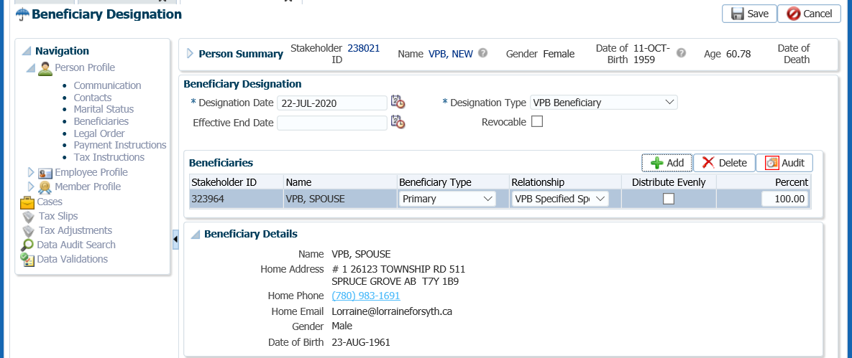

1. A new **Beneficiary Designation Type** will be displayed for VPB.

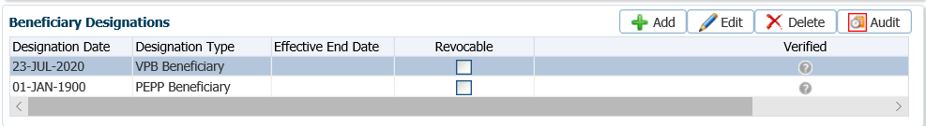

Spouse’s Waiver of Designated Beneficiary Status

If the member has a spouse and the spouse agrees to waive all or a portion of the survivor death benefit, PEPP requires the *Spouse’s Waiver of Designated Beneficiary Status* form to be completed and noted on the member’s account in PENFAX to allow the member to name a beneficiary other than their spouse or their spouse as a non-spouse beneficiary.

* **NOTE:** if the member does not have a spouse this step does not need to be completed.

1. Indicated on the member’s account that the *Spouses Waiver of Designated Beneficiary Status* form has been received. Click on the **Marital Status** screen under the **Person Profile** menu to open the region. Under the **Spousal Relationships** region, click **Add.**

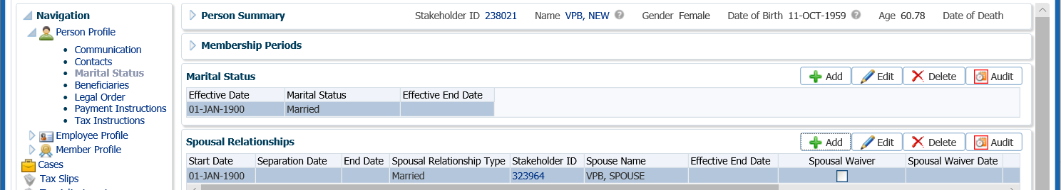

1. In the **Spousal Relationship** pop-up window enter the information from the marriage certificate if it has not been previously entered. In the **Spousal Waiver Date** field enter the date the *Spouse’s Waiver of Designated Beneficiary Status* form has been signed. Click **Save.**

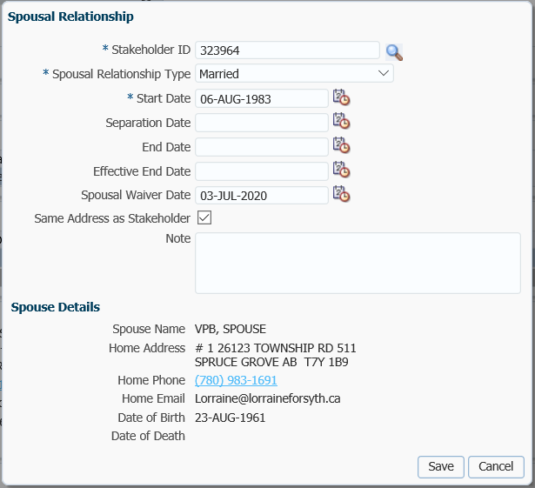

1. Under the **Member Profile** menu, **Membership Periods** region indicate that the *Spouse’s Waiver of Designated Beneficiary Status* form has been received by checking the **Spousal Waiver VPB** box. Click **Edit.**

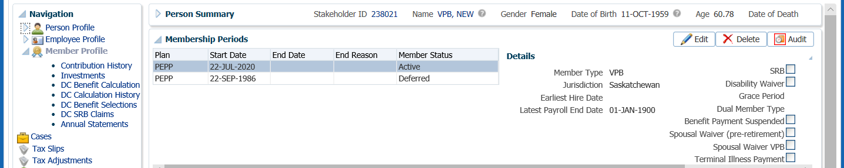

1. In the **Membership Period** pop-up window, select the **Jurisdiction** for the member, check the box beside **Spousal Waiver VPB** and click **Save**. The box will show as checked on the **Membership Periods** region.

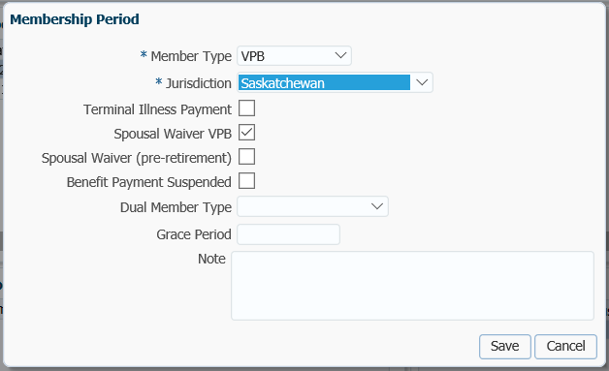

1. Overnight a *VPB Welcome Letter* will be produced and saved to the member’s account under the **Person Profile** menu, **Communications** screen, **Outbound Documents** region. Click on the **Filename** link to open the document.

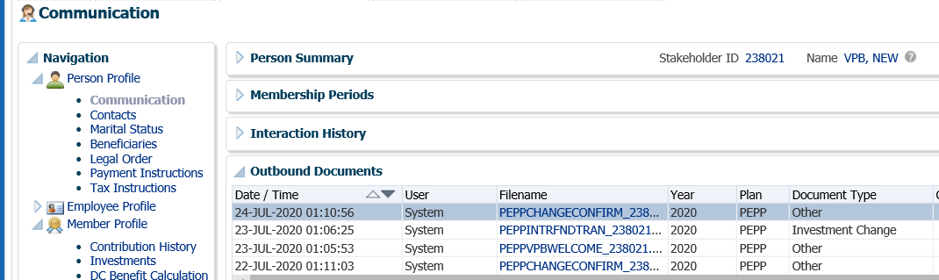

## Variable Pension Benefit Setup of a Former PEPP Member

All former PEPP members have the opportunity to transfer funds to the *VPB*. There is no limit on the amount of monies a former member can transfer to the *VPB*. The amount transferred to a former member’s *VPB* account may exceed the amount originally paid out of PEPP as a termination option but must meet at least the minimum equal to the small benefit amount for the current year.

A former PEPP member must prove their prior membership to PEPP by providing evidence to support they were a PEPP member. Members may provide an employer pay stub indicating contributions to PEPP, a T4 slip, or a PEPP Member Statement.

Members are limited to one transfer to and from an external plan (members cannot move back and forth on an ongoing basis).

To apply for the VPB, members must complete the *Application for Variable Pension Benefit (VPB)* form and other related forms, and return the forms to PEPP along with any other certificates or required documents.

If a member has a spouse or common-law partner, they must be named as the primary *Specified Beneficiary*. If the spouse elects not to be named as the *Specified Beneficiary* the spouse can waive their rights to all or a portion of the survivor benefit by completing the *Spouse’s Waiver of Designated Beneficiary Status* form.

Business Process Requirements - VPB Former Member Enrolment

* Former members must be age 50 or older.
* Members must have a minimum PEPP account balance of approximately $10,000.00
* Former members are allowed to transfer back into the VPB by providing proof of prior membership in PEPP, such as a previous PEPP member statement, payslip or T4).
* If the member has a spouse or common-law partner they must be listed as the *Specified Beneficiary* or complete a *Spouse’s Consent and Waiver of Post-Retirement Survivor Benefits* form.
* If a beneficiary is indicated on the *Application for Variable Pension Benefit* form, the beneficiary is to be listed as the Estate of the member. The beneficiary cannot revert back to the PEPP beneficiary unless indicated on the form by the member “same as PEPP”.
* PEPP must receive the following forms:
  + *Application for Variable Pension Benefit (VPB)* form (original)
  + *Banking Information* form (copy is acceptable)
  + *Spouse’s Consent and Waiver of Post-Retirement Survivor Benefits* form (married members only) (original)
  + *Declaration of Common-Law Relationship* form (if common-law)
  + *Spouse’s Waiver of Designated Beneficiary Status* form (require if spouse chooses to waive their right to a survivor benefit when the member dies and allow the member to name a beneficiary other than their spouse)
  + *TD1 Federal and Provincial Tax Credits Return* forms
* PEPP must receive the following documents:
  + Member’s proof of age document e.g.: certified copy of member’s birth certificate, valid Canadian passport, valid driver’s license. See PEBA Acceptable Documentation.
  + Spouse’s proof of age document e.g.: certified copy of spouse’s birth certificate, valid Canadian passport, valid driver’s license. See PEBA Acceptable Documentation.
  + Marriage certificate
  + Certificate of Divorce or decree absolute
  + Spouse’s death certificate
  + Void cheque, must be either a joint account or member’s own account.  It cannot be the spouse’s or a company’s account.

#### How to Process a VPB Setup of a Former PEPP Member

#### ***Scenario: Member does not exist as a Stakeholder in PENFAX***

1. Ensure the *Application for Variable Pension Benefit (VPB)* form and other related forms and documents have been received, signed and certified if required. ***Refer to Business Process Requirements – VPB Former Member Enrolment*.**

Search for the Member

1. Search for the former member in PENFAX under the **People** menu. Click on the **Person Search** option.

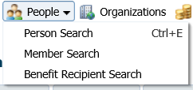

1. In the **Person Search, Search Parameters** screen, enter the first three letters of the last name of the former member and click **Search**.

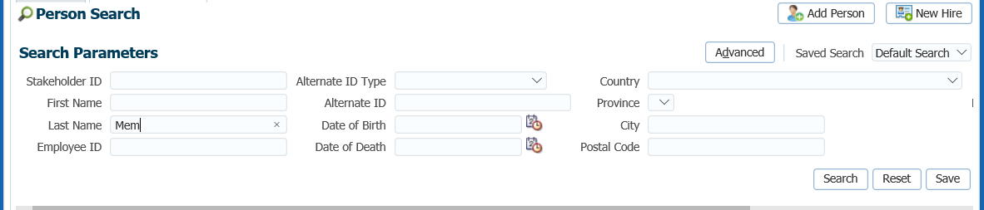

1. In the **Search Results** region, determine if the former member is listed by last name. If they former member is not listed by last name a 2nd search criteria should be performed such as SIN or date of birth. If the former member exists in PENFAX click on the **Stakeholder ID** number to retrieve their record. If it is confirmed that the former member does not exist in PENFAX, click **Add Person.**

Add Person

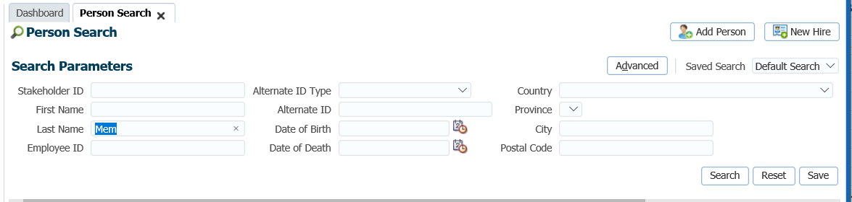

1. In the **Add Person** window, enter the former member’s information and click **Save**.

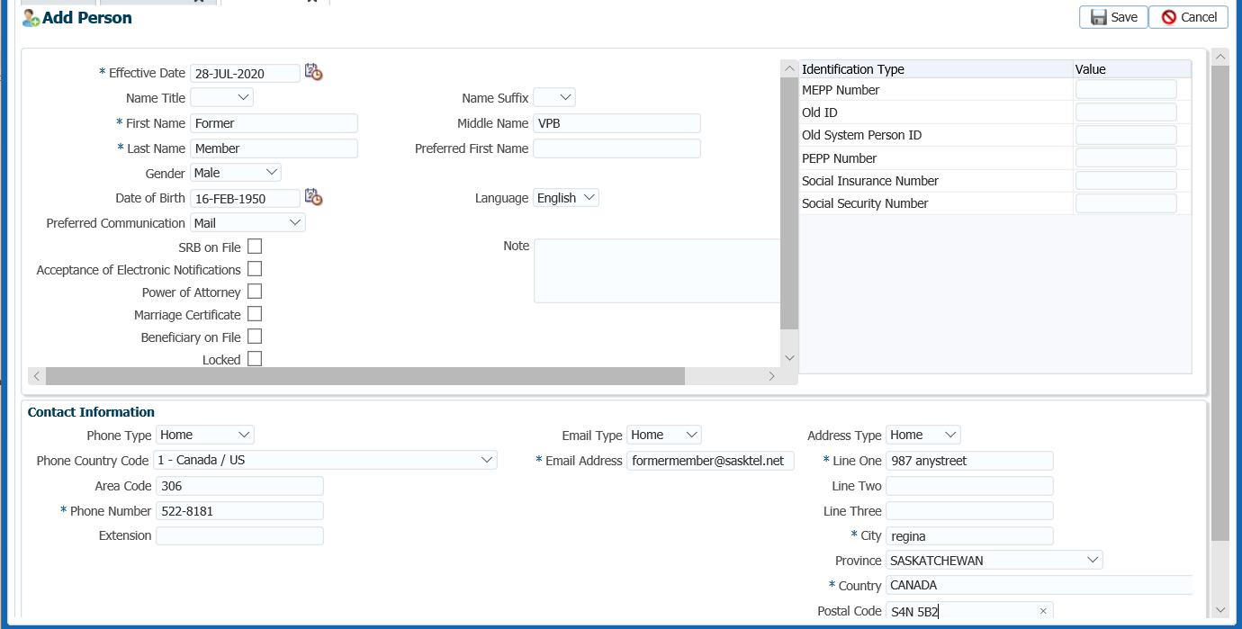

Add Person Details

1. A new Stakeholder Account is now created for the former member of PEPP but further personal details need to be added. Under the **Person Profile** menu, **Person Summary** region, expand the **Identity** region. Under **Identification** click **Add** to add the former member’s SIN.

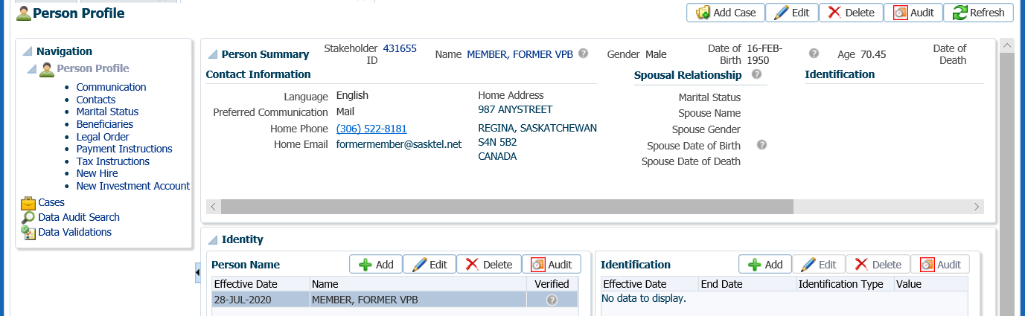

1. In the **Identification** pop-up window, leave the **Effective Date** as the current date, under **Value** enter the SIN and click **Save**.

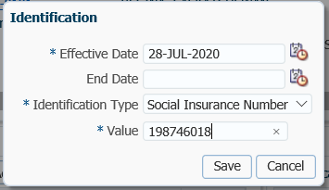

Add Spouse’s Consent and Waiver of Post-Retirement Survivor Benefits form

If the member has a spouse or common-law partner the Waiver and Consent form needs to be Indicate on the member’s account that the *Spouse’s Consent and Waiver of post-Retirement Survivor Benefits* form has been received.

1. Under the **Person Profile** menu, expand the **Status** region and click **Add**

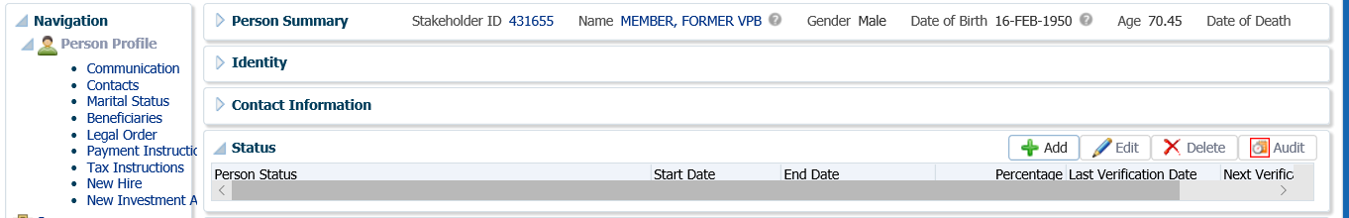

1. In the **Person Status** pop-up window, click on the drop-down list for **Person Status** and select **PEPP VPB – Spousal Consent**. Enter the **Start Date** as the date the form was signed by the spouse. The **End Date** will automatically be entered and calculated to be 90 days from the start date. Under **Percentage** indicate the percentage as per the *Spouse’s Consent and Waiver of Post-Retirement Survivor Benefits* form. Click **Save.**

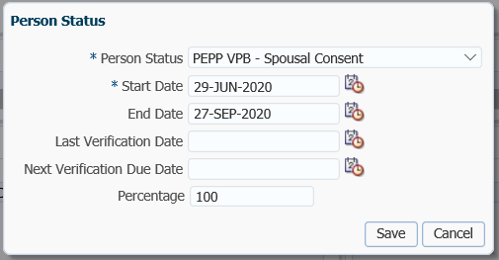

Add Marital Status

1. Under the **Person Profile** menu, **Marital Status** screen, click on the **Marital Status** region. Click Add to add the new marital status.



1. In the **Marital Status** pop-up window, enter the **Effective Date** as per the marriage certificate, select the **Marital Status** from the drop-down list and click **Save**.

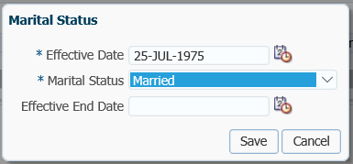

Add Spouse’s Waiver of Designated Beneficiary Status

If the member has a spouse and the spouse agrees to **waive** all or a portion of the survivor death benefit, PEPP requires the *Spouse’s Waiver of Designated Beneficiary Status* form to be completed and noted on the member’s account in PENFAX to allow the member to name a beneficiary other than their spouse or their spouse as a non-spouse beneficiary.

* **NOTE:** If the member does not have a spouse this step does not need to be completed.

1. Under the **Person Profile** menu, **Spousal Relationship** screen, in the **Spousal Relationships** region, click **Add**.

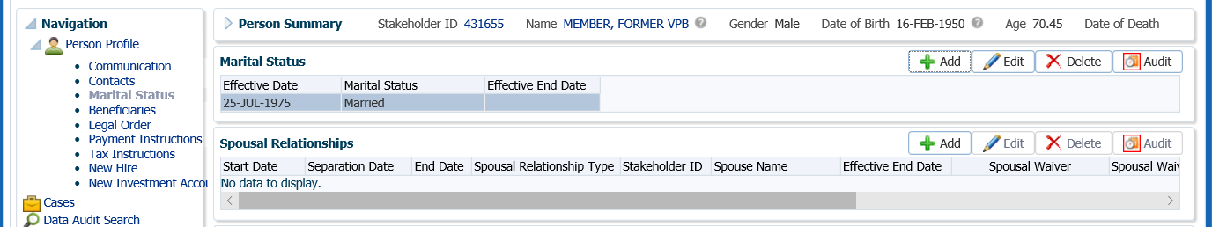

1. In the **Spousal Relationship** pop-up window enter the following information and click **Save**:
   * **Stakeholder ID –** click on the **magnifying glass** to do a search in the **Person Search** to determine if the spouse exists as a Stakeholder. If the spouse is not a Stakeholder you will need to add them as a new Stakeholder. ***Refer to Steps 2 – 6 on how to add a New Person*.**
   * **Spousal Relationship Type -** select the appropriate type
   * **Start Date –** enter the data from the marriage
   * **Separation Date –** applicable only if member and spouse are separated
   * **End Date –** applicable only if separation date was added
   * **Effective End Date –** applicable only if separation date was added
   * **Spousal Waiver Date -** enter the date the *Spouse’s Waiver of Designated Beneficiary Status* form has been signed
   * **Same Address as Stakeholder –** check the box if the spouse and member have the same address
   * **Note –** optional
   * **Spouse Details –** will populate once the Stakeholder ID in entered

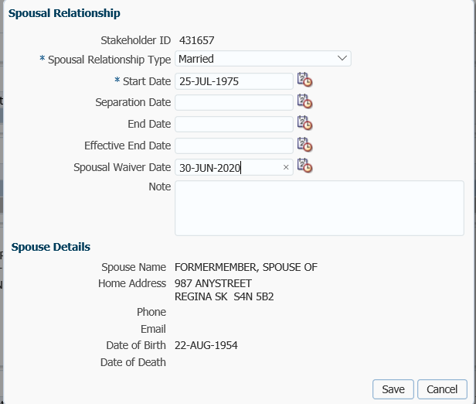

***Refer to the Member Data Changes procedures* to make any updates to name, address, SIN or date of birth if the spouse or non-spouse beneficiary IS an existing Stakeholder in PENFAX.**

Add VPB Investment Account

1. Set up the VPB account under the **Person Profile** menu, **New Investment Account** screen.

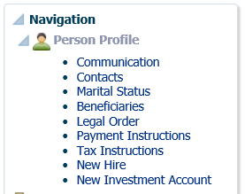

1. In the **Add Investment Account** pop-up window, select the following and click **Save**:

* **Plan –** PEPP
* **Account Class –** VPB
* **Deposit Allocation -** leave unchecked as member would indicate the investment fund on the *VPB Application for Enrolment* form
* **Age Election –** Member or Spouse as per the *VPB Application for Enrolment* form

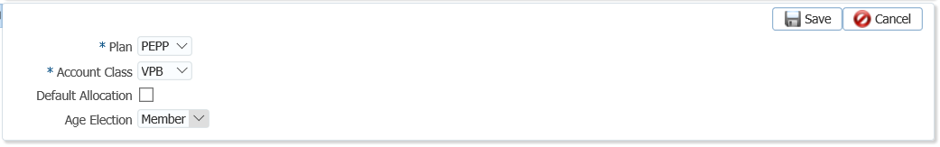

1. This will create a **Member Profile** menu and add a new **Account Class** of **VPB** is under the **Investments Accounts region** with an **Account Status** of **Active**.

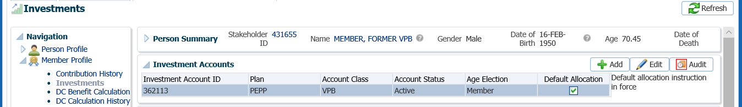

Add Spousal Waiver VPB to the Membership Profile

1. Under the **Member Profile** menu, **Membership Periods** region indicate that the *Spouse’s Waiver of Designated Beneficiary Status* form has been received by checking the **Spousal Waiver VPB** box. Click **Edit.**

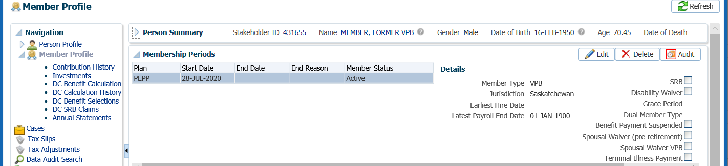

1. In the **Membership Period** pop-up window, select the **Jurisdiction** for the member, check the box beside **Spousal Waiver VPB** and click **Save**. The box will show as checked on the **Membership Periods** region.



Add Spouse as Specified Beneficiary

1. If the spouse is listed as the ***Specified Beneficiary*** on the *VPB Application for Enrolment* form this needs to be added under the **Person Profile** menu, **Beneficiaries** screen in the **Beneficiary Designations** region. Click **Add**.

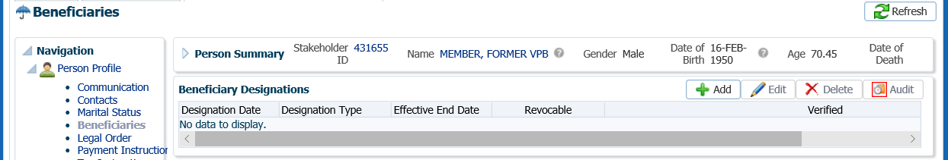

1. In the **Beneficiary Designation** region leave the **Designation Date** as the current date, leave the **Effective End Date** blank and select **Designation Type** of **VPB Beneficiary**. Under the **Beneficiary** region click **Add**.

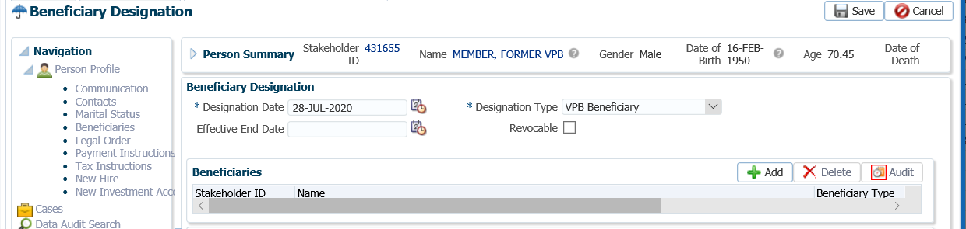

1. In the **Add Beneficiary** pop-up window, enter the following information then click **Save**:
   * **Stakeholder ID** - Spouse’s or non-spouse beneficiary’s Stakeholder ID if known or click the **magnifying glass** to search in the **Person Search**.
   * **Beneficiary Type** – Primary, Contingent or Trustee **Relationship** – as noted on the *VPB Application for Enrolment* form.
   * **Relationship** – VPB Specified Spouse
   * **Same Address as Stakeholder** – check the box if beneficiary listed as the same address as the member
   * **Distribute Evenly** – if there are more than one beneficiary and percentages allotted are to be equal. If box is selected the **Percent** option disappears.
   * **Percent** – 100% or other as noted on the *VPB Application for Enrolment* form
   * **Note** – optional

* **NOTE: *Refer to the procedures on how to add a Beneficiary*** if adding a contingent or trustee as a beneficiary.

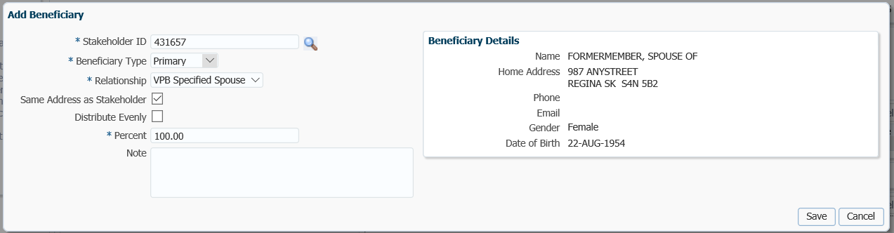

1. On the top of the **Beneficiary Designation** screen click **Save** to save the new information entered for the beneficiary.

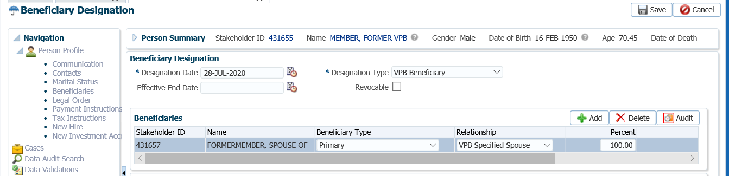

1. A new **Beneficiary Designation Type** will be displayed for VPB.

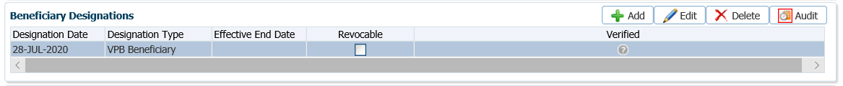

* **NOTE:** It’s important to ensure the date of birth is correct for the spouse if the member is using the spouse date of birth to calculate the minimum payment at age 72

Add Deposit Allocation Instructions

1. Under the **Member Profile** menu, **Investments** screen, highlight the **VPB** **Investment Account**,expand the **Account Instructions** region to add the deposit allocation instructions elected by the member on the VPB Application form. Click **Add**.

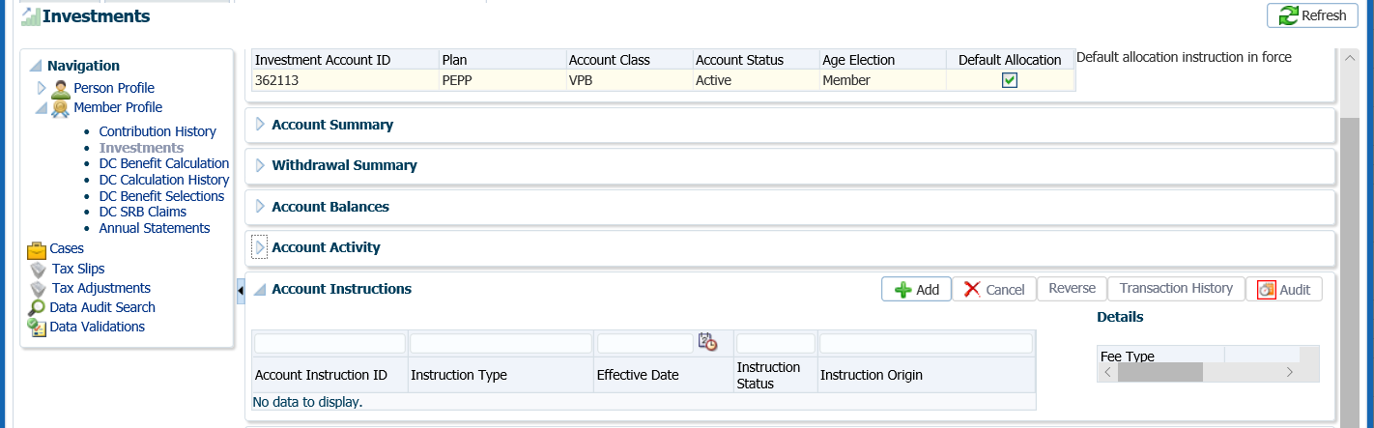

1. In the **Account Instruction** pop-up window, select from the **Instruction Type** drop-down list, **Deposit Allocation** and leave the **Effective Date** as the current date. Under the **Fund** area click **Add**. Choose the **Fund**(s) and **Allocation** percentage the member indicated on the VPB Application form. Click **Save.**

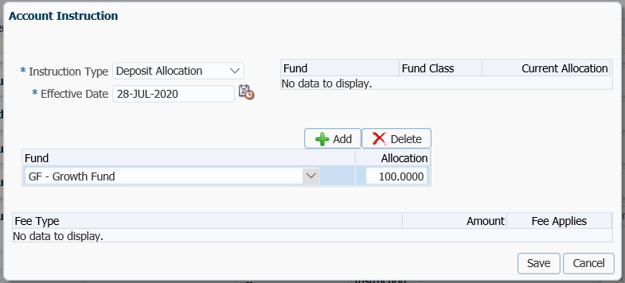

1. The **Account Instructions** will now be updated with the new **Deposit Allocation Instructions** or the member’s VPB account.

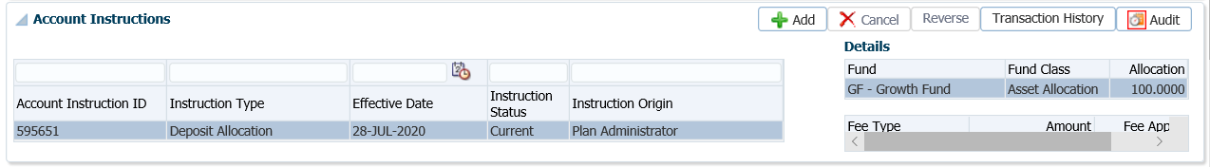

Add Scheduled Withdrawal

1. If the member elected to start taking scheduled withdrawals immediately the schedule needs to be set up. Under the **Investments** screen, **Account Instructions** region, click **Add**.



1. In the **Account Instruction** pop-up window, select the following and click **Save**:

* **Instruction Type -** Scheduled Withdrawal
* **Effective Date –** the date the member is starting VPB scheduled payments (1st day of the month)
* **Scheduled Withdrawal Type -** Fixed Amount, ITA Minimum, or Fixed Amount
* **Scheduled Withdrawal Frequency –** Annual, Monthly
* **Scheduled Withdrawal Amount –** as per the member’s application form
* **Fund Depletion Method –** Prorated, Specified Order, Specified Percentage
* **Fee Type –** not applicable upon setup of a new VPB

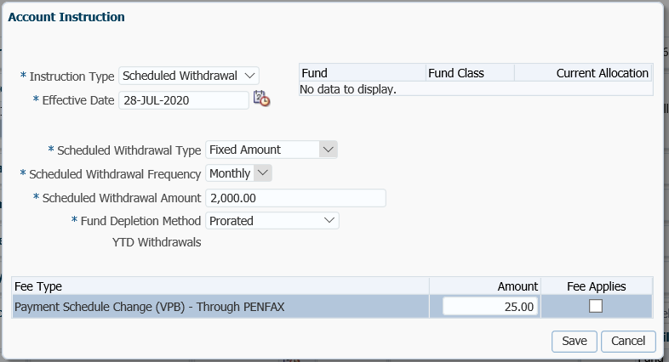

1. The **Scheduled Withdrawal** instructions will now be displayed under the member’s **Account Instructions**.

Add Payment Instructions

1. Add payment instructions under the **Person Profile** menu, **Payment Instructions** screen. Click **Add** under the **Payment Instructions** region.

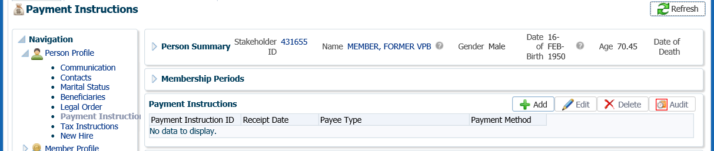

1. In the **Payment Instruction** pop-up window, select the following and click **Save**:

* **Payee Type** – Self
* **Payment Method** – EFT – Canadian, or Cheque
* **Receipt Date** – leave as current date
* **Expiry Date –** only added if there is an expiry date for the payment instructions
* **Payment Note –** a note can be added but is optional
* **Bank Number –** as per the spouse’s void cheque, for EFT
* **Transit Number –** as per the spouse’s void cheque, for EFT
* **Account Number –** as per the spouse’s void cheque, for EFT
* **Note –** optional
* **Payee Name –** will default to spouse’s name
* **Override Payee Name –** used if payment was going to an alternate payee
* **Address Type –** select the address the member elects if there are more than one, for payment by cheque

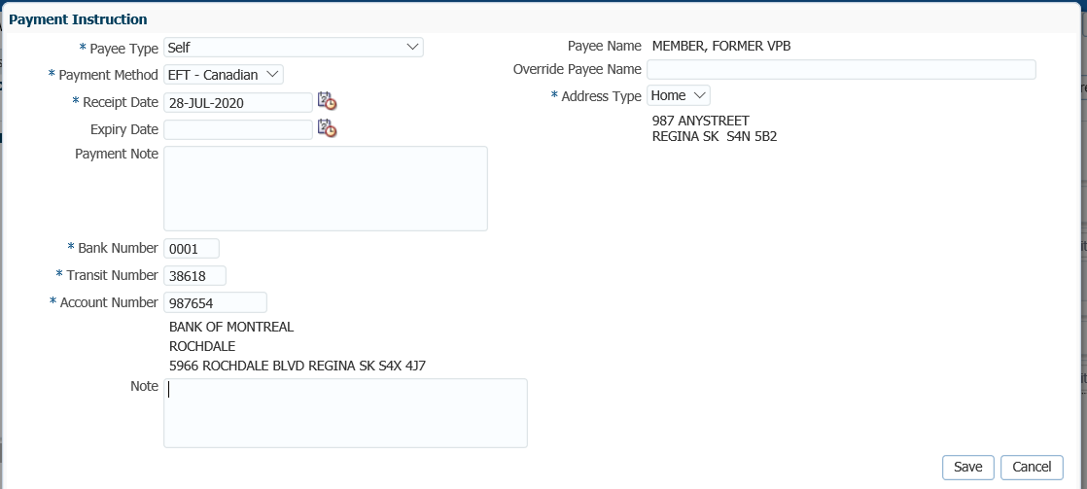

Add Tax Instructions

1. Add the tax instructions under the **Person Profile** menu, **Tax Instructions** screen. In the **Tax Instructions** region, click **Add**.

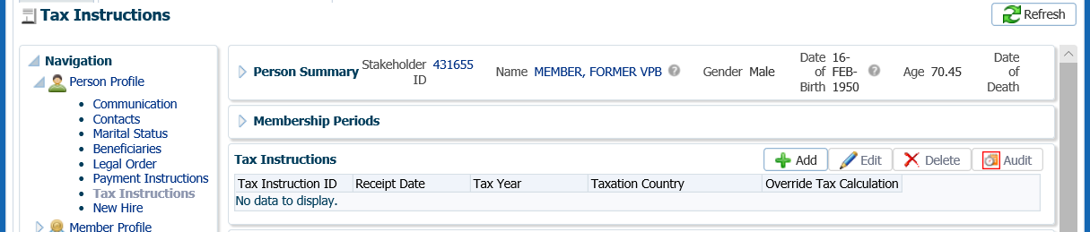

1. In the **Tax Instruction** pop-up window, select the following and click **Save**:

* **Receipt Date –** leave as current date
* **Tax Year –** change to the year the payments are to start
* **Taxation Province –** select the province the member lives in
* **Override Tax Calculation –** if selected will populate Override Federal and Provincial Tax Amount boxes
* **Additional Federal Tax Amount –** enter an amount if requested on TD1 forms
* **Additional Provincial Tax Amount –** enter an amount if requested on TD1 forms
* **Additional Federal Tax Percent –** enter amount if requested on TD1 forms
* **TD1 Type –** select Advanced or Basic
* **Exemptions –** enter any exemptions as per the member’s TD1 forms
* **Other Deductions –** enter if applicable to the member
* **Tax Exemptions –** enter if applicable to the member



1. A *VPB Welcome Letter* will be saved to the member’s account under the **Person Profile** menu, **Communications** screen, **Outbound Documents** region. Click on the **Filename** link to open the document.

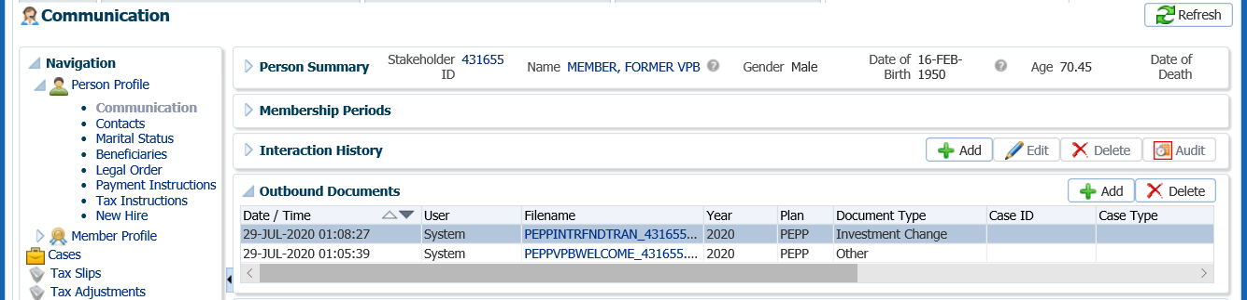

Process External Transfer In Deposit to the VPB Account

1. Once the new VPB account is set up for the former PEPP member, the deposit of registered funds received can be deposited to the member’s VPB account. ***Refer to the procedures under External Transfer In No Service*.**

## VPB Lump Sum Payment

Members may request a lump sum payment at any time by either submitting a *VPB Lump Sum Payment Reques*t form to PEPP, or by logging into their own account via PLANet and submitting the request through to PEPP.

Business Process Requirements – VPB Lump Sum Payment

* Members must submit the *VPB Lump Sum Payment Request* form to PEPP for any requests processed by PEPP administrators.
* If information is missing or unclear, ***refer to******Procedures to Obtain Missing Information***.
* Lump sum payments must be at least a$100.00 except when the payment is to payout the remainder of the account.
* Members are allowed one free lump sum payment request per fiscal year. Additional lump sum payments are charged a $60.00 fee within the fiscal year except for when the payment is to payout the remainder of the account.
* Lump sum payment requests performed via PLANet by the member are unlimited and will not be charged a fee.
* PENFAX will track the number of lump sum payments processed by PEPP administrators and charge the fee automatically on the 2nd and subsequent lump sum payment requests within a fiscal year.
* Lump sum payment requests if received via PLANet prior to 2:00 p.m. Saskatchewan time will be processed using the unit value declared at the end of market close.
* The Bonus tax method is used to calculate the tax for VPB lump sum payments. An example of the calculation is included at the end of the VPB lump sum procedures.

#### How to Process a VPB Lump Sum Payment

1. Search for the member in PENFAX.
2. Confirm that the form is completed in full, signed and dated by the member.
3. Under the **Navigation** menu, click on the **DC Benefit Selections** screen. Under the **Investment Accounts** region, highlight the **VPB Account Class**.

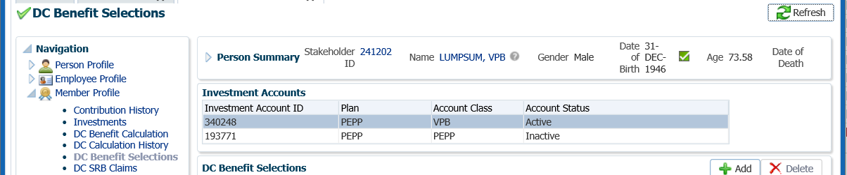

1. Under the **DC Benefit Selections** region, click **Add** to add a new payment in the **DC Benefits Selection** region.

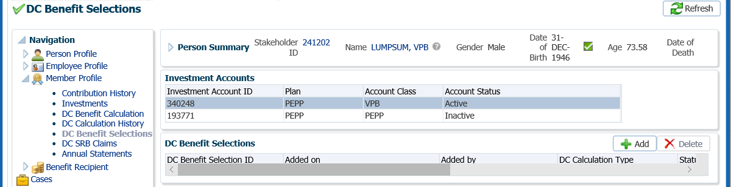

1. In the **Input Data train**, click **Next** to start the **Input Data** process.

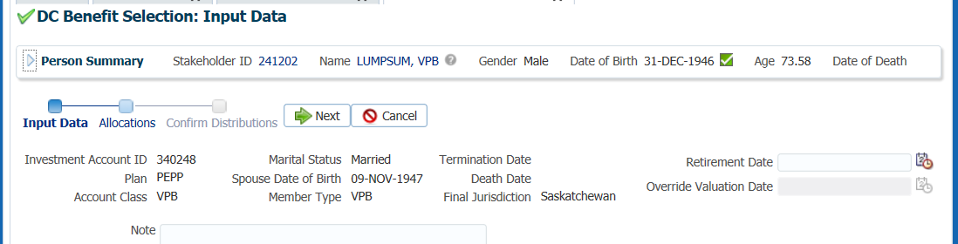

1. In the **Input Data train** under the **Allocations** regionclick **Add**.



1. In the **Allocation** pop-up window, enter the following information, then click **Save:**

* **Fund** – leave blank to pro-rate across all funds or use fund chosen by member on form
* **Contribution Type** – leave blank to pro-rate across all
* **Allocation Method** – Percent, Gross Amount or Net Amount
* **Percent/Gross Amount** – 100% or a specific gross amount as per selection under allocation method
* **Transfer Vehicle** – Cash
* **Estimated Gross Amount –** will populate with the gross amount by fund and contribution source as per the previous selection

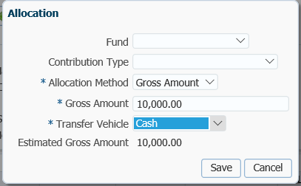

1. In the **Input Data Train** click **Next** to Confirm the Distributions of the payment.

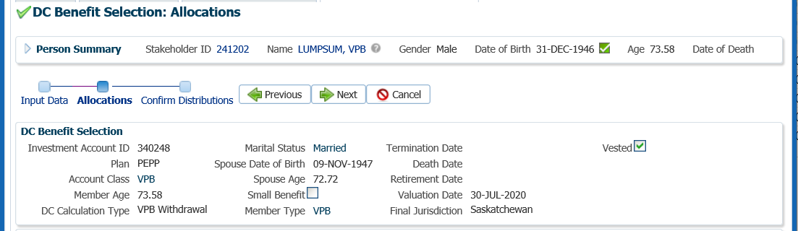

1. In the **Onetime Amounts** region under the **Payment Instruction** column, click onthe drop-down list. If the member did not request a new payment instruction (new banking details), choose the most recent Payment Instructions in the drop-down. If the member requested new payment instructions click on the **Add New** option to add them.



1. In the **Onetime Amounts** region, select the **Tax Instructions** from the drop-down list if the member has previous instruction on file. Select **Add New** if there is no data is displayed or the member requested new tax instructions.



1. In the **Input Data** **train**, click **Submit for Approval**.

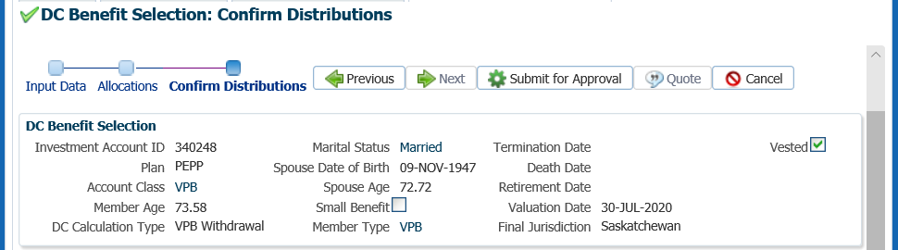

1. The *Pension Specialist* or *Supervisor* will audit and approve the lump sum payment in the **DC Benefit Selection** region by clicking **Approve**,or **Reject** if there were errors or the payment was done in error. Once approved the **Status** will show as **Processed.**

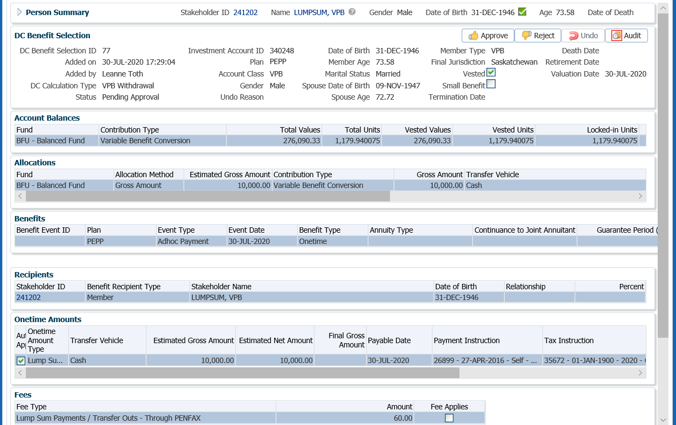

* **NOTE:** If the payment was processed incorrectly or done in error, the *Pension Specialist* or *Supervisor* will select **Reject** and all of the payment steps will need to be redone by the *Pension Information Officer*.

The **Reject** button is enabled if the status is **Pending Approval** or **Approved**, which will update the status to **Rejected** when clicked and prevent the benefit selection from being processed by the investment batch.

The **Undo** button is enabled only if the status is **Processed** and will reverse the payment in the investment batch.

1. In the **Approve DC Benefit Selection** pop-up window, add a **Note** and click **Save**.



1. A history of Transactions, User and Event is shown under the **Audit** button.

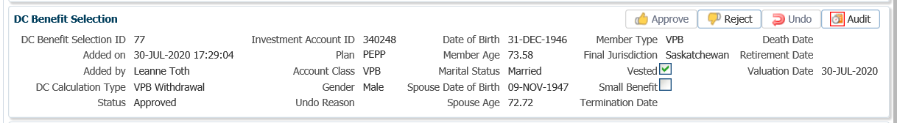

1. To close the **DC Benefit Selection** window, click on the **X** in the tab.



1. The payment will process in the overnight batch process and the EFT sent to the member’s bank account or a cheque produced if payment is by cheque. The payment can be viewed under the **Benefit Recipient** Menu. Click on the **Onetime Amounts** tab to see the details.

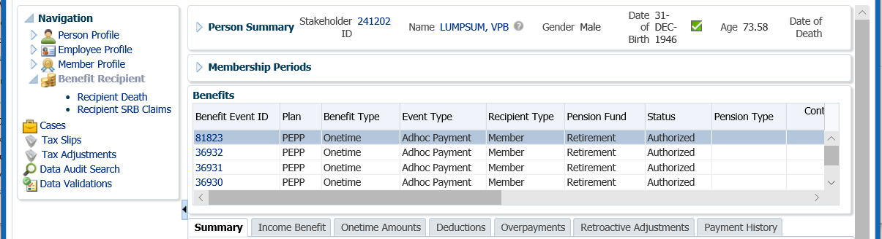

1. In the **Onetime Amounts** tab, the Payment details, Recipient (Payee) details, tax deducted and cheque ID number can be seen by, clicking on the **ID number** beside the **Paid by Payment ID.**

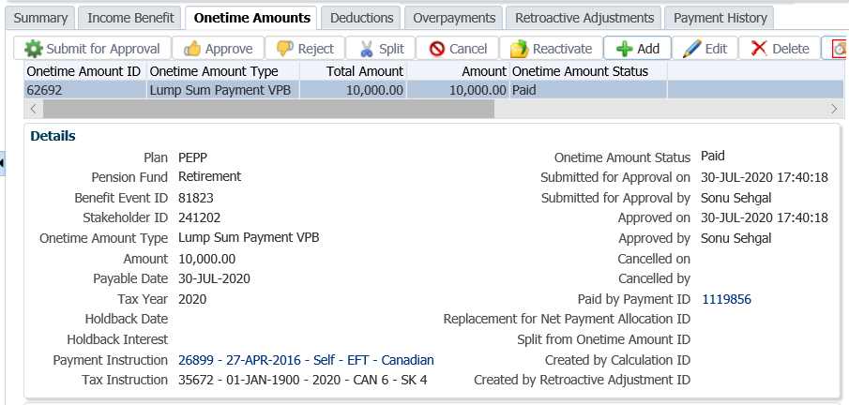

1. To see further details of the payment, click on the tabs to the right of the screen (**Line Items, Tax, Net Pay Allocation** and **Notes**).

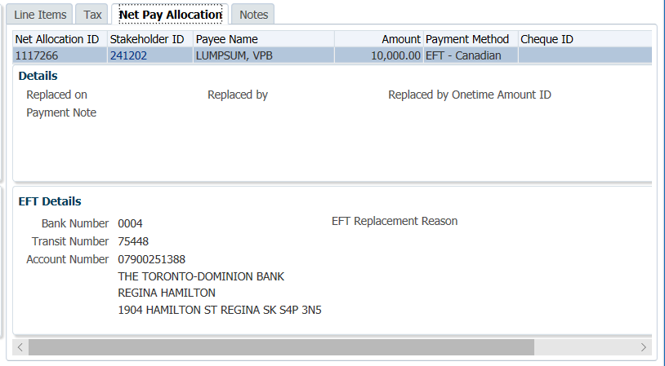

* **NOTE:** Click on the **X** in the **Payment ID Tab** to close the window.



1. To see the transactions details of the lump sum payment, it can be viewed under the **Member Profile** menu, **Investments** screen. Highlight the **VPB Account** under the **Investment Accounts** region, expand the **Account Activity**, **Search Parameters** region, under **Fund Transaction Type** select **Withdrawal – Lump Sum** and click **Search**.

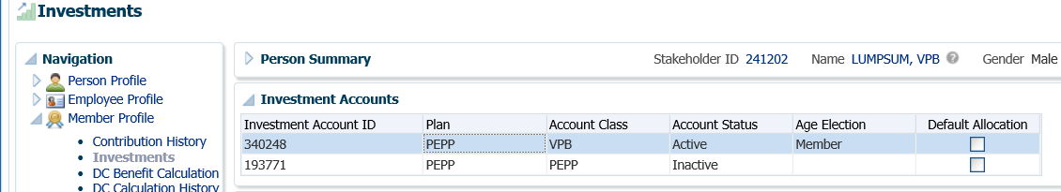

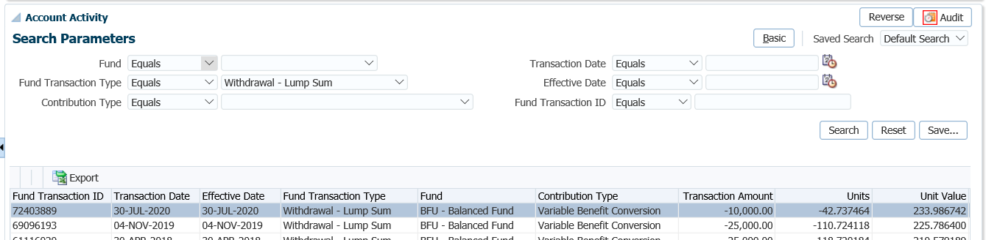

1. A *Withdrawal Confirmation Letter*. The letter will be saved under the **Person Profile**, **Communications** screen underthe **Outbound Documents** region. Click on the **Filename** link to open the document.

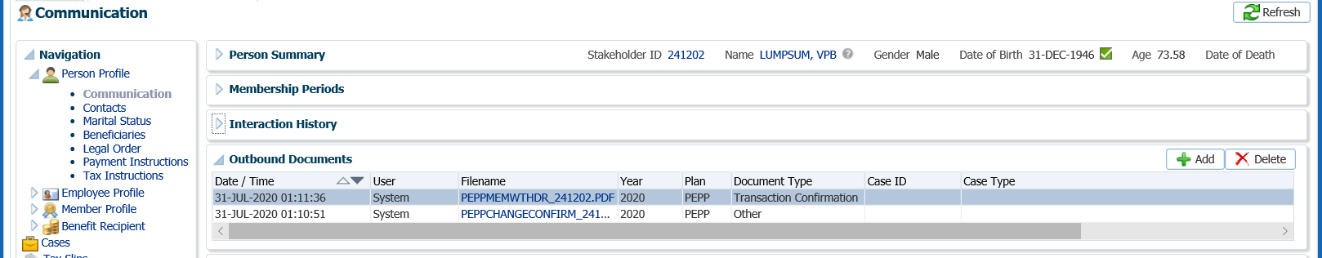

1. Tax slips for any VPB payments will be run at the end of the calendar year and include all income or lump sum payments made in the calendar year. The Tax Slip can be viewed under the **Tax Slips** screen by clicking on the **Tax Slip ID** number.

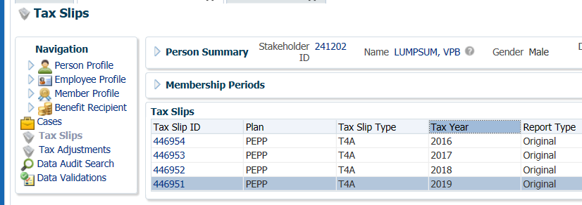

Bonus Tax Method Example:

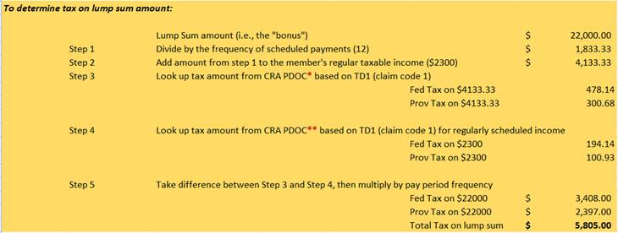

## VPB Full Payout - Transfer to a Registered Plan or Cash Payout

At any time, a member under the VPB account may choose to transfer all or a portion of their VPB account out to another registered plan or take the remaining account balance in cash.

Business Process Requirements – VPB Transfer to a Registered Plan

* If funds are locked-in under PEPP legislation, a member may transfer all or a portion of the VPB account balance to the following registered vehicles:
* Registered Pension Plan (RPP) if age is less than 72;
* Locked-In Retirement Account (LIRA) if age is less than 72;
* Life Annuity that meets the requirements of section 29 of *The Pension Benefits Regulations, 1993;*
* Registered Retirement Income Fund (RRIF) contract as defined in section 29.1 of *The Pension Benefits Regulations, 1993;*
* Registered Retirement Savings Plan (RRSP) if age is less than 72. A T2151 form is required.
* If funds are locked-in outside of PEPP legislation, a member may also transfer to that jurisdiction’s applicable Life Income Fund (LIF) or Locked-in Retirement Income Fund (LRIF).
* If the member is age 72 or older, the balance of the minimum required payment not withdrawn for that calendar year must be withdrawn and paid to the member prior to any transfer out of the VPB account.
* The spouse’s consent form to transfer funds out of the VPB is NOT required to transfer funds out to another registered account.
* There is no fee charged to a member to transfer the full account balance out to another registered plan.
* A signed Canada Revenue Agency T2151 form is required indicating the receiving institutions name and plan type. A copy is acceptable.
* Verify the member’s SIN on the T2151 form to the SIN on the PENFAX account to ensure it matches.
* If any information is missing on the form or unclear follow up with the member. ***Refer to******Procedures to Obtain Missing Information.***

A member may elect to have the full amount of their VPB account closed out and paid to them in cash if applicable legislation permits in the jurisdiction the plan was set up under.

**Business Process Requirements – VPB Full Amount in Cash**

* Members must submit the *VPB Lump Sum Payment Request* form to PEPP for any requests processed by PEPP administrators.
* If a member is transferring the full account balance, lump tax will be applied to the payment. The payment will close the account when the payment type of “Final VPB Lump Sum Payment” is used for the Onetime Amount Type.
* There is no fee charge when the VPB member requests the full amount to be paid out.
* If any information is missing on the form or unclear follow up with the member. ***Refer to******Procedures to Obtain Missing Information***.

#### How to Process a VPB Full Payout to a Registered Plan or Cash Payout

#### Scenario: Member is over Age 72, ITA Minimum has not been paid out

#### Day 1 – Payout Remainder of ITA Minimum for year

1. Search for the member in PENFAX.
2. Confirm that the transfer form is completed in full, signed and dated by the member.

1. Determine if the ITA Minimum amount has been paid to the member for the current year. If there is still an amount remaining of the ITA Minimum it is required to be paid out before transferring.

Under the **Investments** screen, **Investment Accounts** region, highlight the **VPB Account Class**. Expand the **Withdrawal Summary** region to compare the **YTD Withdrawals** to the **Minimum Withdrawal Amount**.

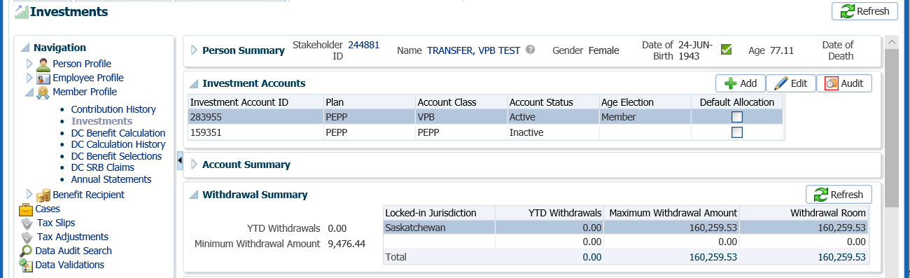

* **ITA Minimum - $9,476.44 - $0.00 (no ITA Min taken) = $9,476.44** ITA Min. to pay out before transferring to another registered plan

1. Under the **Navigation** menu, click on the **DC Benefit Selections** screen. Under the **Investment Accounts** region, highlight the **VPB Account Class**.

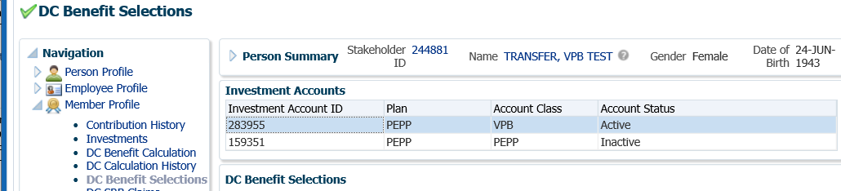

1. Under the **DC Benefit Selections** region, click **Add** to add a new payment in the **DC Benefits Selection** region.

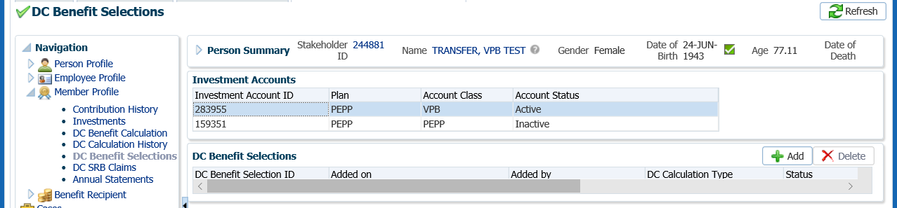

1. In the **Input Data train**, click **Next** to start the **Input Data** process to add the payment.

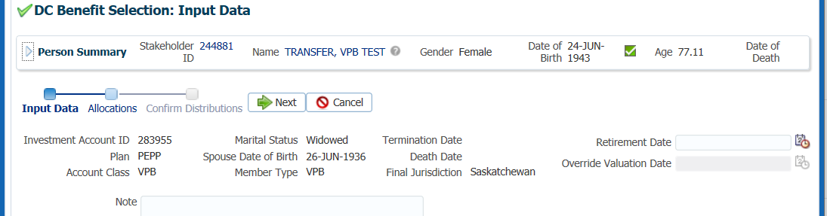

1. In the **Input Data train** under the **Allocations** regionclick **Add**.



1. In the **Allocation** pop-up window, enter the following information, then click **Save:**

* **Fund** – leave blank to pro-rate across all funds or use fund chosen by member on form
* **Contribution Type** – leave blank to pro-rate across all
* **Allocation Method** – Gross Amount
* **Percent/Gross Amount** – the remaining gross amount of the ITA Minimum
* **Transfer Vehicle** – Cash
* **Estimated Gross Amount –** will populate with the gross amount by fund and contribution source as per the previous selection

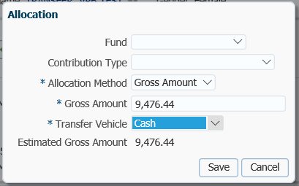

1. In the **Input Data Train** click **Next** to Confirm the Distributions of the payment.

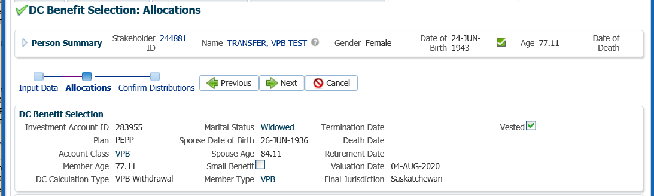

1. In the **Onetime Amounts** region under the **Payment Instruction** column, click onthe drop-down list. If the member did not request a new payment instruction (new banking details), choose the most recent Payment Instructions in the drop-down. If the member requested new payment instructions click on the **Add New** option to add them.

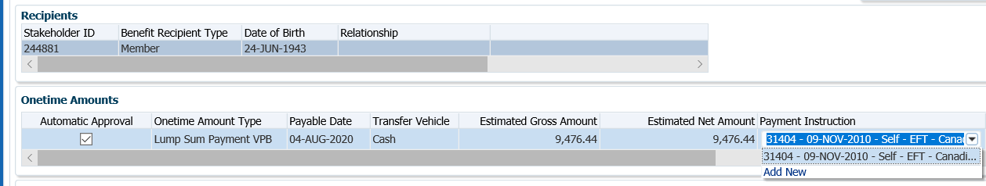

1. In the **Onetime Amounts** region, select the **Tax Instructions** from the drop-down list if the member has previous instruction on file. Select **Add New** if there is no data is displayed or the member requested new tax instructions.

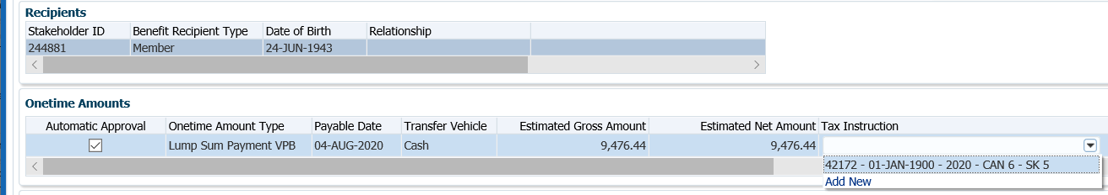

1. In the **Input Data** **train**, click **Submit for Approval**.

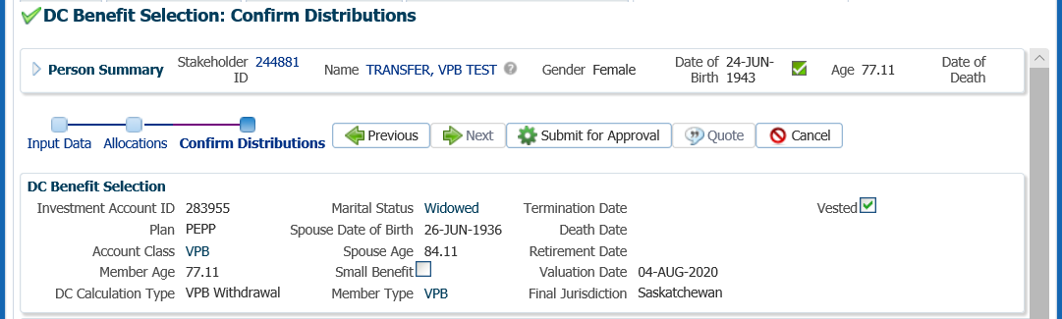

1. The *Pension Specialist* or *Supervisor* will audit and approve the lump sum payment in the **DC Benefit Selection** region by clicking **Approve**,or **Reject** if there were errors or the payment was done in error. Once approved the **Status** will show as **Processed.**

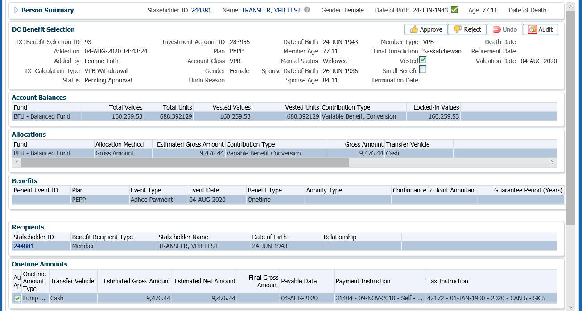

* **NOTE:** If the payment was processed incorrectly or done in error, the *Pension Specialist* or *Supervisor* will select **Reject** and all of the payment steps will need to be redone by the *Pension Information Officer*.

The **Reject** button is enabled if the status is **Pending Approval** or **Approved**, which will update the status to **Rejected** when clicked and prevent the benefit selection from being processed by the investment batch.

The **Undo** button is enabled only if the status is **Processed** and will reverse the payment in the investment batch.

1. In the **Approve DC Benefit Selection** pop-up window, add a **Note** and click **Save**.



1. A history of Transactions, User and Event is shown under the **Audit** button.

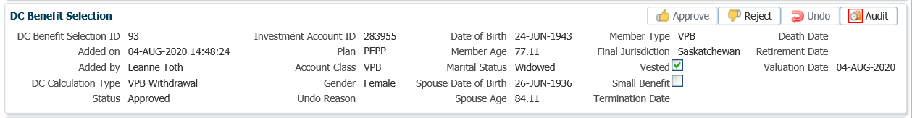

1. To close the **DC Benefit Selection** window, click on the **X** in the tab.



#### Day 2: Confirmation of ITA Minimum Paid Out

1. The payment for the remaining ITA Minimum amount will process in the overnight batch process and the EFT sent to the member’s bank account or a cheque produced if payment is by cheque. The payment can be viewed under the **Benefit Recipient** Menu the next day. Highlight the **VPB** **Membership Periods**, the click on the **Onetime Amounts** tab to see the details.

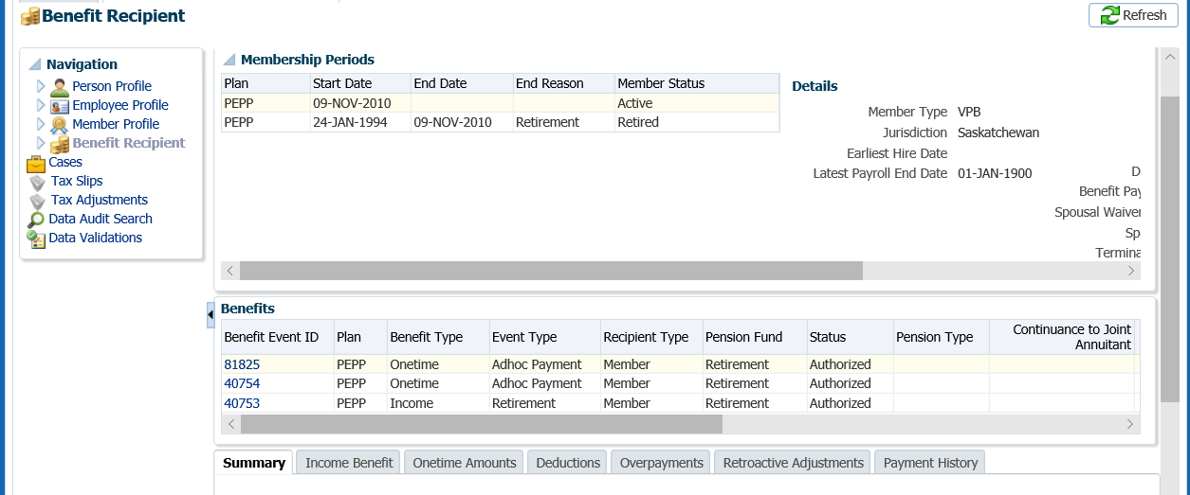

1. In the **Onetime Amounts** tab, click on the **ID number** beside the **Paid by Payment ID** to see the Payment details, Recipient (Payee) details, tax deducted and EFT/cheque ID number**.**

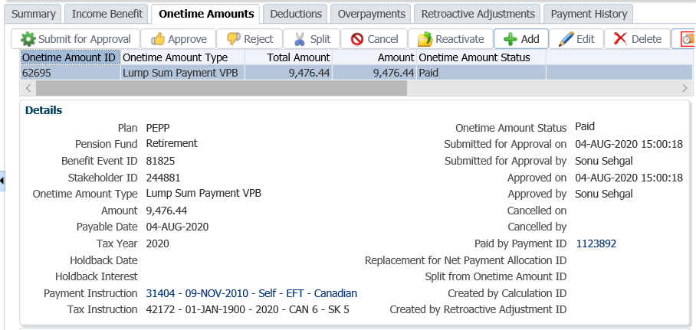

1. To see further details of the payment, click on the tabs to the right of the screen (**Line Items, Tax, Net Pay Allocation** and **Notes**).

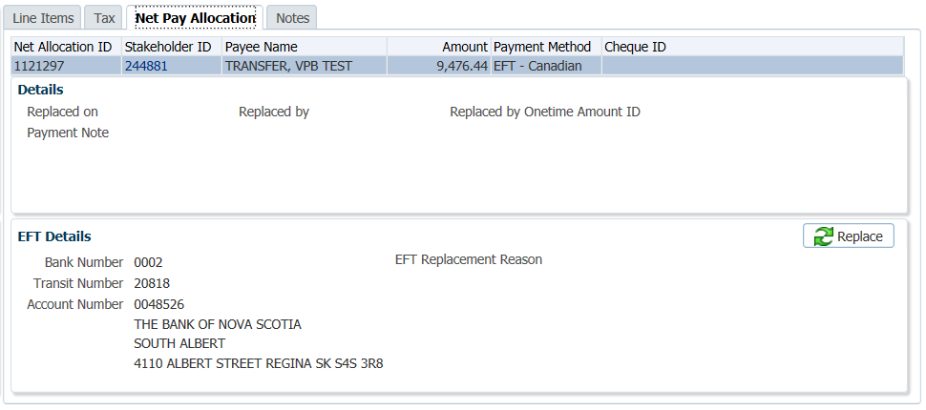

* **NOTE:** Click on the **X** in the **Payment ID Tab** to close the window.



#### Day 2 - Process Payment of Remaining Balance to Registered Plan or as a Cash Payout

In this example member is transferring to a pRIF, a *Spouse’s Consent and Waiver of Post-Retirement Survivor Benefits* form is required to be completed by the spouse and provided to PEPP.

1. Under the **Person Profile** menu, **Person Summary** region, expand the **Status** region. Click **Add.**

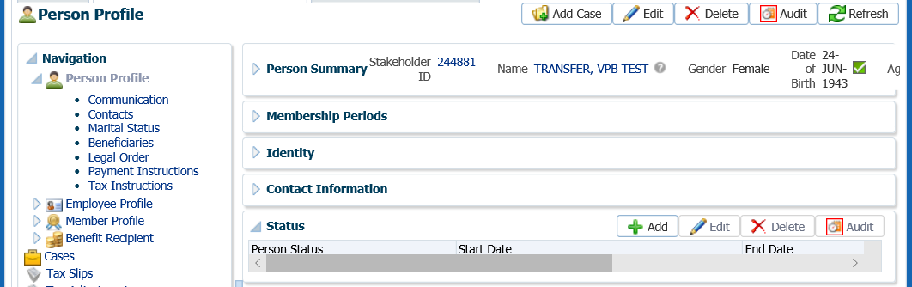

1. In the **Person Status** pop-up window, select the following then click **Save**:

* **Person Status –** PEPP Life Annuity Waiver – Spousal Consent, PEPP pRIF – Spousal Consent, PEPP VPB – Spousal Consent and Proof of Existence Pending
* **Start Date –** The beginning date for which the status is considered accurate
* **End Date –** if applicable, the end date for which the status is considered accurate. The end date will automatically populate for some selections.
* **Last Verification Date –** it applicable, the last time this status was checked or certified
* **Next Verification Due Date –** if applicable, the next time a follow-up or re-certification is required for this status
* **Percentage –** percentage as noted on the document if applicable

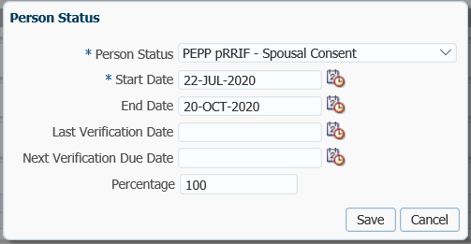

1. The remaining account balance can now be paid as a registered transfer to a qualified financial institution. In the **DC Benefit Selections** screen, select the **VPB Account Class** under the **Investment Accounts** region.

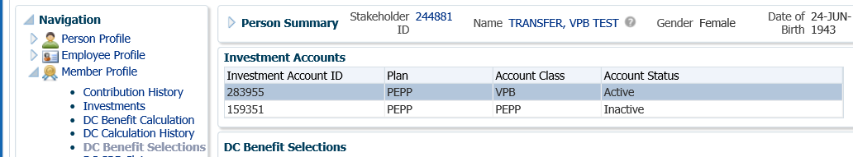

1. Under the **DC Benefits Selections** region, click **Add**, to add a new payment.

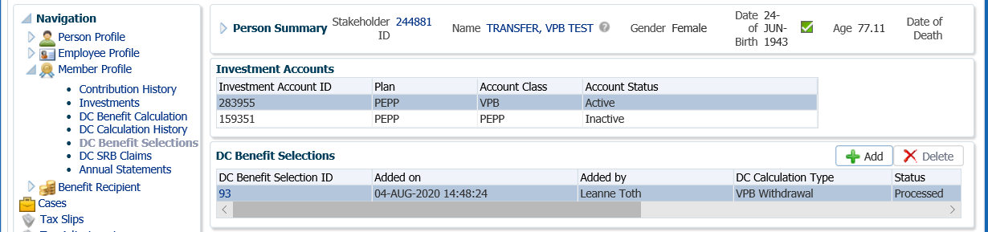

1. In the **DC Benefits Section Input Data Train,** click **Next** to start the payment.

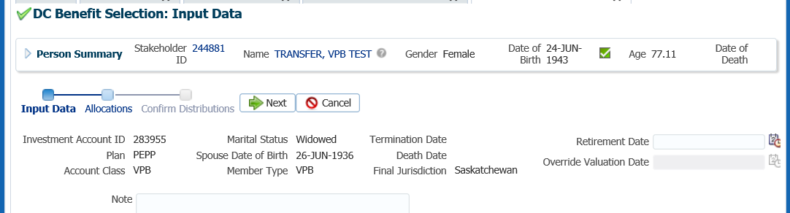

1. In the **Input Data train** under the **Allocations** regionclick **Add.**



1. In the **Allocation** pop-up window, enter the following information, then click **Save:**

* **Fund** – leave blank to pro-rate across all funds or use fund chosen by member on form
* **Contribution Type** – leave blank to pro-rate across all
* **Allocation Method** – Gross Amount
* **Percent/Gross Amount** – the remaining gross amount of the ITA Minimum
* **Transfer Vehicle** – Cash for a Cash Payout or select the Registered Transfer Vehicle
* **Estimated Gross Amount –** will populate with the gross amount by fund and contribution source as per the previous selection

*Cash Option:*

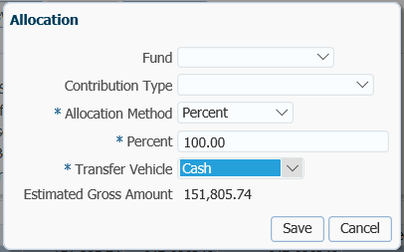

*Transfer to Registered Vehicle:*

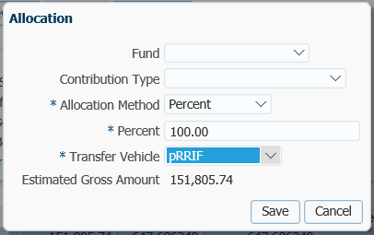

1. In the **Input Data Train** click **Next** to Confirm the Distributions of the payment.

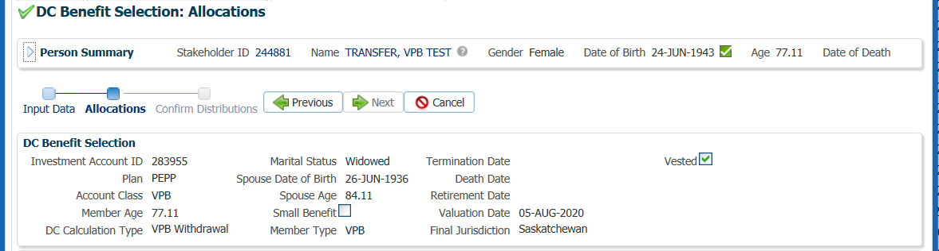

1. *Cash Payout Option – Payment Instructions:* In the **Onetime Amounts** region under the **Payment Instruction** column, click onthe drop-down list and select the payment instructions that exist for scheduled payments to go to the member by EFT.

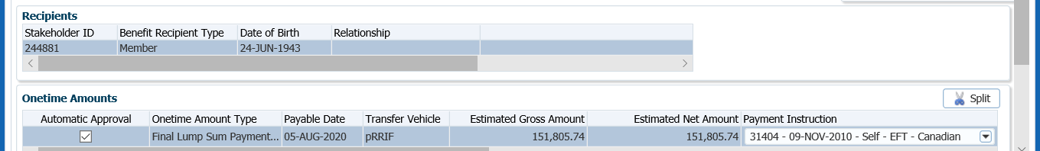

1. *Cash Payout Option – Tax Instructions:* In the **Onetime Amounts** region, select the **Tax Instructions** from the drop-down list that the member has on file for scheduled payments.

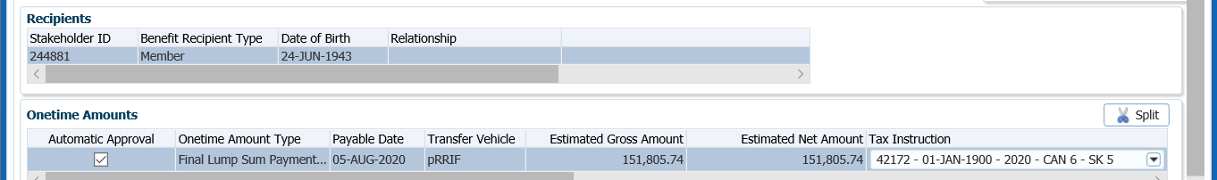

1. *Transfer to Registered Vehicle Option:* In the **Onetime Amounts** region under the **Payment Instruction** column, click onthe drop-down list and choose **Add New**. You will need to add payment instructions for the Qualified Financial Institution.



1. In the **Payment Instruction** pop-up window, select the following:
   * **Payee Type** – Qualified Financial Institution
   * **Payment Method** – Cheque
   * **Receipt Date** – leave as current date
   * **Expiry Date** – not applicalbe (date that banking instructions are valid for EFT only)
   * **Payment Note** ­– used to add a note to the payment documentation (cheque or EFT receipt)
   * **Hold for Pickup ­**– checked if the member would like to pickup the cheque (will be displayed under the member’s Payment Instructionsscreen)
   * **Note** – additional notes pertaining to the payment, will appear under Person Profile Notes.
   * **Payee Stakeholder ID** – enter the stakeholder ID for the financial institution if it is known. If it is not known click on the **magnifying glass** to find the stakeholder ID.
   * **Payee Name** - will automatically populate once the stakeholder ID for the financial institution is entered
   * **Override Payee Name** – not applicable
   * **Account ID** – enter the plan or account name and number in which the funds are being transferred in with the financial institution if known
   * **Address Type** – will populate with the primary address of the financial institution

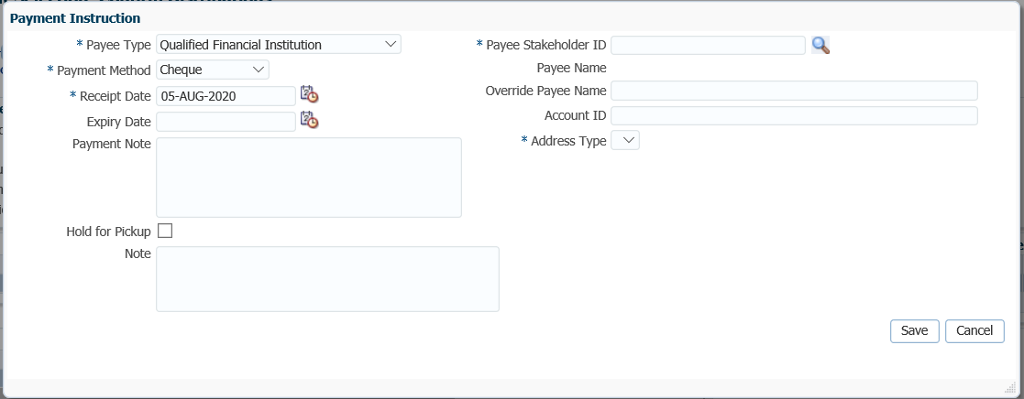

1. If the **Payee Stakeholder ID** is not known, click on the **magnifying glass** to find the stakeholder ID for the Qualified Financial Institution the funds are being transferred to.
2. In the **Search and Select Organization** screen, **Search Parameters**, select **Financial Institution** as the **Organization Type** from the drop-down list.Click **Search**.



1. In the **Search Results** area, highlight the correct Financial Institution from thelist. Click **OK**.

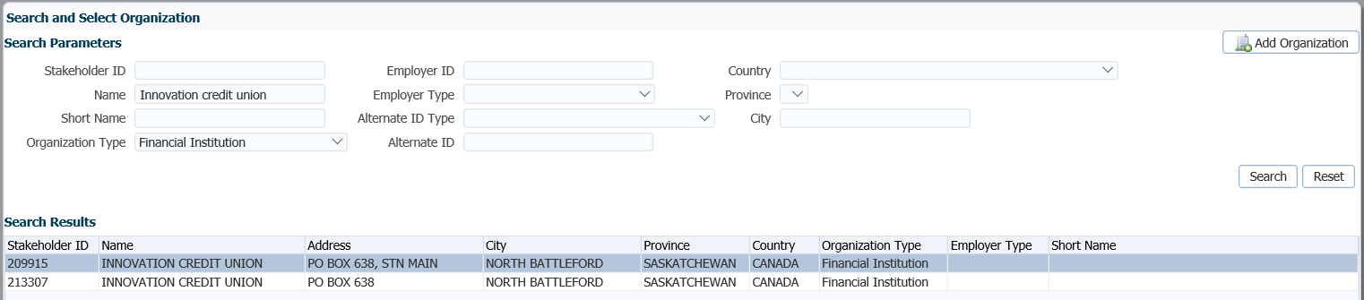



1. The **Payee Stakeholder ID**, the **Payee Name** and **Address** will now be populated in the **Payment Instructions** window. Add the **Account ID** for the financial institution the funds are being transferred to and add a **Note** if applicable. Click **Save**.

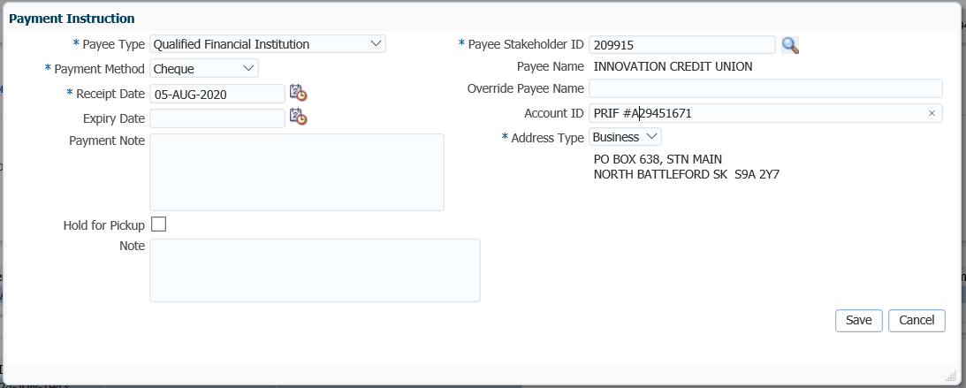

1. *Transfer to a Registered Vehicle Option:*  **Tax Instructions** are not required to be selected for a transfer to a Qualified Financial Institution as it is treated as a tax-free transfer to a registered vehicle.
2. Once the payment instructions and tax instructions have been added, click **Submit for Approval** in the **Input Data** **train**.

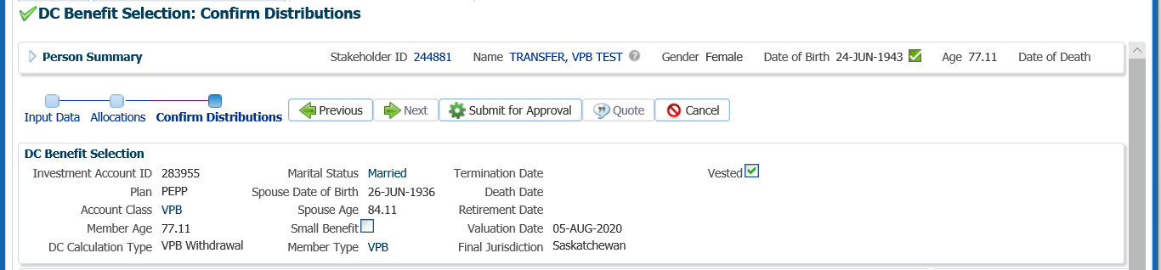

1. The *Pension Specialist* or *Supervisor* will audit and approve the VPB withdrawal in the **DC Benefit Selection** region by clicking **Approve**,or **Reject** if there were errors or the payment was done in error. Once approved the **Status** will show as **Approved.**

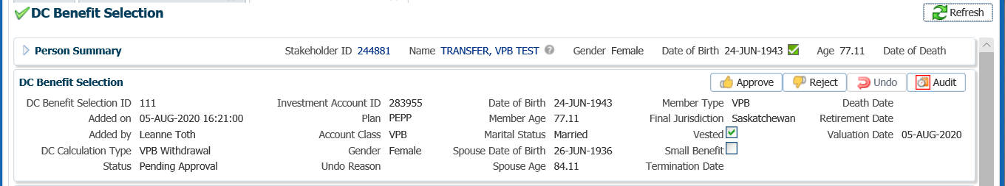

* **NOTE:** If the payment was processed incorrectly or done in error, the *Pension Specialist* or *Supervisor* will select **Reject** and all of the payment steps will need to be redone by the *Pension Information Officer*.

The **Reject** button is enabled if the status is **Pending Approval** or **Approved**, which will update the status to **Rejected** when clicked and prevent the benefit selection from being processed by the investment batch.

The **Undo** button is enabled only if the status is **Processed** and will reverse the payment in the investment batch.

1. In the **Approve DC Benefit Selection** pop-up window, add a **Note** and click **Save**.



1. A history of Transactions, User and Event is shown under the **Audit** button.

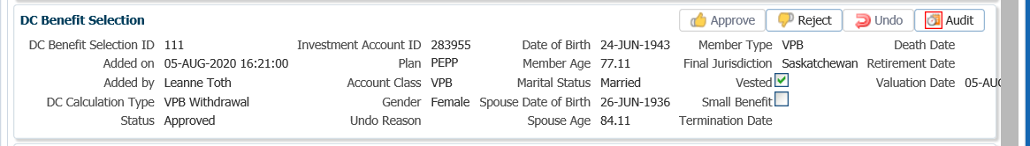

1. To close the **DC Benefit Selection** window, click on the **X** in the tab.



#### Day 3: Confirmation of Payout of Remaining Balance

1. The payment will process in the overnight batch process and the EFT sent to the member’s bank account or a cheque produced if payment is by cheque to the member or to a financial institution. The payment can be viewed under the **Benefit Recipient** Menu the next day. Click on the **Onetime Amounts** tab to see the details.
2. see the transactions details of the lump sum payment, it can be viewed under the **Member Profile** menu, **Investments** screen. Highlight the **VPB Account** under the **Investment Accounts** region,





1. A *Withdrawal or Payment Confirmation Letter*will produce overnight. The letter will be saved under the **Person Profile**, **Communications** screen underthe **Outbound Documents** region. Click on the **Filename** link to open the document.



1. Tax slips for any VPB payments will be run at the end of the calendar year and include all income or lump sum payments made in the calendar year to the member. Tax slips will be saved to the member’s account and can be viewed after year end under the **Navigation** menu, **Tax Slips sc**reen.

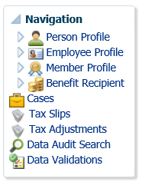

## VPB Maintenance Enforcement Payment

If a member is in arrears of maintenance payments for at least three months, the Director of the Maintenance Enforcement Office (MEO) may file a “*Notice to Administrator of Intention to Attach Pension Entitlement”* with PEPP.

If a notice is filed, an indicator flag or critical note  is added to PENFAX to notify administrators of the receipt of a request for a maintenance order payment from the members account. The indicator flag or critical note  is to advise the pension administrators that **no** further payments can be paid within 60 days unless notified earlier by the MEO.

If the MEO proceeds with the payment from the member’s account, a *Notice of Attachment of Pension Entitlement* will be sent to PEPP. PEPP is obligated to make the payment from the members pension account to enforce the maintenance order. In order for PEPP to comply with the request, the member must request a lump sum payment from their VPB account or they are receiving scheduled payments.

**Business Process Requirements - Maintenance Order Payment**

* Maintenance Enforcement Office (MEO), sends in 2 copies of the *Notice of Intention.*
* Confirm that the member is eligible. The member **cannot** be actively contributing. Must be terminated from all PEPP participating employers or a VPB member.
* Place a 60 day freeze on the member’s account on PENFAX stating “NO WITHDRAWALS permitted until after “date the 60 days are over”.
* Provide the Information letter to the Maintenance Enforcement Office (MEO) with the requested information within 30 days of receiving the *Notice of Intention*.
* Mail the *Notice of Intention* letter to the MEO and send a copy of the letter and a copy of the *Letter of Intention* by registered mail to the member. Keep a copy for the member’s file.
* If the Maintenance Enforcement Office (MEO) is proceeding they will send in 2 copies of the *Notice of Attachment of Pension Entitlement.*
* Remove the 60 day freeze to proceed with the request only if the member is receiving scheduled payments. If the member is not receiving payments leave the 60 day freeze in place if the 60 days has not expired.
* If the VPB member is not receiving scheduled payments they must request a lump sum payment or request to set up scheduled payments within the 60 days in order for PEPP to process a Maintenance Order payment. If the member does not meet these requirements within the 60 days, PEPP is unable to process the request.
* The payment must be for a net amount as specified in the *Notice of Attachment of Pension Entitlement*. The gross amount withdrawn must be for the net amount plus the fee, plus the appropriate withholding tax. This amount will be submitted to the Canada Revenue Agency.
* The payee on the cheque is the name of the person receiving the money, as noted on the *Notice of Attachment of Pension Entitlement*, c/o the Maintenance Enforcement Office, Room 100-3085 Albert Street, Regina SK S4S 0B1.
* A $45 administration fee is charged and deducted from the members account and must be included in the T4A slip.
* Payments are subject to lump sum withholding tax and a T4A slip is issued.
* The member is required to declare the attachment amount as income in the year the payment was issued as per the T4A slip.
* Prepare the Maintenance Payment letter to send with the cheque. Include a copy of the *Notice of Attachment of Pension Entitlement* with the cheque and the payment letter. A copy is to be sent to the member and a copy kept for the member’s file.
* If the MEO advises they are not proceeding prior to the 60-day date or if nothing is received back and the 60-days has lapsed, the critical note to freeze the member’s account must be removed and a note added stating the MEO is not proceeding with the request.
* Verify the member’s SIN on the T2151 form to the SIN on the PENFAX account to ensure it matches.
* Determine if Identification is required from the member. ***Refer to the procedures,******when is Identification Required from a Member****.*
* If any information is missing on the form follow up with the member. ***Refer to Procedures to Obtain Missing Information.***

***How to Process a Maintenance Enforcement Payment***

1. Search for the member in PENFAX.
2. Once the *Notice of Intention* from the Maintenance Enforcement Office is received, determine if the member is eligible. To be eligible, the member must have terminated employment with all PEPP employers and be a Variable Pension Benefit member.
3. Under the **Employee Profile** menu, **Membership Periods** region check the **Member Status** to ensure is shows as *Active* under VPB.

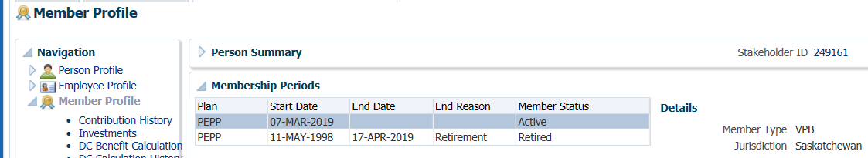

Place 60 Day Freeze on Account – Lock Account

1. Place a 60 day freeze on the member’s account. Under the **Person Profile** menu, **Person Summary** region, click **Edit**.

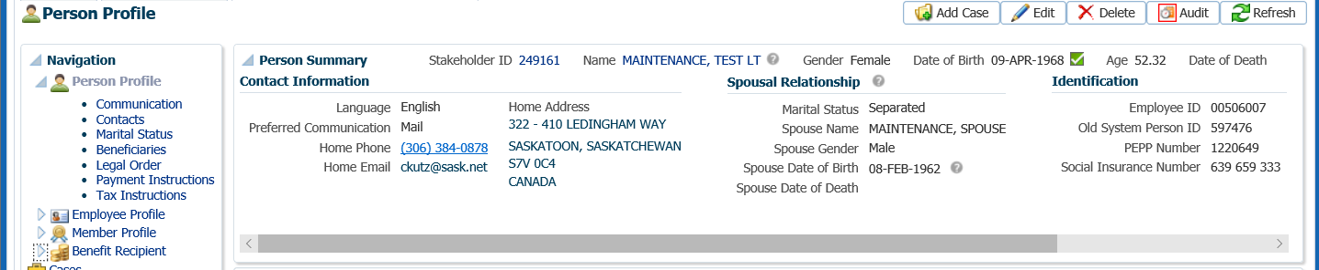

1. In the **Person** pop-up window, check the **Locked** option and click **Save**. This will lock the member’s account so that no further payments will be allowed to be processed.

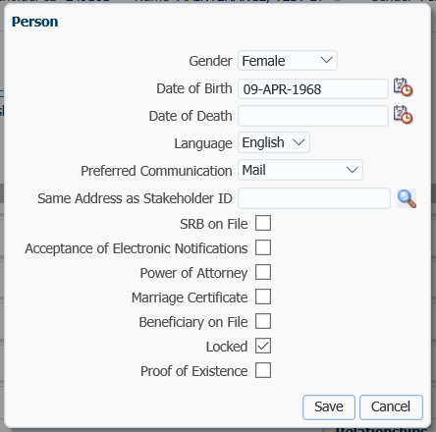

Provide Information Letter to Maintenance Enforcement Office

1. Provide the *Information* letter to the Maintenance Enforcement Office (MEO) with the requested information within 30 days of receiving the *Notice of Intention*. Send a copy of the *Letter of Intention* to the member by registered mail. Keep a copy for the member’s file.

Suspend Case

1. Change your **Case Task** to a 60 day follow up date by **Suspending** the **Task**. Locate your **Case** on your Dashboard, click on the **Case ID** number, Under Your **Case Task** click the **Suspend** option.

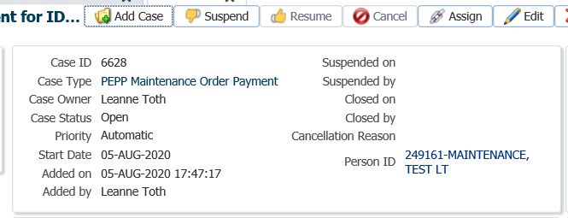

1. Under the **Task** region click on the **Edit** option to add a **Due Date** reminder.

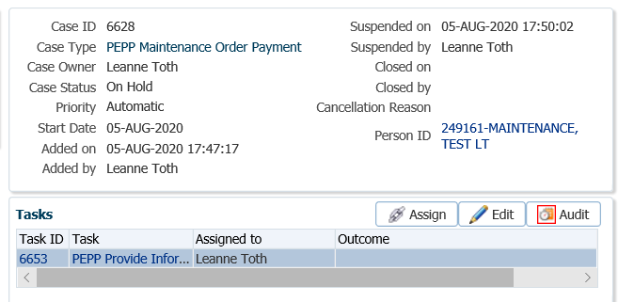

1. In the **Task** pop-up window, change the **Reminder Date** to a date 60 days in the future. Change the **Due Date** to a date in which the service standard for the **Case** type would be due for completion on after the reminder date. Click **Save**.

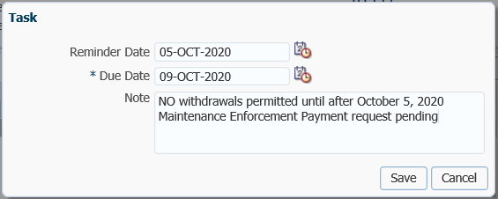

Day 1 - Notice of Attachement of Pension Entitlment Received

1. If the Maintenance Enforcement Office (MEO) is proceeding they will send in 2 copies of the *Notice of Attachment of Pension Entitlement.* Remove the 60 day freeze from the member’s account in PENFAX only if the member is taking scheduled payments. If scheduled payments are not being taken, leave the 60 day freeze in place and your Case open if the 60 days has not expired. If within the 60 days PEPP receives a request from the member for a lump sum payment or to start scheduled payments, PEPP can comply with the order to pay. Members must be taking a cash payment in order for PEPP to be able to process the request.

Check for Scheduled Payments

1. Determine if the member is receiving scheduled payments by checking for active instructions under the **Member Profile** menu, **Investments** screen. In the **Investment Accounts** region, highlight the **Account Class** of **VPB.**

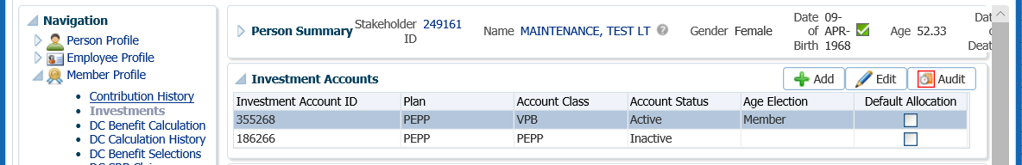

1. Under the **Investments** screen, **Account Instructions** region check for the **Instruction Type** of **Scheduled Withdrawal**. View the Details of the most recent **Scheduled Withdrawal** instruction.

*Example: Member is not Receiving Scheduled Payments*

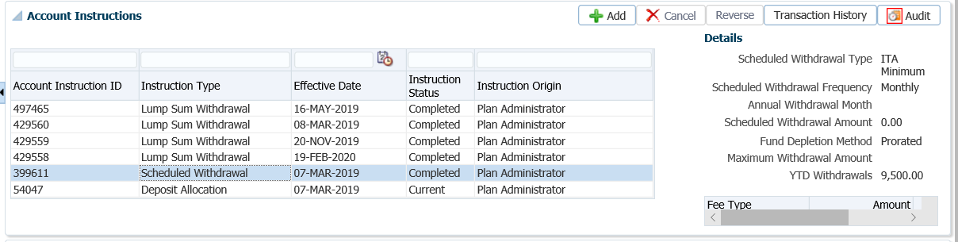

*Example: Member is Receiving Scheduled Payments*

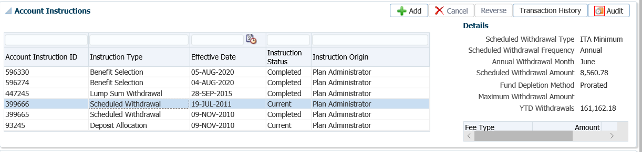

Unfreeze the Account if Proceeding with Payment Request or 60 Days has Expired

1. Under the **Person Profile** menu, **Person Summary** region, click **Edit**.



1. In the **Person** pop-up window un-select the **Locked** box and click **Save**.



Payee Setup

1. Determine if the person noted in the *Notice of Attachment of Pension Entitlement* to receive the payment is a stakeholder on PENFAX. Under the **People Search** option, select the **Person Search.**



1. In the **Search Parameters** region enter in your search criteria the last name of the person and click **Search**.



1. If the correct person has been located, click on the **Stakeholder ID** number to open the record. If the person does not exist as a stakeholder, click **Add Person** to add them as a new stakeholder.



1. Under the **Person Profile** menu, expand the **Contact Information** region for the person the payment is to be made to (e.g.: ex-spouse). Click **Add** to add a new address type.



1. In the **Address** pop-up window, add the mailing address of the Maintenance Enforcement Office as a **Business Address** to the person’s contact information as noted on the request. Enter the following and click **Save**:
   * **Effective Date** – leave as current
   * **End Date** – choose a date a couple of days after the payment will be made
   * **Address Type** – Business (if there is not already a business address)
   * **Line One** – c/o Maintenance Enforcement Office
   * **Line Two** – street address
   * **Line Three –** leave blank
   * **City –** city of Maintenance Enforcement Office
   * **Province** – province of Maintenance Enforcement Office
   * **Country** – country of Maintenance Enforcement Office
   * **Postal Code** – postal code for Maintenance Enforcement Office
   * **Address Type** - select Valid

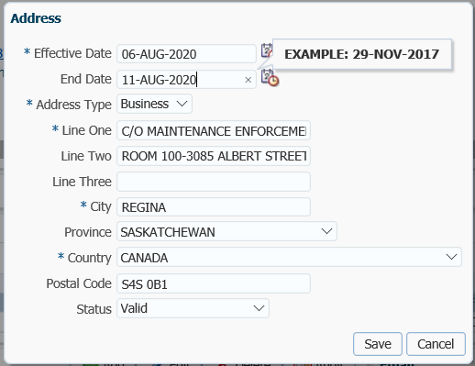

* **NOTE:** The payment has to be payable to the person listed on the *Notice of Attachment of Pension Entitlement* but has to be sent to the Maintenance Enforcement Office.

Add Maintenance Payment on Member’s Account

### Scenario: VPB Lump Sum Payment Request form received

1. Under the **Member Profile** menu, **Investments** screen, highlight the **VPB** **Investment Account**. In the **Account Summary** region below, confirm there is enough money in the member’s account to cover the amount of the payment.

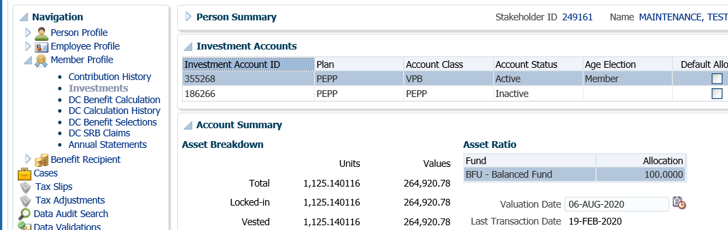

1. Under the **Member Profile** menu, click on the **DC Benefits Selections** screen. Highlight the **VPB Account Class** under the **Investment Accounts** region. In the **DC Benefit Selections** region, click **Add** to start the payment process.

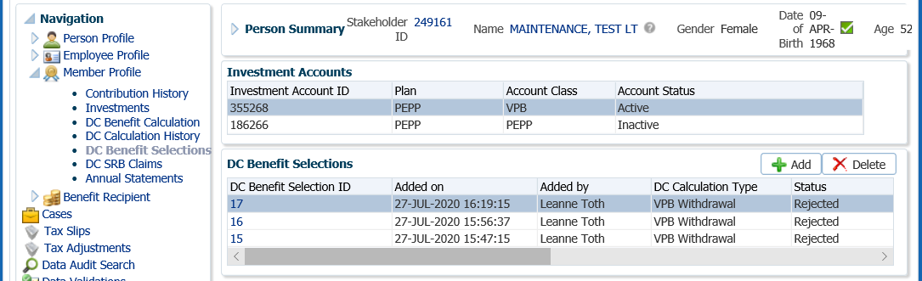

1. In the **Input Data** Train, click **Next** to start the payment process.

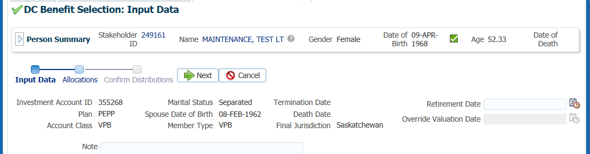

1. Under the **Allocations** region, click **Add.**

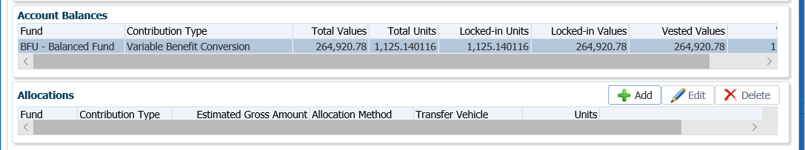

1. In the **Allocation** pop-up window, enter the following information and click **Save**:

* Fund – leave blank if the entire account balance is to be transferred
* Contribution Type – leave blank so that all funds and all sources will be transferred
* Allocation Method – Gross Amount
* Gross Amount – amount as specified in the *VPB Lump Sum Payment Request* form
* Transfer Vehicle – Cash
* Estimated Gross Amount – the amount will automatically populate based on the net amount entered

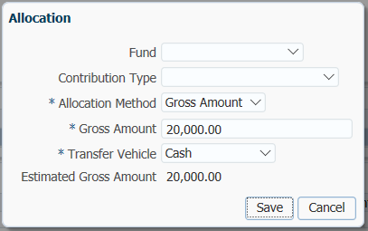

1. In the **Input Data Train** click **Next** to Confirm the Distributions of the payment.

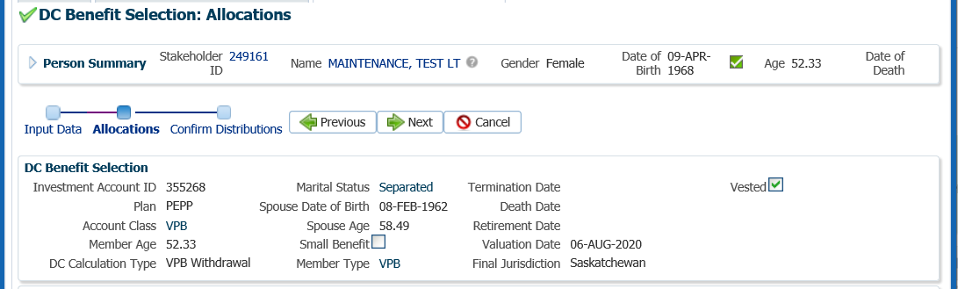

Add Payment Instructions for Member

1. In the **Onetime Amounts** region under the **Payment Instruction** column, click onthe drop-down list. If no information is displayed click on the **Add New** option. Payment Instructions should exist for the member upon set up of the VPB account for EFT or cheque instructions. If none exist add new instructions.

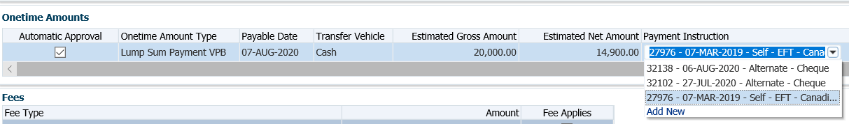

*Existing EFT Payment Instructions were selected for the member in this scenario*



* **TIP:** click on the  to see the Payment Instruction Details.

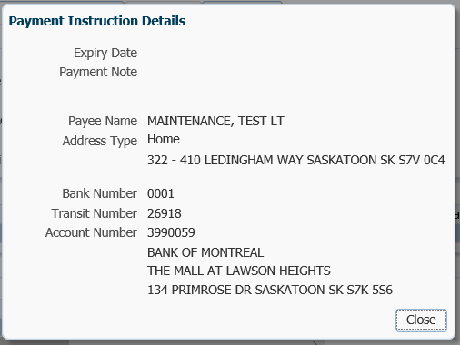

Add Tax Instructions for the Member

1. In the **Onetime Amounts** region, under the **Tax Instruction** column, click on the drop-down list, click on the **Add New** option if the member send in a new TD1 with changes to the tax instructions or choose existing tax instructions.

*Existing Tax Instruction were selected for the member in this scenario*

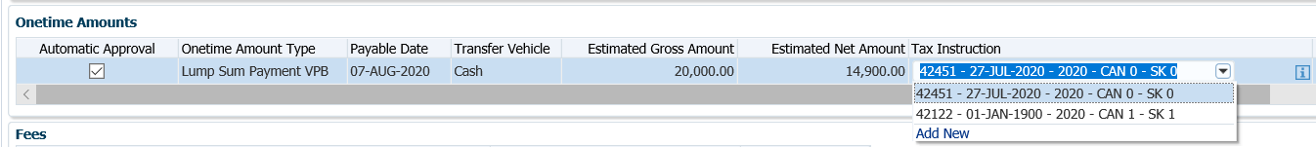

* **TIP:** click on the  to see the Tax Instruction Details.

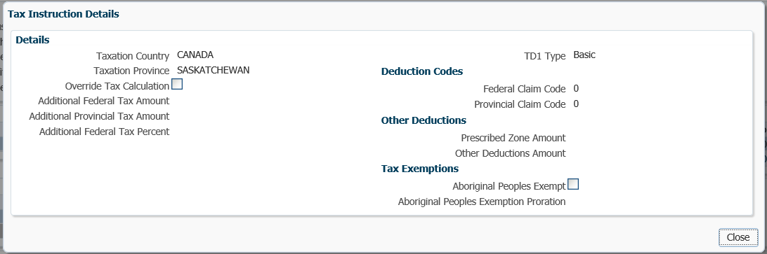

1. In the **Onetime Amounts** region, un-check the **Automatic Approval** box so that the payment is not automatically approved in the Benefit Recipient the next day.



1. In the **Input Data** **train**, click **Submit for Approval.**

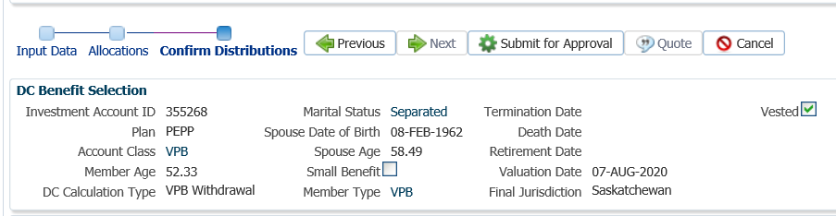

1. The Pension Specialist or Supervisor will audit and approve the VPB lump sum payment in the DC Benefit Selection region by clicking **Approve**, or **Reject** if there were errors or the payment was done in error.

* **NOTE:** If the payment is **Rejected**, the payment steps need to be entered again by the Pension Information Officer. There is no option to edit the existing information.

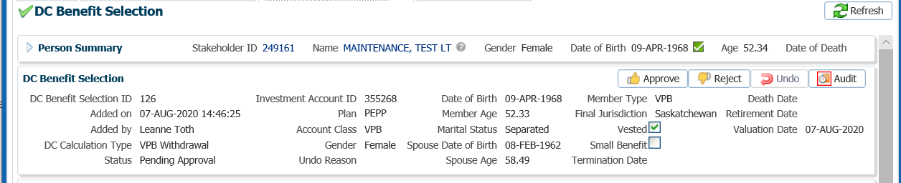

The **Reject** button is enabled if the status is **Pending Approval** or **Approved**. If the payment is rejected the status will update to **Rejected** when clicked and prevent the benefit selection from being processed by the investment batch.

The **Undo** button is enabled only if the status is **Processed** and will update the status to **Pending Undo** after selecting **Save.** Select an **Undo Reason**. After the investment batch runs, the status will be updated to **Undone** as a result of processing the reversal in the investment batch.

1. Add a Note and click **Save.**

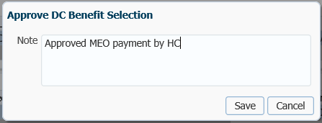

1. A history of Transactions, User and Event is shown under the **Audit** button.



* **NOTE:** Click on the **X** in the **Payment ID Tab** to close the window.



Day 2 – Add the Post-Tax Family Law Garnishment

1. In the **DC Benefits Selection** screen, confirm that the status of the payment is showing as **Processed**.

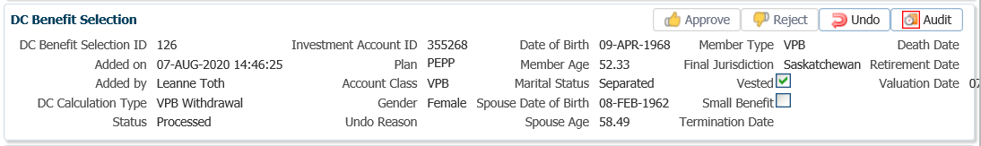

1. Open the **Benefit Recipient** folder that is created by adding the payment the first day. Highlight the VPB Member Type under the **Membership Periods.** In the **Benefits** region highlight the **Benefit Event ID** createdfor the **Benefit Type** of **Onetime**.

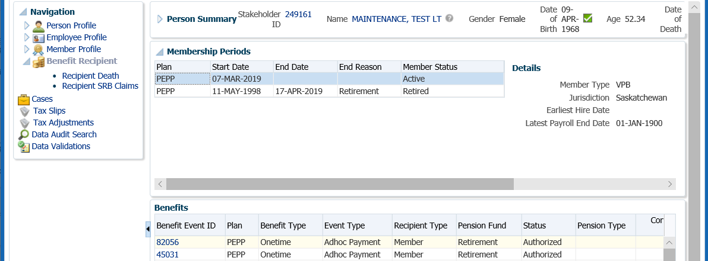

1. In the **Benefits** region open the **Deductions** tab. Click **Add** to add the deduction type for the Maintenance Order.

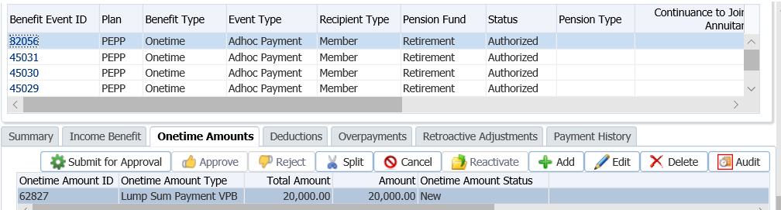

1. In the **Deduction** pop-up window, select or enter the following information, click **Save**:

* **Deduction Type** - Post-Tax Family Law Garnishment
* **Amount –** amount as per the *Notice of Attachment of Pension Entitlement*
* **Percent –** percent if request on the Notice of Attachment of Pension Entitlement
* **Payee Stakeholder ID –** ID of the person receiving the payment. Use the search icon to find the stakeholder ID if required.
* **Garnishment Order ID –** enter if available from the *Notice of Attachment of Pension Entitlement*
* **Note –** optional
* **Onetime Amount** – select the VPB Lump Sum Payment
* **Payee Payment Instruction –** choose **Add New** from the drop-down list

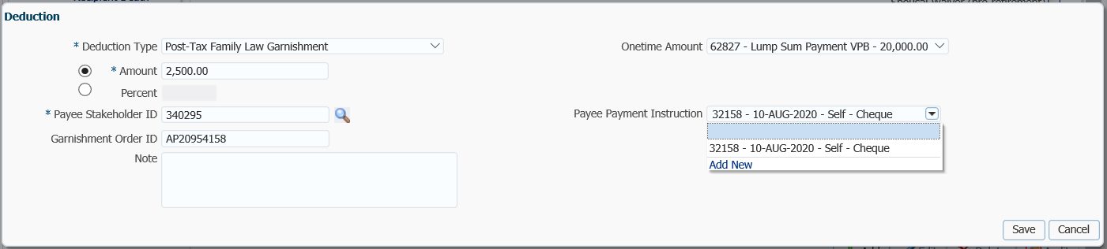

1. In the **Payment Instruction** pop-up window, select the following and click **Save**:
   * **Payee Type –** Self
   * **Payment Method –** Cheque
   * **Receipt Date –** current date
   * **Expiry Date –** leave blank
   * **Payment Note –** optional
   * **Payee Name –** will populate with the stakeholder ID entered on the Deduction window
   * **Override Payee Name –** leave blank
   * **Address Type –** select **Business**

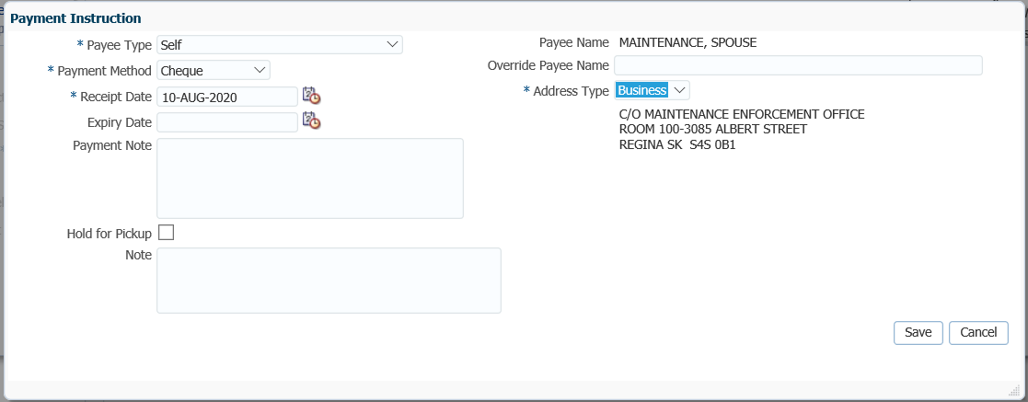

1. In the **Deduction** window the **Payee Payment Instructions** will populate, click **Save**.

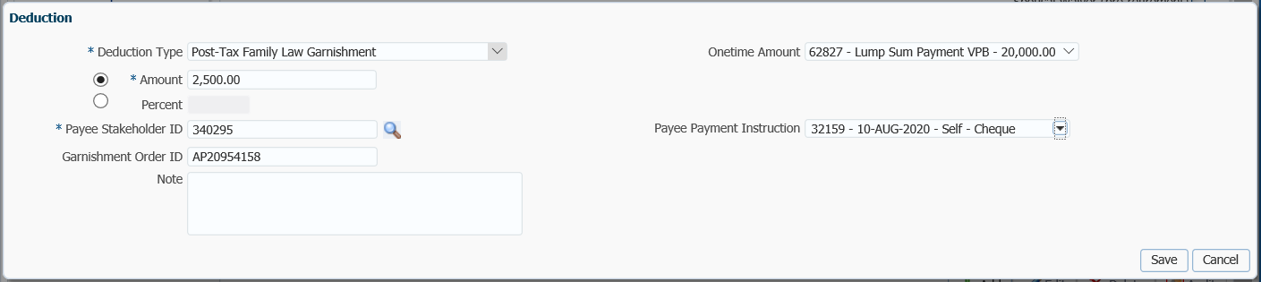

Add Administrative Fee

1. The Post-Tax Family Law Deduction Type and amount will now show under the **Deduction** tab and details displayed below. Click **Add** again to add the administration fee.

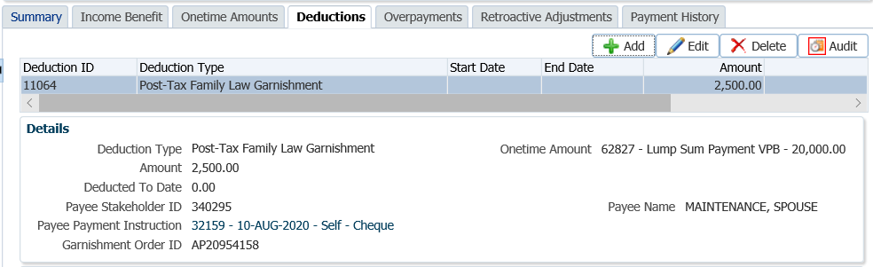

1. In the **Deduction** pop-up window, select the following and click **Save**:

* **Deduction Type - Administrative Fee to Comply with Maintenance Order**
* **Onetime Amount –** select the Lump Sum Payment VPB
* **Amount -** $45.00
* **Note –** optional

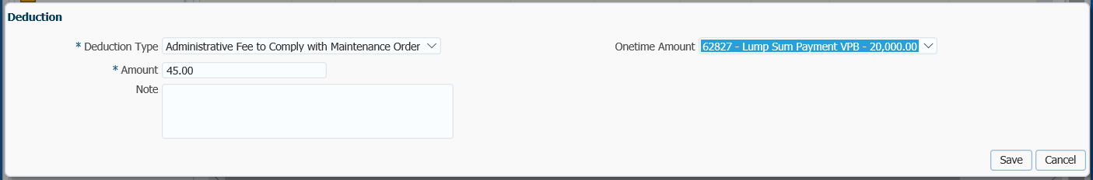

1. The Administrative Fee will now show under the **Deductions** tab and the details displayed below. The deductions will come off the next VPB scheduled payment.

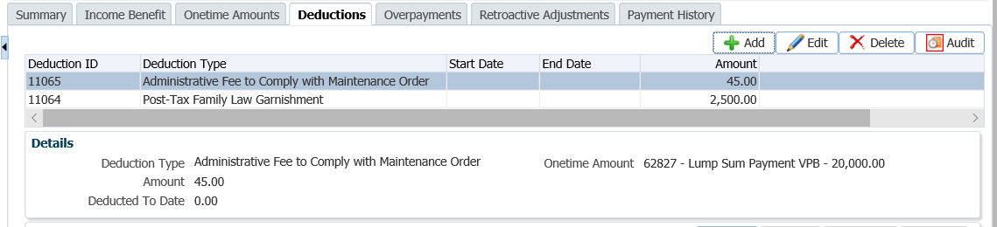

1. Select the **Onetime Amounts** tab and click the **Submit for Approval** button. Add a note in the pop-up window and click **Save.**

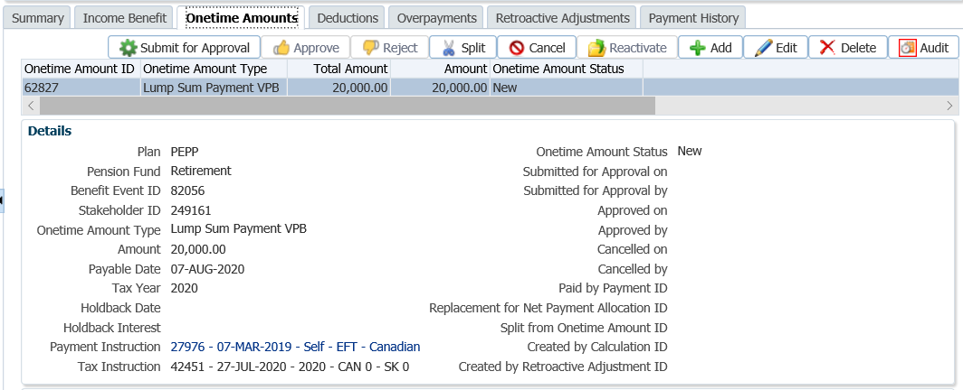

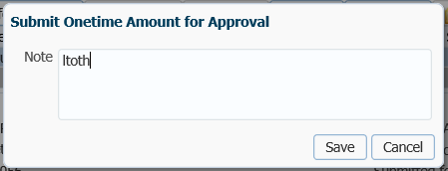

1. The *Pension Specialist* or *Supervisor* will audit and approve the VPB lump sum payment in the **Benefit Recipient** region by clicking **Approve**, or **Reject** if there were errors or the payment was done in error.

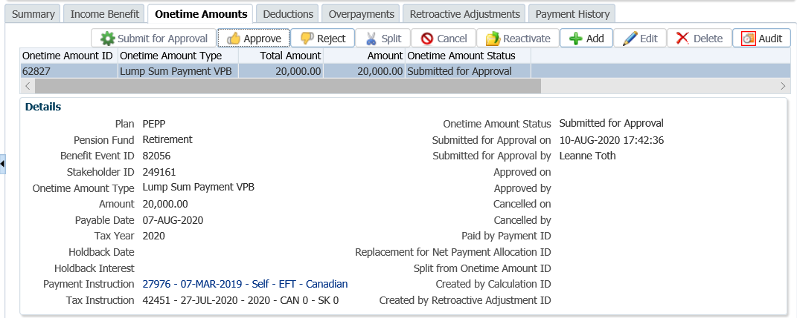

1. Add a **Note** in the **Approve Onetime Amount** pop-up window, click **Save.**

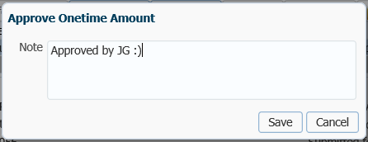

Day 3

1. The lump sum payment and maintenance enforcement garnishment will process in the overnight batch process and the EFT or cheques will be produced. The payment transaction details can be viewed under the **Benefit Recipient** menu, **Benefits** region for the **Onetime Benefit Type** on the VPB **Investment Account**.

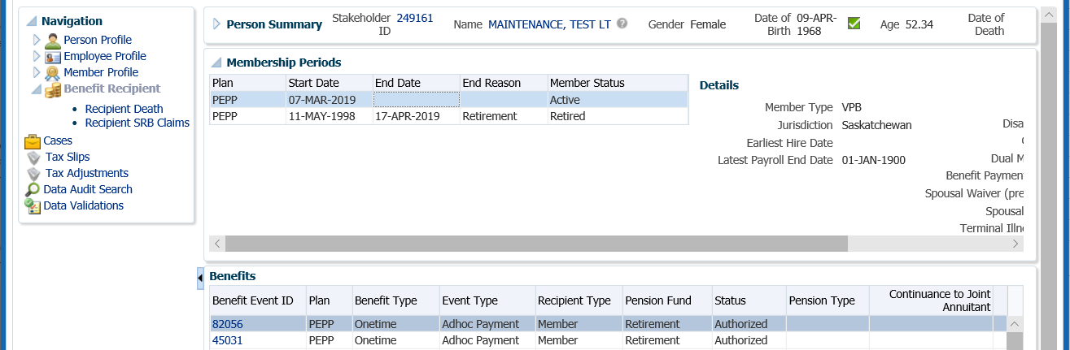

1. Under the **Benefits r**egion, select the **Onetime Amounts** tab. Under the **Onetime Amounts** tab, click on the **Paid by Payment Id** number to see further details of the payment.

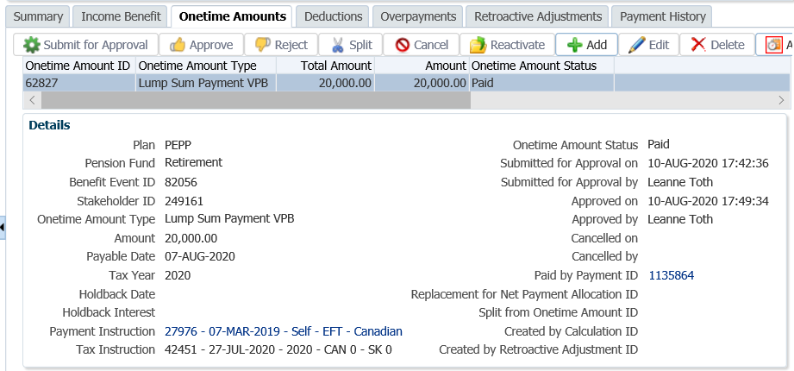

1. The Payment details, Recipient (Payee) details, tax deducted and cheque ID number can be seen by clicking on the Tabs to the right.

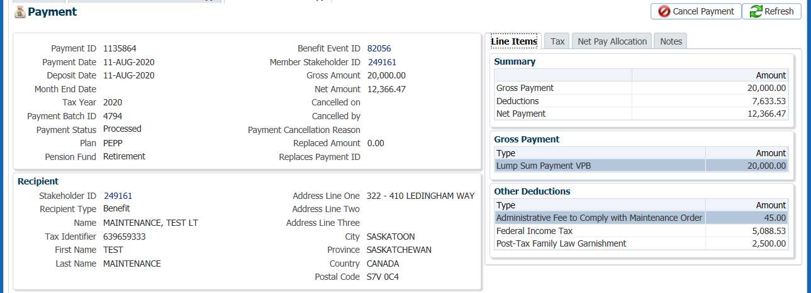

1. Prepare the *Maintenance Payment* letter to be sent with the cheque to the Maintenance Enforcement Office. A copy is to be sent to the member, and a copy kept for the member file.
2. tab.

1. To see the details of the cheque, click on the **Cheque ID** numberunder the **Net Pay Allocation** tab.





* **NOTE:** Click on the **X** in the Tab to close the window when done viewing.



1. A *Withdrawal Confirmation Letter* will be produced overnight and saved under the **Person Profile** menu, **Communications** screen, **Outbound Documents** region. Click on the **Filename** link to open the document.



1. The **Investments** screen, **Investment Accounts** region will now show the current balance under the **Account Summary** region and the **Account Balances** region. The total values will reflect the difference of the payment transaction that was valued overnight.



1. The member will be issue a T4A slip for the gross payment amount at the end of the year. The member is required to declare the attachment amount as income in the year of the payment as per the T4A. The T4A slip will be saved to the member’s account on PENFAX and can be viewed under the **Navigation** menu, **Tax Slips** screen.



### Scenario: Member Receiving or Starting Scheduled Payments

If a member is actively receiving scheduled payments, or sends in request to start VPB scheduled payments, and the request is received within the 60 days of PEPP receiving the *Notice of Attachment of Pension Entitlement,* the request can be processed.

1. **Follow Steps 1 – 20 from the Maintenance Enforcement Lump Sum Payment procedure**.
2. If the member is requesting to start VPB scheduled payments, ***refer to the procedures on******Adding or Changing Payment Schedules*** to set up the payment schedulefirst.
3. If a new scheduled payment instruction was added, hold your maintenance enforcement request until the first monthly payment runs and an Income Benefit Event is created. An Income Benefit Event is required in order to add the Deduction to.
4. In the **Benefit Recipient** menu, highlight the VPB **Investment Account** in the **Membership Periods** region.

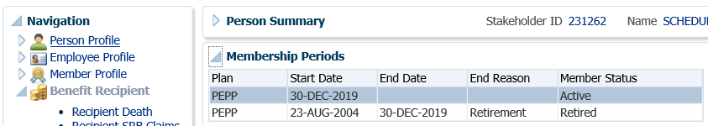

1. Under the **Benefits** region highlight the **Benefit Type** of **Income**. Open the **Deduction** tab.

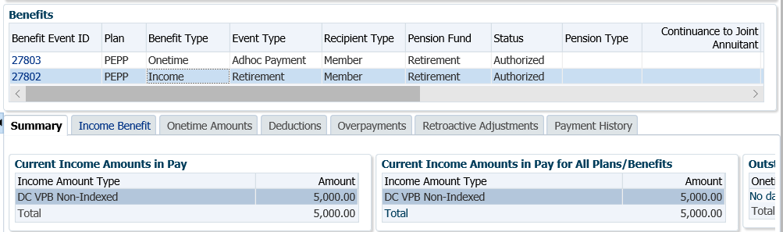

1. Under the **Deductions** tab, click **Add.**

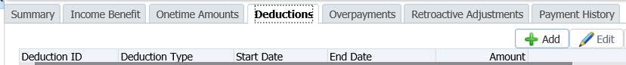

1. In the **Deduction** pop-up window, select and enter the following:

* **Deduction Type** - Post-Tax Family Law Garnishment
* **Start Date –** date the payments can start as soon as the onetime payment is made or the income amount is in pay
* **Amount –** amount as per the *Notice of Attachment of Pension Entitlement*
* **Percent –** percent if request on the *Notice of Attachment of Pension Entitlement*
* **End Date –** enter if the deduction is only to occur for a set amount of time. Leaving blank will ensure the deduction keeps reoccurring
* **Maximum Amount –** if the deduction should only continue until a maximum amount is reached, enter the amount
* **Payee Stakeholder ID –** ID of the person receiving the payment. Use the search icon to find the stakeholder ID if required.
* **Payee Payment Instruction –** choose **Add New** from the drop-down list
* **Garnishment Order ID –** enter if available from the *Notice of Attachment of Pension Entitlement*

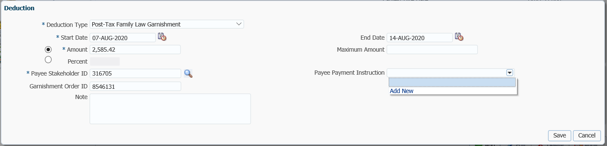

1. In the **Payment Instruction** pop-up window, select the following and click **Save**:
   * **Payee Type –** Self
   * **Payment Method –** Cheque
   * **Receipt Date –** current date
   * **Expiry Date –** leave blank
   * **Payment Note –** optional
   * **Payee Name –** will populate with the stakeholder ID entered on the Deduction window
   * **Override Payee Name –** leave blank
   * **Address Type –** select the “Business” address
   * **Note -** optional

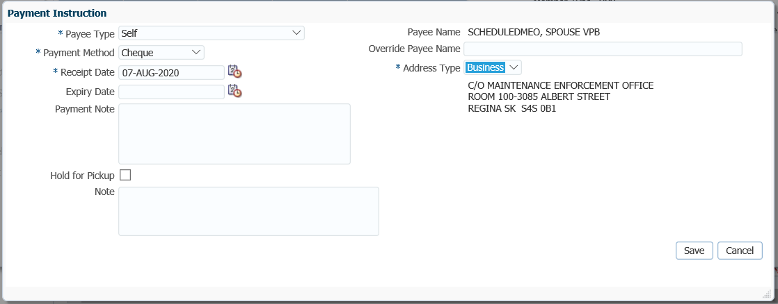

1. In the **Deduction** window the **Payee Payment Instructions** will populate, click **Save**.

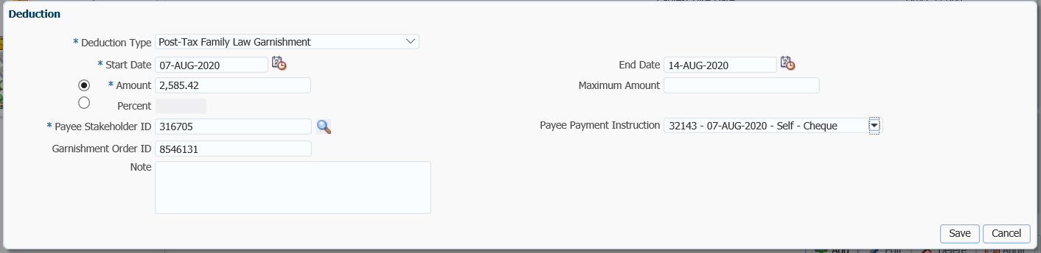

1. The **Post-Tax Family Law Deduction Type** and amount will now show under the **Deduction** tab and details displayed below. Click **Add** again to add the administration fee.

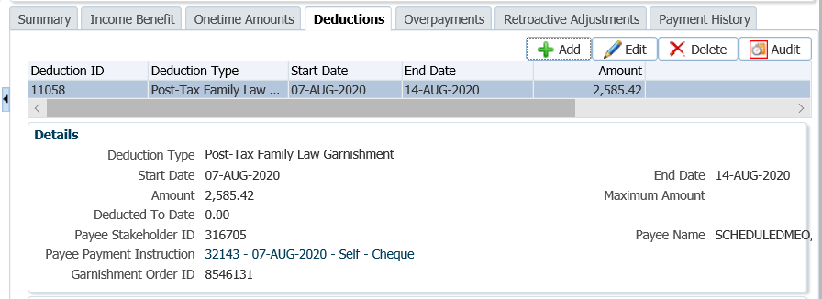

1. In the **Deduction** pop-up window, select the following and click **Save**:

* **Deduction Type -** Administrative Fee to Comply with Maintenance Order
* **Start Date -** current date
* **Amount -** $45.00
* **End Date** - leave blank
* **Maximum Amount** – leave blank
* **Note** - optional

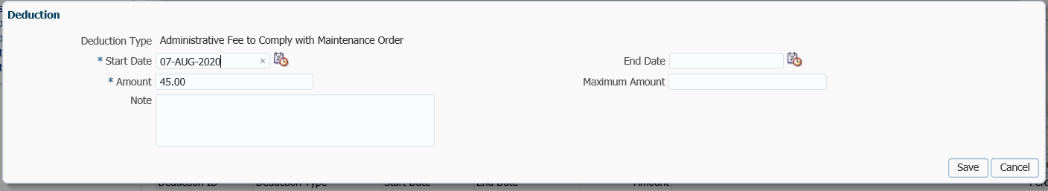

1. The **Administrative Fee** will now show under the **Deductions** tab and the details displayed below. The deductions will come off the next VPB scheduled payment.

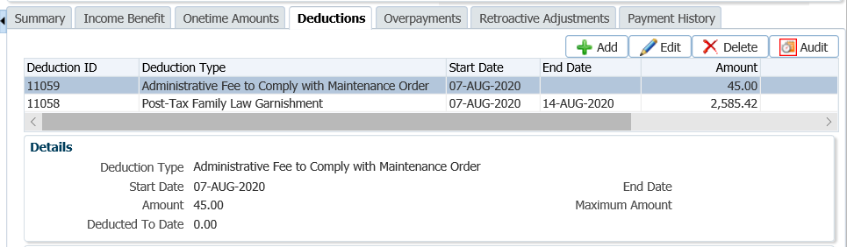

1. The member will be issue a T4A slip for the gross payment amount at the end of the year. The member is required to declare the attachment amount as income in the year of the payment as per the T4A. The T4A slip will be saved to the member’s account on PENFAX and can be viewed under the **Navigation** menu, **Tax Slips** screen.



### Updating and Deleting Garnishments

If a garnishment is added in error and no payments have been taken, the garnishment can be deleted.

1. Highlight the appropriate line and click the **Delete** button.

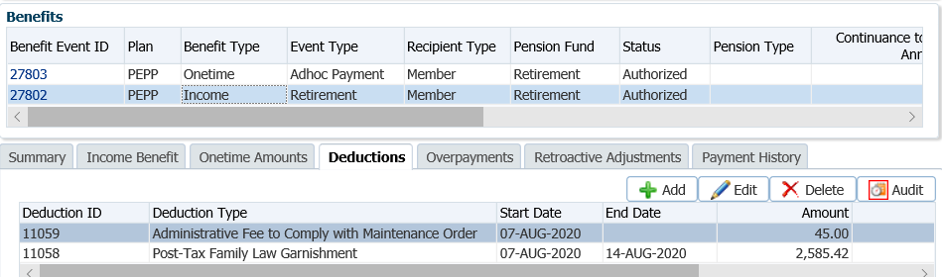

1. In the pop-up window, select **Yes** to delete the deduction.

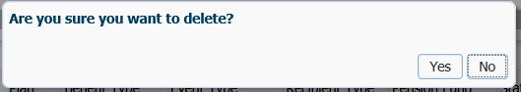

1. To edit the deduction, click **Edit. In the Deduction** pop-up window enter an **End Date**, click **Save.**

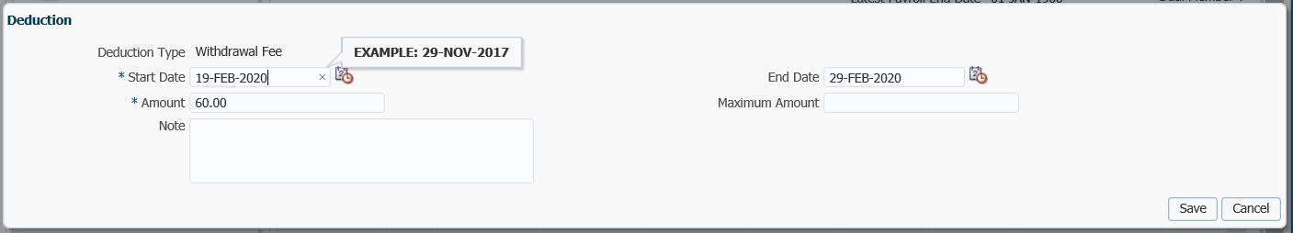

## VPB CRA Requirement to Pay

If a member owes tax but refuses to pay, the CRA can issue a type of garnishment known as a *Requirement to Pay*. The *Requirement to Pay* will advise PEBA to redirect all or a portion of any payment(s) due to the member to the CRA instead (i.e., the member is receiving Variable Pension Benefits). The CRA will then use these funds to reduce or pay off the member’s tax debt.

The *Requirement to Pay* will indicate the maximum amount to withhold from any payment due to the member. PEBA will forward this amount to the CRA for every payment that is made to the member unless the *Requirement to Pay* instructs PEBA to withhold:

* a fixed amount from each payment;
* a fixed amount from all amounts paid in a set time period (for example, one month); or
* a percentage from each payment.

Business Process Requirements – VPB CRA Requirement to Pay

* PEPP must receive a *Requirement to Pay* request from CRA.
* The *Requirement to Pay* will instruct PEPP of the net amount to forward to the CRA after any applicable fees and after the appropriate federal and provincial taxes are withheld.
* No fees are charged for this type of payment.
* A CRA *Requirement to Pay* is **not** allowed to be processed for members who are **actively** contributing to PEPP. PEPP member’s must be in a deferred plan status and request a cash refund to be eligible. The CRA requirement to pay amount would be deducted from the cash refund amount.
* If the member requested a registered transfer to another financial institution we would **not** deduct the CRA requirement to pay amount.
* If the member is in receipt of scheduled payments from the **Variable Pension Benefit**, PEPP will withhold the requested amount of each scheduled payment and send the amount to the CRA during the requirement period, or until the total sent equals the maximum amount on the *Requirement to Pay*.
* PEPP will only submit the percentage of partial payments.
* If a member is doing a full withdrawal, PEPP will pay the CRA the total outstanding debt first.
* PEPP will add a critical note  on PENFAX to advise PEPP administrators not to make any payments to the member that do not comply with the CRA’s directions.
* Once the payments to CRA have been activated, there is no longer an expiry date of one year. PEPP is required to continue to pay the debt until it is paid or until the member depletes their account, whichever comes first.
* Once the requirement to pay has been met, the critical note  is to be removed from PENFAX.
* If the member is not receiving payments, a critical note is added on PENFAX for one year, and then the order will expire. If the member starts scheduled payments or requests a lump sum payment, the CRA requirement to pay request can be honored if within the 1 year.
* Verify the member’s SIN on the Requirement to Pay request to the SIN on the PENFAX account to ensure it matches.
* If any information is missing on the form follow up with the member. ***Refer to Procedures to Obtain Missing Information***.

#### How to Process a CRA Requirement to Pay

1. Search for the member in PENFAX.
2. Confirm that the member meets the qualifications for a payment. If the member is in VPB they must be taking scheduled payments or request a VPB lump sum payment. If a cash refund for the entire account balance is requested the CRA required amount is taken from the payment.
3. If the member meets the qualifications, add a critical note  on PENFAX to advise PEPP administrators **not** to make any payments to the member that do not comply with the CRA’s directions. Under the **Person Profile** menu, **Notes** region, click **add**.

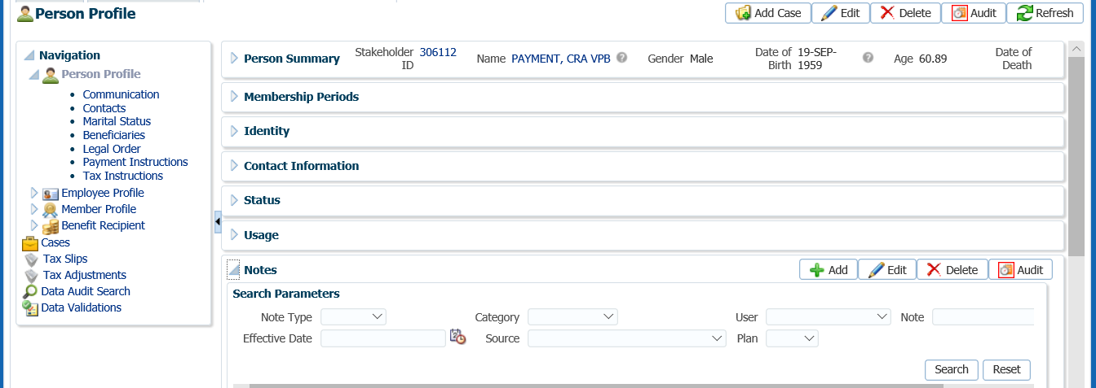

1. In the **Note** pop-up window, choose **Alert** as the **Note Type**, leave the **Category** as **General**. At message in the **Note** area and click **Save.**

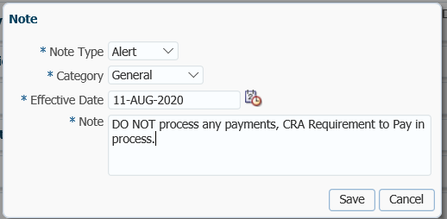

1. If the VPB member does **not** meet the qualifications, add a critical note  to their account for one year. The CRA requirement to pay order will expire after one year. If a VPB member starts scheduled payments or requests a lump sum payment within the one year, the request can be honored.

1. Suspend the assigned **Case** for a future date of one year. Create the **Case**, then go to **Open Tasks** on your Dashboard, select the first **Task** and click **Suspend.**



1. In the same Task, click **Edit**.



1. In the **Task** pop-up window change the **Reminder Date** to a year in advance and the **Due Date** to 3 days after, add a message in the **Note** field. Click **Save.**



1. Under the **Navigation** menu, **Person Profile** menu, **Membership Periods** region ensure the **Member Status** is showing as **Active** in VPB.

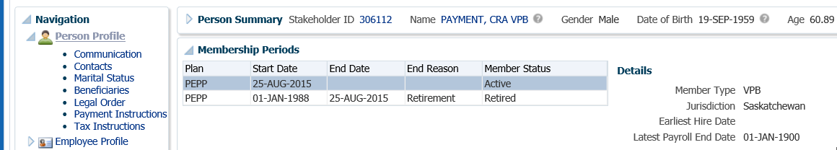

1. *PEPP member requesting a cash refund*. Under the **Navigation** menu, click on the **DC Benefit Selections** screen. Click **Add** to add a new payment in the **DC Benefits Selection** region.



1. In the **Input Data** train, click **Next** to start the **Input Data** process.



1. In the **Input Data** train under the **Allocations** region click **Add**.



1. In the **Allocation** pop-up window, select the following information and click **Save** once completed:

* **Fund** - leave blank to pro-rate across include all funds
* **Contribution Type –** leave blank to include all contribution types
* **Allocation Method –** percent
* **Net Amount –** 100.00(a split payment will be done)
* **Transfer Vehicle –** Cash
* **Estimated Gross Amount** – amount will automatically populate



* **NOTE:** the information will be displayed in the **Allocations** Region once saved.

1. In the **Input Data** **Train** click **Next** to Confirm the Distributions of the payment.



1. In the **Onetime Amounts** region under the **Payment Instruction** column, click on thedrop-down list. If no information is displayed select the **Add New** option.



* **NOTE:** if the same payee was previously added in the **Payment Instructions** screen under the **Person Profile**, then the information will be displayed in the drop-down list under **Payment Instructions** and can be selected for the payment.

1. In the **Payment Instruction** pop-up window, change **Payee Type** to Alternate, **l**eave **Payment Method** as **Cheque**, and the **Receipt Date** as the **Current Date**. Click on the **magnifying glass** to find the stakeholder ID for CRA.



1. In the **Search and Select Stakeholder** screen, select **Organization** as the **Stakeholder Type**. Under **Organization Type,** select **Tax Authority**, click **Search**.



1. In the **Search** Results area, locate the correct tax authority, highlight the name and click **Ok.**



1. The **Payee Stakeholder ID**, the **Payee Name** and **Address** will now be populated in the **Payment Instructions** window. Add the **Account ID** and a **Note** if applicable. Click **Save**.



1. In the **Onetime Amounts** region under the **Payment Instruction** column, click on thedrop-down list. If no information is displayed select the **Add New** option.



1. In the **Payment Instruction** pop-up window, leave the **Payee Type** as Self, the **Payment Method** as Cheque and the **Receipt** Date as the current date. Click **Save.**



The **Address Type** can be changed to an alternate address if the member wants the cheque to go to a mailing address or business address.

The **Notes** region will display any notes that were added during the calculation as well as allow the user to add more notes that pertain to the selected DC Benefit Selection.

## Splitting a Payment

The Split Payment function allows you to split a payment to divide between different financial institutions or accounts

1. In the **Onetime Amounts** region, click to highlight the payment. Choose the **Alternate Payment Instructions.** Click the **Split** button.



1. In the **Split Onetime Amounts** pop-up window, enter in the applicable amount type (gross amount to split, net amount to split or percent to split). For the CRA Requirement to Pay, select **Net Amount to Split** as per the CRA *Requirement to Pay* request. Click **Save**.



1. The **Onetime Amounts** region will now show the split of the payment and the **Estimated Gross Amounts** for each.



1. In the **Onetime Amounts** region, highlight the **Onetime Amount Type** for the payment to **Self**. Under the **Tax Instruction** column, click on the drop-down list, click on the **Add New** option.

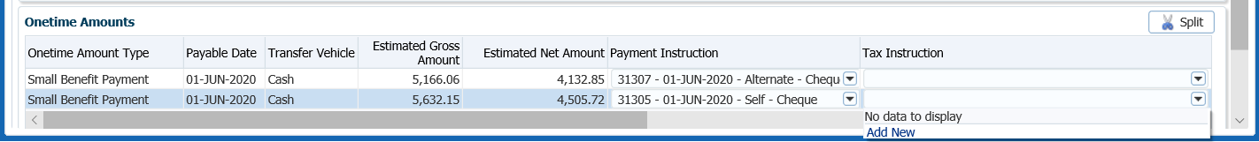

* **NOTE: Add Tax Instructions for the Alternate payment as well by highlighting that Onetime Amount Type row to select and following the same steps outlined.**

1. The **Tax Instructions** windowwill default to the **Advanced** option. If required, an **Additional Federal Tax Amount** or **Percentage** or an **Additional Provincial** **Tax Amount** can be entered. Click **Save**.

*Advanced TD1:*

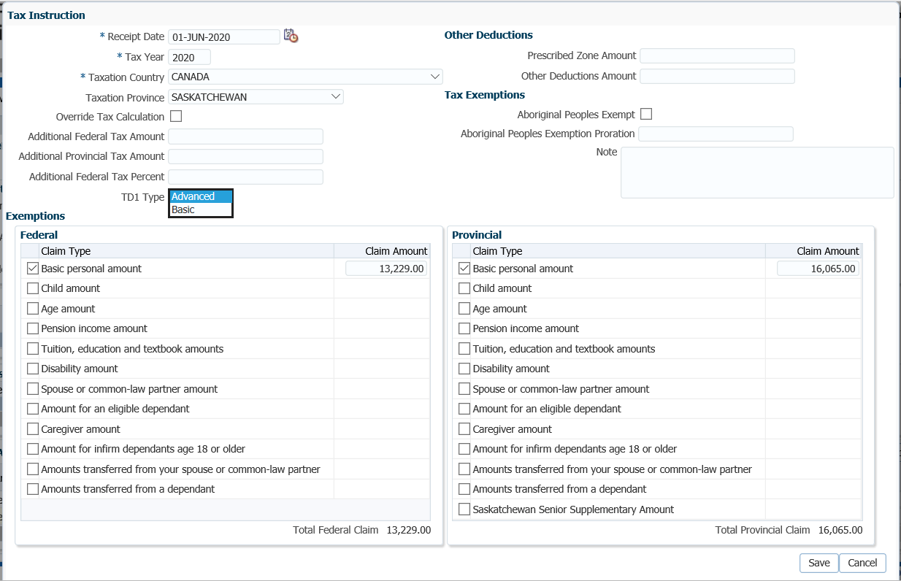

1. In the **Input Data** **train**, click **Submit for Approval.**



1. The *Pension Specialist* or *Supervisor* will audit and approve the payment in the **DC Benefit Selection** region by clicking **Approve,** or **Reject** if there were errors or the payment was done in error**.** Once **Approved** the status will change to **Approved**.



* **NOTE:** If the payment is **Rejected**, the payment steps will need to be entered again by the *Pension Information Officer*. There is no option to edit the existing information.

The **Reject** button is enabled if the status is **Pending Approval** or **Approved**. If the payment is rejected the status will update to **Rejected** when clicked and prevent the benefit selection from being processed by the investment batch.

The **Undo** button is enabled only if the status is **Processed** and will reverse the payment in the investment batch.

1. In the **Approve DC Benefit Selection** window, add a **Note** and click **Save**. The **Status** will now show as Approved. Return to payment request to the *Pension Information Officer*.





1. Close the **DC Benefit Selection** tab by clicking on the **X.**



1. A history of Transactions, User and Event is shown under the **Audit** button.





1. The payment will process in the overnight batch process and a cheque will be produced. The payment can be viewed under the **Benefit Recipient** Menu. Click on the **Onetime Amounts** tab to see the details.



1. Highlight each **Onetime Amount ID** row to see the applicable Payment details, Recipient (Payee) details, tax deducted and cheque ID number, click on the **ID number** beside the **Paid by Payment ID.**



1. Click on the tabs to the right of the screen (**Line Items, Tax, Net Pay Allocation** and **Notes**) to see further details related to the payment.



1. To see the details of the cheque, select the **Net Pay Allocation** tab. Click on the **Cheque ID** to open the **Cheque** window.





* **NOTE:** Click on the **X** in the **Payment ID Tab** to close the window.



1. A *Withdrawal Confirmation Letter* will be produced overnight. The letter will be saved under the **Person Profile**, **Communications** screen underthe **Outbound Documents** region. Click on the **Filename** link to open the document.



1. A **Tax Slip** for a cash payment will be issued at the end of the year and saved under the **Navigation** menu, **Tax Slips** screen.



1. Under the **Member Profile** menu, the **Membership Periods** region will nowshow the **Member Status** as Terminated or Retired, depending on the age of the member once the payment is processed overnight.



1. Under the **Investments** screen the **Investment Accounts** region will now show the **Account Status** as Inactive and the balance under the **Account Summary** region will show $0.00 if all the money was requested to be paid out.



1. Once the payments to CRA have been activated, there is no longer an expiry date of one year. PEPP is required to continue to pay the debt until it is paid or until the member depletes their account, whichever comes first.
2. Remove the critical note  from PENFAX once the requirement to pay has been met, or if the one-year window in which no cash refund request was made by the member. Under the **Person Profile, Notes** region. Highlight the applicable note and click **Delete**.



1. In the note pop-up window, click **Yes**.



## VPB Changes to Schedule Withdrawals, Payment Instructions or Tax Instructions

VPP members may request changes to be made to their scheduled withdrawal instructions, tax instructions or banking details at any time in the year.

**Business Process Requirements – Change in Payment Schedule, Tax or Banking**

* Member are required to submit a VPB *Payment Schedule Change* form or a *VPB Banking Information* form or the applicable TD1 Personal Tax Credits Return form for any changes they would like to make to their payment schedules, tax instructions or banking details.
* If requesting a change to banking details a void cheque or direct deposit form stamped by the financial institution must also be sent with the *VPB Banking Information* form.
* Members are allowed one free change per fiscal year for a payment schedule change or a change of fund from which the payments are made from. Requests for changes exceeding one per fiscal year will be charge a fee of $25.

### Changes to Scheduled Withdrawals for an Income Benefit Amount

Members may request changes to be made to the payment amount, the payment frequency or the fund depletion method for scheduled withdrawals. Members may also request to stop and start payment schedules if they are under the age of 72. A fee will be charged if the member has requested changes to their payment schedule that exceed one per fiscal year.

#### How to Change a Scheduled Withdrawal

1. Search for the member in PENFAX.
2. Under the **Member Profile** menu, **Investments** screen, highlight the VPB Investment Account if the member has more than one account.

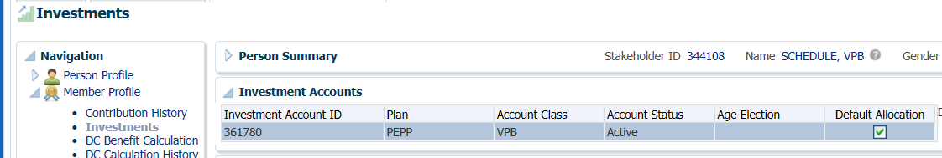

1. Expand the **Account Instructions** region, click **Add** to add the schedule.

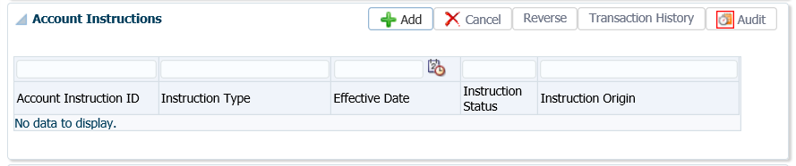

1. In the **Account Instruction** pop-up window select the following and click Save:

* **Instruction Type - Scheduled Withdrawal**
* **Effective Date –** enter the date as the next day from current date
* **Scheduled Withdrawal Type –** Drawdown Guidance, Fixed Amount, ITA Minimum (starts at age 72)
* **Scheduled Withdrawal Frequency –** Annual, Monthly
* **Scheduled Withdrawal Amount –** amount selected by member or will show as $0.00 if ITA Minimum selected
* **Annual Withdrawal Month –** month the member chooses to have the payment made if Monthly chosen
* **Fund Depletion Method** – Prorated, Specified Order, Specified Percentage
* **Fee Type** – will be blank if it is the 1st schedule being set up, it will be checked if there is an existing schedule and a change is being made. PENFAX will automatically charge if applicable. The first schedule setup for the VPB application does not count. Ensure you review the date the member was enrolled into VPB to determine and uncheck the Fee Applies box if required.
* **YTD Withdrawals** – will populate if payments have been taken to date

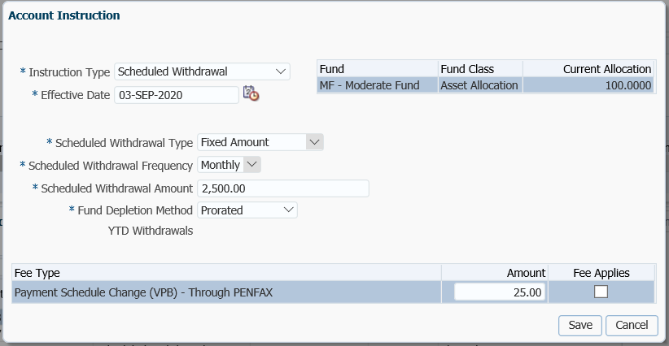

1. The new payment schedule instructions will appear under the **Investment** screen, **Account Instructions** region in a **Current Instruction Status**. The old Scheduled Withdrawal Instructions will show as **Completed**.

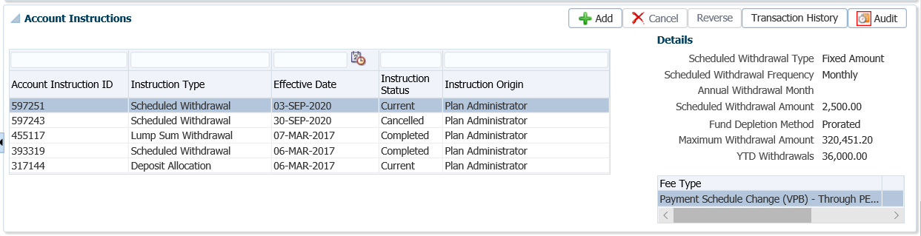

1. The next Scheduled payment will read the new Instructions Type marked as current.

### Changing Payment Instructions and Adding Alternate Instructions

When a member has a change in banking instructions, an expiry date is added to the old payment instructions and new payment instructions with the new banking details are set up.

Changes to Payment Schedules are to be performed for the following reasons:

* Member stopped payments and now they want to resume payments (if under age 72)
* Member has new banking details
* Member receives payments by cheque and has new banking instructions
* Member receives payments by cheque and has a new address
* Member wants a portion of their income benefit to go to a different bank account

#### How to Change Payment Instructions or Add a 2nd Bank Account for Income Benefits

1. Search for the member in PENFAX.
2. Under the **Person Profile** menu, **Payment Instructions** screen, expand the **Membership Periods** region. Highlight the applicable **Membership Period** for the VPB **Member Type** to make the change for.

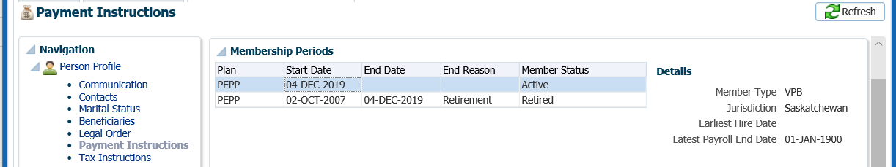

1. Under the **Payment Instructions** region, click **Add**.

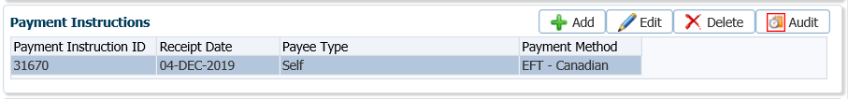

1. In the **Payment Instructions** pop-up window, select the following information and click **Save**:

* **Payee Type** - Self
* **Payment Method** – EFT Canadian
* **Receipt Date** – leave as current date
* **Expiry Date** – used if payment method is EFT, and banking instructions are only to be used for a limited time
* **Payment Note** – add a note if applicable
* **Bank Number** – as per void cheque
* **Transit Number** – as per void cheque
* **Account Number** – as per void cheque
* **Note** – add a note if applicable
* **Payee Name** – will populate with member’s name
* **Override Payee Name** – not applicable for EFT method
* **Address Type** – not applicable for EFT method.

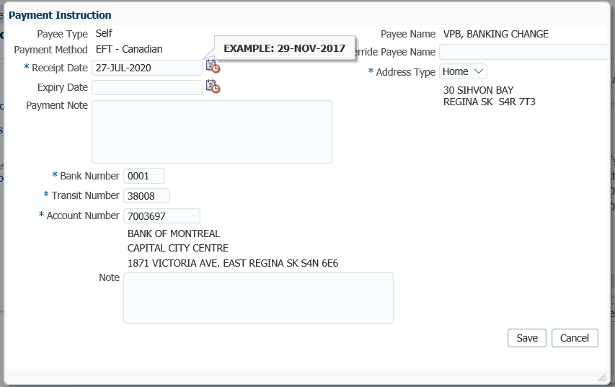

1. In the **Payment Instructions** region, highlight the previous payment instructions, click **Edit**.

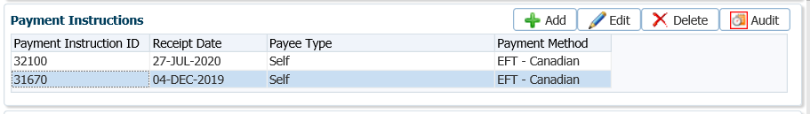

1. In the **Payment Instructions** pop-up window enter a current date in the **Expiry Date** field. This will end the old payment instructions and use the new payment instructions going forward. Click **Save**.

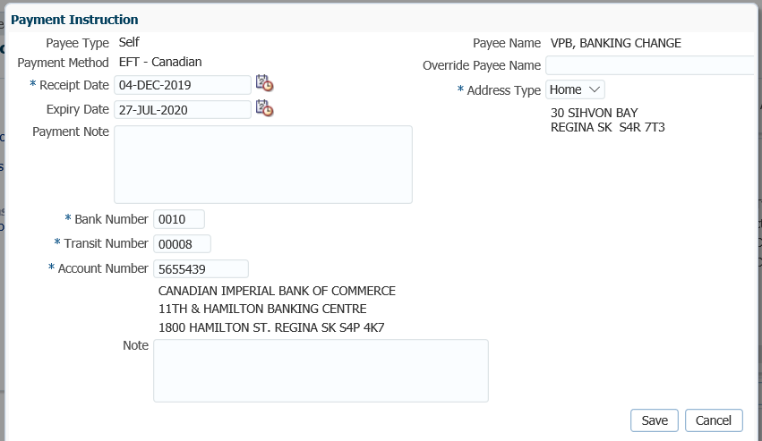

1. Under the **Benefit Recipient** menu, **Benefits** region, highlight the **Income Benefit Type** of **Income**.

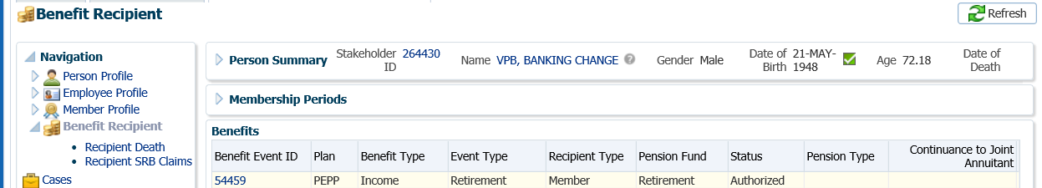

1. Click on the **Income Benefit** tab to open the window. Under the **Payment Instructions** region, click **Add**.

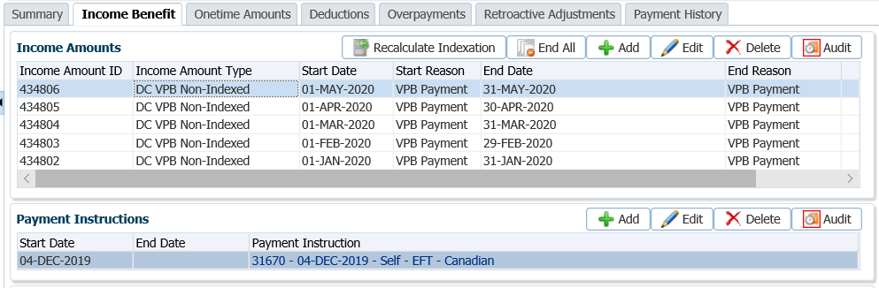

1. In the **Income** **Payment Instructions** pop-up window, select the following information and click **Save**:

* **Start Date –** date the new payment instructions are to start (equal to the last business day of the month)
* **End Date –** only applicable if a temporary payment instruction is required
* **Default Instruction –** select the new payment instructions from the drop-down list if there are existing instructions to be used, if there are none click **Add New** from the drop-down list
* **First/Second/Third Alternate Instruction –** select a 1st, 2nd or 3rd alternate payment instruction if request. Members can have different banking instructions for a portion of their income benefit payment to go to. Can be set to amount or percent.
  + **Amount –** input amount
  + **Percent –** applicable percentage

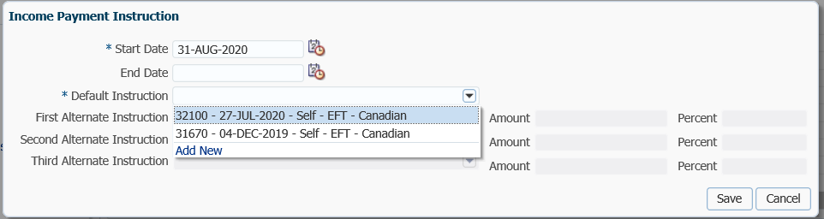

1. If **Add New** was selected, enter in the newinformation in the **Payment Instruction** pop-up window, if EFT is selected enter the new banking details. Click **Save.**

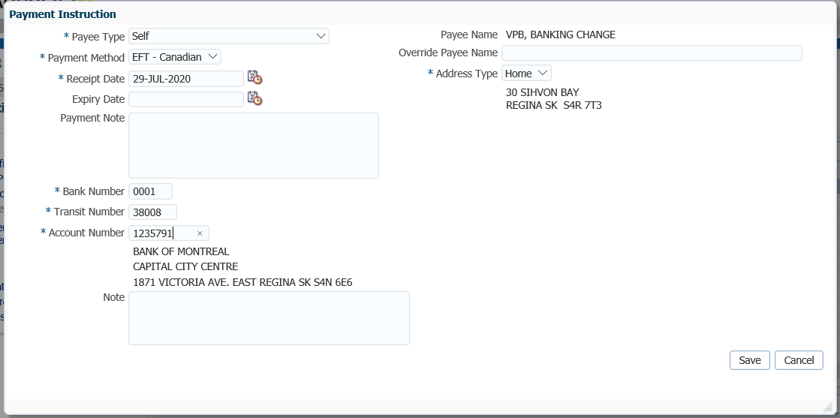

1. In the **Income Payment Instruction** window, click **Save** to save the new payment instructions for the next Income Benefit amount to be deposited to.

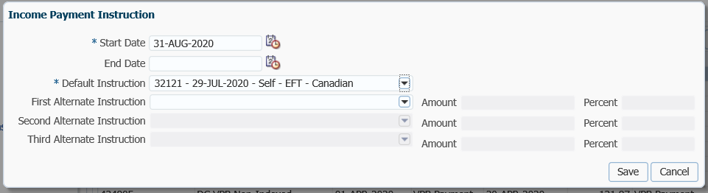

|  |
| --- |
|  |

### Suspending Payment Instructions

When a member requests to stop their VPB payments they must be under the age of 72 or a deceased member.

#### How to Suspend Payment Instructions

1. Under the **Benefit Recipient** menu, **Benefits** region, highlight the most recent **Income Benefit Type**. Under **Authorization History,** click **Suspend**.

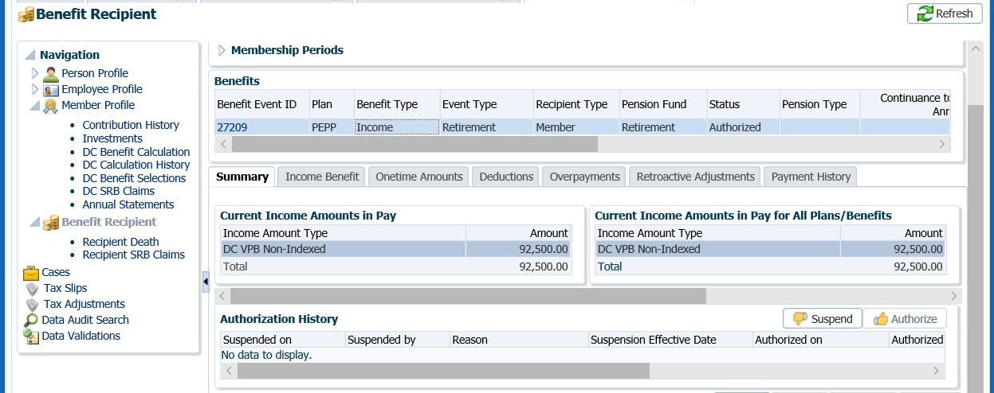

* **NOTE:** It is important to make sure the correct **Benefit Event ID** is selected when you suspend the payment schedule. The last Benefit Type of Income must be highlighted. If you suspend one that has a Benefit Type of Onetime the monthly payments will continue to go through.

1. In the **Suspend Benefit Recipient** pop-up window, select the **Reason** for the suspension of payments. Click **Save**.

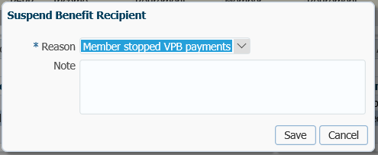

1. The **Authorization History** region will now show the information entered with a reason and an effective date. No further payments will be made to the member while suspended.

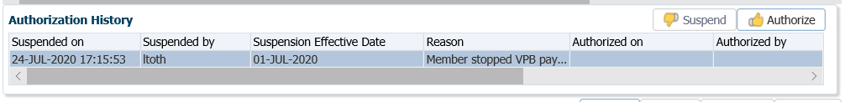

### Change Age for ITA Minimum

Once per year, a member whose marital status is married or common-law may change the age election used to determine the factor to be used to calculate the minimum payment withdrawals when they reach age 72. The change can be requested at any time in the year. Members have the option of using their age or their spouse’s age to calculate the minimum withdrawal amount, the change will take effect the following calendar year and will not impact the current year’s required minimum payment.

Business Process Requirements – Change Age for ITA Minimum

* Members must to submit a signed *Variable Pension Benefit Payment Schedule Change* form.
* A copy of the form is acceptable.
* If any information is missing or unclear contact the member***. Refer to the Procedures to Obtain Missing Information.***
* A change to the minimum payment calculation can be requested once per year but does not take effect until the following calendar year.

#### How to Change the Age for ITA Minimum

1. Search for the member in PENFAX.
2. Under the **Member Profile** menu, **Investments** screen, expand the **Investment Accounts** region.

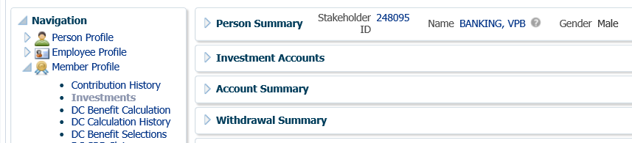

1. In the **Investment Accounts** region, highlight the **VPB Account Class** and click **Edit**.

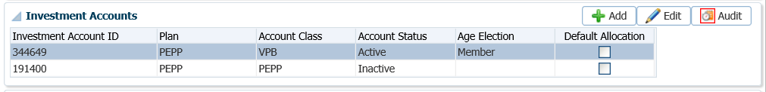

1. In the **Add Investment Account** pop-up window, change the **Age Election** field to **Spouse** or **Member** as per the request. Click **Save**.

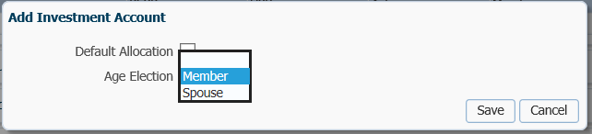

1. The change will now be displayed under the **Investment Accounts** region and will take effect for the following year.

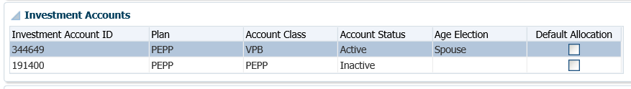

### Deleting Payment Instructions

If payment instructions have been set up but not used (i.e. the payee requested a different set of instructions before the payment was included in a payment run), the instructions can be deleted and a new set created. If payment instructions have been used in at least one payment, they should be end dated, not deleted.

#### How to Delete Payment Instructions

1. Under the **Person Profile** menu, **Payment Instructions** screen, click on the **Payment Instructions** region and click **Delete**.

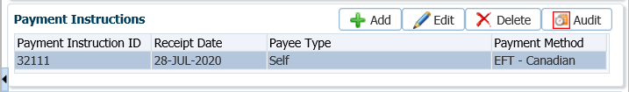

1. Confirm the deletion by selection **Yes**.

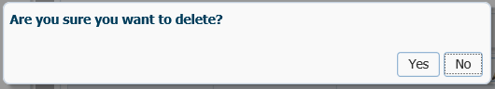

1. If the payment instructions have been used in at least one payment run, they should be end dated rather than deleted. This allows you to keep a copy of the previous instructions for reference. In the **Payment Instructions** region, click **Edit.**



1. In the **Payment Instructions** pop-up window, under **Expiry Date** enter a current date to expiry the payment instructions.

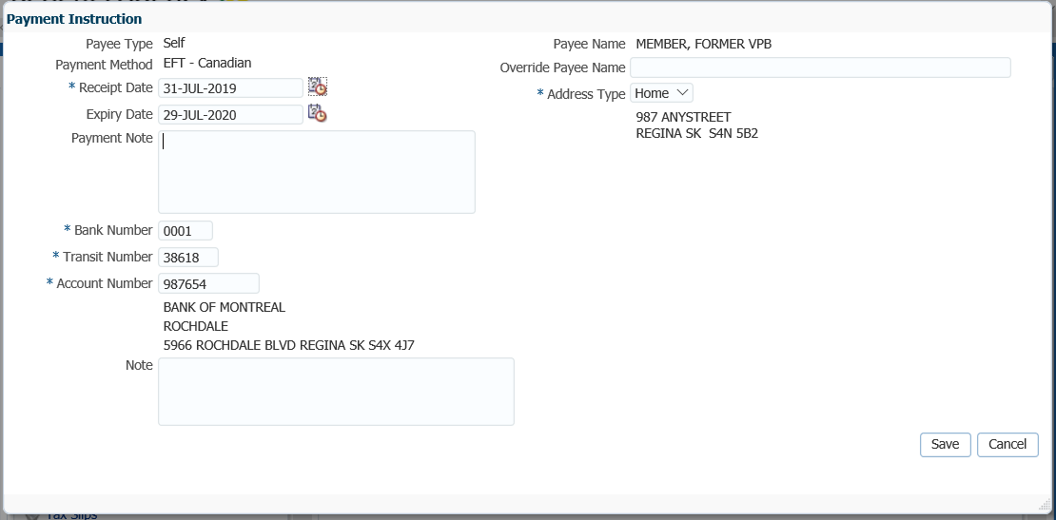

### Changing Tax Instructions for Income Amounts

Tax instructions are performed when a member has new banking, a member is requesting additional tax to be deducted or the member submits a new TD1 Tax Credits Return form.

When a member has a change in tax instructions, an expiry date is added to the old tax instructions and new tax instructions are set up.

#### How to Change Tax Instructions

1. Search for the member in PENFAX.
2. Under the **Benefit Recipient** menu, **Benefits** region, highlight the **Income Benefit Type** of **Income**.

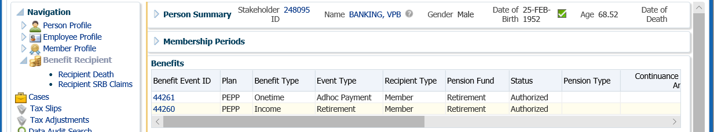

1. Click on the **Income Benefit** tab to open the window. Highlight the last **Income Amount** Type. Under the **Tax Instructions** region, click **Add**.



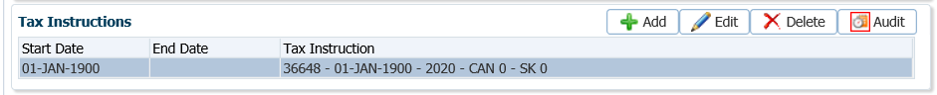

1. In the **Income** **Tax Instruction** pop-up window, select the following information and click **Save**:

* **Start Date –** leave as current date
* **End Date –** only applicable if a temporary payment instruction is required
* **Tax Instruction –** select the **Add New** instructions from the drop-down list

` 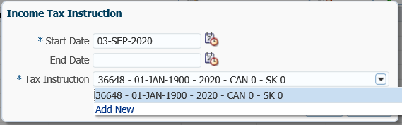

1. If **Add New** was selected, enter in the newinformation in the **Tax Instruction** pop-up window as per the member’s request and TD1 forms. Click **Save.**

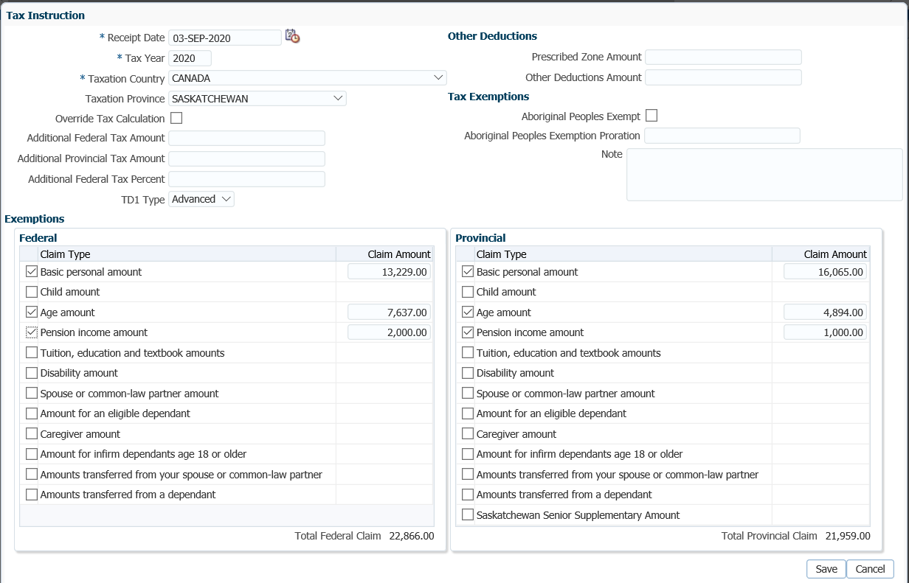

1. In the **Income Tax Instruction** window, click **Save**.

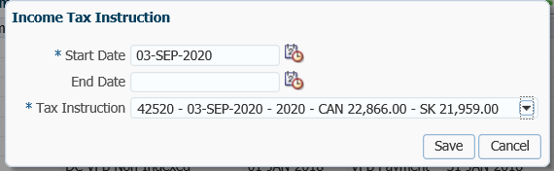

1. The new tax instructions will be selected for the next Income Benefit amount.

### Deleting Tax Instructions

If tax instructions have been set up but not used (i.e. the payee requested a different set of instructions before the payment was included in a payment run), the instructions can be deleted and a new set created. If the tax instructions have been used in at least one payment run, they should be end dated rather than deleted. This allows you to keep a copy of the previous instructions for reference.

#### How to Delete Tax Instructions

1. Under the **Person Profile** menu, **Tax Instructions** screen, **Tax Instructions** region. Click **Delete.**

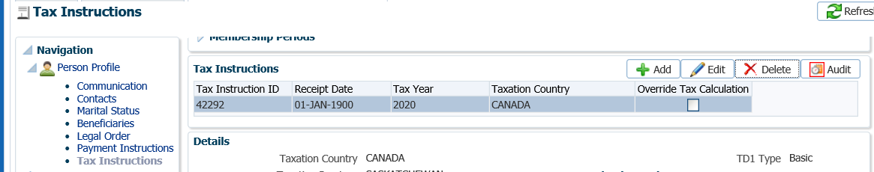

1. In the pop-up window, select **Yes**.

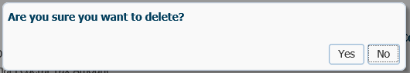

# Reversals and Corrections

When transactions are entered incorrectly or in error on a member’s account, they are required to be cancelled, reversed or deleted from the member’s account in PENFAX in order to correct the error.

It is very important to first determine if there have been any downstream transactions prior to doing any reversals and if so, complete an Error Correction form to document the steps. ***Refer to the Business Process Requirements for Reversals*.**

Business Process Requirements - Reversals

* Determine if there has been any downstream activity:
  + Has the member requested an inter-fund transferred to a new fund since the date the deposit error happened?
  + Has the member taken a payment (partial or full)?
* Have new contributions been deposited since the deposit in error?
* Complete an Error Correction form to document the steps for each transaction prior to processing any reversals.
* If there has been downstream activity on the member’s account, the transactions that occurred after the transaction in error are to be reversed first in sequential order, newest to oldest up until the date of the transaction the error occurred on.
* Ensure a 2nd person audit occurs before any processing to review the processing steps outlined on the Error Correction form and after processing to ensure the member’s account is correct.
* Administrative breakage will result from reversing the transaction(s) as the units previously bought/sold are then bought/sold back based on the current days unit value. Breakage could result in positive or negative breakage depending on whether the price of the units originally sold have now gone up or down.
* ***Refer to procedures on how to cancel and reverse financial and non-financial transactions***.

## Deleting an Enrolment

If an enrolment was received and entered into PENFAX in error, the employment events, membership period and Welcome letter must be deleted from the system. There is no ability in PENFAX to delete the stakeholder record. The process is the same for a PEPP enrolment or a VPB enrolment.

It is very important to first determine if there have been any downstream transactions prior to doing any reversals and if so, complete an Error Correction form to document the steps. If contributions were send in error, the contributions need to be reversed from the account prior to the enrolment being deleted. ***Refer to the Business Process Requirements for Reversals*.**

#### How to Delete an Enrolment

1. Search for the member in PENFAX.

1. Under the **Navigation** menu, **Employee Profile** screen, confirm the **Membership Periods** region is showing as Active.

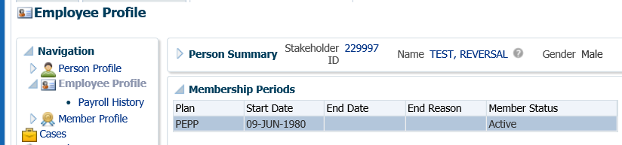

1. Under the **Navigation** menu, **Employee Profile** screen, confirm the **Employment Periods** region has a new **Enrolment Date** and a new **Employment Event** exists under **Employment Events**.

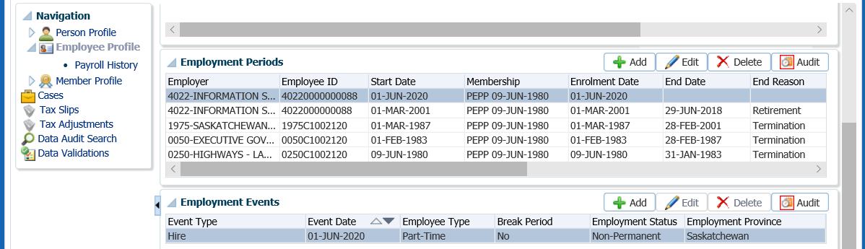

1. Under the **Employee Profile** menu, **Employment Periods** region, click **Delete**.

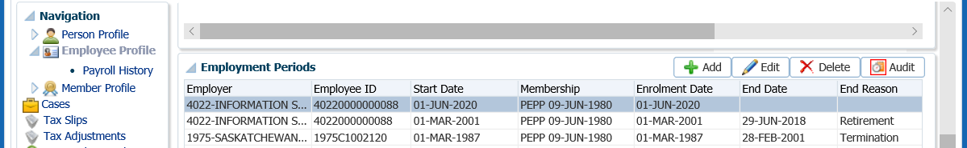

1. In the pop-up window, click **Yes** to delete the record.

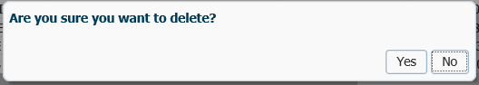

1. Go to the **Member Profile** menu, under the **Membership Periods** region, click **Delete**.

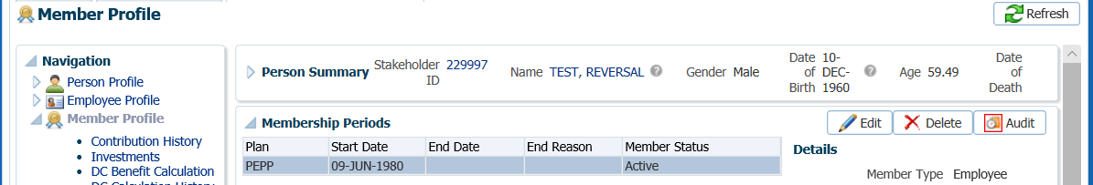

1. In the pop-up window, click **Yes** to delete.

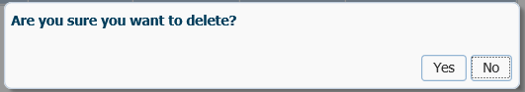

1. Under the **Person Profile** menu, **Communications** screen, **Outbound** Documents, highlight the row with the Welcome Letter. Click **Delete**.

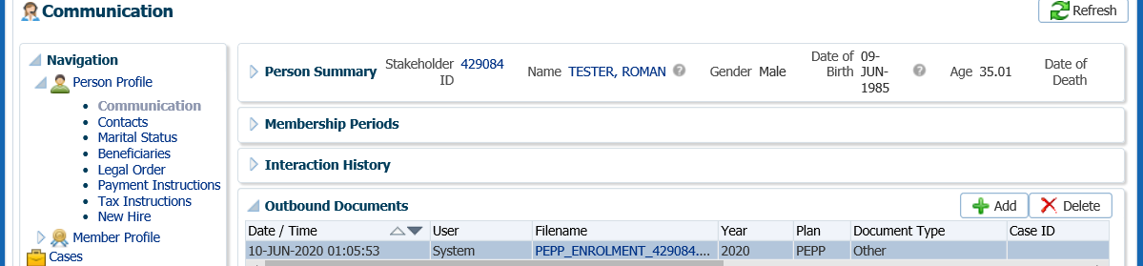

1. In the pop-up window, click **Yes** to delete the letter.

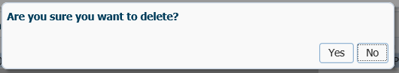

## Reverse an Employment Termination

If a Termination form was received in error from an employer or added to the wrong member and the DC Benefit processed, the termination can be reversed or undone if payments have not been made to the member.

#### How to Reverse and Employment Termination

1. Search for the member in PENFAX.
2. Under the **Employee Profile** menu, **Membership Periods** region, confirm that the member is in a deferred plan status.

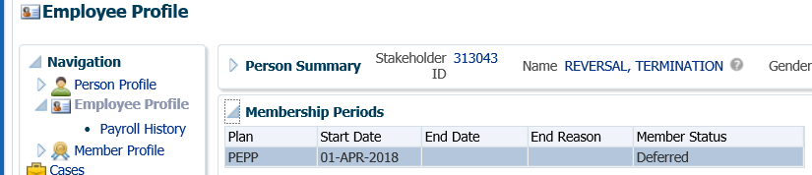

1. From the **Member Profile** menu, select the **DC Calculation History** screen. Highlight the **DC Calculation ID**, click the **Delete** option.

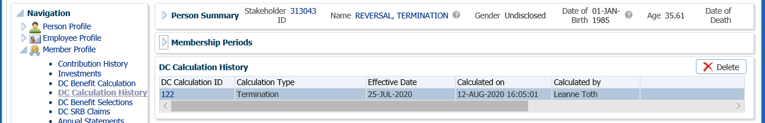

1. Click **Yes**, to confirm the deletion of the termination option calculation.

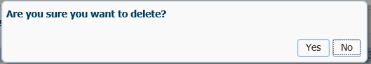

1. Under the **Employee Profile** menu, **Employment Periods** region, click **Edit** to remove the **End Date, End Reason** and **Final Jurisdiction**.

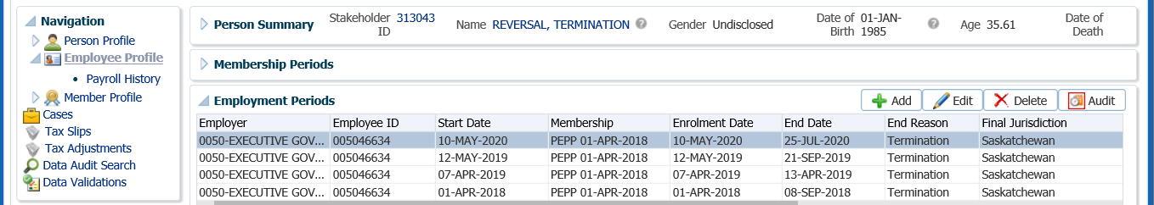

1. In the **Employment Period** pop-up window, remove the **Jurisdiction, End Date, End Reason** and **Final Jurisdiction**, click **Save**.

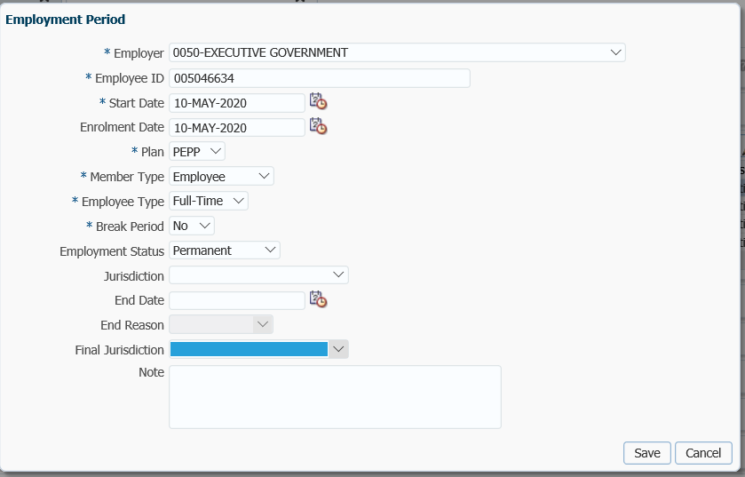

1. Confirm the **Membership Periods** region under the **Employee Profile** menu is now showing as **Active**.

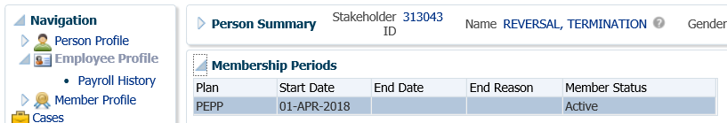

1. Under the **Person Profile** menu, **Communications** screen, **Outbound Documents** delete the Termination Option Letter from the member’s account. Highlight the correct letter and click **Delete**.

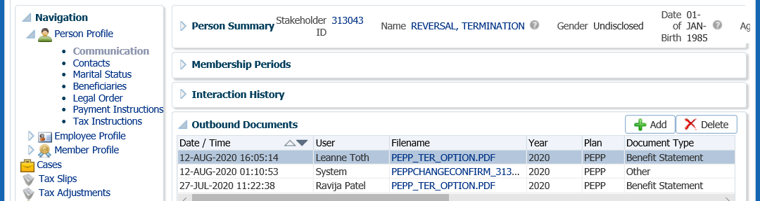

1. In the pop-up window, click **Yes** to remove the letter from the account.

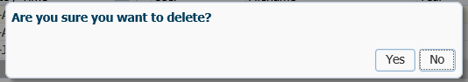

## Reverse a Payment from DC Benefit Selections

If a payment was processed from **DC Benefit Selections** and needs to be reversed after valuation, it must be reversed in the **DC Benefit Selections** region.

#### How to Reverse a Payment from DC Benefit Selections

1. Search for the member in PENFAX.
2. Navigate to the **Member Profile** menu, **DC Benefit Selections** screen. Under the **DC Benefit Selections** region click on the **DC Benefit Selection ID** number for the payment to be reversed.

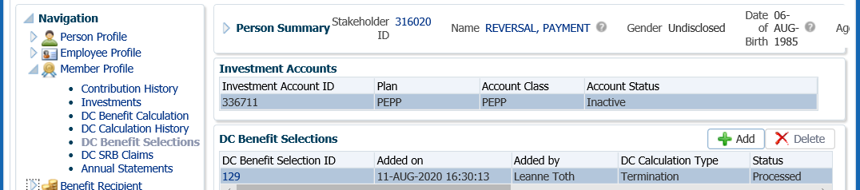

1. Under the **DC Benefit Selection** region, click **Undo.**

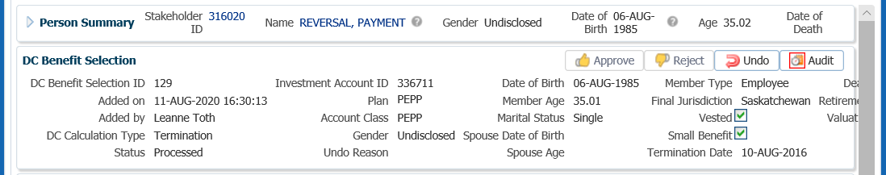

1. From the **Undo Reason** drop-down list, select the reason for undoing the DC Benefit selection “Calculation should not have been processed”. Enter a **Note** with any additional information if required. Click **Save**.

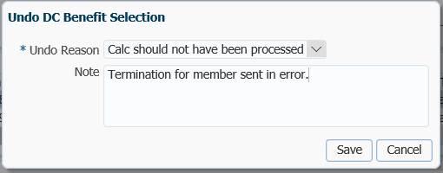

1. The member’s DC Benefit Selection **Status** will be updated to **Pending Undo** and the **Undo Reason** will be populated.

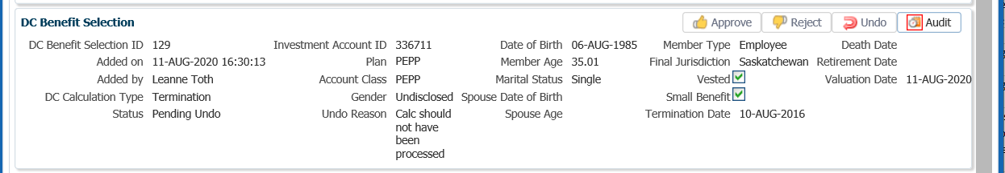

1. Once the **Process Investment Transaction** batch (PIT) runs overnight the **Benefit Recipient** menu item will be removed from the **Navigation** menu.
2. From the **Navigation** menu, **Member Profile** menu, select the **DC Benefit Selections**.
3. The member’s DC Benefit Selection Status will be updated to **Undone**.
4. From the **Navigation** menu, select the **Employee Profile** screen.
5. Under the **Employment Periods** region click **Edit**.
6. Remove the **End Date, End Reason** and **Final Jurisdiction**. Click **Save**.
7. The member’s status will now show as **Active** under the **Membership Periods** region.

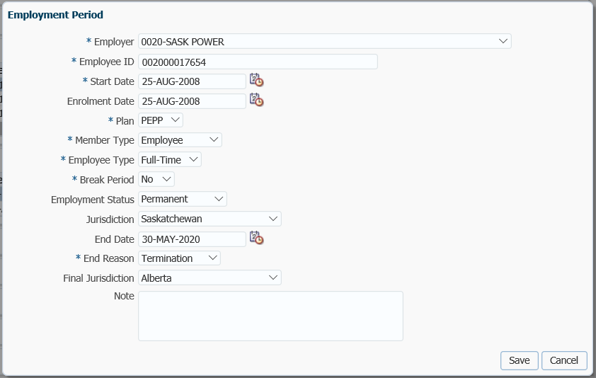

remove

1. Under the **Employment Periods** region, make sure the information in the **End Date**, **End Reason** and **Final Jurisdiction** is no longer displaying.

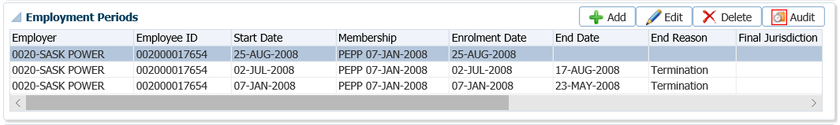

1. Click on the **Membership Periods** region, ensure the **Member Status** is showing as **Active**.

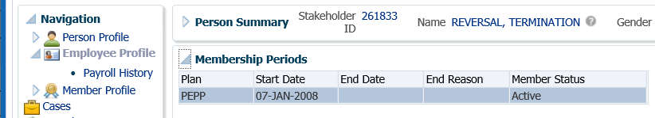

1. In the **Member Profile** menu, **Investments** screen, confirm the funds have been restored to the members account but checking the **Account Summary** region.
2. Under the **Person Profile** menu, **Communications** screen, **Outbound Documents** region, click **Delete** to delete the *Termination Option* letter for the date of the termination.

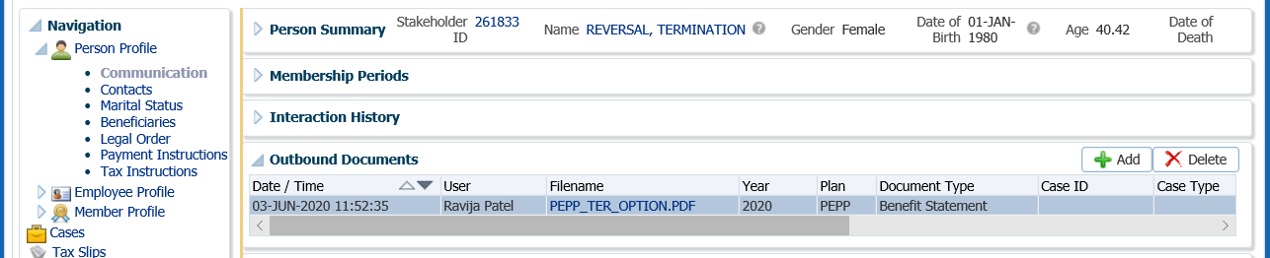

1. In the pop-up window, click **Yes** to delete the letter.

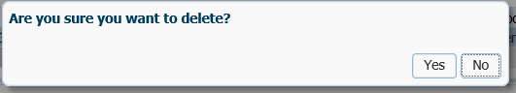

1. The *Termination Options* Letter will now be removed from the **Outbound Document** region and the member would not be able to see it on Member PLANet.



"Go to Batches and then **Breakage Occurences**. Do a search by the Stakeholder of the member that was just reversed. There should be a result of the breakage for the reversal done."

"Click on Accounting and go to the General Ledger. Verify that there are breakage records caused by the reversal which would affect one of these GL's.

Search by account 46581 and 46582 the Admin Breakage accounts.

## Cancel a Pending Inter-Fund Transfer, Asset Rebalance, Processing Fee or Adjustment

If a financial transaction in the **Account Instructions** region is still in a **Pending** status (pre-valuation), it can be cancelled by the administrator in the **Account Instruction** region. This will update the **Status** to **Cancelled**.

#### How to Cancel a Pending Inter-fund Transfer, Asset Rebalance, Processing Fee or Adjustment

1. Under the **Investment** screen, **Account Instructions** region, highlight the **Instruction Type** (**Interfund Transfer, Asset Rebalance, Processing Fee)** to be cancelled. Click the **Cancel** button.

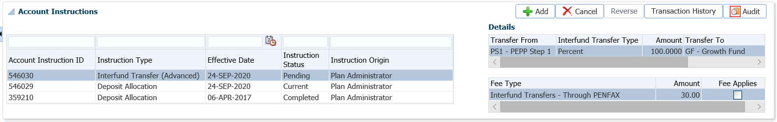

1. In the **Cancel Account Interaction** pop-up window, click Yes.

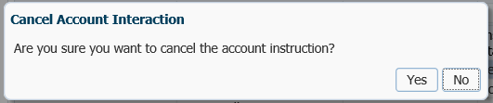

1. The **Instruction Status** will update to **Cancelled** and the transaction will not be performed.

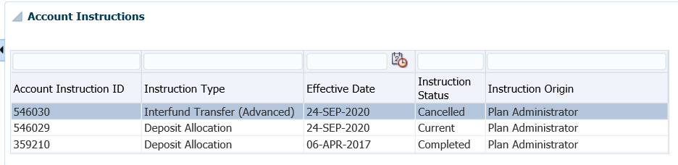

1. If a new **Deposit Allocation Instruction** was added at the same time as the Interfund Transfer, the **Deposit Allocation Instruction** needs to also be changed back to the previous instruction. Click **Add** to add a new instruction which will override the one done in error.

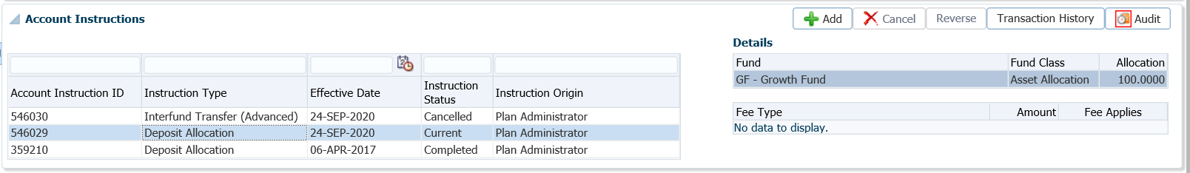

1. Add the new **Deposit Allocation** in the **Account Instruction** pop-up window. Click **Save**.

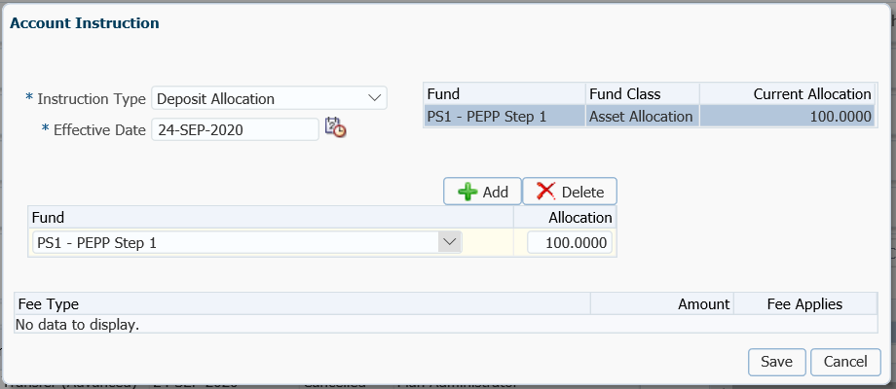

1. The previous **Deposit Allocation, Instruction Status** is now changed to **Completed** to ensure it won’t be used for future deposits. The new instructions added show as **Current**.

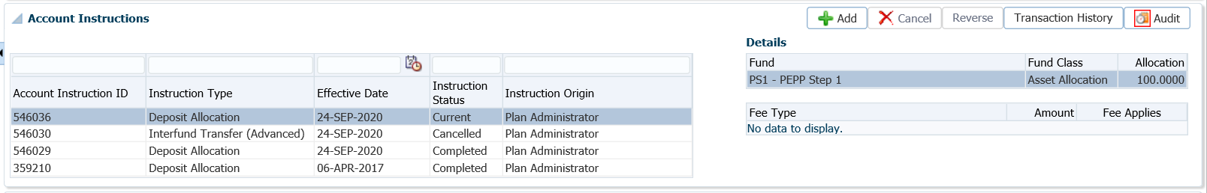

## Reverse a Deposit Post-Valuation

If a deposit was posted to a member’s account in error, the deposit must be reversed from the member’s account in PENFAX.

#### How to Reverse a Deposit Post-Valuation

1. Search for the member in PENFAX.
2. Under the **Member Profile** menu, **Investments** screen, **Account Summary** and **Account Balances** regions, take a screen print of the account balances prior to the reversal.

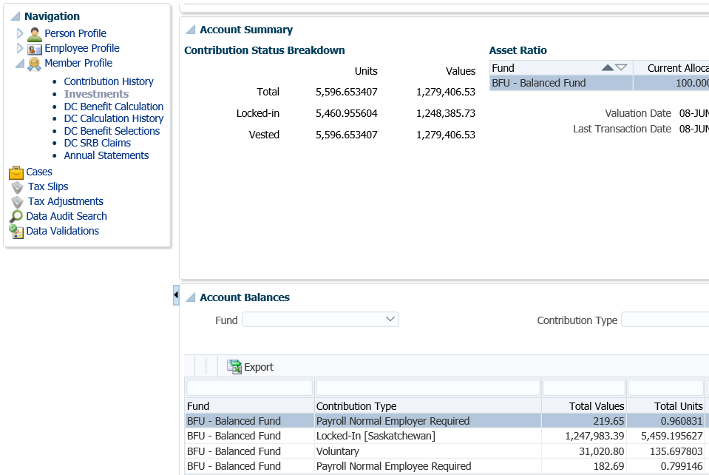

1. Determine if there has been any downstream activity. ***Refer to Business Process Requirements for Reversals***. If there has been no downstream activity or if it has been reversed, continue processing the steps below.
2. Under the **Member Profile** menu, **Investments** screen, **Account Activity** region, do a search by Fund Transaction type for the transaction type the deposit pertains to (Transfer In, Contribution). Click **Search.**

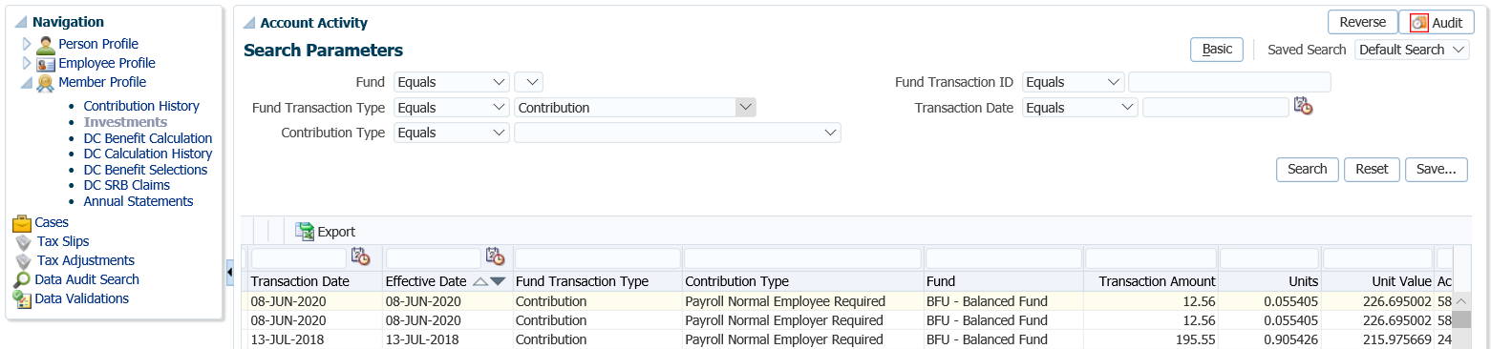

1. In the **Account Activity** region, highlight the transaction to be deleted, click **Reverse**. If there are more than one, you have to highlight and reverse each separately.

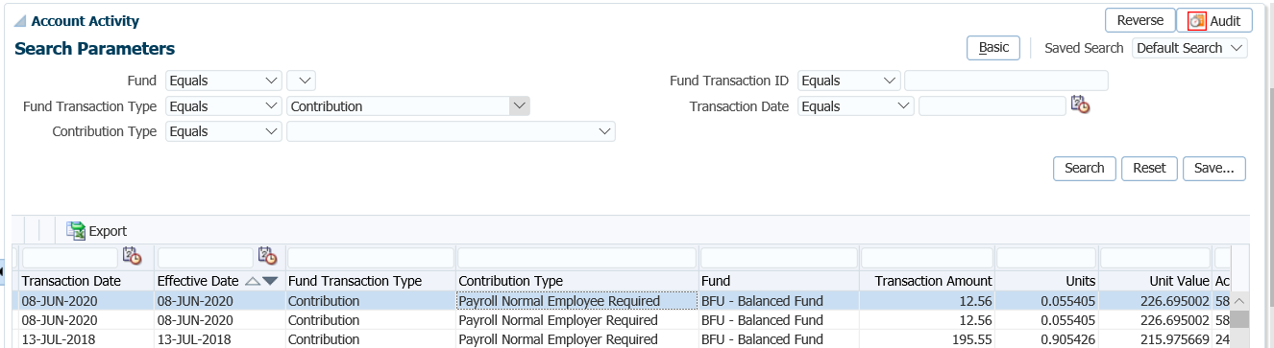

1. In the pop-up window, click **Yes**.

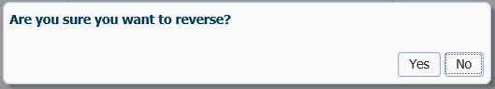

1. On the **Account Activity** region, click the **Refresh** button to refresh the page, to ensure the **Account Summary Values** have been decreased by the deposit amount(s).

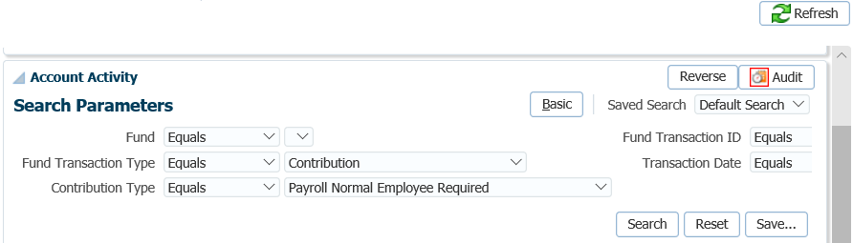

1. Take a print screen of the **Account Summary** region to ensure the **Units** and **Values** have been decreased after the reversal.

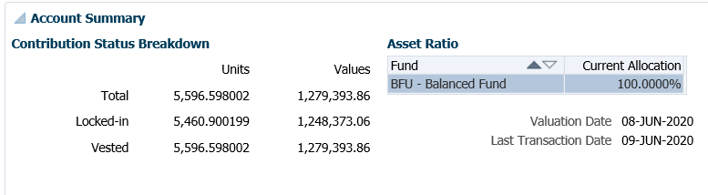

1. In the **Account Activity** region, a new row will populate with a **Transaction Date** of the day the amount was reversed and display as a negative amount for the **Contribution Type** that was reversed.

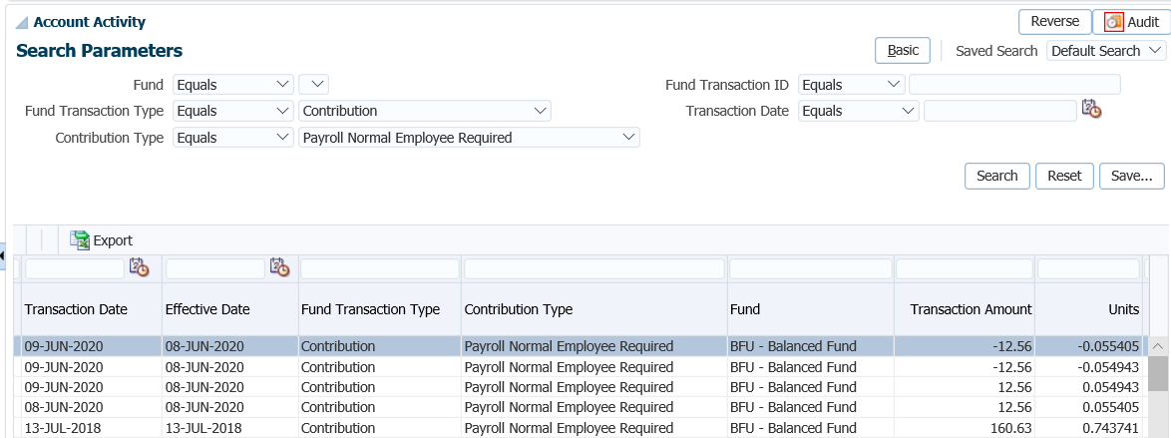

1. On the following business day determine the amount of breakage that resulted from the reversal. Under the Batches menu, select Breakage Occurrences from the drop-down list.

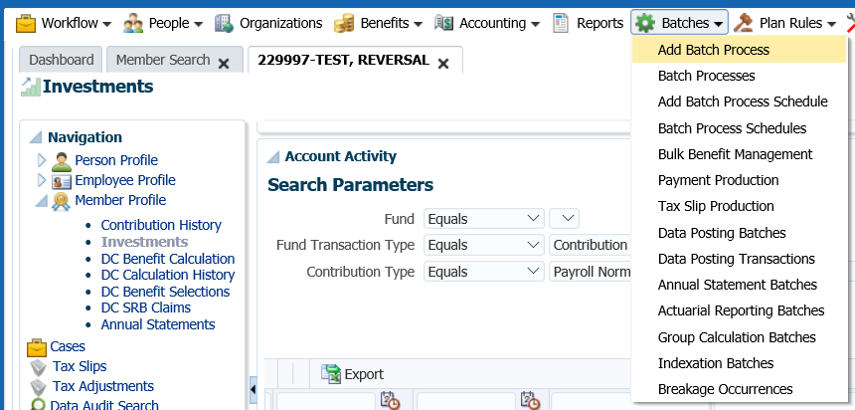

1. In the **Breakage Occurrences** window, enter the Stakeholder ID and click **Search**

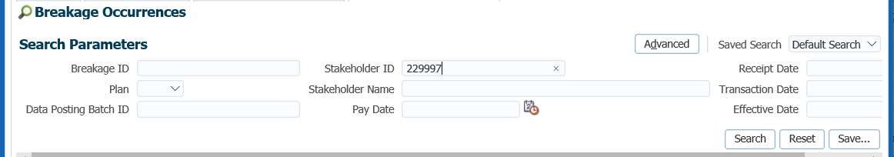

1. The **Total Admin Breakage** will be displayed for the deposit reversal for the member.

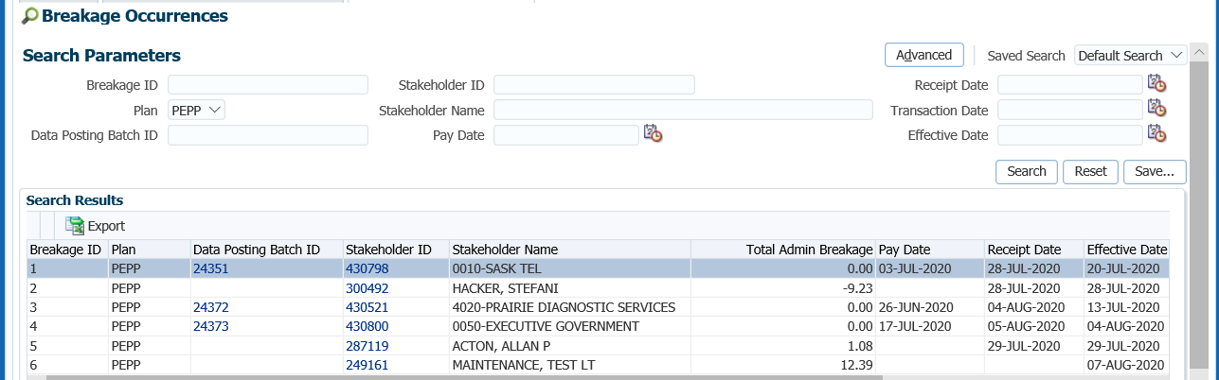

1. Go to the **Accounting, General Leger, General Ledger** to see the breakage displayed in the GL.

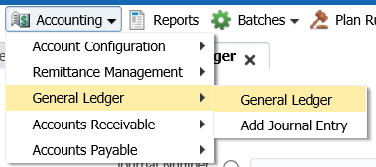

1. Change **Plan** to PEPP, select the breakage **Accounts** **46581 Administrative Positive Breakage** and **46582 Administrative Negative Breakage** separately**.** The reversal will show in one of the two accounts. Click **Search**.

**46581 Administrative Positive Breakage**

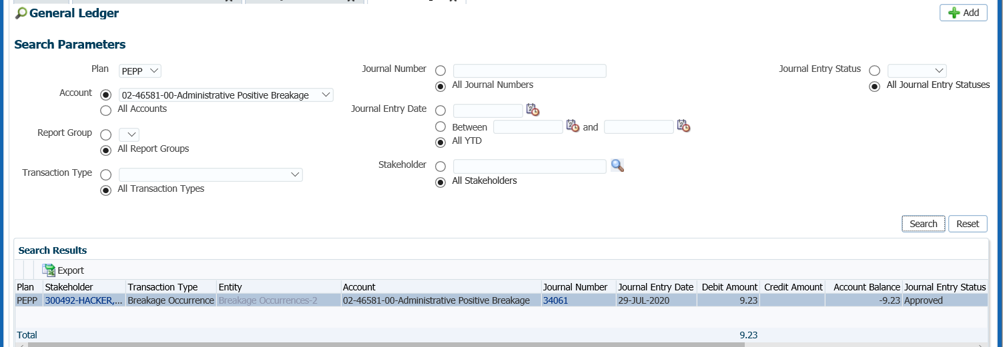

**46582 Administrative Negative Breakage**

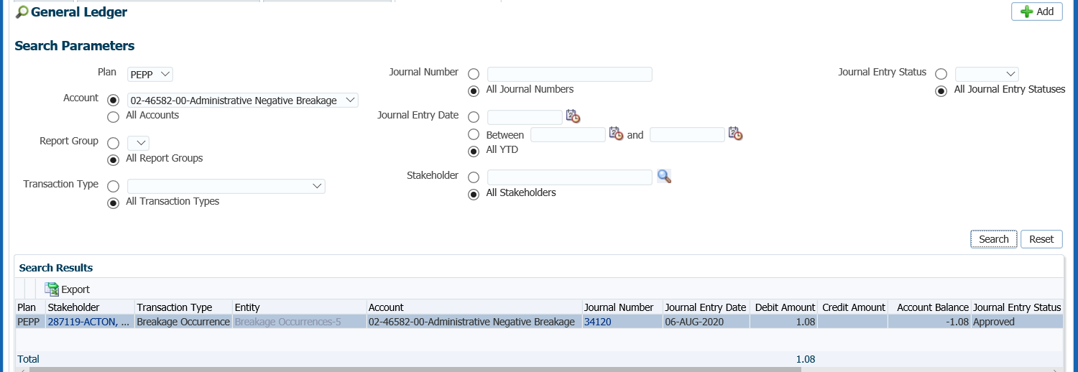

## Reverse an Inter-fund Transfer Post Valuation

If an inter-fund transfer instruction was processed in error by an administrator and the status is now showing as **Completed**, the transaction is required to be reversed from the member’s account.

It is very important to first determine if there have been any downstream transactions prior to doing any reversals and if so, complete an Error Correction form to document the steps. ***Refer to the Business Process Requirements for Reversals.***

Administrative breakage will result from reversing the transaction as the units previously bought in the new fund are then sold back based on the current days unit value. Breakage could result in positive or negative breakage depending on whether the price of the units originally have now gone up or down.

#### How to Reverse an Inter-fund Transfer Post Valuation

1. Confirm the account balances prior to the reversal in the **Investments** menu, **Account Balances** region.

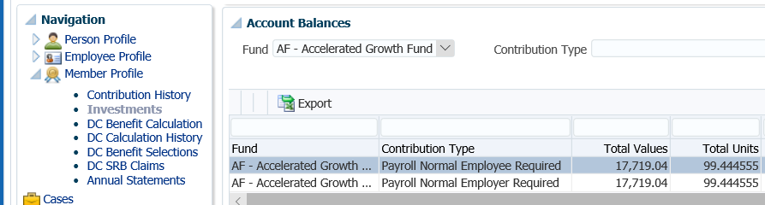

1. Determine if there has been any downstream activity.

* Has the member transferred to a new fund since the date the error happened?
* Has the member taken a payment (partial or full)?
* Have contributions came in since the inter-fund transfer was processed?

1. If there has been downstream activity on the member’s account, the transactions that occurred after the inter-fund transfer need to be reversed first in sequential order, newest to oldest up until the date of the inter-fund transfer that the error occurred on.
2. If there have been downstream transactions complete an Error Correction form to document the steps in order prior to processing. If there are many steps, ensure a 2nd person audit occurs before and after processing. See procedures on how to reverse deposits, withdrawals, etc.
3. If there has not been any downstream activity on the member’s account, in the **Investment** screen, **Account Instructions** region, highlight the **Interfund Transfer** instruction to be reversed. Click the **Reverse** button.

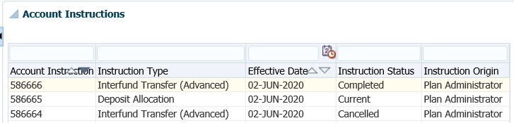

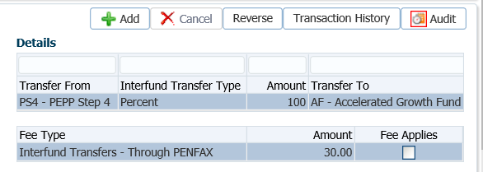

1. A pop-up window will be display to confirm the reversal. Click **Yes**.

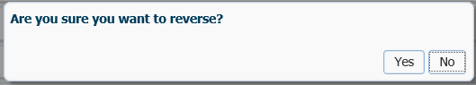

1. The **Status** on the **Account Instruction** is then updated to **Pending Reversal.** The update to the member’s investment will occur when the transaction is valued during the nightly PIT batch process.

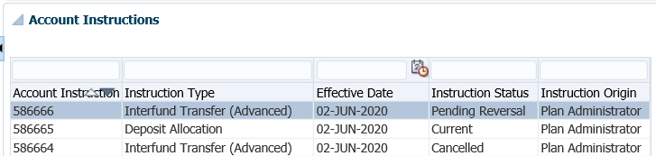

1. The next business day following the reversal, under the **Investment** screen, **Account Balances** the member’s account balance will reflect the investments the member had prior to the inter-fund transfer that was processed in error.

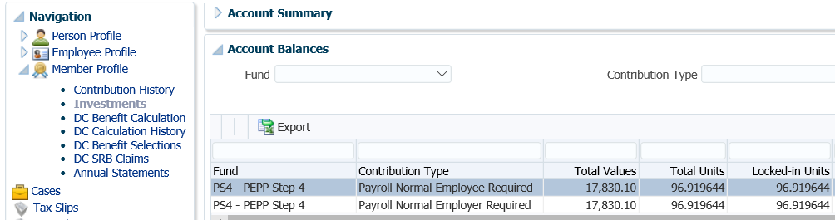

1. In the **Account Instructions** region, the status of the inter-fund transfer instruction will now show as **Reversed**.

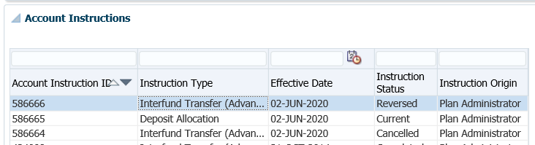

1. The details of the reverse can been seen in the **Account Activity** region. Perform a search for the transaction type.

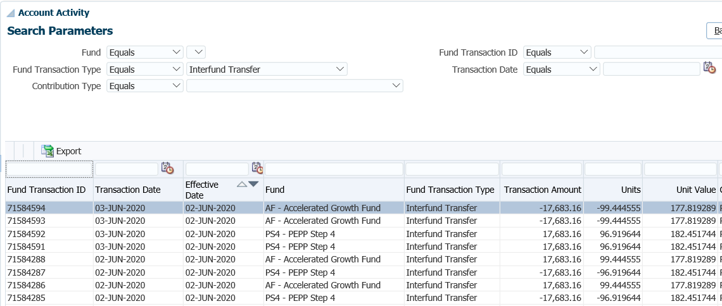

1. On the following business day determine the amount of breakage that resulted from the reversal. Under the Batches menu, select Breakage Occurrences from the drop-down list.



1. In the **Breakage Occurrences** window, enter the Stakeholder ID and click **Search**



1. The **Total Admin Breakage** will be displayed for the inter-fund transfer reversal for the member.



1. Go to the **Accounting, General Leger, General Ledger** to see the breakage displayed in the GL.



1. Change **Plan** to PEPP, select the breakage **Accounts** **46581 Administrative Positive Breakage** and **46582 Administrative Negative Breakage** separately**.** The reversal will show in one of the two accounts. Click **Search**.

**46581 Administrative Positive Breakage**



**46582 Administrative Negative Breakage**



## Cancel a Payment Post-Valuation

If a payment was made to a recipient in error or processed incorrectly after the daily valuation, it must be cancelled in PENFAX from the member’s account.

It is very important to first determine if there have been any downstream transactions prior to doing any reversals and if so, complete an Error Correction form to document the steps. ***Refer to the Business Process Requirements for Reversals*.**

Administrative breakage will result from reversing the transaction as the units previously sold are then bought back based on the current days unit value. Breakage could result in positive or negative breakage depending on whether the price of the units originally sold have now gone up or down.

#### How to Cancel a Payment Post-Valuation

1. Search for the member in PENFAX.
2. From the **Navigation** menu, select the **Benefit Recipient** screen. In the **Benefit Recipient** screen, click on the **Payment History** tab.

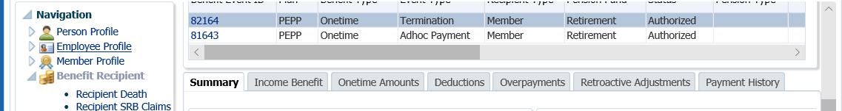

1. In the **Payment History** tab, click on the **Payment ID** of the payment to be cancelled.

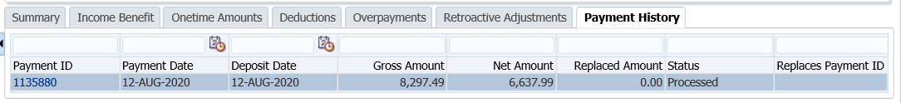

1. From the **Payment** screen, click the **Cancel Payment** button.

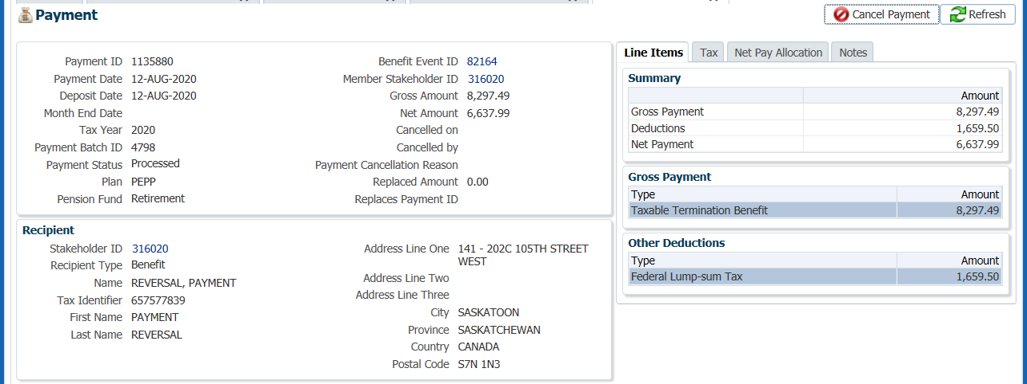

1. From the **Cancel Payment** window, select a **Payment Cancellation Reason** from the drop-down list. Options are: Cheque Cancelled, Cheque Returned, Death, Other, Paid in Error. Enter a **Note** if required. Click **Save**.

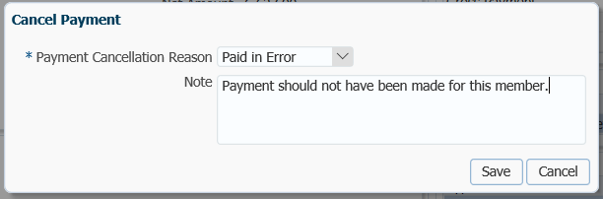

1. The payment status will be changed to **Cancelled – Pending Recovery** and the details of the cancellation are saved on the payment record.

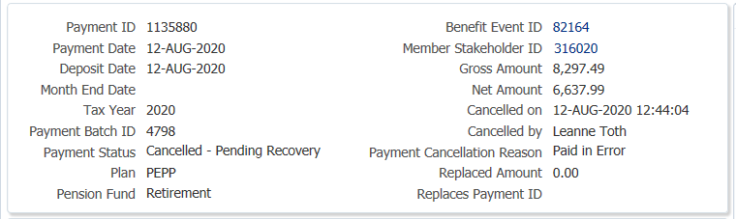

1. Close the **Payment** tab by clicking on the **X** to return to the payee’s **Benefit Recipient** screen.



1. Click on the **Overpayments** tab.

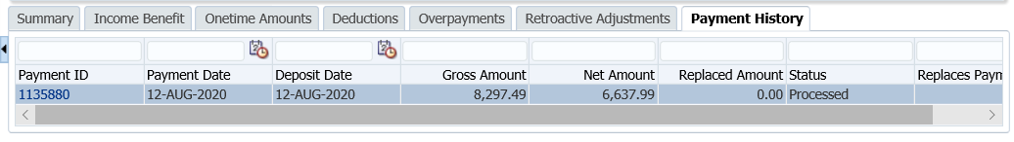

1. The payment can now be recovered by a manual overpayment by creating a deduction on future payments, **Lump Sum to be Collected**, or in the case of the cheque being returned, can be **Marked as Recovered**.

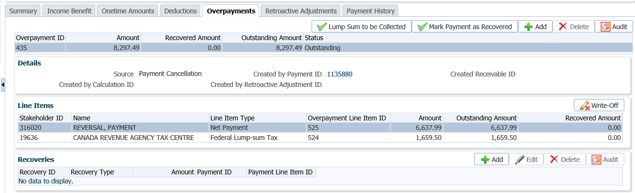

* **NOTE:** PEPP is not likely to use this **Lump Sum to be Collected** to recover an amount on future payments. The **Marked as Recovered** option is likely the preferred method.

1. Click the **Lump Sum to be Collected** button to create the receivable if any part of the recovery is to be collect by cheque. The member would return the PEPP cheque issued in error? Enter the **Amount** returned, add a **Note** and click **Save**.

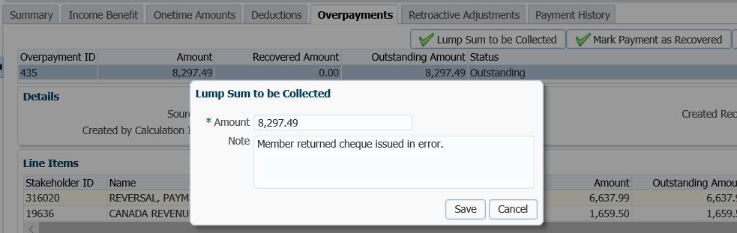

1. Click the **Deductions** tab, click the **Add** button. Enter the details for the first line item. If required create a second deduction for the **income tax**. Click **Save**.

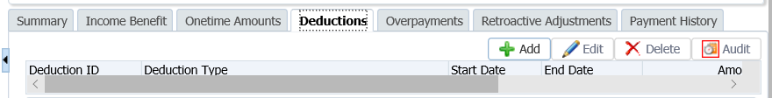

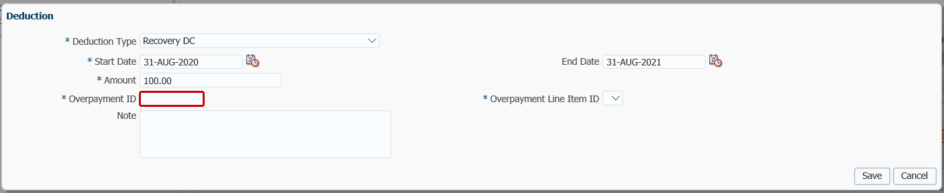

1. If the payment is recovered manually, the **Mark Payment as Recovered** button allows you to update the payment status to **Cancelled – Recovered**. For this option the member would have returned the actually cheque, or they returned a personal cheque for the same amount.

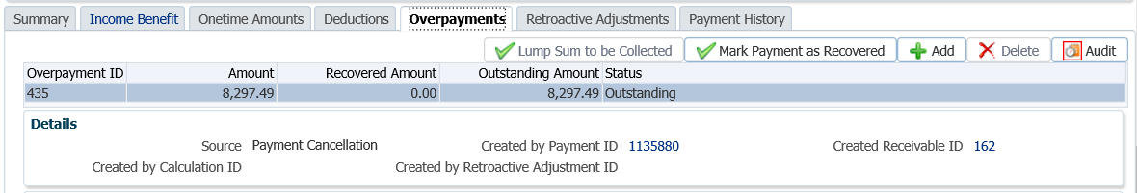

1. In the **Mark Payment as Recovered** pop-up window, enter a **Note** and click **Save.**

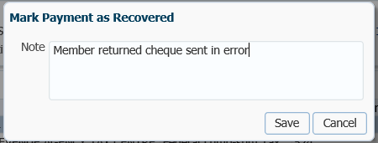

A payment that is pending recovery will still be included in Tax Reporting, however a payment that is **Cancelled – Recovered** will be excluded from Tax Reporting.

## Adjustment of Units

The **Adjustment** instruction is used to correct an administrative error for a financial transaction that has been previously valued. Instead of reversing the financial transaction the fund units are adjusted to reflect the correction to the fund(s) and contribution type(s) at a current date.

#### How to Process an Adjustment of Units

1. Search for the member in PENFAX.
2. Under the **Investments** screen, **Account Balances** region, confirm and print the account balances prior to the reversal in the **Investments** menu, **Account Balances** region.

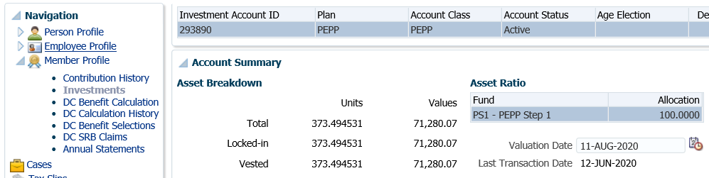

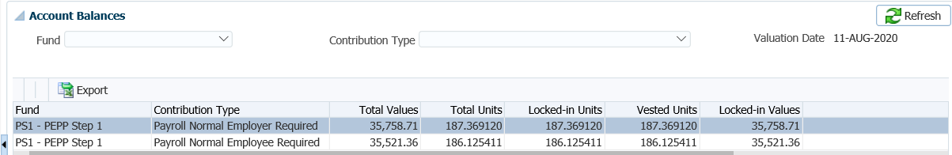

1. If there are multiple adjustments to be made, complete an *Error Correction* form to document the steps prior to processing the adjustments and calculating the number of units to adjust per fund and per contribution type. Ensure a 2nd person audit occurs before and after processing the adjustments.
2. From the **Investment** screen, under **Account Instructions** region, click **Add**.

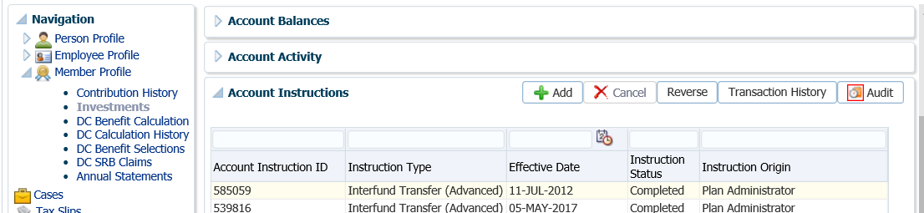

1. In the Account Instruction pop-up window, from the **Instruction Type** drop-down list, select the following and click Save:

* **Instruction Type –** Adjustment
* **Effective Date –** defaults to current date, can select a past date to backdate if required
* **Fund –** the fund the adjustment is applicable
* **Contribution Type –** select the contribution type that the units are to be adjusted in
* **Units –** enter the number of positive or negative units.

-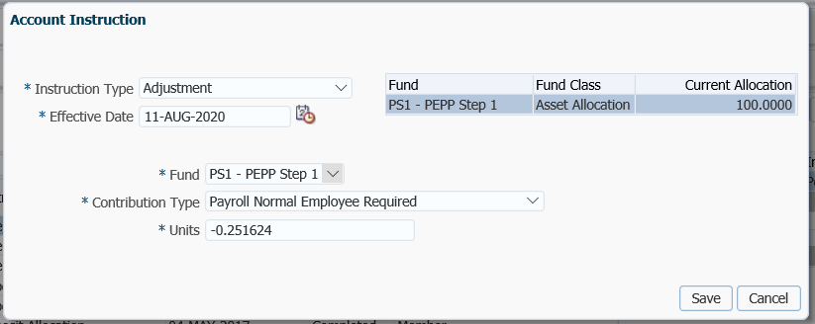

1. Repeat Step 5 for each Contribution Type or Fund in which an adjustment of units is required to be performed.

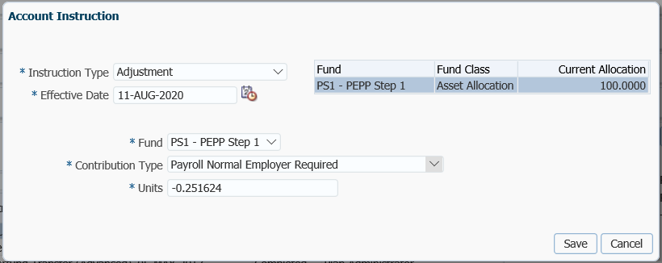

1. The **Account Instruction** will have a **Status** of **Pending** until the unit value is declared for the effective date used. No other instruction can be added when there is a pending instruction.

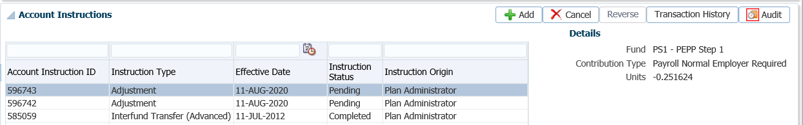

1. Once the unit value is declared during the nightly PIT batch process, the member’s account balance will be updated to show the difference in value as a result of the adjustment transaction. The results can be seen under the **Account Summary** region and the **Account Balances** region.

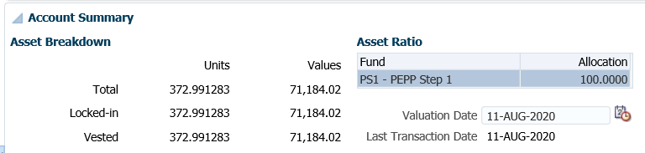

1. In the **Account Balances** region, under the **Fund** drop-down list, select the fund the adjustment was processed from and the **Contribution Type** to see the balances per contribution type. If you leave the **Contribution Type** blank it will display all contribution types for the fund. Click **Refresh** to see the information.

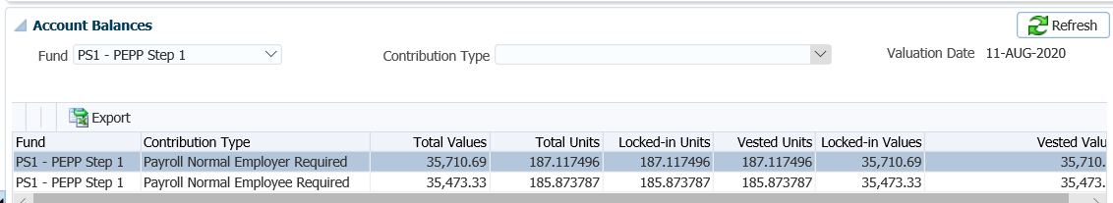

1. The details of the adjustment transaction will be display in the **Account Activity** region. Under the **Fund Transaction Type** select **Adjustment**, click **Search**.

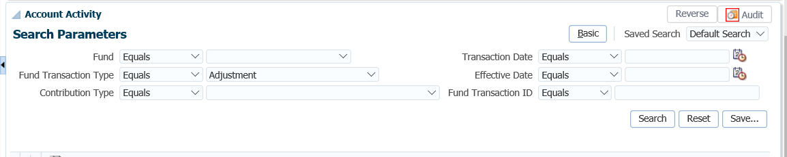

1. The **Adjustment** instruction **Status** will now show as **Completed**.

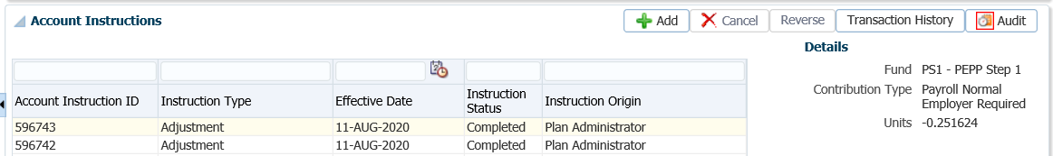

1. The details of the breakage resulting from the adjustment of units can be seen on the following business day under the **Batches** menu. Select **Breakage Occurrences** from the drop-down list.





1. In the **Breakage Occurrences** window, enter the **Stakeholder ID** and click **Search.**

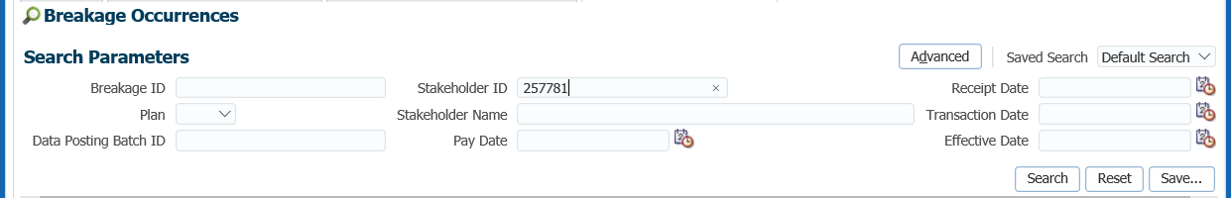

1. The breakage results will be displayed in the **Search Results** region for the adjustment of units for the member.
2. Under **Accounting, General Leger, General Ledger** breakage should be displayed in the GL. Change plan to PEPP, search by the breakage account numbers 46581 and 46582. The reversal will show in one of the two accounts.

## Merge Duplicate Stakeholder Records

If it has been determined that two stakeholder accounts exist for the same person, the stakeholder accounts need to be combined into one account.

If financial data exists on both accounts the information is to be corrected by doing and adjustment of units to both stakeholder accounts.

#### How to Correct Duplicate Stakeholder Records in PENFAX

1. Request both files from the file room if there are two.
2. Add a critical note to each account stating which stakeholder account is the correct one, and which is the incorrect account prior to adjusting the units.
3. Complete an *Error Correction* form to ensure all steps are completed and in order.
4. Make sure both accounts are in the same fund, if not do an inter-fund transfer.
5. In the situation with different funds – depending on the situation and reason for the duplicate accounts, you may have to confirm with the member which fund they want unless the other fund is the default. Once determined or confirmed, proceed with an inter-fund transfer.
6. Ensure all the most current details of the member are on the member account that you are keeping.
7. Perform the adjustment of units to add and/or remove units to 6 decimal places for the member number that you are not keeping. Adjustments are to be done per contribution type using a current date. Under the **Investments** region, **Account Instructions** region click **Add**.

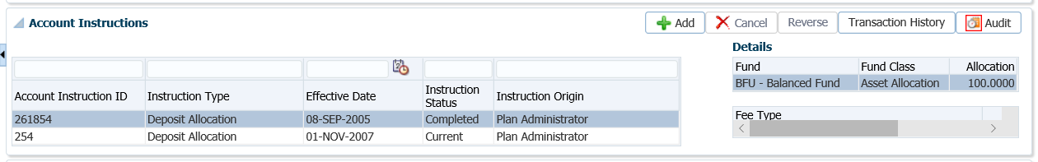

1. Add the same number of units to the correct member number by contribution type using a current date.
2. Change the Plan Status on the wrong account to a Terminated Plan Status. Under the **Person Profile** menu, **Membership Periods** region, click **Edit**.
3. Add notes on both PENFAX stakeholder accounts.
4. Send the member a letter to inform them of the correction that was done to combine both social insurance numbers and the correct member number to use going forward.
5. If there are two files that were created in the file room we will need to combine all the correspondence in the file from the wrong SIN and place it in the file that is to be kept for the correct SIN.

* **NOTE:** Breakage will be avoided as long as the adjustments are done on the same day. The positive and negative adjustments to units should offset on the valuation report.

## Reissue a Cheque

If a payment is required to be cancelled due to incorrect EFT or cheque instructions or a cheque is determined to be stale dated, the payment should not be cancelled, only the instructions are to be corrected.

#### How to Reissue a Cheque

1. Search for the member on PENFAX.
2. From the **Navigation** menu, select the **Benefit Recipient** screen.
3. Under the **Benefit Recipient**  screen, click on the **Payment History** tab
4. Click the **Payment ID** of the payment to be cancelled
5. From the **Payment** screen, click the **Net Pay Allocation** tab
6. Click the **Replace** button
7. From the **EFT Replacement Reason** drop-down, select **EFT Rejected** or **Other**
8. Click the **Save** button

The **Net Pay Allocation** tab is updated with the replacement details. Note the **Replaced by Onetime Amount ID** field indicates a new onetime amount has been created.

1. Close the **Payment** tab to return to the payee’s **Benefit Recipient** screen
2. Ensure the correct benefit is highlighted if there is more than one
3. Click the **Onetime Amounts** tab
4. Ensure the **Replacement Payment** is highlighted
5. Click the **Edit** button
6. Add the new **Payment Instructions**

## Manual Cheque Request

Ensure a stop payment has been placed on the cheque or have the cheque returned and provide the returned cheque to Financial Services.

Complete the Manual Cheque Request form with the payee details and payment details. Once it is approved provide it to Financial Services to create the manual cheque along with the appropriate backup.

Sent the manual cheque to the member/employer along with a cover letter.

## Returned Cheques/EFTs for VPB

## Voiding a Remittance

Once a remittance record is created it cannot be deleted. The user is restricted from editing **Remittance ID**, **Receipt Date** and **Remittance Amount** due to accounting implications in the General Ledger. If the remittance was added in error but not linked to a deposit, it can be **Voided**.

#### How to Void a Remittance

1. If a remittance was added in error, not linked to a deposit and you wish to void it, go to the **Remittance** screen and search for the remittance number. Enter in the **Remittance ID** number, **Plan** and **Employer** number, click **Search**.

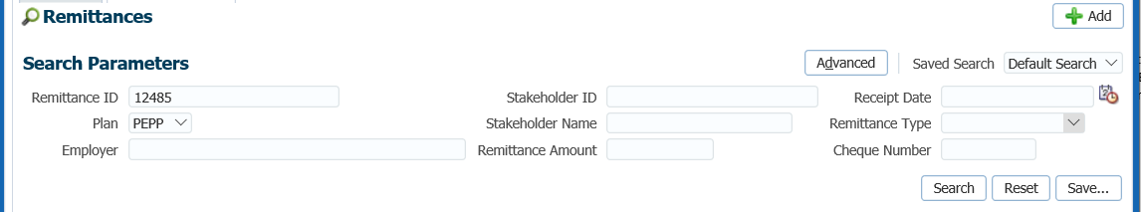

1. In the **Search Results** region, confirm that the Remittance ID is not Linked to a Data Posting or AR. If it was linked you would see the information in the **Associated Data Postings** region or the **Associated Accounts Receivable** region.

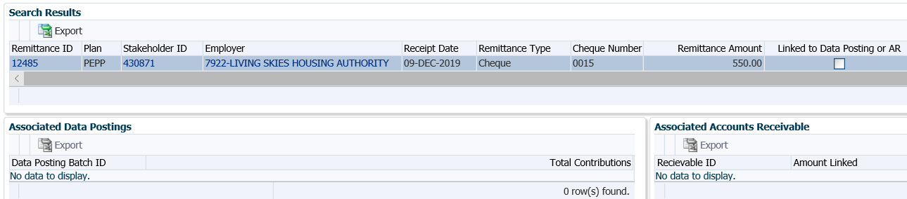

1. In the **Search Results** region, click on the **Remittance ID** number.

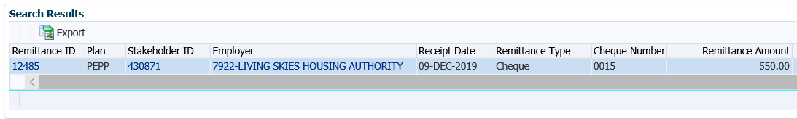

1. In the **Remittance** screen, click **Edit**.

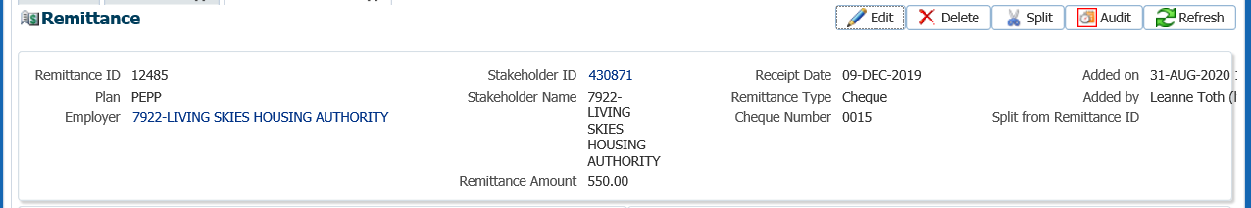

1. In the **Remittance** pop-up window, tick the **Remittance Voided** checkbox and add a **Note** with the reason the Remittance ID is being voided. Click **Save**.

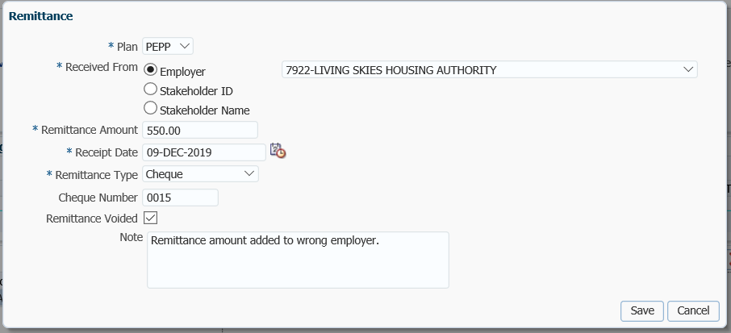

1. The **Remittance** screen will now show a check mark in the **Remittance Voided** area.

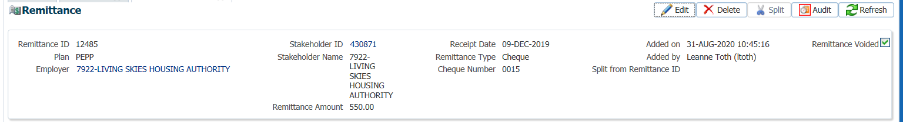

* **NOTE:** Voiding the Remittance creates a reversing journal entry in the PENFAX General Ledger. The journal entry will debit and credit opposite accounts as the Remittance account mapping in the amount of the original remittance record.  If you then “uncheck” the **Remittance Voided** checkbox and click the **Save** button, the reversing journal entry will be reversed, thereby “redoing” the journal entry for creating the remittance. Note that remittances that have already been linked to a data posting file or account receivable cannot be voided. The user must first unlink the remittance and then will be able to void it.

# Tax Slips

## Print a Duplicate Tax Slip

Tax slips that have been issued for a payment for a member are displayed under the **Tax Slips** screen under the **Navigation** menu. All the information reported on an individual tax slip including any adjustments can be viewed in the **Tax Slip** screen.

When a member requests another copy of their tax slip, the **Tax Slip** screen can be used to indicate in PENFAX that an official duplicate tax slip has been issued to the member. A duplicate tax slip is often requested when the original tax slip was not received by the benefit recipient due to an incorrect name or mailing address.

If a duplicate tax slip is requested the first step is to correct the Person record information. Once this information is corrected, the slip can be re-issued. ***Refer to the procedures in Member Data Changes, Address or Member’s Name to make the required changes*.**

#### How to Print a Duplicate Tax Slip

1. Search for the member in PENFAX.
2. From the **Person Profile** menu, expand the **Contact Information** region.

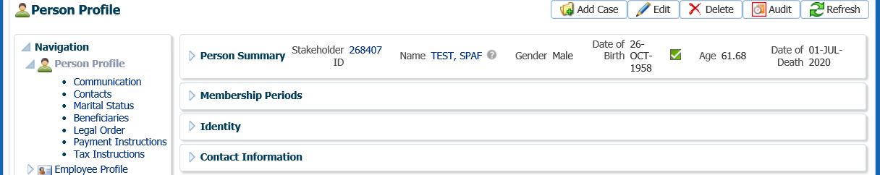

1. Click the **Add** button in the **Contact Information, Address** region.

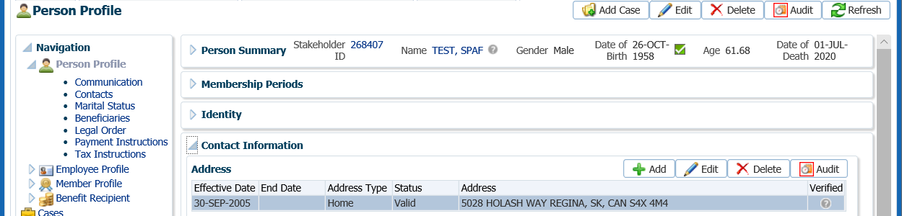

1. In the **Address** pop-up window, make the required changes, click **Save**.

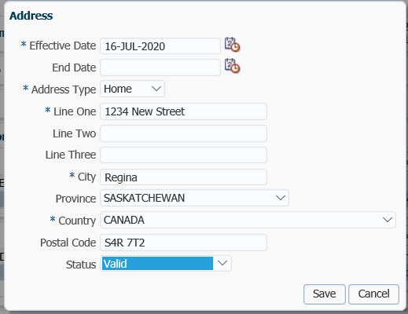

1. From the **Navigation** menu, select the **Tax Slips** menu.

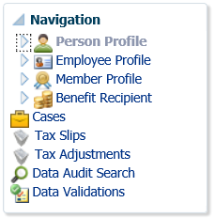

1. In the **Tax Slips** region, click on the **hyperlink** for the applicable tax slip.

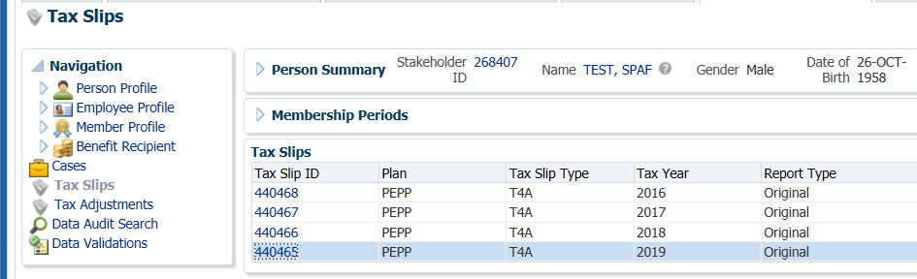

Click

1. Click the **Update Information** button to update the address to the new one.

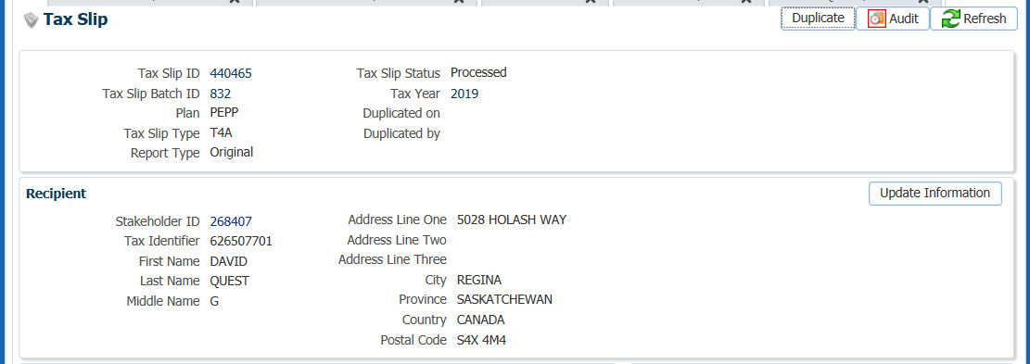

1. In the pop-up window, select **Yes** to apply the changes to the **Tax Slip** screen.

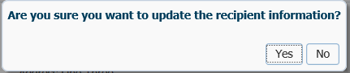

1. To request a duplicate tax slip, click on the **Duplicate** button.

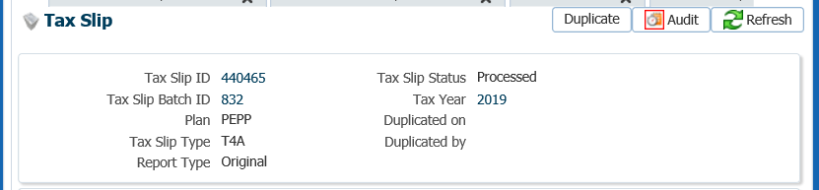

1. In the **Duplicate Confirmation** pop-up window, click **Yes**.

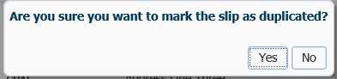

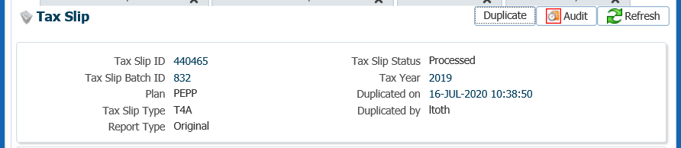

1. Click on the **X** in the **Tax Slip** tab to close the window.



1. The tax slip will be marked as a **Duplicate** and will be saved under the **Person Profile** to the **Communication Centre** screen, **Outbound Documents** region.

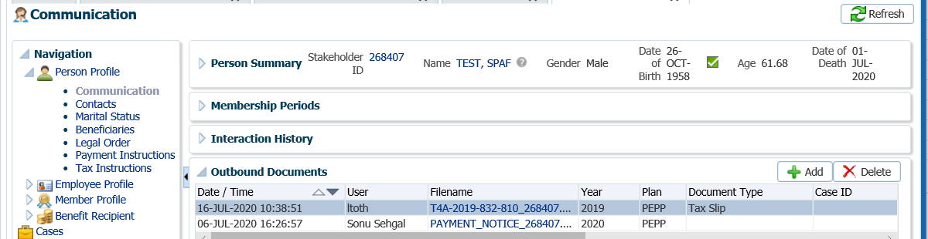

## Cancel a Tax Slip

If a payment was processed in error in which a tax slip was produced at the end of the calendar year, it will need to be deleted from the member’s account after the payment has been reversed.

Provide Financial Services with the member’s name, Year the tax slip was issued and the Tax Slip ID number.

## Tax Slip Adjustment

The **Tax Adjustments** screen is used to view and manage the approval process for creating tax adjustments.

Tax adjustment records must be reviewed and submitted to a second tier level of approval in order for the adjustment to be included in production of the tax slip.

#### How to Create a Tax Slip Adjustment

1. Search for the member in PENFAX.
2. From the **Navigation** menu, select the **Tax Adjustments** screen.

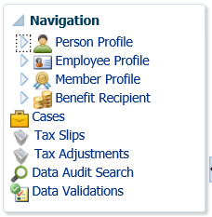

1. Click the **Add** button to create the adjustment.

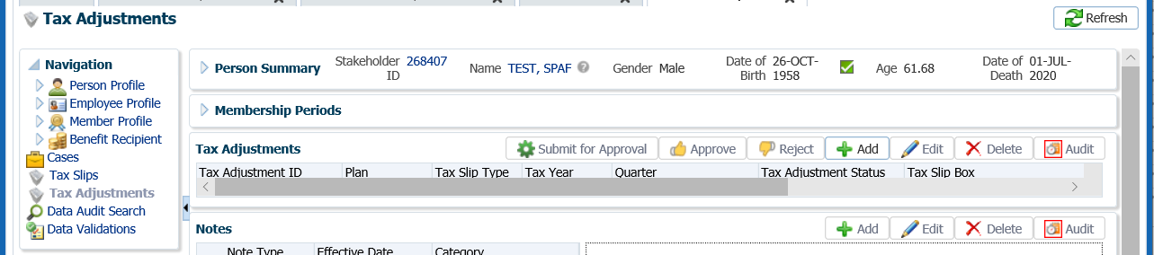

1. In the **Tax Adjustment** pop-up window, select and enter the following information from the drop-down menu:

* **Plan –** PEPP
* **Tax Slip Type –** T4A, T4, T10, NR4 or RL2
* **Tax Year –** applicable tax year for the adjustment
* **Tax Slip Box –** the applicable box the adjustment pertains to
* 016 - Pension or superannuation
* 018 - Lump-sum payments
* 022 - Income tax deducted
* 028 – Other income
* 032 - Registered pension plan (RPP) contributions (past service)
* 046 – Donations and gifts
* 106 - Death benefits
* 108 - Lump-sum payments out of an RPP - not eligible for transfer
* 109 – Periodic payments from an unregistered plan
* 118 - Medical premium benefits
* 119 - Premiums paid to a group term life insurance plan
* 125 - Disability benefits
* 126 - Pre-1990 past service contributions (included in box 032)
* 133 – Variable Pension Benefits
* 135 - Recipient-paid premiums for private health services plans
* 144 - Status Indian (exempt income) - other income
* 146 - Status Indian (exempt income) - pension or superannuation
* 148 - Status Indian (exempt income) - lump-sum payments
* 158 - 158 - Lump-sum payments - not eligible for transfer
* 16-02 - Gross Income - Periodic Other
* 16-03 - Gross Income - Lump-sum Other
* 16-39 - Gross Income - Periodic Pension
* 16-40 - Gross Income - Lump-sum Pension
* 162 – Pre-1990 past service contributions while not a contributor
* 17-02 - Tax Withheld - Periodic Other
* 17-03 - Tax Withheld - Lump-sum Other
* 17-39 - Tax Withheld - Periodic Pension
* 17-40 - Tax Withheld - Lump-sum Pension
* 210 – Charitable donations
* 235 – Premium paid to a private health services plans
* A - Life annuity payments amount
* C - Other payments amount
* J - Québec income tax withheld
* **Amount –** enter the applicable dollar value

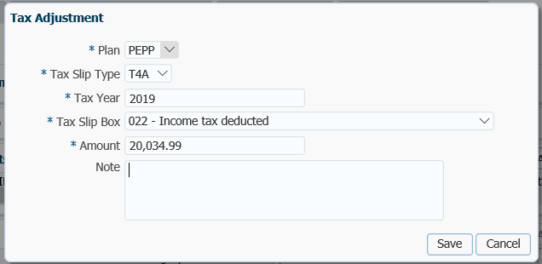

1. Click **Save** to create the adjustment. The adjustment has been created and pending approval. The **Tax Slip Adjustment Status** is set to **New**. Click the **Submit for Approval.**

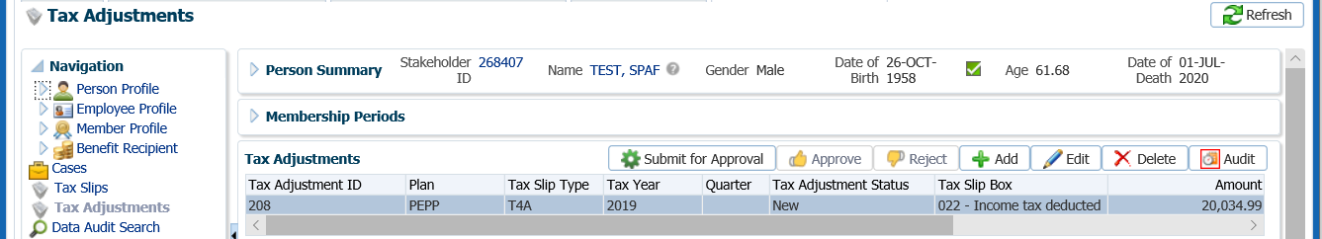

1. In the In the **Tax Adjustment Approval Confirmation** pop-upwindow, select **Yes.**

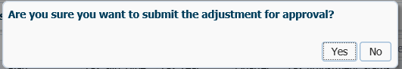

1. The **Tax Adjustment Status** will now be updated to **Submitted for Approval** and is ready for the second level of approval.



1. Tax Adjustment records must be reviewed and submitted to a second tier level of approval in order for the adjustment to be included in the production of a tax slip. Click the **Approve** button to submit the final authorization for the adjustment.

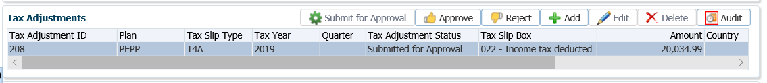

1. In the **Tax Adjustment Approval** pop-up window, select **Yes**.

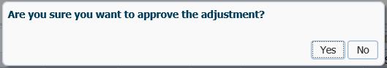

1. Once a tax adjustment record has completed, the approval process and the **Tax Adjustment Status** is set to **Approved**, it is now available to be included in the production of tax slips (either an Original or Amended as applicable). When the tax adjustment has been applied to a tax slip, the Tax Adjustment Status is changed to **Applied**.

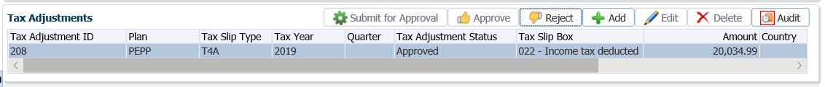

## Tax Slip for a Single Member

1. From the **Batches** menu, select **Tax Slip Production.**

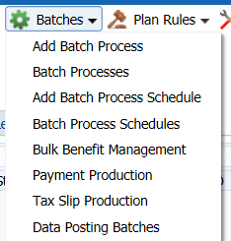

1. In the **Tax Slip Production** screen, click the **Add Tax Slip Batch.**

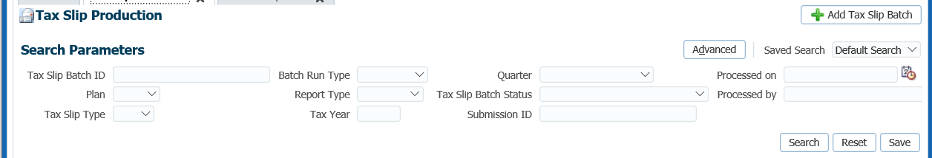

1. In the **Add Tax Slip Batch** screen complete the fields with the following information:

* **Plan –** PEPP
* **Tax Slip Type –** T4
* **Batch Run Type –** Test or Production (run a test batch first to verify the data is correct)
* **Report Type –** Original
* **Tax Year –** 2020 (or year you are producing the tax slip for)
* **Start Date/Time –** n/a
* **Produce PDFs for All Recipients –** check the box

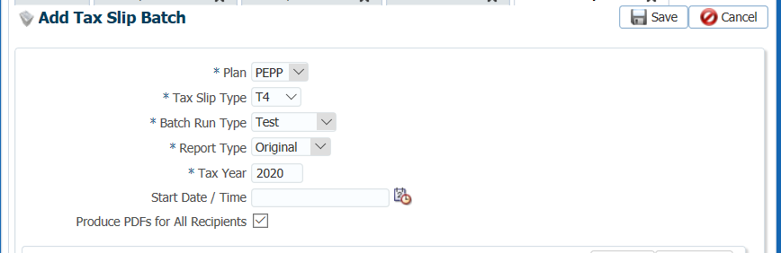

1. In the **Recipients to include** region, click the selected, option, then click **Add** to select the member.

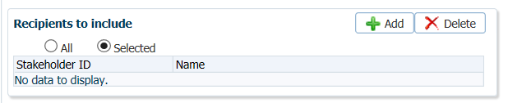

1. In the **Add Recipient** pop-up window, select the applicable Stakeholder ID the tax slip is for and click **Save**.

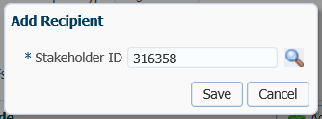

1. The Stakeholder name and Stakeholder ID will be populated in the **Add Tax Slip Batch** screen, click **Save.**

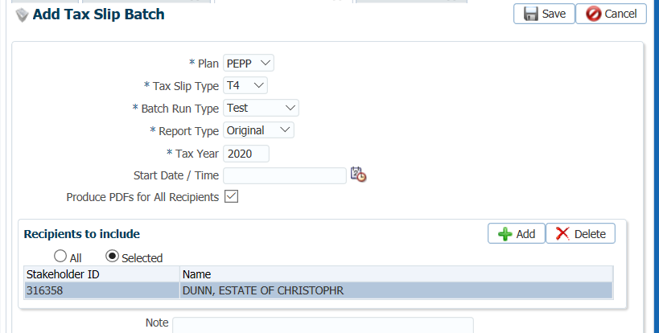

1. The **Tax Slip Batch** screen will appear where you will review the information under the tabs.

* Summary tab - This tab shows information on the Tax Slip Batch totals. Compare these totals to your payroll and tax reconciliations.
* Review the Validation Results tab. This tab displays a list of validation rules that failed while running the Tax Slip Batch. If the Tax Slip Batch contains validation errors, the user must correct the data as required.
* Information - Batch can still be processed as the validation rules did not identify a problem serious enough to cause an issue.
* Warning - Warning messages attract attention to potential issues but do not block the batch from being processed.
* Error - Batch cannot be processed with any errors as these signify a data problem that prevents a payment from being made correctly.
* Review the Exceptions tab. An exception is an unexpected condition in the database for a given Benefit Recipient that will not allow the system to process a payment. All exceptions must be investigated and corrected in order for the batch to be processed.
* Once all errors and exceptions have been addressed and corrected, you must run another Tax Slip Batch until it has completed successfully without errors.

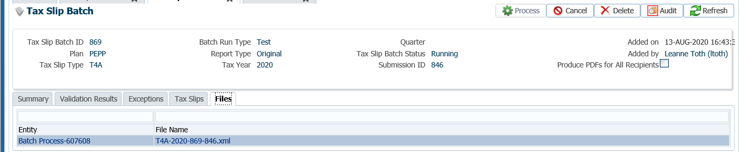

1. Once the **Test** batch has been reviewed and the information looks correct, a **Production** batch can be run following the same steps as for the **Test** batch.

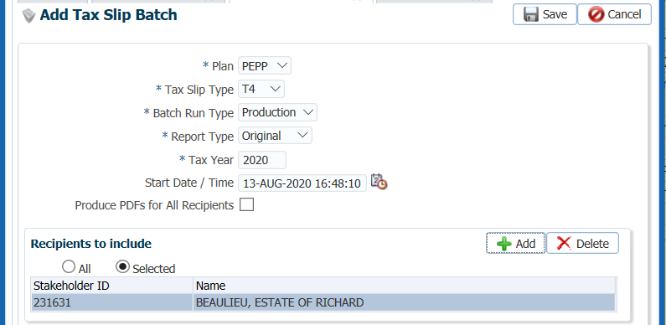

1. Once the **Production** batch has been run successfully, review the **Files** tab. This tab lists the extract files created for the **Tax Slip Batch**. The .xml file is the file that contains all the information for CRA that is verified and uploaded to the CRA website by Financial Services.
2. Once the extract has been saved and all the data has been confirmed, click the **Process** button to finalize the Tax Slip Batch and generate the Tax Slip.

